Table e-1. Comparison of burden of AE in China vs. the United States ^{e1}
 | China n = 208 | The US n= 63
Antibodies-positive | 208/208 (100%) | 31/63 (49%)
Age, mean (SD), y | 34 (±16) | 47.2 (±2.3)
Male sex | 102 (49.0%) | 29/63 (46.0%)
ICU admission | 22/208 (11%) | 27/63 (42.9%)
MRI, abnormality | 63/155 (40.6%) | 41/63 (65%)
EEG, abnormality | 108/155 (69.7%) | 40/52 (76.9)
Tumor | 38/208 (18.2%) | 15/63 (23.8%)
Age of ICU-patient, median (IQR), y | 25 (18.3-38) | 34.5 (21.75-51.75)
Male sex of ICU-patient | 9/22 (40.9%) | 10/27 (37%)
Admission mRs of ICU-patient, median (IQR) | 5 (5-5) | 4 (3-5)
Discharge mRs of ICU-patient, median (IQR) | 4 (3-5) | 3 (2-5)
Tumor of ICU-patient | 9/22 (40.9%) | 6/27 (22.2%)
LOS, median (IQR), d | 24 (16-33) | 15 (7.4-36)
LOS of ICU-patient (IQR), d | 55 (26-107) | 36.0 (18.5-52.5)
LOS of non-ICU patient (IQR), d | 23 (16-30) | 9.1 (5.4-15.7)
LOS in ICU (IQR), d | 25.5 (7-51) | 12.9 (1.8-32.4)
Inpatient costs of ICU-patient (IQR), USD | 33,097 (21,013-52,371) | 173,020 (104,695-375,013)
Inpatient costs of non-ICU-patient (IQR), USD | 9,067 (6,558-12,127) | 50,456 (30,087-78,378)
Inpatient costs (IQR), USD | 9,636 (6,707-13,625) | 74,319 (37,569-173,020)
LOS = length of stay; IQR: inter-quartile range; ICU = intensive care unit; SD = standard deviation; IQR = interquartile range; USD = United States dollars
References
e1. Cohen J, Sotoca J, Gandhi S, et al. Autoimmune encephalitis: A costly condition. Neurology. 2019.

Table e-2. Number of complications of AE patients by type
 | NMDAR n=155 | GABA_{B}R n=26 | LGI1/CASPR2  n=27 | Total  n=208
Infection & | 84 | 13 | 5 | 102
Organ dysfunction $ | 20 | 3 | 1 | 24
Electrolyte disturbance | 20 | 5 | 3 | 28
Gastrointestinal bleeding | 8 | 2 | 1 | 11
Other * | 6 | 2 | 1 | 9
& : Infection included urinary tract infection, pulmonary infection, sepsis and bacteremia.
$ : Organ dysfunction included liver dysfunction, kidney dysfunction, respiratory failure.
* : Other included hypoproteinaemia, anemia, venous thrombosis, rash, etc.

Table e-3 Clinicodemographic characteristic and burden of anti-LGI1, CASPR2 and dual antibodies positive encephalitis.
Variable | Anti-LGI1 antibody positive  N = 19 | Aiti-CASPR2 antibody positive  N = 3 | Dual antibodies positive  N = 5 | Total  N = 27 | P
Gender (male) | 10/19 （52.6%） | 1 (33.3%) | 2 (40%) | 13 | 1
Age, median (IQR), y | 41 (32-64) | 42 (14-48) * | 44 (43-54) | 44 (32-58) | 0.6
a Tumor | 0 | 0 | 1/1 (100%) | 1/1 (100%) | 1
Complication | 9/19 (47.4%) | 3/3 (100%) | 2/5 (40%) | 14/27 (51.9%) | 0.3
mRs admission, median (IQR) | 3 (3-3) | 2 (2-2) * | 4 (2-5) | 3 (2-4) | 0.06
mRs discharge, median (IQR) | 2 (1-2) | 1 (1-1) * | 2 (1-2) | 1 (1-2) | 0.3
LOS in hospital, median (IQR), d | 18 (13-24) | 22 (15-24) * | 17 (16-23) | 17 (15-24) | 0.9
Total cost, median (IQR), rmb | 56647 (25562-68746) | 45939 (28537-108382) * | 50437 (40017-67582) | 52180 (34958-68746) | 1
Direct nonmedical, median (IQR), rmb | 2414 (1700-4445) | 7600 (1590-10300) * | 2050 (1867-5754) | 2414 (1709-4850) | 0.5
Direct medical, median (IQR), rmb | 51814 (23258-67046) | 44349 (18237-100782) * | 47922 (38151-62061) | 48387 (33249-67046) | 1
a : ovarian cancer
*: range are in the parentheses

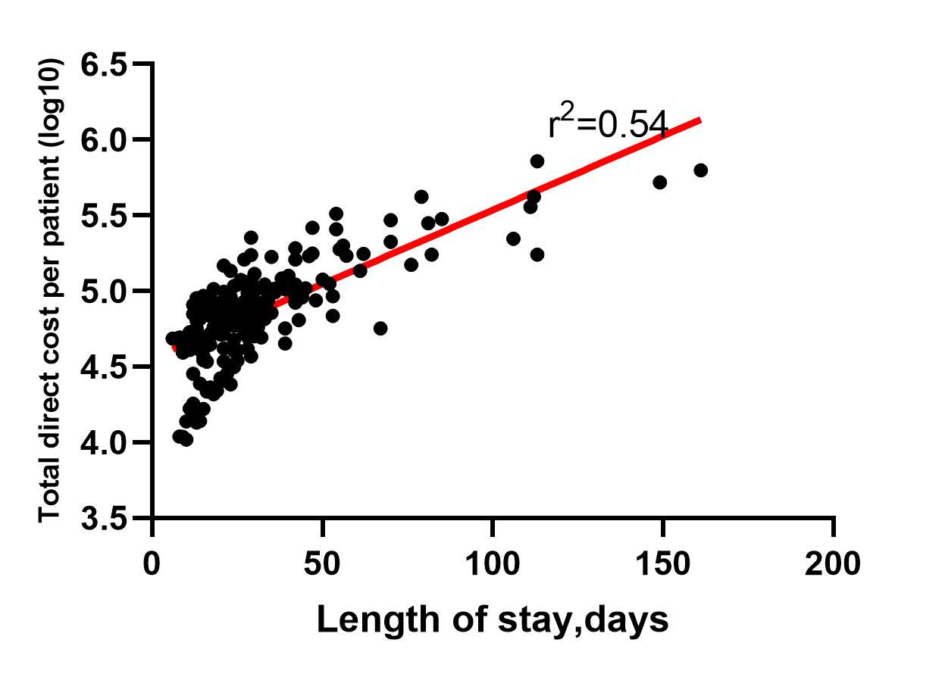
Figure e-1. Scatterplot of total direct cost (log10) vs length of stay.
Red lines represent best fit by linear regression (r²= 0.54, p < 0.001).

Figure e-2. Health care expense and income of resident of China. Health care expense (A) and per capita disposable income of resident (B) vs years. (Data are available at: website. http://www.stats.gov.cn/tjsj/ndsj/2018/indexch.htm. Accessed April 20, 2020)

