Supplemental Data
Supplementary Figure e-1
Title:
Digital subtraction angiography showing MMS-typical vasculopathy
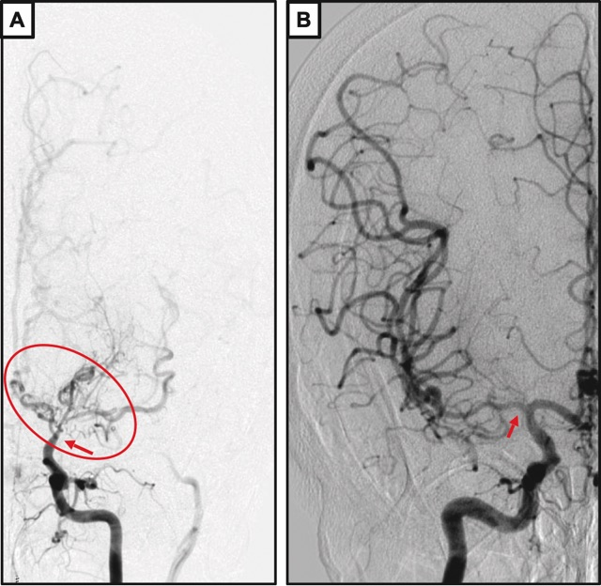

Legend of Supplementary Figure e-1:
Digital subtraction angiography showing occlusion of the left terminal carotid artery (ICA)/anterior cerebral artery (A1)/middle cerebral artery (M1) segment (indicated by red arrow) with MMS-typical prominent arterial collateral circulation (indicated by oval-shaped tag) (A) and stenosis of the right ICA/A1/M1 segment (indicated by red arrow) (B).

