Seizure-related 6 homolog like 2 (SEZ6L2) autoimmunity: Neurologic syndrome and antibody effects
Supplemental material
- Table 1S
- Legend of figure 1S
- References
Table 1S. Cerebellar ataxia and antibodies against neuronal surface antigens
Antibody | Distinctive clinical features | Cancer | Improvement with immunotherapy
VGCC¹ | Association with LEMS | SCLC | 1/11 (9%)
mGluR1² | Occasional association with dysgeusia, head titubation or orthostatic myoclonus | 7/20(35%), mostly lymphoma | 12/19 (63%)
mGluR2³ | 2 patients reported. One with acute cerebellitis. Another with relapsing ataxic episodes | Sarcoma, SCC | 1 patient
Septin5⁴ | 4 patients reported. Prominent oscillopsia in 2 and vertigo in 1 at onset | No | 2/3 patients
SEZ6L2⁵ | Mild cognitive impairment, parkinsonism | No | 1/6 patients

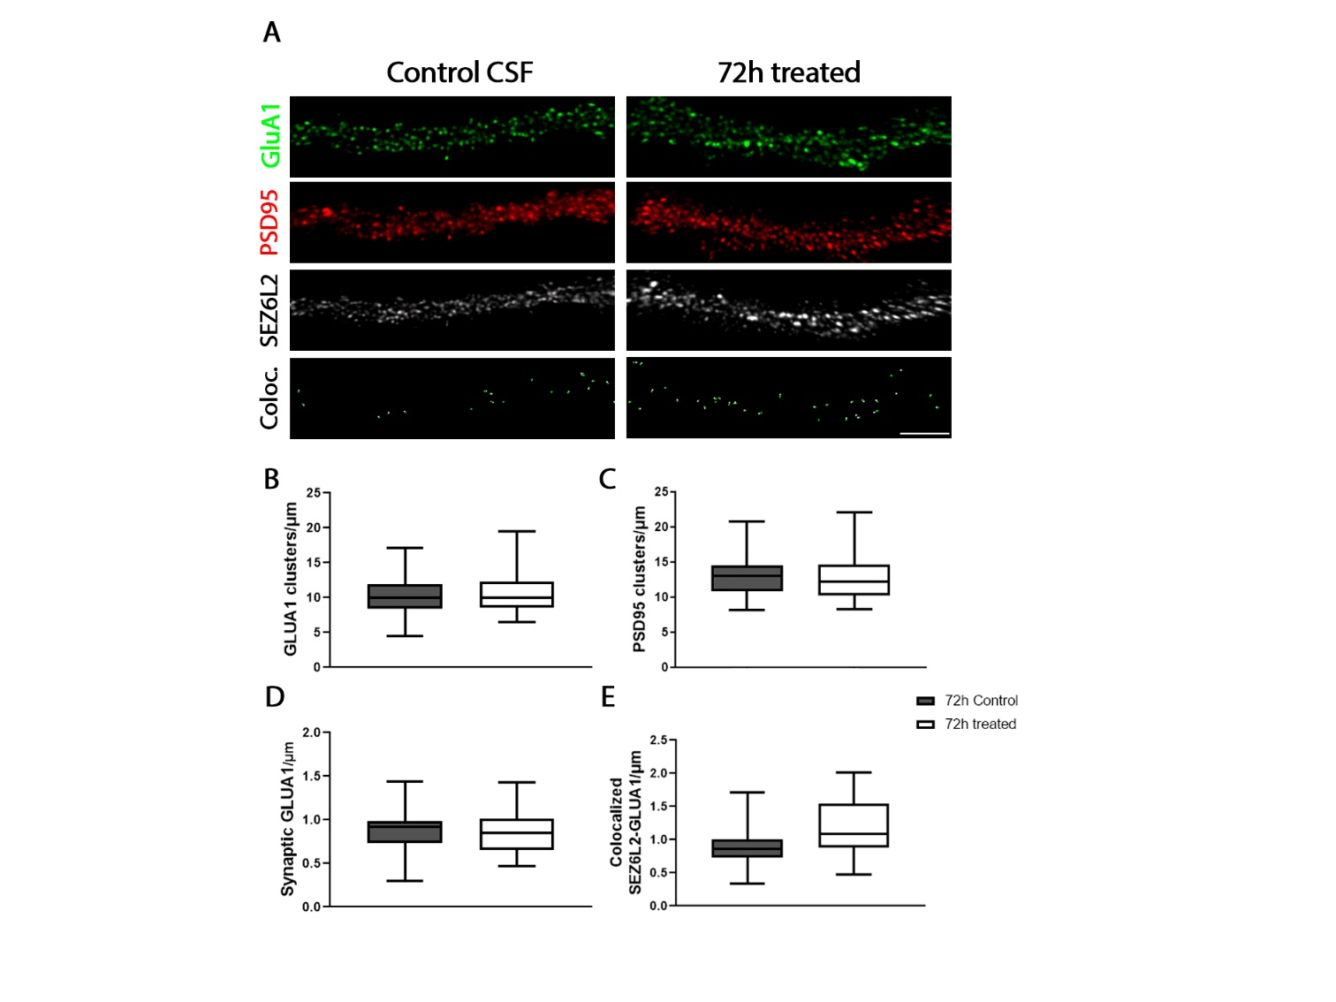

Figure 1S. SEZ6L2-ab do not decrease GluA1 clusters on neuronal surface.
A) Immunofluorescence on hippocampal neurons treated for 72 hours with control or patient CSF with SEZ6L2-ab. SEZ6L2-ab did not affect the surface cluster density of SEZ6L2, GluA1 or its degree of colocalization. Scale bar=5 μm. Quantification of total (B) and synaptic (D) GluA1 and PSD95 clusters (C), and colocalization analysis between SEZ6L2 and GluA1 (E) after treatment with SEZ6L2-ab-positive or control CSF for 72h.
References
1. Graus F, Lang B, Pozo-Rosich P, Saiz A, Casamitjana R, Vincent A. P/Q type calcium-channel antibodies in paraneoplastic cerebellar degeneration with lung cancer. Neurology 2002;59:764-766.
2. Christ M, Muller T, Bien C, Hagen T, Naumann M, Bayas A. Autoimmune encephalitis associated with antibodies against the metabotropic glutamate receptor type 1: case report and review of the literature. Therapeutic advances in neurological disorders 2019;12:1756286419847418.
3. Ruiz-Garcia R, Martinez-Hernandez E, Joubert B, et al. Paraneoplastic cerebellar ataxia and antibodies to metabotropic glutamate receptor 2. Neurol Neuroimmunol Neuroinflamm 2020;7.
4. Honorat JA, Lopez-Chiriboga AS, Kryzer TJ, et al. Autoimmune septin-5 cerebellar ataxia. Neurol Neuroimmunol Neuroinflamm 2018;5:e474.
5. Yaguchi H, Yabe I, Takahashi H, et al. Identification of anti-Sez6l2 antibody in a patient with cerebellar ataxia and retinopathy. J Neurol 2014;261:224-226.

