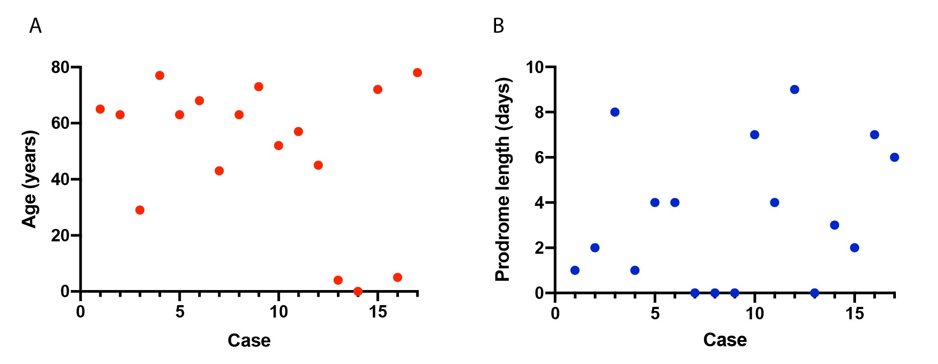

Figure e-1. Patient Characteristics: Age and Length of Viral Prodrome in Patients with Eastern Equine Encephalitis. (A) Plot of case number vs. patient age at admission. The average patient age was 50.4 years (SD = 26 years) with a range from 8 months old to 78 years old. (B) Plot of case number vs prodromal period in days, defined by the time between onset of symptoms attributable to EEE to presentation to the hospital. The average prodrome length was 3.4 days (SD = 3 days), with a range of 0-9 days.

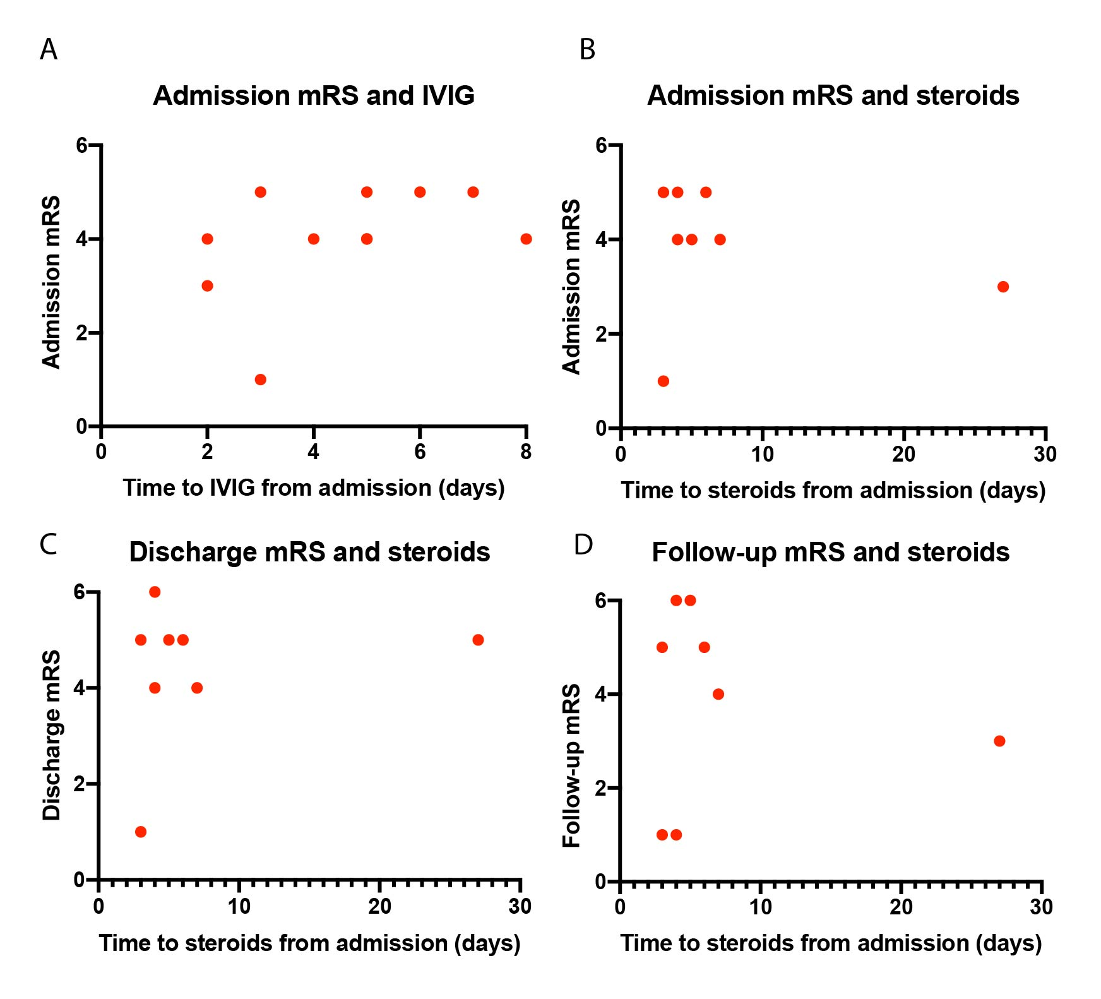

Figure e-2. Time to High-dose Steroid Administration and Modified Rankin Scale in Patients with Eastern Equine Encephalitis. (A) Time to IVIG administration compared to mRS at admission (days). Time to high-dose steroid treatment (either methylprednisolone or dexamethasone) compared to mRS at (B) hospital admission, (C) discharge from hospital, or (D) most recent follow-up.

Figure e-3. Number of Neuroanatomical Regions Affected Compared to Modified Rankin Scale in Patients with Eastern Equine Encephalitis. Discharge mRS vs. EEE case number, with number of neuroanatomical regions with T2-FLAIR abnormality on first MRI indicated at each data point. Cases 13,14, and 15 are pediatric patients. Case 5 was immunocompromised. All other cases are immunocompetent adults.

Case | Age | Gender | State of Residence | Risk Factors | Relevant Medical History
1 | 65 | M | MA, CT | Works on a farm | PE, alcohol use disorder, HTN, asthma
2 | 63 | F | MA, NH | NA | HTN, asthma
3 | 29 | M | MA | Lives near wetlands and live stock | None
4 | 77 | M | MA | Works as a landscaper | None
5 | 63 | F | MA | Time spent outdoors near a lake | HTN, lymphoma
6 | 68 | M | MA, NH | Camping at a state park | HTN
7 | 43 | M | MA, ME | Camping in wooded area | None
8 | 63 | F | MA | Works as a landscaper | None
9 | 73 | M | MA | Performs yard work | HTN
10 | 52 | F | MA | Lives near swamp | None
11 | 57 | M | NH | Time spent fishing | Diabetes mellitus, HTN
12 | 45 | F | NH, NJ | Home adjoins a swamp | None
13 | 4 | M | NH | NA | None
14 | 8mo | F | MA | NA | None
15 | 72 | M | MA | NA | HTN
16 | 5 | F | MA | Day program on a farm | None
17 | 78 | M | ME | Hiking and outdoor activities | None
Case | Treatment |  | Dose of IVIG, Duration |  | CSF WBC (cells/uL) |  | CSF Protein (mg/dL) |  | CSF Glucose (mg/dL) |  | Symptom onset to LP (days)
1 | IVIG, Steroids | 0.4g/kg, 5 days |  | 1113 |  | 230 |  | 49 |  | 3
2 | IVIG, Steroids | 0.4g/kg, 1 day |  | 294 |  | 81 |  | 56 |  | NA
3 | None | None |  | 310 |  | 146 |  | 60 |  | 9
4 | IVIG, Steroids | 0.4g/kg, 5 days |  | 177 |  | 142 |  | 71 |  | 2
5 | IVIG, Steroids | Unknown, 5 days |  | 530 |  | 106.9 |  | 66 |  | 5
6 | IVIG | 0.4g/kg, 5 days |  | 235 |  | 94 |  | 64 |  | 5
7 | Steroids | None |  | 802 |  | 73 |  | 68 |  | 2
8 | IVIG, Steroids | Unknown, 5 days |  | 77 |  | 120 |  | 53 |  | 1
9 | Steroids | None |  | 2200 |  | 169 |  | 77 |  | 2
10 | IVIG, Steroids | 0.4g/kg, 5 days |  | 2500 |  | 169 |  | 82 |  | 6
11 | None | None |  | 106 |  | 73 |  | 136 |  | 5
12 | None | None |  | 747 |  | 86 |  | 63 |  | 9
13 | IVIG | 2g/kg load, then 0.5g/kg, 2 days |  | 411 |  | 38 |  | 92 |  | 3
14 | None | None |  | 193 |  | 74 |  | 51 |  | 4
15 | IVIG | 0.4g/kg, 5 days |  | 47 |  | 77 |  | 63 |  | 2
16 | IVIG | Unknown, 2 days |  | 369 |  | NA |  | NA |  | 7
17 | IVIG | 1g/kg, 2 days |  | 860 |  | 119 |  | 78 |  | 6

Table e-1. Eastern Equine Encephalitis Patient Data by Case Number: Demographics, Medical History, Treatment Regimen, and CSF Laboratory Values. Abbreviations: PE = pulmonary embolism, HTN = hypertension, IVIG = intravenous immunoglobulin, CSF = cerebrospinal fluid, LP = lumbar puncture.

