Supplementary Material

Figure e-1. Forest plot of the results of the Leave-one-out sensitivity analysis in the MS1 cohort. The missing variant was removed and the IVW MR recalculated. CI = confidence interval; OR = odds ratio.

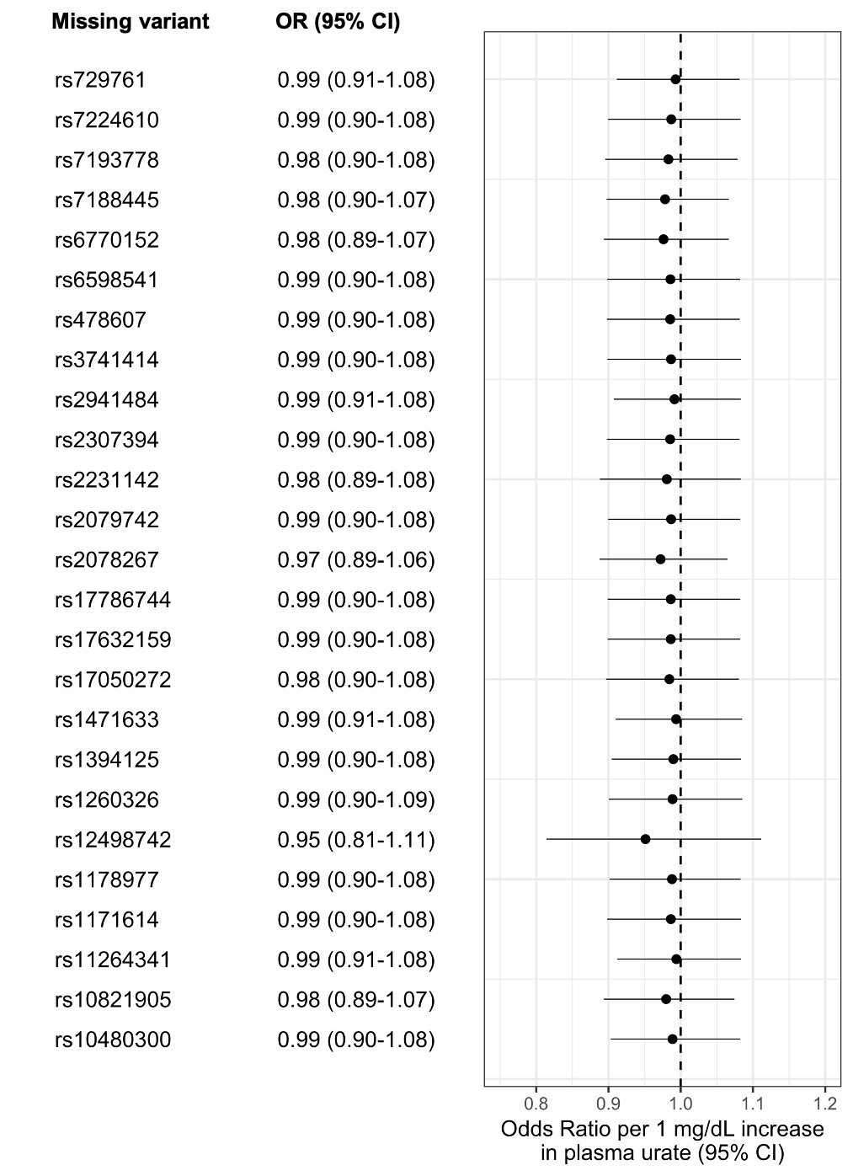
Supplementary Figure 2. Forest plot of the results of the Leave-one-out sensitivity analysis in the MS2 cohort. The missing variant was removed and the IVW MR recalculated. CI = confidence interval; OR = odds ratio.

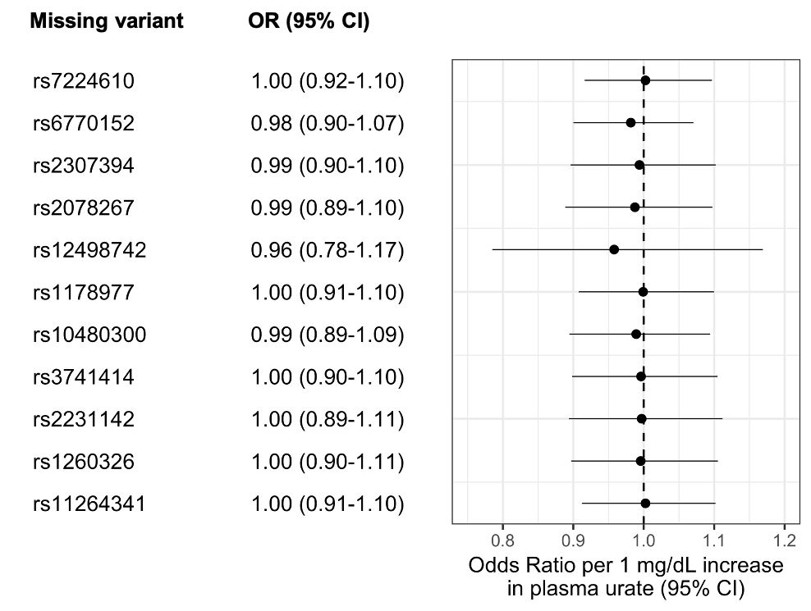

Supplementary Figure 3. Forest plot of the results of the Leave-one-out sensitivity analysis in the MS3 cohort. The missing variant was removed and the IVW MR recalculated. CI = confidence interval; OR = odds ratio.

