Appendix e-1

All serum samples tested for PNS antibodies were MOG antibody seropositive using a live cell based assay analyzed by flow cytometry which has high specificity and sensitivity (as described in Dale et al Neurol Neuroimm Neuroinflamm 2014¹, Ramanathan et al Neurol Neuroimm Neuroinflamm 2014², Ramanathan et al JNNP 2018³, and Tea et al Acta Neuropath Comm 2019⁴).

The assay used by our study group for MOG antibody detection provides a quantitative value with delta mean fluorescence intensity (MFI) which we have identified as a validated proxy for titers in extensive testing of 139 children and 148 adults with MOGAD (Tea et al, Acta Neuropath Comm 2019⁴). The delta MFI value of the MOGAD PNS cohort, and the 10 MOG patients without PNS involvement all demonstrate these patients had delta MFIs above the determined threshold (mean delta MFI + 3SD from a cohort of healthy and other neurological disease controls). In the patients in whom we had access to serial samples, there was variation in the evolution of the titre and delta MFI values over time as we have previously described⁴, and this may be explained within the context of clinical disease activity and treatment.

References

1. Dale RC, Tantsis E, Merheb V, et al. Antibodies to MOG have a demyelination phenotype and affect oligodendrocyte cytoskeleton. Neurol Neuroimmunol Neuroinflammation 2014; 1: e12.
2. Ramanathan S, Reddel SW, Henderson A, et al. Antibodies to myelin oligodendrocyte glycoprotein in bilateral and recurrent optic neuritis. Neurol Neuroimmunol Neuroinflammation 2014; 1(4):e40.
3. Ramanathan S, Mohammad S, Tantsis E, et al. Clinical course, therapeutic responses and outcomes in relapsing MOG antibody-associated demyelination. J Neurol Neurosurg Psychiatry 2018; 89: 127-137.
4. Tea F, Lopez JA, Ramanathan S, et al. Characterization of the human myelin oligodendrocyte glycoprotein antibody response in demyelination. Acta Neuropathol Commun 2019; 7: 145.

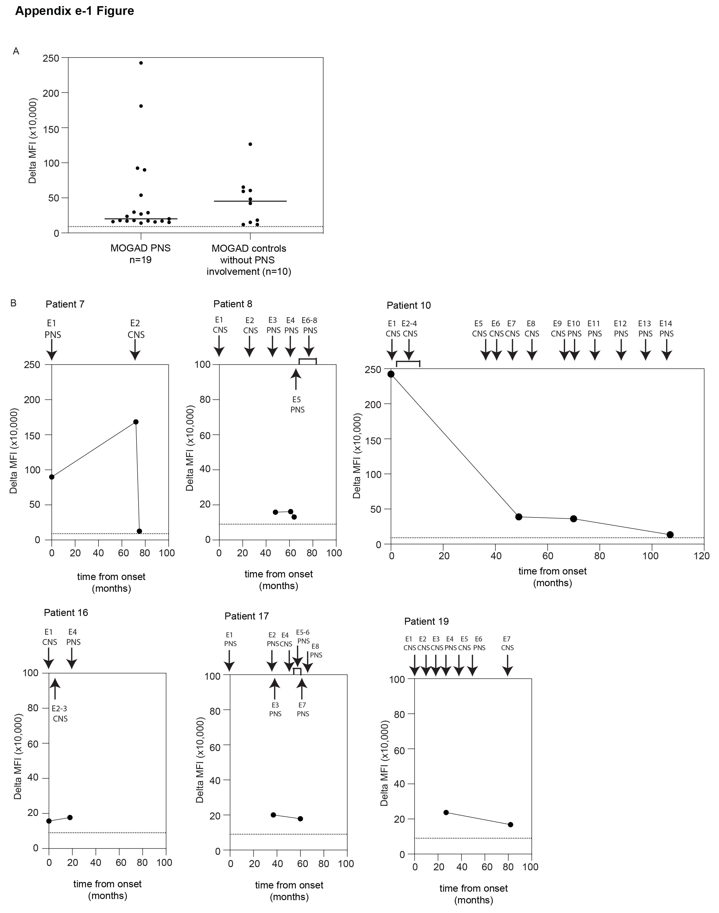
Appendix e-1 Figure 1. MOG antibody serostatus in patients (A) The 19 MOGAD PNS patients and 10 MOGAD patients without PNS involvement all demonstrated a delta MFI value over the positive threshold (dotted line) for MOG antibody detection. Representative experiment of three shown. (B) Serial samples demonstrate the evolution of MOG antibody delta MFI values over the course of clinical disease activity in six patients. All patients remained above the positive threshold (dotted line) for MOG antibody seropositivity, although their delta MFI fluctuated over time.

CNS central nervous system; E episode; MFI mean fluorescence intensity; PNS peripheral nervous system

