Data Supplement
Appendix e-1
NAWM segmentation
Appendix e-2
Areas included in NAWM sub-regions
Appendix e-3
Correlation of serum NfL level and DTI parameters with clinical and conventional MRI data
Figure e-1.
Correlation of serum NfL level with demographic and volumetric MRI parameters in patients with MS.
Table e-1.
Spearman correlations between volumetric brain MRI data and DTI-MRI indices.
Table e-2.
Spearman correlations between EDSS and DTI-MRI indices.
Appendix e-1 NAWM segmentation
T2-FLAIR NAWM mask (green) on T2-FLAIR
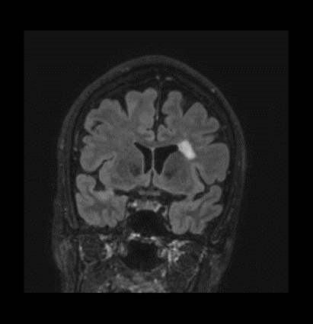
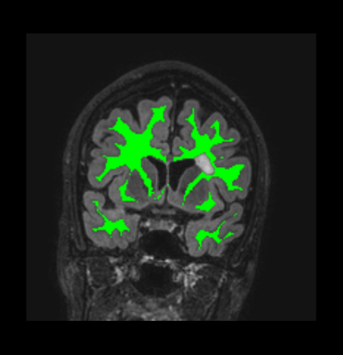
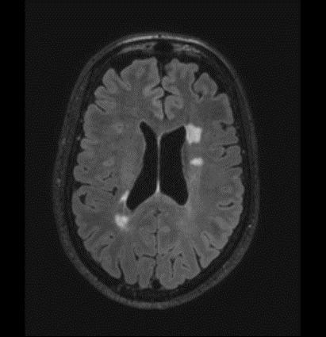
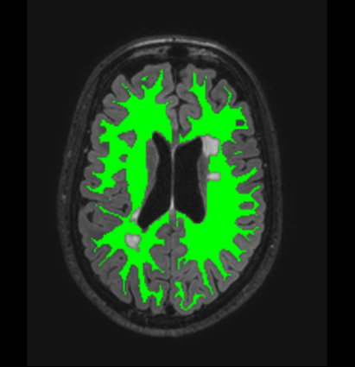
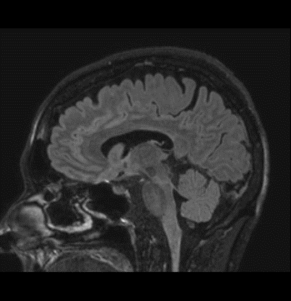
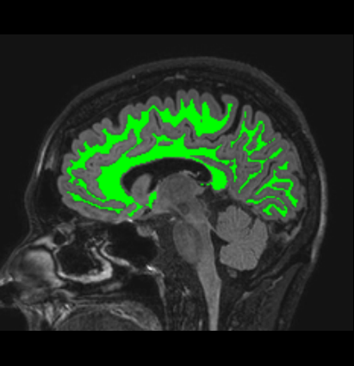

Appendix e-2 Areas included in NAWM sub-regions
The NAWM was segmented to six sub-regions (frontal, parietal, temporal, occipital, cingulate and remaining white matter) using Freesurfer-generated cortical surfaces.

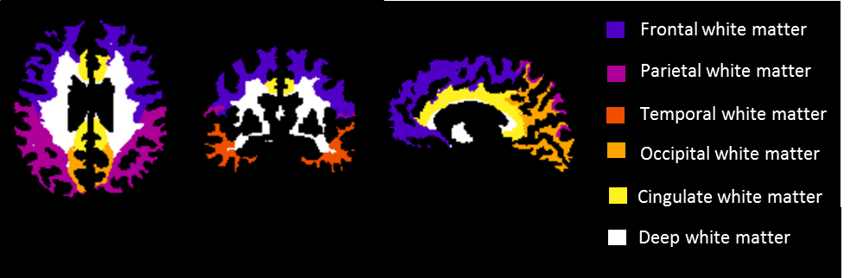

The white matter parcellation methodology was adapted from Salat DH, Greve DN, Pacheco JL, et al. Regional white matter volume differences in nondemented aging and Alzheimer's disease. Neuroimage 2009;44:1247-1258. Shortly, cortical parcellations were used to label an underlying white matter, where the sub-regions included following areas:
Frontal: frontal, precentral, paracentral, superior frontal, rostral middle frontal, caudal middle frontal, pars opercularis, pars triangularis, pars orbitalis, medial orbitofrontal, lateral orbitofrontal, precentral, paracentral, frontal pole
Parietal: parietal, postcentral, superior parietal, inferior parietal, supramarginal, postcentral, precuneus
Temporal: temporal superior, temporal inferior, temporal middle, temporal transverse, inferior temporal, middle temporal, superior temporal, bankssts (cortical areas around superior temporal sulcus), fusiform, transverse temporal, entorhinal, temporal pole, parahippocampal
Occipital: occipital, cuneus, lateral occipital, lingual, cuneus, pericalcarine
Cingulate: cingulate, caudal anterior cingulate, rostral anterior cingulate, isthmus cingulate, posterior cingulate
Deep: corona radiata, external capsule, limb of internal capsule, fornix, insula.

Appendix e-3 Correlation of serum NfL level and DTI parameters with clinical and conventional MRI data
In the entire MS cohort increased NfL levels correlated significantly with older age, longer disease duration, higher EDSS, higher T2 lesion volume and lower cortical gray matter volume, but not with NAWM volume (figure e-1 A). In the NfL(high) group increased NfL levels correlated significantly with higher EDSS, higher T2 lesion load and lower NAWM volumes, but not with age, disease duration or cortical gray matter volume (figure e-1 B). In RRMS, SPMS or NfL(low) sub-groups NfL did not correlate significantly with EDSS (ρ = 0.2 and P = 0.07, ρ = 0.3 and P = 0.1, ρ = 0.1 and P = 0.5, respectively). The results remained similar when patients with a relapse during the previous year were omitted from the analyses (data not shown).
The correlation between DTI and EDSS was most pronounced among all patients with MS where EDSS correlated with all four DTI measures in the entire, cingulate and deep NAWM (table e-1). Significance of these correlations was sustained after adjustment using False Discovery Rate method for the number of DTI parameters (n = 28). There were several significant correlations also among patients with RRMS. In contrast, for SPMS there were no correlations of the EDSS with any DTI parameter (table e-1).
In MS overall decreased fractional anisotropy and increased mean, axial and radial diffusivities of the entire NAWM were associated with greater T1 and T2 lesion loads and smaller NAWM and cortical gray matter volumes (table e-2). Similar, but fewer, significant correlations were observed also when relapsing remitting, secondary progressive, NfL(low) and NfL(high) MS subgroups were examined separately (table e-2). Significance of these correlations was sustained after adjustment using False Discovery Rate method for the number of correlation coefficients per group (n = 16) except for the correlation between radial diffusivity and cortical gray matter volume among patients with RRMS.
Figure e-1. Correlation of serum NfL level with demographic and volumetric MRI parameters in patients with MS.
(A) In the whole MS cohort (n = 79) higher NfL correlates with increased age, disease duration, EDSS and parenchymal fraction of T2 lesion volume, and decreased parenchymal fraction of cortical gray matter volume. (B) In the NfL(high) subgroup (n = 34) higher NfL correlates with increased EDSS and parenchymal fraction of T2 lesion volume, and decreased parenchymal fraction of NAWM volume. NfL(high) subgroup is comprised of MS patients with serum NfL above the median value of healthy controls (23.1 pg/ml). Shown are Spearman correlation coefficients (ρ) and P-values. The black lines indicate the level and direction of the relationship. y = year; PF = parenchymal fraction; GM = gray matter
Table e-1. Spearman correlations between EDSS and DTI-MRI indices.
 |  | All MS |  | RRMS |  | SPMS
 |  | ρ | P-value | ρ | P-value | ρ | P-value
 | FA | -0.27 | 0.02 | -0.34 | 0.01 | -0.07 | 0.8
Entire | MD | 0.29 | 0.009 | 0.29 | 0.03 | 0.05 | 0.8
NAWM | AD | 0.25 | 0.03 | 0.20 | 0.1 | 0.08 | 0.7
 | RD | 0.30 | 0.006 | 0.34 | 0.01 | 0.01 | 0.9
 | FA | -0.17 | 0.2 | -0.24 | 0.08 | 0.08 | 0.7
Frontal | MD | 0.31 | 0.006 | 0.26 | 0.06 | 0.02 | 0.9
NAWM | AD | 0.32 | 0.004 | 0.18 | 0.2 | 0.25 | 0.3
 | RD | 0.28 | 0.01 | 0.28 | 0.04 | 0.03 | 0.9
 | FA | -0.19 | 0.09 | -0.26 | 0.05 | 0.07 | 0.7
Parietal | MD | 0.18 | 0.1 | 0.22 | 0.1 | -0.02 | 0.9
NAWM | AD | 0.15 | 0.2 | 0.17 | 0.2 | 0.04 | 0.9
 | RD | 0.22 | 0.05 | 0.27 | 0.04 | -0.03 | 0.9
 | FA | -0.31 | 0.005 | -0.35 | 0.008 | -0.09 | 0.7
Temporal | MD | 0.28 | 0.014 | 0.3 | 0.03 | 0.01 | 1.0
NAWM | AD | 0.17 | 0.139 | 0.19 | 0.2 | -0.05 | 0.8
 | RD | 0.30 | 0.007 | 0.33 | 0.01 | -0.02 | 0.9
 | FA | -0.26 | 0.02 | -0.34 | 0.01 | -0.10 | 0.6
Occipital | MD | 0.25 | 0.03 | 0.30 | 0.03 | -0.07 | 0.7
NAWM | AD | 0.16 | 0.2 | 0.19 | 0.2 | -0.03 | 1.0
 | RD | 0.29 | 0.01 | 0.34 | 0.01 | -0.07 | 0.8
 | FA | -0.34 | 0.002 | -0.40 | 0.002 | -0.17 | 0.4
Cingulate | MD | 0.41 | < 0.001 | 0.39 | 0.003 | 0.25 | 0.2
NAWM | AD | 0.36 | 0.001 | 0.23 | 0.09 | 0.26 | 0.2
 | RD | 0.40 | < 0.001 | 0.41 | 0.002 | 0.25 | 0.2
 | FA | -0.32 | 0.00 | -0.29 | 0.03 | -0.17 | 0.4
Deep | MD | 0.38 | <0.001 | 0.39 | 0.003 | 0.26 | 0.2
NAWM | AD | 0.29 | 0.01 | 0.29 | 0.03 | 0.20 | 0.4
 | RD | 0.38 | 0.001 | 0.40 | 0.002 | 0.29 | 0.2
Fractional anisotropy and mean, axial and radial diffusivities of the entire NAWM and of six parcellated sub-regions of NAWM were correlated to EDSS in all MS, RRMS and SPMS patients. Shown are Spearman correlation coefficients and uncorrected P-values. The significance of bolded P-values was sustained after adjustment using False Discovery Rate method for the number of DTI parameters (n = 28). AD = axial diffusivity; DTI = diffusion tensor imaging; EDSS = expanded disability status scale; FA = fractional anisotropy; MD = mean diffusivity; MS = multiple sclerosis; NAWM = normal appearing white matter; RD = radial diffusivity; ρ = coefficient; RRMS = relapsing remitting multiple sclerosis; SPMS = secondary progressive multiple sclerosis
Table e-2. Spearman correlations between volumetric brain MRI data and DTI-MRI indices.
 |  | All MS |  | RRMS |  | SPMS |  | NfL(low) |  | NfL(high)
 |  | ρ | P | ρ | P | ρ | P | ρ | P | ρ | P
FA | NAWM | 0.5 | <0.001 | 0.4 | 0.002 | 0.7 | <0.001 | 0.6 | <0.001 | 0.5 | 0.003
 | GMctx | 0.3 | 0.007 | 0.2 | 0.1 | 0.4 | 0.07 | 0.5 | <0.001 | 0.1 | 0.6
 | T1 | -0.5 | <0.001 | -0.5 | <0.001 | -0.5 | 0.010 | -0.6 | <0.001 | -0.5 | 0.006
 | T2 | -0.5 | <0.001 | -0.4 | 0.001 | -0.6 | 0.001 | -0.6 | 0.002 | -0.5 | 0.001
MD | NAWM | -0.6 | <0.001 | -0.5 | <0.001 | -0.8 | <0.001 | -0.6 | <0.001 | -0.7 | <0.001
 | GMctx | -0.4 | <0.001 | -0.3 | 0.02 | -0.5 | 0.03 | -0.4 | 0.002 | -0.4 | 0.02
 | T1 | 0.6 | <0.001 | 0.5 | <0.001 | 0.5 | 0.017 | 0.6 | <0.001 | 0.5 | 0.002
 | T2 | 0.6 | <0.001 | 0.5 | <0.001 | 0.6 | 0.002 | 0.6 | <0.001 | 0.6 | <0.001
AD | NAWM | -0.6 | <0.001 | -0.5 | <0.001 | -0.8 | <0.001 | -0.5 | 0.002 | -0.7 | <0.001
 | GMctx | -0.4 | 0.002 | -0.2 | 0.1 | -0.5 | 0.018 | -0.3 | 0.050 | -0.5 | 0.008
 | T1 | 0.5 | <0.001 | 0.4 | <0.001 | 0.4 | 0.1 | 0.5 | <0.001 | 0.5 | 0.005
 | T2 | 0.5 | <0.001 | 0.5 | <0.001 | 0.6 | 0.026 | 0.5 | <0.001 | 0.5 | 0.001
RD | NAWM | -0.6 | <0.001 | -0.5 | <0.001 | -0.7 | <0.001 | -0.6 | <0.001 | -0.6 | <0.001
 | GMctx | -0.4 | <0.001 | -0.3 | 0.04 | -0.4 | 0.03 | -0.4 | <0.001 | -0.3 | 0.2
 | T1 | 0.5 | <0.001 | 0.5 | <0.001 | 0.5 | 0.01 | 0.6 | <0.001 | 0.5 | 0.002
 | T2 | 0.6 | <0.001 | 0.5 | <0.001 | 0.6 | 0.001 | 0.6 | <0.001 | 0.6 | <0.001
Patients with MS were divided to NfL(low) and NfL(high) subgroups based on the median value of healthy controls (23.1 pg/ml). Fractional anisotropy and mean, axial and radial diffusivities of the entire NAWM were correlated with the parenchymal fractions of the NAWM, cortical gray matter, T1 lesion and T2 lesion volumes. Shown are Spearman correlation coefficients (ρ) and uncorrected P-values. Significance of bolded P-values were sustained after adjustment using False Discovery Rate method for the number of correlation coefficients per group (n = 16). AD = axial diffusivity; DTI = diffusion tensor imaging; FA = fractional anisotropy; GMctx = cortical gray matter; MD = mean diffusivity; MS = multiple sclerosis; NAWM = normal appearing white matter; NfL = neurofilament light chain; RD = radial diffusivity; RRMS = relapsing remitting multiple sclerosis; SPMS = secondary progressive multiple sclerosis

