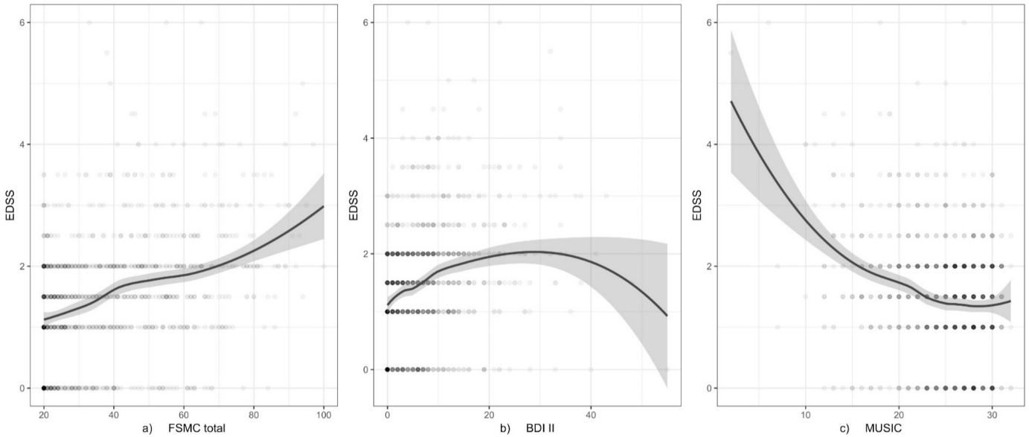Figure e-1: Correlation analyses between physical disability (EDSS) and neuropsychological assessments
Fig. 1a) EDSS versus FSMC total score, Fig. 1b) EDSS versus BDI-II, Fig. 1c) EDSS versus MUSIC. Dots represent pairs of data, blue line represents Kendall’s tau-b, grey area represents CI.
(BDI-II: Beck Depression Inventory II; CI: confidence interval; EDSS: Expanded Disability Status Scale; FSMC: Fatigue Scale for Motor and Cognitive Functions; MUSIC: Multiple Sclerosis Inventory of Cognition)

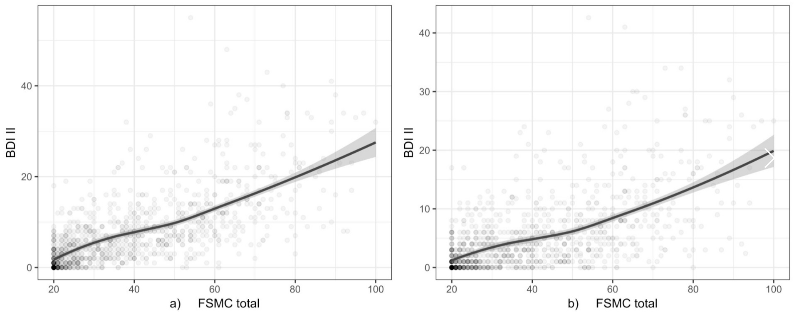Figure e-2: Correlation analyses between BDI-II and FSMC (total score)
Fig. 2a) Without correction for overlapping questions, Fig. 2b) After exclusion of overlapping questions. The following 4 questions of the BDI-II were excluded: loss of energy, change in sleep pattern, concentration difficulties, tiredness/fatigue. Dots represent pairs of data, blue line represents Kendall’s tau-b, grey area represents CI.
(BDI-II: Beck Depression Inventory II; CI: Confidence Interval; FSMC: Fatigue Scale for Motor and Cognitive Functions)

