Table e-1 Characteristics of DMF/MEF-treated patients with MS
Characteristic | Patients (N = 36)
MS disease course, n/N
RRMS or relapsing progressive MS | 18/36
Progressive MS | 17/36
Neuromyelitis optica | 1/36
Any previous MS medication, n/N | 28/36
MS therapy within 3 months before switch, n/N
None | 26/36
Interferon-beta formulations | 5/36
Fingolimod | 2/36
Mitoxantrone | 2/36
Azathioprine | 1/36
Mean (SD) age at switch to MEF/DMF, y | 56 (10.6)
Female, n/N | 24/36
MS duration (SD) at switch to MEF/DMF, y | 13.1 (7.8)
IV steroids at baseline (within 2 weeks), n/N | 3/36
Mean (SD) IV steroids dose, mg | 1167 (577)
Immunosuppressive drug in medical history, n/N | 16/36
Mitoxantrone, n/N | 14/36
Mean (SD) cumulative dose of mitoxantrone, mg/m² body surface area | 73 (31.6)
Mean (SD) interval between mitoxantrone and Fumaderm©, y | 2.4 (1.9)
Azathioprine, n/N | 3/36
Mean (SD) interval between azathioprine and Fumaderm©, y | 7.7 (6.8)
Methotrexate, n/N | 2/36
Mean (SD) interval between methotrexate and Fumaderm©, y | 2 (1.4)
Switch MEF/DMF to DMF
Mean (SD) therapy durations MEF/DMF, mo | 12 (8)
Mean (SD) follow-up during DMF, mo | 7.7 (4.1)
No therapy-free interval, n/N | 6/7
Therapy-free interval, wk (n) | 6 (1)
Abbreviations: DMF = dimethyl fumarate; MEF = monoethyl fumarate; MS = multiple sclerosis; RRMS = relapsing-remitting multiple sclerosis.
Table e-2 Specific genes/pathways in mice most impacted by DMF and MEF
Pathways | Gene Symbols | -log  (P-value)
Interaction Pathways
Aldosterone Signaling in Epithelial Cells | DNAJA1, DNAJB1, HSPA8, HSPH1, SOS1 | 3.13
Assembly of RNA Polymerase III Complex | GTF3C4, GTF3C2 | 2.790
Unfolded protein response | Hspa1b, HSPA8, HSPH1 | 2.68
Huntington's Disease Signaling | Hspa1b, DNAJB1, HSPA8, NCOR1, SOS1 | 2.34
DMF-specific Pathways
NRF2-mediated Oxidative Stress Response | SQSTM1, GSTA3, GSTA5, GCLC, CBR1, TXN, NQO1, GSTK1, MGST1, PRDX1, GSTM1, GSTM5, CAT, AOX1, MAFG, FTL, GSTP1, FTH1 | 9.27
Xenobiotic Metabolism Signaling | GSTA3, GSTA5, GCLC, UGT2B7, UGT1A9 (includes others), CAMK2D, Ces1g, NQO1, GSTK1, MGST1, ESD, GSTM1, GSTM5, CAT, UGT2B28, FTL, NDST1, GSTP1, ABCC3, UGT1A6 | 7.92
Glutathione-mediated Detoxification | GSTA3, GSTA5, GSTM1, GSTM5, GSTP1, GSTK1, MGST1 | 6.48
Aryl Hydrocarbon Receptor Signaling | GSTA3, GSTA5, GSTM1, GSTM5, RBL1, NQO1, GSTP1, GSTK1, CTSD, MGST1 | 4.13
Nicotine Degradation III | UGT2B7, UGT1A9 (includes others), AOX1, UGT2B28, Aox3, UGT1A6 | 3.71
Formaldehyde Oxidation II (Glutathione-dependent) | ADH5, ESD | 3.61
Nicotine Degradation II | UGT2B7, UGT1A9 (includes others), AOX1, UGT2B28, Aox3, UGT1A6 | 3.34
Serotonin Degradation | UGT2B7, UGT1A9 (includes others), ADH5, ALDH2, UGT2B28, UGT1A6 | 3.30
LPS/IL-1 Mediated Inhibition of RXR Function | GSTA3, GSTA5, GSTM1, GSTM5, CAT, APOE, NDST1, GSTP1, GSTK1, MGST1, ABCC3 | 3.14
Thyroid Hormone Metabolism II (via Conjugation and/or Degradation) | UGT2B7, UGT1A9 (includes others), UGT2B28, UGT1A6 | 2.67
Pentose Phosphate Pathway (Oxidative Branch) | PGD, G6PD | 2.62
Glutathione Redox Reactions I | PRDX6, GSTK1, MGST1 | 2.51
Superoxide Radicals Degradation | CAT, NQO1 | 2.31
Estrogen-mediated S-phase Entry | E2F6, SKP2, RBL1 | 2.22
Role of BRCA1 in DNA Damage Response | E2F6, RFC1, FAM175A, SMARCA2, RBL1 | 2.12
MEF-specific Pathways
RhoA Signaling | MYL12B, PIP5K1A, ROCK1, CDC42EP3, ACTR3, RDX | 3.10
Apoptosis Signaling | MAP2K7, KRAS, PARP1, ROCK1, CYCS | 2.92
Signaling by Rho Family GTPases | MAP2K7, GNG5, MYL12B, PIP5K1A, ROCK1, CDC42EP3, ACTR3, RDX | 2.91
Death Receptor Signaling | MAP2K7, PARP1, TNKS2, ROCK1, CYCS | 2.86
Sphingosine and Sphingosine-1-phosphate Metabolism | SGPP1, ASAH1 | 2.67
fMLP Signaling in Neutrophils | KRAS, Calm1 (includes others), GNG5, PPP3CB, ACTR3 | 2.55
Cardiac Hypertrophy Signaling | MAP2K7, KRAS, Calm1 (includes others), GNG5, MYL12B, PPP3CB, ROCK1 | 2.41
autophagy | NBR1, LAMP2, BECN1 | 2.40
RhoGDI Signaling | GNG5, MYL12B, PIP5K1A, ROCK1, ACTR3, RDX | 2.34
Ephrin Receptor Signaling | KRAS, GNG5, RAP1B, ABI1, ROCK1, ACTR3 | 2.32
B Cell Receptor Signaling | MAP2K7, KRAS, BCL6, Calm1 (includes others), RAP1B, PPP3CB | 2.30
Role of NFAT in Cardiac Hypertrophy | MAP2K7, CSNK1A1, KRAS, Calm1 (includes others), GNG5, PPP3CB | 2.27
Regulation of IL-2 Expression in Activated and Anergic T Lymphocytes | MAP2K7, KRAS, Calm1 (includes others), PPP3CB | 2.26
Axonal Guidance Signaling | KRAS, GNG5, TUBB6, MYL12B, NRP1, RAP1B, PPP3CB, ROCK1, BRCC3, ACTR3 | 2.25
Regulation of the Epithelial-Mesenchymal Transition Pathway | MAP2K7, ESRP2, KRAS, PSEN2, FRS2, ZEB2 | 2.21
Telomere Extension by Telomerase | TNKS2, HNRNPA2B1 | 2.11
UVA-Induced MAPK Signaling | KRAS, PARP1, TNKS2, CYCS | 2.10
Granzyme B Signaling | PARP1, CYCS | 2.06
Regulation of Actin-based Motility by Rho | MYL12B, PIP5K1A, ROCK1, ACTR3 | 2.05
RAN Signaling | RAN, KPNB1 | 2.01
Abbreviations: DMF = dimethyl fumarate; MEF = monoethyl fumarate; MS = multiple sclerosis; RRMS = relapsing-remitting multiple sclerosis.

Table e-3 Specific pathways in mice most impacted by a combination of DMF and MEF
Tissue | Ingenuity Canonical Pathways | Proportion of pathway molecules represented in DEG list | Genes | P-value
Blood | Aryl Hydrocarbon Receptor Signaling | 1.17E-02 | NQO1,TGM2 | 1.10E-03
Blood | Superoxide Radicals Degradation | 1.25E-01 | NQO1 | 2.19E-03
Blood | Pregnenolone Biosynthesis | 7.69E-02 | MICAL3 | 2.19E-03
Blood | Histidine Degradation VI | 5.00E-02 | MICAL3 | 3.31E-03
Blood | Ubiquinol-10 Biosynthesis (Eukaryotic) | 3.33E-02 | MICAL3 | 4.79E-03
Brain | Superoxide Radicals Degradation | 1.25E-01 | NQO1 | 6.31E-04
Brain | Nicotine Degradation III | 1.37E-02 | Aox3 | 5.37E-03
Brain | Nicotine Degradation II | 1.18E-02 | Aox3 | 6.31E-03
Brain | Hypoxia Signaling in the Cardiovascular System | 1.47E-02 | NQO1 | 6.92E-03
ILN | Aryl Hydrocarbon Receptor Signaling | 1.17E-02 | GSTM5,NQO1 | 7.76E-04
ILN | NRF2-mediated Oxidative Stress Response | 1.03E-02 | GSTM5,NQO1 | 1.29E-03
ILN | Superoxide Radicals Degradation | 1.25E-01 | NQO1 | 1.86E-03
ILN | Xenobiotic Metabolism Signaling | 6.94E-03 | GSTM5,NQO1 | 2.88E-03
ILN | Glutathione-mediated Detoxification | 2.27E-02 | GSTM5 | 8.71E-03
Jejunum | Xenobiotic Metabolism Signaling | 5.56E-02 | ABCC2,ABCC3,ALDH1A1,CES1,Ces1, GCLC,GSTA3,GSTA5,GSTK1,GSTM1,Gstm3,GSTM4,GSTM5,NQO1,UGT2B15,UGT2B7 | 1.58E-18
Jejunum | Glutathione-mediated Detoxification | 1.82E-01 | GSTA3,Gsta4,GSTA5,GSTK1,GSTM1,Gstm3,GSTM4,GSTM5 | 2.00E-15
Jejunum | NRF2-mediated Oxidative Stress Response | 5.64E-02 | ABCC2,CBR1,GCLC,GSTA3,GSTA5,GSTK1,GSTM1,Gstm3,GSTM4,GSTM5,NQO1 | 5.01E-13
Jejunum | LPS/IL-1 Mediated Inhibition of RXR Function | 4.49E-02 | ABCC2,ABCC3,ACOX2,ALDH1A1,GSTA3,GSTA5,GSTK1,GSTM1,Gstm3,GSTM4,GSTM5 | 5.01E-12
Jejunum | Aryl Hydrocarbon Receptor Signaling | 5.26E-02 | ALDH1A1,GSTA3,GSTA5,GSTK1,GSTM1,Gstm3,GSTM4,GSTM5,NQO1 | 5.01E-11
Jejunum | PXR/RXR Activation | 5.43E-02 | ABCC2,ABCC3,ALDH1A1,Aldh1a7,GSTM1 | 6.17E-07
Jejunum | Serotonin Degradation | 5.13E-02 | ALDH1A1,Aldh1a7,UGT2B15,UGT2B7 | 1.51E-05
Jejunum | Glutathione Biosynthesis | 1.82E-01 | GCLC,GSS | 1.78E-05
Jejunum | Histamine Degradation | 6.90E-02 | ALDH1A1,Aldh1a7 | 4.47E-04
Jejunum | Î³-glutamyl Cycle | 7.14E-02 | GCLC,GSS | 6.03E-04
Jejunum | Fatty Acid Î±-oxidation | 8.70E-02 | ALDH1A1,Aldh1a7 | 6.92E-04
Jejunum | Oxidative Ethanol Degradation III | 5.00E-02 | ALDH1A1,Aldh1a7 | 6.92E-04
Jejunum | Putrescine Degradation III | 6.67E-02 | ALDH1A1,Aldh1a7 | 7.76E-04
Jejunum | Tryptophan Degradation X (Mammalian, via Tryptamine) | 6.90E-02 | ALDH1A1,Aldh1a7 | 8.71E-04
Jejunum | Ethanol Degradation IV | 6.90E-02 | ALDH1A1,Aldh1a7 | 8.71E-04
Jejunum | Dopamine Degradation | 5.26E-02 | ALDH1A1,Aldh1a7 | 1.58E-03
Jejunum | Sorbitol Degradation I | 2.00E-01 | SORD | 2.45E-03
Jejunum | Retinoate Biosynthesis I | 5.41E-02 | AKR1B10,ALDH1A1 | 2.82E-03
Jejunum | Thyroid Hormone Metabolism II (via Conjugation and/or Degradation) | 3.77E-02 | UGT2B15,UGT2B7 | 2.82E-03
Jejunum | Ethanol Degradation II | 4.65E-02 | ALDH1A1,Aldh1a7 | 2.95E-03
Jejunum | Retinol Biosynthesis | 4.44E-02 | CES1,Ces1e | 3.31E-03
Jejunum | Noradrenaline and Adrenaline Degradation | 3.77E-02 | ALDH1A1,Aldh1a7 | 3.55E-03
Jejunum | Nicotine Degradation III | 2.74E-02 | UGT2B15,UGT2B7 | 7.24E-03
Jejunum | L-serine Degradation | 1.67E-01 | SRR | 7.41E-03
Jejunum | Melatonin Degradation I | 3.03E-02 | UGT2B15,UGT2B7 | 8.13E-03
Jejunum | Superpathway of Melatonin Degradation | 2.47E-02 | UGT2B15,UGT2B7 | 9.55E-03
Jejunum | Heme Degradation | 9.09E-02 | BLVRB | 9.77E-03
Jejunum | Nicotine Degradation II | 2.35E-02 | UGT2B15,UGT2B7 | 9.77E-03
Kidney | LXR/RXR Activation | 6.47E-02 | ALB,APOA1,APOC1,APOC2,APOC3,APOE,GC,SERPINA1,TTR | 7.41E-08
Kidney | LPS/IL-1 Mediated Inhibition of RXR Function | 4.49E-02 | ALAS1,ALDH3A1,APOC1,APOC2,APOE,FABP5,GSTA3,Gstm3,GSTM4,GSTM5,GSTP1 | 1.58E-07
Kidney | NRF2-mediated Oxidative Stress Response | 5.13E-02 | AOX1,EPHX1,GSR,GSTA3,Gstm3,GSTM4,GSTM5,GSTP1,HMOX1,NQO1 | 2.14E-07
Kidney | Glutathione-mediated Detoxification | 1.14E-01 | GSTA3,Gstm3,GSTM4,GSTM5,GSTP1 | 8.13E-07
Kidney | Atherosclerosis Signaling | 5.76E-02 | ALB,APOA1,APOC1,APOC2,APOC3,APOE,PLA2G7,SERPINA1 | 1.07E-06
Kidney | Xenobiotic Metabolism Signaling | 3.82E-02 | ALDH3A1,Ces2b/Ces2c,GSTA3,Gstm3,GSTM4,GSTM5,GSTP1,HMOX1,NQO1,UGT2B10,UGT2B15 | 1.20E-06
Kidney | Nicotine Degradation III | 6.85E-02 | AOX1,CYP2D6,CYP2J2,UGT2B10,UGT2B15 | 1.91E-05
Kidney | IL-12 Signaling and Production in Macrophages | 4.46E-02 | ALB,APOA1,APOC1,APOC2,APOC3,APOE,SERPINA1 | 2.29E-05
Kidney | Clathrin-mediated Endocytosis Signaling | 4.04E-02 | ALB,APOA1,APOC1,APOC2,APOC3,APOE,ITGB6,SERPINA1 | 2.29E-05
Kidney | Aryl Hydrocarbon Receptor Signaling | 4.09E-02 | ALDH3A1,GSTA3,Gstm3,GSTM4,GSTM5,GSTP1,NQO1 | 3.02E-05
Kidney | Pentose Phosphate Pathway | 1.30E-01 | G6PD,PGD,TKT | 3.89E-05
Kidney | Nicotine Degradation II | 5.88E-02 | AOX1,CYP2D6,CYP2J2,UGT2B10,UGT2B15 | 4.17E-05
Kidney | Production of Nitric Oxide and Reactive Oxygen Species in Macrophages | 3.30E-02 | ALB,APOA1,APOC1,APOC2,APOC3,APOE,SERPINA1 | 1.41E-04
Kidney | Heme Degradation | 1.82E-01 | BLVRB,HMOX1 | 2.34E-04
Kidney | Pentose Phosphate Pathway (Oxidative Branch) | 1.82E-01 | G6PD,PGD | 3.89E-04
Kidney | Melatonin Degradation I | 6.06E-02 | CYP2D6,CYP2J2,UGT2B10,UGT2B15 | 3.98E-04
Kidney | Superpathway of Melatonin Degradation | 4.94E-02 | CYP2D6,CYP2J2,UGT2B10,UGT2B15 | 5.62E-04
Kidney | Coagulation System | 7.89E-02 | PLAU,PLAUR,SERPINA1 | 1.38E-03
Kidney | FXR/RXR Activation | 3.64E-02 | APOA1,APOC2,APOC3,APOE | 2.14E-03
Kidney | Acute Phase Response Signaling | 2.76E-02 | ALB,APOA1,HMOX1,SERPINA1,TTR | 4.37E-03
Kidney | Serotonin Degradation | 3.85E-02 | ALDH3A1,UGT2B10,UGT2B15 | 6.76E-03
MLN | Airway Pathology in Chronic Obstructive Pulmonary Disease | 1.82E-01 | MMP2,MMP9 | 1.00E-04
MLN | NRF2-mediated Oxidative Stress Response | 2.05E-02 | GSTA3,GSTM5,HMOX1,NQO1 | 3.89E-04
MLN | Glutathione-mediated Detoxification | 4.55E-02 | GSTA3,GSTM5 | 1.32E-03
MLN | Xenobiotic Metabolism Signaling | 1.39E-02 | GSTA3,GSTM5,HMOX1,NQO1 | 1.78E-03
MLN | Hepatic Fibrosis / Hepatic Stellate Cell Activation | 1.94E-02 | AGTR1,MMP2,MMP9 | 2.40E-03
MLN | Aryl Hydrocarbon Receptor Signaling | 1.75E-02 | GSTA3,GSTM5,NQO1 | 2.45E-03
MLN | Inhibition of Matrix Metalloproteases | 5.00E-02 | MMP2,MMP9 | 2.57E-03
MLN | IL-8 Signaling | 1.33E-02 | HMOX1,MMP2,MMP9 | 5.62E-03
MLN | Glioma Invasiveness Signaling | 3.03E-02 | MMP2,MMP9 | 5.62E-03
MLN | Eicosanoid Signaling | 2.33E-02 | LTC4S,PTGDS | 6.61E-03
MLN | Heme Degradation | 9.09E-02 | HMOX1 | 7.76E-03
MLN | LPS/IL-1 Mediated Inhibition of RXR Function | 1.22E-02 | GSTA3,GSTM5,HMGCS2 | 8.71E-03
Spleen | NRF2-mediated Oxidative Stress Response | 1.54E-02 | AOX1,GSTA3,GSTM5 | 8.13E-06
Spleen | Glutathione-mediated Detoxification | 4.55E-02 | GSTA3,GSTM5 | 2.04E-05
Spleen | Aryl Hydrocarbon Receptor Signaling | 1.17E-02 | GSTA3,GSTM5 | 5.25E-04
Spleen | LPS/IL-1 Mediated Inhibition of RXR Function | 8.16E-03 | GSTA3,GSTM5 | 1.29E-03
Spleen | Xenobiotic Metabolism Signaling | 6.94E-03 | GSTA3,GSTM5 | 1.95E-03
Spleen | Guanosine Nucleotides Degradation III | 4.35E-02 | AOX1 | 3.39E-03
Spleen | Urate Biosynthesis/Inosine 5'-phosphate Degradation | 4.35E-02 | AOX1 | 3.63E-03
Spleen | Adenosine Nucleotides Degradation II | 3.57E-02 | AOX1 | 4.47E-03
Spleen | Purine Nucleotides Degradation II (Aerobic) | 2.70E-02 | AOX1 | 5.25E-03
Abbreviations: DEG = differentially expressed gene; ILN = inguinal lymph node; MLN = mesenteric lymph node.
Pathways with significant changes (p<0.01) after treatment of mice with the combination of DMF and MEF.

Figure e-1 Steady-state tissue-specific DEGs in response to chronic DMF, MEF, and DMF/MEF administration in mice
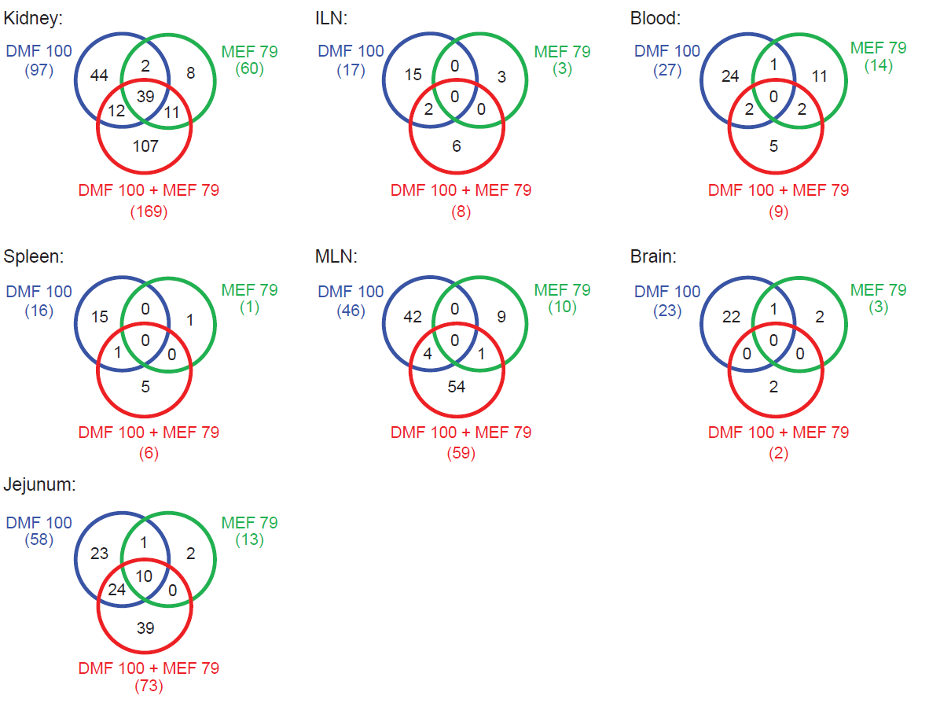
Tissue was harvested after 10 days of daily treatment with DMF, MEF, or DMF/MEF. DEGs were identified by comparing the groups DMF-vs-vehicle, MEF-vs-vehicle, and DMF/MEF-vs-vehicle in each tissue. The number in parentheses designates the total number of DEGs for that treatment. DEG = differentially expressed gene; DMF = dimethyl fumarate; ILN = inguinal lymph node; MLN = mesenteric lymph node; MEF = monoethyl fumarate.

