B-cell activity predicts response to glatiramer acetate and interferon in relapsing-remitting MS

Figure e-1 Representative ELISPOT wells showing the four different responder types
“No antigen” indicates wells that were coated with 10% fetal bovine serum only, “antigen” refers to coating with whole normal human brain lysate, and immunoglobulin (Ig)κ coating was used as a positive control. Counting and quality control of the individual wells was performed using an ImmunoSpot® Series 6 Analyzer (Cellular Technology Limited, Shaker Heights, OH). Individual antigen-specific B-cell spots are marked by green outlines in the representative enlarged well. Spots outlined in white were disregarded as they were too small; spots outlined in black were not included in the count following quality checking. The number of verified spots in this case is 48.
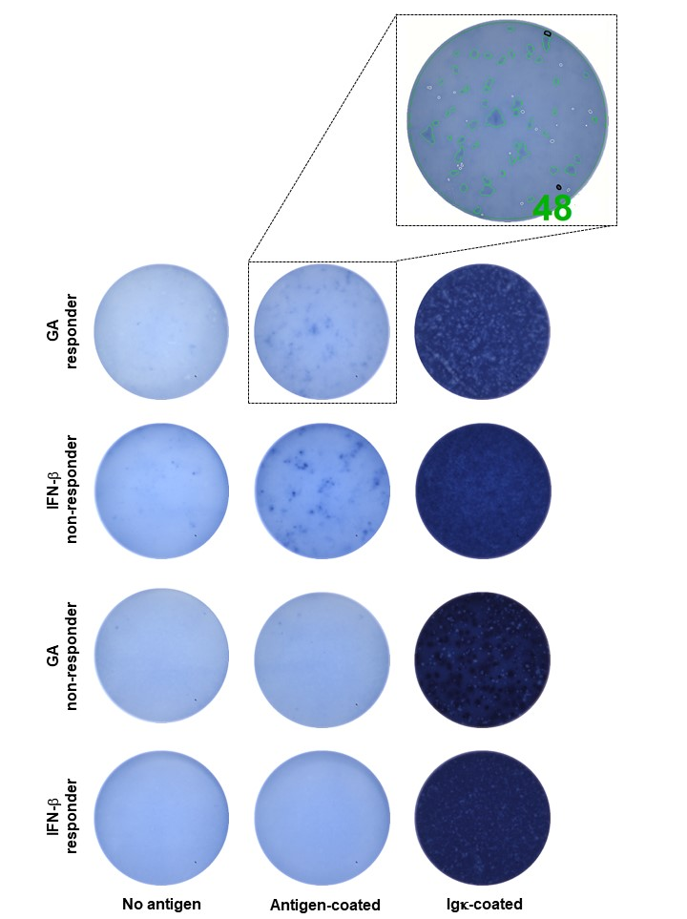
GA = glatiramer acetate; IFN-β = interferon-β.

