Disability outcomes in the N-MOmentum trial of inebilizumab in neuromyelitis optica spectrum disorder: supplementary data

Appendix e-1 Modified Rankin Scale

Appendix e-2 Analysis of NMOSD attack severity and attack recovery

Figure e-1 Characterization of attacks in the N-MOmentum study by (A) severity and (B) recovery

Appendix e-1 Modified Rankin Scale
mRS score | Score definition
0 | No symptoms
1 | No significant disability; able to carry out all usual activities despite some symptoms
2 | Slight disability; able to look after own affairs without assistance, but unable to carry out all previous activities
3 | Moderate disability; requires some help, but able to walk unassisted
4 | Moderately severe disability; unable to attend to own bodily needs without assistance and unable to walk unassisted
5 | Severe disability; requires constant nursing care and attention, bedridden, incontinent
6 | Dead
Abbreviation: mRS = modified Rankin Scale.

Appendix e-2 Analysis of NMOSD attack severity and attack recovery
A severity and recovery classification for each type of NMOSD attack (optic neuritis, myelitis,
brain, and brainstem) was based on changes in the respective subscale scores presented below. Attack severity assessments (graded as ‘minor’ or ‘major’) were based on a shift in subscale scores corresponding to the domain of interest at the time of attack from the last assessment of the subscale. When measuring attack recovery, the shift in subscale score at the follow-up visit relative to the time of attack was used to grade the level of ‘recovery or improvement’, graded as ‘minor’ or ‘major’. The VA represents the corrected VA assessment based on high-contrast Landolt broken ring C-chart.

Subscale scores by domain of NMOSD attack
Domain | Subscale score |  | Description
Optic neuritis (VA) | 1 |  | Scotoma but VA ≥ 50 characters
 | 2 |  | VA ≥ 35–49 characters
 | 3 |  | VA ≥ 20–34 characters
 | 4 |  | VA ≥ 1–19 characters
 | 5 |  | Counting fingers only
 | 6 |  | Light perception only
 | 7 |  | No light perception
Myelitis (motor function) | 0 |  | Normal
 | 1 |  | Abnormal signs (hyperreflexia, Babinski sign) without weakness
 | 2 |  | Mild weakness (MRC grade 5− or 4+) in affected limb(s)
 | 3 |  | Moderate weakness (MRC grade 3 or 4) in 1 or 2 UMN muscles in affected limb(s)
 | 4 |  | Moderate weakness (MRC grade 3 or 4) in 3 UMN muscles in affected limb(s)
 | 5 |  | Severe weakness (MRC grade 2) in 1 or more muscles in affected limb(s)
 | 6 |  | Some plegic (MRC grade 0 or 1) muscles in 1 or more limbs
 | 7 |  | Plegia (MRC grade 0 or 1) of all muscles in 1 or more limbs
Brain | 0 |  | Normal
 | 1 |  | Drowsiness or mood changes only
 | 2 |  | Mild confusion/disorientation (able to manage all self-care functions); mild focal impairment (mild aphasia, apraxia, agnosia, anorexia, or drowsiness)
 | 3 |  | Moderate confusion/disorientation (able to manage some self-care functions); moderate focal impairment (moderate aphasia, apraxia, agnosia, anorexia, or drowsiness)
 | 4 |  | Severe confusion/disorientation (unable to manage self-care functions); severe focal impairment (aphasia such that is unable to comprehend simple 1-step commands or speak 5-word sentences; severe apraxia, agnosia, anorexia, or drowsiness)
 | 5 |  | Stupor or coma
Brainstem | 0 |  | Normal
 | 1 |  | Signs only (unsustained nystagmus, impaired saccadic pursuit, ocular dysmetria, mild facial weakness, or sensory loss)
 | 2 |  | Sustained conjugate nystagmus, incomplete INO, moderate facial weakness or sensory loss, or other mild disability; mild nausea and vomiting for 48 hours or longer without other explanation, with vomiting not more than 3 times per day; intractable hiccups occurring more than 20 times per hour for less than 6 hours per day
 | 3 |  | Dysconjugate nystagmus (INO) or severe extraocular weakness, loss of facial sensation or facial paralysis (unilateral or bilateral), moderate dysarthria or dysphagia; moderate nausea and vomiting lasting 48 hours or longer without other explanation, with vomiting between 3 and 7 times per day; intractable hiccups occurring more than 20 times per hour for 6–12 hours per day
 | 4 |  | Severe dysarthria or dysphagia, almost complete ophthalmoplegia, or other severe disability of a cranial nerve/nerves; severe nausea and vomiting lasting 48 hours or longer without other explanation, with vomiting occurring more than 7 times per day; intractable hiccups occurring more than 20 times per hour for more than 12 hours per day
 | 5 |  | Inability to swallow or speak because of bulbar dysfunction; respiratory failure requiring intubation because of brainstem lesion
Assessment of attack severity
Domain |  | Subscale score  at pre-attack visit |  | Subscale score  at time of attack | Severity
Optic neuritis, myelitis, brainstem |  | < 2 |  | < 3 | Minor
 |  |  |  | ≥ 3 | Major
 |  | ≥ 2 |  | Increase by 1 point | Minor
 |  |  |  | Increase by ≥ 2 points | Major
Brain |  | Not applicable |  | Increase by 1 point | Minor
 |  |  |  | Increase by ≥ 2 points | Major
Assessment of attack recovery
Domain |  | Subscale score  at time of attack |  | Improvement at  follow-up visit | Recovery
Optic neuritis, myelitis,  brainstem |  | Any score |  | ≤ 2 | Minor
 |  | ≥ 3 |  | > 2 | Major
Brain |  | Any score |  | 1 | Minor
 |  | ≥ 2 |  | > 1 | Major
Abbreviations: INO = internuclear ophthalmoplegia; MRC = Medical Research Council; NMOSD = neuromyelitis optica spectrum disorder; UMN = upper motor neuron; VA = visual acuity.

Figure e-1 Characterization of attacks in the N-MOmentum study by (A) severity and (B) recovery
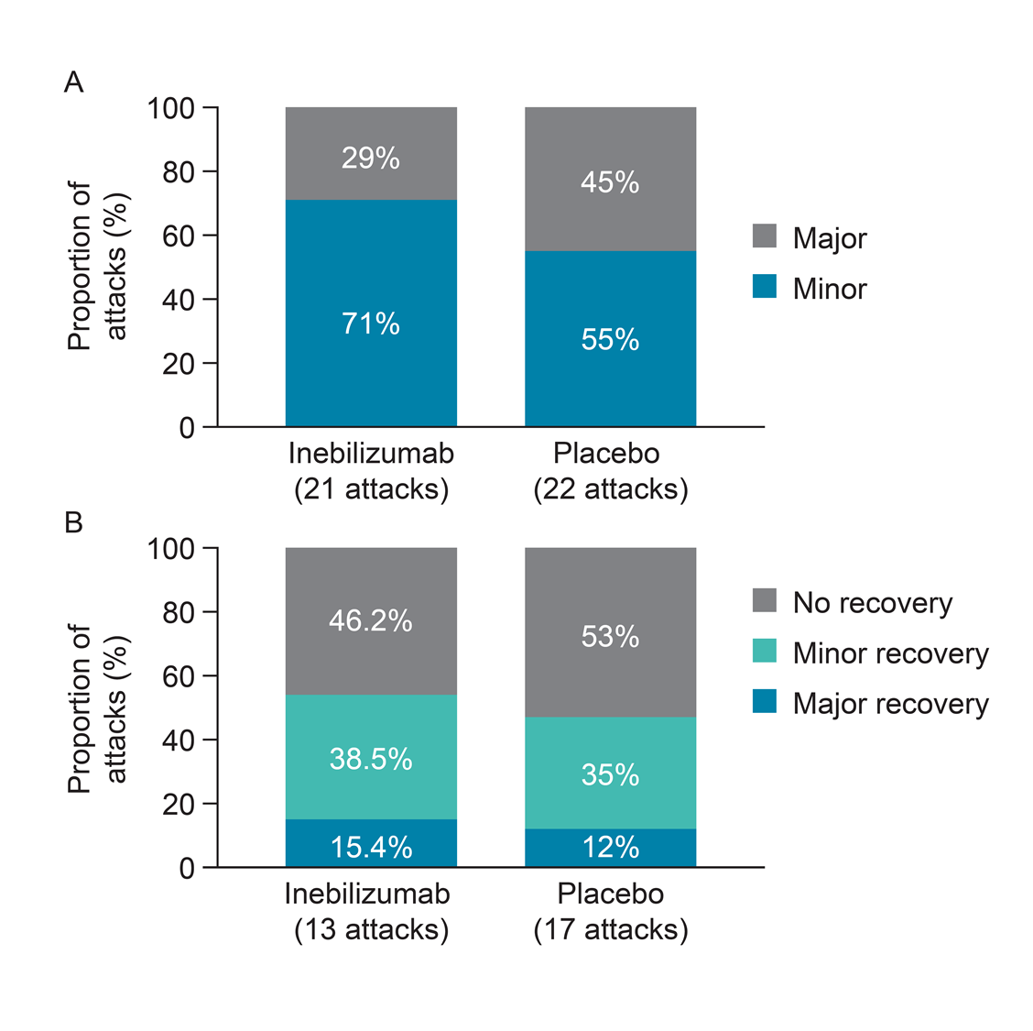

(A) Attack severity graded as major or minor according to a pre-defined scale based on domain-specific neurological changes since the last assessment. (B) Level of recovery graded as major, minor, or no recovery based on the degree of domain-specific neurological improvement 30 days after the attack assessment.

