Supplementary Information

JCPyV diagnostics for PML
Determination of JCPyV DNA concentrations in cerebrospinal fluid by PCR was performed as routine tests at the Institute of Virology, Hannover Medical School, and at the Institute of Virology, University of Düsseldorf.¹ Reproducibility of the results was assessed by at least 3 independent experiments in two independent centers. The sensitivity of the PCR had been established by titration of the JCV genome in the pGem vector, and the detection level was found to be 115 cop/ml (95% probit analysis). The time schedule for CSF JCPyV PCR can be found in Fig. 1.

JCV_{AI} diagnostics for PML
Sera and CSF were tested in pairs in the validated ELISA assay. Albumin levels and IgG concentrations were determined immunnephelometrically and JCV_{AI} was calculated as standard. JCV_{AI} > 1.5 was considered pathological and indicated intrathecal anti-JCV IgG production.²

Brain MRI protocol
Multisequence brain magnetic resonance (MR) acquisition was performed in a standardized way with respect to repositioning, pulse sequences and spatial resolution including axial FLAIR, T2-weighted, diffusion weighted and T1-weighted sequences after intravenous administration of macrocyclic Gadolinium (0.1 mmol/KG bodyweight). The time schedule for the MRI examination is shown in Fig. 1.

Preparation of donor T cells for adoptive transfer
We selected partially HLA compatible third party donors (8/10 and 6/10 HLA low resolution (single field resolution); 6/10 and 6/10 high resolution (two field resolution) from the pre-examined T-cell donor registry alloCELL (www.allocell.org). Donor pretesting was performed as described using overlapping peptide pools covering the proteins VP1 and LT of BKV.³ Manufacturing of clinical-grade BKV-specific CD4+ and CD8+ T-cells was performed on a CliniMACS Prodigy device using MACS GMP Peptivators VP1 and LT in combination (cross-reactivity with JCV demonstrated in the preliminary examination) and the IFN-γCytokine Capture System (Miltenyi Biotech). The comparison of the sequences of the proteins for LT and VP1, on which the 4 peptivators are based, revealed a very high sequence homology with more than 80%. Quality control of the final T-cell product was done as described. The patients got fresh and cryopreserved BKV-specific T-cell products from a single manufacturing process each. In addition to the HLA type of the patient, we considered the HLA type of the donor organ of patient 1 and excluded the mismatched HLA antigens to avoid donor-specific immunization.

Frequencies of antiviral T cells before and after T cell transfer
Both patients were closely monitored for viral load and cellular BK virus and JC virus immunity before and after T cell therapy. Immunity against JC virus and BK virus was very weak in both patients prior to BKV-CTLs (0-2.5 spots/5 x10e5 Peripheral Blood Mononuclear Cells) and markedly increased for both BK virus and JC virus after the adoptive transfer of BKV-CTLs. Taken together, viral control by BKV-CTLs could be assumed after transfer of CTLs. For patient 1, we were able to detect the patient’s own as well as the adoptively transferred antiviral T cells, based on the serological detection of the mismatched HLA alleles of the allogeneic T cells by flow cytometry.

Monitoring of BKV-specific T cells before, during and after T cell therapy: Functional Assay
Individual patient’s cellular BKV and JCV immunity was determined before and after T-cell therapy by an IFN-γ ELISpot (enzyme-linked immunospot) assay, based on the stimulation of 500,000 peripheral blood mononuclear cells (PBMCs) with overlapping peptide pools covering the proteins VP1 and LT of BKV and JCV.⁴ If suitable numbers of PBMCs were obtained antiviral T-cells were expanded over 7 days using the respective antigens in TexMACS media (Miltenyi Biotec) containing 50 U/ml IL-2 (Peprotec).⁵ After 7 days the IFN-γ ELISpot assay was repeated using the respective antigens. In order to distinguish the T cells from the patient and the donor HLA staining for the mismatched HLA alleles on T cells of patient 1 was performed.

A

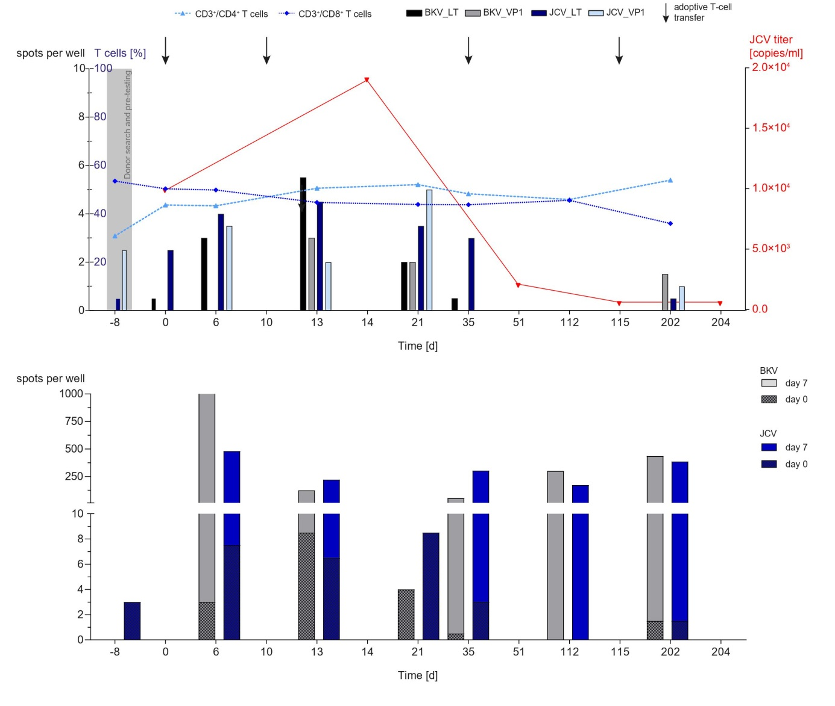 Supplementary Figure 1. Adoptive T-cell therapy and patient 1 follow-up
B

- Monitoring of patient´s 1 cellular immunity was performed with blood samples collected at different time points before and after BKV-specific T cell transfer. Frequencies of CD3, CD4 and CD8 T cells were assessed by flow cytometry following detection of the BKV- and JCV specific T-cell repertoire in response to the premium-grade BKV and JCV peptide pools VP1 and LT by IFN-γ ELISpot assay. JCV copy numbers were determined in cerebrospinal fluid by quantitative PCR.
- PBMCs were isolated at different time points before and after transfer (light bars [before expansion, day 0]) and restimulated with the premium-grade peptide pools over seven days (dark bars [after expansion, day 7]) followed by the assessment of the JCV- and BKV-specific T-cell response against VP1 and LT Consensus by IFN-γ ELISpot.

Supplementary references

1. Warnke C, Smolianov V, Dehmel T, et al. CD34+ progenitor cells mobilized by natalizumab are not a relevant reservoir for JC virus. Mult Scler 2011;17:151-156.
2. Warnke C, Pawlita M, Dehmel T, et al. An assay to quantify species-specific anti-JC virus antibody levels in MS patients. Mult Scler 2013;19:1137-1144.
3. Priesner C, Esser R, Tischer S, et al. Comparative Analysis of Clinical-Scale IFN-gamma-Positive T-Cell Enrichment Using Partially and Fully Integrated Platforms. Front Immunol 2016;7:393.
4. Tischer S, Dieks D, Sukdolak C, et al. Evaluation of suitable target antigens and immunoassays for high-accuracy immune monitoring of cytomegalovirus and Epstein-Barr virus-specific T cells as targets of interest in immunotherapeutic approaches. J Immunol Methods 2014;408:101-113.
5. Schultze-Florey RE, Tischer S, Kuhlmann L, et al. Dissecting Epstein-Barr Virus-Specific T-Cell Responses After Allogeneic EBV-Specific T-Cell Transfer for Central Nervous System Posttransplant Lymphoproliferative Disease. Front Immunol 2018;9:1475.

