Supplemental data
Fig. e1 – Peripheral cytokines/chemokines/growth factor in COVID-19 and controls patient. Bar plot representation (mean ± SEM) of IL-1RA, IL-6, CCL2, CXCL8, CXCL9, CXCL10, CXCL12, HGF and VEGF-A expression in the serum of patient with (red circles, n=16) or without (black dot, n=45, combination of MS, IND and NIND groups) SARS-CoV-2 infection. Statistical significance was calculated using Mann-Whitney test (p:* ≤ 0.05 *** ≤ 0.001, **** ≤ 0.001).

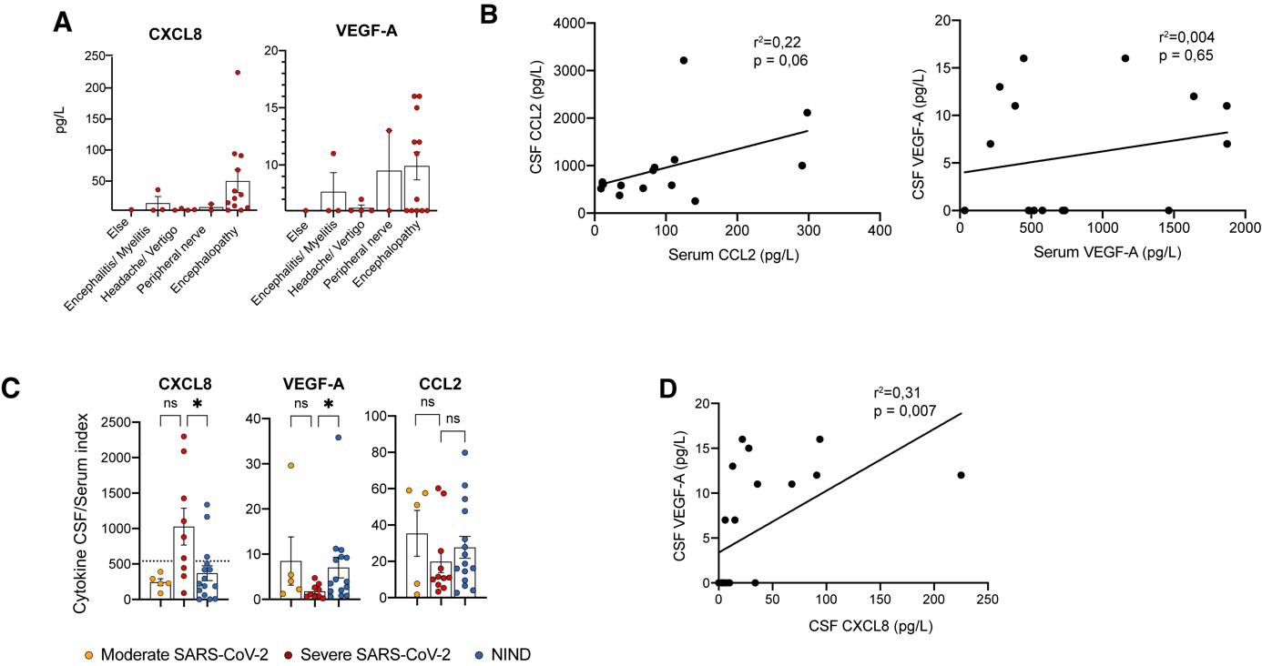
Fig. e2 – CXCL8, CCL2 and VEGF-A synthesis in the CSF. (A) CXCL8 and VEGF-A expression (mean ± SEM) according to neurological diagnosis associated to COVID-19. (B) Linear regression of level of CCL2 (left panel) and VEGF-A (Right panel) in the CSF and the serum (n=16). (C) CSF/serum index for CXCL8, VEGF-A and CCL2 in moderate (yellow circle, n=5) and severe (red circles, n=11) SARS-CoV-2 patients compared to NIND (blue circles, n=15). Dotted line represent positivity threshold for CXCL8 determined by receiver operating curve (D) Linear regression of level of VEGF-A in the CSF in function of CXCL8 expression in the CSF (n=22).

Main Neurological diagnosis | IND (n=21) | NIND (n=19)
Headache | HaNDL syndrome (ansient headache and neurologic deficits with cerebrospinal fluid lymphocytosis) (1) | Headache from undetermined cause (2)  Migraine (1)
Vascular/Stroke | Vasculitis of the CNS (1) | Lacunar stroke (1)  Ischemic stroke (1)
Encephalitis/ Meningitis | Meningoencephalitis of unknown origin (4)  Bacterial meningoencephalitis (2)  Tick borne meningoencephalitis (2)  Lyme’s disease (1)  HSV-1 meningoencephalitis (1)  Neurosyphilis (2)  Paraneoplastic cerebellar degeneration (1)  Anti-NMDA limbic encephalitis (1)  Autoimmune opsoclonus myoclonus (1) | -
Neuro-degenerative disease | - | Lewy body disease (1)  Parkinsonian syndrome (2)
Encephalopathy | - | -
Peripheral nerve | Guillain Barré Syndrome (1)  Inflammatory mononeuritis multiplex (1)  CANOMAD syndrome (1) | Radicular conflict (1)  Post-radiation radiculopathy (1)  Trigeminal hypoesthesia of unknown origin (1)  Idiopathic peripheral facial paralysis (1)
Epilepsy | - | Isolated epileptic seizure (1)
Else | Neurosarcoidosis (1) | Pseudotumor cerebri (1)  Distal paraesthesia of unknown origin (1)  Major depressive state (2)  Resolved Vogt-Koyanagi Harada disease (1)  Functional neurological symptoms (1)

Table. e1 – Detailed diagnosis of control study patients. CANOMAD : Chronic Ataxic Neuropathy Ophthalmoplegia IgM paraprotein Cold Agglutinins Disialosyl antibodies

