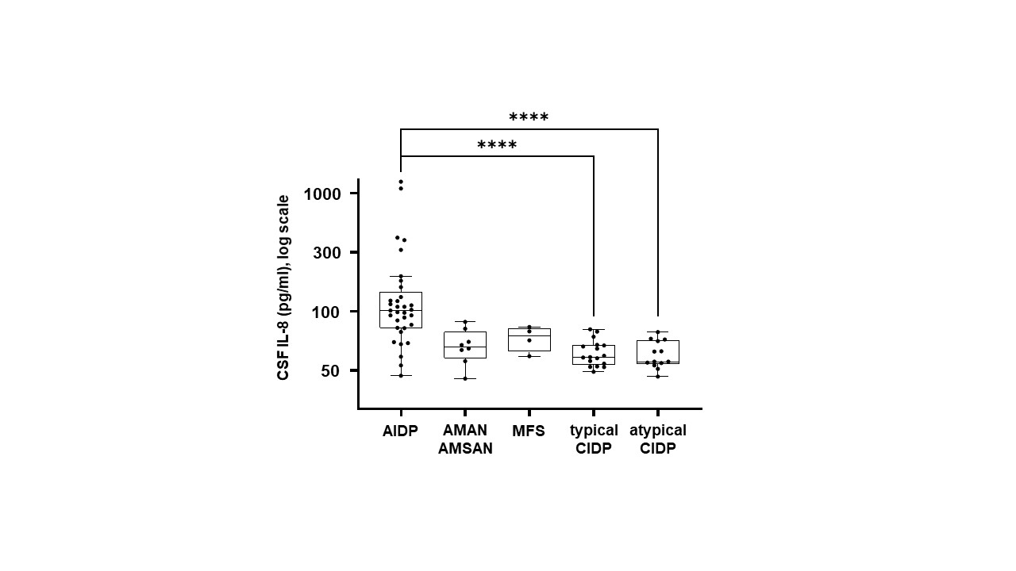
Supplemental Figure. Distribution of CSF IL-8 levels in patient subgroups according to electro-clinical criteria.
Box-and-whisker plot (median, first and third quartiles, range) of the distribution of CSF IL-8 levels in patient subgroups. Among GBS subcategories, CSF IL-8 concentration was higher in AIDP as opposed to axonal GBS phenotypes (AMAN and AMSAN) or MFS (p<0.001). When compared with typical (n = 17, median: 41.1 pg/ml; IQR 16.6 (51.9-35.3)) and atypical CIDP (n=13, median: 37.6 pg/ml; IQR 21.2 (57-35.8)), CSF IL-8 was significantly increased in the AIDP variant (n = 33; median: 101.8 pg/ml, IQR 74.2 (146.6-72.4)) (p<0.0001). Abbreviations: AIDP, acute inflammatory demyelinating polyneuropathy; AMAN, acute motor axonal neuropathy; AMSAN, acute motor and sensitive axonal neuropathy; GBS, Guillain-Barre syndrome; CIDP, chronic inflammatory demyelinating polyneuropathy.

