Supplementary online Materials
Figure e-1. Gating strategy for identifying B cell subsets.
Figure e-2. Expression of genes related to cytokines/chemokines, interferon, and inflammatory responses in B cell subsets.
Figure e-3. B cell subpopulations in CSF from NMOSD patients.
Figure e-4. Frequency of total B cells and subpopulations in CSF and blood in NMOSD patients compared with those in patients with multiple sclerosis and healthy controls.
Figure e-5. Gene expression of IFN-response, inflammation, and exhaustion-related among B cell clusters in NMOSD.
Figure e-6. Expression of inflammatory and exhaustion-related genes in B cell clusters across different organs in NMOSD.
Figure e-7. Expression of type I interferon-related genes in patients with NMOSD, MS, and HCs.
Figure e-8. Effects of IFN-α on cell viability and apoptosis of transitional B cells.
Figure e-9. Comparative analysis of genetic expression between different tissues for ASCs.
Figure e-10. Clonal expansion of B cells in patients with NMOSD.
Figure e-11. Differential expression of CD19 in NMOSD ASCs.
Figure e-12. Flow cytometry analysis of CD19⁺ ASCs and CD19⁻ ASCs.

Table e-1. Demographic information of NMOSD patients and healthy controls enrolled for single cell RNA sequencing.
Table e-2. Interferon stimulator genes (ISGs).
Table e-3. Inflammatory gene markers.
Table e-4. Exhaustion gene markers.
Table e-5. Characteristics of NMOSD patients, MS patients, and healthy controls for B cell subsets analysis by flow cytometry and specific expression of type I interferon related genes.
Table e-6. RT-PCR primer sequence for IFN-related genes.
Table e-7. Demographic information of patients with NMOSD receiving rituximab or tocilizumab
Table e-8. Gene expression profiles of blood B cells from NMOSD patients versus heathy controls.
Table e-9. Gene expression profiles of bone marrow B cells versus blood B cells in NMOSD.
Table e-10. Gene expression profiles of blood B cells versus CSF B cells in NMOSD.
Table e-11. Differentially expressed genes in blood ASCs versus CSF ASCs from NMOSD patients.
Table e-12. Differentially expressed genes in blood ASCs versus bone marrow ASCs from NMOSD patients.

Figure e-1

Figure e-1. Gating strategy for identifying B cell subsets. Live CD19⁺ B cells were divided into four canonical subsets based on CD27 and IgD expression: naïve B cells (Q3, IgD⁺ CD27⁻), double positive B cells (pre-switch memory B cells) (Q2, IgD⁺CD27⁺), memory B cells (switched memory B cells) (Q1, IgD⁻CD27⁺) and double negative B cells (Q4, IgD⁻CD27⁻). Antibody secreting cells (ASCs) were categorized into two types: CD19⁺ ASCs (CD19⁺CD27^{high}CD38^{high}) and CD19⁻ ASCs (CD3⁻CD14⁻CD16⁻CD19⁻CD56⁻CD27^{high}CD38^{high}).

Figure e-2
Figure e-2. Expression of genes related to cytokines/chemokines, interferon, and inflammatory response in B cell subsets. Cells were pooled from all samples and eight B cell subsets were identified. ASC, antibody secreting cells.

Figure e-3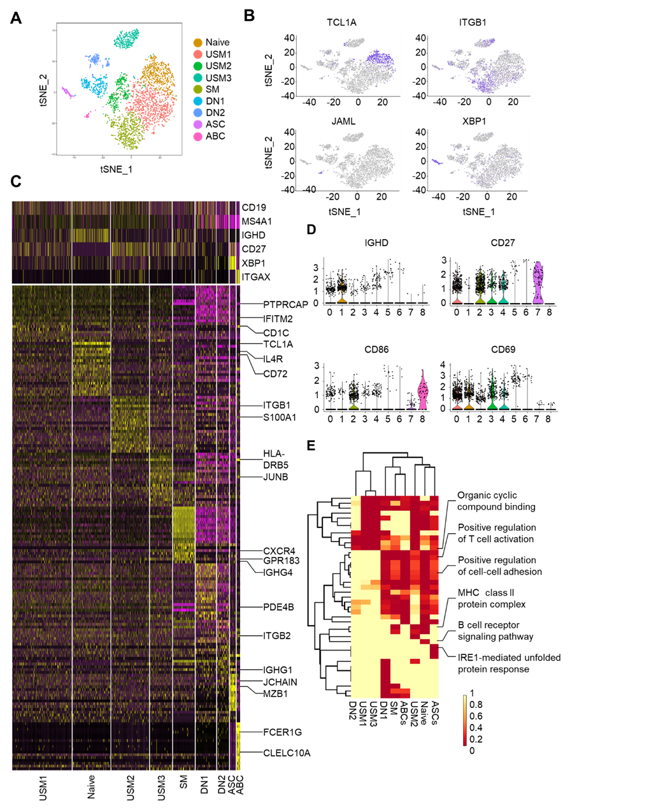
Figure e-3. B cell subpopulations in CSF from NMOSD patients. A. Single cell analysis revealed CSF B cells subpopulations in NMOSD. B. Heterogeneous distribution of B cell subpopulations in NMOSD CSF. C. Heatmap showing the expression of canonical markers that identified B cell subpopulations (top) or genes that were differentially upregulated in each subpopulation (bottom). Scaled expression of discriminative gene sets for B cells was shown. Color scheme is based gene expression abundance from -2 (purple) to 2 (yellow). D. Expression patterns of IGHD, CD27, CD86 and CD69 amongst the subsets. C0 cluster, unswitched memory B cells type 1 (USM1) had high levels of CD24 and PTPRCAP, key regulators of T- and B-lymphocyte activation. C1 cluster were naïve B cells. C2 cluster were switched memory B cells. Both cluster C3 (unswitched memory B cells type 2 [USM2]) and C4 (unswitched memory B cells type 3 [USM3]) expressed similar levels of TNFRSF13C (BAFF-R), however, cluster C3 had higher levels of CD69, but cluster C4 had unique high levels of IGHG1, IGHG4, GPR183 and CXCR4. Both clusters C5 and C6, were double negative memory B cells that expressed very low levels of CD86 and CD24. Cluster C5 had higher levels of CD69 and CD83 than cluster. C6 had low expression of CD19, similar expression was observed in the C7 cluster. C7 cluster were antibody secreting cells (ASCs). C8 cluster were age-associated B cells (ABCs). E. Pathway enrichment analysis showing the expression of the indicated pathways in CSF B cell subsets in NMOSD patients. Scaled expression of signaling pathway by GO analysis for indicated B cell subpopulations was shown. Color scheme is based on relative expression level among B cell subpopulations from 0 (yellow) to 1 (red).

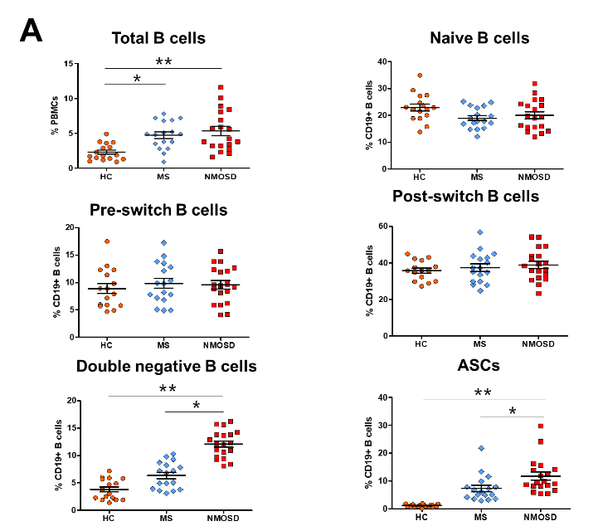
Figure e-4

Figure e-4. Frequency of total B cells and subpopulations in CSF and blood of NMOSD patients, compared with those in multiple sclerosis patients and healthy controls. A. Counts of total B cells and indicated B cell subpopulations in CSF. B. Counts of total B cells and indicated B cell subpopulations in blood. N = 23 in NMOSD cohort, n = 15 in MS cohort, n = 16 in HCs cohort. HCs, healthy controls. MS, multiple sclerosis. Error bars represent S.E.M. *p < 0.05, **p < 0.01.

Figure e-5
Figure e-5. Gene expression of IFN-response, inflammation and exhaustion-related genes among B cell clusters in NMOSD. A. Plots showing increased expression of IFN-response genes. B. Plots showing inflammation-related genes with higher scores. C. Plots showing scores of inflammation-related gene in indicated B cell subsets. D. Plots showing increased expression of exhaustion-related genes. E. Plots showing scores of exhaustion-related genes of indicated B cell subsets. *p < 0.05.

Figure e-6
Figure e-6. Expression of inflammatory and exhaustion-related genes in B cell clusters across different organs in NMOSD. A. Memory B cells and naïve B cells had higher Z-scores of inflammation-related genes in CSF. B. Memory B cells and CD27^{high} ASCs had significantly differences in Z-scores of exhaustion genes. *p < 0.05.

Figure e-7
Figure e-7. Expression of type I interferon-related genes in patients with NMOSD, MS and HCs. RT-PCR analysis revealed expression of type I interferon-related genes (IRF4, IFI44, IFI44L, MX1 and IFI6) of blood B cells were significantly higher in NMOSD patients (n = 27) compared with MS patients (n = 15) and healthy controls (n = 16). Relative mRNA expression was normalized to house housekeeping gene GAPDH and calculated by the 2_ΔΔCt method. The data were presented as fold change relative to control samples. MS, multiple sclerosis. *p < 0.05, **p < 0.01, ***p < 0.001.

Figure e-8
Figure e-8. Effects of IFN-α on cell viability and apoptosis of transitional B cells. Purified B cells from NMOSD patients were cultured with indicated concentrations of IFN-α for 24 h, followed by flow cytometry analysis of Annexin V and 7-AAD. A. Representative flow cytometry graph showing IFN-α promoted the survival of transitional B cells, B. Plot graph showing the effects of IFN-α in the cell viability and apoptosis of transitional B cells. n = 6 per group. *p < 0.05, **p < 0.01, ***p < 0.001.

Figure e-9
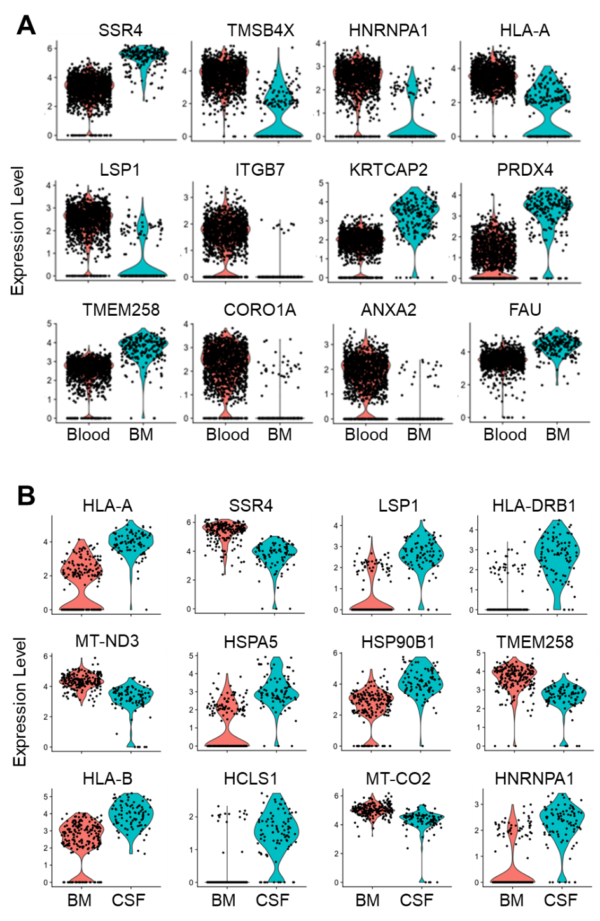
Figure e-9. Comparative analysis of genetic expression between different tissues for ASCs. A. Plots showing higher expression of ANXA2 and ITGB7 in blood ASCs than bone marrow ASCs. B. Plots showing higher expression of HLA-A, HLA-DRB1 and HLA-B in bone marrow ASCs than CSF ASCs.

Figure e-10
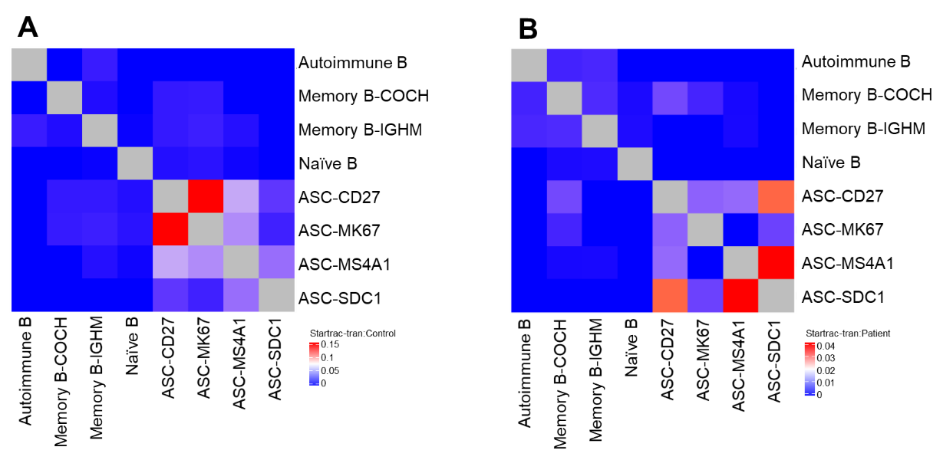
Figure e-10. Clonal expansion of B cells in patients with NMOSD. A-B. Distinct Startrac-tran pattern found between healthy controls (A) and the patients with NMOSD (B). ASC-SDC1 plasma cells have the highest Startrac-expa index across all clusters. n = 3 in healthy control group; n = 11 in NMOSD group.

Figure e-11
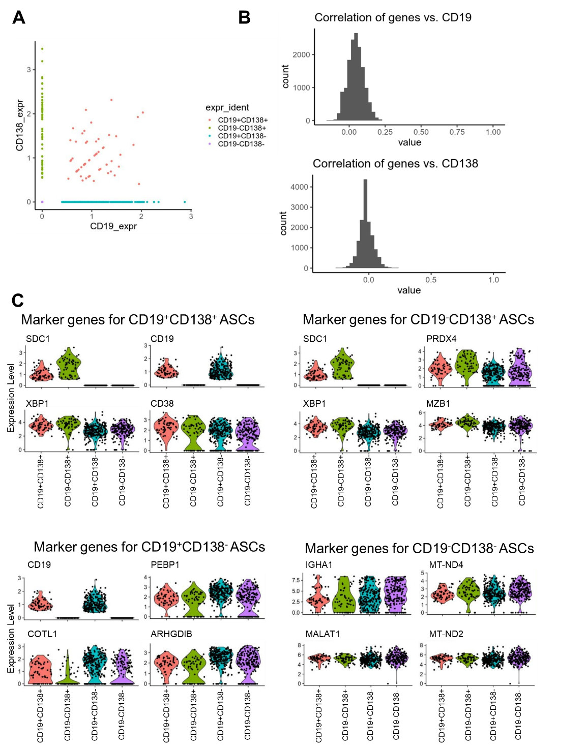
Figure e-11. Differential expression of CD19 in NMOSD ASCs. A. Distribution of NMOSD ASCs in silico FACS based on original expression. B. Correlation analysis of ASC genes versus CD19 or CD138 in NMOSD ASCs. C. Four subsets of ASCs based on the expression of CD19 and CD138, and related marker genes. ASCs, antibody secreting cells.

Figure e-12
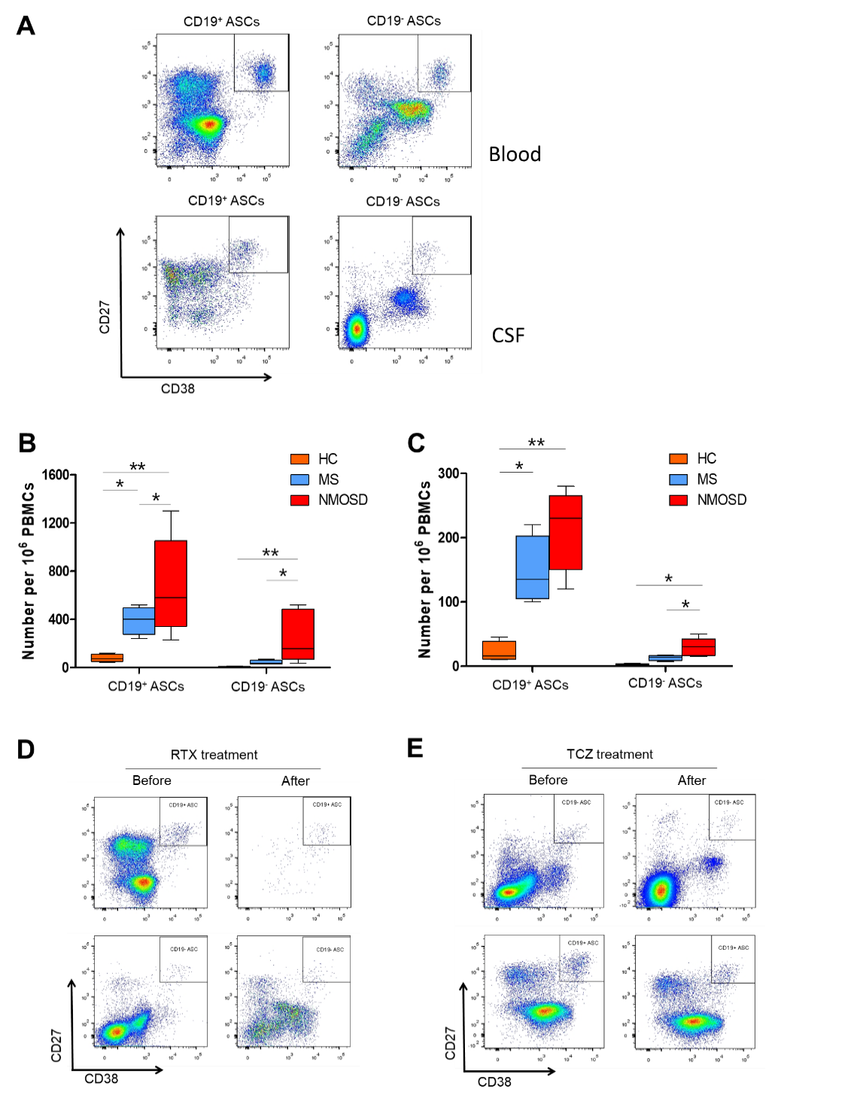
Figure e-12. Flow cytometry analysis of CD19⁺ ASCs and CD19⁻ ASCs. A. Flow cytometry plots showing the gating of CD19⁺ and CD19⁻ ASCs in NMOSD blood and CSF. B. Bar graph showing the counts of CD19⁺ and CD19⁻ ASCs in peripheral blood from patients with NMOSD, MS, and healthy controls. C. Bar graph showing the counts of CD19⁺ and CD19⁻ ASCs in CSF from patients with NMOSD, MS and healthy controls. n = 10 per group. D. Representative flow cytometry plots showing changes of ASCs in NMOSD patients before and after rituximab treatment. RTX, rituximab. E. Representative flow cytometry plots showing changes of ASCs in NMOSD patients before and after tocilizumab treatment. TCZ, tocilizumab. *p < 0.05, **p < 0.01.

Table e-1. Demographic information of patients with NMOSD and healthy controls enrolled for single cell RNA sequencing.
 | NMOSD Patients (n = 11) | Controls (n = 3)
Age, mean (SD)⁎ | 44.2 ± 7.3 | 45.3 ± 6.2
Female, n (%) | 10 (91) | 3 (100)
Mean years of disease duration (SD) | 5.5 ± 1.2 | -
AQP4-ab positive, n (%) | 11 (100) | -
EDSS at attack⁎ | 5.5 ± 1.4 | -
Preventive medications before attack
Prednisone | 6 (75) | -
Azathioprine | 2 (67) | -
Prednisone+Azathioprine | 2 (13) | -
Prednisone+Mycophenolate mofetil | 1 (4) | -
⁎EDSS are shown as average ± standard deviation.

Table e-2. Interferon stimulator genes (ISGs)⁎
ABCA1 | GALM | IL1RN | P38/MAPK | TIMM10
ACTA2 | GBP1 | IL28RA | PARP10 | TLR3/4
ADAR | GBP2 | IRF3 | PARP12 | TMEM140
AIM2 | GBP3 | IRF4 | PARP14 | TNFAIP6
APOL6 | GBP4 | IRF5 | PARP9 | TNFSF10
ASPRV1 | GBP5 | IRF6 | PHF11 | TNFSF13B
BATF2 | GBP6 | IRF7 | PISK | TRAFD1
BCL2L13 | HELZ2 | IRF8 | PSMB8 | TRANK1
BST2 | HERC5 | IRF9 | PSMB9 | TRIM21
BTN3A1 | HERC6 | ISG15 | RBCK1 | TRIM22
CARD16 | HES4 | ISG20 | REC8 | TRIM38
CARD17 | Histone h3 | ISGF3 | RHBDF2 | TRIM5
CCL8 | HSH2D | LAP3 | RNASEL | TRIM56
CCR1 | IDO1 | LDL | RNF213 | TRIM6
CEACAM1 | IFI16 | LGALS9 | RSAD2 | TRIM69
CHMP5 | IFI27 | LY6E | RTP4 | TYMP
CMPK2 | IFI27L2 | MOV10 | SARM1 | UBA7
CPT1B | IFI35 | MT1A | SERPING1 | UBE2L6
CXCL10 | IFI44 | MX | SOCS1 | UNC93B1
DDX58 | IFI44L | MX1 | SP100 | WARS
DDX60 | IFI44L | MX2 | SP110 | XAF1
DHRS9 | IFIH1 | NBN | SP140 | ZBP1
DHX58 | IFIT1 | NCOA7 | SPATS2L | ZC3HAV1
DYNLT1 | IFIT1L | NMI | SRBD1 | ZNF684
EIF2AK2 | IFIT2 | NT5C3A | STAT1 | ZNFX1
ERK | IFIT3 | OAS1 | STAT2
FBXO6 | IFIT5 | OAS2 | STING
FCGR1C | IFITM1 | OAS3 | TAP1
FSH | IFITM3 | OASL | TAP2
GADD45B | IL12 | OTOF | TCN2
⁎Adapted from Arazi et al., Nat Immunol 2019, 20 (7), 902-914.

Table e-3. Inflammation-related gene markers⁎
CHUK | MYD88 | TNFRSF1B
FADD | NFKB1 | TRADD
IKBKB | NFKBIA | TRAF6
IKBKG | RELA
IL1A | RIPK1
IL1R1 | TAB1
IRAK1 | TLR4
MAP3K1 | TNF
MAP3K14 | TNFAIP3
MAP3K7 | TNFRSF1A

Table e-4. Exhaustion gene markers⁎
BUB1 | CXCL10 | JAK3 | SERPINA3 | TRIM25
CAPZB | CXorf56 | LAG3 | SH2D2A
CCRL2 | ENTPD1 | LMAN2 | SHKBP1
CD160 | EOMES | NR4A2 | SNRPB2
CD244 | ETF1 | PDCD1 | SPP1
CIT | GPD2 | PON2 | TANK
CPSF2 | GPR65 | PTGER2 | TCEA2
CPT2 | IER5 | PTGER4 | TNFRSF9
CRYGB | ISG20 | RNF11 | TOR3A
CTLA4 | ITGAV | S100A13 | TRGV11
⁎This list is based on the genes upregulated in exhaustion, according to Wherry et al, Immunity 2007;27(4):670-84.

Table e-5. Characteristics of NMOSD patients, MS patients, and healthy controls for B cell subsets analysis by flow cytometry and specific expression of type I interferon related genes
 | NMOSD (n = 27) |  | MS (n = 15) |  | Controls (n = 16)
Age, mean (SD)⁎ | 44.3 ± 14.5 |  | 38.8 ± 11.4 |  | 42.5 ± 12.3
Female, n (%) | 25 (92.6) |  | 9 (60) |  | 14 (87.5)
Mean years of disease duration (SD) | 4.3±1.6 |  | 5.8±2.8 |  | -
AQP4-ab positive, n (%) | 20 (70) |  | 0 (0) |  | -
EDSS at attack⁎ | 4.5±1.7 |  | 2.5±1.6 |  | -
Preventive medications before attack
Prednisone | 12 (44.4) |  | 5 (33.3) |  | -
Tocilizumab | 5 (18.5) |  | 0 (0) |  | -
Rituximab | 1 (3.7) |  | 2 (13.3) |  | -
Azathiophrine | 2 (7.4) |  | 0 (0) |  | -
Teriflunomide | 0 (0) |  | 4 (26.7) |  | -

⁎EDSS are shown as average ± standard deviation. MS, multiple sclerosis. NMOSD, neuromyelitis optica spectrum disorder.
Inclusion criteria for NMOSD patients were the same as previously described. Inclusion criteria for MS patients were: 1) older than 18 years of age; 2) diagnosed in accordance with 2017 McDonald diagnostic criteria; 3) experiencing acute MS attacks without receiving high dose intravenous methylprednisolone. Exclusion criteria were those with concomitant autoimmune diseases, acute myocardial infarction, heart failure, liver diseases, tumor or hematological system diseases, and concomitant use of B cell depleting drugs.

Table e-6. RT-PCR primer sequence for IFN-related genes.
Gene | Forward Primer (5’-3’) | Reverse Primer (5’-3’)
IRF4 | GAGCAATGACTTTGAGGAACTG | CATCATGTAGTTGTGAACCTGC
IFI6 | CATGCGGCAGAAGGCGGTATC | TCCGACGGCCATGAAGGTCAG
MX1 | CAGGACATTTGAGACAATCGTG | TCGAAACATCTGTGAAAGCAAG
IFI44 | TTTTCGATGCGAAGATTCACTG | AAGTTCTCAAGGCAGACAGTAA
IFI44L | CTTTCCTAGAGTCTCTGAAGCCA | GCAGCTTGCGCAGATGATTT
GAPDH | GCACCGTCAAGGCTGAGAAC | TGGTGAAGACGCCAGTGGA

Table e-7. Demographic information of patients with NMOSD receiving rituximab or tocilizumab
 | Rituximab (n = 10) | Tocilizumab (n = 10)
Age, mean (SD) | 45.1 ± 13.5 | 43.8 ± 12.7
Female, n (%) | 10 (100) | 10 (100)
Mean years of disease duration (SD) | 5.3±2.6 | 4.9±2.3
AQP4-ab positive, n (%) | 10 (100) | 10 (100)
EDSS at initiation of treatment⁎ | 4.2±1.7 | 4.6±1.8
EDSS at 6 months after treatment | 3.1±1.0 | 2.7±0.9
⁎EDSS are shown as average ± standard deviation. Rituximab was administered at 100 mg/d for three consecutive days to reduce the frequency of CD19⁺ B cells to less than 1% of peripheral blood mononuclear cells, as quantified by flow cytometry. Tocilizumab was administered to patient at the dose of 8 mg/kg/months. NMOSD, neuromyelitis optica spectrum disorder.

Table e-8. Gene expression profiles of blood B cells from NMOSD patients versus heathy controls.
Table e-9. Gene expression profiles of bone marrow B cells versus blood B cells in NMOSD.
Table e-10. Gene expression profiles of blood B cells versus CSF B cells in NMOSD.
Table e-11. Differentially expressed genes in blood B cells versus CSF B cells from NMOSD patients.
Table e-12. Differentially expressed genes in blood B cells versus bone marrow B cells from NMOSD patients.

Table e-8-12 are provided in separate Excel spreadsheets.

