Supplementary data 1: Serological assay for myelin oligodendrocyte glycoprotein immunoglobulin-G (MOG-IgG).
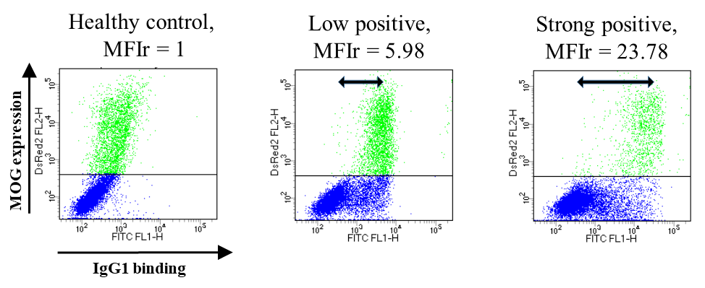
Supplementary figure 1. Examples of serum flow cytometric assay results

HEK-293T cells were transiently transfected using Lipofectamine (Life Technologies, USA) for four hours using the pIRES2-DsRed2 plasmid containing the cDNA for individual MOG isoforms, and cultured for 24 hours. The cells were incubated with heat-inactivated patient serum at 56°C for 30 minutes (dilution 1:10 for 1 hour at 4°C). After washing, the cells were incubated with Alexa Fluor 488 goat anti-human IgG1 (1:100 dilution; A10631, Invitrogen) for one hour. Finally, the cells were washed, re-suspended in fluorescence-activated cell sorting (FACS) buffer, and analyzed by flow cytometry using a FACS calibur (BD bioscience).
The mean fluorescence intensity ratio (MFIr) of the patients’ sera were determined using the following formula (supplementary figure 1):
MFIr = green MFI of patient antibody binding to the dsRed MOG transfected cells (upper gate on red channel)/green MFI of the same gate with healthy control sera.
Two positive control sera (from MOGAD) and two negative controls (one serum from healthy individual and one with secondary antibody only) were used in each assay to establish the intra-assay variability.
Patients with AQP4-IgG positive neuromyelitis optica spectrum disorder (AQP4-IgG+ NMOSD, n = 50), relapsing remitting multiple sclerosis (RRMS, n = 33), and non-IDDs (n = 90) (supplementary data 2 for detailed diagnosis) were classified as the MOG-IgG negative-controls group (n = 173). The cut-off for serum MOG-IgG assay positivity was set at eight SD above the mean MFIr values of the ‘negative controls’ group and was 2.36.

Supplementary data 2. The non-IDDs group was composed of patients with optic neuropathy (anterior ischemic optic neuropathy [n=1], non-arteritic anterior ischemic optic neuropathy [n=3], Leber hereditary optic neuropathy [n=1], toxic optic neuropathy [n=1], tuberculosis related optic neuropathy [n=2]), retinopathy (acute zonal occult outer retinopathy [n=2], retinitis [n=1], white dot syndrome [n=1]), branch retinal artery occlusion (n=1), central retinal vein occlusion (n=2), amyotrophic lateral sclerosis (n=2), hereditary spastic paraparesis (n=1), acute myeloid leukemia (n=2), CNS tumor (lymphoma [n=10], anaplastic astrocytoma [n=3], germinomatosis cerebri [n=2], glioblastoma multiforme [n=1], low grade glioma [n=1]), metachromatic leukodysrophy (n=1), infarction (cerebral infarction [n=4], spinal cord infarction [n=4]), perinatal brain hypoxia (n=1), vascular malformation (arteriovenous fistula [n=3], cavernous malformation [n=1]), neuro-Behcet’s disease [n=4], CNS Lupus (n=1), CNS vasculitis (n=7), Bickerstaff's brainstem encephalitis (n=2), myelodysplastic syndrome (n=1), encephalitis (n=7), inflammatory pseudotumor (n=3), meningitis (n=1), toxocariosis related myelopathy (n=2), neurocysticercosis (n=1), CNS infection (n=3), fungal sinusitis (n=1), syphilis (n=1), traumatic myelopathy (n=2), radiation related myelopathy (n=1), compressive myelopathy (n=5), conus medularis syndrome (n=1), LS plexopathy (n=1), polyneuropathy (Guillain-Barré syndrome [n=3], Miller-Fisher Syndrome [n=1], chronic inflammatory demyelinating polyneuropathy [n=5], idiopathic sensorimotor polyneuropathy [n=2]), dermatomyositis (n=1), Churg-Strauss syndrome (n=1), oculomotor nerve palsy (n=1), trochlear nerve palsy (n=1), fibromyalgia (n=1), sensory ganglinopathy (n=1), somatiform disorder (n=4), infectious spondylitis (n=1), degenerative spondylosis (n=1), syringomyelia (n=1), primary headache (n=1), and hypoxic brain damage (n=1).

Supplementary data 3. Cut-off value for serum MOG-IgG assay with IgG Fc secondary antibody
Patients with AQP4-IgG+ NMOSD (n = 19), RRMS (n = 8), and non-IDDs (n = 38) were classified as the MOG-IgG negative-controls group (n = 65). The cut-off for serum MOG-IgG assay positivity was set at eight SD above the mean MFIr values of the ‘negative controls’ group and was 2.43.

table e-1. Description of CSF+ MOGAD patients (other IDDs patients with CSF MOG-IgG)
Case | Sex | Age at onset (yr) | Clinical phenotype | MRI Lesions | OCB* | IgG  index | Number of attack | Onset to LP (days) | Steroid response | Maintenance Tx | Relapse/Follow-up duration (yr) |  | Tx before LP | MOG-IgG MFIr (titer)
 |  |  |  |  |  |  |  |  |  |  | Before Tx | After Tx |  | CSF | Serum
1 | M | 17 | ADEM, seizure | Rt. external capsule and internal capsule | ND | - | 1 | 20 | Good | No | - | 0/1.92 | IV dexa Pd | 20.99  (ND) | Neg  (ND)
2 | M | 42 | Recurrent ADEM, seizure | Uniateral cortex, thalamus, midbrain, Lt cerebral peduncle, Sup cerebellar peduncle, Sup cerebellar white matter | ND | 0.67 | 2 | 3 | Good | Pd | 1/0.25 | 0/0.08 | No | 13.38  (1:16) | 1.14  (0)
3 | F | 27 | Recurrent ADEM | Bilat. Cb hemispheres, corpus callosum, pons, Lt thalamus and medulla | ND | 0.75 | 3 | 4 | Good | IFNβ-1b | 1/0.42 | 1/0.33 | No | 6.38  (1:8) | Neg  (1:10)
 |  |  |  |  |  |  |  |  |  | RTX | 2/0.75 | 0/6
4 | M | 40 | CIS | Spinal cord at C1-4, medulla, pons | ND | 0.49 | 1 | 15 | Good | No | - | 0/0.08 | No | 5.53  (1:8) | 1.63  (1:20)
5 | F | 24 | Recurrent ADEM, seizure | Bilat. Cb cortical and subcortical white matter, Rt. thalamus | ND | - | 2 | 3 | Good | RTX | 1/0.33 | 0/6 | Pd | 4.95  (1:4) | 1.34  (0)
6 | M | 14 | ADEM | Bilat. Cb white matter, unilateral cortex, left thalamus, midbrain, pons, medulla, and spinal cord | Neg | 0.47 | 1 | 37 | Good | No | - | 0/2.42 | No | 3.83  (1:4) | 1.78  (1:10)
7 | F | 44 | Recurrent myelitis | Multiple patch Spinal cord lesion at C2-3, C3-4, and T11 | Neg | 0.49 | 2 | 13 | Good | IFNβ | - | 1/4.00 | No | 3.13  (1:4) | 1.31  (0)
 |  |  |  |  |  |  |  |  |  | DMF | 1/4.00 | 0/2.08
8 | M | 47 | Recurrent ON | Rt. Optic nerve, upper cervical spinal cord | ND | 0.49 | 2 | 16 | Poor | Pd (8 months) | 1/7.50 | 0/4.00 | No | 2.37  (1:2) | 1.37 (0)
9 | M | 28 | Recurrent ON | Rt. Optic nerve, Rt parietal subcortex | Neg | 0.60 | 2 | 16 | Partial | Pd (4 months) | - | 1/1.92 | No | 2.05 (1:2) | 1.06 (0)
 |  |  |  |  |  |  |  |  |  | Monthly IVIg | 1/1.92 | 0/0.42

* OCB test result included only isoelectric focusing test result.
Abbreviations: ADEM = acute disseminated encephalomyelitis; Bilat. = bilateral; Cb = cerebral; CIS = clinically isolated syndrome; dexa = dexamethasone; DMF = dimethyl fumarate; F = female; GA = glatiramer acetate; iATM = idiopathic acute transverse myelitis; IFNβ = interferon beta; IV = intravenous; IVIg = intravenous immunoglobulin; LP = lumbar puncture; Lt. = left; M = male; MFIr = mean fluorescence intensity ratio; MOG-IgG = anti-myelin oligodendrocyte glycoprotein immunoglobulin-G; ND = not done; Neg = negative; NMOSD = neuromyelitis optica spectrum disorder; Rt. = right; Sup = superior; Pd = prednisolone; Rt. = right; RTX = rituximab; Tx = treatment; yr = year

table e-2. Patients positive for CSF MOG-IgG in MS group
Case | Sex | Age (yr) | Clinical phenotype | Distinctive MRI pattern^{23,30} |  | OCB | Number of attack | Onset to LP (days) | Tx before LP | DMT | Relapse / follow-up duration (yr) |  | MOG-IgG MFIr (titer)
 |  |  |  | Inf. temporal lesion | Dawson’s finger sign |  |  |  |  |  | Before Tx | After Tx | CSF | Serum
10 | F | 54 | SPMS | + | + | Pos | - | - | No | - | Progression | Progression | 13.43  (1:4) | 1.99  (1:80)
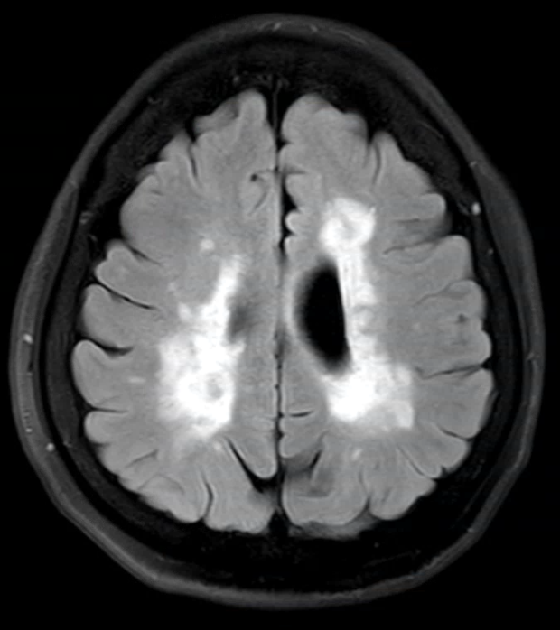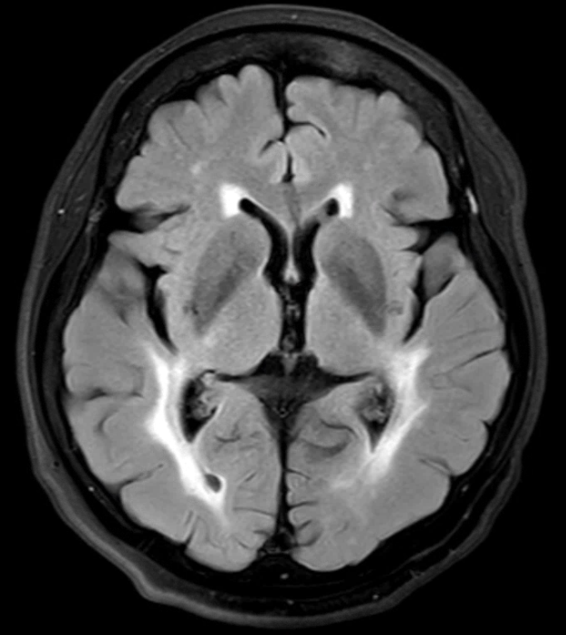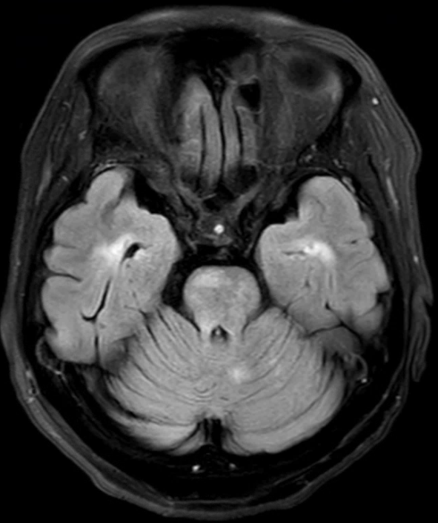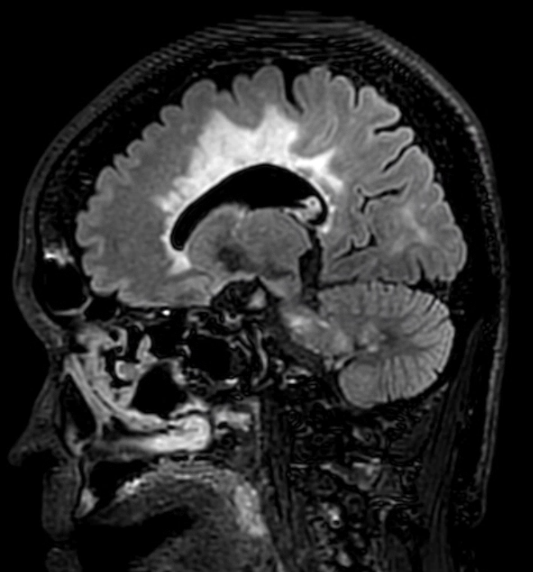
T2FLAIR
11 | F | 39 | RRMS | - | - | Neg | 2 | 11 | IFNβ-1a | GA | 1/0.5 | 0/2.83 | 3.62  (1:2) | 1.51  (0)
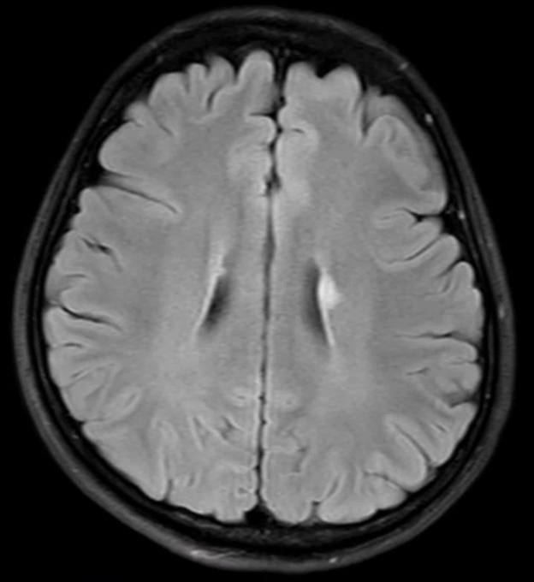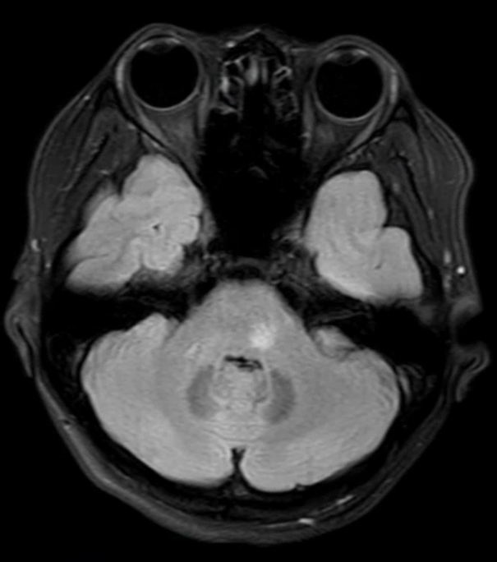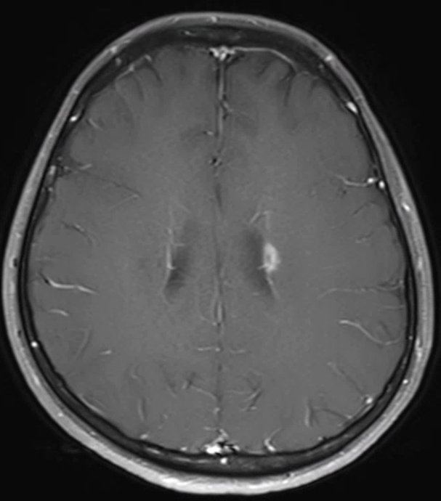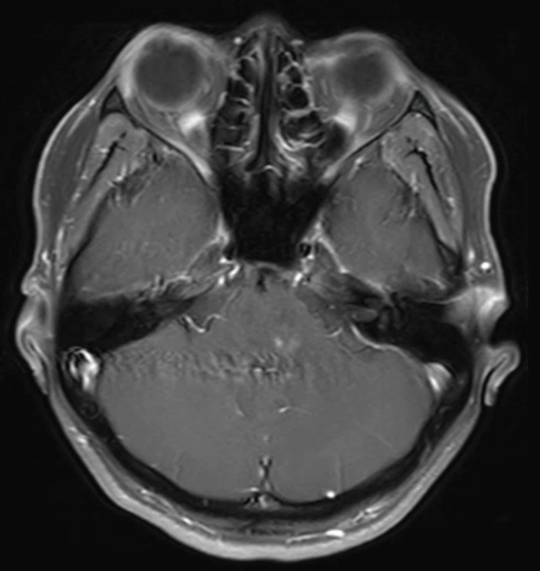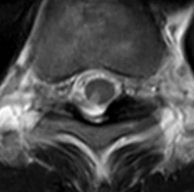
T2FLAIR
T1 Gd(+)
T2
12 | M | 37 | RRMS →SPMS | + | + | Neg →Pos | 3 | 1 | IFNβ-1a | IFNβ-1a | 2/1.17 | Progression | 2.39 (1:2) | 0.99  (0)
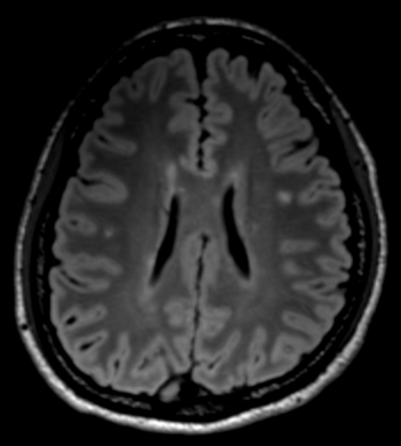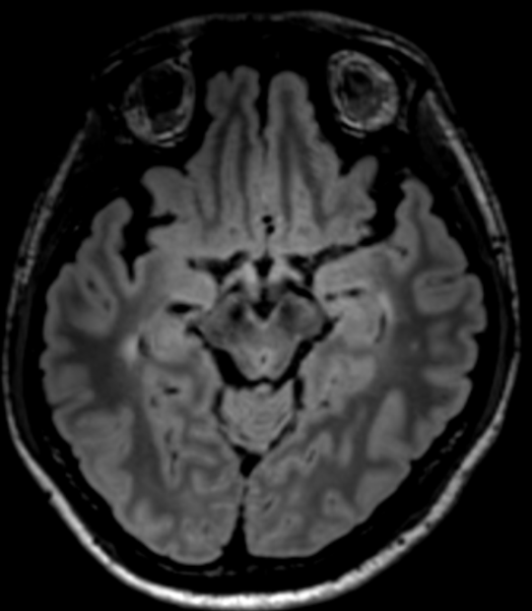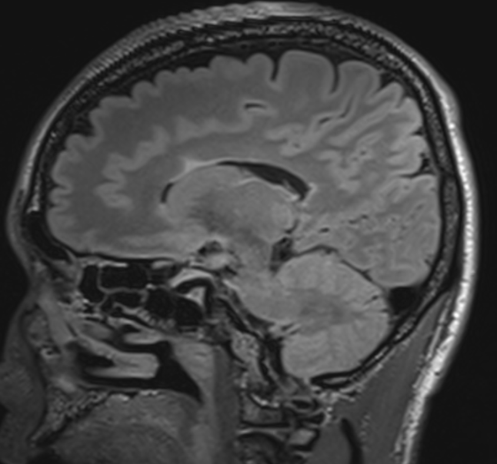
T2FLAIR
13 | F | 41 | RRMS | - | - | Neg | 2 | 4 | No | IFNβ | 1/0.25 | 0/2.67 | 2.02 (1:2) | 1.39  (0)
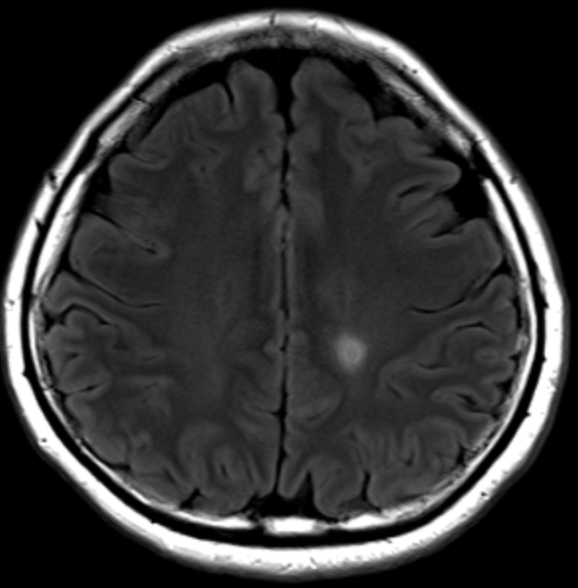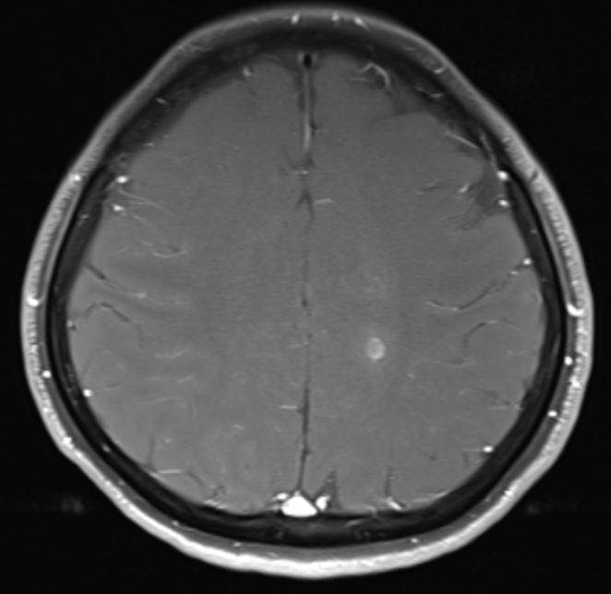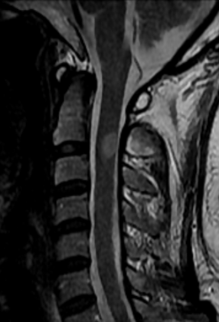
T2FLAIR
T1 Gd(+)
T2FLAIR
Abbreviation: ARR = annualized relapse rate; DMT = disease modifying therapy; Dx = diagnosis; F = female; FLAIR = fluid attenuated inversion recovery; GA = glatiramer acetate; Gd(+) = gadolinium enhancement; Inf. = inferior; IFNβ = interferon beta; LP = lumbar puncture; MFIr = mean fluorescence intensity ratio; MOG-IgG = anti-myelin oligodendrocyte glycoprotein antibody; Neg = negative; RRMS = relapse-remitting multiple sclerosis; SPMS = secondary progressive multiple sclerosis; OCB = oligoclonal band; Pos = positive; Tx = treatment; yr = year
table e-3. Comparison of demographics and clinical features between MOGAD without intrathecal MOG-IgG synthesis and MOGAD with intrathecal MOG-IgG synthesis
 | Intrathecal MOG synthesis (-)  (n=24) | Intrathecal MOG synthesis (+)  (n=12) | p
Age at sampling, mean [range], years | 47.9 [19-70] | 31.9 [14-47] | 0.003
Female, n (%) | 16 (66.7) | 5 (41.7) | n.s.
Serum MOG-IgG1 MFIr, mean (± SD)* | 10.5 (± 6.92) | 4.0 (± 5.82) | 0.001
CSF MOG-IgG MFIr, mean (± SD) | 2.41 (± 1.79) | 15.8 (± 26.77) | < 0.001
CSF MOG-IgG titier, median [range] | 0 [0 - 1:2] | 1:8 [1:2 - 1:256] | < 0.001
Recurrence, n (%) | 11 (45.8) | 7 (58.3) | n.s.
Clinical presentation | ADEM (n=4), seronegative NMOSD (n=1),  CRION (n=6), ON (n=12), myelitis (n=1) | ADEM (n=7), CIS (n=1),  myelitis (n=2), ON (n=2)
EDSS, median [range] | 3.0 [0.0 - 5.0] | 3.5 [2.0 -6.0] | n.s.
Recent attack to sampling, median [range], days | 8.5 [1-72] | 14 [3-37] | n.s.
First onset to sampling, median [range], month | 0.54 [0.03 – 349.96] | 1.03 [0.20 – 90.15] | n.s
Treatment within 1 month before sampling | None (n=13), IVMP (n=5), dexamethasone (n=1), AZA (n=1), MMF (n=1), RTX (n=1), dasatinib (n=1), MTX+Pd (n=1) | None (n=9), Pd (n=1), IFN (n=1), IVMP (n=1)
Involved structure
Brain / Spinal cord | 33.3 | 100 | < 0.001
Optic nerve | 79.2 | 25.0 | 0.003
CSF WBC, median [range], cells/mm³ | 1 [0-70] | 10.5 [0-58] | 0.011
CSF Protein, median [range], mg/dL | 43.0 [22-90] | 54.0 [27-137] | n.s.
Q_{IgG} (CSF/serum), mean (± SD) | 0.55 (± 0.52) | 0.59 (± 0.48) | n.s.
Q_{alb} (CSF/serum), mean (± SD)** | 0.52 (± 0.27) | 0.68 (± 0.31) | n.s
IgG index, mean (± SD) | 1.10 (± 2.27) | 0.65 (± 0.29) | n.s.

* Intrathecal MOG-IgG synthesis (-), n = 19; Intrathecal MOG-IgG synthesis (+), n = 10
** Intrathecal MOG-IgG synthesis (-), n = 20; without intrathecal MOG-IgG synthesis (+), n = 10
Abbreviation: ADEM = acute disseminated encephalomyelitis; Alb = albumin; AQP4-IgG+ NMOSD = aquaporin-4 antibody positive neuromyelitis optica; AZA = azathioprine; CIS = clinically isolated syndrome; CRION = chronic relapsing inflammatory optic neuropathy; EDSS = expanded disability status scale; IDD = inflammatory demyelinating disease; IFN = interferon; IgG = immunoglobulin-G; IVMP = intravenous methylprednisolone; MFIr = mean fluorescence intensity ratio; MOGAD = myelin oligodendrocyte glycoprotein antibody associated disease; MOG-IgG = anti-myelin oligodendrocyte glycoprotein immunoglobulin-G; MMF = mycophenolate mofetil; MS = multiple sclerosis; MTX = methotrexate; NMOSD = neuromyelitis optica spectrum disorder; n.s. = not significant; OCB = oligoclonal band; ON = optic neuritis; Pd = prednisolone; Q_{alb} = albumin quotient; Q_{IgG} = IgG quotient; RTX = rituximab; WBC = white blood cell

figure e-1. Independent confirmation of the CSF MOG-IgG assay accuracy at two centres. Disease control CSF samples from non-IDD (45; blue dots) and query MOG positive CSF samples (28, MOGAD or IDDs black, 4 MS red) were tested at a second centre (Oxford). All controls were negative on both tests; all samples positive in Seoul were positive in Oxford, two additional MOGAD samples were identified as positive in Oxford. Both assays used IgG Fc as the secondary antibody. Four MS patients with RRMS-(3) or SPMS-(1) were MOG antibody positive at both centres.
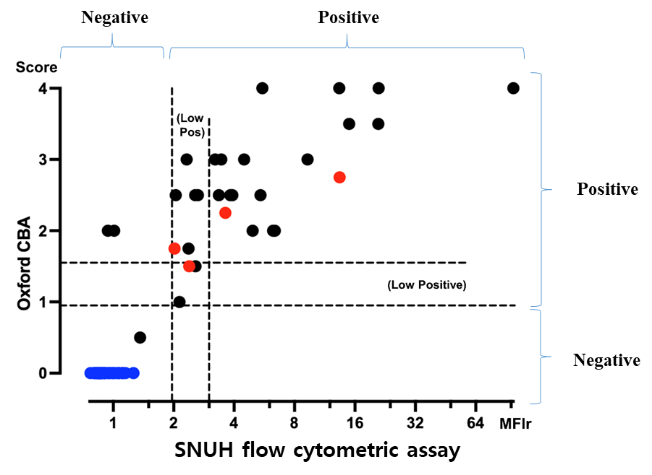
figure e-2. Longitudinal follow up data of CSF MOG-IgG. (A) In 28 relapsed patients, we could collect the follow-up CSF samples. The MFIr for the MOG-IgG assay in the initial CSF samples did not differ from those in the follow-up CSF samples except 1 seropositive MOGAD patient. (B) In one seropositive MOGAD patient presented with CRION, five serial paired samples of sera and CSF were collected at relapses. The MFIr of serum and CSF were consistently positive during 28 months of this follow-up period.
Abbreviation: MFIr = mean fluorescence intensity ratio; MOG-IgG = myelin oligodendrocyte glycoprotein antibody

