eAppendix1
eFigure 1. Study design of MAGNIFY-MS including the immune cell subtype analyses conducted as part of this sub-study.

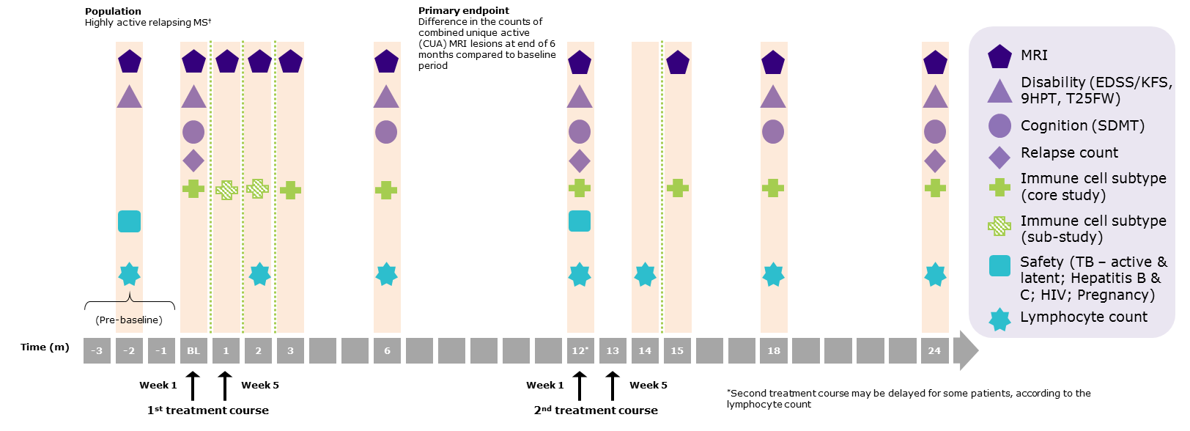

9HPT, 9-hole peg test; BL, Baseline; CUA, combined unique active; DMT, disease-modifying therapy; EDSS, Expanded Disability Status Scale; HIV, human immune deficiency virus; KFS, Kurtzke Functional System; MRI, magnetic resonance imaging; MS, multiple sclerosis; SDMT, symbol digit modalities test; T25FW, timed 25-foot walk; TB, tuberculosis.

eFigure 2. Median serum concentration of immunoglobulins in patients treated with cladribine tablets.

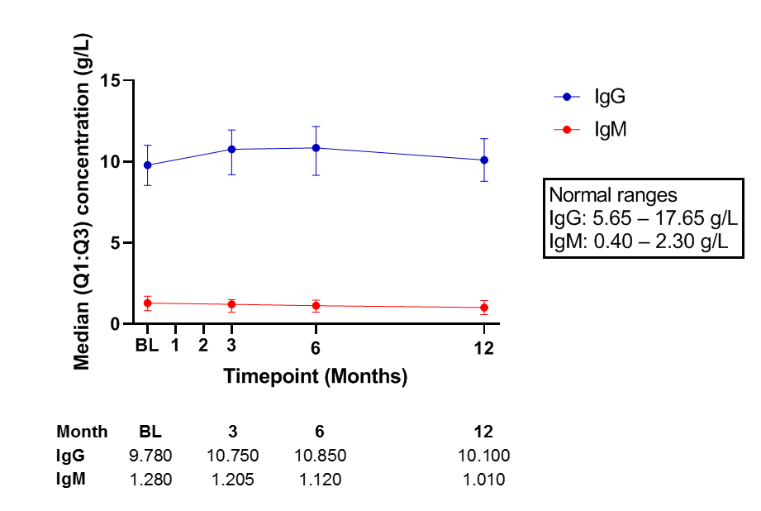
The first treatment course of cladribine tablets was administered at Baseline and Month 1.
BL, Baseline; Ig, immunoglobulin; Q, quartile.

Supplementary Information
FLOW CYTOMETRY
B cell Panel-4
The B cell Panel-4 (CD19, CD20, CD27, CD38, CD69, CD24, CD138, CD10, IgD) assay was conducted as an eight-color wash/lyse/wash, four-tube panel fluorescence-minus-one (FMO) gating analysis using a control tube and three experimental (EXP) tubes (eTable 1).
The single fluorochrome, BV510, was used to detect CD3/CD14/CD56 phenotypes and exclude T cells, monocytes and NK cells from the analysis. In addition, the expression of IgD and CD27 was used to differentiate between naïve, memory, and short-lived plasma cells, CD38 was used to define terminal effector plasma cell and regulatory B cell subsets, and CD69 or CD10 was used to define activated or transitional B cells, respectively.
eTable 1. B cell Panel-4 immunophenotyping configuration.
Detector | FL1 | FL2 | FL3 | FL4 | FL5 | FL6 | FL7 | FL8
Fluorochrome | BV 421 | BV510 | FITC | PE | PerCP-Cy5.5 | PE-Cy7 | APC | APC-H7
Control (Tube 1) | CD19 | CD3/CD14/CD56 | - | - | CD20 | - | - | CD45
EXP 1 (Tube 2) | CD19 | CD3/CD14/CD56 | IgD | CD27 | CD20 | - | CD69 | CD45
EXP 2 (Tube 3) | CD19 | CD3/CD14/CD56 | CD138 | CD24 | CD20 | CD38 | - | CD45
EXP 3 (Tube 4) | CD19 | CD3/CD14/CD56 | IgD | CD27 | CD20 | - | CD10 | CD45
APC, allophycocyanin (fluorochrome); BV, brilliant violet (fluorochrome); EXP, experimental; FITC, fluorescein isothiocyanate (fluorochrome); PE, phycoerythrin (fluorochrome); PerCP, peridinin-chlorophyll proteins (conjugated reagent).

A total of nine B cell subtypes were reported using this assay, as listed in eTable 2. Each phenotype was analysed using a gating strategy (eFigure 3).
eTable 2. Reportable results for B cell Panel-4.
Population | Phenotype
CD19 B cells | CD45^{bright}, SSC^{low}, CD3⁻, CD14⁻, CD56⁻, CD19⁺
CD20 B cells | CD45^{bright}, SSC^{low}, CD3⁻, CD14⁻, CD56⁻, CD20⁺
Activated B cells | CD45^{bright}, SSC^{low}, CD3⁻, CD14⁻, CD56⁻, CD19⁺, CD20⁺, CD69⁺
Naïve B cells | CD45^{bright}, SSC^{low}, CD3⁻, CD14⁻, CD56⁻, CD19⁺, CD20⁺, IgD⁺, CD27⁻
Memory B cells | CD45^{bright}, SSC^{low}, CD3⁻, CD14⁻, CD56⁻, CD19⁺, CD20⁺, CD27⁺
Short-lived plasma cells | CD45^{bright}, SSC^{low}, CD3⁻, CD14⁻, CD56⁻, CD19^{dim}, CD20^{-/dim}, CD27^{bright}
Regulatory B cells | CD45^{bright}, SSC^{low}, CD3⁻, CD14⁻, CD56⁻, CD19⁺, CD24^{bright}, CD38^{bright}
CD38^{bright} plasma cells | CD45^{bright}, SSC^{low}, CD3⁻, CD14⁻, CD56⁻, CD19^{dim}, CD20⁻, CD38^{bright}
Transitional B cells | CD45^{bright}, SSC^{low}, CD3⁻, CD14⁻, CD56⁻, CD19⁺, CD20⁺, IgD⁺, CD10⁺, CD27⁻

Flow cytometry was conducted using a Becton Dickinson FACSCanto™ II cell analyzer equipped with 405 nm, 488 nm, and 633 nm laser detection (instrument SN V33896201853 and V33896301544). Specimens were acquired on the FACSCanto™ II flow cytometer using a saved FACSDiva™ B cell panel-4 V1 acquisition template. BD FACSDiva™ software (version 6.1.2) and Microsoft Office Excel software 2003 were used to collate and analyze the data.

eFigure 3. Gating strategy for the analysis of B cell panel-4.
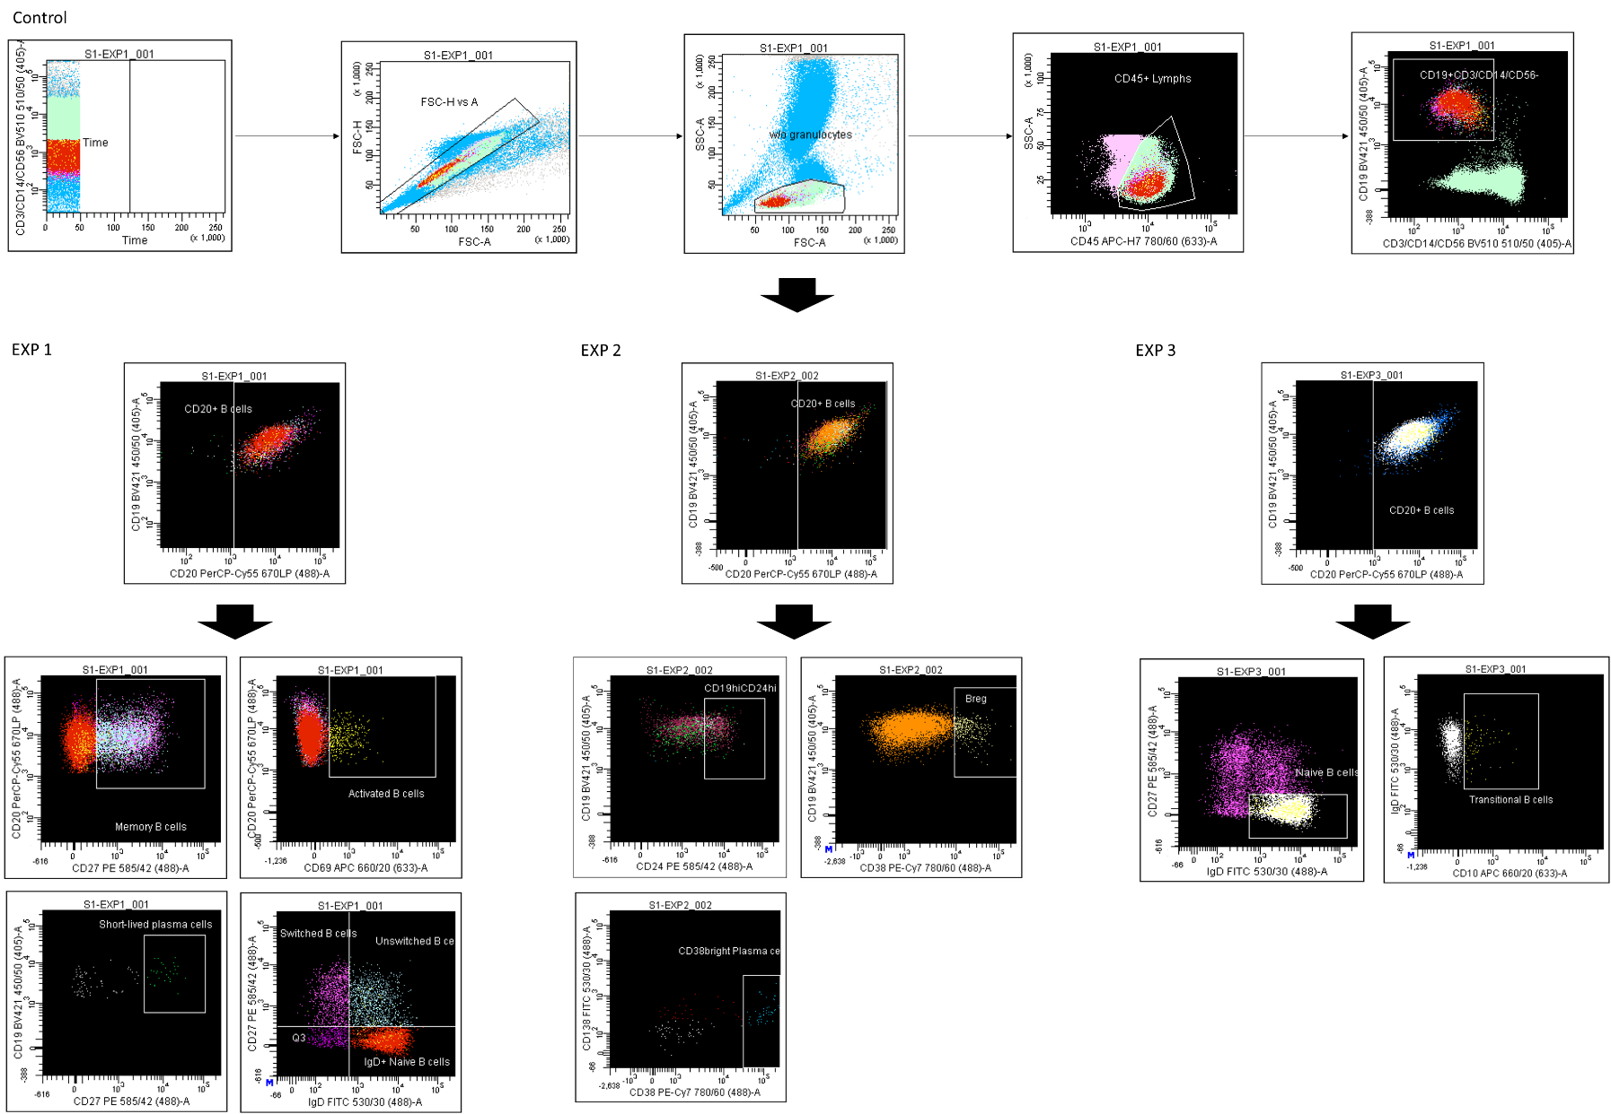
T cell Panel-1, -2, and -3
T cell Panel-1 subtypes of CD4 and CD8 T cells: CD4, naïve, CD4 central memory, CD4 effector memory, CD8 naïve, CD8 central memory, CD8 effector memory, CD8 terminally differentiated effector memory, Th1, and T_{reg} T cells were reported. In addition, T cell Panel-2 included Th17, and T cell Panel-3 included Th17 and Th2.
The T cell Panel-1, -2, and -3 assays were eight-color lyse/wash panels designed to measure functionally distinct T cell subtypes (eTable 3). T cell Panel-1 was a two-tube panel consisting of the control tube and one EXP tube, while cell Panel-2 and -3 were three-tube panels consisting of the control tube and two EXP tubes.

eTable 3. T cell Panel-1, -2, and -3 immunophenotyping configuration.
Detector | FL1 | FL2 | FL3 | FL4 | FL5 | FL6 | FL7 | FL8
Fluorochrome | BV 421 | V500 | FITC | PE | PerCP | PE-Cy7 | APC | APC-H7
PANEL-1
Control (Tube 1) | - | CD4 | - | - | CD8 | - | - | CD3
EXP 1 (Tube 2) | CD197 (CCR7) | CD4 | CD45RA | CD25 | CD8 | CD127 | CD183 (CXCR3) | CD3
PANEL-2
Control (Tube 1) | - | CD4 | - | - | CD8 | - | - | CD3
EXP 1 (Tube 2) | CD197 (CCR7) | CD4 | CD45RA | CD25 | CD8 | CD127 | CD183 (CXCR3) | CD3
EXP 2 (Tube 3) | CD197 (CCR7) | CD4 | CD45RA | CD146 | CD8 | CD196 (CCR6) | - | CD45
PANEL-3
Control (Tube 1) | - | CD4 | - | - | CD8 | - | - | CD3
EXP 1 (Tube 2) | CD197 (CCR7) | CD4 | CD45RA | CD25 | CD8 | CD127 | CD183 (CXCR3) | CD3
EXP 2 (Tube 3) | CD197 (CCR7) | CD4 | CD45RA | CD146 | CD8 | CD196 (CCR6) | CD183 (CXCR3) | CD45
APC, allophycocyanin (fluorochrome); BV, brilliant violet (fluorochrome); EXP, experimental; FITC, fluorescein isothiocyanate (fluorochrome); PE, phycoerythrin (fluorochrome); PerCP, peridinin-chlorophyll proteins (conjugated reagent).

A total of 11 T cell subtypes were reported with this assay as listed in eTable 4. Each phenotype was analysed using a gating strategy (eFigure 4).

eTable 4. Reportable results for T cell Panels-1, -2, and -3.
Population | Phenotype | Generated from
CD4 naïve cells | CD3⁺, CD8⁻, CD4⁺, CD45RA⁺, CCR7⁺ | T cell Panel-1, -2 and -3
CD4 central memory cells | CD3⁺, CD8⁻, CD4⁺, CD45RA⁻, CCR7⁺ | T cell Panel-1, -2 and -3
CD4 effector memory cells | CD3⁺, CD8⁻, CD4⁺, CD45RA⁻, CCR7⁻ | T cell Panel-1, -2 and -3
CD8 naïve cells | CD3⁺, CD4⁻, CD8⁺, CD45RA⁺, CCR7⁺ | T cell Panel-1, -2 and -3
CD8 central memory cells | CD3⁺, CD4⁻, CD8⁺, CD45RA⁻, CCR7⁺ | T cell Panel-1, -2 and -3
CD8 effector memory cells | CD3⁺, CD4⁻, CD8⁺, CD45RA⁻, CCR7⁻ | T cell Panel-1, -2 and -3
CD8 TEMRA cells | CD3⁺, CD4⁻, CD8⁺, CD45RA⁺, CCR7⁻ | T cell Panel-1, -2 and -3
Th1 cells | CD3⁺, CD8⁻, CD4⁺, CCR7^{-/+}, CXCR3⁺ | T cell Panel-1, -2 and -3
T_{reg} cells | CD3⁺, CD8⁻, CD4⁺, CD25^{hi}, CD127^{-/dim} | T cell Panel-1, -2 and -3
Th17 cells | CD3⁺, CD8⁻, CD4⁺, CD45RA⁻, CCR7^{-/dim}, CCR6⁺, CD146⁺ | T cell Panel -2 and -3
Th2 cells | CD3⁺, CD8⁻, CD4⁺, CXCR3⁻, CCR6⁻ | T cell Panel-3
TEMRA, Terminally Differentiated Effector Memory; Th, T helper; T_{reg}, regulatory T cells.

Flow cytometry was conducted using a Becton Dickinson FACSCanto™ II cell analyzer equipped with 405 nm, 488 nm, and 633 nm laser detection. Specimens were acquired on the FACSCanto™ II flow cytometer using a saved FACSDiva™ acquisition template. BD FACSDiva™ software (version 6.1.2) or or FCS Express Clinical (Version 4) and Microsoft Office Excel software 2003 or later were used to collate and analyze the data.

eFigure 4. Gating strategy for T cell Panel-1, -2, and -3.
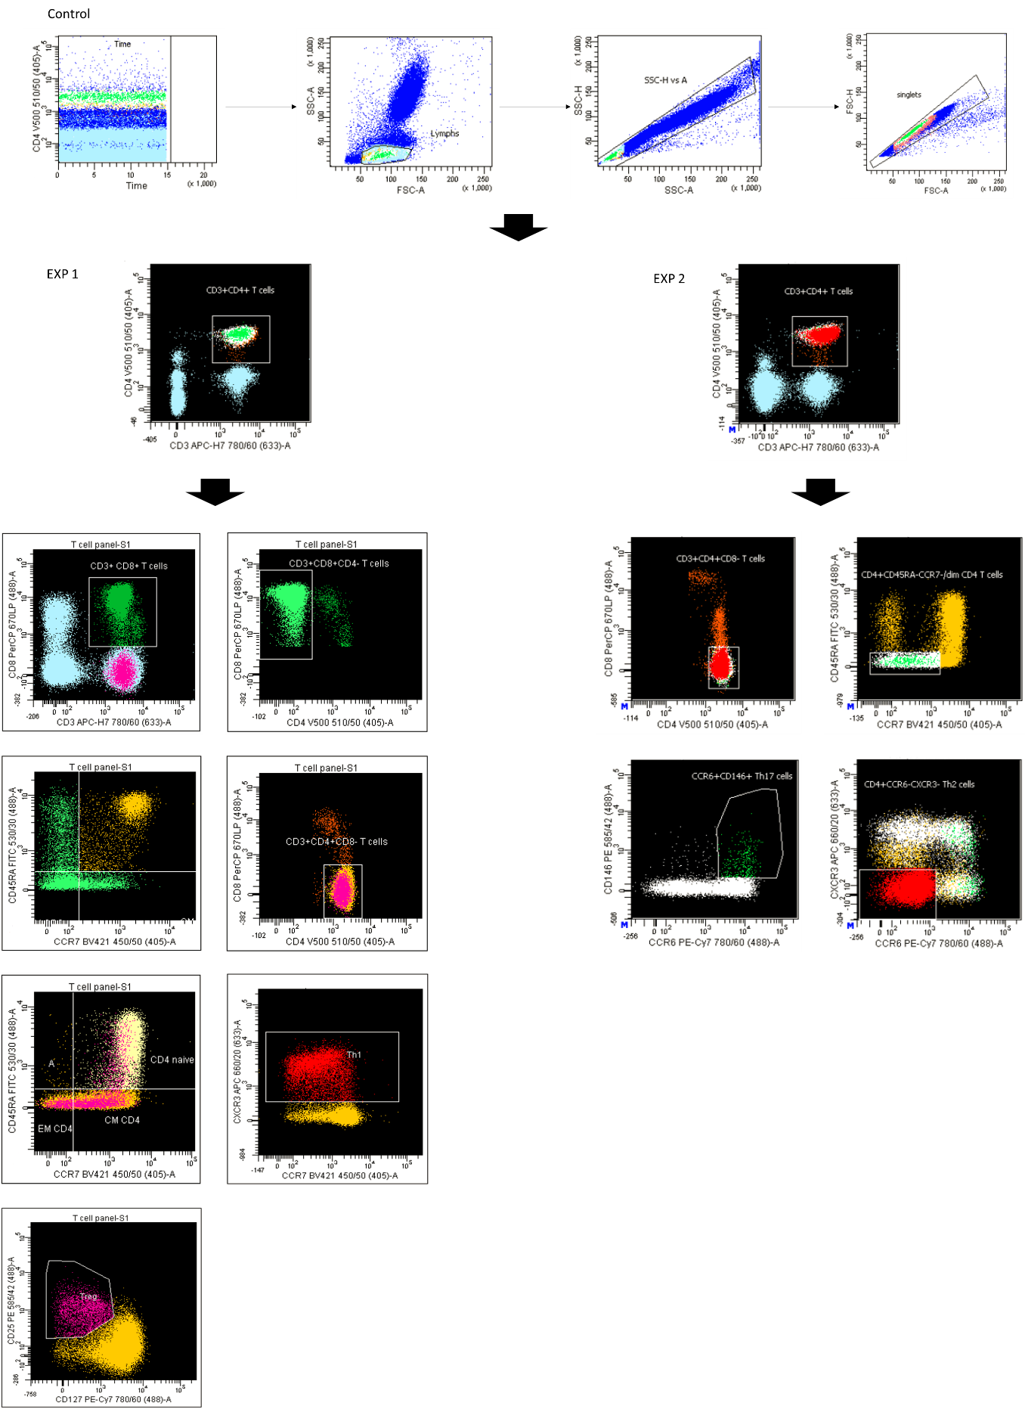

Natural Killer (NK) Panel-2
NK panel-2 (CD3, CD16, CD19, CD56, and NKp46 [CD335]) is a three-tube, six-color method panel (eTable 5). Tubes 2 and 3 contain Molecules of Equivalent Soluble Fluorescence (MESF) beads were used for quantitative antigen expression of CD16 (in allophycocyanin dye) and NKp46 or CD335 (in phycoerythrin dye).

eTable 5. NK immunophenotyping panel configuration.
Detector | FL1 | FL2 | FL3 | FL4 | FL5 | FL6 | FL7 | FL8
Fluorochrome | V500 | BV 421 | FITC | PE | PerCP-Cy5.5 | PE-Cy7 | APC | APC-H7
Tube 1  EXP 1  (Lyse/Wash) | CD3 | CD19 | - | NKp46 (CD335) | - | CD56 | CD16 | CD45
Tube 2  Quantum  R-PE MESF | - | - | - | MESF beads | - | - | - | -
Tube 3  Quantum  R-APC MESF | - | - | - | - | - | - | MESF beads | -
APC, allophycocyanin (fluorochrome); BV, brilliant violet (fluorochrome); EXP, experimental; FITC, fluorescein isothiocyanate (fluorochrome); FMO, fluorescence-minus-one; MESF, Molecules of Equivalent Soluble Fluorescence; PE, phycoerythrin (fluorochrome); PerCP, peridinin-chlorophyll proteins (conjugated reagent).

A total of eight NK cell subtypes were reported with this assay, as listed in eTable 6.

eTable 6. Reportable results for NK cell Panel-2.
Population | Phenotype | Reportable results
NKp46 NK cells | SSC^{low}, CD45⁺, CD19⁻, CD3⁻, CD56⁺, CD335⁺ | Relative percentage of  NK cells*
CD16 NK cells | SSC^{low}, CD45⁺, CD19⁻, CD3⁻, CD16⁺, CD56⁺ | Relative percentage of  NK cells*
NKp46 NK cells | SSC^{low}, CD45⁺, CD19⁻, CD3⁻, CD56⁺, CD335⁺ | NKp46 MESF PE expression levels
CD16 NK cells | SSC^{low}, CD45⁺, CD19⁻, CD3⁻, CD16⁺, CD56⁺ | CD16 MESF APC expression levels
CD16^{bright} CD56^{dim}  NK cells | SSC^{low}, CD45⁺, CD19⁻, CD3⁻, CD56^{dim}, CD16^{bright} | Relative percentage of  NK cells*
CD16^{low} CD56^{bright}  NK cells | SSC^{low}, CD45⁺, CD19⁻, CD3⁻, CD56^{bright}, CD16^{-/+} | Relative percentage of  NK cells*
CD16⁻CD56^{dim}  NK cells | SSC^{low}, CD45⁺, CD19⁻, CD3⁻, CD56^{dim}, CD16⁻ | Relative percentage of  NK cells*
CD16⁺ CD56⁻  NK cells | SSC^{low}, CD45⁺, CD19⁻, CD3⁻, CD56⁻, CD16⁺ | Relative percentage of  NK cells*
* Data from the TBNK assay (CCLS SOP 800658-180, TBNK Flow Cytometry Set-up and Analysis Using BD FACSCanto Clinical Software) were used to calculate the absolute counts.
APC, allophycocyanin (fluorochrome); MESF, Molecules of Equivalent Soluble Fluorescence; PE, phycoerythrin (fluorochrome).

Flow cytometry was conducted using a Becton Dickinson FACSCanto™ II cell analyzer equipped with 405 nm, 488 nm, and 633 nm laser detection (serial number V96300446 and serial number V96300428). Specimens were acquired on the FACSCanto™ II flow cytometer using a saved FACSDiva™ acquisition template “NK panel-2”. BD FACSDiva™ software (version 6.1.2) and EP Evaluator™ Release 9 (version 9.4.0.457) were used to collate and analyze the data.

eFigure 5. Gating strategy for Natural Killer (NK) Panel-2.
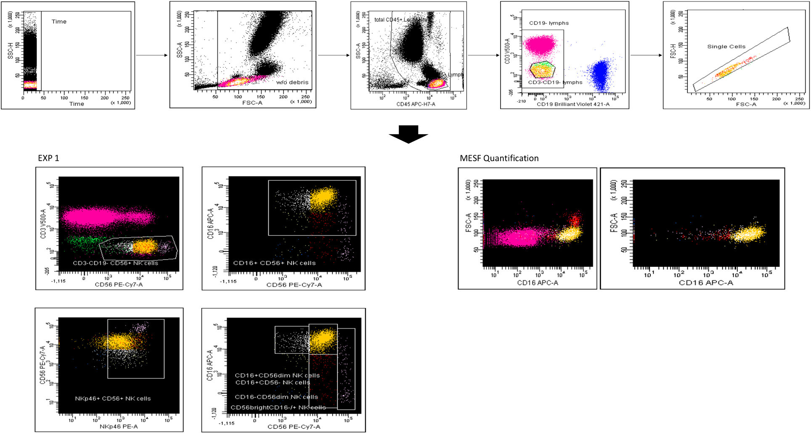
MESF, Molecules of Equivalent Soluble Fluorescence.
TBNK
The TBNK assay was a one-tube, six-color, lyse/no-wash panel consisting of a BD Trucount™ Tube (eTable 7).

eTable 7. TBNK immunophenotyping panel configuration.
Detector | FL1 | FL2 | FL3 | FL4 | FL5 | FL6 | FL7 | FL8
Fluorochrome | - | - | FITC | PE | PE-Cy7 | PerCP-Cy5.5 | APC | APC-H7
BD Trucount™ Tube | - | - | CD3 | CD16 and CD56 | CD4 | CD45 | CD19 | CD8
APC, allophycocyanin (fluorochrome); FITC, fluorescein isothiocyanate (fluorochrome); PE, phycoerythrin (fluorochrome); PerCP, peridinin-chlorophyll proteins (conjugated reagent).

A total of five TBNK cells were reported with this assay as listed in eTable 8.
eTable 8. Reportable results for TBNK cells.
Population | Phenotype
T lymphocytes (T cells) | CD45^{bright}, SCC^{low}, CD3⁺
CD4⁺ T cells | CD45^{bright}, SCC^{low}, CD3⁺, CD4⁺
CD8⁺ T cells | CD45^{bright}, SCC^{low}, CD3⁺, CD8⁺
B cells | CD45^{bright}, SCC^{low}, CD3⁻, CD19⁺
Natural killer cells | CD45^{bright}, SCC^{low}, CD3⁻, CD16⁺/CD56⁺

Flow cytometry was conducted using a Becton Dickinson FACSCanto™ II cell analyzer equipped with 405 nm, 488 nm and 633 nm laser detection. Specimens were acquired using a saved FACSCanto™ II Software TBNK acquisition template. BD FACSCanto™ clinical software (version 2.2), EP Evaluator™ Release 8, and Microsoft Excel were used to collate and analyze the data.

eFigure 6. Gating strategy for TBNK.
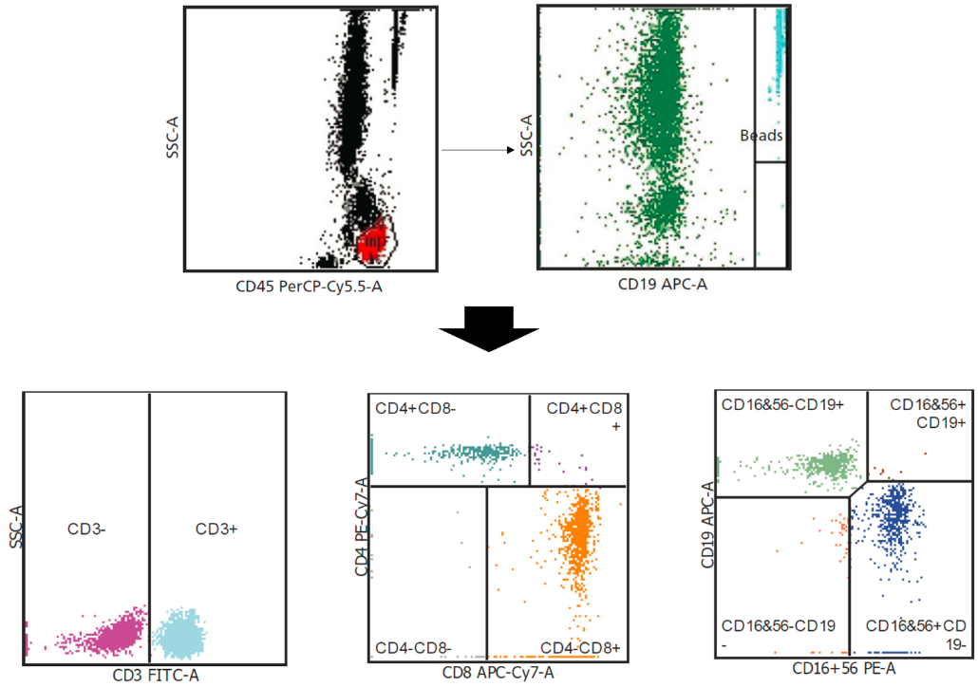
NEPHELOMETRIC ASSAY
Serum immunoglobulins (Igs) were analyzed by Covance using a Siemens BNII nephlometer. All serum specimens were considered stable for 7 days at ambient or refrigerated temperature, and stable for 360 days when stored frozen at -20°C or below. Samples were stable for three freeze/thaw cycles. IgG and IgM were calibrated every 14 days using the manufacturer’s N Protein Standard. Immunoglobulin analyses were performed daily using a minimum volume of 300 μL. For quality control, three levels of material were assayed daily before running patient samples, when new reagents were used, or every 12 hours. Manufacturer guidelines indicate that intra-assay precision was less than 5.0% coefficient of variation (CV), and inter-assay precision was less than 6.6% CV.
Immunoglobulin G (IgG)
The reference range for IgG is 5.65–17.65 g/L.
The serum IgG test detects concentrations of IgG up to approximately 46.00 g/L using the instrument’s 1:400 dilution. Alternate dilutions are automatically performed by the instrument for samples with IgG concentration greater than 46.00 g/L, extending the upper limit. If necessary, the instrument continued to dilute up to 1:160,000 and the exact upper limit of quantitation was dependent on the manufacturer’s calibration set point. The exact low-end detection limit for serum IgG is dependent on the concentration of the standard material used to calibrate the assay. IgG concentrations below 0.70 g/L are reported as <0.70 g/L.
Immunoglobulin M (IgM)
The reference range for IgM is 0.40–2.30 g/L.
The serum IgM test detects concentrations of IgM up to approximately 6.40 g/L using the instrument’s 1:20 dilution. Alternate dilutions are automatically performed by the instrument for results greater than 6.40 g/L. If necessary, the instrument continues to dilute up to 1:160,000 and the exact upper limit of quantitation is dependent on the manufacturer’s calibration set point. The exact low-end detection limit for IgM is dependent on the concentration of the standard material used to calibrate the assay. IgM concentrations below 0.20 g/L are reported as <0.20 g/L.

