eTable 1. Total Study population by study and by outcome
Outcome | Statistical modeling strategy | JHU | CombiRx | IMID | Total N
Laboratory
25(OH)D level, ng/mL | Linear regression | 935 | - | - | 935
Clinical outcome
Timed 25-foot walk | Linear mixed effects model | 144 | 575 | 197 | 916
Nine-hole peg test | Linear mixed effects model | 144 | 575 | 197 | 916
PASAT-3 | Linear mixed effects model | 144 | 575 | - | 719
EDSS progression (primary) | Linear mixed effects model | 294 | 575 | 197 | 1066
EDSS progression (secondary) | Cox proportional hazards model | 294 | 575 | 197 | 1066
Relapse | Andersen Gill model for recurrent events | - | 575 | - | 575
Brain Imaging Outcome
Normalized gray matter volume | Linear mixed effects model | 437 | 575 | - | 1012
Normalized white matter volume | Linear mixed effects model | 437 | 575 | - | 1012
Normalized brain volume | Linear mixed effects model | 437 | 575 | - | 1012
T2 lesion volume | Linear mixed effects model | 437 | 575 | - | 1012
New lesions | Negative binomial model | 266 | 575 | - | 841
Retinal Imaging Outcome
GCIPL | Linear mixed effects model | 1105 | - | - | 1105

eTable 2. Characteristics of the sub-cohort of JHU participants with measured 25(OH)D levels.
Characteristics | JHU cohort with 25(OH)D levels
N | 935
Age, years, mean (SD) | 43.11 (11.92)
Male sex, % | 241 (25.8)
BMI, kg/m², mean (SD) | 28.08 (6.51)
Disease duration, years, mean (SD) | 6.88 (7.63)
RRMS Subtype, n (%) | 780 (83.4)
MS DMTs, n (%)
Glatiramer acetate | 193 (20.6)
Interferon beta | 144 (15.4)
Glatiramer acetate+Interferon beta | 0 (0.0)
Dimethyl Fumarate | 97 (10.4)
Teriflunomide | 14 (1.5)
Fingolimod | 30 (3.2)
Natalizumab | 117 (12.5)
Anti-CD20 | 32 (3.4)
No therapy | 301 (32.2)
Other | 7 (0.7)
Number of relapses in previous 3 years (CombiRx, JHU) or 1 year (IMID), mean (SD)² | 0.74 (0.89)
Use of vitamin D supplement any time during follow-up, n (%) | 542 (58.0)
Use of other medication potentially affecting vitamin D levels¹, n (%) | 572 (61.2)

eTable 3. Pooled results for models additionally adjusting for vitamin D supplement use and medications potentially impacting vitamin D status
 | Quartile of 25(OH)D PGS |  |  |  |  | P for trend¹ |  | P for het² |  | I²
 | Q1 | Q2 | Q3 | Q4
Clinical outcome, Parameter, 95% CI
%Change in T25FW, Rate, 95% CI | 0.00 [ref] | -0.14 (-1.37, 1.12) | -1.01 (-2.20, 0.19) | 0.53 (-0.71, 1.80) | 0.76 |  | 0.42 |  | 0.00%
%Change in 9HPT, Rate, 95% CI | 0.00 [ref] | -0.01 (-0.71, 0.70) | -0.22 (-0.93, 0.50) | 0.50 (-0.22, 1.23) | 0.30 |  | 0.36 |  | 0.00%
%Change in PASAT-3, Rate, 95% CI | 0.00 [ref] | 0.28 (-0.39, 0.95) | 0.32 (-0.28, 0.93) | 0.09 (-0.53, 0.72) | 0.70 |  | 0.57 |  | 0.00%
Rate of change in EDSS, Rate, 95% CI | 0.00 [ref] | 0.046 (-0.004, 0.096) | 0.023 (-0.097, 0.143) | 0.037 (-0.012, 0.086) | 0.40 |  | 0.25 |  | 24.09%
Relapse rate, HR, 95% CI | 1.00 [ref] | 1.19 (0.86, 1.65) | 1.21 (0.89, 1.64) | 1.07 (0.77, 1.50) | 0.68 |  | - |  | -
MRI outcome, Parameter, 95% CI
%Change in BPF, Rate, 95% CI | 0.00 [ref] | -0.01 (-0.05, 0.04) | -0.01 (-0.06, 0.04) | -0.01 (-0.06, 0.04) | 0.9 |  | 0.005 |  | 87.38%
%Change in GMF, Rate, 95% CI | 0.00 [ref] | 0.01 (-0.02, 0.04) | 0.01 (-0.02, 0.04) | 0.01 (-0.01, 0.04) | 0.11 |  | 0.41 |  | 0.00%
%Change in WMF, Rate, 95% CI | 0.00 [ref] | -0.02 (-0.04, 0.00) | -0.02 (-0.04, 0.00) | -0.01 (-0.04, 0.01) | 0.17 |  | 0.72 |  | 0.00%
%Change in T2 lesion volume, Rate, 95% CI | 0.00 [ref] | -0.14 (-0.74, 0.46) | -0.14 (-0.73, 0.46) | -0.18 (-0.78, 0.43) | 0.39 |  | 0.83 |  | 0.00%
Rate of new lesions, RR, 95% CI | 1.00 [ref] | 1.48 (1.02, 2.14) | 1.31 (0.90, 1.91) | 1.02 (0.70, 1.49) | 0.92 |  | 0.4 |  | 0.00%
Retinal imaging outcome, Parameter, 95% CI
%Change in GCIP, Rate, 95% CI | 0.00 [ref] | 0.02% (-0.08, 0.13) | 0.00% (-0.10, 0.11) | -0.04% (-0.15, 0.06) | 0.34 |  | - |  | -

eTable 4. Mendelian randomization (MR) estimates for 1 SD unit increase in genetically predicted log(25[OH]D) levels and selected MS outcomes (relapse rate¹ and rate of new lesions²).
Outcome | N SNPs | Effect Estimate | P value
Relapse rate (n exposure=485,762; n outcome=575)
IVW | 81 | 0.50 (0.19, 1.33) | 0.17
MR Egger | 81 | 0.29 (0.05, 1.89) | 0.20
Weighted median | 81 | 0.38 (0.08, 1.76) | 0.22
IVW Radial | 81 | 0.50 (0.21, 1.19) | 0.12
Test for heterogeneity | - | - | 0.93
MR Egger regression intercept (pleiotropy) | - | 0.01 (-0.03, 0.05) | 0.51
Rate of new lesions (n exposure=485,762; n outcome=841)
IVW | 79 | 0.95 (0.26, 3.38) | 0.93
MR Egger | 79 | 0.78 (0.07, 9.05) | 0.84
Weighted median | 79 | 1.16 (0.17, 7.86) | 0.88
IVW Radial | 79 | 0.95 (0.26, 3.38) | 0.93
Test for heterogeneity | - | - | 0.10
MR Egger regression intercept (pleiotropy) | - | 0.005 (-0.05, 0.06) | 0.86
¹Relapse IVs were derived from participants in CombiRx (n=575). Initial analyses indicated potential heterogeneity (Q statistic: 111.6; p=0.05). Results displayed exclude potential outlying SNPs (n=10 SNPs). ²Rate of new lesions were derived from pooled estimates derived from JHU and CombiRx participants (n=841). No heterogeneity was observed.

eFigure 1. Results for clinical outcomes and continuous 25(OH)D PGS (not adjusted for BMI) for individual studies and the pooled estimate¹ across studies.
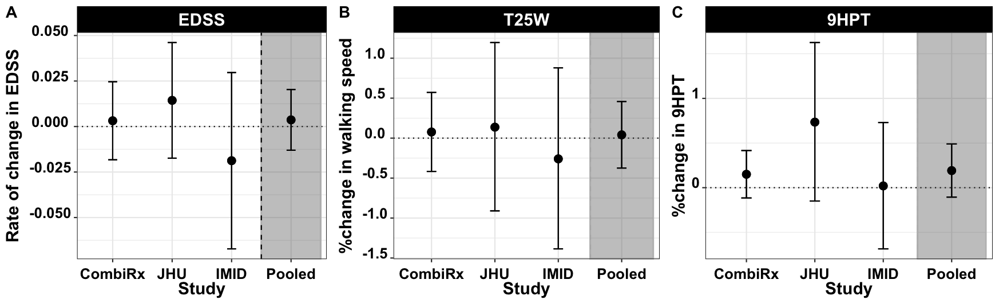
¹Effect estimates displayed are for a 1 SD increase in 25(OH)D PGS. They are adjusted for age, 5 ancestry PCs, MS DMT, disease duration and number of relapses in previous 3 years. The pooled effect estimate is results from a random effects meta-analysis. A. Results for rate of EDSS progression (Heterogeneity I²=0.00%; p het=0.53). B. Results for annualized percent change T25FW (I²=0.0%; p het=0.85). C. Results for annualized percent change 9HPT (I²=12.38%; p het=0.42).

eFigure 2. Results for MRI outcomes and continuous 25(OH)D PGS (not adjusted for BMI) for individual studies and the pooled estimate¹ across studies.
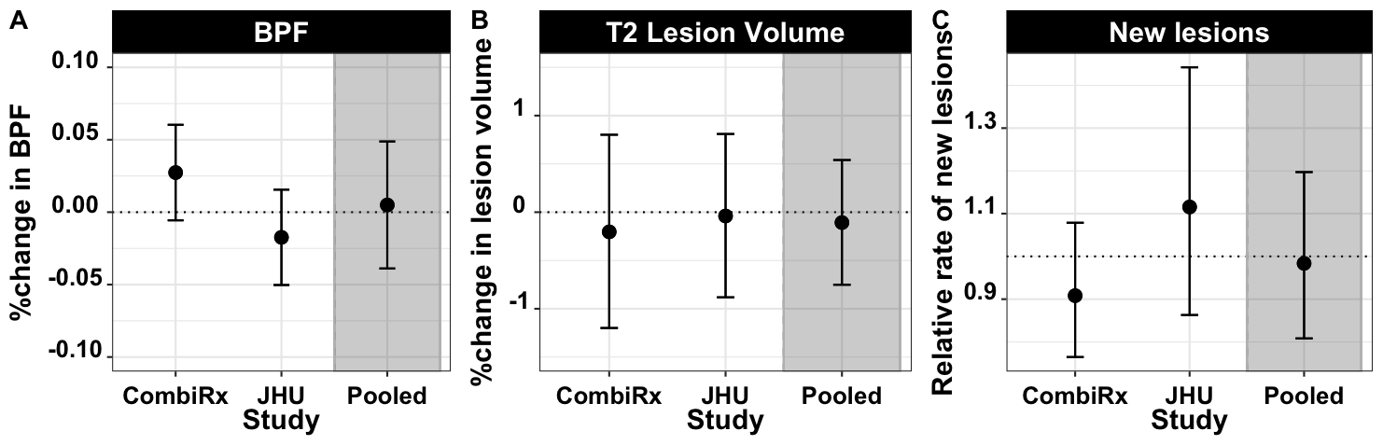
¹Effect estimates displayed are for a 1 SD increase in 25(OH)D PGS. They are adjusted for age, 5 ancestry PCs, MS DMT, disease duration and number of relapses in previous 3 years. The pooled effect estimate is results from a random effects meta-analysis. A. Results for annualized percent change in BPF (Heterogeneity I²=71.7%; p het=0.06). B. Results for annualized percent change in lesion volume (I²=0.0%; p het=0.74). C. Relative rate for new lesions (I²=41.2%; p het=0.19).

eFigure 3. Results for clinical outcomes and continuous 25(OH)D PGS for individual studies and the pooled estimate¹ across studies using PGS p-value threshold of 5e-5.
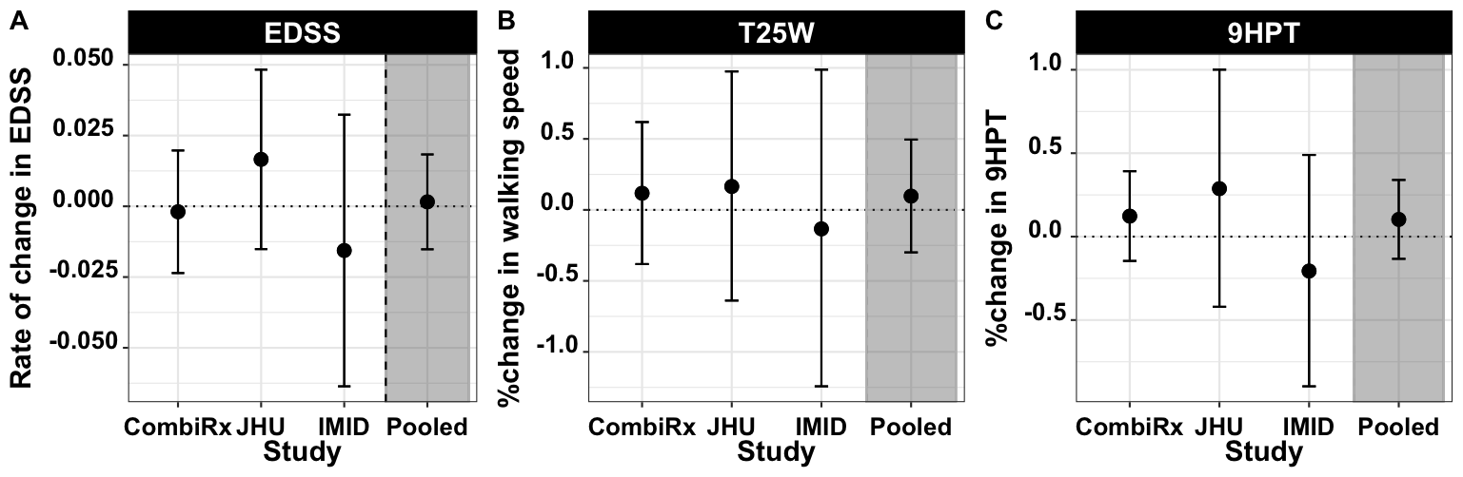
¹Effect estimates displayed are for a 1 SD increase in 25(OH)D PGS. They are adjusted for age, 5 ancestry PCs, MS DMT, disease duration and number of relapses in previous 3 years. The pooled effect estimate is results from a random effects meta-analysis. A. Results for rate of change in EDSS (Heterogeneity I²=0.0%; p het=0.48). B. Results for annualized percent change T25FW (I²=0.0%; p het=0.91). C. Results for annualized percent change 9HPT (I²=0.0%; p het=0.59).

eFigure 4. Results for MRI outcomes and continuous 25(OH)D PGS for individual studies and the pooled estimate¹ across studies using PGS p-value threshold of 5e-5.
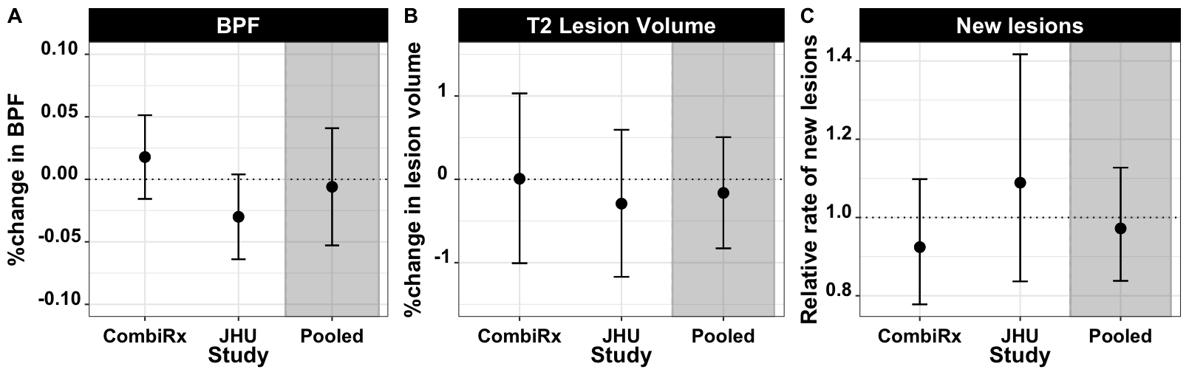
¹Effect estimates displayed are for a 1 SD increase in 25(OH)D PGS. They are adjusted for age, 5 ancestry PCs, MS DMT, disease duration and number of relapses in previous 3 years. The pooled effect estimate is results from a random effects meta-analysis. A. Results for annualized percent change in BPF (Heterogeneity I²=74.1%; p het=0.05). B. Results for annualized percent change in lesion volume (I²=0.0%; p het=0.66). C. Relative rate for new lesions (I²= 4.1%; p het=0.31).

eFigure 5. Scatterplots for MR of 25(OH)D with relapse and rate of new lesions. Scatterplots showing the genetic estimates for the outcome along the y axis against the estimates for the exposure along the x axis (log rate ratio with 95% CI). A. Effect of genetically determined 25(OH)D levels on log(rate) of relapse. B. Effect of genetically determined 25(OH)D levels on log(rate) of new lesions. The slope of each line represents the MR estimate for the corresponding method.
