eFigure 1. Distribution of disability evaluation modalities over the study timeframe, i.e March 2020 through February 2022, for 207 participants (636 total evaluations: 268 Tele-video + 100 in-clinic Neurostatus + 268 patient-reported questionnaires).

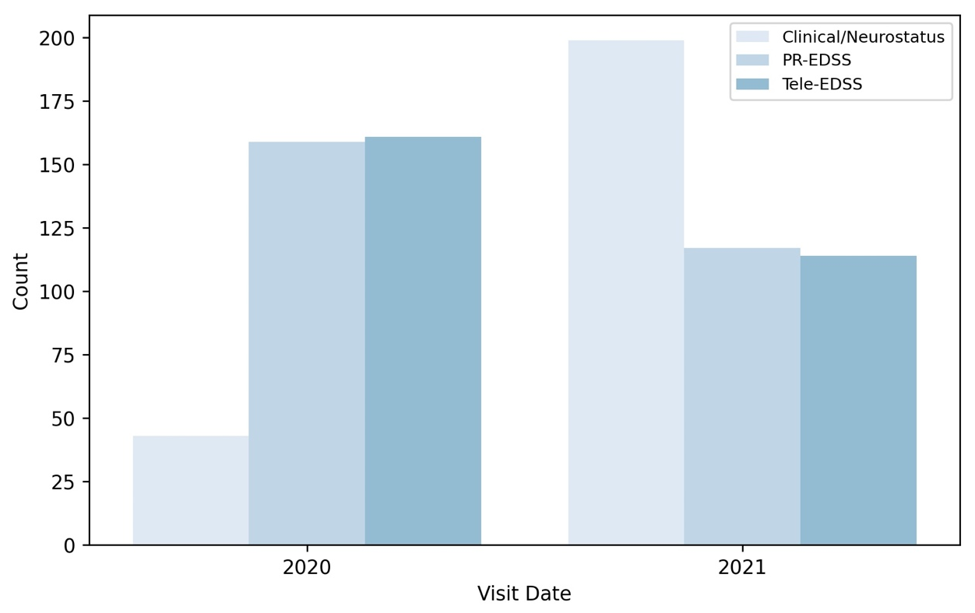

eFigure 2. Comparison of Functional Systems scores across the 3 protocols for the 100 matched participant visits. The Table represents the mean (standard deviation) scores for each Function System when compared across the 3 assessment modalities. The Panels display the distribution of scores for each individual Functional System.

