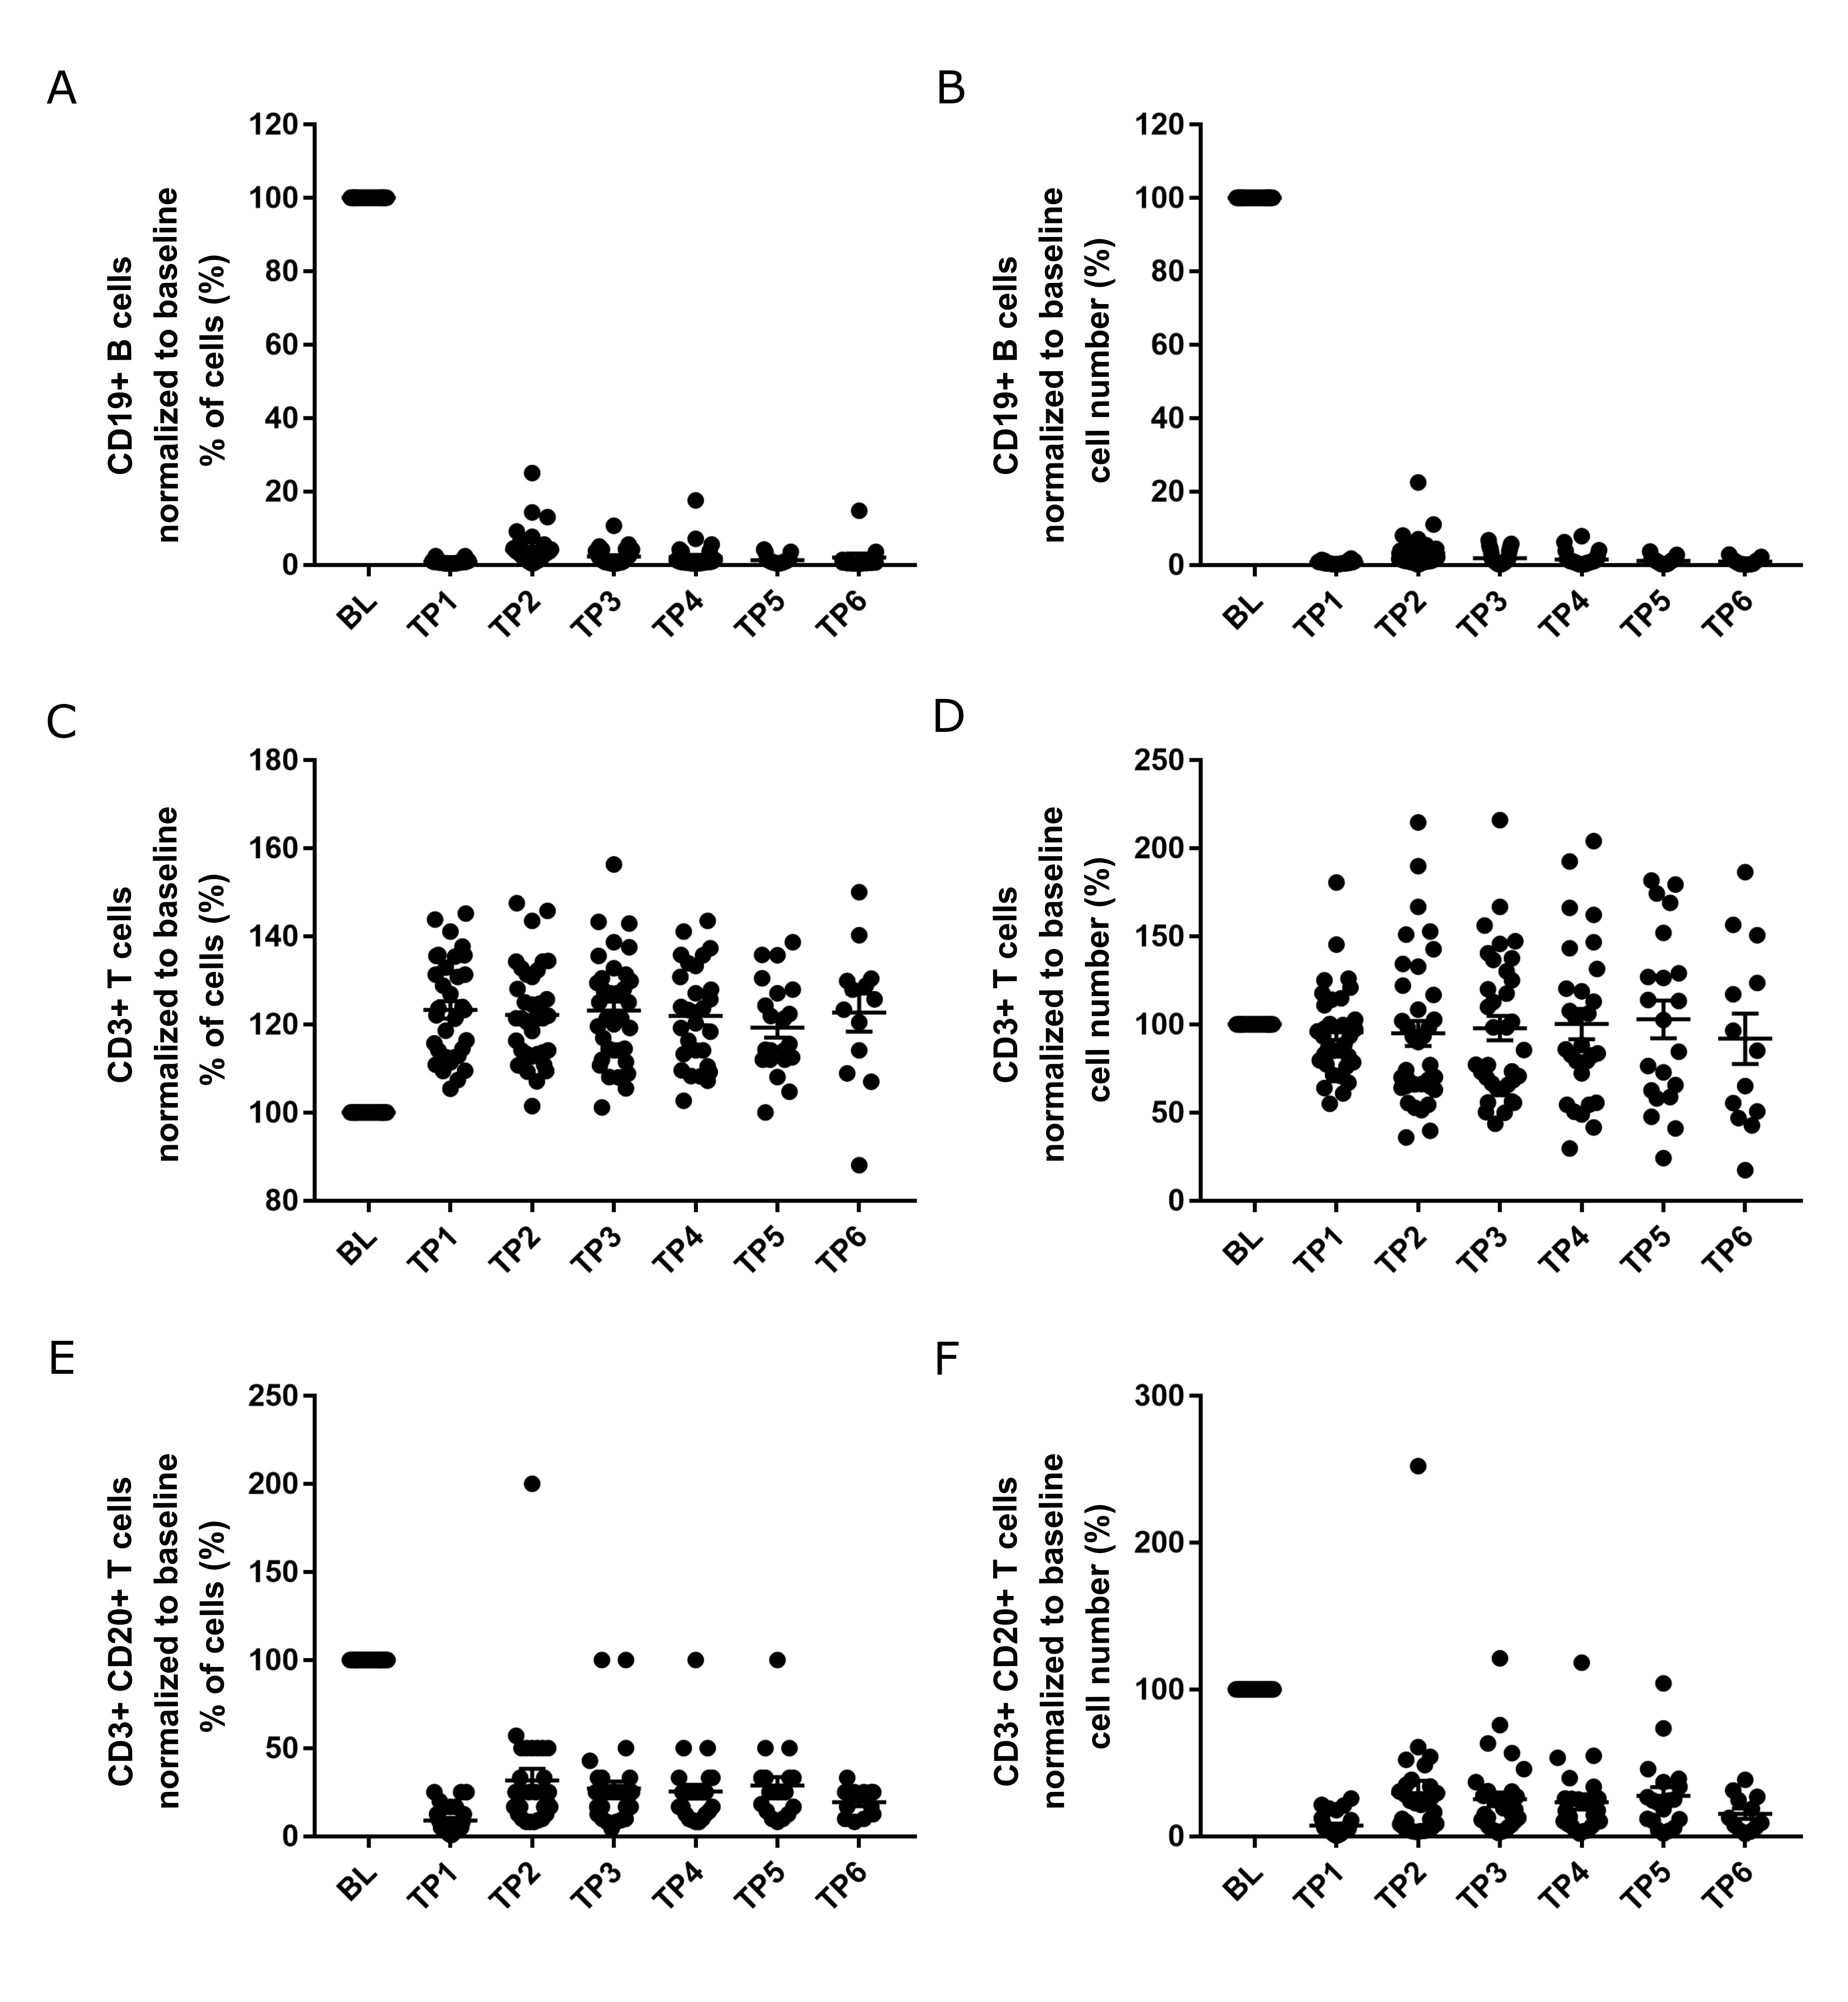eFigure 1: Effect of ocrelizumab treatment on lymphocyte subsets. Lymphocyte subsets were analyzed from the patient cohort 1 longitudinally by FACS at baseline (BL; n=36), TP1 (mean 17 days; n=34), TP2 (mean 6 months; n=36), TP3 (mean 12.9 months; n=35), TP4 (mean 19.8 months; n=28), TP5 (mean 25.6 months; n=23) and TP6 (mean 31.2 months; n=13). We set the baseline values for each patient as 100 % and calculated the relative levels of the lymphocyte subsets (CD19+ B cells in Fig. 1A, CD3⁺ T cells in Fig 1B, CD3⁺CD20⁺ T cells in Fig. 1C). Raw values are provided in eTable 3. The data are shown as % of all lymphocytes (left) or as absolute cell count per µl (right). When the measured values were below 1 %, we used 0.5 % as a surrogate value. When there were no cells detectable, we used 0.1 % as surrogate. Data are given as arithmetic mean ± standard error of the mean (SEM).
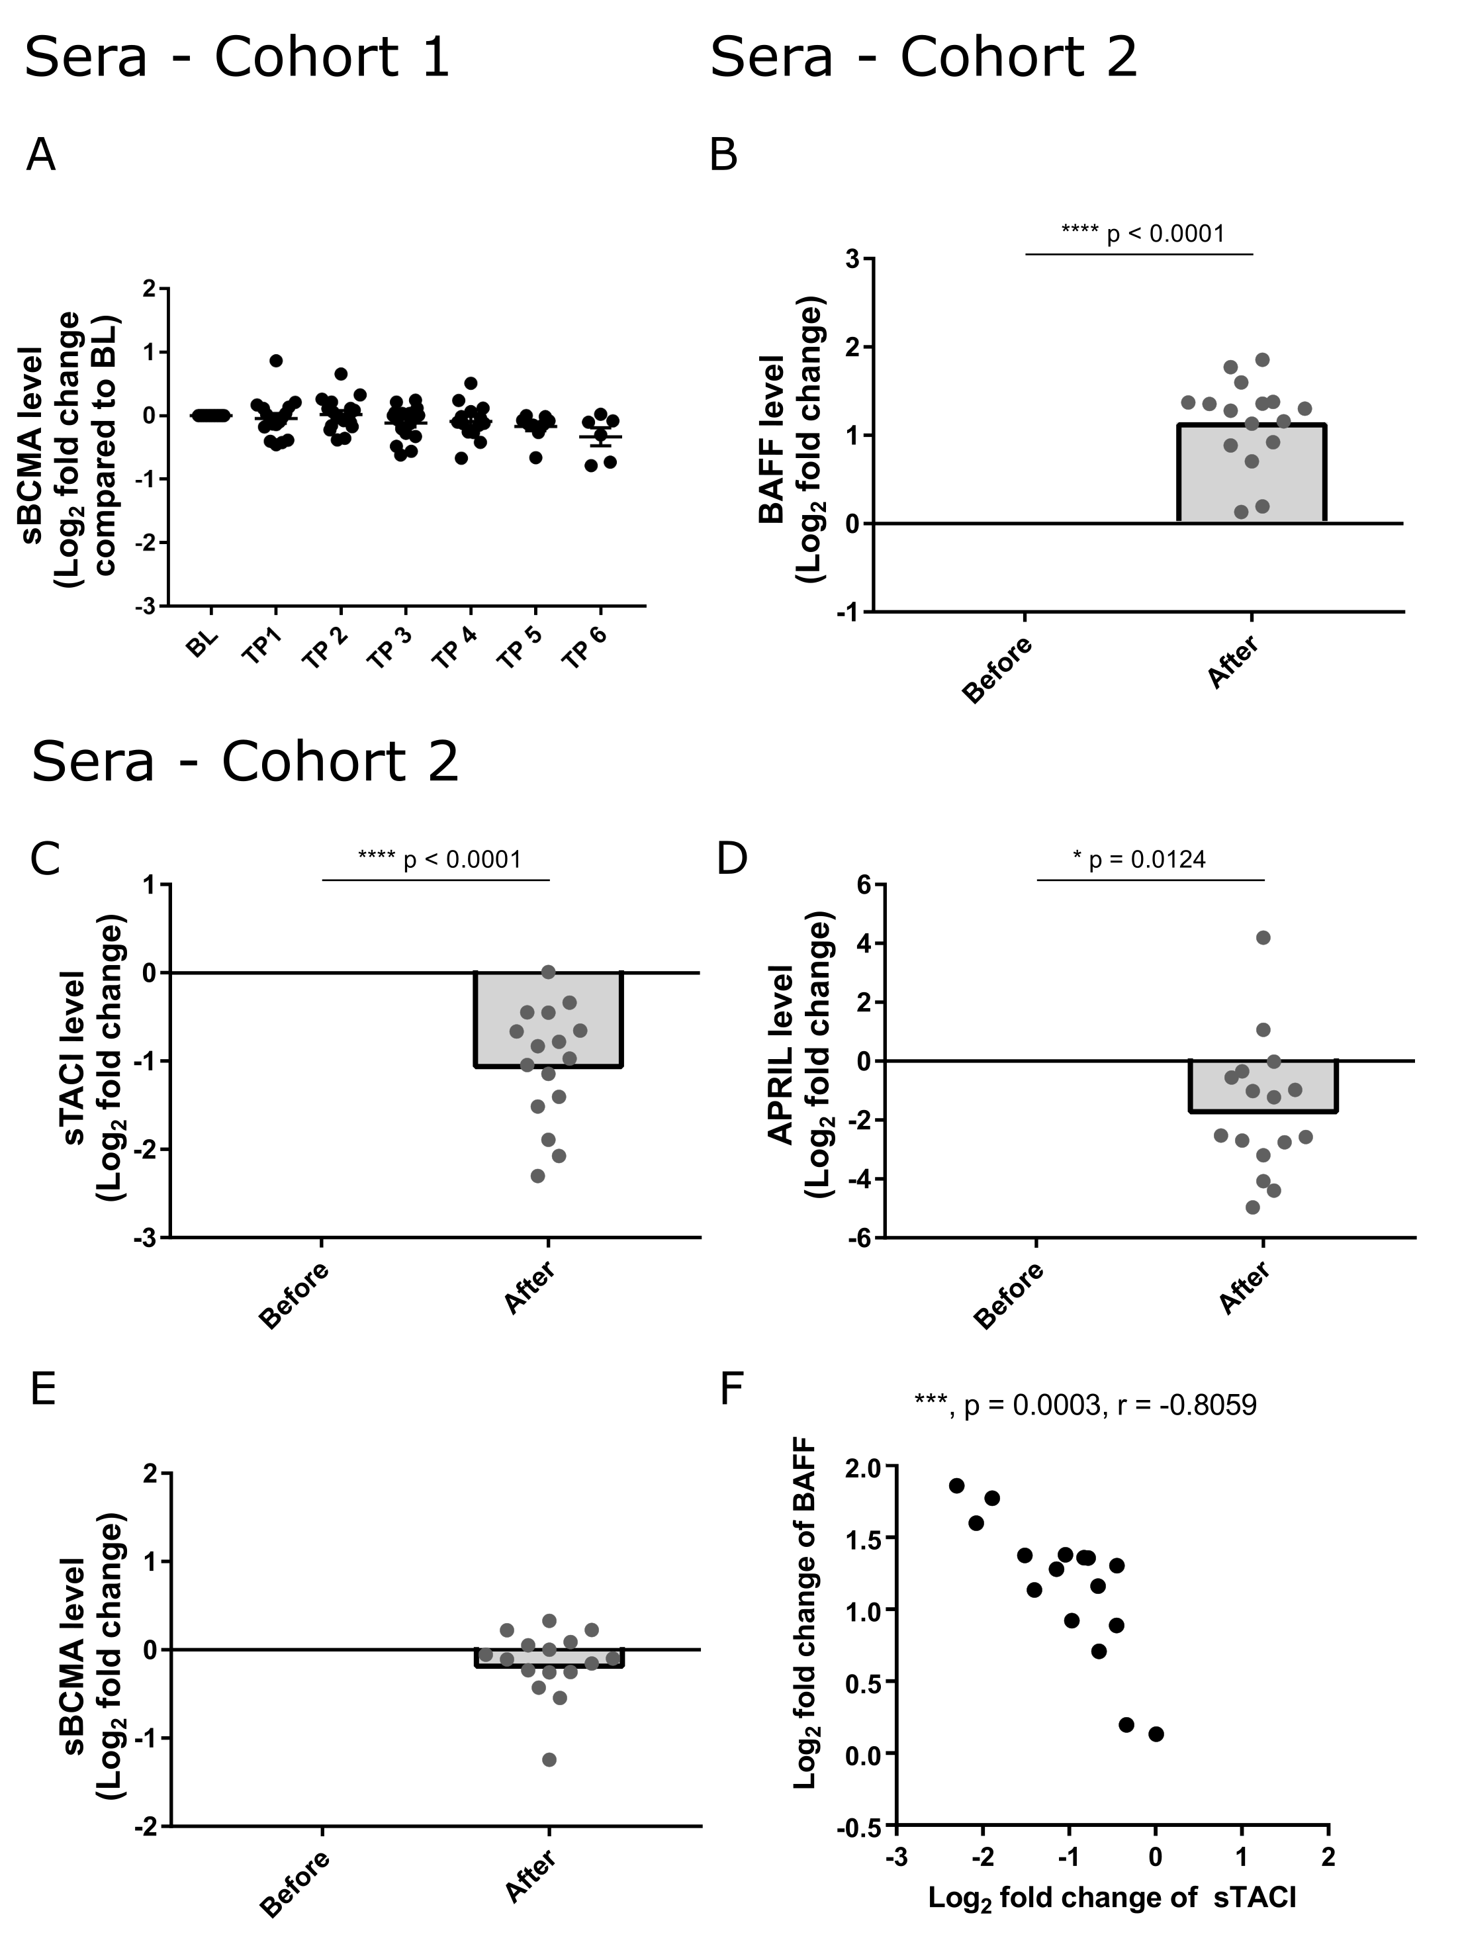
eFigure 2: Effect of ocrelizumab treatment on components of the BAFF/APRIL system in serum of patients.
Serum levels of sBCMA (A) were evaluated from patient cohort 1 by ELISA from 17 patients receiving ocrelizumab at baseline (BL) (n=17), TP1 (mean 18 days; n=17), TP2 (mean 6.7 months; n=17), TP3 (mean 12.9 months; n=17), TP4 (mean 19.1 months; n=14), TP5 (mean 25.2 months; n=10) and TP6 (mean 31.3 months; n=7). Serum levels of BAFF (B), sTACI (C), APRIL (D), sBCMA (E) were evaluated in the patient cohort 2 (n=16) at baseline and after ocrelizumab treatment (12 to 19 months). Raw values are provided in eTable 3. Data are presented as log₂ fold change compared to baseline. We performed a one-sample t test to compare baseline and follow up samples. p-values are shown if they were < 0.05. Data are given as arithmetic mean ± standard error of the mean (SEM). Negative correlation between BAFF and sTACI levels are shown by the Pearson correlation analyses of log₂ fold change of BAFF to log₂ fold change of sTACI in serum of patient cohort 2 (F).

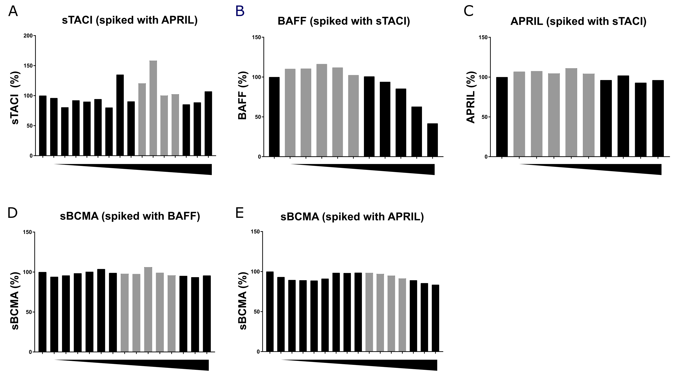

eFigure 3: Spiking experiments: interference of complex formation on protein detection.
(A) The detection of sTACI (500 pg/ml) was evaluated with the addition of APRIL from 30 ng/ml to 0 ng/ml. (B) BAFF (300 pg/ml) detection was evaluated with the addition of sTACI from 6000 pg/ml down to 0 pg/ml. (C) APRIL (1500pg/ml) detection was evaluated with addition of sTACI from 6000 pg/ml to 0 pg/ml. (D) The detection of sBCMA (20 ng/ml) was evaluated with addition of BAFF from 15ng/ml to 0 ng/ml-and (E) APRIL from 30 ng/ml to 0 ng/ml. The triangles below the x-axes represent titration of interaction partners added to the samples. The data is presented in % of detection compared to the sample detection without interaction partners. The bars in grey represent physiological levels of the spiked APRIL (A), sTACI (B,C), BAFF (D) and APRIL (E).

