eSupplemental Material
eFigure 1. Kaplan–Meier Analyses and Hazard Ratios of 24W-CDP Grouped by Median Circulating B-Cell Levels Over 96-Week DBP and OLE, and During the OLE Only, in Patients With RMS, and Over 120-Week DBP, ECP, and OLE, and During the OLE Only, in Patients With PPMS
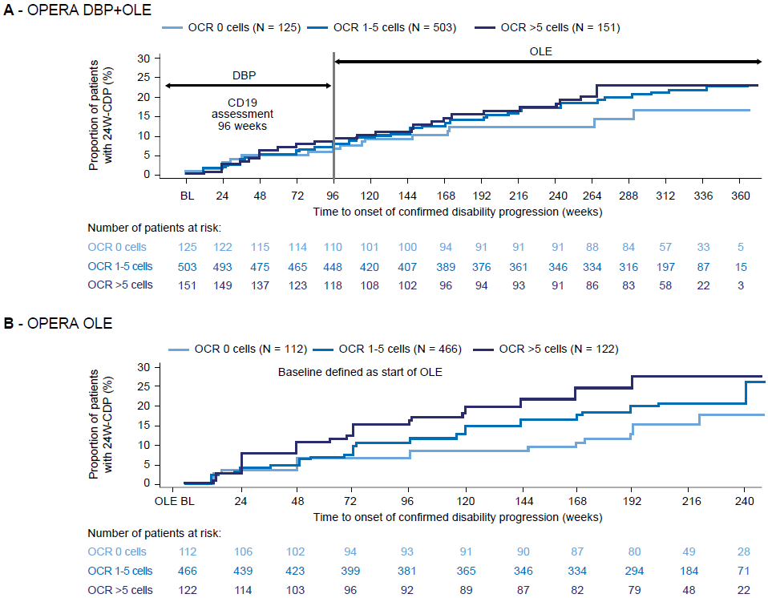
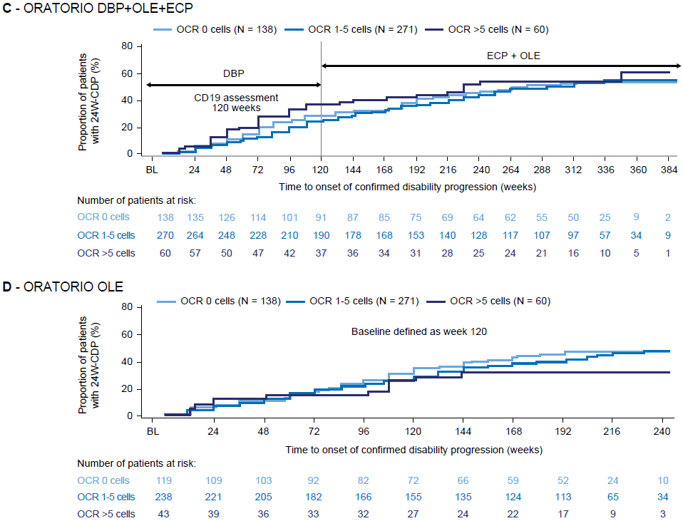
Abbreviations: 24W-CDP = 24-week confirmed disease progression; BL = baseline; DBP = double-blind period;
ECP = extended controlled period; OLE = open-label extension; PPMS = primary progressive multiple sclerosis;
RMS = relapsing multiple sclerosis.
Univariate and Multivariate Analyses
In order to assess whether there were patient characteristics that were confounding the observed association between ocrelizumab exposure and disability progression, we performed univariate and multivariate subgroup analyses, comparing the time to 24-week confirmed disease progression (24W-CDP) of low (Quartiles 1/2) and high (Quartiles 3/4) exposures in ocrelizumab-treated patients with all interferon (IFN) β-1a- or placebo-treated patients, within patient subgroups defined by baseline characteristics (eFigure 2 and eTable 2).
Within patients from the USA and with Expanded Disability Status Scale (EDSS) score ≥4, ocrelizumab-treated patients with lower exposure showed numerically greater reduction in risk compared with patients with higher exposure in both univariate and multivariate analyses; however, these subgroups were relatively small and observed effects had overlapping confidence intervals. This observation might be driven by a complex interaction of age, sex, and body mass index (BMI), as the USA subgroup vs the rest of world (ROW) showed a markedly different BMI dependency on age and sex (data not shown). When comparing the magnitude of reduction of risk between low- and high-exposure groups across subgroups, age shows the strongest difference, with patients >45 years of age deriving the strongest benefit from high ocrelizumab exposure.
Among patients with primary progressive multiple sclerosis (PPMS) from the USA, ocrelizumab-treated patients with lower exposure showed greater reductions in risk compared with patients with higher exposure in both univariate and multivariate analyses. A similar difference in BMI dependency on age and sex between region USA and ROW patients as in the relapsing multiple sclerosis (RMS) studies was observed in PPMS, potentially explaining the difference in exposure–response relationship (as noted above; data not shown). When comparing the magnitude of reduction of risk increase between low- and high-exposure groups across subgroups, duration since symptom onset, BMI, and T1 gadolinium-enhancing lesions showed the strongest differences, with patients with >5 years of duration since symptom onset and patients with BMI <25 deriving the strongest benefit from high-exposure ocrelizumab treatment in both univariate and multivariate analyses. For patients with T1 gadolinium-enhancing lesions at baseline, the benefit from high-exposure ocrelizumab treatment was reduced in the multivariate analysis.

eFigure 2. Univariate (Black Dots and 95% Confidence Intervals) and Multivariate Analyses (Red Dots) of Covariate Effects on 24W-CDP Grouped by Low (Quartiles 1/2) and High (Quartiles 3/4) Ocrelizumab Exposure Relative to Comparator in Patients With RMSª (A) or PPMS^{b} (B)
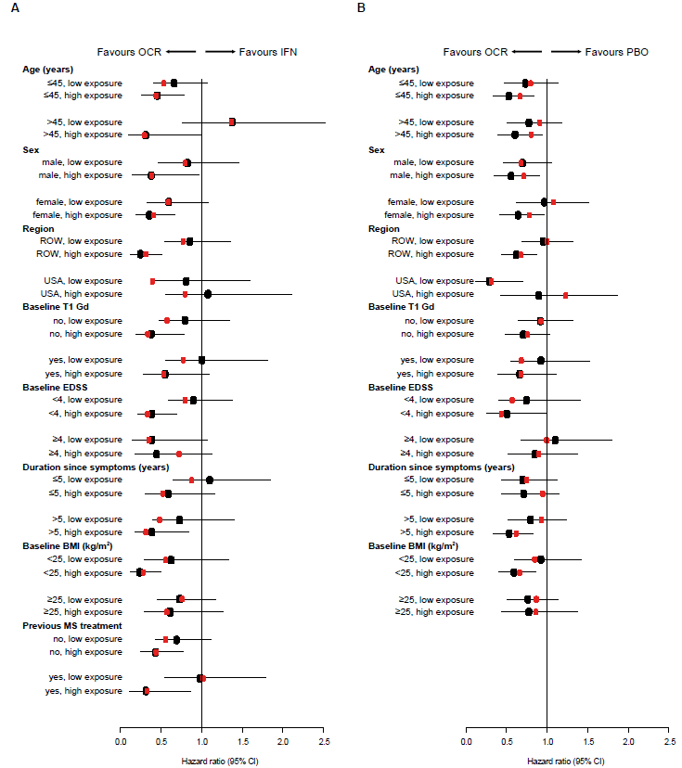
Hazard ratios were estimated by a stratified Cox regression model with treatment group as a covariate. ^{a,b}Stratified by region (USA vs ROW), ªbaseline EDSS (<4.0 vs ≥4.0), ^{b}age (≤45 vs >45 years), and ªOCR exposure (low: C_{mean}<18.7 vs high: 18.7≤C_{mean}) or ^{b}OCR exposure (low: C_{mean}<18.9 vs high: 18.9≤C_{mean}). Treated patients with missing C_{mean} values were excluded.
Abbreviations: 24W-CDP = 24-week confirmed disease progression; BMI = body mass index;
CI = confidence interval; C_{mean} = average ocrelizumab serum concentration in an individual patient over their treatment period; EDSS = Expanded Disability Status Scale; Gd = gadolinium; IFN = interferon; OCR = ocrelizumab; PBO = placebo; PPMS = primary progressive multiple sclerosis; RMS = relapsing multiple sclerosis; ROW = rest of world.

eTable 1. Hazard Ratios of 12W-CDP Grouped by Ocrelizumab Exposure or BMI and 12W-cCDP Grouped by Ocrelizumab Exposure in Patients With RMSª or PPMS^{b} Relative to Comparator
Parameter hazard ratio and 95% CI /  quartile grouping | OCR Exposure Quartile 1 | OCR Exposure Quartile 2 | OCR Exposure Quartile 3 | OCR Exposure Quartile 4 | High (OCR 3/4) vs  low (OCR 1/2) exposure
12W-CDP
RMS exposure | 0.77 (0.49, 1.21) | 0.80 (0.51, 1.24) | 0.45 (0.26, 0.79) | 0.33 (0.17, 0.64) | 0.51 (0.31, 0.83) p = 0.0059
RMS BMI | 0.27 (0.13, 0.57) | 0.59 (0.30,1.16) | 0.80 (0.48,1.35) | 0.82 (0.47, 1.45) | -
PPMS exposure | 0.87 (0.60, 1.27) | 0.83 (0.58, 1.19) | 0.78 (0.54, 1.13) | 0.59 (0.40, 0.86) | 0.80 (0.58, 1.10) p = 0.16
PPMS BMI | 0.51 (0.31, 0.84) | 0.75 (0.45,1.26) | 0.93 (0.54, 1.59) | 0.87 (0.52, 1.46) | -
12W-cCDP by exposure grouping
RMS 12W-cCDP | 0.80 (0.58, 1.10) | 0.74 (0.54, 1.02) | 0.61 (0.43, 0.85) | 0.50 (0.35, 0.72) | 0.67 (0.49, 0.92) p = 0.0117
RMS Time to 20% increase in 9HPT | 0.71 (0.28, 1.84) | 0.72 (0.30, 1.72) | 0.46 (0.16, 1.31) | 1.34 (0.67, 2.67) | 1.15 (0.52, 2.55) p = 0.72
RMS Time to 20% increase in T25FW | 0.88 (0.59, 1.31) | 0.63 (0.41, 0.97) | 0.78 (0.52, 1.17) | 0.49 (0.30, 0.80) | 0.75 (0.50, 1.12) p = 0.16
PPMS 12W-cCDP | 0.84 (0.64, 1.11) | 0.70 (0.53, 0.93) | 0.73 (0.56, 0.97) | 0.69 (0.52, 0.90) | 0.93 (0.73, 1.18) p = 0.54
Time to 20% increase in 9HPT | 0.68 (0.42, 1.09) | 0.51 (0.31, 0.85) | 0.65 (0.41, 1.04) | 0.42 (0.24, 0.72) | 0.89 (0.57, 1.37) p = 0.59
Time to 20% increase in T25FW | 0.88 (0.65, 1.19) | 0.68 (0.50, 0.92) | 0.75 (0.55, 1.01) | 0.71 (0.53, 0.96) | 0.94 (0.73, 1.22) p = 0.65
A significant treatment-by-baseline BMI (low ≤median vs high >median) interaction was observed between patients with RMS for 12W-CDP, where lighter patients received more benefit than heavier patients (HR, 95% CI: 2.05 [1.10, 3.82]; p = 0.0245); no such effect was evident in patients with PPMS (HR, 95% CI: 1.27 [0.74, 2.16]; p = 0.39).
ªExposure quartile ranges: Quartile 1, min–<15.4 µg/mL, Quartile 2, ≥15.4–<18.7 µg/mL, Quartile 3, ≥18.7–<22.2 µg/mL, Quartile 4, ≥22.2–max µg/mL (comparator was
IFN β-1a); BMI quartile range: Quartile 1, min–<22.1, Quartile 2, ≥22.1–<25.0, Quartile 3, ≥25.0–<28.9, Quartile 4, ≥28.9–max.
^{b}Exposure quartile ranges: Quartile 1, min–<15.8 µg/mL, Quartile 2, ≥15.8-<18.9 µg/mL, Quartile 3, ≥18.9-<23.2 µg/mL, Quartile 4, ≥23.2-max µg/mL (comparator was placebo); BMI quartile range: Quartile 1, min–<21.5, Quartile 2, ≥21.5–<24.0, Quartile 3, ≥24.0–<27.6, Quartile 4, ≥27.6–max.
Abbreviations: 9HPT = Nine-Hole Peg Test; 12W, 12-week; BMI = body mass index; cCDP = composite confirmed disease progression;
CDP = confirmed disability progression; CI = confidence interval; HR = hazard ratio; OCR = ocrelizumab; PPMS = primary progressive multiple sclerosis;
RMS = relapsing multiple sclerosis; T25FW = Timed 25-Foot Walk.

eTable 2. Multivariate Analyses of the Ocrelizumab Treatment Effect on 24W-CDP by Patient Baseline Characteristics and Exposure in Patients With RMSª or PPMS^{b} Relative to Comparator
Covariate | N | RMS hazard ratio (95% CI) | N | PPMS hazard ratio (95% CI)
Age, years
≤45 years: low/high exposure | 306/310 | 0.53 (0.24, 1.17)/0.44 (0.19, 1.02) | 114/112 | 0.79 (0.41, 1.54)/0.67 (0.34, 1.34)
>45 years: low/high exposure | 87/83 | 1.37 (0.60, 3.16)/0.30 (0.08, 1.11) | 127/129 | 0.91 (0.42, 1.95)/0.80 (0.38, 1.72)
Sex
Male: low/high exposure | 177/98 | 0.80 (0.37, 1.74)/0.39 (0.13, 1.18) | 151/95 | 0.68 (0.35, 1.34)/0.70 (0.34, 1.41)
Female: low/high exposure | 216/295 | 0.59 (0.26, 1.33)/0.41 (0.18, 0.95) | 90/146 | 1.08 (0.54, 2.13)/0.78 (0.40, 1.52)
Region
Rest of world: low/high exposure | 280/308 | 0.78 (0.37, 1.64)/0.32 (0.13, 0.79) | 201/216 | 1.00 (0.54, 1.85)/0.68 (0.36, 1.28)
USA: low/high exposure | 113/85 | 0.40 (0.13, 1.17)/0.79 (0.28, 2.22) | 40/25 | 0.32 (0.09,1.17)/1.23 (0.35, 4.24)
T1 gadolinium-enhancing lesions present at baseline
No: low/high exposure | 244/216 | 0.58 (0.26, 1.28)/0.34 (0.13, 0.86) | 178/168 | 0.92 (0.48, 1.76)/0.76 (0.40, 1.47)
Yes: low/high exposure | 145/172 | 0.78 (0.34, 1.80)/0.53 (0.22, 1.31) | 61/71 | 0.68 (0.32, 1.49)/0.67 (0.32, 1.45)
Expanded Disability Status Scale score at baseline
<4: low/high exposure | 303/298 | 0.79 (0.38, 1.67)/0.34 (0.14, 0.80) | 64/65 | 0.56 (0.25, 1.25)/0.44 (0.19, 0.99)
≥4: low/high exposure | 90/95 | 0.35 (0.10, 1.26)/0.72 (0.22, 2.36) | 176/176 | 0.99 (0.52, 1.89)/0.89 (0.47, 1.71)
Duration since symptom onset, years
≤5: low/high exposure | 205/187 | 0.88 (0.41, 1.88)/0.52 (0.21, 1.29) | 98/89 | 0.75 (0.37, 1.52)/0.95 (0.47, 1.90)
>5: low/high exposure | 188/206 | 0.48 (0.20, 1.17)/0.31 (0.12, 0.85) | 132/148 | 0.93 (0.48, 1.81)/0.62 (0.31, 1.21)
Baseline BMI, kg/m²
<25: low/high exposure | 112/282 | 0.56 (0.21, 1.47)/0.28 (0.12, 0.69) | 95/190 | 0.85 (0.42, 1.69)/0.66 (0.34, 1.27)
≥25: low/high exposure | 280/104 | 0.76 (0.37, 1.54)/0.58 (0.21, 1.59) | 146/50 | 0.86 (0.45, 1.67)/0.86 (0.40, 1.86)
Received prior multiple sclerosis DMT
No: low/high exposure | 286/291 | 0.55 (0.25, 1.23)/0.44 (0.19, 1.02) | - | Not determined
Yes: low/high exposure | 107/102 | 1.02 (0.44, 2.35)/0.33 (0.10, 1.13) | -
ªRMS exposure ranges: low, min–<18.7 µg/mL; high, ≥18.7–max µg/mL.
^{b}PPMS exposure ranges: low, min–<18.9 µg/mL; high, ≥18.9–max µg/mL.
Abbreviations: BMI = body mass index; 24W-CDP = 24-week confirmed disability progression; CI = confidence interval; DMT = disease-modifying therapy;
PPMS = primary progressive multiple sclerosis; RMS = relapsing multiple sclerosis.

eTable 3. Measures of Brain Atrophy in Patients With RMS or PPMS Grouped by Ocrelizumab Exposure (C_{mean}) Quartile (Week 0 Baseline to End of Controlled Treatment Periodª)
 | Quartile exposure groups (C_{mean}) |  |  |  | Comparator | Mean change difference
 | OCR 1 | OCR 2 | OCR 3 | OCR 4 | IFN or PBOª | High (OCR 3/4) vs  low (OCR 1/2) exposure
Percentage change in total brain volume in patients with RMS (vs IFN β-1a)
Mean (95% CI); n | –0.84 (–0.99, –0.68); 140 | –0.99 (–1.14, –0.83); 144 | –1.06 (–1.21, –0.91); 151 | –1.07 (–1.22, –0.92); 159 | –1.29 (–1.38, –1.21); 545 | -
Δ Mean (95% CI) | 0.39 (0.18, 0.60)  p < 0.001 | 0.31 (0.14, 0.48)  p < 0.001 | 0.23 (0.06, 0.40)  p = 0.007 | 0.22 (0.05, 0.39)  p = 0.01 |  | –0.13 (–0.28, 0.03)  p = 0.10
Percentage change in cortical gray matter in patients with RMS (vs IFN β-1a)
Mean (95% CI); n | –1.05 (–1.26, –0.95); 135 | –1.12 (–1.27, –0.96); 139 | –1.12 (–1.28, –0.97); 142 | –1.09 (–1.24, –0.94); 154 | –1.50 (–1.59, –1.42); 527 | -
Δ Mean (95% CI) | 0.40 (0.22, 0.57)  p < 0.001 | 0.39 (0.22, 0.56)  p < 0.001 | 0.38 (0.21, 0.55)  p < 0.001 | 0.41 (0.25, 0.58)  p < 0.001 |  | 0.003 (–0.15, 0.03)  p = 0.10
Percentage change in white matter in patients with RMS (vs IFN β-1a)
Mean (95% CI); n | –0.54 (–0.73, –0.35); 135 | –0.61 (–0.80, –0.43); 139 | –0.83 (–1.02, –0.64); 142 | –0.99 (–1.17, –0.80); 154 | –0.93 (–1.03, –0.83); 525 | -
Δ Mean (95% CI) | 0.39 (0.18, 0.60)  p < 0.001 | 0.32 (0.11, 0.52)  p = 0.003 | 0.10 (–0.11, 0.30)  p = 0.36 | –0.06 (–0.26, 0.15)  p = 0.58 |  | –0.31 (–0.50, –0.13)  p = 0.0011
Percentage change in total brain volume in patients with PPMS (vs PBO)
Mean (95% CI); n | –1.29 (–1.52, –1.05); 72 | –1.40 (–1.62, –1.18); 88 | –1.42 (–1.65, –1.19); 80 | –1.13 (–1.35, –0.91); 92 | –1.47 (–1.64, –1.31); 153 | -
Δ Mean (95% CI) | 0.19 (–0.09, 0.47)  p = 0.19 | 0.08 (–0.19, 0.34)  p = 0.58 | 0.05 (–0.22, 0.33)  p = 0.70 | 0.35 (0.08, 0.60)  p = 0.01 |  | 0.07 (–0.16, 0.30)  p = 0.53
Percentage change in cortical gray matter in patients with PPMS (vs PBO)
Mean (95% CI); n | –1.21 (–1.41, –1.01); 73 | –1.27 (–1.46, –1.08); 83 | –1.09 (–1.29, –0.89); 78 | –1.06 (–1.23, –0.87); 88 | –1.28 (–1.42, –1.13); 150 | -
Δ Mean (95% CI) | 0.07 (–0.18, 0.31)  p = 0.59 | 0.004 (–0.23, 0.24)  p = 0.97 | 0.19 (–0.05, 0.43)  p = 0.11 | 0.21 (–0.02, 0.44)  p = 0.07 |  | 0.16 (–0.04, 0.36)  p = 0.13
Percentage change in white matter in patients with PPMS (vs PBO)
Mean (95% CI); n | –0.99 (–1.26, –0.72); 73 | –1.11 (–1.36, –0.86); 84 | –1.16 (–1.42, –0.90); 79 | –0.95 (–1.20, –0.70); 88 | –1.13 (–1.32, –0.93); 150 | -
Δ Mean (95% CI) | 0.14 (–0.18, 0.46)  p = 0.40 | 0.02 (–0.29, 0.32)  p = 0.92 | 0.03 (–0.35, 0.28)  p = 0.84 | 0.18 (–0.13, 0.48)  p = 0.26 |  | –0.08 (–0.35, 0.19)  p = 0.57
ªEnd of the controlled treatment period was week 96 for RMS and week 120 for PPMS.
RMS exposure quartile ranges: Quartile 1 min–<15.4 µg/mL, Quartile 2 ≥15.4–<18.7 µg/mL, Quartile 3 ≥18.7–<22.2 µg/mL, Quartile 4 ≥22.2–max µg/mL.
PPMS exposure quartile ranges: Quartile 1 min–<15.8 µg/mL, Quartile 2 ≥15.8–<18.9 µg/mL, Quartile 3 ≥18.9–<23.2 µg/mL, Quartile 4 ≥23.2–max µg/mL.
Abbreviations: C_{mean} = average ocrelizumab serum concentration in an individual patient over their treatment period; IFN = interferon; OCR = ocrelizumab; PBO = placebo;
PPMS = primary progressive multiple sclerosis; RMS = relapsing multiple sclerosis.

