Supplemental Table 1: Full cohort: pairwise between-phenotype differences in baseline characteristics
 | Type II v I | Type III v I | Type IV v I | Type III v II | Type IV v II | Type IV v III
Age | -0.50; 95% CI: (-2.00, 1.00); p=0.525 | 7.20; 95% CI: (5.70, 8.80); p<0.001 | 5.80; 95% CI: (4.50, 7.10); p<0.001 | 7.70; 95% CI: (5.90, 9.60); p<0.001 | 6.20; 95% CI: (4.60, 7.90); p<0.001 | -1.50; 95% CI: (-3.20, 0.20); p=0.084
Female | 0.93; 95% CI: (0.61, 1.43); p=0.721 | 0.58; 95% CI: (0.39, 0.87); p=0.008 | 0.50; 95% CI: (0.36, 0.70); p<0.001 | 0.63; 95% CI: (0.38, 1.02); p=0.061 | 0.54; 95% CI: (0.35, 0.83); p=0.006 | 0.86; 95% CI: (0.57, 1.30); p=0.483
Disease duration | 2.50; 95% CI: (1.30, 3.70); p<0.001 | 3.40; 95% CI: (2.10, 4.70); p<0.001 | 7.30; 95% CI: (6.30, 8.40); p<0.001 | 0.90; 95% CI: (-0.60, 2.40); p=0.244 | 4.80; 95% CI: (3.50, 6.20); p<0.001 | 4.00; 95% CI: (2.60, 5.30); p<0.001
Smoking history | 1.12; 95% CI: (0.77, 1.63); p=0.541 | 1.37; 95% CI: (0.94, 1.99); p=0.101 | 2.05; 95% CI: (1.49, 2.83); p<0.001 | 1.22; 95% CI: (0.78, 1.91); p=0.393 | 1.82; 95% CI: (1.22, 2.74); p=0.004 | 1.50; 95% CI: (1.00, 2.25); p=0.050
BPF | -0.01; 95% CI: (-0.02, -0.01); p<0.001 | -0.06; 95% CI: (-0.07, -0.06); p<0.001 | -0.09; 95% CI: (-0.09, -0.082); p<0.001 | -0.05; 95% CI: (-0.06, -0.05); p<0.001 | -0.08; 95% CI: (-0.08, -0.07); p<0.001 | -0.02; 95% CI: (-0.03, -0.02); p<0.001
T2LV | 6.20; 95% CI: (5.10, 7.20); p<0.001 | 0.30; 95% CI: (-0.80, 1.40); p=0.618 | 14.00; 95% CI: (13.10, 14.90); p<0.001 | -5.90; 95% CI: (-7.20, -4.60); p<0.001 | 7.80; 95% CI: (6.70, 9.00); p<0.001 | 13.70; 95% CI: (12.50, 14.90); p<0.001
EDSS score | 0.30; 95% CI: (0.00, 0.60); p=0.035 | 0.60; 95% CI: (0.30, 0.80); p<0.001 | 1.50; 95% CI: (1.30, 1.70); p<0.001 | 0.30; 95% CI: (-0.10, 0.60); p=0.114 | 1.20; 95% CI: (0.90, 1.50); p<0.001 | 0.90; 95% CI: (0.60, 1.20); p<0.001
SPMS | 2.66; 95% CI: (1.02, 6.91); p=0.042 | 3.56; 95% CI: (1.45, 8.98); p=0.006 | 11.11; 95% CI: (5.62, 24.55); p<0.001 | 1.34; 95% CI: (0.54, 3.40); p=0.528 | 4.18; 95% CI: (2.09, 9.31); p<0.001 | 3.12; 95% CI: (1.63, 6.50); p=0.001
Key: Values are estimated mean differences, (95% confidence interval), and p-value for age, disease duration, BPF, T2LV and EDSS at baseline using linear regression with pairwise group comparisons using regression coefficients. Estimated odds ratio, (95% confidence interval), and p-value are reported for sex, smoking history, and SPMS at baseline. BPF = brain parenchymal fraction; T2LV = brain T2 hyperintense lesion volume; EDSS = Expanded Disability Status Scale; SPMS = secondary progressive multiple sclerosis.

Supplemental Table 2: Between-phenotype pairwise comparisons of 5-year changes
 | Type II v I | Type III v I | Type IV v I | Type III v II | Type IV v II | Type IV v III
BPF | -0.012  (-0.019, -0.005) p=0.001* | -0.004  (-0.011, 0.003) p=0.290 | -0.002  (-0.008, 0.003) p=0.420 | 0.008  (-0.0002, 0.017) p=0.056 | 0.010  (0.002, 0.017) p=0.013* | 0.001  (-0.006, 0.009) p=0.710
T2LV | 0.74  (-0.79, 2.27) p=0.34 | -0.23  (-1.72, 1.26) p=0.76 | -0.11  (-1.35, 1.14) p=0.87 | -0.97  (-2.76, 0.81) p=0.28 | -0.85  (-2.43, 0.74) p=0.29 | 0.13  (-1.42, 1.67) p=0.87
EDSS score | -0.11  (-0.73, 0.52) p=0.730 | -0.05  (-0.66, 0.55) p=0.860 | 0.51  (0.01, 1.02) p=0.048* | 0.05  (-0.67, 0.78) p=0.880 | 0.62  (-0.03, 1.27) p=0.059 | 0.57  (-0.06, 1.20) p=0.077
Key: Values are mean differences in 5-year change between MRI phenotype groups, (95% confidence interval), and p-values as derived from linear mixed effect models. For BPF, data in the table represent absolute change; percent change differences were: Type II v I, -1.39%; Type III v I, -0.57%; Type IV v I, -0.42%; Type III v II, 0.82%; Type IV v II, 0.97%; Type IV v III, 0.15%. BPF = brain parenchymal fraction; T2LV = brain T2 hyperintense lesion volume; EDSS = Expanded Disability Status Scale. *=p<0.05

Supplemental Table 3: Five year cohort: baseline predictors of MRI phenotype conversion from Types I and II
 | Stable | Worsen | OR (95% CI) | p-value
n | 52 | 29 | - | -
Age (years) | 38.5±8.4 | 44.1±9.3 | 1.08; 95% CI: (1.02, 1.14) | 0.008
Men (n, %) | 7 (13%) | 3 (10%) | 0.74; 95% CI: (0.18, 3.12) | 0.683
Disease duration (years) | 7.1±5.2 | 7.8±7.3 | 1.02; 95% CI: (0.95, 1.10) | 0.597
Smoking history† (n, %) | 15 (33%) | 10 (38%) | 1.30; 95% CI: (0.49, 3.43) | 0.599
Gd+ lesion (n,%) | 14 (27%) | 5 (17%) | 0.57; 95% CI: (0.18, 1.77) | 0.328
BPF | 0.888±0.018 | 0.870±0.018 | 0.58; 95% CI: (0.43, 0.79)* | 0.001
T2LV (ml) | 3.6±3.0 | 5.7±6.4 | 1.13; 95% CI: (0.98, 1.31) | 0.085
EDSS | 1.3±1.0 | 1.6±1.4 | 1.23; 95% CI: (0.83, 1.82) | 0.303
DMT (n, %) | 35 (67%) | 18 (62%) | 0.79; 95% CI: (0.31, 2.05) | 0.635
Key: Values are means ± standard deviation unless otherwise indicated. BPF = brain parenchymal fraction; T2LV = brain T2 hyperintense lesion volume; EDSS = Expanded Disability Status Scale; DMT = disease modifying therapy, Gd+ = one or more gadolinium-enhancing brain lesion(s). Significance values were derived from univariable logistic regression models with worsening phenotype as the outcome variable, and differences expressed as the odds ratio (OR). †n=72; *=OR for 0.01 increase in BPF.

Supplemental Table 4: Significant miRNAs differentiating MRI phenotypes
miRNA | Type I | Type II | Type III | Type IV | Prior study: Protective/  Pathogenic† | Adjusted p-value | FDR-corrected p-value
hsa.miR.22.3p | -2.16±0.80 | -1.46±0.67 | -2.01±0.72 | -1.59±0.68 | Pathogenic | 0.0005 | 0.0959
hsa.miR.195.5p | -6.37±0.97 | -7.42±1.01 | -7.30±0.99 | -7.22±1.23 | Pathogenic | 0.0023 | 0.2030
hsa.miR.1271.5p | -9.76±1.35 | -10.18±1.13 | -10.09±0.81 | -9.37±0.86 | Protective | 0.0046 | 0.2393
hsa.miR.651.5p | -7.74±1.42 | -7.36±0.82 | -7.84±1.37 | -7.37±1.23 | Unknown | 0.0060 | 0.2393
hsa.miR.139.5p | -4.68±1.18 | -5.38±1.17 | -4.44±0.58 | -4.28±0.73 | Pathogenic | 0.0067 | 0.2393
hsa.miR.345.5p | -3.64±0.72 | -3.13±0.53 | -3.62±0.63 | -3.33±0.52 | Pathogenic | 0.0132 | 0.3927
hsa.miR.32.3p | -8.72±0.54 | -11.22±1.88 | -9.17±0.13 | -9.33±1.39 | Protective | 0.0167 | 0.4271
hsa.miR.10b.5p | -4.01±0.95 | -4.33±1.32 | -4.74±0.91 | -3.99±0.80 | Pathogenic | 0.0192 | 0.4290
hsa.miR.28.5p | -4.44±0.72 | -4.85±0.87 | -4.65±0.69 | -4.37±0.69 | Protective | 0.0262 | 0.4854
hsa.miR.330.5p | -10.18±1.33 | -9.62±1.36 | -8.73±0.75 | -9.03±1.06 | Protective | 0.0271 | 0.4854
hsa.miR.193a.5p | -1.78±1.07 | -2.38±1.41 | -2.30±1.11 | -2.27±1.02 | Pathogenic | 0.0364 | 0.5102
hsa.miR.503.5p | -7.49±1.20 | -8.78±1.16 | -8.50±0.28 | -7.23±1.01 | Pathogenic | 0.0371 | 0.5102
hsa.miR.361.5p | -2.47±0.65 | -2.78±0.53 | -2.81±0.42 | -2.51±0.33 | Mixed | 0.0384 | 0.5102
hsa.miR.660.5p | -2.80±0.71 | -2.16±0.81 | -2.67±0.70 | -2.45±0.68 | Protective | 0.0415 | 0.5102
hsa.miR.145.5p | -2.40±0.63 | -2.87±1.12 | -2.86±0.70 | -2.57±0.58 | Pathogenic | 0.0434 | 0.5102
hsa.miR.1972 | -0.73±1.09 | -1.41±1.07 | -1.64±1.13 | -1.33±1.08 | Pathogenic | 0.0478 | 0.5102
Key: All values are means ± standard deviation in subjects with detected expression of the microRNAs (miRNAs); p-values are derived from a 4-group comparison using proportional odds linear regression modeling adjusted for age and gender. All miRNAs listed obtained significance at p<0.05 and are ordered by ascending p-value. †As determined by prior publication⁷

Supplemental Table 5: Significant miRNA differences in pairwise comparisons between MRI phenotypes
 | Phenotype Comparison | p-value | miRNA expression | Biological directionality | Biologic MRI association | Prior literature biologic directionality¹ | Prior literature biologic MRI association¹
hsa.miR.10b.5p | I v III | 0.0047 | ↑ Type I | Protective | Atrophy | Pathogenic | Lesions
 | III v IV | 0.0063 | ↑ Type IV | Pathogenic | Lesions
hsa.miR.1271.5p | I v II | 0.0252 | ↑ Type I | Protective | Lesions | Mixed | Both
 | I v III | 0.0136 | ↑ Type I | Protective | Atrophy
 | I v IV | 0.0007 | ↑ Type IV | Pathogenic | Both
hsa.miR.139.5p | I v II | 0.0128 | ↑ Type I | Protective | Lesions | Pathogenic | Lesions
 | II v III | 0.0401 | ↑ Type III | Unknown | Unknown
 | II v IV | 0.0007 | ↑ Type IV | Pathogenic | Atrophy
hsa.miR.145.5p | I v II | 0.0218 | ↑ Type I | Protective | Lesions | Pathogenic | Both
 | I v III | 0.0304 | ↑ Type I | Protective | Atrophy
hsa.miR.193a.5p | I v II | 0.0115 | ↑ Type I | Protective | Lesions | Pathogenic | Atrophy
 | I v III | 0.0186 | ↑ Type I | Protective | Atrophy
hsa.miR.195.5p | I v II | 0.0006 | ↑ Type I | Protective | Lesions | Pathogenic | Both
 | I v III | 0.0036 | ↑ Type I | Protective | Atrophy
 | I v IV | 0.0071 | ↑ Type I | Protective | Both
hsa.miR.1972 | I v III | 0.0103 | ↑ Type I | Protective | Atrophy | Pathogenic | Atrophy
 | I v IV | 0.0291 | ↑ Type I | Protective | Both
hsa.miR.22.3p* | I v II | 0.0005 | ↑ Type II | Pathogenic | Lesions | Pathogenic | Lesions
 | I v IV | 0.0015 | ↑ Type IV | Pathogenic | Both
 | II v III | 0.0104 | ↑ Type II | Unknown | Unknown
 | III v IV | 0.0381 | ↑ Type IV | Pathogenic | Lesions
hsa.miR.28.5p | I v II | 0.0185 | ↑ Type I | Protective | Lesions | Protective | Atrophy
 | II v IV | 0.0056 | ↑ Type IV | Pathogenic | Atrophy
hsa.miR.32.3p | II v IV | 0.0203 | ↑ Type IV | Pathogenic | Atrophy | Protective | Both
 | III v IV | 0.0179 | ↑ Type III | Protective | Lesions
hsa.miR.330.5p | I v III | 0.0084 | ↑ Type III | Pathogenic | Atrophy | Protective | Lesions
hsa.miR.345.5p* | I v II | 0.0048 | ↑ Type II | Pathogenic | Lesions | Pathogenic | Lesions
 | I v IV | 0.0268 | ↑ Type IV | Pathogenic | Both
 | II v III | 0.0192 | ↑ Type II | Unknown | Unknown
hsa.miR.361.5p* | I v II | 0.0347 | ↑ Type I | Protective | Lesions | Mixed | Atrophy
 | I v III | 0.0238 | ↑ Type I | Protective | Atrophy
hsa.miR.503.5p | I v III | 0.0162 | ↑ Type I | Protective | Atrophy | Pathogenic | Atrophy
 | II v III | 0.0275 | ↑ Type III | Unknown | Unknown
 | III v IV | 0.0498 | ↑ Type IV | Pathogenic | Lesions
hsa.miR.651.5p | I v II | 0.0117 | ↑ Type II | Pathogenic | Lesions | n/a | n/a
 | I v III | 0.0216 | ↑ Type I | Protective | Atrophy
 | I v IV | 0.0010 | ↑ Type IV | Pathogenic | Both
hsa.miR.660.5p | I v II | 0.0156 | ↑ Type II | Pathogenic | Lesions | Protective | Atrophy
 | II v III | 0.0207 | ↑ Type II | Unknown | Lesions
Key: ¹Regev et al. 2017; *= internally and externally consistent miRNA. P-values from pairwise proportional odds linear regression model comparing microRNA (miRNA) expression between MRI phenotype groups. Biological directionality determined by comparing mean expression values between phenotypes: higher expression in a numerically higher phenotype was presumed pathological, and conversely: lower expression presumed protective. Comparisons of Type II and III were labeled unknown due to lesion/atrophy dissociation. miRNAs are listed in numerical order.

Supplemental Figure 1: Subject selection flowsheet
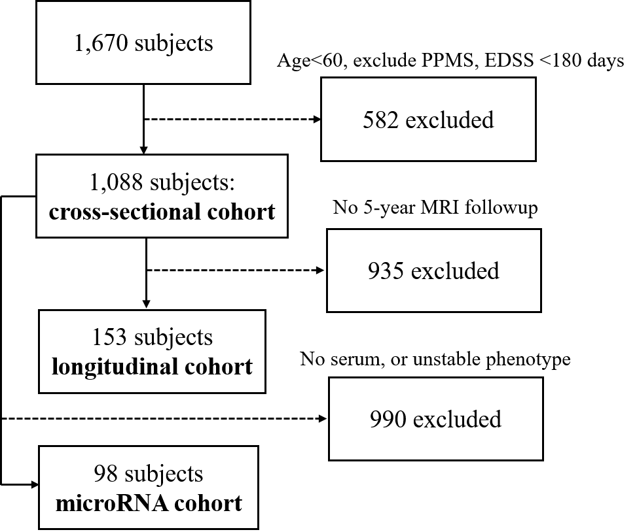
An overview of the multiple sclerosis subject selection process to identify the three cohorts; the number of excluded subjects and reasons for their exclusion are shown on the right and depicted by dotted lines. PPMS= primary progressive multiple sclerosis, EDSS = Expanded Disability Status Scale. MRI quality control included only specific, standardized acquisition protocols and manually-reviewed quantified data; subjects without a documented EDSS score and clinical visit within 180 days of their MRI scan were excluded as well. The microRNA cohort excluded patients without stored serum samples, or subjects who underwent an MRI phenotype change over a 2-year follow-up period.

Supplemental Figure 2: MRI Phenotype 5-year atrophy rates
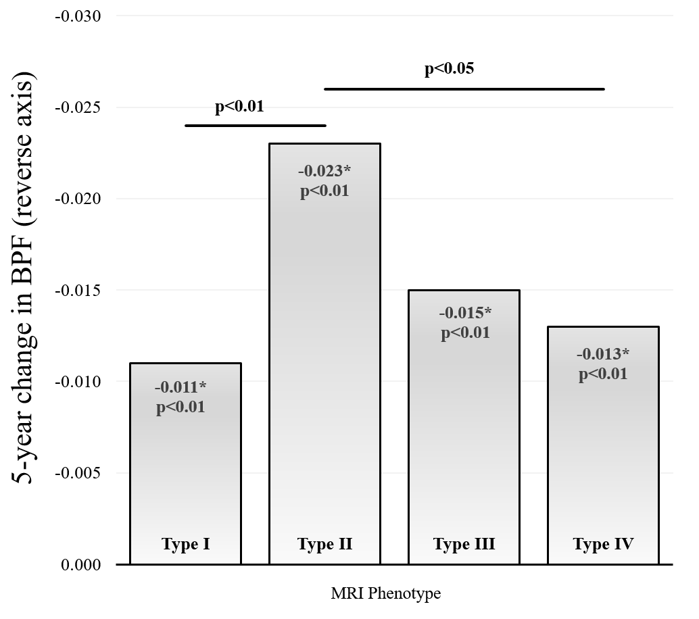
Solid lines represent significant between-phenotype comparisons as evaluated by linear mixed-effect models. Unlisted comparisons were not significant (p>0.05). Data in the figure represent absolute change. Within each phenotype group. The 5-year percent change was: Type I, -1.21%; Type II, -2.60%; Type III, -1.78%; Type IV, -1.63%.

Supplemental Figure 3: MRI Phenotype 5-year disability score changes
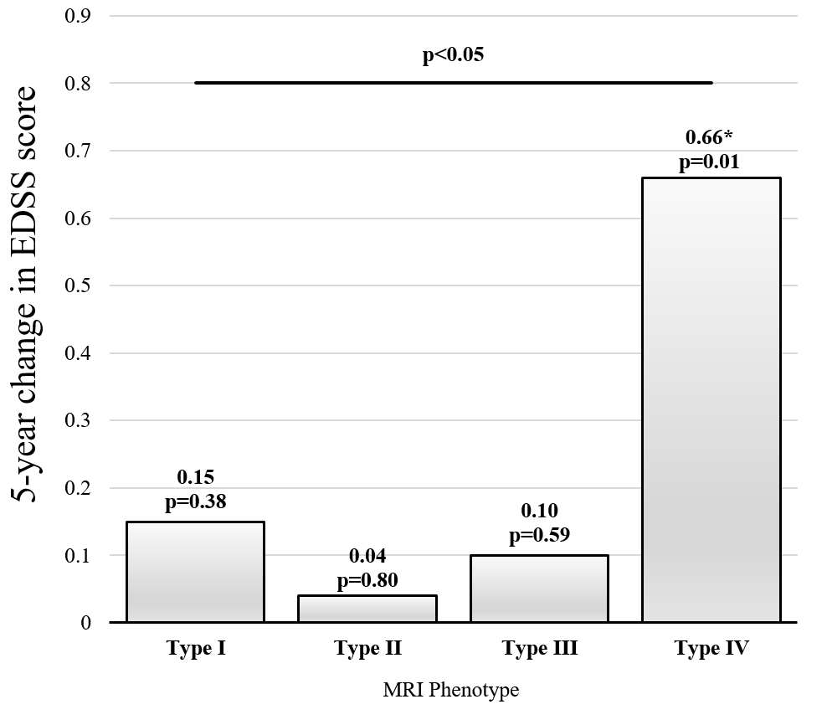
EDSS = Expanded Disability Status Scale. *=p<0.05; the Type IV group showed a significant change from baseline value as evaluated by a paired t-test (p=0.01). The solid line shows statistically significant pairwise phenotype comparison in 5-year change as evaluated by a linear mixed-effect model; all other pairwise comparisons were not significant (p>0.05).

Supplemental Figure 4: Heatmap of significant microRNAs
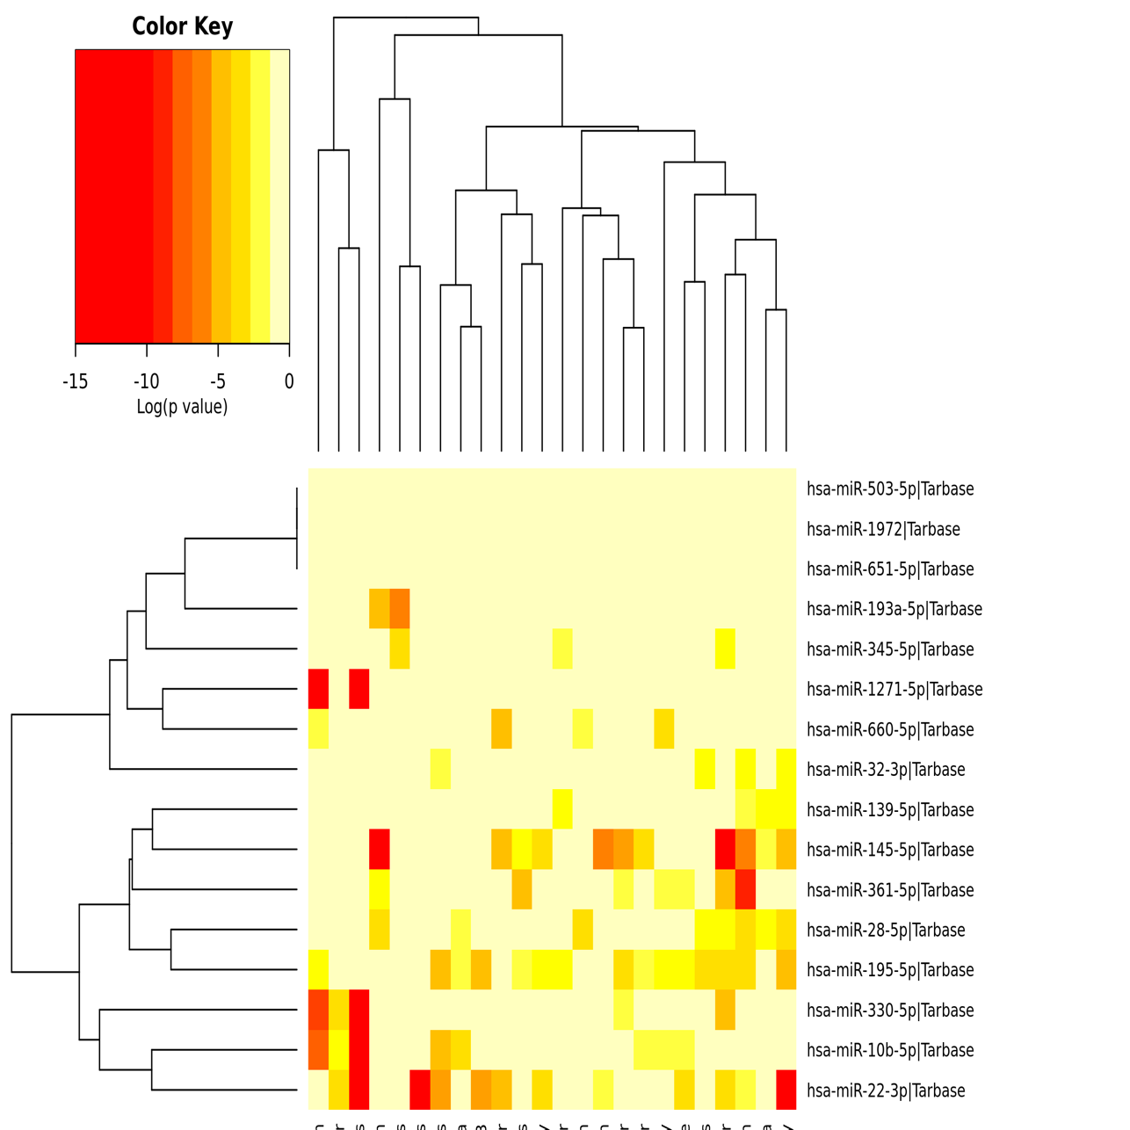
Pathways union heatmap of the 16 significant microRNAs (miRNAs) determined by analysis from DIANA miRPath v3.0 using TarBase 7.0²². Log-scaled colorized significance values are empirically based on KEGG pathway analysis. X-axis labels are the biological pathways associated with the miRNAs (y-axis). Multiple miRNAs are potentially involved in pathways related to MS including blood-brain barrier integrity and lymphocyte maturation. For example, extracellular matrix-receptor interactions (hsa-miR-361-5p, hsa-miR-145-5p, hsa-miR-28-5p, and hsa-miR-193a-5p), focal adhesion (hsa-miR-145-5p and hsa-miR-22-3p), adherens junction (hsa-miR-361-5p, hsa-miR-145-5p, hsa-miR-139-5p, hsa-miR-22-3p, hsa-miR-195-5p, hsa-miR-28-5p, and hsa-miR-32-3p), and TGF-beta signaling (hsa-miR-145-5p, hsa-miR-22-3p, hsa-miR-195-5p). We speculate further on mechanisms in the discussion section of this paper. Darker colors represent increased strength of association as denoted in the upper left color key.

Supplemental Figure 5: Depiction of MRI phenotypes
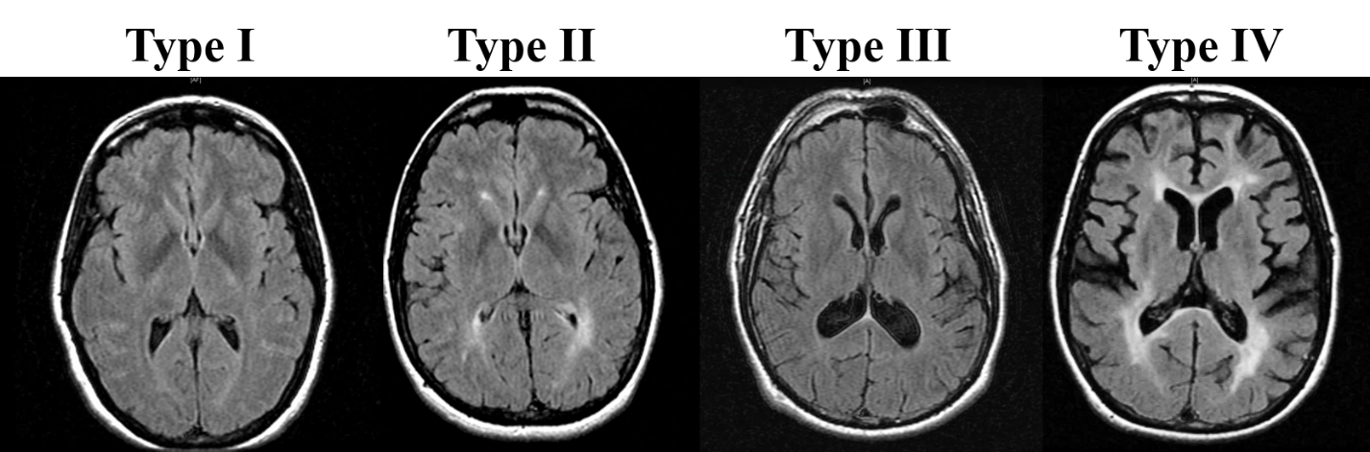
Archetypal axial T2 FLAIR examples of each MRI phenotype in age-matched patients with MS as classified by our criteria. Type I is defined as low atrophy and low T2LV (48 year-old woman); type II by low atrophy and high T2LV (43 year-old woman); type III by high atrophy and low T2LV (48 year-old man); and type IV by high atrophy and high T2LV (47 year-old woman). T2LV = brain T2 hyperintense lesion volume; FLAIR = Fluid-attenuated-inversion recovery.

