Technical appendix for Markov model
The Markov model stratifies the female cohort population in to six main categories, some of which are also stratified by whether the woman is infected with HSV-2 or not (signified by the hsv and nhsv subscript). At the start of the first time step (t=0) all women are receiving HSV-2 suppressive therapy and are either infected with HSV-2 or not (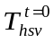and 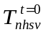 are the number of women in treatment). Over a specific time step, women receiving treatment can either remain in treatment, default from treatment, go on to antiretroviral therapy (ART) because their CD4 count has become <200cells/μL, or die. If a woman enters the defaulters class in time step 'k' then they may return to treatment in the next time step 'k+1'. Otherwise, women in the defaulters class (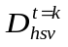and 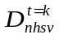) remain there until they die or their CD4 count becomes <200cells/μL. These women do not go on to ART. When a woman enters the 'dead' state (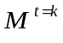) or one of the 'CD4<200cells/μL' states (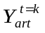if on ART and 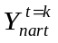 if not on ART) then they remain there (‘end states’ of the model).

The Markov model was used to estimate the impact of HSV-2 suppressive therapy on the rate at which HIV and HSV-2 co-infected women have their first CD4 count <200cells/μL or rate of HIV-related death. The model assumed that HIV and HSV-2 co-infected women, when not on HSV-2 therapy, have an increased rate of progressing to CD4 count <200cells/μL and HIV-related death compared to HSV-2-uninfected women (by factors RR_{μ} and RR_{η}). HSV-2 suppressive therapy was then assumed to decrease these rates by relative proportions ε_{μ} and ε_{η}. To produce conservative cost-effectiveness projections, the factors RR_{μ} and RR_{η} were assumed to be equivalent to the decrease resulting from HSV-2 suppressive therapy (relative decreases ε_{μ} and ε_{η}).

A flow diagram for the model is shown in Figure 1 and the equations for the different state variables at time t=k+1 are shown in equations 1 with all previously undefined parameters given in Appendix table 1.

Appendix Figure 1: Flow diagram of Markov model. The hatched box encloses the end states of the Markov model.
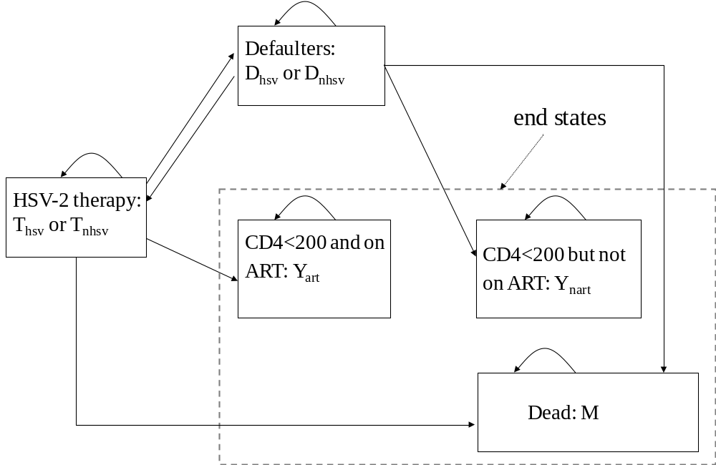
Table 1: Parameter definitions
Parameter definition | Model parameter
Probability of defaulting from HSV-2 suppressive therapy in next time step | d
Probability that return to treatment from defaulting in next time step | δ
Probability that CD4 count goes below 200cells/μL in next time step without effect of HSV-2 suppressive therapy (average over all women in cohort) | μ
Probability that die due to HIV in next time step without effect of HSV-2 suppressive therapy (average over all women in cohort) | η
Factor increase in probability of CD4 count going below 200cells/μL if have HSV-2 | RR_{μ}
Factor increase in probability of HIV related death if have HSV-2 | RR_{η}
Efficacy of HSV-2 suppressive therapy in:
Decreasing the probability that CD4 count goes below 200cells/μL | ε_{μ}
Decreasing the probability of HIV-related death | ε_{η}
Prevalence of HSV-2 amongst women in the cohort at start of intervention | 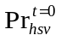
Number of new defaulters occurring in time step t=k-1 to t=k, with HSV-2 or not, that have not died or their CD4 count gone below 200cells/μL by time t=k+1 | 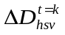 and 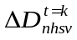

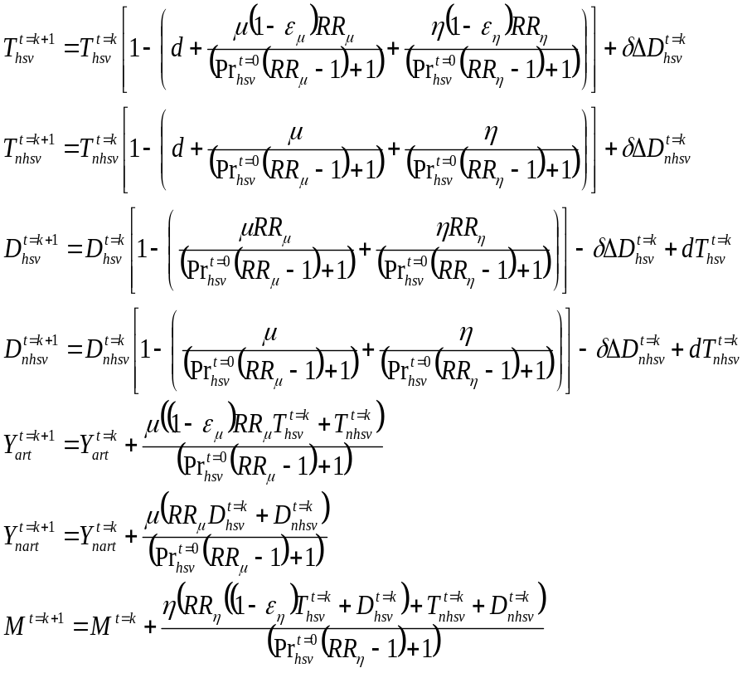
, Equations 1
Where and are calculated as below:
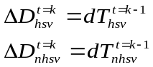
Equations 2
Estimating the life years gained
The number of life years that the women are in the cohort at time k+1 is defined as 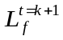 and is estimated as follows:
, Equation 4
where 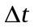is the length of each time step in years. To estimate the life years gained at time k+1 due to using HSV-2 suppressive therapy, the number of life years for when the HSV-2 suppressive treatment effect is not included is subtracted from the estimated number of life years for when the treatment effect is included. Additional life years are also added for those women that are still alive when they leave the cohort, with more life years being given to those on ART.

Appendix figure 2 Effect on the incremental impact achieved due to more women initiating ART of uncertainty in the factor decrease in the default rate when on HSV-2 suppressive treatment and the degree to which the default tracer returns women to the intervention.
1a: Effect of factor increase in default rate when not on HSV-2 suppressive treatment
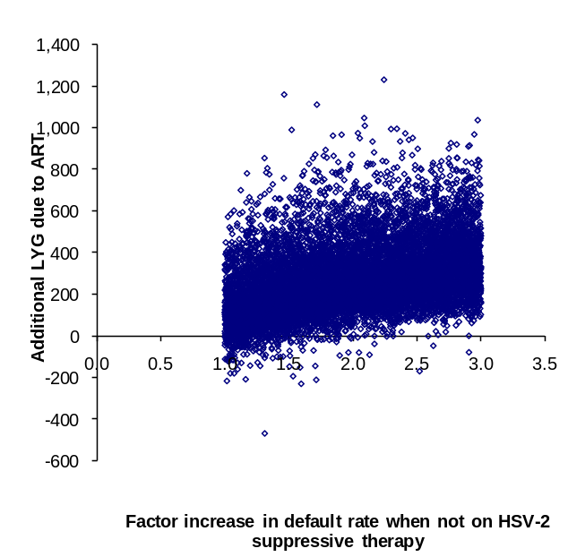
1b. Effect of degree to which the default tracer returns women to the intervention


