The potential impact of a gel-based point-of-sex intervention in reducing gonorrhoea incidence among gay and bisexual men: a modelling study
Michael W. Traeger§, Tom Tidhar, Martin Holt, Chris Williams, Edwina J. Wright, Mark A. Stoové, Nick Scott, Margaret E. Hellard.

Supplementary Materials
Contents
Supplementary Table 1: Model parameters and references for parameters 2
Supplementary Methods 1: Population sizes 4
Supplementary Methods 2: Gonorrhea testing rate 5
Supplementary Methods 3: Condom use 6
Supplementary Methods 4: Condom effectiveness, gonorrhoea symptomatic rate and sexual mixing 7
Supplementary Methods 5: Gonorrhoea risk groups 9
Supplementary Figure 1: Model inputs for the HIV care cascade 10
Supplementary Figure 2: HIV model calibration. 10
Supplementary Figure 3. Projected gonorrhoea incidence among Victorian GBM from 2007 to 2025 by subpopulation 12
Supplementary Figure 4: Projected gonorrhoea prevalence by HIV status 13
Supplementary Table 2: HIV model calibration data 14
Supplementary Table 3: Proportion of HIV-negative GBM classified as PrEP users. 15
Supplementary Table 4: Gonorrhoea model calibration data 16
Supplementary Figure 5: Sensitivity analysis (force of infection) model fit 17
Supplementary Table 5: Sensitivity analysis (force of infection) results 17
Supplementary Table 6. Sensitivity analysis (parameters) results 18
Supplementary Figure 6: Sensitivity analysis, cumulative gonorrhoea incidence 19
Supplementary Figure 7: Sensitivity analysis, relative reduction in cumulative gonorrhoea incidence 20
Supplementary Methods 6: Model equations 21
Supplementary References 24

Supplementary Table 1: Model parameters and references for parameters
Parameter | Value | Reference/comment
HIV parameters
Effectiveness of latex condoms at preventing HIV | 91% | Estimated condom effectiveness during anal sex between men in two prospective cohort studies [S1]
Effectiveness of latex condoms at preventing gonorrhoea | 75% | Conservative estimate (Supplementary Methods 4)
Effectiveness of PrEP at preventing HIV transmission | 99% | US CDC PrEP effectiveness estimate [S2]
Reduction in HIV infectiousness when on treatment | 100% | Reduction in HIV transmission from Opposites Attract study [S3]
Gonorrhoea parameters
Duration of exposed stage for symptomatic individuals | 5 days | [S4]
Duration of treatment | 7 days | Australian STI guidelines recommend abstaining from sex for 7 days post treatment [S5]
Proportion of GBM with gonorrhoea who are symptomatic | 29% | Calculated from ACCESS study data. Proportion diagnosed with either rectal infection only or including urethral infection, and corresponding probabilities of being symptomatic  (Supplementary Methods 4)
Increased gonorrhoea risk for high-risk GBM | 7.5 | Estimated from the PrEPX study [S6] (Supplementary Methods 6)
Proportion of GBM at high-risk of gonorrhoea | 13%
Gonorrhoea testing frequency
HIV-negative GBM on PrEP | 1/90 days | Australian PrEP guidelines recommend quarterly testing [S7]
HIV-negative GBM not on PrEP | 1/224 days | Previous analysis of Victorian GBM in ACCESS data [S8]
HIV-positive GBM | 1/133 days | Previous analysis of Victorian GBM in ACCESS data [S8]
Sexual risk parameters
Proportion of HIV serodiscordant sex acts (HIV-negative non-PrEP) | 10% | Estimated from large cross-sectional survey of GBM [S9]
Proportion of HIV serodiscordant sex acts (HIV-negative PrEP users) | 17%
Proportion of HIV serodiscordant sex act (HIV-positive) | 34%
Relative condom use of GBM on PrEP and HIV-positive GBM compared to HIV-negative GBM not on PrEP | 0.3 | Estimated from Melbourne Gay Community Period Survey 2019 [S10]
S1. Smith DK, Herbst JH, Zhang X, Rose CE. Condom effectiveness for HIV prevention by consistency of use among men who have sex with men in the United States. JAIDS Journal of Acquired Immune Deficiency Syndromes 2015; 68(3): 337-44.
S2. Effectiveness of Prevention Strategies to Reduce the Risk of Acquiring or Transmitting HIV. Vol. 2019: Centres for Disease Control and Prevention, 2019.
S3. Bavinton BR, Pinto AN, Phanuphak N, et al. Viral suppression and HIV transmission in serodiscordant male couples: an international, prospective, observational, cohort study. The Lancet HIV 2018; 5(8): e438-e47.
S4. Shim BS. Current concepts in bacterial sexually transmitted diseases. Korean J Urol 2011; 52(9): 589-97.
S5. Templeton DJ, Read P, Varma R, Bourne C. Australian sexually transmissible infection and HIV testing guidelines for asymptomatic men who have sex with men 2014: a review of the evidence. Sex Health 2014; 11(3): 217-29.
S6. Traeger MW, Cornelisse VJ, Asselin J, et al. Association of HIV Preexposure Prophylaxis With Incidence of Sexually Transmitted Infections Among Individuals at High Risk of HIV Infection. JAMA 2019; 321(14): 1380-90.
S7. Wright E, Grulich A, Roy K, et al. Australasian Society for HIV, Viral Hepatitis and Sexual Health Medicine HIV pre-exposure prophylaxis: clinical guidelines. J Virus Erad 2017; 3(3): 168-84.
S8. Wilkinson AL, Scott N, Tidhar T, et al. Estimating the syphilis epidemic among gay, bisexual and other men who have sex with men in Australia following changes in HIV care and prevention. Sex Health 2019; 16(3): 254-62.
S9. Wang L, Moqueet N, Lambert G, et al. Population-Level Sexual Mixing By HIV Status and Pre-exposure Prophylaxis Use Among Men Who Have Sex with Men in Montreal, Canada: Implications for HIV Prevention. Am J Epidemiol 2019.
S10. Broady T, Mao L, Bavinton B, et al. Gay Community Periodic Survey: Melbourne 2019. Sydney: Centre for Social Research in Health, UNSW Sydney.

Supplementary Methods 1: Population sizes
The size of the GBM population living in Victoria in 2006 was estimated at 42,000 [S11] and increased at a rate of 2.5% per year in line with Victorian population growth. The annual population size of GBM living with HIV in Victoria was estimated as the total GBM population multiplied by an HIV prevalence of 7.2% [S12]. Annual HIV notifications among GBM were calibrated from 2010 to 2018, with 233, 194 and 155 HIV notifications in Victoria with male-to-male sex as the exposure category in 2016, 2017 and 2018 respectively ([S13]; Supplementary Table 2). The annual number of HIV notifications from 2019 onwards was kept as constant at 155. The proportion of HIV-negative GBM in the model using PrEP between 2009 and 2019 was derived from routine behavioural surveillance of Australian gay and bisexual men [S10] (Supplementary Table 3). PrEP became publically subsidised in April 2018, and the proportion of GBM in the model using PrEP was assumed to remain constant from 2019 onwards. Scenarios of further PrEP uptake post-2019 were explored in sensitivity analyses (Supplementary Table 5).

Supplementary Methods 2: Gonorrhea testing rate
Gonorrhoea testing rate was estimated from data from the Australian Collaboration for Coordinated Enhanced Sentinel Surveillance (ACCESS) project. ACCESS is a government-funded, national STI surveillance network which routinely extracts de-identified clinical data from sexual health clinics and diagnostic laboratories in each Australian state and territory [S14]. Gonorrhoea testing rate was a constant parameter for each subpopulation (HIV-negative on PrEP, HIV-negative not on PrEP, HIV-positive), and reflected the mean number of days between asymptomatic gonorrhoea tests among each subpopulation. Gonorrhea testing rate for GBM using PrEP in the model was every three months, as Australian PrEP guidelines outline quarterly testing for bacterial STIs for all GBM using PrEP [S7]. The average testing frequency for HIV-negative GBM not using PrEP (1.6 tests per year) and HIV-positive GBM (2.7 tests per year) was estimated from previous analysis of ACCESS surveillance data [S8].

Supplementary Methods 3: Condom use
Condom use was included as a time-varying parameter for each subpopulation (HIV-negative on PrEP, HIV-negative not on PrEP, HIV-positive) which reflected the proportion of each population using condoms consistently with casual partners. Consistent condom use among HIV-negative non-PrEP users was estimated as the proportion of GBM in self-reported behavioural surveillance data reporting anal sex with casual partners in the last 6 months who always used a condom with casual partners, and steadily decreased from 44% in 2010 to 29% in 2019 [S10, 15]. Consistent condom use among PrEP users and HIV-positive GBM was estimated to be 0.3 times that of HIV-negative GBM not on PrEP [S16]. Although condom use is likely to continue to decrease among the GBM population in the future, condom use was held constant in the model from 2019 onwards, (except for reductions resulting from the introduction of the gel-PSI intervention, described below), in order to produce a conservative estimate of the benefit of gel-PSI introduction given the scenario of maintaining current levels of condom use. This was explored in sensitivity analysis.
The model population and equations were not explicitly stratified by condom use (non-condom user and condom users) as this would require significant assumptions to be made about different testing practices, sexual mixing and PrEP use among condom and non-condom users.

Supplementary Methods 4: Condom effectiveness, gonorrhoea symptomatic rate and sexual mixing
Condom effectiveness: The effectiveness of condoms in reducing HIV transmission among GBM was taken from a study which estimated the per partner effectiveness of condoms using data from four cohorts of GBM to be 91% [S17]. As we did not model site-specific gonorrhoea transmission, and as there are limited estimates for the effectiveness of condoms in reducing transmission risk of gonorrhoea in GBM, we chose to set effectiveness of condoms in reducing gonorrhoea transmission as 75%. This is likely an overestimate for the per partner effectiveness of condoms in reducing gonorrhoea transmission risk, however was chosen as a conservative estimate; different effectiveness levels were explored in sensitivity analyses.
Gonorrhoea symptomatic rate: The proportion of gonorrhoea infections (any site) which were symptomatic was set as 39%, and was calculated using ACCESS data on site-specific rates of gonorrhoea among Victorian GBM and corresponding symptomatic rates [S18, 19]. Given that we did not model site-specific gonorrhoea infections, the proportion of gonorrhea-infected individuals who were symptomatic in the model (39%) was estimated based on a combination of site-specific diagnosis data and the chance of infection being symptomatic at each site. The parameter was calculated as the proportion of GBM visiting Victorian sentinel surveillance sites in ACCESS diagnosed with gonorrhoea between 2016 and 2018 who had a urethral infection (24%) plus the proportion who had a rectal infection without urethral infection, each multiplied by the respective estimated chance of symptomatic presentation for infection at that site (89% for urethral infections [S18], 24% for rectal infections [S19]).
Sexual mixing: Sexual mixing was incorporated in the gonorrhoea model by including a parameter for each subpopulation (HIV-negative on PrEP, HIV-negative not on PrEP and HIV-positive) which represented the proportion of sex acts which were serodiscordant. Proportion of sex acts which were serodiscordant were estimated from a published study on sexual mixing among GBM [S9] and were set at 17% for HIV-negative PrEP users, 10% for HIV-negative non-PrEP users and 35% for HIV-positive individuals (model equations are provided in the supplementary material). Sexual mixing in the gonorrhoea model was explored in sensitivity analysis. It was not necessary to include a sexual mixing paramter in the HIV model, as HIV tranmission could only occur between HIV-positive (non-virally supressed) and HIV-negative individuals. The force of HIV infection is influeced by: average condom use among HIV-negative population, PrEP coverage in the HIV-negative population, and HIV prevalence (excluding virally supressed individuals) among the entire population.

Supplementary Methods 5: Gonorrhoea risk groups
We estimated the proportion of GBM belonging to the high and low gonorrhoea risk groups using data published from the PrEPX study, a large, multisite PrEP intervention study which ran from July 2016 to March 2018 and provided more than 4,200 Victorian GBM access to PrEP prior to public subsidy of PrEP in April 2018 [S20]. Analysis of STI diagnoses among PrEPX participants found that STIs were highly concentrated among a subgroup of men experiencing repeat infections, with 53% of diagnoses concentrated among 13% of participants [S6]. We considered participants diagnosed with two or more STIs during the PrEPX study (13%) as at high gonorrhoea-risk. To estimate the relative increase in force of infection for gonorrhoea in the high gonorrhoea-risk group compared to the low gonorrhoea-risk group in the model, we used the relative increase in the ratio of STI diagnoses to participants among the high-risk group in PrEPX (52% of STIs among 13% of participants) compared to the ratio of STI diagnoses to participants among the low-risk group in PrEPX (48% of STIs among 87% of participants). This equated to an increased risk factor of 7.5. This was also explored in sensitivity analyses.

Supplementary Figure 1: Model inputs for the HIV care cascade

Supplementary Figure 2: HIV model calibration.

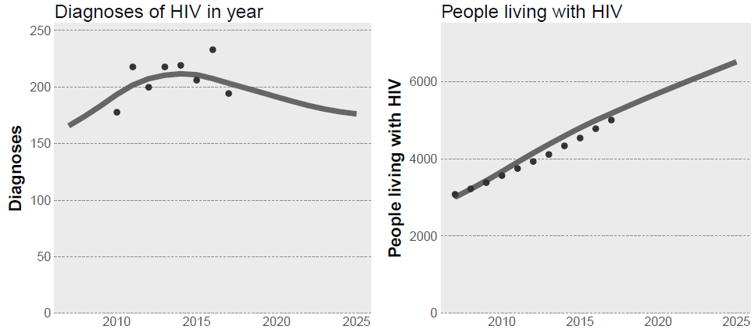
Left: annual HIV diagnoses among GBM in Victoria versus the calibrated model projections. Right: estimated HIV-positive GBM in Victoria versus the calibrated model projection.
Calibration of the HIV model to the data was reasonably accurate. Changes in diagnoses (left), including the slight decrease over the projection period (2019-2025), were largely driven by improvement to the care cascade (Supplementary Figure 1, left) and increasing PrEP coverage (Supplementary Figure 1, right), which led to a decreasing population-level viral load and suseptible population, and reduced number of incident cases.
In Victoria, estimates suggest that HIV prevalence among GBM has remained stable over time (~7.2%), however the total GBM population size has been increasing, in line with general population growth. Therefore, the HIV model is dynamic, with force of infection calibrated to produce new HIV infections at a rate sufficient to maintain a stable HIV prevalence among an increasing population.

Supplementary Figure 3. Projected gonorrhoea incidence among Victorian GBM from 2007 to 2025 by subpopulation
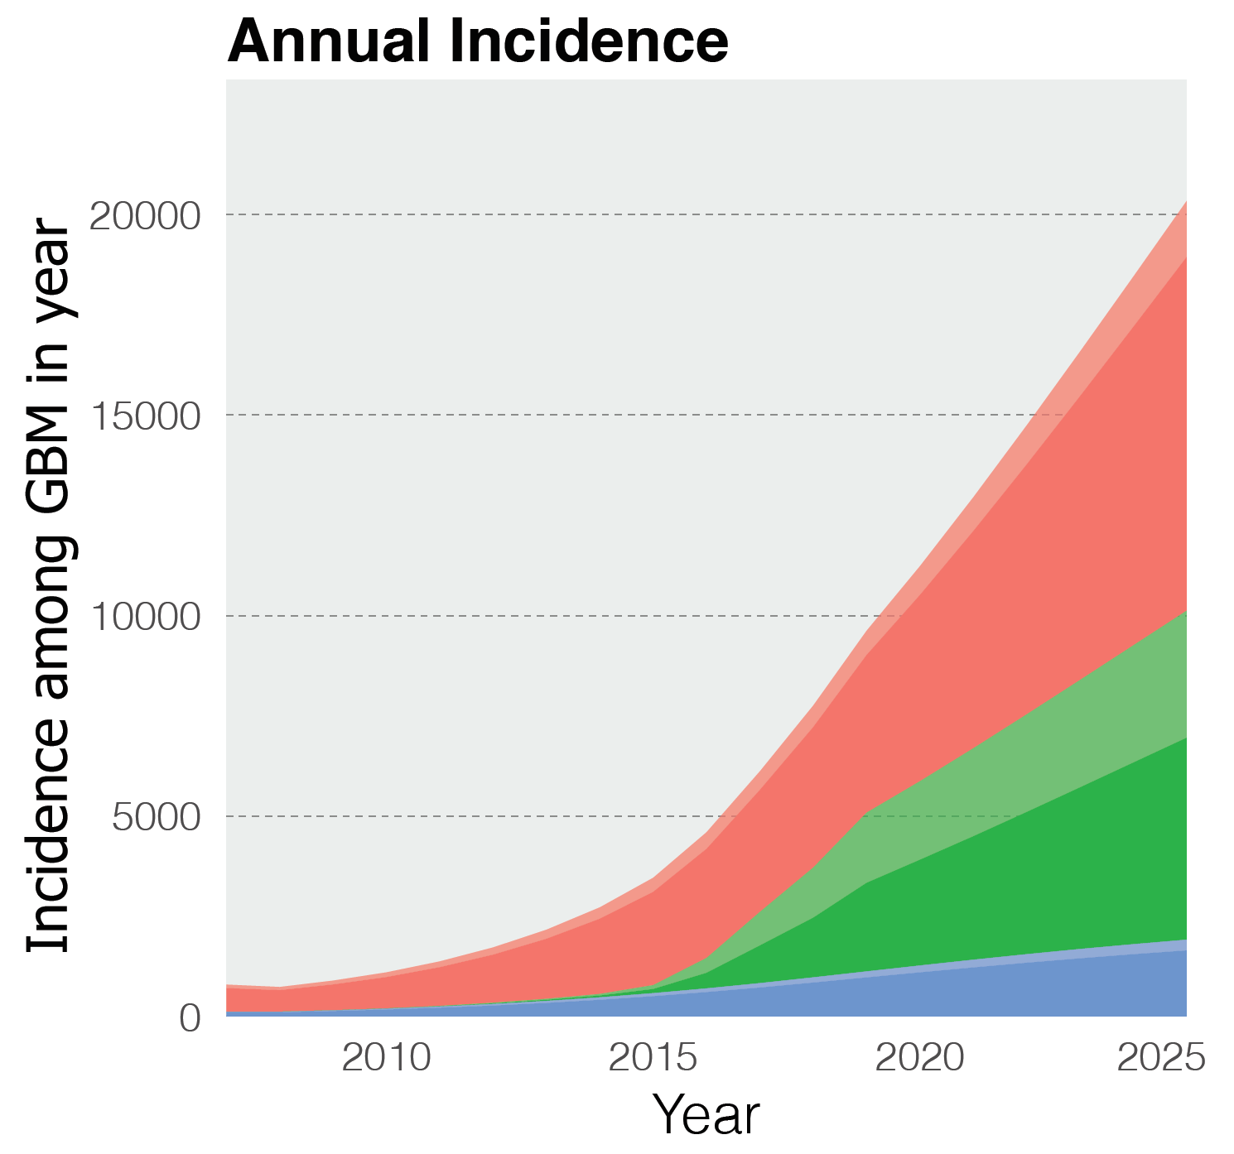
Dark-shaded areas reflect number of incidence infections attributable to those categorised as ‘high gonorrhoea risk’ in the model.

Supplementary Figure 4: Projected gonorrhoea prevalence by HIV status
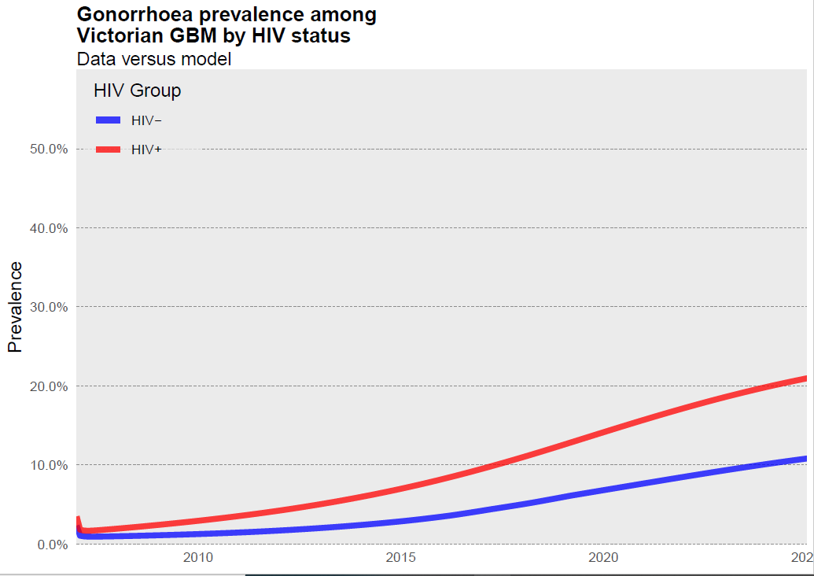

Supplementary Table 2: HIV model calibration data
Year | VICTORIAN GBM POPULATION SIZEª | Annual HIV diagnoses^{b} | Total GBM WITH HIV^{c}
2007 | 42714 |  | 3075
2008 | 44850 |  | 3229
2009 | 47092 |  | 3391
2010 | 49447 | 178 | 3560
2011 | 51919 | 218 | 3738
2012 | 54515 | 200 | 3925
2013 | 57241 | 218 | 4121
2014 | 60103 | 219 | 4327
2015 | 63108 | 206 | 4544
2016 | 66263 | 233 | 4771
2017 | 69577 | 194 | 5010
ª Estimated to be 42,000 in Victoria in 2006 [S11], assuming annual growth rate of 5%
^{b} Victorian Department of Health notification data [S13] (number of notified cases of HIV by exposure category “male-to-male sex”)
^{c} Calculated based on estimated average 7.2% HIV prevalence among GBM [S13]
[S21]

Supplementary Table 3: Proportion of HIV-negative GBM classified as PrEP users.
Year | Proporttion of HIV-negative GBM classified as PrEP usersª
2007 | 0%
2008 | 0%
2009 | 0%
2010 | 0%
2011 | 0%
2012 | 0%
2013 | 0%
2014 | 0%
2015 | 1.9%
2016 | 5.7%
2017 | 17.9%
2018 | 21.8%
2019 | 30.4%
ªTaken from the Gay Community Periodic Survey: Melbourne 2019[S10]

Supplementary Table 4: Gonorrhoea model calibration data
Year | Annual gonorrhoea notifications among GBM in victoriaª | Annual gonorrhoea diagnoses among HIV-negative ^{b} | Annual gonorrhoea diagnoses among HIV-positive ^{b}
2007 | 989 | 545 | 112
2008 | 927 | 511 | 105
2009 | 1491 | 822 | 168
2010 | 1755 | 968 | 198
2011 | 1885 | 1039 | 213
2012 | 2561 | 1412 | 289
2013 | 3234 | 1783 | 365
2014 | 3266 | 1801 | 369
2015 | 4902 | 2702 | 554
2016 | 6321 | 3485 | 714
2017 | 7352 | 4248 | 635
2018 | 8026 | 4638 | 693
ª Taken from the National Notifiable Diseases Surveillance System, available from the Australian Government Department of Health website [REF]. Adjusted for the proportion of notifications that were among males (81%)[S22], the proportion of notifications among males where the men reported sex with other men as a risk factor (82%)[S22]
^{b} Estimated from the proportion of notifications that were among people with HIV (17%) [S23].

Supplementary Figure 5: Sensitivity analysis (force of infection) model fit
Annual gonorrhoea notifications among gay and bisexual men in Victoria (dots) versus calibrated model projections (lines) for HIV-negative (blue) and HIV-positive (red) gay and bisexual men, with force of infection held constant from 2018 onwards, rather than being dynamic and dependent on gonorrhoea prevalence. Note that increases in notifications are driven by increases in population size.

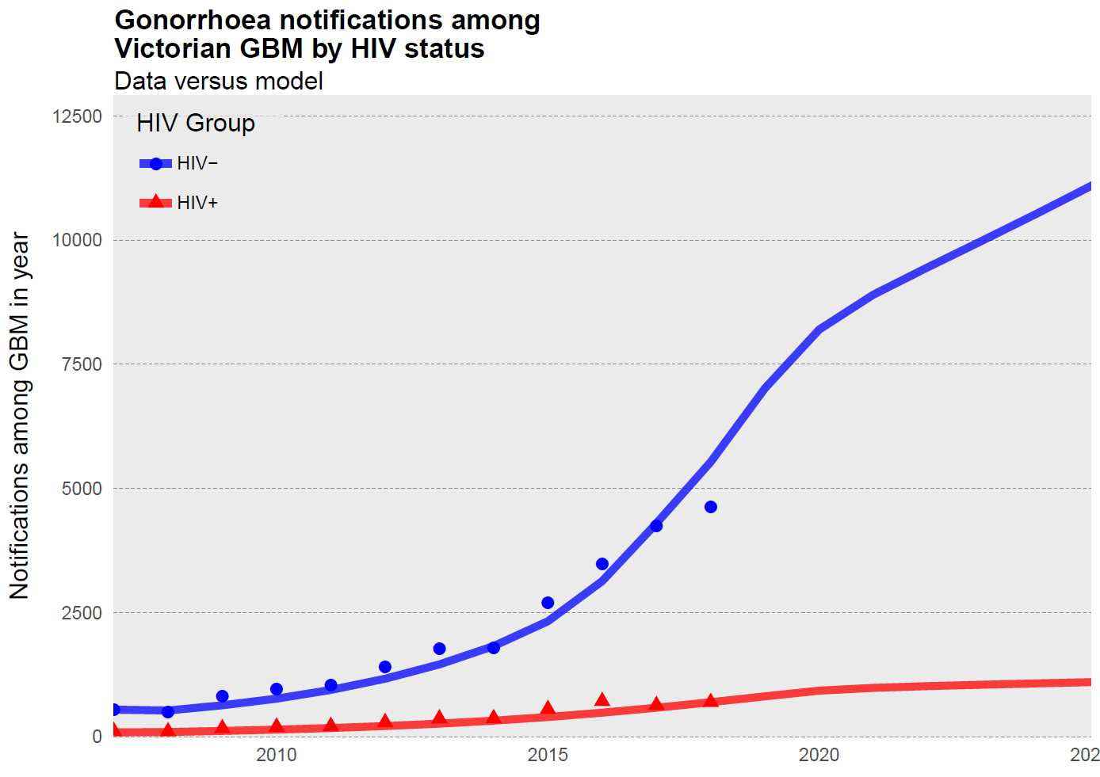

Supplementary Table 5: Sensitivity analysis (force of infection) results
Cumulative gonorrhoea incidence among Victorian GBM from 2020 to 2025 across different model scenarios of uptake of a gel-based point-of-sex intervention according to HIV-status, PrEP use and condom use, with force of infection held constant from 2018 onwards.
 | Scenario | Cumulative incidence 2020 - 2025 | Difference in cumulative incidence to status quo | Relative reduction in cumulative incidence
 | Status quo (no gel-PSI uptake) | 73780
a | Uptake in all subpopulations up to 50% threshold* | 51204 | -22576 | -31%
b | 50% of condom users downgrade and 50% of non-condom users upgrade | 65788 | -7992 | -11%
c | All condom users downgrade to gel-PSI | 78167 | 4387 | 6%
d | All PrEP users switch to gel-PSI | 66090 | -7690 | -10%
e | 50% of PrEP users and HIV-positive GBM switch to gel-PSI | 69136 | -4644 | -6%
f | 50% of non-PrEP users switch to gel-PSI | 70360 | -3420 | -5%

Supplementary Table 6. Sensitivity analysis (parameters) results
Changes in projected cumulative gonorrhoea notifications among Victorian GBM from 2018-2025 and relative reduction in gonorrhoea notifications with gel-PSI uptake by varying values for models parameters included in sensitivity analysis.
Parameter | Parameter estimate used in model | Sensitivity value | Cumulative gonorrhoea notifications 2020-2025 (no gel-PSI uptake) | Cumulative gonorrhoea notifications 2018-2025 (Model Scenario B: 50% gel-PSI uptake and 40% gel-PSI efficacy) | Difference in cumulative notifications | Proportion reduction
No sensitivity parameters altered |  |  | 94367 | 72559 | -21808 | -23.11
Condom effectiveness for gonorrhoea | 75% | 50% | 86052ª | 63558 | -22494 | -26.14
Condom effectiveness for gonorrhoea | 75% | 100% | 104771ª | 84389 | -20382 | -19.45
PrEP coverage among HIV-negative GBM from 2020 to2025 | 30% | 50% at 2025 | 99450 | 75014 | -24436 | -24.57
PrEP coverage among HIV-negative GBM from 2020 to2025 | 30% | 75% at 2025 | 105741 | 77881 | -27860 | -26.35
NG symptomatic rate | 45% | 25% | 131778 | 102789 | -28989 | -22.00
NG symptomatic rate | 45% | 75% | 64590 | 48969 | -15621 | -24.18
Increased risk factor of high-risk group | 7.5 | 2 | 83164 | 63177 | -19987 | -24.03
Increased risk factor of high-risk group | 7.5 | 10 | 96673 | 74951 | -21722 | -22.47
Increased risk factor of high-risk group | 7.5 | 20 | 100290 | 79611 | -20679 | -20.62
Sexual mixing | Model mixing^{b} | No serodiscordant sex acts | 92523 | 71447 | -21076 | -22.78
Sexual mixing | Model mixing^{b} | 50% of sex acts serodiscordant | 89762 | 68656 | -21106 | -23.51
Sexual mixing | Model mixing^{b} | Mix at random (no serosorting) | 93982 | 72574 | -21408 | -22.78
Condom use among HIV-negative GBM not on PrEP from 2020-2025^{c} | Stays at 29% | Reduces to 15% by 2025 | 104934 | 77600 | -27334 | -26.05
Condom use among HIV-negative GBM not on PrEP from 2020-2025 ^{c} | Stays at 29% | Reduces to 5% by 2025 | 112887 | 81337 | -31550 | -27.95
Mean days between NG testing among non-PrEP users from 2020 to 2025 | Model testing rates | Reduced by 25% by 2025 | 76782 | 57352 | -19430 | -25.31
Mean days between NG testing among non-PrEP users from 2020 to 2025 | Model testing rates | Reduced by 50% by 2025 | 50796 | 36890 | -13906 | -27.38
ªGreater baseline projections for gonorrhoea incidence in sensitivity analysis with greater condom efficacy is a product of the method of calibration; with greater condom efficacy, the calibrated force of gonorrhoea infection is overestimated to fit the data points, leading to greater gonorrhoea incidence as condom use is decreased through the years 2020-2025
^{b}Proportion of sex acts which were HIV serodiscordant were estimated as 17% for HIV-negative PrEP users, 10% for HIV-negative non-PrEP users and 35% for HIV-positive individuals
^{c}Consistent condom use among HIV-negative GBM on PrEP and HIV-positive GBM was 0.3 times that of HIV-negative GBM not on PrEP

Supplementary Figure 6: Sensitivity analysis, cumulative gonorrhoea incidence
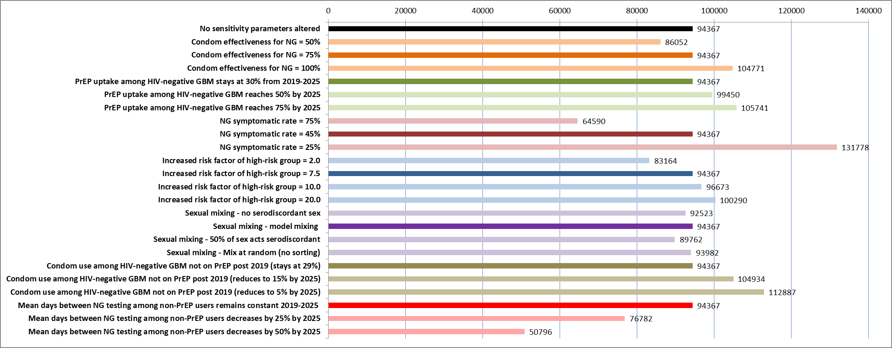
Number of cumulative gonorrhoea infections among Victorian gay and bisexual men between 2020 to 2025 (inclusive) under the scenario of no uptake of a gel point-of-sex intervention by different variations of specific parameters included in the model. Dark bars reflect parameter values used in the main model. Other parameters are kept constant for each sensitivity analysis.

Supplementary Figure 7: Sensitivity analysis, relative reduction in cumulative gonorrhoea incidence
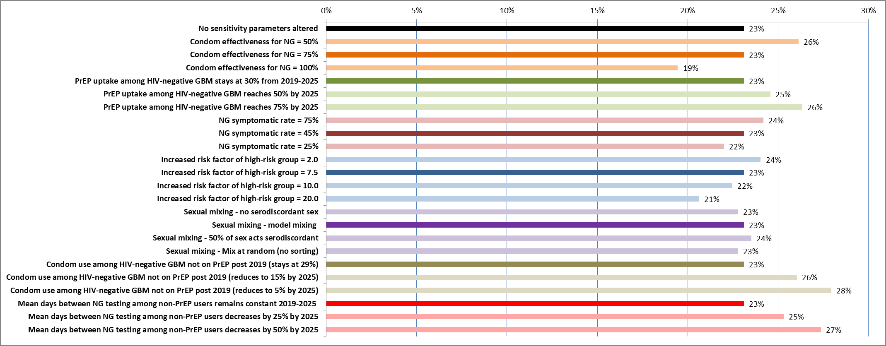
Relative reduction in cumulative number of gonorrhoea infections among Victorian gay and bisexual men between 2020 to 2025 (inclusive) between model Scenario B (50% gel-PSI uptake among condom and non-condom users with a gel-PSI efficacy of 40% for gonorrhoea risk reduction) and the base scenario of no gel-PSI uptake, by different variations of specific parameters included in the model. Dark bars reflect parameter values used in the main model. Other parameters are kept constant for each sensitivity analysis.

Supplementary Methods 6: Model equations
Define the following compartments and stratifications
$t=$time (implemented in monthly time steps)
$P\left(t\right)=$ total estimated GBM population size
$P^{+}(t), P^{-}(t),\hat{P^{-}}(t)=$ total model population size for HIV-positive, HIV-negative (no PrEP) and HIV-negative (PrEP) GBM respectively. Note that these are functions of time due to population growth.
$S^{+}(t), S^{-}(t),\hat{S^{-}}(t)=$ total size of the HIV-positive, HIV-negative (no PrEP) and HIV-negative (PrEP) susceptible for gonorrhoea compartments
$E^{+}(t), E^{-}(t),\hat{E^{-}}(t)=$ total size of the HIV-positive, HIV-negative (no PrEP) and HIV-negative (PrEP) exposed to gonorrhoea compartments
${Ia}^{+}(t), {Ia}^{-}(t),\hat{{Ia}^{-}}(t)=$ total size of the HIV-positive, HIV-negative (no PrEP) and HIV-negative (PrEP) infected with gonorrhoea, asymptomatic compartments
$T^{+}(t), T^{-}(t),\hat{T^{-}}(t)=$ total size of the HIV-positive, HIV-negative (no PrEP) and HIV-negative (PrEP) treatment compartments

i = subscript to indicate whether or not someone is at low or high risk of gonorrhoea (i=0 for low and i=1 for high). Note that for the HIV-negative non-PrEP and HIV-positive groups, the high and low risk groups for gonorrhoea were the same.

Define the following parameters
$β_{1}=1/$ average duration of gonorrhoea exposed period (5 days)
$β_{2}=$ proportion of gonorrhoea cases that are symptomatic
$β_{3}=1/$ gonorrhoea treatment duration (7 days)
$τ_{i}^{+},τ_{i}^{-},\hat{τ_{i}^{-}}=$1/average time between tests for HIV-positive, HIV-negative (no PrEP) and HIV-negative (PrEP) GBM.
$γ^{+},γ^{-},\hat{γ^{-}}=$fraction of HIV-positive, HIV-negative (no PrEP) and HIV-negative (PrEP) GBM are at high risk for gonorrhoea
$δ=$relative reduction in the risk of HIV infection for people with viral suppression
$δ_{P}=$relative reduction in the risk of HIV infection for people on PrEP
D(t) = fraction of people with HIV who are virally supressed
$μ=$ 1/average time at risk (assumed to be 50 years; 15-64 year olds)
$α_{1}=$ proportion of HIV serodiscordant sex acts among HIV-negative non-PrEP GBM
$α_{2}=$ proportion of HIV serodiscordant sex acts occurring among HIV-negative PrEP GBM
$α_{3}=$ proportion of HIV serodiscordant sex acts occurring among HIV-positive GBM
$Γ_{i}=$ additional risk factor for GBM at high-risk of gonorrhoea. Note that $Γ_{i}=1$ if i=0 (low risk is the reference)
$c^{+},c^{-},\hat{c^{-}}=$ average condom use among HIV-positive, HIV-negative (no PrEP) and HIV-negative (PrEP) GBM
$g^{+},g^{-},\hat{g^{-}}=$ average gel-based prevention use among HIV-positive, HIV-negative (no PrEP) and HIV-negative (PrEP) GBM
$ϵ_{c}=$ effectiveness of condoms
$ϵ_{g}=$ effectiveness of gel-based prevention at preventing gonorrhoea

Force of infection
Let $λ_{HIV}$ be the proportionality constant (determined in the calibration procedure) for the force of HIV infection. Then the force of infection for HIV among non-PrEP ($Θ^{-}$) and PrEP ($\hat{Θ^{-}}$) users is given by:
$$Θ^{-}=λ_{HIV}(1-ϵ_{c}c^{-})\frac{\left[\left(1-δ\right)D\left(t\right)+\left(1-D\left(t\right)\right)\right]P^{+}}{\left[P^{+}+P^{-}+\hat{P^{-}}\right]}$$
$$\hat{Θ^{-}}=λ_{HIV}δ_{P}(1-ϵ_{c}\hat{c^{-}})\frac{\left[\left(1-δ\right)D\left(t\right)+\left(1-D\left(t\right)\right)\right]P^{+}}{\left[P^{+}+P^{-}+\hat{P^{-}}\right]}$$

Let $λ^{+},λ^{-}, \hat{λ^{-}}$ be the proportionality constants (determined in the calibration procedure) for the force of gonorrhoea infection among HIV-positive, HIV-negative (no PrEP) and HIV-negative (PrEP) GBM respectively. The force of infection for gonorrhoea among these populations was modelled to account for condom use and mixing between HIV-positive and HIV-negative GBM populations:
$$Φ_{i}^{+}=λ^{+}Γ_{i}\left(1-{ϵ_{c}c}^{+}-{ϵ_{g}g}^{+}\right)\left(α_{3}\frac{Ia^{-}+I\hat{a^{-}}}{P^{-}+\hat{P^{-}}}+\left(1-α_{3}\right)\frac{Ia^{+}}{P^{+}}\right)$$
$$Φ_{i}^{-}=λ^{-}Γ_{i}\left(1-{ϵ_{c}c}^{-}-{ϵ_{g}g}^{-}\right)\left((1-α_{1})\frac{Ia^{-}+I\hat{a^{-}}}{P^{-}+\hat{P^{-}}}+α_{1}\frac{Ia^{+}}{P^{+}}\right)$$
$$\hat{Φ_{i}^{-}}=\hat{λ^{-}}Γ_{i}\left(1-ϵ_{c}\hat{c^{-}}-ϵ_{g}\hat{g^{-}}\right)\left((1-α_{2})\frac{Ia^{-}+I\hat{a^{-}}}{P^{-}+\hat{P^{-}}}+α_{2}\frac{Ia^{+}}{P^{+}}\right)$$

HIV-positive GBM differential equations
$$\frac{dS_{i}^{+}}{dt}=Θ^{-}S_{i}^{-}+\hat{Θ^{-}}\hat{S_{i}^{-}}-Φ_{i}^{+}S_{i}^{+}+β_{3}T_{i}^{+}-μS_{i}^{+}$$
$$\frac{dE_{i}^{+}}{dt}=Θ^{-}E_{i}^{-}+\hat{Θ^{-}}\hat{E_{i}^{-}}+Φ_{i}^{+}S_{i}^{+}-β_{1}E_{i}^{+}-μE_{i}^{+}$$
$$\frac{d{Ia}_{i}^{+}}{dt}=Θ^{-}{Ia}_{i}^{-}+\hat{Θ^{-}}\hat{{Ia}_{i}^{-}}+{β_{1}(1-β}_{2})E_{i}^{+}-τ_{i}^{+}{Ia}_{i}^{+}-μ{Ia}_{i}^{+}$$
$$\frac{dT_{i}^{+}}{dt}=Θ^{-}T_{i}^{-}+\hat{Θ^{-}}\hat{T_{i}^{-}}+{β_{1}β}_{2}E_{i}^{+}+{τ_{i}^{+}Ia}_{i}^{+}-β_{3}T_{i}^{+}-μT_{i}^{+}$$

HIV-negative (no PrEP) GBM differential equations
$$\frac{dS_{i}^{-}}{dt}=\frac{dP\left(t\right)}{dt}-Θ^{-}S_{i}^{-}-Φ_{i}^{-}S_{i}^{-}+β_{3}T_{i}^{-}-μS_{i}^{-}$$
$$\frac{dE_{i}^{-}}{dt}=-Θ^{-}E_{i}^{-}+Φ_{i}^{-}S_{i}^{-}-β_{1}E_{i}^{-}-μE_{i}^{-}$$
$$\frac{d{Ia}_{i}^{-}}{dt}=-Θ^{-}{Ia}_{i}^{-}+{β_{1}(1-β}_{2})E_{i}^{-}-τ_{i}^{-}{Ia}_{i}^{-}-μ{Ia}_{i}^{-}$$
$$\frac{dT_{i}^{-}}{dt}=-Θ^{-}T_{i}^{-}+{β_{1}β}_{2}E_{i}^{-}+{τ_{i}^{-}Ia}_{i}^{-}-β_{3}T_{i}^{-}-μT_{i}^{-}$$

HIV-negative (PrEP) GBM differential equations
$$\frac{d\hat{S_{i}^{-}}}{dt}=-\hat{Θ^{-}}\hat{S_{i}^{-}}-Φ_{i}^{-}\hat{S_{i}^{-}}+β_{3}\hat{T_{i}^{-}}-μ\hat{S_{i}^{-}}$$
$$\frac{d\hat{E_{i}^{-}}}{dt}=-\hat{Θ^{-}}\hat{E_{i}^{-}}+Φ_{i}^{-}\hat{S_{i}^{-}}-β_{1}\hat{E_{i}^{-}}-μ\hat{E_{i}^{-}}$$
$$\frac{d\hat{{Ia}_{i}^{-}}}{dt}=-\hat{Θ^{-}}\hat{{Ia}_{i}^{-}}+β_{1}(1-β_{2})\hat{E_{i}^{-}}-\hat{τ_{i}^{-}}\hat{{Ia}_{i}^{-}}-μ\hat{{Ia}_{i}^{-}}$$
$\frac{d\hat{T_{i}^{-}}}{dt}=-\hat{Θ^{-}}\hat{T_{i}^{-}}+β_{1}β_{2}\hat{E_{i}^{-}}+\hat{τ_{i}^{-}}\hat{{Ia}_{i}^{-}}-β_{3}\hat{T_{i}^{-}}-μ\hat{T_{i}^{-}}$

Supplementary References

S1. Smith DK, Herbst JH, Zhang X, Rose CE. Condom effectiveness for HIV prevention by consistency of use among men who have sex with men in the United States. JAIDS Journal of Acquired Immune Deficiency Syndromes 2015; 68(3): 337-44.
S2. Effectiveness of Prevention Strategies to Reduce the Risk of Acquiring or Transmitting HIV. Vol. 2019: Centres for Disease Control and Prevention, 2019.
S3. Bavinton BR, Pinto AN, Phanuphak N, et al. Viral suppression and HIV transmission in serodiscordant male couples: an international, prospective, observational, cohort study. The Lancet HIV 2018; 5(8): e438-e47.
S4. Shim BS. Current concepts in bacterial sexually transmitted diseases. Korean J Urol 2011; 52(9): 589-97.
S5. Templeton DJ, Read P, Varma R, Bourne C. Australian sexually transmissible infection and HIV testing guidelines for asymptomatic men who have sex with men 2014: a review of the evidence. Sex Health 2014; 11(3): 217-29.
S6. Traeger MW, Cornelisse VJ, Asselin J, et al. Association of HIV Preexposure Prophylaxis With Incidence of Sexually Transmitted Infections Among Individuals at High Risk of HIV Infection. JAMA 2019; 321(14): 1380-90.
S7. Wright E, Grulich A, Roy K, et al. Australasian Society for HIV, Viral Hepatitis and Sexual Health Medicine HIV pre-exposure prophylaxis: clinical guidelines. J Virus Erad 2017; 3(3): 168-84.
S8. Wilkinson AL, Scott N, Tidhar T, et al. Estimating the syphilis epidemic among gay, bisexual and other men who have sex with men in Australia following changes in HIV care and prevention. Sex Health 2019; 16(3): 254-62.
S9. Wang L, Moqueet N, Lambert G, et al. Population-Level Sexual Mixing By HIV Status and Pre-exposure Prophylaxis Use Among Men Who Have Sex with Men in Montreal, Canada: Implications for HIV Prevention. Am J Epidemiol 2019.
S10. Broady T, Mao L, Bavinton B, et al. Gay Community Periodic Survey: Melbourne 2019. Sydney: Centre for Social Research in Health, UNSW Sydney.
S11. Prestage G, Ferris J, Grierson J, et al. Homosexual men in Australia: population, distribution and HIV prevalence. Sex Health 2008; 5(2): 97-102.
S12. Holt M, Lea T, Asselin J, et al. The prevalence and correlates of undiagnosed HIV among Australian gay and bisexual men: results of a national, community-based, bio-behavioural survey.
S13. HIV in Victoria - surveillance report for April-June 2018. Melbourne: Department of Health and Human Services, Victorian Government, 2018.
S14. Callander D, Moreira C, El-Hayek C, et al. Monitoring the Control of Sexually Transmissible Infections and Blood-Borne Viruses: Protocol for the Australian Collaboration for Coordinated Enhanced Sentinel Surveillance (ACCESS). JMIR Res Protoc 2018; 7(11): e11028.
S15. Lee E, Mao L, McKenzie T, et al. Gay Community Periodic Survey: Melbourne 2016. Sydney: Centre for Social Research in Health, UNSW Australia.
S16. Holt M, Lea T, Mao L, et al. Adapting behavioural surveillance to antiretroviral-based HIV prevention: reviewing and anticipating trends in the Australian Gay Community Periodic Surveys. Sex Health 2017; 14(1): 72-9.
S17. Johnson WD, O'Leary A, Flores SA. Per-partner condom effectiveness against HIV for men who have sex with men. AIDS 2018; 32(11): 1499-505.
S18. Ong JJ, Fethers K, Howden BP, et al. Asymptomatic and symptomatic urethral gonorrhoea in men who have sex with men attending a sexual health service. Clin Microbiol Infect 2017; 23(8): 555-9.
S19. Barbee LA, Dombrowski JC, Kerani R, Golden MR. Effect of nucleic acid amplification testing on detection of extragenital gonorrhea and chlamydial infections in men who have sex with men sexually transmitted disease clinic patients. Sexually transmitted diseases 2014; 41(3): 168-72.
S20. Ryan KE, Mak A, Stoové M, et al. Protocol for an HIV Pre-exposure Prophylaxis (PrEP) Population Level Intervention Study in Victoria Australia: The PrEPX Study. Front Public Health 2018; 6: 151.
S21. HIV, viral hepatitis and sexually transmissible infections in Australia: Annual surveillance report 2018. Sydney: Kirby Institute, University of New South Wales 2018.
S22. Victorian Prevention, Epidemiology & Surveillance Fact Sheet: Sexually Transmissible Infections. Melbourne: Department of Health and Human Services, Victorian Government, 2017.
S23. Victorian Annual Surveillance Factsheet, 2017 : Sexually Transmissible Infections. Melbourne: Department of Health and Human Services, Victorian Government, 2017.

