Online Supplement

Trends of sexually acquired chlamydia infection and the role of testing in Sweden: a population-based time series analysis

Figure 1S. Data on chlamydia cases and chlamydia tests included into the study
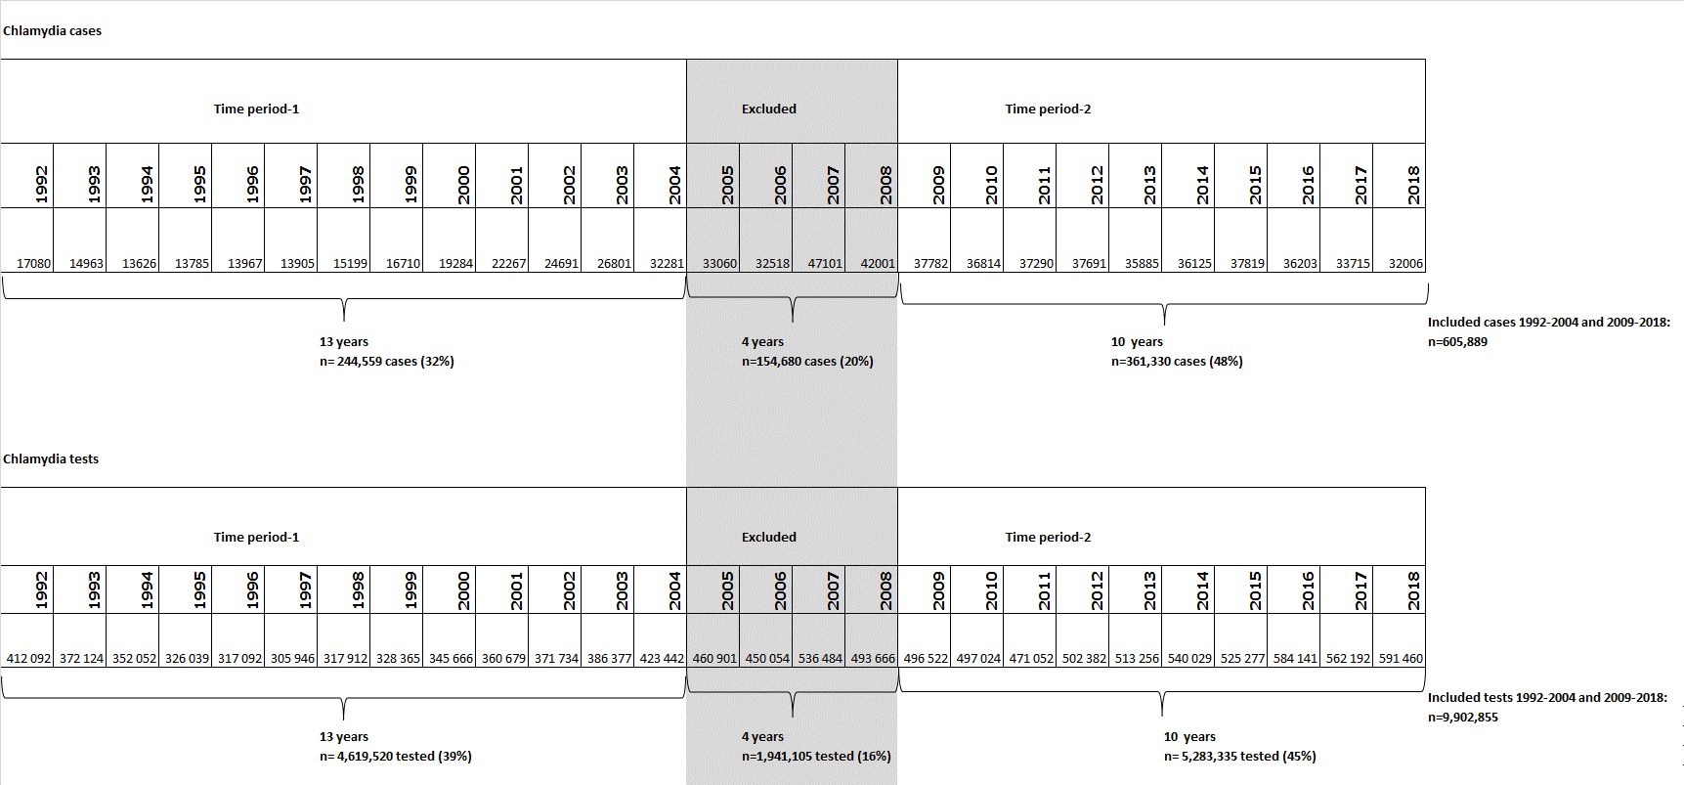

Figure 2S. Estimated Periodicity (Monthly Incidence Rate Ratio) From Fitted Model for the National Number of Chlamydia Cases in Sweden, 1992-2004 and 2009-2018.

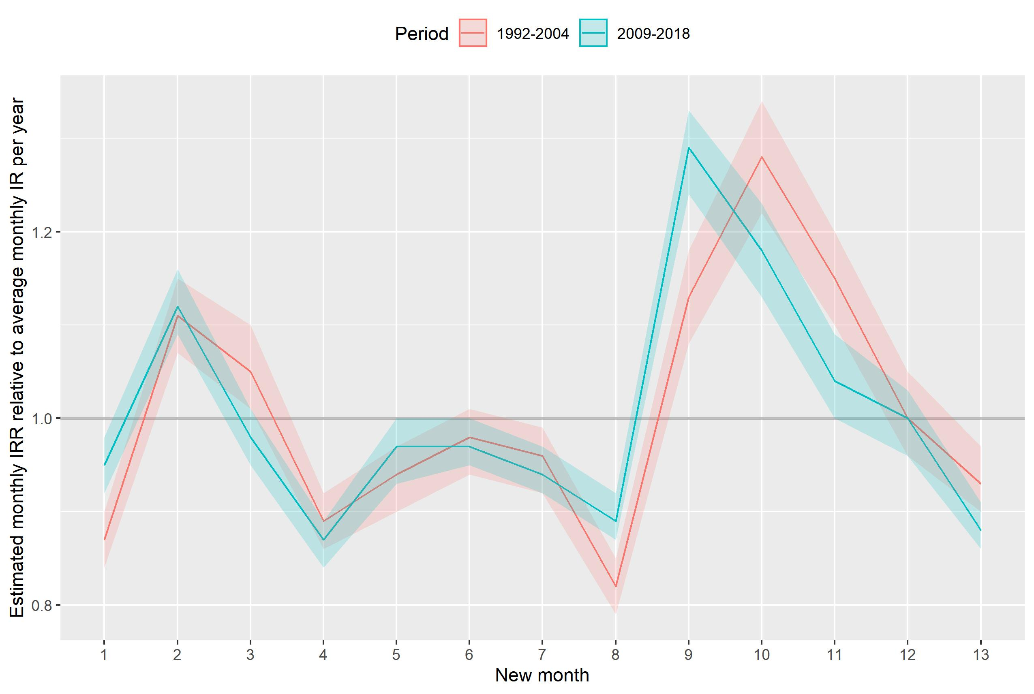

Table S1. Compilation of the Counties by the Laboratory Test Used Until Discovery (2006) of new Swedish Variant of Chlamydia trachomatis

Laboratory test used | Counties (n=21)
“Able-to-detect” group of counties:  used ProbecTec ET kit by Becton Dickinson (Could detect new genetic variant of C.trachomatis) prior and during 2006. | Blekinge, Jämtland, Jönköping, Norrbotten, Uppsala, Västerbotten, Västmanland, Västra Götaland
“Unable-to-detect” group of counties:  used a Cobas Amplicor (Roche Diagnostics), Cobas TagMan48 (Roche Diagnostics) or Abbott m2000 (Abbott Laboratories) (Could not detect new genetic variant of C.trachomatis) prior and during 2006. | Dalarna, Gotland, Gävleborg, Halland, Kalmar, Kronoberg, Skåne, Stockholm, Södermanland, Värmland, Västernorrland, Örebro, Östergötland

Table S2. Final Model for National Number of Chlamydia Cases, 1992-2004 and 2009-2018
 | 1992-2004 |  |  |  | 2009-2018
 | coefficient | 95% CI lower | 95% CI upper | P value |  | coefficient | 95% CI lower | 95% CI upper | P value
Spline term (1st) | -0.005 | -0.006 | -0.003 | 0.000 | Spline term (1st) | -0.001 | -0.002 | 0.000 | 0.014
Spline term (2nd) | 0.017 | 0.011 | 0.022 | 0.000 | Spline term (2nd) | 0.002 | -0.001 | 0.006 | 0.154
Spline term (3rd) | -0.034 | -0.047 | -0.021 | 0.000 | Spline term (3rd) | -0.011 | -0.021 | -0.001 | 0.029
Month-1 | -0.144 | -0.178 | -0.109 | 0.000 | Month-1 | -0.053 | -0.085 | -0.020 | 0.002
Month-2 | 0.103 | 0.065 | 0.140 | 0.000 | Month-2 | 0.117 | 0.087 | 0.147 | 0.000
Month-3 | 0.052 | 0.012 | 0.091 | 0.011 | Month-3 | -0.023 | -0.053 | 0.006 | 0.119
Month-4 | -0.118 | -0.152 | -0.084 | 0.000 | Month-4 | -0.143 | -0.169 | -0.116 | 0.000
Month-5 | -0.067 | -0.102 | -0.032 | 0.000 | Month-5 | -0.034 | -0.068 | 0.000 | 0.050
Month-6 | -0.023 | -0.058 | 0.012 | 0.203 | Month-6 | -0.027 | -0.057 | 0.003 | 0.079
Month-7 | -0.045 | -0.079 | -0.012 | 0.008 | Month-7 | -0.058 | -0.086 | -0.029 | 0.000
Month-8 | -0.197 | -0.231 | -0.163 | 0.000 | Month-8 | -0.112 | -0.142 | -0.083 | 0.000
Month-9 | 0.122 | 0.077 | 0.166 | 0.000 | Month-9 | 0.254 | 0.219 | 0.289 | 0.000
Month-10 | 0.245 | 0.198 | 0.292 | 0.000 | Month-10 | 0.165 | 0.125 | 0.205 | 0.000
Month-11 | 0.138 | 0.094 | 0.182 | 0.000 | Month-11 | 0.042 | -0.004 | 0.088 | 0.073
Month-12 | 0.003 | -0.046 | 0.052 | 0.906 | Month-12 | -0.002 | -0.036 | 0.032 | 0.922
Lag1month | 0.112 | -0.037 | 0.261 | 0.140 | Lag1month | 0.410 | 0.252 | 0.568 | 0.000
Lag2months | 0.202 | 0.053 | 0.350 | 0.008 | Constant (β₀) | -10.968 | -12.325 | -9.610 | 0.000
Constant (β₀) | -10.813 | -12.290 | -9.336 | 0.000
CI – Confidence Interval

Table S3. Monthly Incidence Rate Ratio Compared to the Average Annual Incidence Rate for the National Chlamydia Cases, 1992-2004 and 2009-2018
 |  | 1992-2004 |  |  | 2009-2018
 |  | IRR | 95% CI lower | 95% CI upper | IRR | 95% CI lower | 95% CI upper
Week 1-4 | Month-1 | 0.87 | 0.84 | 0.90 | 0.95 | 0.92 | 0.98
Week 5-8 | Month-2 | 1.11 | 1.07 | 1.15 | 1.12 | 1.09 | 1.16
Week 9-12 | Month-3 | 1.05 | 1.01 | 1.10 | 0.98 | 0.95 | 1.01
Week 13-16 | Month-4 | 0.89 | 0.86 | 0.92 | 0.87 | 0.84 | 0.89
Week 17-20 | Month-5 | 0.94 | 0.90 | 0.97 | 0.97 | 0.93 | 1.00
Week 21-24 | Month-6 | 0.98 | 0.94 | 1.01 | 0.97 | 0.95 | 1.00
Week 25-28 | Month-7 | 0.96 | 0.92 | 0.99 | 0.94 | 0.92 | 0.97
Week 29-32 | Month-8 | 0.82 | 0.79 | 0.85 | 0.89 | 0.87 | 0.92
Week 33-36 | Month-9 | 1.13 | 1.08 | 1.18 | 1.29 | 1.24 | 1.33
Week 37-40 | Month-10 | 1.28 | 1.22 | 1.34 | 1.18 | 1.13 | 1.23
Week 41-44 | Month-11 | 1.15 | 1.10 | 1.20 | 1.04 | 1.00 | 1.09
Week 45-48 | Month-12 | 1.00 | 0.96 | 1.05 | 1.00 | 0.96 | 1.03
Week 49-52 | Month-13 | 0.93 | 0.90 | 0.97 | 0.88 | 0.86 | 0.91
IRR – Incidence Rate Ratio
CI – Confidence Interval

Table S4. Final Model by Group of Counties, 1992 - 2004

 | “Able-to-detect” group of counties |  |  |  | “Unable-to-detect” group of counties
 | coefficient | 95% CI lower | 95% CI upper | P value |  | coefficient | 95% CI lower | 95% CI upper | P value
Spline term (1st) | -0.010 | -0.011 | -0.008 | 0.000 | Spline term (1st) | -0.003 | -0.005 | -0.002 | 0.000
Spline term (2nd) | 0.032 | 0.028 | 0.037 | 0.000 | Spline term (2nd) | 0.014 | 0.008 | 0.019 | 0.000
Spline term (3rd) | -0.068 | -0.081 | -0.055 | 0.000 | Spline term (3rd) | -0.026 | -0.038 | -0.014 | 0.000
Month-1 | -0.115 | -0.163 | -0.067 | 0.000 | Month-1 | -0.154 | -0.190 | -0.117 | 0.000
Month-2 | 0.094 | 0.047 | 0.141 | 0.000 | Month-2 | 0.103 | 0.063 | 0.143 | 0.000
Month-3 | 0.033 | -0.014 | 0.080 | 0.168 | Month-3 | 0.053 | 0.011 | 0.095 | 0.013
Month-4 | -0.074 | -0.122 | -0.026 | 0.002 | Month-4 | -0.129 | -0.165 | -0.093 | 0.000
Month-5 | -0.086 | -0.134 | -0.038 | 0.000 | Month-5 | -0.056 | -0.094 | -0.019 | 0.003
Month-6 | -0.048 | -0.095 | 0.000 | 0.050 | Month-6 | -0.022 | -0.059 | 0.015 | 0.250
Month-7 | -0.080 | -0.128 | -0.032 | 0.001 | Month-7 | -0.039 | -0.074 | -0.004 | 0.028
Month-8 | -0.217 | -0.266 | -0.168 | 0.000 | Month-8 | -0.196 | -0.231 | -0.160 | 0.000
Month-9 | 0.057 | 0.010 | 0.104 | 0.018 | Month-9 | 0.137 | 0.091 | 0.182 | 0.000
Month-10 | 0.230 | 0.184 | 0.276 | 0.000 | Month-10 | 0.232 | 0.183 | 0.281 | 0.000
Month-11 | 0.170 | 0.124 | 0.217 | 0.000 | Month-11 | 0.137 | 0.093 | 0.182 | 0.000
Month-12 | 0.060 | 0.013 | 0.107 | 0.012 | Month-12 | 0.005 | -0.044 | 0.054 | 0.836
Constant (β₀) | -8.249 | -8.367 | -8.130 | 0.000 | Lag1month | 0.125 | -0.023 | 0.274 | 0.098
 |  |  |  |  | Lag2months | 0.200 | 0.054 | 0.347 | 0.007
 |  |  |  |  | Constant (β₀) | -10.824 | -12.174 | -9.474 | 0.000
CI – Confidence Interval

Table S5. Final Model by Group of Counties, 2009 – 2018

 | “Able-to-detect” group of counties |  |  |  | “Unable-to-detect” group of counties
 | coefficient | 95% CI lower | 95% CI upper | P value |  | coefficient | 95% CI lower | 95% CI upper | P value
Spline term (1st) | 0.001 | 0.000 | 0.001 | 0.107 | Spline term (1st) | -0.002 | -0.003 | -0.001 | 0.000
Spline term (2nd) | -0.002 | -0.003 | -0.001 | 0.000 | Spline term (2nd) | 0.004 | 0.001 | 0.008 | 0.021
Month-1 | -0.095 | -0.137 | -0.054 | 0.000 | Spline term (3rd) | -0.016 | -0.026 | -0.005 | 0.004
Month-2 | 0.131 | 0.092 | 0.171 | 0.000 | Month-1 | -0.053 | -0.089 | -0.017 | 0.004
Month-3 | 0.007 | -0.037 | 0.051 | 0.764 | Month-2 | 0.098 | 0.067 | 0.130 | 0.000
Month-4 | -0.146 | -0.184 | -0.109 | 0.000 | Month-3 | -0.014 | -0.045 | 0.017 | 0.373
Month-5 | -0.037 | -0.078 | 0.003 | 0.072 | Month-4 | -0.148 | -0.177 | -0.119 | 0.000
Month-6 | -0.003 | -0.041 | 0.036 | 0.890 | Month-5 | -0.052 | -0.088 | -0.015 | 0.005
Month-7 | -0.049 | -0.086 | -0.013 | 0.008 | Month-6 | -0.038 | -0.070 | -0.006 | 0.022
Month-8 | -0.125 | -0.162 | -0.087 | 0.000 | Month-7 | -0.062 | -0.093 | -0.032 | 0.000
Month-9 | 0.256 | 0.215 | 0.298 | 0.000 | Month-8 | -0.111 | -0.143 | -0.080 | 0.000
Month-10 | 0.219 | 0.159 | 0.278 | 0.000 | Month-9 | 0.242 | 0.207 | 0.278 | 0.000
Month-11 | 0.010 | -0.039 | 0.060 | 0.682 | Month-10 | 0.184 | 0.142 | 0.227 | 0.000
Month-12 | -0.036 | -0.085 | 0.012 | 0.142 | Month-11 | 0.074 | 0.026 | 0.122 | 0.003
Lag1month | 0.347 | 0.182 | 0.512 | 0.000 | Month-12 | 0.010 | -0.026 | 0.047 | 0.589
Lag2months | 0.211 | 0.047 | 0.374 | 0.012 | Lag1month | 0.298 | 0.135 | 0.462 | 0.000
Constant (β₀) | -12.189 | -13.282 | -11.096 | 0.000 | Constant (β₀) | -9.660 | -11.039 | -8.280 | 0.000
CI – Confidence Interval

Table S6. Monthly Incidence Rate Ratio Compared to the Average Annual Incidence Rate by Group of Counties, 1992-2004
 |  | “Able-to-detect” group of counties |  |  | “Unable-to-detect” group of counties
 |  | IRR | 95% CI lower | 95% CI upper | IRR | 95% CI lower | 95% CI upper
Week 1-4 | Month-1 | 0.89 | 0.85 | 0.94 | 0.86 | 0.83 | 0.89
Week 5-8 | Month-2 | 1.10 | 1.05 | 1.15 | 1.11 | 1.06 | 1.15
Week 9-12 | Month-3 | 1.03 | 0.99 | 1.08 | 1.05 | 1.01 | 1.10
Week 13-16 | Month-4 | 0.93 | 0.89 | 0.97 | 0.88 | 0.85 | 0.91
Week 17-20 | Month-5 | 0.92 | 0.87 | 0.96 | 0.95 | 0.91 | 0.98
Week 21-24 | Month-6 | 0.95 | 0.91 | 1.00 | 0.98 | 0.94 | 1.02
Week 25-28 | Month-7 | 0.92 | 0.88 | 0.97 | 0.96 | 0.93 | 1.00
Week 29-32 | Month-8 | 0.81 | 0.77 | 0.85 | 0.82 | 0.79 | 0.85
Week 33-36 | Month-9 | 1.06 | 1.01 | 1.11 | 1.15 | 1.10 | 1.20
Week 37-40 | Month-10 | 1.26 | 1.20 | 1.32 | 1.26 | 1.20 | 1.32
Week 41-44 | Month-11 | 1.19 | 1.13 | 1.24 | 1.15 | 1.10 | 1.20
Week 45-48 | Month-12 | 1.06 | 1.01 | 1.11 | 1.01 | 0.96 | 1.06
Week 49-52 | Month-13 | 0.98 | 0.93 | 1.02 | 0.93 | 0.89 | 0.97
IRR – Incidence Rate Ratio
CI – Confidence Interval

Table S7. Monthly Incidence Rate Ratio Compared to the Average Annual Incidence Rate by Group of Counties, 2009-2018
 |  | “Able-to-detect” group of counties |  |  | “Unable-to-detect” group of counties
 |  | IRR | 95% CI lower | 95% CI upper | IRR | 95% CI lower | 95% CI upper
Week 1-4 | Month-1 | 0.91 | 0.87 | 0.95 | 0.95 | 0.92 | 0.98
Week 5-8 | Month-2 | 1.14 | 1.10 | 1.19 | 1.10 | 1.07 | 1.14
Week 9-12 | Month-3 | 1.01 | 0.96 | 1.05 | 0.99 | 0.96 | 1.02
Week 13-16 | Month-4 | 0.86 | 0.83 | 0.90 | 0.86 | 0.84 | 0.89
Week 17-20 | Month-5 | 0.96 | 0.92 | 1.00 | 0.95 | 0.92 | 0.98
Week 21-24 | Month-6 | 1.00 | 0.96 | 1.04 | 0.96 | 0.93 | 0.99
Week 25-28 | Month-7 | 0.95 | 0.92 | 0.99 | 0.94 | 0.91 | 0.97
Week 29-32 | Month-8 | 0.88 | 0.85 | 0.92 | 0.89 | 0.87 | 0.92
Week 33-36 | Month-9 | 1.29 | 1.24 | 1.35 | 1.27 | 1.23 | 1.32
Week 37-40 | Month-10 | 1.24 | 1.17 | 1.32 | 1.20 | 1.15 | 1.25
Week 41-44 | Month-11 | 1.01 | 0.96 | 1.06 | 1.08 | 1.03 | 1.13
Week 45-48 | Month-12 | 0.96 | 0.92 | 1.01 | 1.01 | 0.97 | 1.05
Week 49-52 | Month-13 | 0.88 | 0.84 | 0.91 | 0.88 | 0.85 | 0.90
IRR – Incidence Rate Ratio
CI – Confidence Interval

Table S8. Proportion of Tested for Chlamydia by Sex in Sweden, 1996-2018

 | Men | Women | Unknown sex
1996 | 20.0 | 80.0 | 0.0
1997 | 20.0 | 80.0 | 0.0
1998 | 20.0 | 80.0 | 0.0
1999 | 20.0 | 80.0 | 0.0
2000 | 23.0 | 77.0 | 0.5
2001 | 24.0 | 76.0 | 0.7
2002 | 25.0 | 75.0 | 0.8
2003 | 25.0 | 75.0 | 0.6
2004 | 26.0 | 74.0 | 0.6
2005 | 26.3 | 73.0 | 0.7
2006 | 26.3 | 71.8 | 1.9
2007 | 28.0 | 70.0 | 2.0
2008 | 27.6 | 70.7 | 1.7
2009 | 28.3 | 69.7 | 2.1
2010 | 26.2 | 66.9 | 6.9
2011 | 26.7 | 65.1 | 8.2
2012 | 28.1 | 63.7 | 8.2
2013 | 27.5 | 64.1 | 8.5
2014 | 28.7 | 68.6 | 2.6
2015 | 29.5 | 67.9 | 2.6
2016 | 29.2 | 70.3 | 0.5
2017 | 27.9 | 69.6 | 2.5
2018 | 29.5 | 70.4 | 0.1
Average, 1996-2004 | 22.6 | 77.4 | 0.4
Median, 1996-2004 | 23.0 | 77.0 | 0.5
Average, 2009-2018 | 28.1 | 67.6 | 4.2
Median, 2009-2018 | 28.2 | 68.3 | 2.6

Table S9. Proportion of 15-29 Years Old Among All Tested for Chlamydia (for Counties Reporting Age Groups), 2009-2018

 | Proportion of 15-29 years old among all tested | Number of reporting counties
2009 | 67 | 19
2010 | 71 | 21
2011 | 69 | 16
2012 | 69 | 20
2013 | 68 | 20
2014 | 63 | 16
2015 | 62 | 20
2016 | 60 | 20
2017 | 64 | 19
2018 | 65 | 17
Average | 65.8
Median | 66

Table S10. Adjusted† Models of Chlamydia Incidence Rate Ratios by Group of Counties. 1992-2004 and 2009-2018.

 | 1992-2004 |  |  | 2009-2018
 | IRR | 95% CI | P -value | IRR | 95% CI | P -value
Model for national Chlamydia IRR
Proportion population tested | 1.07 | 1.04. 1.09 | 0.000 | 1.001 | 0.988. 1.014 | 0.892
Year# | 0.97 | 0.94. 0.99 | 0.015 | 1.012 | 0.995. 1.030 | 0.165
Proportion population tested * Year# | 0.996 | 0.993. 0.999 | 0.019 | NA | NA | NA
Year * Year | 1.01 | 1.008. 1.010 | 0.000 | 0.995 | 0.993. 0.997 | 0.000
Model for Chlamydia IRR in “able-to-detect” group of counties
Proportion population tested | 1.102 | 1.043. 1.164 | 0.000 | 1.001 | 0.971. 1.031 | 0.964
Year# | 0.98 | 0.93. 1.03 | 0.469 | 1.045 | 1.017. 1.073 | 0.002
Proportion population tested * Year# | 0.99 | 0.98. 0.997 | 0.004 | NA | NA | NA
Year * Year | 1.011 | 1.008. 1.014 | 0.000 | 0.992 | 0.989. 0.995 | 0.000
Model for Chlamydia IRR in “unable-to-detect” group of counties
Proportion population tested | 1.048 | 1.021. 1.077 | 0.001 | 1.004 | 0.989. 1.019 | 0.639
Year# | 0.966 | 0.939. 0.993 | 0.015 | 0.993 | 0.972. 1.015 | 0.536
Proportion population tested * Year# | 0.998 | 0.996. 1.002 | 0.512 | NA | NA | NA
Year * Year | 1.008 | 1.007. 1.009 | 0.000 | 0.996 | 0.994. 0.999 | 0.003

† - Models adjusted for the individual counties.
NA – Not applicable. Without a statistically significant main effect for proportion population tested. no interaction with calendar year was retained in the model.
Abbreviation: CI. Confidence Interval; IRR. Incidence Rate Ratio.
^{# -} 1992 is a reference year for the modelling the joint testing- and calendar effects in the model

Equation 1S: Model specification for monthly incidence rates of chlamydia with cubic spline trend. fixed effects of months and autocorrelation from the preceding months

$$\log{E\left(\frac{y_{t}}{{pop}_{t}}\right)= β_{0}}+ β_{1}s_{1}\left(t\right)+ …+ β_{i}s_{i}\left(t\right)+ γ_{1} m_{1}+ γ_{2}m_{2}+…+ γ_{13}m_{13}+ α_{1}\log\left(y_{\left(t-1\right)}\right)+…+α_{j}\log\left(y_{\left(t-j\right)}\right)$$

where:
- t: running month of study period (t=1. 2. .... )
- m_{k}: month k (k=1. 2.…. 13). required to sum to 0
- y_{t}: number of reported cases of chlamydia in month t
- s_{i}(t): function of month t. as an additive component of the cubic spline term (i=3. 4. 5)
- y_{(t-j):} lagged reported cases of chlamydia in month t-j (j=1. 2. 3. 4)
- pop_{t}: population count in month t

Equation 2S: Model specification for annual incidence rates of chlamydia as function of calendar year and proportion of subjects tested

$$\log{E\left(\frac{y_{zc}}{{pop}_{zc}}\right)= β_{0}}+ β_{1}z+ β_{2}z^{2}+ β_{3} w_{zc}+ β_{4}\left(z* w_{zc}\right)+ λ_{c}$$
where:
- z: calendar year of study period
- c: index of county (c=1. .... 21)
- y_{zc}: number of reported cases of chlamydia during year z in county c
- w_{zc}: proportion of tested individuals aged 15–64 years during year z in county c
- λ_{c}: fixed effect for baseline IR in county c (c = 1. …. 21)
- pop_{zc}: population count during year z in county c

