Appendix A: Summary of measures

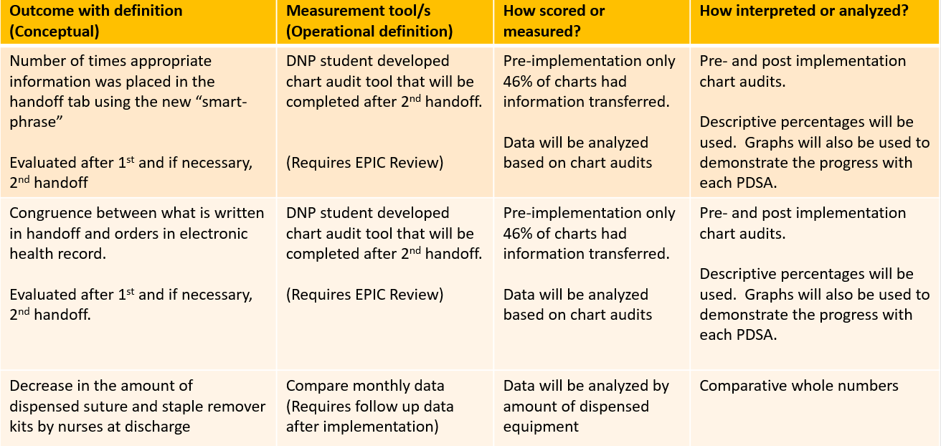

Appendix B:

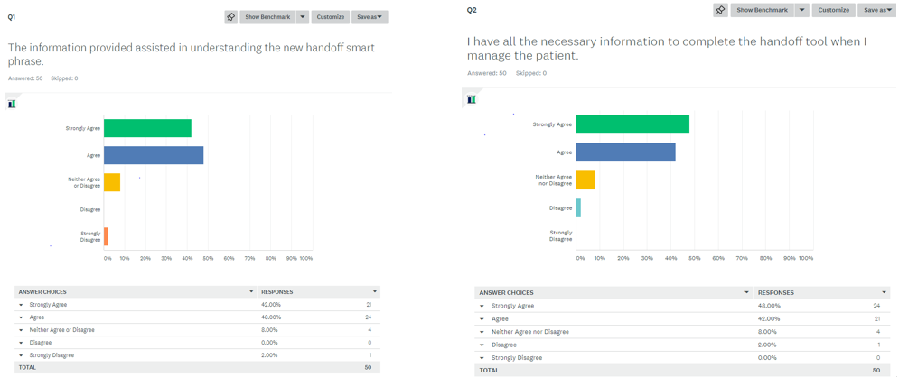

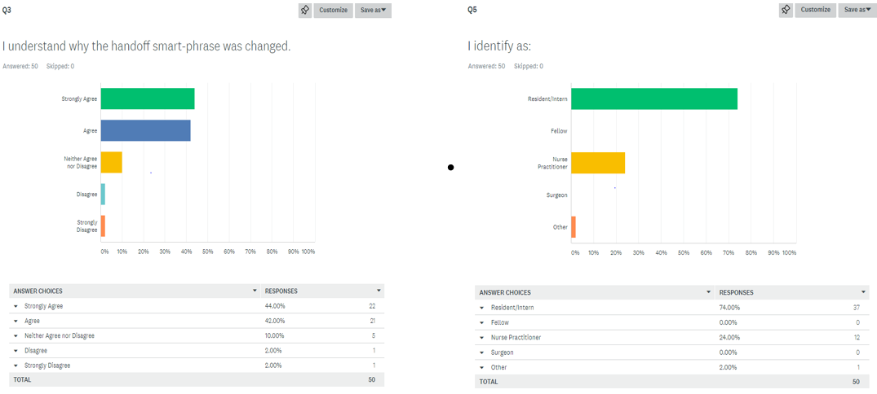

Appendix C:
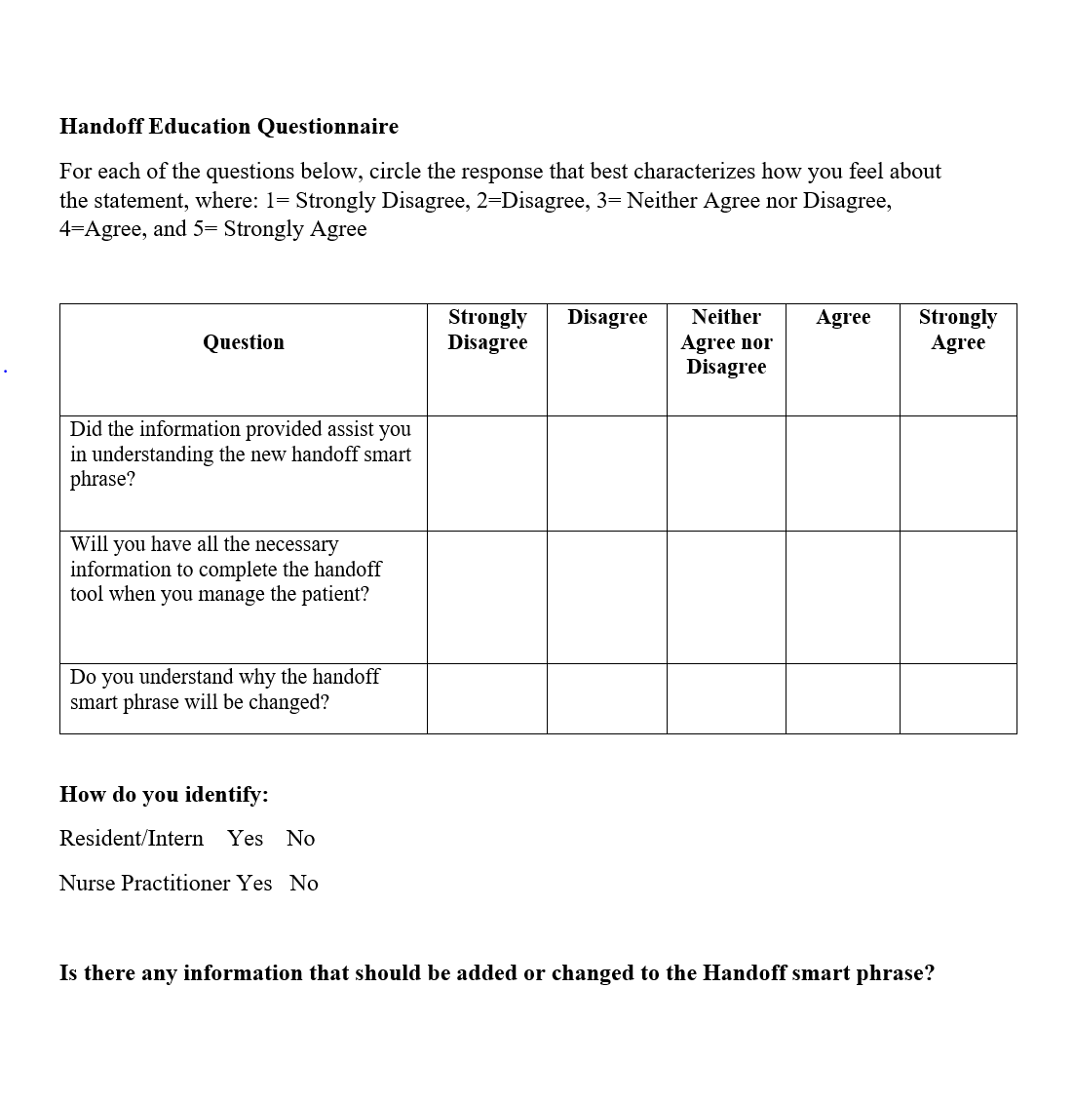

Appendix D: Chart Audit Review Questions

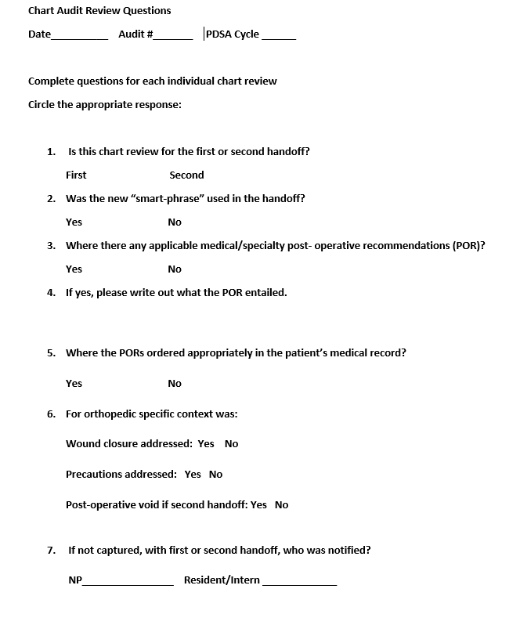

Appendix E: Education Session Results

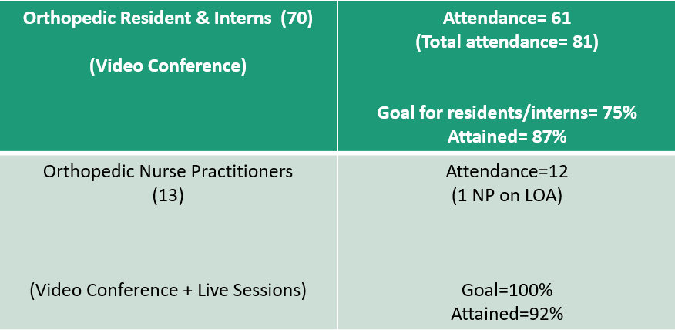

Appendix F: Suture & Staple Removal Usage Result

Kit Type | COST | Usage for the Acute Units for  March 2020  (226 surgeries) | Usage for the Acute Units for June 2020  (244 Surgeries) | Usage for Acute Units for July 2020  (231 Surgeries)
Suture Removal Kit | $ 1.21 | 354 kits  $428.34 | 295  $356.95 | 294  $355.74
Staple Removal Kit | $ 1.94 | 226kits  $438.44 | 224  $434.56 | 190  $368.60
Total: |  | $866.78  $3.83  per surgical case | $791.51  $3.21  Per surgical case | $724.34  $3.14 per surgical case

