Supplementary material 1:
Figure: Change of HADS score: Before surgery to 6-month post-surgery
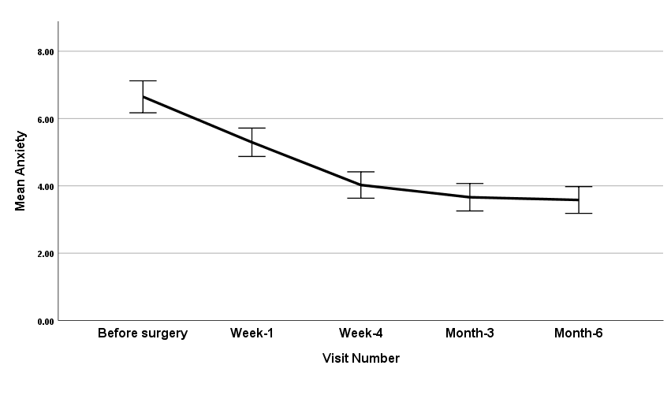

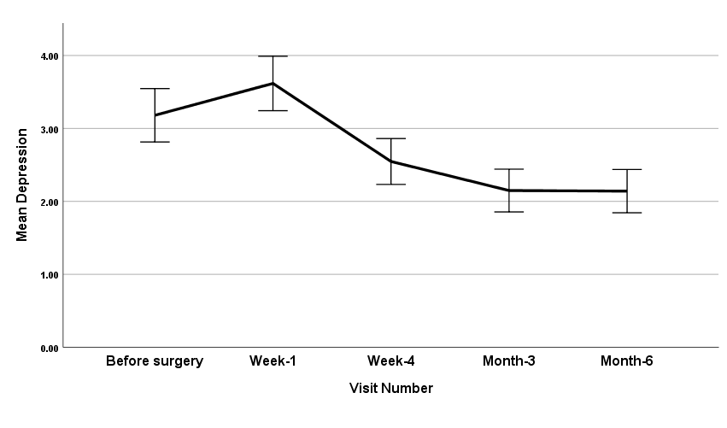

Supplementary material 2: Parameter estimates, interaction for anxiety and depression
Table A: Linear mixed model: Parameter estimates†
Anxiety |  |  |  | Depression
Factors | Mean  (SE) | 95% CI | P value | Factors | Mean  (SE) | 95% CI | P value
Main effects
1. Visit number |  |  | <0.001 | 1. Visit number |  |  | <0.001
Before surgery | 8.43(0.80) | 6.85-10.02 |  | Before surgery | 4.88(0.60) | 3.69-6.07
Week-1 | 7.17(0.80) | 5.58-8.76 |  | Week-1 | 5.34(0.60) | 4.15-6.53
Week-4 | 5.94(0.81) | 4.35-7.53 |  | Week-4 | 4.30(0.60) | 3.00-5.49
Month-3 | 5.67(0.81) | 4.08-7.26 |  | Month-3 | 3.96(0.60) | 2.76-5.15
Month-6 | 5.66(0.81) | 4.07-7.26 |  | Month-6 | 4.08(0.60) | 2.89-5.27
2. Ethnicity |  |  | <0.001
European | 5.80(0.78) | 4.27-7.35
Other | 7.34(0.88) | 5.60-9.08
OR- Odds Ratio, CI- Confidence Interval, SE- Standard Error.
†Income for anxiety and hypertension for depression was interacted with visit number and showed statistically significant association (p<0.05). The parameter of estimates and line graph is presented in the Supplementary material 2.

Table A: Interaction for anxiety and depression
Factors | Mean (Standard Error) | 95% Confidence Interval | P value
Anxiety: Income*Visit number |  |  | <0.001
≥AUS$40,001*Before surgery | 8.71(0.61) | 7.51-9.90
Not stated * Before surgery | 8.55(0.64) | 7.28-9.82
<AUS$40,000*Before surgery | 6.91(0.38) | 6.17-7.65
≥AUS$40,001*Week-1 | 5.60(0.61) | 4.40-6.79
Not stated *Week-1 | 6.64(0.65) | 5.36-7.92
<AUS$40,000*Week-1 | 5.14(0.38) | 4.39-5.89
≥AUS$40,001*Week-4 | 5.13(0.61) | 3.93-6.34
Not stated *Week-4 | 4.75(0.65) | 3.47-6.04
<AUS$40,000*Week-4 | 4.43(0.38) | 3.68-5.18
≥AUS$40,001*Month-3 | 4.95(0.62) | 3.73-6.17
Not stated *Month-3 | 4.83(0.67) | 3.51-6.16
<AUS$40,000*Month-3 | 3.84(0.38) | 3.08-4.60
≥AUS$40,001*Month-6 | 4.49(0.62) | 3.27-5.71
Not stated*Month-6 | 5.41(0.68) | 4.06-6.75
<AUS$40,000*Month-6 | 3.78(0.39) | 3.01-4.55
Depression: Hypertension*Visit number |  |  | 0.03
No*Before surgery | 4.83(0.47) | 3.89-5.76
Yes*Before surgery | 4.09(0.45) | 3.20-4.99
No*Week-1 | 4.94(0.48) | 4.00-5.89
Yes*Week-1 | 3.76(0.46) | 2.85-4.67
No*Week-4 | 3.64(0.48) | 2.70-4.58
Yes*Week-4 | 3.07(0.56) | 2.17-3.97
No*Month-3 | 2.94(0.48) | 1.99-3.90
Yes*Month-3 | 2.48(0.46) | 1.57-3.39
No*Month-6 | 3.23(0.49) | 2.25-4.21
Yes*Month-6 | 2.90(0.47) | 1.97-3.83

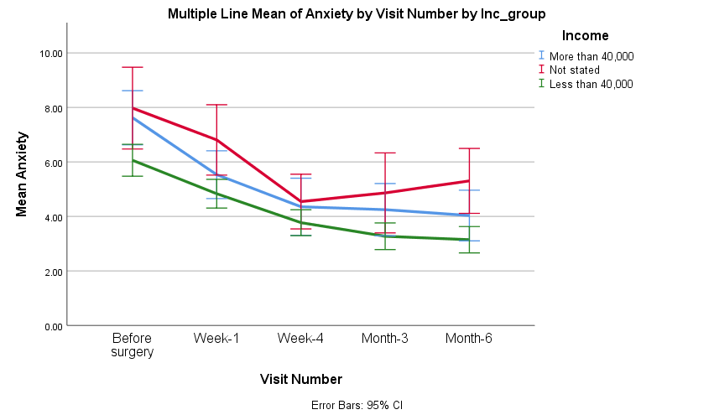
Figure A: Line graph between the interaction of anxiety and income at five different time point

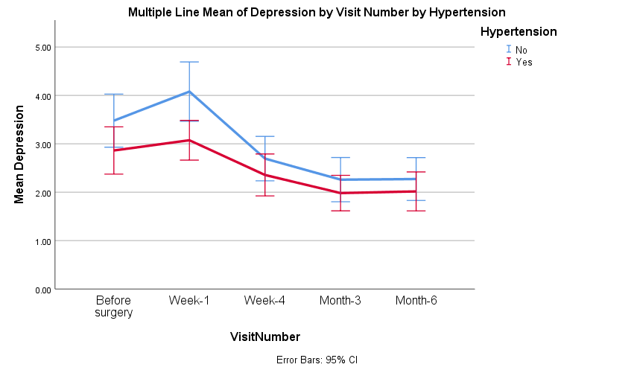
Figure B: Line graph between the interaction of depression and hypertension (HTN) at five different time point

