The ARRIVE Guidelines Checklist
Animal Research: Reporting In Vivo Experiments
Carol Kilkenny¹, William J Browne², Innes C Cuthill³, Michael Emerson⁴ and Douglas G Altman⁵
¹The National Centre for the Replacement, Refinement and Reduction of Animals in Research, London, UK, ²School of Veterinary Science, University of Bristol, Bristol, UK, ³School of Biological Sciences, University of Bristol, Bristol, UK, ⁴National Heart and Lung Institute, Imperial College London, UK, ⁵Centre for Statistics in Medicine, University of Oxford, Oxford, UK.

 |  | ITEM | RECOMMENDATION | Section/  Paragraph
 |  |  |  | Title
 |  |  |  | Abstract
 | INTRODUCTION
 | 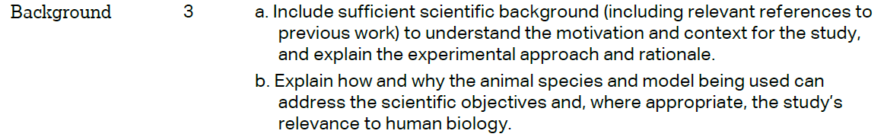 |  |  | - 1. Introduction/Paragraphs 1-4  - 1. Introduction/Paragraph 4
 |  |  |  | 1. Introduction/Paragraph 5
 | METHODS
 |  |  |  | 2. Materials and Methods/2.1 Ethical statement
 | 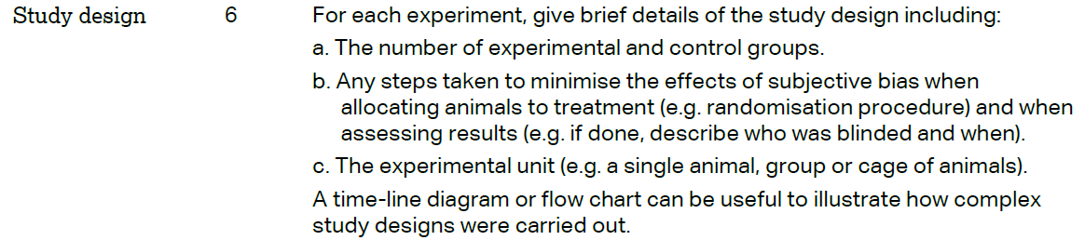 |  |  | - 3. Results/3.1 Study profile, animal characteristics and experimental design  - Materials and Methods/Table 1  - 2. Materials and Methods/2.6 Statistical analysis
 | 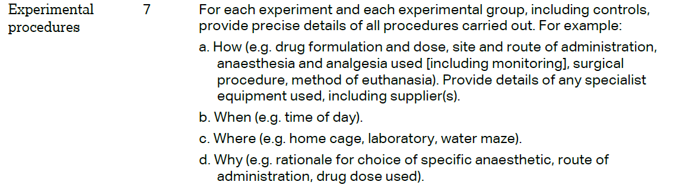 |  |  | - 2. Materials and Methods/2.3 Complete Freund’s Adjuvant (CFA)-induced inflammation and 2.4 Burrowing and 3. Results/Table 3  - 2. Materials and Methods/2.5 Study design  - 2. Materials and Methods/2.4 Burrowing  - 2. Materials and Methods/2.3 Complete Freund’s Adjuvant (CFA)-induced inflammation
 | 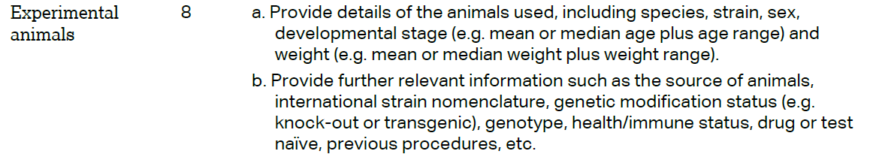 |  |  | - 2. Materials and Methods/2.2 Experimental Animals and environmental conditions; Results/Table 3  - 3. Results/Figure2 and Table 3
The ARRIVE guidelines. Originally published in PLoS Biology, June 2010¹
 | 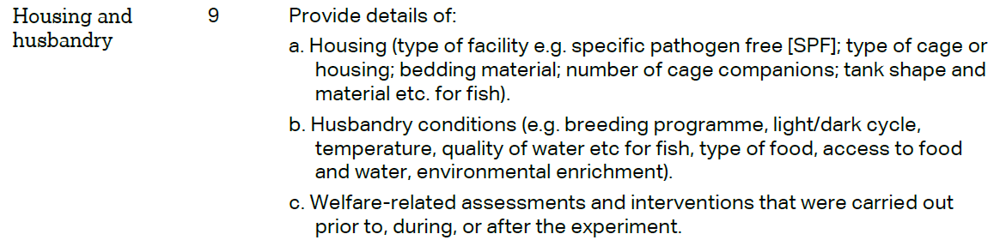 | - 2. Materials and Methods/2.2 Experimental Animals and environmental conditions and Table 1  - 2. Materials and Methods/2.2 Experimental Animals and environmental conditions and Table 1  - 2. Materials and Methods/2.2 Experimental Animals and environmental conditions
 | 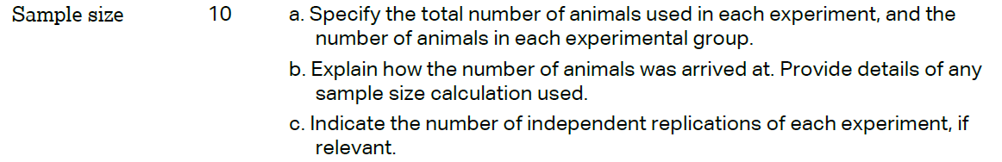 | - 3. Results/Figure 2  - 2. Materials and Methods/2.6 statistical analysis and Table 1  - 3. Results/Figure 2
 | 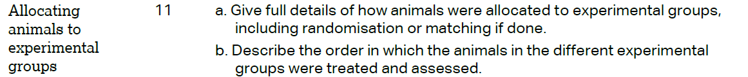 | - 2. Materials and Methods/Table 1  - 2. Materials and Methods/2.2.2 Baseline performance and testing; 3. Results/Figure 3
 |  | 2. Materials and Methods/2.5 Study design
 | 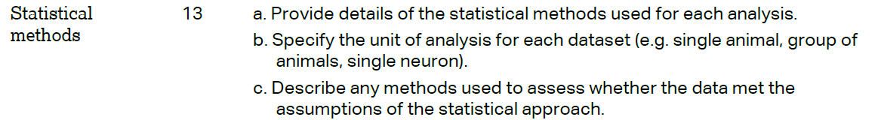 | - 2. Materials and Methods/2.6 Statistical analysis  - 2. Materials and Methods/2.6 Statistical analysis  - 2. Materials and Methods/2.6 Statistical analysis
 | RESULTS
 |  | 3. Results/ 3.1 Study profile, animal characteristics and experimental design and Table 3
- 3. Results/Figure 2, Figure 6 and Supplemental 3
- / 3.1 Study profile, animal characteristics and experimental design and Figure 2
 |  | 3. Results/Figures 4,5; Tables 4,5,6; Supplemental 2,3,4,5
- N/A – no adverse events
- N/A – no adverse events
 | DISCUSSION
 | 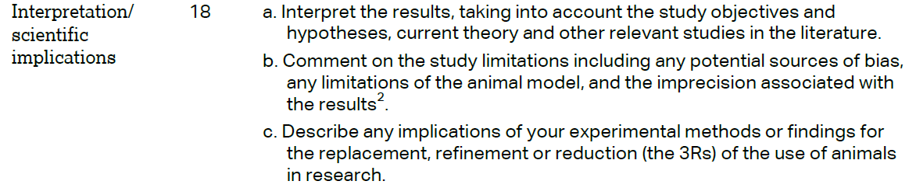 | - 4. Discussion  - 4. Discussion  - 4. Discussion
 |  | 4. Discussion/Paragraph 6
 |  | Acknowledgments
