Supplementary Methods For

Brain white matter changes associated with urological chronic pelvic pain syndrome:
Multi-site neuroimaging from a MAPP case-control study

Lejian Huang¹, Jason J. Kutch², Benjamin M. Ellingson³
Katherine T. Martucci⁴, Richard E. Harris⁵, Daniel J. Clauw⁵,
Sean Mackey⁴, Emeran A. Mayer³,
Anthony J. Schaeffer⁶, A. Vania Apkarian^{1,7}* and Melissa A.Farmer¹*
on behalf of the MAPP Research Network⁸

- Department of Physiology, Northwestern University, Feinberg School of Medicine, Chicago, IL
- Division of Biokinesiology and Physical Therapy, University of Southern California, Los Angeles, CA
- Oppenheimer Center for Neurobiology of Stress and Pain, David Geffen School of Medicine, University of California-Los Angeles, Los Angeles, CA
- Departments of Anesthesiology, Perioperative and Pain Medicine, Division of Pain Medicine, Stanford University Medical Center, Stanford, CA
- Department of Anesthesiology, and the Chronic Pain and Fatigue Research Center, University of Michigan, Ann Arbor, MI
⁵ Department of Urology, Northwestern University, Feinberg School of Medicine, Chicago, IL
⁶ Departments of Surgery and Anesthesia, Northwestern University, Feinberg School of Medicine, Chicago, IL
⁷ Members of the MAPP Research Network members can be found in ¹

METHODS

- Sample Characteristics
Participants were recruited as part of the MAPP Epidemiology/Phenotyping (EP) Study between December 2009 and December 2012, which enrolled 1,039 men and women consisting of the following groups: 424 urological chronic pelvic pain syndrome (UCPPS) participants, 415 healthy controls, and 200 positive controls presenting with non-pelvic chronic pain, between. Neuroimaging data was collected in 302 men and women, including participants meeting traditional criteria for interstitial cystitis/bladder pain syndrome (IC/BPS n=56), chronic prostatitis/chronic pelvic pain syndrome (CP/CPPS n=85), positive controls (n=52, including irritable bowel syndrome, fibromyalgia, and chronic fatigue syndrome), and healthy controls (n=88). A subset of sites collected DTI data (NU, UCLA, and SU, n=201) based on inclusion/exclusion criteria shown in suppl. Table 1 and included 52 UCPPS patients (23 women, 29 men), 39 positive visceral pain controls with irritable bowel syndrome (IBS; 24 women, 15 men), and 61 healthy controls (32 women, 29 men). Positive and healthy controls were age- (± 3 years) and sex-matched to the UCPPS group.

Standardized quality assurance pipelines for images and clinical data evaluated data quality and cross-compatibility, given that multiple technical, acquisition, and procedural confounds can influence the quality of imaging data. Scanner compatible acquisition parameters were developed based on recommendations from fBIRN (https://xwiki.nbirn.org:8443/bin/view/Function-BIRN/ FBIRN_Best_Practices). After excluding scans (n=49) of poor quality, patients with fibromyalgia and chronic fatigue syndrome, and patients without age-matched controls, 152 scans were eligible to be included in this study.
Questionnaires administered on the day of scanning included the following: Symptom and Health Care Utilization Questionnaire (SYM-Q), Hospital Anxiety and Depression Scale (HADS), McGill Pain Questionnaire-Short Form (SF-MPQ), Gracely Box Scales (pain unpleasantness and intensity, range of scores 0-20), Positive and Negative Affective Scales (PANAS), and the Genitourinary Pain Index (GUPI), including pain (score range: 0-23), urinary function (score range: 0-10), and quality of life (score range: 0-12) subdomains. Table 1 in the main text provides an overview of questionnaire results by patient groups. Note that only a subset of self-report variables were used in region of interest (ROI) analyses.

- Measuring White Matter Diffusivity

Multiple measures of diffusivity were examined in the white matter regions that significantly differed between women with and without IC/BPS. Fractional anisotropy (FA) is the primary index of white matter integrity and reflects the degree of diffusion anisotropy within a voxel (FA values range from 0-1.0, where large values indicate directional dependence related to the structural confines of white matter tracts, and smaller values indicate more isotropic diffusion) ².

FA maps were generated for the primary diffusion directions: axial diffusivity (λ1), which describes parallel diffusivity along the longitudinal axis of the axonal tract, and radial diffusivity (λ2+λ3/2), which describes perpendicular diffusivity to the principal diffusion direction (e.g., diffusion away from the primary longitudinal axis of the axonal tract). Additionally, mean diffusivity maps, which provide a global index of anisotropic change (in all directions), were calculated by averaging mean skeletal brain λ1 and mean skeletal brain (λ2+λ3/2) values. Axial, radial, and mean diffusivity measurements can provide additional nuanced information about how axonal tracts are changing.

- Analysis of White Matter Properties

DTI data from 22 IC/BPS patients and 32 age-and sex-matched healthy controls were examined. Using FDT in FSL5.1 software ³, FA was calculated for each voxel (e.g., “voxel-wise” analysis). The FSL FNIRT registration tool was used on the first no-diffusion weighted volume of each subject to correct for eddy-currents and head motion. Skulls were removed from brain images using the BET tool ⁴. FA images were generated by modeling the fit between the diffusion tensors and the raw diffusion data. Tract-based spatial statistics (TBSS) of FSL ⁵ were used to generate voxel-wise statistical analyses. IC/BPS and controls’ FA data was pooled to create a common white matter template, which was thresholded to create a mean FA “skeleton” and represented areas of white matter tracts common to all study participants, thereby establishing a search area for further FA analyses (fig 1A in main text). Individual participants’ FA data was projected onto this group skeleton. We then calculated each participant’s mean skeletal brain FA as a global index of diffusion in the white matter ⁶ by averaging FA values within each participant’s white matter skeleton. This mean FA value was compared between groups and used to determine corrections for center and age effects (see below). Group differences were evaluated with permutation testing (n = 5000 permutations, p < 0.05). White matter regions of interest (ROIs) were derived from the contrasts of patient and control white matter skeletons, and ROIs ≥ 30 voxels in size were preserved (an arbitrary clustering criterion).

Planned post-hoc analyses included the correlation of white matter ROIs with clinical parameters that were hypothesized to play important roles in IC/BPS. Peak ROI FA values (averaged for a 30-voxel area) was extracted from each subject and related to clinical parameters using planned t-tests and Pearson correlations.

Statistical Correction for Site Effects
A linear correction for site effect took the following variables into account: (a) correction takes into account variability within and between sites; (b) correction makes means/variability comparable across sites, (c) corrected data will exhibit correlation with biologic traits that have been demonstrated in prior literature (e.g., negative correlation between age and FA is preserved). Therefore the correction factor that met these criteria was:

(Mean_{a} – Mean_{b}) + FA_{c}

where a = a subject’s uncorrected FA value, b = the mean FA value of each subject’s site, and c = mean FA value of all sites. This correction accounts for the impact of center mean on a subject’s data (thereby correcting for individual site effect) and adds this corrected value to the grand mean of all sites.

Suppl. Table 1: Overview of MAPP inclusion/exclusion criteria

Inclusion Criteria for UCPPS
1. | Female or male, 18 years of age or older;
2. | A diagnosis of IC/BPS or CP/CPPS, with urologic symptoms present a majority of the time during any 3 of the past 6 months (CP/CPPS) or the most recent 3 months (IC/BPS);
3. | Symptoms have been present for the majority of the time during any 3 months in the previous 6 months;
4. | Symptoms have been present for the majority of the time during the most recent 3 months;
5. | Score of at least 1 on the pain, pressure, or discomfort question on the Symptom and Health Care Utilization Questionnaire  “Think about the pain, pressure, and discomfort associated with your bladder/prostate and/or pelvic region. On average, how would you rate these symptoms during the past 2 weeks?” (with a score of 0 indicating no pain or pressure or discomfort, and 10 indicating most severe discomfort I can imagine);
6. | Agrees to participate in Trans-MAPP epidemiological study procedures;
7. | Gave permission for the collection of DNA sample; and
8. | Read and signed informed consent form prior to participation in the study.
Inclusion Criteria for Healthy Controls
1. | Reports no urological symptoms;
2. | Score of 0 (zero) on the pain, pressure, or discomfort question on the Symptom and Health Care Utilization Questionnaire;
3. | Reports no chronic pain in pelvic or bladder region, and reports chronic pain in no more than one other body region [note: our study-specific inclusion criteria required no comorbid chronic pain in healthy controls];
4. | Agrees to participate in Trans-MAPP epidemiological study procedures;
5. | Gave permission for the collection of DNA sample; and
6. | Read and signed informed consent form prior to participation in the study.
Exclusion Criteria (UCPPS, IBS, and Healthy Controls)
1. | Participant has ongoing symptomatic urethral stricture;
2. | Evidence of a facultative Gram negative or enterococcus with a value of ≥ 100,000 CFU/ml in mid-stream urine;
3. | Ongoing neurological disease or disorder affecting the bladder or bowel fistula;
4. | History of cystitis caused by tuberculosis, radiation therapy, or Cytoxan/cyclophosphamide therapy;
5. | Augmentation cystoplasty or cystectomy;
6. | Presence of systemic autoimmune disorder (such as Crohn’s Disease, Ulcerative Colitis, Lupus, Rheumatoid Arthritis, or Multiple Sclerosis);
7. | History of cancer (with the exception of skin cancer);
8. | Current major psychiatric disorder or other psychiatric or medical issues that would interfere with study participation (e.g., dementia, psychosis, upcoming major surgery, etc.);
9. | History of high-grade squamous intraepithelial lesion (HGSIL) / high-grade cervical dysplasia;
10. | (Women Only) Pregnant or breastfeeding;
11. | (Men Only) Unilateral orchalgia without pelvic symptoms, history of microwave thermotherapy, trans-urethral or needle ablation or other specified prostate procedures;
11. | Left-handed (to control for hemispheric differences related to handedness); and
12. | Has a ferromagnetic implant or electrical device, tattoo, etc. that is not MRI-compatible or is a contraindication to MRI scanning.

Suppl. Figure 1. Regions of interest that significantly differed between UCPPS, IBS, and controls
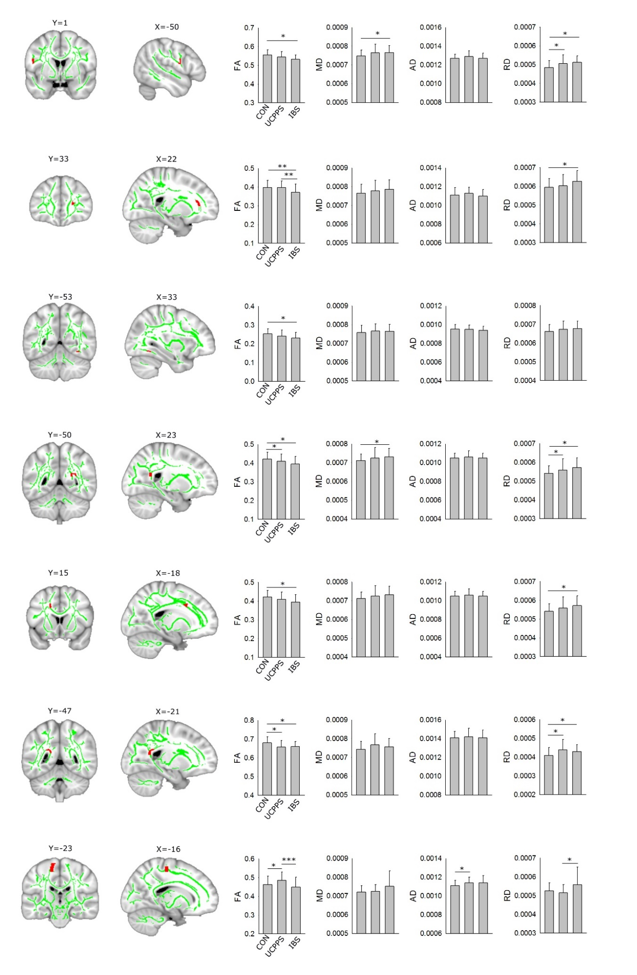

SUPPL. METHODS REFERENCES
1. Clemens, J. Q., Mullins, C., Kusek, J. W. et al.: The MAPP research network: a novel study of urologic chronic pelvic pain syndromes. BMC Urol, 14: 57, 2014
2. Beaulieu, C.: The basis of anisotropic water diffusion in the nervous system - a technical review. NMR Biomed., 15: 435, 2002
3. Smith, S. M., Jenkinson, M., Woolrich, M. W. et al.: Advances in functional and structural MR image analysis and implementation as FSL. Neuroimage, 23 (S1): 208, 2004
4. Smith, S. M.: Fast robust automated brain extraction. Hum.Brain Mapp., 17: 143, 2002
5. Smith, S. M., Jenkinson, M., Johansen-Berg, H. et al.: Tract-based spatial statistics: voxelwise analysis of multi-subject diffusion data. Neuroimage, 31: 1487, 2006
6. Giorgio, A., Watkins, K. E., Douaud, G. et al.: Changes in white matter microstructure during adolescence. Neuroimage, 39: 52, 2008

