Supplemental data
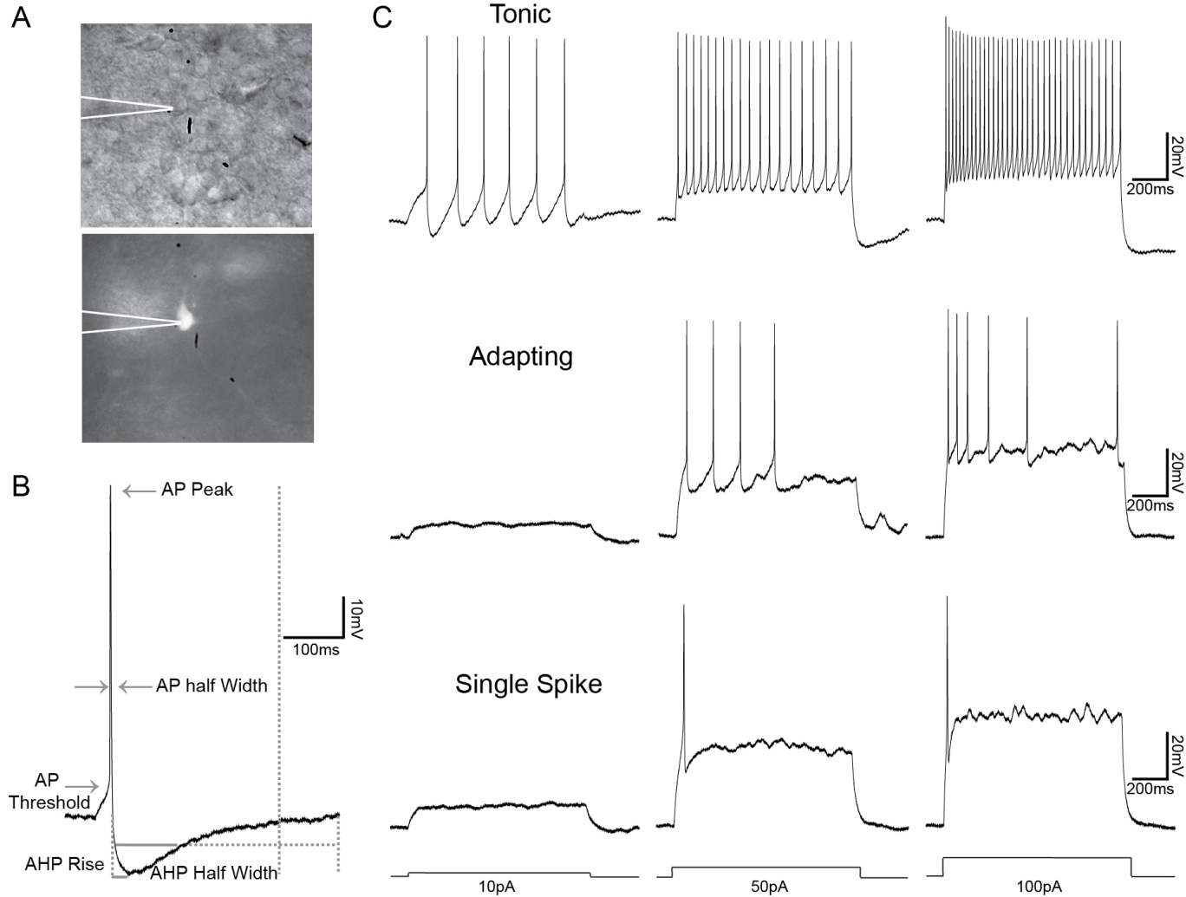
Supplemental Figure 1. Characteristic firing properties of Grpr-Cre neurons in the spinal cord dorsal horn. A, A Grpr-Cre neuron visualized under bright field (top) and fluorescent (bottom) light. White lines denote recording pipette. B, An example action potential from a Grpr-Cre neuron as a representation of the population (n = 46). Neurons fired robust action potentials with an amplitude of 75.24 ± 1.16 mV, action potential rise of 11.03 ± 0.80 ms and an action potential half width of 3.64 ± 0.21 ms when triggered over their action potential threshold by short depolarizing current pulses (10 ms duration, 5pA increments). Solid and dashed grey lines illustrate analysis parameters. C, Injection of depolarizing current steps (10pA, 50pA, 100pA, 1s duration) revealed three firing groups within the Grpr-Cre population. Almost half (48%, 24/50) of the Grpr-Cre population exhibited tonic firing (top trace), whilst adapting (middle trace) and phasic (bottom trace) firing were each independently observed in 18% (9/50) of the population. Eight neurons were excluded from spike train analysis due to low recording quality.

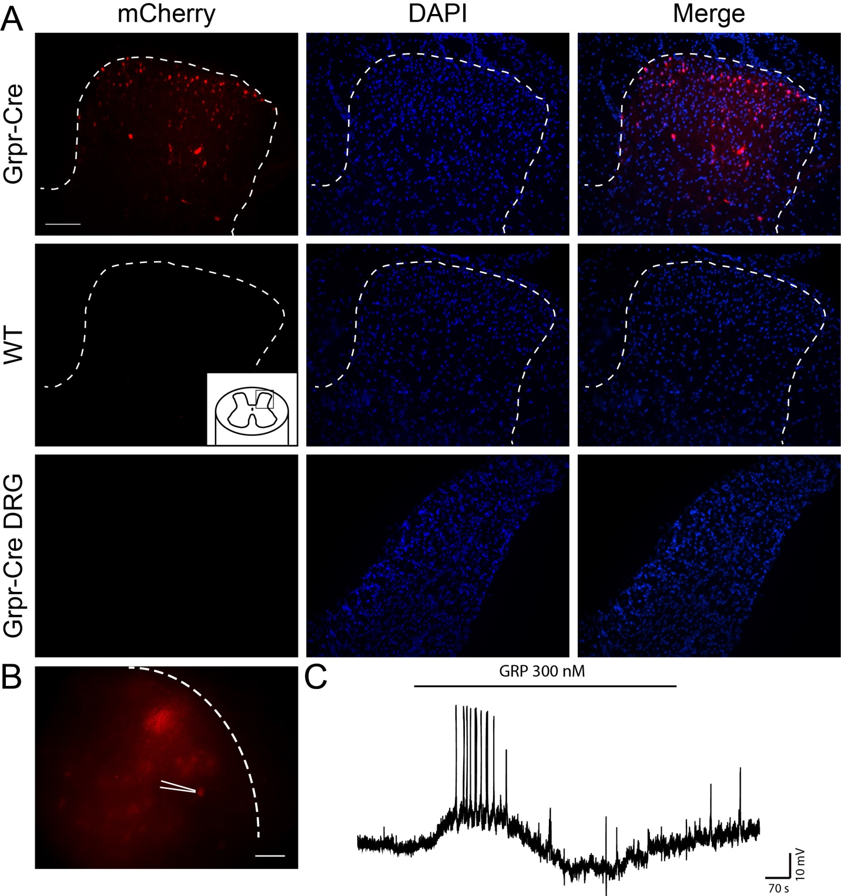Supplemental Figure 2. Expression pattern and . A, AAV8/hSyn-DIO-mCherry virus infects Cre-expressing neurons in the dorsal horn. No fluorescence is seen in WT mice, nor in the dorsal root ganglia (DRG) of Grpr-Cre mice. Scale bar 100 µm for all panels. B, Dorsal horn Grpr-Cre neuron expressing AAV8/hSyn-DIO-mCherry patch clamp recorded in a 300 µM slice. Scale bar, 80 µm. C, Representative trace of induced response after GRP 300 nM bath applied.
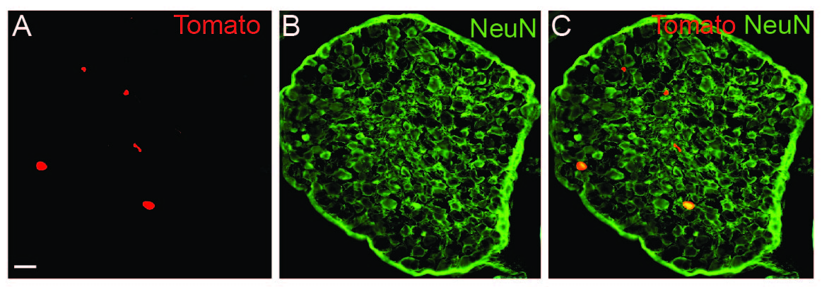
Supplemental Figure 3. Expression of Grpr-Cre in adult DRG.
A-C, tdTomato;Grpr-Cre expressing neurons in the DRG labeled with NeuN. Scale bar 37 µm.

