Supplementary Information

Targeting BDNF in the medial thalamus for the treatment of central poststroke pain in a rodent model

Hsi-Chien Shih, Yung-Hui Kuan, Bai-Chung Shyu

Institute of Biomedical Science, Academia Sinica, Taipei, Taiwan

Supplementary Figure 1. Lesion site in histological section and representation of region of interest for cell count.

Supplementary Figure S1. Lesion site in histological section and representation of region of interest for cell counts. (A) Representative full coronal section showing the lesion site in the VPM/VPL. Scale bar = 500 μm. (B) Representative lesion site (upper panel) with margin line marked (lower panel) to indicate the region of interest that was selected for cell counts. Scale bar = 200 μm.

Supplementary Figure 2. Rotarod test

Supplementary Figure S2. Rotarod test. Rats were pretrained at a stable rotarod speed of 4 rpm in 3-5 training sessions. Animals that could remain on the rotarod for 60 s during the training trials were selected for the test trials. In the test session, the rotarod speed began at 4 rpm and increased to 40 rpm over 300 s. The rotarod test was performed pre-lesion and on days 7, 14, and 28 post-lesion. Each rat was tested in three trials per day, with a 15 min intertrial interval. No significant difference was found between the sham control group (n = 11) and CPSP group (n = 11).

Supplementary Figure 3. The correlation between von Frey and changes in cellular composition post-lesion

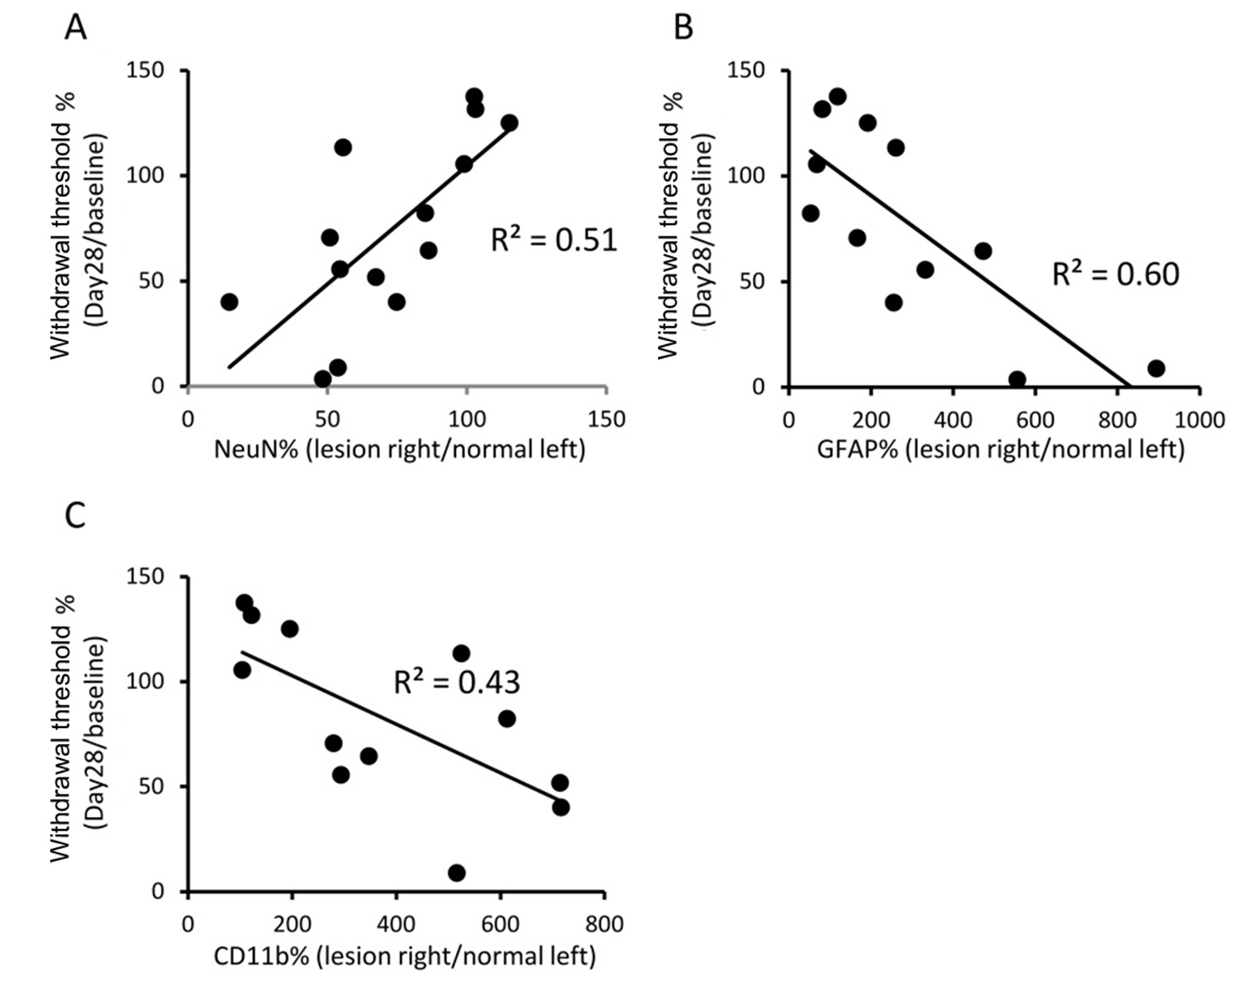
Supplementary Figure S3. Correlation between von Frey test results and changes in cellular composition post-lesion. Twenty-eight days after the injection of saline or collagenase into the VB complex, the animals were sacrificed, and NeuN (A), GFAP (B), and CD11b (C) immunostaining was performed. The changes in cellular composition were calculated as the cell number on the lesion side divided by the cell number on the contralateral side (i.e., left side; mirror area of right lesion area). Changes in mechanical sensitivity were calculated as the mechanical threshold of the left hind limb divided by the left hind limb’s baseline mechanical threshold. Scatter plots of changes in cellular composition and mechanical thresholds were generated. The correlation coefficients of two factors are presented.

Supplementary Figure 4. Effect of TrkB-Fc and BDNF antagonist on thermal pain sensitivity in CPSP

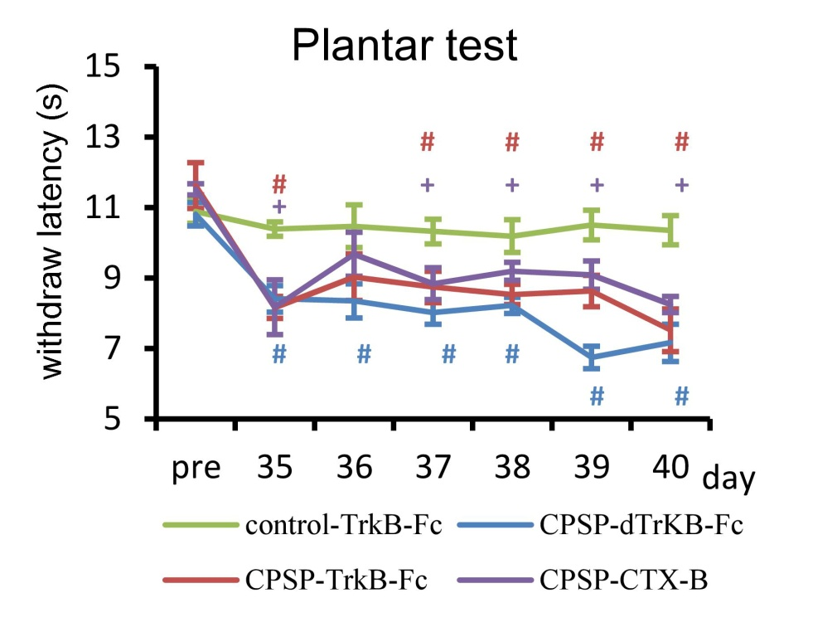
Supplementary Figure S4. Effect of TrkB-Fc and BDNF antagonist on thermal pain sensitivity in CPSP. In the plantar test, a 4 × 6 mixed two-way ANOVA indicated that the control-TrkB-Fc, CPSP-dTrkB-Fc, CPSP-TrkB-Fc, and CPSP-CTX-B groups were significantly different (F_{3,22} = 19.97, p < 0.05), with a significant effect of Days (F_{5,110} = 2.77, p < 0.05) but no Group × Days interaction (F_{15,110} = 1.12, p > 0.05). Tukey’s post hoc test indicated that thermal thresholds in the control-TrkB-Fc group were not altered by the TrkB-Fc injection. Thermal thresholds in the control-TrkB-Fc group were significantly different from the CPSP-TrkB-Fc, CPSP-dTrkB-Fc, and CPSP-CTX-B groups over days 35-40 (all p < 0.05). Thermal allodynia in the CPSP-TrkB-Fc and CPSP-CTX-B groups was not significantly different from the CPSP-dTrkB-Fc group on days 35-40 (both p > 0.05). These data indicate that thermal allodynia in CPSP animals was not reduced by TrkB-Fc or CTX-B treatment.

Supplementary Table S1. Primer pairs for RT-PCR and real-time qPCR.

Target | Forward primer (5’-3’) | Reverse primer (3’-5’)
GAPDH | TGATTCTACCCACGGCAAGTT | TGATGGGTTTCCCATTGATGA
BDNF | ATTGGCTGGCGATTCATAAG | GTTTCCCTTCTGGTCATGGA
iNOS | TATGCCGAGATTCTTGCTCA | AATTTAAGCTGCCCACGAGA
vCAM1 | CAAGCGAATGCAGCTGTTTA | CTGTGATGCCGTAGAGGACA
TNFα | AATACCGTGACGCCTGTTTC | ACTAATGCCGTCGCGATAAT
IL-6 | CTACGAACCGATTTGGGCTA | CCGCCGTATTGGATAATCAC
IFNγ | GTACGGATGCGGTAATGCTT | ACCTTCCATACGGTGACGAG
IL-10 | CGCAAATCAAAGCACGAGTA | ACCGGCTAATTTTGCAACAC
IL-1β | CGTGTTGCAAAAACGATGAC | GCATAAAGCCGGCAAATAAG

