SUPPLEMENTARY MATERIALS
Supplementary methods
In a supplemental set of analyses, we explored whether accounting for potential nonlinear associations between sensory stimuli and autonomic responses [3,5] would lead to different conclusions from those derived from the models described above. Researchers have characterized the non-linear relationship between stimulation and pain using power functions which one can model linearly using log-transformations of both predictor and predictand variables [1,4]. Adapting established log-transformation procedures for heat pain sensory testing [2,4], we used a temperature of 32°C to baseline-correct the stimulus temperature variable. To ensure positive values on all our variables as log-transformation requires, we added .1 (on 10-point VAS) to the pain variable in the ASC and 1 (on 100-point VAS) to the thermal intensity variable in the TSPA, and set negative and zero values of AUC variables to 1 and of autonomic response amplitudes to 0.01. The resulting model can be depicted as follows:
log(AR) = b₀ + b₁ log(T – t₀) + b₂ log(I + i)
with AR denoting the autonomic response using measures of SCR and PDR AUC, amplitude, and latency; t₀ denoting the baseline temperature of 32°C which we used to baseline-correct the stimulus temperature variable T; and i denoting a 0.1 unit in the adaptive staircase and 1 unit in the two-step pain assessment which we added to the thermal intensity variable I. When testing interactions with thermal stimulus categorization (painful vs. nonpainful), we added the categorization variable and the multiplicative terms of the categorization variable with the log-transformed temperature or the intensity variables to the regression model. Using the same procedures as in our previous mediation analyses, we calculated mediation model coefficients while controlling for nonlinear associations of temperature and intensity with ANS responses.

Supplementary results
Modelling non-linearity in the independent associations of objective and subjective stimulation intensity with autonomic responses. Log-transforming variables did not substantially change results in the ASC data. Pain still statistically mediated the effect of temperature on SCR and PDR AUC (paths a*b), and continued to predict both SCR and PDR AUC when controlling for stimulus temperature (paths b). As when using non-transformed model variables, controlling for pain substantially weakened the effect of temperature on SCR and PDR AUC (paths c’). Complete details are reported in Supplemental Table 4 and conclusions do not vary from those made using non-transformed variables.
Similarly, log-transforming the TSPA data also led to the same conclusions as the basic linear mediation analyses reported in the main paper. The log-transformed intensity × categorization interaction remained significant when controlling for the log-transformed temperature × categorization interaction (paths b). When restricting analyses in the TSPA to stimulation categorized as painful, perceived intensity still statistically mediated the effect of temperature on SCR AUC (path a*b). In contrast, when restricting analyses to stimulation categorized as nonpainful, intensity still did not statistically mediate the effect of temperature on SCR AUC (path a*b). It is noteworthy that intensity mediated the effect of temperature on other SCR indicators, consistent with analogous analyses using non-transformed model variables. Complete results from log-transformed mediation analyses are reported in Supplemental Table 4.
Taken together, these findings suggest that non-linearity in the modelled associations cannot account for the association between perceived stimulation intensity and autonomic responses over and above stimulus temperature.
Effects of pain categorization on autonomic responses within constant temperature ranges. Our moderated mediation analysis results suggest that simply characterizing a stimulus as painful increases SCR and pain, and that temperature effects on arousal are consistently mediated by subjective intensity only when temperatures are characterized as painful. However, temperature could be a confound in these analyses, e.g., if high temperatures are always characterized as painful and low temperatures are always characterized as non-painful. This would prevent us from making meaningful inferences on the effects of categorization per se. Thus, to rule out this possibility, we tested effects of stimulus categorization within restricted temperature ranges. Specifically, we created different temperature intervals and limited analyses to participants who had provided both painful and nonpainful ratings in a given interval to calculate within person effects of stimulus categorization. As reported in Table 2, we found no significant effect of categorization on any SCR measure for temperatures below 41 degrees. Overall, SCR AUC did not differ as a function of categorization within restricted ranges. However, particularly in the medium and high temperature range (44 to 50°C) we found that SCR amplitudes and latencies were elevated when thermal stimuli were characterized as painful relative to nonpainful, probably because temperature stimulus categorization predicted SCR AUC after the heat episode. In addition, stimulus categorization predicted SCR amplitude even at the 41 to 44°C temperature range. Furthermore, we found significant effects of categorization during peak heat (SCR AUC from 4 to 8 sec) in the high temperature range (47 to 50°C). Thus, in the medium to high temperature range, simply categorizing a stimulus as painful increased features of the autonomic response to the stimulus. Because we conducted analyses within different temperature ranges and thus held temperature constant, we ruled out the possibility that effects of stimulus categorization on the autonomic response are due to a positive association between stimulus categorization and temperature.
Effects of stimulation duration within the ASC task. Trial length (10 vs 8 seconds) did not moderate the effect of temperature (B = -6.27, SE = 170.10, t = -0.04, P = 0.971) or pain (B = -248.35, SE = 198.58, t = -1.25, P = 0.216) on SCR area under the curve (AUC). Intercepts in these analyses indicated that trial length alone did not predict SCR AUC (Bs ≤ 1759.79, SEs ≥ 5038.4, ts = 0.35, Ps = 0.728). Similarly, trial length did not moderate the effect of temperature (B = -7607.60, SE = 10,685.65, t = -0.74, P = 0.479) or pain (B = -4505.13, SE = 14,480.71, t = -0.31, P = 0.767) on PDR AUC. Again, intercepts in these analyses indicated that trial length alone did not predict PDR AUC (Bs ≤ 47,632.12, SEs ≥ 281,933.80, ts ≤0.17, Ps ≥ 0.866).

Supplementary references

[1] Adair ER, Stevens JC, Marks LE. Thermally induced pain, the dol scale, and the psychophysical power law. Am. J. Psychol. 1968;81:147–164.
[2] Coghill RC. Wide dynamic range but not nociceptive-specific neurons encode multidimensional features of prolonged repetitive heat pain. J. Neurophysiol. 1993;69:703.
[3] Fechner GT. Elemente der Psychophysik. Leipzig: Breitkopf und Härtel, 1860.
[4] Price DD, McGrath PA, Rafii A, Buckingham B. The validation of visual analogue scales as ratio scale measures for chronic and experimental pain. Pain 1983;17:45–56.
[5] Stevens SS. To honor Fechner and repeal his law. Science 1961;133:80–86.

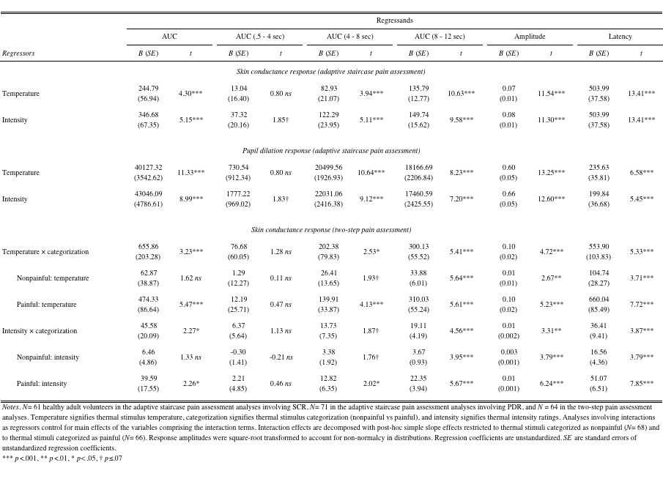
Supplementary Table 1. Stimulus temperature and thermal intensity predicting autonomic arousal responses (adaptive staircase and two-step pain assessments).

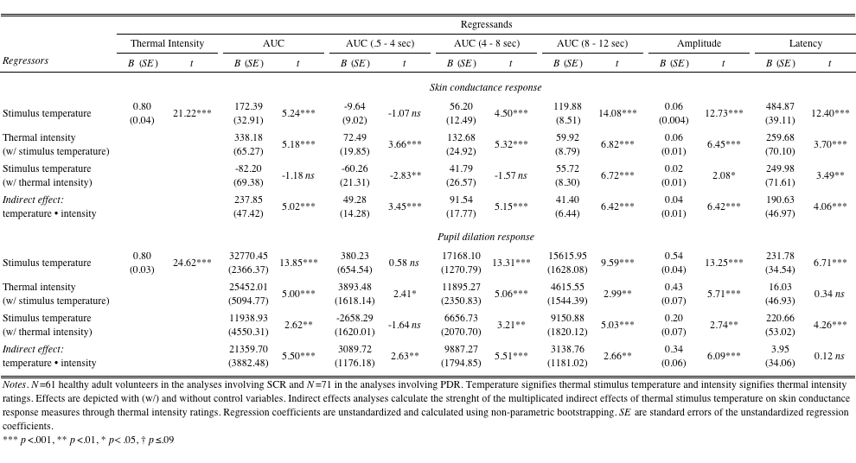
Supplementary Table 2. Process analyses predicting skin conductance and pupil dilation responses (adaptive staircase pain assessment).

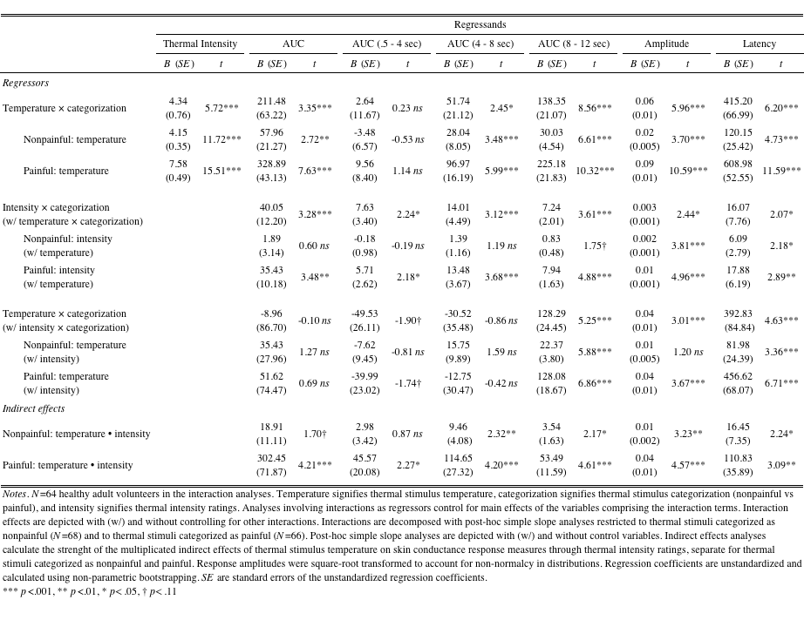
Supplementary Table 3. Process analyses including post-hoc simple slope analyses predicting skin conductance responses to heat stimulation (two-step pain assessment).

Supplementary Table 4. Modelling non-linearity in the unique associations of actual and perceived stimulus intensity with autonomic responses (adaptive staircase and two-step pain assessments).
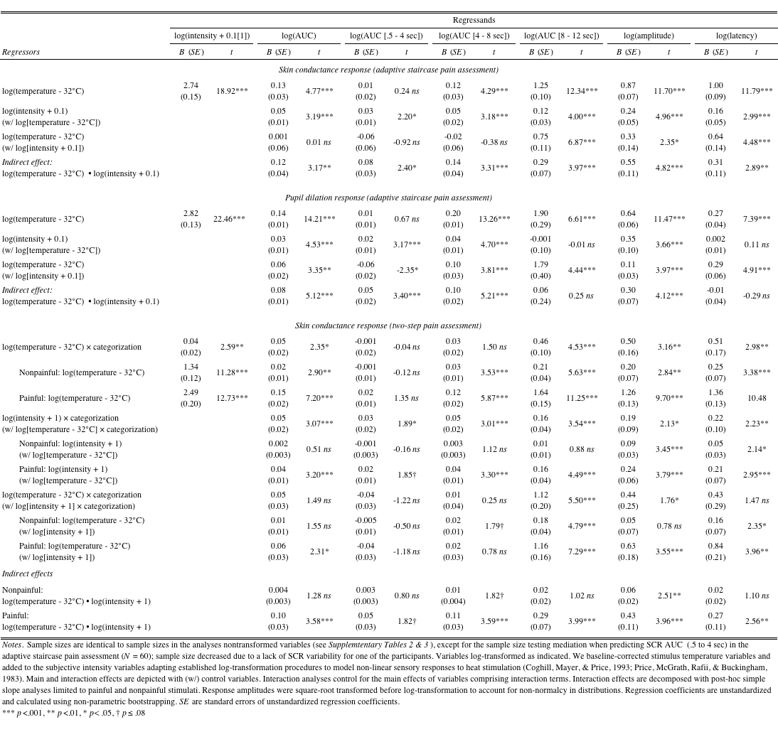

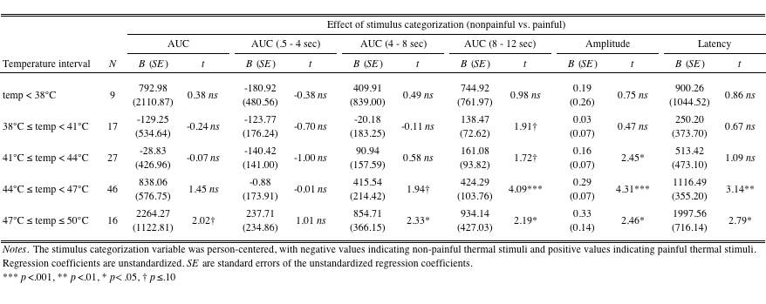
Supplementary Table 5. Thermal stimulus categorization predicting SCR separately by temperature interval (two-step pain assessment).

