**Supplementary appendix to:**

**Cannabis and cannabinoids for the treatment of people with chronic non-cancer pain conditions:**

**A systematic review and meta-analysis of controlled and observational studies**

Contents

PRISMA checklist 4

Review protocol: Cannabis and cannabinoids for medical purposes: a systematic review for the treatment of chronic non-cancer pain 6

Appendix A: Search terms 11

Table A1*.* Medline search strategy – pain review of reviews 11

Table A2. Medline search strategy – neuropathic pain 12

Table A3. Medline search strategy – arthritis 13

Table A4. Medline search strategy – fibromyalgia 14

Table A5. Medline search strategy – chronic non-cancer pain 15

Appendix B: Included and excluded studies 17

Figure B1. PRISMA flowchart for the systematic review of reviews 17

Table B1. Characteristics of included observational studies, n = 57 18

Table B2: Ongoing trials and trials for which results are not yet reported 33

Table B3. List of studies excluded at full text review stage and reasons for exclusion 40

Table B4. Characteristics of cannabis and cannabinoids used in interventions 53

Appendix C: Risk of bias in included studies 58

Figure C1. Randomised controlled trials risk of bias graph: review authors’ judgements about each risk of bias item presented as percentages across all included studies 58

Figure C2. Randomised controlled trials risk of bias summary: review authors’ judgements about each risk of bias item for each included study 59

Table C3. Observational studies and non- controlled trials risk of bias graph: review authors’ judgements about each risk of bias item presented as percentages across all included studies 60

Appendix D: Outcomes 61

Table D1. Reporting of IMMPACT outcomes for randomised controlled trials (n = 47) 61

Table D2. Reporting of IMMPACT outcomes for observational studies (n = 57) 64

Appendix E: Additional results tables and figures 68

Table E1: Effect sizes for pain-related outcomes from meta-analyses of RCTs and observational studies of cannabis or cannabinoids in chronic non-cancer pain, by cannabinoid, outcome type and comparator, with associated GRADE rating 68

Table E2: Effect sizes for other outcomes from meta-analyses of RCTs and observational studies of cannabis or cannabinoids in CNCP, by outcome type, CNCP condition and comparator, with associated GRADE rating 70

Table E3: Effect sizes for other outcomes from meta-analyses of RCTs and observational studies of cannabis or cannabinoids in CNCP, by outcome type, cannabinoid, and comparator, with associated GRADE rating 74

Table E4: Effect sizes for adverse events (all-cause, serious and treatment-related) and study withdrawals (all-cause, adverse events and lack of efficacy) from meta-analyses of RCTs and observational studies of cannabis or cannabinoids in chronic non-cancer pain, by cannabinoid, dose, outcome type and comparator, with associated GRADE rating 77

Figure E1: Forest plot for RCT study evidence for impact of cannabis or cannabinoids used for treatment of CNCP upon 30% reduction in pain, by pain type 80

Figure E1.1: Forest plot for RCT study evidence for impact of cannabis or cannabinoids used for treatment of CNCP upon 30% reduction in pain, by study risk of bias 81

Figure E1.1a: Forest plot for RCT study evidence for impact of cannabis or cannabinoids used for treatment of CNCP upon 30% reduction in pain, by study risk of bias based on sample size 82

Figure E1.2: Forest plot for RCT study evidence for impact of cannabis or cannabinoids used for treatment of CNCP upon 30% reduction in pain, by study intervention length 83

Figure E2: Forest plot for RCT study evidence for impact of cannabis or cannabinoids used for treatment of CNCP upon 50% reduction in pain, by pain type 84

Figure E2.1: Forest plot for RCT study evidence for impact of cannabis or cannabinoids used for treatment of CNCP upon 50% reduction in pain, by study risk of bias 85

Figure E2.1a: Forest plot for RCT study evidence for impact of cannabis or cannabinoids used for treatment of CNCP upon 50% reduction in pain, by study risk of bias based on sample size 86

Figure E2.2: Forest plot for RCT study evidence for impact of cannabis or cannabinoids used for treatment of CNCP upon 50% reduction in pain, by study intervention length 87

Figure E3: Forest plot for RCT study evidence for impact of cannabis or cannabinoids used for treatment of CNCP upon pain intensity, by pain type 88

Figure E3.1: Forest plot for RCT study evidence for impact of cannabis or cannabinoids used for treatment of CNCP upon pain intensity, by study risk of bias 89

Figure E3.1a: Forest plot for RCT study evidence for impact of cannabis or cannabinoids used for treatment of CNCP upon pain intensity, by study risk of bias based on sample size 90

Figure E3.2: Forest plot for RCT study evidence for impact of cannabis or cannabinoids used for treatment of CNCP upon pain intensity, by study intervention length 91

Figure E3.3: Forest plot for RCT study evidence for impact of cannabis or cannabinoids used for treatment of CNCP upon pain intensity, by study imputation method 92

Figure E5. Forest plot for the proportion of participants achieving 30% reduction in pain in observational studies, and cross-over trials that were not amenable to meta-analysis, by cannabinoid type 93

Figure E6: Forest plot for RCT study evidence for impact of cannabis or cannabinoids used for treatment of CNCP upon physical functioning 94

Figure E7: Forest plot for RCT study evidence for impact of cannabis or cannabinoids used for treatment of CNCP upon sleep problems 95

Figure E8: Forest plot for RCT study evidence for impact of cannabis or cannabinoids used for treatment of CNCP upon quality of life 96

Figure E9: Forest plot for RCT study evidence for impact of cannabis or cannabinoids used for treatment of CNCP upon overall emotional functioning 97

Figure E10: Forest plot for RCT study evidence for impact of cannabis or cannabinoids used for treatment of CNCP upon depression scores 98

Figure E11: Forest plot for RCT study evidence for impact of cannabis or cannabinoids used for treatment of CNCP upon anxiety scores 99

Figure E12: Forest plot for RCT study evidence for impact of cannabis or cannabinoids used for treatment of CNCP upon patient global impression of change (continuous outcome) 100

Figure E13. Forest plot for RCT study evidence for impact of cannabis or cannabinoids used for treatment of CNCP upon patient global impression of change (dichotomous outcome) 101

Appendix F: Findings for Observational studies and cross-over trials where comparative meta-analysis was not possible 102

30% reduction in pain 102

50% reduction in pain 102

Change in pain intensity 103

Appendix G: Summary of the statistics and metrics used in this review 105

References 106

# PRISMA checklist

| **Section/topic** | **#** | **Checklist item** | **Reported on page #** |
| --- | --- | --- | --- |
| **TITLE** | | |  |
| Title | 1 | Identify the report as a systematic review, meta-analysis, or both. | 1 |
| **ABSTRACT** | | |  |
| Structured summary | 2 | Provide a structured summary including, as applicable: background; objectives; data sources; study eligibility criteria, participants, and interventions; study appraisal and synthesis methods; results; limitations; conclusions and implications of key findings; systematic review registration number. | 2 |
| **INTRODUCTION** | | |  |
| Rationale | 3 | Describe the rationale for the review in the context of what is already known. | 3 |
| Objectives | 4 | Provide an explicit statement of questions being addressed with reference to participants, interventions, comparisons, outcomes, and study design (PICOS). | 3 |
| **METHODS** | | |  |
| Protocol and registration | 5 | Indicate if a review protocol exists, where it can be accessed, and, if available, provide registration information including registration number. | 4 |
| Eligibility criteria | 6 | Specify study characteristics (e.g., PICOS, length of follow-up) and report characteristics (e.g., years considered, language, publication status) used as criteria for eligibility, giving rationale. | 4, appendix |
| Information sources | 7 | Describe all information sources (e.g., databases with dates of coverage, contact with study authors to identify additional studies) in the search and date last searched. | 4, appendix |
| Search | 8 | Present full electronic search strategy for at least one database, including any limits used, such that it could be repeated. | Appendix |
| Study selection | 9 | State the process for selecting studies (i.e., screening, eligibility, included in systematic review, and, if applicable, included in the meta-analysis). | 5 |
| Data collection process | 10 | Describe method of data extraction (e.g., piloted forms, independently, in duplicate) and any processes for obtaining and confirming data from investigators. | 6-7 appendix |
| Data items | 11 | List and define all variables for which data were sought (e.g., PICOS, funding sources) and any assumptions and simplifications made. | 7-8 |
| Risk of bias in individual studies | 12 | Describe methods used for assessing risk of bias of individual studies (including specification of whether this was done at the study or outcome level), and how this information is to be used in any data synthesis. | 6 |
| Summary measures | 13 | State the principal summary measures (e.g., risk ratio, difference in means). | 7-8, Appendix |
| Synthesis of results | 14 | Describe the methods of handling data and combining results of studies, if done, including measures of consistency (e.g., I2) for each meta-analysis. | 7-8, Appendix |
| Risk of bias across studies | 15 | Specify any assessment of risk of bias that may affect the cumulative evidence (e.g., publication bias, selective reporting within studies). | Appendix |
| Additional analyses | 16 | Describe methods of additional analyses (e.g., sensitivity or subgroup analyses, meta-regression), if done, indicating which were pre-specified. | 7-8, |
| **RESULTS** | | |  |
| Study selection | 17 | Give no. studies screened, assessed for eligibility, and included in the review, with reasons for exclusions at each stage, ideally with a flow diagram. | 9 |
| Study characteristics | 18 | For each study, present characteristics for which data were extracted (e.g., study size, PICOS, follow-up period) and provide the citations. | Appendix |
| Risk of bias within studies | 19 | Present data on risk of bias of each study and, if available, any outcome level assessment (see item 12). | Appendix |
| Results of individual studies | 20 | For all outcomes considered (benefits or harms), present, for each study: (a) simple summary data for each intervention group (b) effect estimates and confidence intervals, ideally with a forest plot. | Appendix |
| Synthesis of results | 21 | Present results of each meta-analysis done, including confidence intervals and measures of consistency. | 11-14, Appendix |
| Risk of bias across studies | 22 | Present results of any assessment of risk of bias across studies (see Item 15). | Appendix |
| Additional analysis | 23 | Give results of additional analyses, if done (e.g., sensitivity or subgroup analyses, meta-regression [see Item 16]). | Appendix |
| **DISCUSSION** | | |  |
| Summary of evidence | 24 | Summarize the main findings including the strength of evidence for each main outcome; consider their relevance to key groups | 15-16 |
| Limitations | 25 | Discuss limitations at study and outcome level (e.g., risk of bias), and at review-level (e.g., incomplete retrieval of identified research, reporting bias). | 16-17 |
| Conclusions | 26 | Provide a general interpretation of the results in the context of other evidence, and implications for future research. | 17 |
| **FUNDING** | | |  |
| Funding | 27 | Describe sources of funding for the systematic review and other support (e.g., supply of data); role of funders for the systematic review. | 18-19 |

# Review protocol: Cannabis and cannabinoids for medical purposes: a systematic review for the treatment of chronic non-cancer pain

**Question**

The aim of the review is to identify all clinical trials conducted that examine treatment of chronic non-cancer pain with cannabinoids in humans, focusing on those trials that present high-quality evidence, and looking for agreement, inconsistency and gaps in the published literature to guide clinicians and policy makers on the use of therapeutic cannabinoids for chronic non-cancer pain.

**Searches**

Databases searched were Embase, The Cochrane Library, PsycINFO and MEDLINE.

The databases were searched with the terms below (and their corresponding subject headings in each database where specialised thesauri existed):

1. Cannabis or marijuana or cannabinoids or endocannabinoids or dronabinol or nabilone or marinol or levonantradol or tetrahydrocannabinol or cesamet or delta-9-THC or delta-9-tetrahydrocannabinol or nabiximols or sativex pr cannabidiol

2. therapeutic use or drug therapy or analgesics

3. 1 and 2

4. (medical or medicinal) adj (mari?uana or cannab*) or "medical mari?uana" or "medicinal cannabis"

5. 3 or 4

6. chronic pain.mp. or exp Chronic Pain/ or chronic non-cancer pain.mp.

7. 5 and 6

The searches limited to studies published from 1980 to current (2017).

**Types of study to be included**

We will include both experimental and epidemiological study designs including randomized controlled trials, non-randomized controlled trials, quasi-experimental, before and after studies, prospective and retrospective cohort studies, case control studies and analytical cross-sectional studies for inclusion. We will also include observational studies, self-report, and N-of-1 studies.

**Condition or domain being studied**

CNCP conditions are prevalent, and rank among the most significant causes of disability globally. In this review, chronic non-cancer pain is defined as persistent pain for a period of three months or more in the last 6 months not attributed to cancer or the end of life ([10]). Some common examples of CNCP include MS-related pain, Parkinson’s disease-related pain, spinal cord injury and visceral pain (e.g. pain due to irritable bowel syndrome).

Separate reviews were conducted for the following specific pain conditions: neuropathic pain (PROSPERO registration: CRD42017065248), fibromyalgia (PROSPERO registration: CRD42017067057) and arthritis (PROSPERO registration: CRD42017067059).

**Participants/population**

The review will consider clinical trials that include participants of any age, with any form of chronic non-cancer pain.

**Intervention(s), exposure(s)**

The review will consider studies that evaluate plant based and pharmaceutical cannabinoids administered to treat neuropathic pain. The review will consider studies of: tetrahydrocannabinol; cannabidiol; combination tetrahydrocannabinol + cannabidiol; cannabis sativa; and where evidence exists, other cannabinoids e.g. tetrahydrocannabinolic acid (thca), cannabidiolic acid, cannabidivarin, and the synthetic delta-9-tetrahydrocannabinol formulations nabilone and dronabinol).

**Comparator(s)/control**

Where possible, comparisons will be made to

1. Placebo

2. Active comparators.

**Primary outcome(s)**

• Patient function (as measured by the BPI interference scale or other comparable measure of functioning)

• Patient-reported pain intensity reduction by 30% or greater

• Patient-reported pain intensity reduction by 50% or greater• Patient-reported change in overall pain intensity

**Secondary outcome(s)**

• Physical functioning (e.g. change in quality of sleep, fatigue etc.)

• Emotional functioning (e.g. anxiety, depression and mood)

• Patient-reported global impression of clinical change

• Adverse events (include serious adverse events and treatment-related adverse events)

• Withdrawals

**Data extraction (selection and coding)**

Full text studies considered eligible by two reviewers will be assessed for quality by one reviewer, with quality ratings checked by a second review. An evidence grade will be given to each reported analysis, based on the Grades of Recommendation, Assessment, Development and Evaluation (GRADE) scale.

**Risk of bias (quality) assessment**

As the review contains both randomized controlled trials, and nonrandomized methods, an adapted version of the standard GRADE tool will be used, as suggested by others ([191]). Methodological quality ratings for risk of bias in randomized controlled trials will describe the methodological quality using the Cochrane risk of bias tool ([98]). Observational or case study reports will be evaluated using an adapted version of the Cochrane risk of bias tool specific to observational studies (ROBINS-I; [228]). Any disagreements that arise between the reviewers will be resolved through discussion, or with a third reviewer. The final review will contain an appendix that will have the scores for each included trial or report on each domain measured by the respective tools.

**Strategy for data synthesis**

Key findings of studies will first be summarised descriptively before considering if studies are appropriate for quantitative meta-analysis. We will contact study authors if we require additional information to enable inclusion of studies in meta-analyses.

Statistical analysis will be undertaken using Review Manager 5.3.

The outcomes of the individual trials will be combined through meta-analysis where possible (depending on the comparability of interventions and outcomes between trials) with the use of a random-effects model, as some variability is expected in the included studies. Where meta-analysis is not possible a narrative synthesis of the findings will be reported.

Review findings will be synthesized to highlighting where multiple studies find consistent effects and where studies have come to different conclusions about the strength of the evidence. This will involve the aggregation or synthesis of findings to generate a set of statements that represent that aggregation, through assembling the findings rated according to their quality, and categorizing these findings based on similarity in outcomes. Where possible, a meta-analysis will be performed to estimate the effect size of treatment.

Assessment of heterogeneity

We will consider clinical heterogeneity (variability in the participants, interventions and outcomes studied) and methodological heterogeneity (variability in study design and risk of bias).

Meta-analysis will be considered if a group of studies are sufficiently homogeneous in terms of participants, interventions and outcomes to provide a meaningful summary. Where this is not the case, and the heterogeneity of the included studies precludes a meta-analysis being performed, the relevant studies will be described separately.

To assess heterogeneity, initially we will inspect the results graphically. Heterogeneity was assessed using the I2 statistic, and described as low (≤25%), moderate (>25% and ≤50%) or high (≥75%) ([98]).

Assessment of reporting biases

If a meta-analysis is conducted, funnel plots (plots of the effect estimate from each study against the standard error) will be used to assess the potential for bias related to the size of the trials, which could indicate possible publication bias.

When there appears to be selective outcome reporting, we will contact the study authors to request additional information.

Sensitivity analysis

Where the effect of a decision on the outcome of the review is uncertain (for example, the decision to include or exclude a study remains unclear, or the impact of unavailable data on the findings is uncertain), sensitivity analysis will be conducted, with the results described in a summary table (see Cochrane Handbook section 9.7 ([98]).

To incorporate risk of bias assessment in the review process we will first plot intervention effect estimates for different outcomes stratified for risk of bias for each item. If differences in results are present among studies at different risk of bias, we will perform sensitivity analysis, excluding studies at a high risk of bias. We will also perform subgroup analysis for studies at a low and unclear risk of bias.

**Analysis of subgroups or subsets**

If sufficient studies are included in the review, the following subgroups of participants will be examined and investigated for potential sources of heterogeneity:

1. Type of neuropathic pain

2. Concurrent treatments.

**Contact details for further information**

Emily Stockings

e.stockings@unsw.edu.au

**Organisational affiliation of the review**

National Drug and Alcohol Research Centre, The University of New South Wales

**Review team members and their organisational affiliations**

Dr Gabrielle Campbell. National Drug and Alcohol Research Centre, The University of New South Wales

Professor Wayne Hall. Centre for Youth Substance Abuse Research, The University of Queensland

Dr Suzanne Neilsen. National Drug and Alcohol Research Centre, The University of New South Wales

Mr Dino Zagic. National Drug and Alcohol Research Centre, The University of New South Wales Mr Rakin Rahman. National Drug and Alcohol Research Centre, The University of New South Wales

Professor Michael Farrell. National Drug and Alcohol Research Centre, The University of New South Wales

Dr Megan Weier. National Drug and Alcohol Research Centre, The University of New South Wales  
Professor Louisa Degenhardt. National Drug and Alcohol Research Centre, The University of New South Wales

**Collaborators**

Professor Bridin Murnion. The University of Sydney

**Anticipated or actual start date**

20 February 2017

**Anticipated completion date**

31 December 2017

**Funding sources/sponsors**

Funding was received from the Health Products Regulation Group, Commonwealth Department of Health, who determined the topics and scope of the reviews to be conducted. SN and LD are supported by NHMRC research fellowships (#1132433 and #1041472). The National Drug and Alcohol Research Centre at the University of NSW is supported by funding from the Australian Government under the Substance Misuse Prevention and Service Improvements Grant Fund

**Conflicts of interest**

SN, MF and LD have all been investigators on untied investigator-driven educational grants funded by Reckitt Benckiser. MF and LD have received an untied educational grant from Mundipharma for post-marketing surveillance studies of Reformulated OxyContin®. SN, MF and LD have been investigators on untied investigator-driven educational grants funded by Indivior. SN and MF are named investigators on a current funding application where INSYS Pharmaceuticals have indicated support to provide investigational drug if the grant is awarded.

**Language**

English

**Country**

Australia

**Stage of review**

Review_Ongoing

**Subject index terms**

Analgesics; Cannabinoids; Cannabis; Humans; Neuralgia

# Appendix A: Search terms

## Table A*.* Medline search strategy – pain review of reviews

|  |  |  |
| --- | --- | --- |
| MEDLINE | |  |
| # | **Searches** | **Results** |
| 1 | exp Cannabinoids/ | 11577 |
| 2 | exp Cannabis/ | 7439 |
| 3 | cannab*.mp. | 31779 |
| 4 | marijuana.mp. | 15239 |
| 5 | marinol.mp. | 84 |
| 6 | dronabinol.mp. | 6304 |
| 7 | nabilone.mp. | 273 |
| 8 | levonantradol.mp. | 70 |
| 9 | tetrahydrocannabinol.mp. | 5897 |
| 10 | cesamet.mp. | 18 |
| 11 | delta-9-THC.mp. | 1209 |
| 12 | delta-9-tetrahydrocannabinol.mp. | 3355 |
| 13 | nabiximols.mp. | 61 |
| 14 | sativex.mp. | 140 |
| 15 | cannabidiol.mp. or exp Cannabidiol/ | 1651 |
| 16 | or/1-15 | 41178 |
| 17 | "therapeutic use".mp. or exp Therapeutic Uses/ | 4747283 |
| 18 | drug therapy.mp. or exp Drug Therapy/ | 1206414 |
| 19 | analgesics.mp. or exp Analgesics/ | 488299 |
| 20 | exp Analgesia/ | 39349 |
| 21 | or/17-20 | 5220311 |
| 22 | "medical marijuana".mp. or exp Medical Marijuana/ | 795 |
| 23 | "medicinal cannabis".mp. | 93 |
| 24 | "medical mari?uana".mp. | 796 |
| 25 | ((medical or medicinal) adj (mari?uana or cannab*)).mp. | 974 |
| 26 | or/22-25 | 974 |
| 27 | 16 and 21 | 16747 |
| 28 | 26 or 27 | 17502 |
| 29 | meta-analysis.mp. or exp Meta-Analysis/ | 120968 |
| 30 | exp Meta-Analysis as Topic/ | 15462 |
| 31 | metaanalysis.tw. | 1340 |
| 32 | exp "Review"/ | 2207349 |
| 33 | review.ti. | 338747 |
| 34 | exp "Review Literature as Topic"/ | 9111 |
| 35 | cochrane.ti. | 2103 |
| 36 | or/29-35 | 2404605 |
| 37 | pain.mp. or exp Pain/ | 654060 |
| 38 | chronic pain.mp. or exp Chronic Pain/ | 30664 |
| 39 | exp Neuralgia/ or neuralgia.mp. | 26386 |
| 40 | "neuropathic pain".tw. | 14568 |
| 41 | "cancer pain".tw. | 6156 |
| 42 | or/37-41 | 659290 |
| 43 | 28 and 36 and 42 | 422 |
| 44 | limit 43 to yr="1980 -Current" | 422 |
| 45 | (animals not (humans and animals)).sh. | 4292843 |
| 46 | 44 not 45 | 415 |
| 47 | limit 46 to (congresses or editorial or letter) | 2 |
| 48 | 46 not 47 | 413 |
| 49 | remove duplicates from 48 | 395 |

## Table A2. Medline search strategy – neuropathic pain

|  |  |  |
| --- | --- | --- |
| MEDLINE |  |  |
| # | **Search** |  |
| 1 | cannabis.mp. or exp Cannabis/ | 14595 |
| 2 | marijuana.mp. or exp cannabis/ | 18938 |
| 3 | cannabinoids.mp. or exp Cannabinoids/ | 13443 |
| 4 | endocannabinoids.mp. or exp Endocannabinoids/ | 5561 |
| 5 | endocannabinoid.mp. | 4774 |
| 6 | dronabinol.mp. or exp Dronabinol/ | 6234 |
| 7 | dronabinol.mp. | 6234 |
| 8 | nabilone.mp. | 240 |
| 9 | marinol.mp. | 75 |
| 10 | levonantradol.mp. | 68 |
| 11 | tetrahydrocannabinol.mp. or exp tetrahydrocannabinol/ | 7565 |
| 12 | cesamet.mp. | 13 |
| 13 | delta-9-THC.mp. | 1137 |
| 14 | delta-9-tetrahydrocannabinol.mp. | 3121 |
| 15 | nabiximols.mp. | 46 |
| 16 | sativex.mp. | 118 |
| 17 | cannabidiol.mp. or exp Cannabidiol/ | 1478 |
| 18 | 1 or 2 or 3 or 4 or 5 or 6 or 7 or 8 or 9 or 10 or 11 or 12 or 13 or 14 or 15 or 16 or 17 | 35422 |
| 19 | drug therapy.mp. or exp Drug Therapy/ | 1220769 |
| 20 | analgesics.mp. or exp Analgesics/ | 488481 |
| 21 | prescription drugs.mp. or exp Prescription Drugs/ | 7051 |
| 22 | analgesic drugs.mp. | 1950 |
| 23 | medical marijuana.mp. or exp Medical Marijuana/ | 717 |
| 24 | medicinal marijuana.mp. | 49 |
| 25 | medical cannabis.mp. | 103 |
| 26 | medicinal cannabis.mp. | 72 |
| 27 | 19 or 20 or 21 or 22 or 23 or 24 or 25 or 26 | 1622876 |
| 28 | factorial*.ti,ab. | 20141 |
| 29 | random*.ti,ab. | 790677 |
| 30 | (crossover* or "cross over" or cross-over*).ti,ab. | 64205 |
| 31 | placebo*.ti,ab. | 173954 |
| 32 | double blind.tw. | 117610 |
| 33 | single blind.tw. | 10294 |
| 34 | randomized controlled trial.mp. or exp Randomized controlled Trial/ | 457420 |
| 35 | assign*.ti,ab. | 223824 |
| 36 | allocat*.ti,ab. | 78597 |
| 37 | "evaluation study".mp. or exp evaluation/ | 899548 |
| 38 | intervention.mp. | 397923 |
| 39 | treatment effectiveness evaluation.mp. | 8 |
| 40 | prospective study.mp. or exp Prospective Studies/ | 466961 |
| 41 | Comparative Study/ | 1770599 |
| 42 | "comparative study".ti,ab. | 59360 |
| 43 | N-of-1.mp. | 49100 |
| 44 | Clinical trials.mp. | 330100 |
| 45 | 28 or 29 or 30 or 31 or 32 or 33 or 34 or 35 or 36 or 37 or 38 or 39 or 40 or 41 or 42 or 43 or 44 | 4140553 |
| 46 | neuropathic pain.mp. or exp Neuralgia/ | 24095 |
| 47 | neuropathy.mp. | 56223 |
| 48 | 46 or 47 | 77377 |
| 49 | 18 and 27 and 45 and 48 | 125 |
| 50 | limit 49 to yr="1980 -Current" | 125 |
|  |  |  |

## Table A3. Medline search strategy – arthritis

|  |  |  |
| --- | --- | --- |
| MEDLINE | |  |
| 1 | cannabis.mp. or exp Cannabis/ | 14595 |
| 2 | marijuana.mp. or exp cannabis/ | 18938 |
| 3 | cannabinoids.mp. or exp Cannabinoids/ | 13443 |
| 4 | endocannabinoids.mp. or exp Endocannabinoids/ | 5561 |
| 5 | endocannabinoid.mp. | 4774 |
| 6 | dronabinol.mp. or exp Dronabinol/ | 6234 |
| 7 | dronabinol.mp. | 6234 |
| 8 | nabilone.mp. | 240 |
| 9 | marinol.mp. | 75 |
| 10 | levonantradol.mp. | 68 |
| 11 | tetrahydrocannabinol.mp. or exp tetrahydrocannabinol/ | 7565 |
| 12 | cesamet.mp. | 13 |
| 13 | delta-9-THC.mp. | 1137 |
| 14 | delta-9-tetrahydrocannabinol.mp. | 3121 |
| 15 | nabiximols.mp. | 46 |
| 16 | sativex.mp. | 118 |
| 17 | cannabidiol.mp. or exp Cannabidiol/ | 1478 |
| 18 | 1 or 2 or 3 or 4 or 5 or 6 or 7 or 8 or 9 or 10 or 11 or 12 or 13 or 14 or 15 or 16 or 17 | 35422 |
| 19 | drug therapy.mp. or exp Drug Therapy/ | 1220769 |
| 20 | analgesics.mp. or exp Analgesics/ | 488481 |
| 21 | prescription drugs.mp. or exp Prescription Drugs/ | 7051 |
| 22 | analgesic drugs.mp. | 1950 |
| 23 | medical marijuana.mp. or exp Medical Marijuana/ | 717 |
| 24 | medicinal marijuana.mp. | 49 |
| 25 | medical cannabis.mp. | 103 |
| 26 | medicinal cannabis.mp. | 72 |
| 27 | 19 or 20 or 21 or 22 or 23 or 24 or 25 or 26 | 1622876 |
| 28 | factorial*.ti,ab. | 20141 |
| 29 | random*.ti,ab. | 790677 |
| 30 | (crossover* or "cross over" or cross-over*).ti,ab. | 64205 |
| 31 | placebo*.ti,ab. | 173954 |
| 32 | double blind.tw. | 117610 |
| 33 | single blind.tw. | 10294 |
| 34 | randomized controlled trial.mp. or exp Randomized controlled Trial/ | 457420 |
| 35 | assign*.ti,ab. | 223824 |
| 36 | allocat*.ti,ab. | 78597 |
| 37 | "evaluation study".mp. or exp evaluation/ | 899548 |
| 38 | intervention.mp. | 397923 |
| 39 | treatment effectiveness evaluation.mp. | 8 |
| 40 | prospective study.mp. or exp Prospective Studies/ | 466961 |
| 41 | Comparative Study/ | 1770599 |
| 42 | "comparative study".ti,ab. | 59360 |
| 43 | N-of-1.mp. | 49100 |
| 44 | Clinical trials.mp. | 330100 |
| 45 | 28 or 29 or 30 or 31 or 32 or 33 or 34 or 35 or 36 or 37 or 38 or 39 or 40 or 41 or 42 or 43 or 44 | 4140553 |
| 46 | exp Arthritis, Reactive/ or exp Arthritis/ or exp Arthritis, Rheumatoid/ or arthritis.mp. or exp Arthritis, Psoriatic/ | 261649 |
| 47 | 18 and 27 and 45 and 46 | 17 |
| 48 | limit 47 to yr="1980 -Current" | 17 |

## Table A4. Medline search strategy – fibromyalgia

|  |  |  |
| --- | --- | --- |
| MEDLINE | |  |
| 1 | cannabis.mp. or exp Cannabis/ | 14595 |
| 2 | marijuana.mp. or exp cannabis/ | 18938 |
| 3 | cannabinoids.mp. or exp Cannabinoids/ | 13443 |
| 4 | endocannabinoids.mp. or exp Endocannabinoids/ | 5561 |
| 5 | endocannabinoid.mp. | 4774 |
| 6 | dronabinol.mp. or exp Dronabinol/ | 6234 |
| 7 | dronabinol.mp. | 6234 |
| 8 | nabilone.mp. | 240 |
| 9 | marinol.mp. | 75 |
| 10 | levonantradol.mp. | 68 |
| 11 | tetrahydrocannabinol.mp. or exp tetrahydrocannabinol/ | 7565 |
| 12 | cesamet.mp. | 13 |
| 13 | delta-9-THC.mp. | 1137 |
| 14 | delta-9-tetrahydrocannabinol.mp. | 3121 |
| 15 | nabiximols.mp. | 46 |
| 16 | sativex.mp. | 118 |
| 17 | cannabidiol.mp. or exp Cannabidiol/ | 1478 |
| 18 | 1 or 2 or 3 or 4 or 5 or 6 or 7 or 8 or 9 or 10 or 11 or 12 or 13 or 14 or 15 or 16 or 17 | 35422 |
| 19 | drug therapy.mp. or exp Drug Therapy/ | 1220769 |
| 20 | analgesics.mp. or exp Analgesics/ | 488481 |
| 21 | prescription drugs.mp. or exp Prescription Drugs/ | 7051 |
| 22 | analgesic drugs.mp. | 1950 |
| 23 | medical marijuana.mp. or exp Medical Marijuana/ | 717 |
| 24 | medicinal marijuana.mp. | 49 |
| 25 | medical cannabis.mp. | 103 |
| 26 | medicinal cannabis.mp. | 72 |
| 27 | 19 or 20 or 21 or 22 or 23 or 24 or 25 or 26 | 1622876 |
| 28 | factorial*.ti,ab. | 20141 |
| 29 | random*.ti,ab. | 790677 |
| 30 | (crossover* or "cross over" or cross-over*).ti,ab. | 64205 |
| 31 | placebo*.ti,ab. | 173954 |
| 32 | double blind.tw. | 117610 |
| 33 | single blind.tw. | 10294 |
| 34 | randomized controlled trial.mp. or exp Randomized controlled Trial/ | 457420 |
| 35 | assign*.ti,ab. | 223824 |
| 36 | allocat*.ti,ab. | 78597 |
| 37 | "evaluation study".mp. or exp evaluation/ | 899548 |
| 38 | intervention.mp. | 397923 |
| 39 | treatment effectiveness evaluation.mp. | 8 |
| 40 | prospective study.mp. or exp Prospective Studies/ | 466961 |
| 41 | Comparative Study/ | 1770599 |
| 42 | "comparative study".ti,ab. | 59360 |
| 43 | N-of-1.mp. | 49100 |
| 44 | Clinical trials.mp. | 330100 |
| 45 | 28 or 29 or 30 or 31 or 32 or 33 or 34 or 35 or 36 or 37 or 38 or 39 or 40 or 41 or 42 or 43 or 44 | 4140553 |
| 46 | fibromyalgia.mp. or exp Fibromyalgia/ | 8934 |
| 47 | 18 and 27 and 45 and 46 | 10 |

## Table A5. Medline search strategy – chronic non-cancer pain

|  |  |  |
| --- | --- | --- |
| MEDLINE |  |  |
| 1 | cannabis.mp. or exp CANNABIS/ | 15256 |
| 2 | marijuana.mp. or exp MARIJUANA/ or exp MARIJUANA USAGE/ | 19828 |
| 3 | cannabinoids.mp. or exp CANNABINOIDS/ | 13974 |
| 4 | endocannabinoids.mp. | 5800 |
| 5 | exp Tetrahydrocannabinol/ or dronabinol.mp. | 6391 |
| 6 | nabilone.mp. | 255 |
| 7 | marinol.mp. | 77 |
| 8 | levonantradol.mp. | 69 |
| 9 | tetrahydrocannabinol.mp. or exp TETRAHYDROCANNABINOL/ | 7783 |
| 10 | cesamet.mp. | 14 |
| 11 | delta-9-THC.mp. | 1162 |
| 12 | delta-9-tetrahydrocannabinol.mp. | 3196 |
| 13 | nabiximols.mp. | 53 |
| 14 | sativex.mp. | 133 |
| 15 | cannabidiol.mp. | 1561 |
| 16 | drug therapy.mp. or exp Drug Therapy/ | 1267391 |
| 17 | exp Drug Therapy/ or exp Prescription Drugs/ or exp ANALGESIC DRUGS/ or analgesics.mp. | 1655153 |
| 18 | medical marijuana.mp. | 822 |
| 19 | medicinal marijuana.mp. | 51 |
| 20 | medical cannabis.mp. | 115 |
| 21 | medicinal cannabis.mp. | 83 |
| 22 | factorial*.ti,ab. | 21174 |
| 23 | random*.ti,ab. | 831514 |
| 24 | (crossover* or "cross over" or cross-over*).ti,ab. | 67014 |
| 25 | placebo*.ti,ab. | 180938 |
| 26 | "double blind".tw. | 121868 |
| 27 | "single blind".tw. | 10801 |
| 28 | "randomized controlled trial".mp. or exp Randomized Controlled Trial/ | 478897 |
| 29 | assign*.ti,ab. | 234209 |
| 30 | allocat*.ti,ab. | 82951 |
| 31 | exp Treatment Effectiveness Evaluation/ or exp Intervention/ or exp Evaluation/ or "evaluation study".mp. | 942139 |
| 32 | "prospective study".mp. or exp Prospective Studies/ | 491302 |
| 33 | Comparative Study/ | 1821473 |
| 34 | "comparative study".ti,ab. | 61370 |
| 35 | exp Clinical Trials/ or N-of-1.mp. | 50898 |
| 36 | exp OBSERVATION METHODS/ or observation*.mp. | 676145 |
| 37 | 1 or 2 or 3 or 4 or 5 or 6 or 7 or 8 or 9 or 10 or 11 or 12 or 13 or 14 or 15 | 35959 |
| 38 | 16 or 17 | 1677358 |
| 39 | 18 or 19 or 20 or 21 | 943 |
| 40 | 22 or 23 or 24 or 25 or 26 or 27 or 28 or 29 or 30 or 31 or 32 or 33 or 34 or 35 or 36 | 4382688 |
| 41 | 38 or 39 | 1678105 |
| 42 | pain.mp. or exp Pain/ | 622979 |
| 43 | chronic pain.mp. or exp Chronic Pain/ | 28991 |
| 44 | neuropathic pain.mp. or exp Neuralgia/ | 25057 |
| 45 | neuropathy.mp. | 58635 |
| 46 | rheumatoid arthritis.mp. or exp Arthritis, Rheumatoid/ | 129074 |
| 47 | exp Arthritis/ or arthritis.mp. | 270542 |
| 48 | fibromyalgia.mp. or exp Fibromyalgia/ | 9253 |
| 49 | chronic non-cancer pain.mp. | 347 |
| 50 | multiple sclerosis.mp. or exp Multiple Sclerosis/ | 64850 |
| 51 | Crohn's disease.mp. or exp Crohn Disease/ | 43711 |
| 52 | upper motor neuron spasticity.mp. | 4 |
| 53 | spinal cord injury.mp. or exp Spinal Cord Injuries/ | 48480 |
| 54 | exp Brachial Plexus/ or brachial plexus avulsion.mp. | 23116 |
| 55 | chemotherapy induced neuropathic pain.mp. | 60 |
| 56 | exp Diabetic Neuropathies/ or diabetic peripheral neuropathy.mp. | 20594 |
| 57 | 42 or 43 or 44 or 45 or 46 or 47 or 48 or 49 or 50 or 51 or 52 or 53 or 54 or 55 or 56 | 1079977 |
| 58 | 37 and 40 and 41 and 57 | 472 |
| 59 | limit 58 to humans | 348 |
| 60 | limit 59 to yr="2014 -Current" | 110 |

# Appendix B: Included and excluded studies

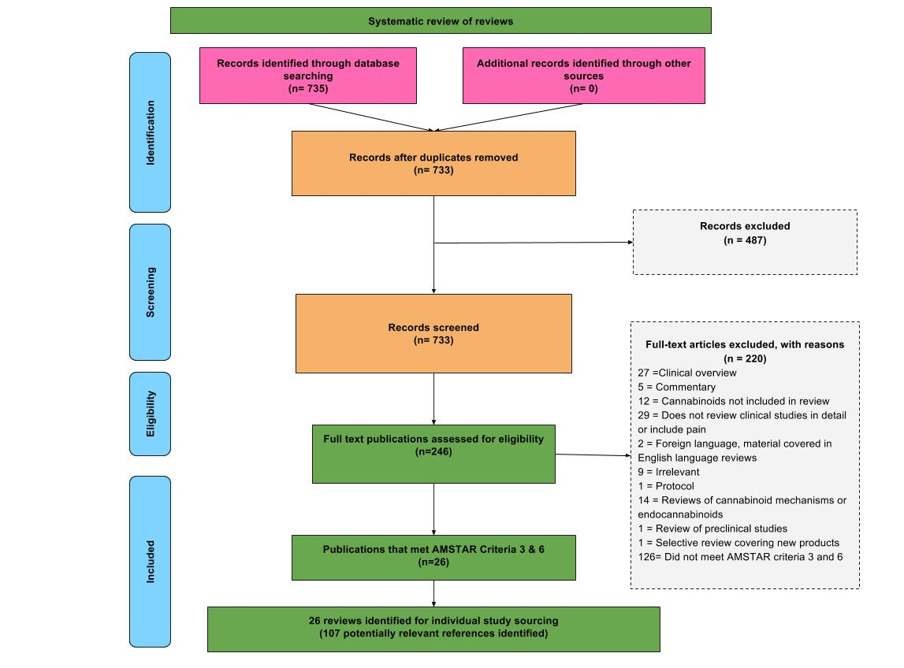

## Figure B1. PRISMA flowchart for the systematic review of reviews

## Table B1. Characteristics of included observational studies, n = 57

| Study ID (Country) | Design | Sample N  Age: Mean (SD)  Male % | Pain classification  (Specific condition) | Indication (s)  Place in therapeutic hierarchy  Co-interventions | Cannabinoid classification | Treatment duration | Daily dose (lower and upper limits) | Pain outcomes | GRADE methodology rating/RoB  Analysis |
| --- | --- | --- | --- | --- | --- | --- | --- | --- | --- |
| Aggarwal 2009 (USA) [3] | Retrospective chart review | Total N: 139  Age: NR  Male %: 63 | CNCP - mixed  (Myofascial pain syndromes (n = 114); neuropathic pain syndromes (n = 89); discogenic back pain (n = 72); osteoarthritic pain (n = 37); central pain syndromes (n = 32); fibromyalgia (n = 19); visceral pain (n = 14); spinal cord injury (n = 8); rheumatoid arthritis (n = 6); diabetic neuropathic pain (n = 5); malignant pain (n = 5); phantom pain (n = 1); HIV neuropathic pain (n =1)) | Indication (s): NR  Place in therapeutic hierarchy: NR  Co-interventions: NR | Cannabis sativa (NR) | 11 days to 8.31 years  (very short-term to long-term study) | NR | 50%: Not assessed  30%: Not assessed  Pain intensity: No benefit | Low/Critical risk  NR |
| Allegretti 2013 (USA) [6] | Prospective cohort survey study | Total N: 292  Age: 39.3 (14.1)  Male %: 32.2 | CNCP – visceral pain  (Inflammatory Bowel Disease-related pain) | Indication (s): symptom management, including analgesic  Place in therapeutic hierarchy: adjuvant  Co-interventions: biologics | Cannabis sativa (smoking, eating) | NR | NR | 50%: Not assessed  30%: Not assessed  Pain intensity: No benefit | Very low/Critical risk  NR |
| Attal 2004 (France) [13] | Open label exploratory trial | Total N: 8  Age: 63.3 (14)  Male %: 50 | Neuropathic pain  (Peripheral or central) | Indication (s): analgesic  Place in therapeutic hierarchy: adjuvant  Co-interventions: antiepileptics; antidepressants | Dronabinol (oral) * | 16 weeks  (intermediate-term study) | 16.6mg (7.5mg-25mg) | 50%: Not assessed  30%: Not assessed  Pain intensity: No benefit | Low/Critical risk  NR |
| Bestard 2011 (Canada) [27] | Open-label, prospective study | Total N: 249  Age: 61.2 (11.3)  Male %: 40.9 | Neuropathic pain  (peripheral) | Indication (s): analgesic  Place in therapeutic hierarchy: adjuvant  Co-interventions: NR | Nabilone (oral) * | 6 months  (intermediate term study) | 3.02mg | 50%: Not assessed  30%: Not assessed  Pain intensity: Significant, positive effect | Low/Serious risk  LOCF |
| Indication (s): analgesic  Place in therapeutic hierarchy: primary  Co-interventions: not applicable | Nabilone (oral) * | 6 months  (intermediate term study) | 3.05mg |
| Boehnke 2016 (USA) [29] | Retrospective, cross-sectional survey | Total N: 244  Age: NR  Male %: 63.78 | CNCP | Indication (s): analgesic  Place in therapeutic hierarchy: adjuvant  Co-interventions: opioids; NSAIDs; disease-modifying antirheumatic drugs; antidepressants; SNRIs; SSRI | Cannabis sativa (smoked) | 4 years  (long-term study) | NR | 50%: Not assessed  30%: Not assessed  Pain intensity: Significant, positive effect | Very low/Critical risk  Other: sensitivity analyses were performed on the entire set of questionnaires, questionnaires that were ≥60% complete, ≥80% complete, and those that were fully completed |
| Bonn-Miller 2014 (USA) [30] | Cross sectional study | Total N: 123  Age: 41.2 (14.9)  Male %: 73.3 | CNCP | Indication (s): various  Place in therapeutic hierarchy: NR  Co-interventions: other illicit drugs--alcohol; hallucinogens; cocaine; inhalants; stimulants; sedatives; opiates | NR (NR) | NR | NR (1.7g-5.1g) | 50%: Not assessed  30%: Not assessed  Pain intensity: No benefit | Very low/Critical risk  NR |
| Brady 2004a (USA) [33] | Open label pilot study | Total N: 21  Age: 48(NR)  Male %: 19 | CNCP  (MS-related) | Indication (s): MS-related lower urinary tract symptoms (voiding, incontinence, bladder sensations); anti-spasticity; analgesic; sleep; constipation; healthy-related quality of life; mental health  Place in therapeutic hierarchy: adjuvant  Co-interventions: anti-cholinergics; self-catheterization | i) THC:CBD (oromucosal spray) * | 11 weeks  (short-term study) | 33.7mg THC (2.5mg-97.5mg); 33.7mg CBD (2.5mg-97.5mg) | 50%: Not assessed  30%: Not assessed  Pain intensity: Significant, positive effect | Very low/Serious risk  NR |
| ii) THC-only extract (oromucosal spray) * | 10 weeks  (short-term study) | 31.2mg (2.5mg-75.5mg) |
| Brady 2004b (USA)[33] | Long-term open label extension trial | Total N: 11  Age: NR  Male %: NR | CNCP  (MS-related) | Indication (s): MS-related lower urinary tract symptoms (voiding, incontinence, bladder sensations); anti-spasticity; analgesic; sleep; constipation; healthy-related quality of life; mental health  Place in therapeutic hierarchy: adjuvant  Co-interventions: anti-cholinergics; self-catheterization | THC extract (oromucosal spray) * | 108 weeks  (long-term study) | 23.4mg (max dose of 120mg) | 50%: Not assessed  30%: Not assessed  Pain intensity: Significant, positive effect | Very low/Serious risk  NR |
| Cameron 2014 (Canada) [36] | Retrospective chart review | Total N: 104  Age: 32.7 (NR)  Male %: 100 | CNCP | Indication (s): analgesic  Place in therapeutic hierarchy: NR  Co-interventions: antipsychotics; sedative hypnotics; antidepressants  antiadrenergics; NSAIDs; opioids; anticonvulsants; prednisone (for inflammatory bowel disease) | Nabilone (oral) * | 11.2 weeks  (short-term study) | 4mg (0.5mg-6mg) | 50%: Not assessed  30%: Not assessed  Pain intensity: Significant, positive effect (data not shown) | Very low/Critical risk  Other: participants with missing data were removed from the analysis |
| Centonze 2009 (Italy) [39] | Open label | Total N: 20  Age: NR  Male %: 35 | Neuropathic pain  (MS-related) | Indication (s): analgesic  Place in therapeutic hierarchy: adjuvant  Co-interventions: NR | Nabiximols (oromucosal spray) * | 6 weeks  (short-term study) | Max dose of 108mg THC; 100mg CBD | 50%: Not assessed  30%: Not assessed  Pain intensity: No benefit | Low/Serious risk  NR |
| Chung 2009b (Canada) [42] | Retrospective chart review | Total N: 5  Age: NR  Male %: 0 | Fibromyalgia | Indication (s): analgesic; sleep  Place in therapeutic hierarchy: primary  Co-interventions: not applicable | Nabilone (oral) * | 52 weeks  (long-term study) | NR | 50%: Not assessed  30%: Not assessed  Pain intensity: Not reported | Low/Unclear risk  NR |
| Cimas-Hernando 2015 (Spain) [43] | Observational study | i) Age: 44(NR)  Male %: 100 | Neuropathic pain | Indication (s): analgesic  Place in therapeutic hierarchy: adjuvant  Co-interventions: NR | Nabiximols (oromucosal spray) * | 26 weeks  (intermediate-term study) | 9.99mg THC (8.1mg-16.2mg); 9.25mg CBD (7.5mg-15mg) | 50%: Not assessed  30%: Not assessed  Pain intensity: Significant, positive effect | Very low/Critical risk  NR |
| i) Age: 55(NR)  Male %: 100 | Neuropathic pain | Indication (s): analgesic  Place in therapeutic hierarchy: adjuvant  Co-interventions: NR | Nabiximols (oromucosal spray) * | 26 weeks  (intermediate-term study) | 9.99mg THC (8.1mg-16.2mg); 9.25mg CBD (7.5mg-15mg) |
| i) Age: 55(NR)  Male %: 0 | Neuropathic pain | Indication (s): analgesic  Place in therapeutic hierarchy: adjuvant  Co-interventions: NR | Nabiximols (oromucosal spray) * | 26 weeks  (intermediate-term study) | 9.99mg THC (8.1mg-16.2mg); 9.25mg CBD (7.5mg-15mg) |
| Clermont 2002 (France) [46] | Observational cohort study | Total N: 7  Age: 60 (14)  Male %: 57.1 | Neuropathic pain | Indication (s): analgesic  Place in therapeutic hierarchy: adjuvant  Co-interventions: analgesics | Dronabinol (oral) * | 55.4 days  (short-term study) | 15mg (5mg-25mg) | 50%: Not assessed  30%: Not assessed    Pain intensity: No benefit | Low/Serious risk  NR |
| Degenhardt 2015 (Australia)[61] | Observational study | Total N: 649  Age: 49.78 (10.61)  Male %: 56.7 | CNCP | Indication (s): analgesic  Place in therapeutic hierarchy: adjuvant  Co-interventions: opioids; over-the-counter pain medication; NSAIDS; benzodiazepines; antidepressants; antipsychotics | cannabis sativa (NR) | NR | NR | 50%: Not assessed  30%: Not assessed  Pain intensity: Significant, positive effect | Very low/Serious risk  NR |
| Eisenberg 2014 (Israel) [67] | Single-dose, open-label clinical trial | Total N: 10  Age: 42 (14)  Male %: 62.5 | Neuropathic pain  (Complex regional pain syndrome (n = 4); lumbosacral radiculopathy (n = 2); pelvic neuropathic pain (n = 1); spinal cord injury (n = 1)) | Indication (s): analgesic  Place in therapeutic hierarchy: adjuvant  Co-interventions: opiates; antidepressants; anticonvulsants; benzodiazepines; steroids; NSAIDS; beta blockers | Cannabis sativa (vaporised) * | 1 day | 3.08mg | 50%: Not assessed  30%: Not assessed  Pain intensity: Significant, positive effect | Very low/Critical risk  NR |
| Ferre 2016 (Italy) [73] | Non- randomised unblinded observational study | Total N: 144  Age: 49.7 (10.3)  Male %: 68.2 | Neuropathic pain  (MS-related) | Indication (s): anti-spasticity; analgesic  Place in therapeutic hierarchy: adjuvant  Co-interventions: 36.8% no disease-modifying treatment; 19.4% on combination therapy for symptomatic treatment | Nabiximols 9 oromucosal spray) * | 4-48 weeks  (short-term to long-term study) | 16.74mg THC; 15.5mg CBD | 50%: Not assessed  30%: Not assessed  Pain intensity: Significant, positive effect | Moderate/Serious risk  NR |
| Fiz 2011 (Spain) [81] | Cross sectional survey | Total N: 56  Age: 50 (10.02)  Male %: 5.35 | Fibromyalgia | Indication (s): analgesic; health-related quality of life; sleep; change in functioning  Place in therapeutic hierarchy: adjuvant  Co-interventions: antidepressants; analgesics; opioids; NSAIDs; anxiolytics; myorelaxants; hypnotics | Cannabis sativa (smoked (11%); eaten (46%); smoked & eaten (43%)) | 1-3 years  (long-term study) | NR | 50%: Not assessed  30%: Not assessed  Pain intensity: Significant, positive effect | Very low/Critical risk  NR |
| Gerardi 2016 (Italy) [87] | Observational open-label study | Total N: 15  Age: NR  Male %: 13.3 | Fibromyalgia | Indication (s): analgesic; fatigue; sleep disturbances; anxiolytic; antidepressant  Place in therapeutic hierarchy: adjuvant  Co-interventions: Pregabalin (n = 2); Duloxetine (n = 7); Amitriptyline (n = 1); Tramadol (n = 4); Tapentadol (n = 2); Others SNRIs (n = 2); Other opioids (n = 3); Benzodiazepine (n = 4) | Cannabis sativa (oral) * | 2 months  (short-term study) | NR (60mg-120mg) | 50%: Not assessed  30%: Not assessed  Pain intensity: Significant, positive effect | Very low/Unclear risk  NR |
| Gurevich 2015 (Israel) [90] | Cross sectional survey | Total N: 39  Age: 63.6 (9.6)  Male %: 80 | CNCP  (Parkinson’s Disease-related) | Indication (s): analgesic; mood; PD symptoms  Place in therapeutic hierarchy: NR  Co-interventions: NR | Cannabis sativa (smoked, oil, smoking + oil, vaporiser) * | 16.8 months  (long-term study) | 1.1g | 50%: Not assessed  30%: Not assessed  Pain intensity: No benefit | Very low/Critical risk  NR |
| Hagenbach 2007a (Switzerland) [92] | Open label | Total N: 25  Age: 42.6 (NR)  Male %: 92 | CNCP  (Spinal cord injury) | Indication (s): anti-spasticity; analgesic  Place in therapeutic hierarchy: adjuvant  Co-interventions: NR | Dronabinol (oral) * | 6 weeks  (short-term study) | 31mg (15mg-60mg) | 50%: Not assessed  30%: Not assessed  Pain intensity: No benefit | Low/Critical risk  NR |
| Hagenbach 2007b (Switzerland) [92] | Open label | Total N: 25  Age: 42.6 (NR)  Male %: 92 | CNCP  (Spinal cord injury) | Indication (s): anti-spasticity; analgesic  Place in therapeutic hierarchy: adjuvant  Co-interventions: NR | THC-HS (rectal) * | 6 weeks  (short-term study) | 43mg (20mg-60mg) | 50%: Not assessed  30%: Not assessed  Pain intensity: Not reported | Low/Critical risk  NR |
| Haroutiunian 2008 (Israel) [94] | Open label | Total N: 13  Age: 46 (17)  Male %: 53.8 | CNCP  (Cervical discopathy (n = 2); low back pain radiating into the leg (n = 4); joint pain and abdominal pain due to inflammatory bowel disease (n = 1); complex regional pain syndrome (n = 1); fibromyalgia (n = 3); trigeminal neuralgia (n = 1); diffuse, nonspecific bone pain (n = 1)) | Indication (s): analgesic  Place in therapeutic hierarchy: adjuvant  Co-interventions: opioids; NSAIDs; paracetamol; anticonvulsant anti-neuropathic agents; antidepressant anti-neuropathic agents | THC extract (oral) | 35.1 weeks  (long-term study) | NR (10mg-15mg) | 50%: Not assessed  30%: Not assessed  Pain intensity: No benefit | Low/Critical risk  NR |
| Haroutiunian 2011 (Israel) [93] | Cohort study | Total N: 42  Age: 49 (17.6)  Male %: 71.5 | CNCP  (Peripheral neuropathic pain (n = 12); low back pain/radiculopathy (n = 8); diffuse widespread pain (n = 8); cancer pain (n = 7); central neuropathic pain (n = 5); inflammatory bowel disease (n = 2)) | Indication (s): analgesic; health-related quality of life  Place in therapeutic hierarchy: NR  Co-interventions: NR | Cannabis sativa (NR) | 12-26 weeks  (intermediate-term study) | NR | 50%: Not assessed  30%: Not assessed  Pain intensity: Significant, positive effect | Very low/Unclear risk  NR |
| Haroutiunian 2016 (Israel) [95] | Prospective, open-label study | Total N: 206  Age: 51.2 (15.4)  Male %: 62 | CNCP  (Muscle/joint pain (n = 45); peripheral nerve injury and polyneuropathy (n = 41); radicular low back pain (n = 39); fibromyalgia (n = 17); localised musculoskeletal pain (n = 14); cancer pain (n = 14); headache/facial pain (n = 9); supraspinal lesion (n = 7); phantom pain (n = 6); abdominal pain due to inflammatory bowel disease (n = 6); spinal cord injury (n =3); plexopathy (n = 2); nerve and muscle injury (n = 1); painful systemic lupus erythematosus (n =1); avascular necrosis (n =1)) | Indication (s): analgesic  Place in therapeutic hierarchy: adjuvant  Co-interventions: opioids | Cannabis sativa (smoked or oral) | 26 weeks  (intermediate-term study) | 1.42g | 50%: Not assessed  30%: Not assessed  Pain intensity: Significant, positive effect | Moderate/Serious risk  Other: baseline observation carried forward |
| Hoggart 2015 (Multicentre - 38 centres in UK, 15 in Czech Republic, 8 in Romania, 4 in Belgium, 1 in Canada) [101] | Open label extension study | Total N: 380  Age: 57.8 (12.03)  Male %: 53 | Neuropathic pain  (Diabetic neuropathy (n = 204); allodynia (n = 176)) | Indication (s): analgesic  Place in therapeutic hierarchy: adjuvant  Co-interventions: anticonvulsants; tricyclic anti-depressants; opioids; and NSAIDs; HMG-CoA reductase inhibitors; ACE inhibitors; biguanides; platelet aggregation inhibitors | Nabiximols (oromucosal spray) * | 249 days  (long-term study) | 17.82mg THC; 16.5mg CBD (max dose of 64.8mg THC; 60mg CBD) | 50%: No benefit  30%: No benefit  Pain intensity: No benefit | Moderate/Critical risk  NR |
| Holdcroft 1997 (UK) [103] | N-of-1 | Total N: 1  Age: 29 (NR)  Male %: 100 | CNCP  (Familial Mediterranean fever) | Indication (s): analgesic  Place in therapeutic hierarchy: adjuvant  Co-interventions: NR | THC extract (oral) | 2 weeks  (very short-term study) | 50mg | 50%: Not assessed  30%: Not assessed  Pain intensity: No benefit | Low/Critical risk  NR |
| Ko 2016 (Canada) [119] | Case studies | i) Age: 49(NR)  Male %: 100 | i) Neuropathic pain | Indication (s): analgesic  Place in therapeutic hierarchy: adjuvant  Co-interventions: Nabilone 0.25mg; pregabalin; ibuprofen; omeprazole; baclofen; clonazepam | Cannabis sativa (vaporised) | 60 days  (short-term study) | 9% THC; 13% CBD | 50%: Not assessed  30%: Not assessed  Pain intensity: No benefit | Very low/Serious risk  NR |
| i) Age: 57(NR)  Male %: 100 | ii) Fibromyalgia | Indication (s): analgesic  Place in therapeutic hierarchy: adjuvant  Co-interventions: Nabilone 0.25mg; pregabalin; ibuprofen; omeprazole; baclofen; clonazepam | Cannabis sativa (vaporised) | 60 days  (short-term study) | 12% THC; 8% CBD |
| i) Age: 67(NR)  Male %: 0 | iii) Neuropathic pain  (MS-related) | Indication (s): analgesic  Place in therapeutic hierarchy: adjuvant  Co-interventions: Nabilone 0.25mg; pregabalin; ibuprofen; omeprazole; baclofen; clonazepam | Cannabis sativa (vaporised) | 60 days  (short-term study) | 9% THC; 13% CBD |
| Lahat 2012 (Israel) | Open-label, prospective, single-arm trial | Total N: 13  Age: 41.8 (10.2)  Male %: 69.2 | CNCP - visceral  (IBD-related pain) | Indication (s): IBD symptom management, appetite stimulation/weight gain, quality of life  Place in therapeutic hierarchy: adjuvant  Co-interventions: medication for gastrointestinal disorders (5 ASA (n = 2); immunomodulators (n = 7); corticosteroids (n = 2); TNF inhibitors (n = 6)) | Cannabis sativa (smoked) | 12 weeks  (short-term study) | ~1.8g | 50%: Not assessed  30%: Not assessed  Pain intensity: Significant, positive effect | Low/Critical risk  NR |
| Langford 2013b (Multicentre - 12 centres in UK, 7 in Czech Republic, 5 in Canada, 5 in Spain, 4 in France) [125] | Open-label, randomised withdrawal | Total N: 58  Age: 48 (9.41)  Male %: 36 | Neuropathic pain  (MS-related) | Indication (s): analgesic  Place in therapeutic hierarchy: adjuvant  Co-interventions: anticonvulsant; NSAID; analgesics; tricyclic anti-depressants; opioids; antiarrhythmic | Nabiximols (oromucosal spray) * | 14 weeks  (intermediate-term study) | 18.09mg THC; 16.75mg CBD (max dose of 32.4mg THC; 30mg CBD) | 50%: Not assessed  30%: Not assessed  Pain intensity: significant, positive effect | Moderate/Serious risk  ITT analysis |
| Lotan 2014 (Israel) [134] | Open label | Total N: 22  Age: 65 (10.2)  Male %: 59 | CNCP  (Parkinson’s Disease-related) | Indication (s): analgesic  Place in therapeutic hierarchy: adjuvant  Co-interventions: antiparkinsonian medication | Cannabis sativa (smoked) | 1 day | 0.5g (amount inhaled per cigarette) | 50%: Not assessed  30%: Not assessed  Pain intensity: Significant, positive effect | Low/Critical risk  NR |
| Lynch 2014b (Canada) [137] | Extension trial | Total N: 10  Age: NR  Male %: NR | Neuropathic pain  (Chemotherapy-induced) | Indication (s): analgesic  Place in therapeutic hierarchy: adjuvant  Co-interventions: analgesics | Nabiximols (oromucosal spray) * | 26 weeks  (intermediate-term study) | 12.15mg THC (5.4mg-27mg); 11.25mg CBD (5mg-25mg) | 50%: Not assessed  30%: Not assessed  Pain intensity: No benefit | Very low/Serious risk  LOCF |
| Martinez-Rodriguez 2008 (Spain) [144] | Cross-sectional survey | Total N: 175  Age: 42.84 (11.23)  Male %: 35.5 | CNCP  (MS-related) | Indication (s): analgesic; spasticity; sleep  Place in therapeutic hierarchy: NR  Co-interventions: NR | Cannabis sativa (smoked, ingested) | NR | NR | 50%: Not assessed  30%: Not assessed  Pain intensity: No benefit | Very low/Critical risk  NR |
| Martyn 1995 (UK) [145] | N-of-1 | Total N: 1  Age: 45 (NR)  Male %: 100 | CNCP  (MS-related) | Indication (s): anti-spasticity; analgesic  Place in therapeutic hierarchy: NR  Co-interventions: NR | Nabilone (oral) * | 4 weeks  (short-term study) | 1mg | 50%: Not assessed  30%: Not assessed  Pain intensity: Not reported | Low/Critical risk  NR |
| Maurer 1990 (Switzerland) [146] | Single case double-blind trial | Total N: 1  Age: 28 (NR)  Male %: 100 | CNCP  (Severe paraesthesias and painful spastic paraparesis) | Indication (s): anti-spasticity; analgesic  Place in therapeutic hierarchy: adjuvant  Co-interventions: NR | THC extract (oral) | 5 months  (intermediate-term study) | NR | 50%: Not assessed  30%: Not assessed  Pain intensity: Significant, positive effect (for THC vs. Placebo, but not THC vs. Codeine) | Low/Critical risk  NR |
| Narang 2008b (USA) [158] | Open label | Total N: 28  Age: 43.76 (11.8)  Male %: 46.7 | CNCP  (Neuropathic pain (n = 7); nociceptive pain (n = 7); mixed neuropathic and nociceptive (n = 11) and uncategorised pain (n = 6)) | Indication (s): analgesic  Place in therapeutic hierarchy: adjuvant  Co-interventions: opioids | Dronabinol (oral) * | 4 weeks  (short-term study) | NR (5mg-60mg) | 50%: Not assessed  30%: Not assessed  Pain intensity: Significant, positive effect | Moderate/Critical risk  LOCF |
| Notcutt 2004 (UK) [165] | N-of-1 | Total N: 34  Age: 46.7 (NR)  Male %: 32 | CNCP  (MS-related pain (n = 16); disc degeneration (n = 3); spinal cord tethering (laminectomy; n = 1); Low back, sciatica (laminectomy; n =1); spinal fusion (n = 1); paraplegia, AV malformation of cord (n = 1); brachial plexus avulsion injury (n = 1); femoral plexopathy from phenol injury (n = 1); laminectomy (n = 1); myopathy (n = 1); complex regional pain syndrome (n = 2); polyarthralgia (n = 1); radiculopathy, cervical fusion (n =1); diffuse systemic atrophy (n = 1); massive trauma to left arm (n = 1); stiff man syndrome (n = 1)) | Indication (s): analgesic  Place in therapeutic hierarchy: NR  Co-interventions: NR | THC extract; CBD extract; THC:CBD extract (sublingual spray) * | NR | 2.5mg THC; 2.5mg CBD; 2.5mg:2.5mg THC:CBD | 50%: No benefit  30%: Not assessed  Pain intensity: Significant, positive effect | Low/Unclear risk  NR |
| Notcutt 2014 (UK) [164] | Retrospective survey | Total N: 212  Age: NR  Male %: 51 | CNCP | Indication (s): analgesic  Place in therapeutic hierarchy: NR  Co-interventions: NR | Nabilone (oral) * | NR | 1.41mg (0.25mg-8mg) | 50%: Not assessed  30%: Not assessed  Pain intensity: No benefit | Very low/Critical risk  NR |
| Palmieri 2017 (Italy) [176] | Observational open label | Total N: 21  Age: 16.7 (NR)  Male %: 0 | CNCP  (Due to adverse drug effects following human papillomavirus vaccine) | Indication (s): physical functioning; social role functioning; analgesic  Place in therapeutic hierarchy: NR  Co-interventions: NR | CBD extract (oral) * | 12 weeks  (short-term study) | NR (25mg-150mg) | 50%: Not assessed  30%: Not assessed  Pain intensity: Significant, positive effect | Low/Critical risk  NR |
| Paolicelli 2016 (Italy) [177] | Non- randomised unblinded observational study | Total N: 102  Age: 48.8 (10.4)  Male %: 51 | Neuropathic pain  (MS-related) | Indication (s): anti-spasticity; analgesic  Place in therapeutic hierarchy: adjuvant  Co-interventions: anti-spasticity agents | Nabiximols (oromucosal spray) * | 40 weeks  (long-term study) | 17.55mg THC (10.8mg-27mg); 16.25mg CBD (10mg-25mg) | 50%: Not assessed  30%: Not assessed  Pain intensity: Significant, positive effect | Moderate/Serious risk  NR |
| Pinsger 2006b (Austria) [190] | Modified early-escape study | Total N: 30  Age: NR  Male %: 71 | CNCP  (Cervical syndrome; lumbago and thoracic syndrome; intervertebral disc prolapse; polyarthritis; scoliosis; osteochondrosis; foraminal stenosis; intervertebral disc protrusion; spondylarthrosis) | Indication (s): analgesic  Place in therapeutic hierarchy: adjuvant  Co-interventions: NR | Nabilone (oral) * | 16 weeks  (intermediate-term study) | 0.25mg (0.25mg-1mg) | 50%: Not assessed  30%: Not assessed  Pain intensity: No benefit | Moderate/Critical risk  ITT analysis |
| Robinson 2016 (Israel) [202] | Follow up study | Total N: 18  Age: NR  Male %: NR | Neuropathic pain  (Diabetes-related) | Indication (s): analgesic  Place in therapeutic hierarchy: adjuvant  Co-interventions: Duloexetine; pregabalin | Cannabis sativa (NR) | 6 months  (intermediate-term study) | NR | 50%: Not assessed  30%: Not assessed  Pain intensity: No benefit | Low/Unclear risk  NR |
| Rog 2007 (UK) [205] | Open label extension study | Total N: 63  Age: 49 (8.4)  Male %: 22.2 | Neuropathic pain  (MS-related) | Indication (s): analgesic  Place in therapeutic hierarchy: adjuvant  Co-interventions: Amitriptyline; analgesics | Nabiximols (oromucosal spray) * | 463 days  (long-term study) | 16.47mg THC (0.81mg-66.96mg); 15.25mg CBD (0.75mg-62mg) | 50%: Not assessed  30%: Not assessed  Pain intensity: No benefit | Moderate/Serious risk  LOCF |
| Rudich 2003 (Canada) [206] | Case study | i) Age: 15 (NR)  Male %: 0 | Neuropathic pain  (Complex regional pain syndrome type I) | Indication (s): analgesic  Place in therapeutic hierarchy: adjuvant  Co-interventions: antidepressant therapy | Dronabinol (oral) * | 52 weeks  (long-term study) | NR (5mg-20mg) | 50%: Not assessed  30%: Not assessed  Pain intensity: No benefit | Very low/Critical risk  NR |
| i) Age: 14(NR)  Male %: 0 | Neuropathic pain  (Complex regional pain syndrome type I) | Indication (s): analgesic  Place in therapeutic hierarchy: adjuvant  Co-interventions: antidepressant therapy | Dronabinol (oral) * | 52 weeks  (long-term study) | NR (5mg-25mg) |
| Schimrigk 2017b (Germany) | Open-label trial | Total N: 209  Age: 47.7 (9.7)  Male %: 27.1 | Neuropathic pain  (MS-related) | Indication (s): analgesic, quality of life  Place in therapeutic hierarchy: adjuvant  Co-interventions: analgesics (most common was gabapentin (20.8% of patients) | Dronabinol (NR) * | 32 weeks  (long-term study) | 12.7mg (0mg-15.9mg) | 50%: Not assessed  30%: Not assessed  Pain intensity: No benefit | Low/Serious risk  Other: efficacy parameters are based on the full analysis set |
| Schimrigk 2017c (Germany) | Open-label trial with long-term follow-up | Total N: 100  Age: 47.7 (9.7)  Male %: 27.1 | Neuropathic pain  (MS-related) | Indication (s): analgesic, quality of life  Place in therapeutic hierarchy: adjuvant  Co-interventions: analgesics (most common was gabapentin (20.8% of patients) | Dronabinol (NR) * | 144 weeks  (long-term study) | 12.7mg (0mg-15.9mg) | 50%: Not assessed  30%: Not assessed  Pain intensity: No benefit | Low/Serious risk  Other: efficacy parameters are based on the full analysis set |
| Schley 2006 (Germany) [216] | Non- randomised pilot study | Total N: 11  Age: 43 (12)  Male %: 25 | Fibromyalgia | Indication (s): analgesic  Place in therapeutic hierarchy: primary  Co-interventions: not applicable | THC extract (oral) | 12 weeks  (short-term study) | NR (2.5mg-15mg) | 50%: No benefit  30%: Not assessed  Pain intensity: Significant, positive effect | Low/Critical risk  Other: only report data for patients that completed the study |
| Shah 2017 (USA) [223] | Retrospective exploratory study | Total N: 48  Age: 45.1 (14.02)  Male %: 41.67 | CNCP | Indication (s): analgesic; mental health  Place in therapeutic hierarchy: adjuvant  Co-interventions: daily group-based cognitive behavioural therapy (CBT); biofeedback and relaxation training; psychoeducation; physical therapy; occupational therapy; classes on mood and stress management; opioids; benzodiazepine | Unknown (smoked or oral) | NR | NR | 50%: Not assessed  30%: Not assessed  Pain intensity: Significant, positive effect | Very low/Critical risk  NR |
| Storr 2014 (Germany) [229] | Cross sectional survey study | Total N: 319  Age: 39.5 (12.6)  Male %: 68.6 | CNCP – visceral  (IBD-related) | Indication (s): symptom management; analgesic  Place in therapeutic hierarchy: adjuvant  Co-interventions: steroids; analgesics; aminosalicylates; immunomodulators; narcotics; loperamide; biologicals; IV medication; CAM | Cannabis sativa (smoked, drunk, eaten) | 57.1% of sample used for > 12 months, 8.9% for 6-12 months, 16.1% for 1-6 months, 5.4% <1 month | NR | 50%: Not assessed  30%: Not assessed  Pain intensity: No benefit | Very low/Critical risk  NR |
| Toth 2008 (Canada) [234] | Prospective study | Total N: 182  Age: 59.4 (6.7)  Male %: 44 | Neuropathic pain  (Idiopathic (n = 60); diabetes-related (n = 51); immune-mediated (n = 15); definite cobalamin deficiency (n = 15); monoclonal gammopathy of uncertain cause (n = 11); excessive alcohol use (n = 12); other (n = 18)) | Indication (s): analgesic  Place in therapeutic hierarchy: NR  Co-interventions: NR | i) Nabilone (oral) * | 26 weeks  (intermediate-term study) | 2mg | 50%: No benefit  30%: No benefit  Pain intensity: No benefit | Moderate/Critical risk  NR |
| ii) THC:CBD extract (oromucosal spray) * | 26 weeks  (intermediate-term study) | 34.02mg THC; 31.5mg CBD |
| Toth 2012a (Canada) [235] | Single-blind flexible dose run-in phase | Total N: 37  Age: 62.2 (9.3)  Male %: 45 | Neuropathic pain  (Diabetes-related) | Indication (s): analgesic; health-related quality of life; mental health; sleep  Place in therapeutic hierarchy: adjuvant  Co-interventions: Metformin; statins/ezetimibe; blood pressure medications; insulin; thyroid replacement; SSRIs; anxiolytics/insomnia medications; glyburide; gliclazide; methotrexate; NSAIDs; acetaminophen; gabapentin; pregabalin; codeine; amitriptyline; oycodone/acetaminophen; nortriptyline; duloxetine | Nabilone (oral) * | 4 weeks  (short-term study) | 2.24mg (1mg-4mg) | 50%: Not assessed  30%: Not reported  Pain intensity: Significant, positive effect | Very low/Serious risk  LOCF |
| Toth 2012b (Canada) [235] | Open-label trial | Total N: 26  Age: 61.2 (14.95)  Male %: 53.8 | Neuropathic pain    (Diabetes-related) | Indication(s): analgesic; health-related quality of life; mental health; sleep  Place in therapeutic hierarchy: adjuvant  Co-interventions: Metformin; statins/ezetimibe; blood pressure medications; insulin; thyroid replacement; SSRIs; anxiolytics/insomnia medications; glyburide; gliclazide; methotrexate; NSAIDs; acetaminophen; gabapentin; pregabalin; codeine; amitriptyline; oycodone/acetaminophen; nortriptyline; duloxetine | Nabilone (oral) * | 4 weeks  (short-term study) | 2.85mg (1mg-4mg) | 50%: No benefit  30%: Significant, positive effect  Pain intensity: Significant, positive effect | Moderate/Unclear risk  LOCF |
| Vermersch 2016 (Multicentre - 34 centres in Italy, 2 in Norway, 1 in Denmark) [251] | Prospective observational study | Total N: 433  Age: 50.4 (10.4)  Male %: 44.8 | CNCP  (MS-related) | Indication (s): anti-spasticity; analgesic  Place in therapeutic hierarchy: adjuvant  Co-interventions: Baclofen; Gabapentin; Tizanidine; Clonazepam; Physiotherapy | Nabiximols (oromucosal spray) * | 3 months  (short-term study) | 16.2mg THC; 15mg CBD | 50%: Not assessed  30%: Not assessed  Pain intensity: Significant, positive effect | Low/Serious risk  Other: effectiveness analyses were performed on the full analysis set |
| Wade 2003a (UK) [255] | Open label | Total N: 24  Age: 48 (NR)  Male %: 50 | Neuropathic pain  (MS-related (n = 14); spinal cord injury (n = 4); brachial plexus lesion and a neuropathy (n = 1); phantom limb pain (n = 1)) | Indication (s): neurogenic symptoms  Place in therapeutic hierarchy: adjuvant  Co-interventions: NR | THC:CBD extract (sublingual spray) * | 2 weeks  (very short-term study) | NR (2.5mg-120mg THC; 2.5mg-120mg CBD) | 50%: Not assessed  30%: Not assessed  Pain intensity: No benefit | Moderate/Serious risk  NR |
| Wade 2006 (UK)[252] | Open label, extension study | Total N: 137  Age: 50.5 (NR)  Male %: 39 | CNCP  (MS-related) | Indication (s): anti-spasticity; analgesic  Place in therapeutic hierarchy: adjuvant  Co-interventions: NR | Nabiximols (oromucosal spray) * | 434 days  (long-term study) | 29.7mg THC; 27.5mg CBD (max dose of 129.6mg THC; 120mg CBD) | 50%: Not assessed  30%: Not assessed  Pain intensity: No benefit | Moderate/Moderate risk  NR |
| Ware 2003 (Canada) [260] | Prospective cohort study | Total N: 209  Age: NR  Male %: 37.7 | CNCP  (Due to trauma/surgery (n = 82); arthritis (n = 22); multiple sclerosis (n = 3); infection (n = 3); stroke (n =1)) | Indication (s): analgesic  Place in therapeutic hierarchy: adjuvant  Co-interventions: analgesics | Cannabis sativa (smoked, eaten) | NR | NR | 50%: Not assessed  30%: Not assessed  Pain intensity: No benefit | Very low/Critical risk  Other: data was tabulated, and statistical analyses were not performed |
| Ware 2015 (Canada) [262] | Prospective cohort study | Total N: 431  Age: 48.95 (NR)  Male %: 43.1 | CNCP | Indication (s): analgesic  Place in therapeutic hierarchy: adjuvant  Co-interventions: opioids; antidepressants; anticonvulsants | Cannabis sativa (smoked, oral, vaporised) | 52 weeks  (long-term study) | 2.46g (0.09g-13.4g) | 50%: Not assessed  30%: Not assessed  Pain intensity: Significant, positive effect | Low/Serious risk  Other: data from all patients were included in the safety analysis |
| Weber 2009 (Germany) [265] | Retrospective interview study | i) Total N: 43  Age: 55(13)  Male %: 37.9 | i) Inflammatory Nep pain | Indication (s): analgesic  Place in therapeutic hierarchy: adjuvant  Co-interventions: NSAIDs; COX2-inhibitors; paracetamol; metamizol; opioids; antidepressants; anticonvulsants | Dronabinol (oral) * | 31 weeks  (long-term study) | 7.5mg | 50%: Not assessed  30%: Not assessed  Pain intensity: Significant, positive effect | Low/Serious risk  NR |
| i) Total N: 49  Age: 55(13)  Male %: 37.9 | ii) Central NeP pain | Indication (s): analgesic  Place in therapeutic hierarchy: adjuvant  Co-interventions: NSAIDs; COX2-inhibitors; paracetamol; metamizol; opioids; antidepressants; anticonvulsants | Dronabinol (oral) * | 31 weeks  (long-term study) | 7.5mg |
| i) Total N: 32  Age: 55(13)  Male %: 37.9 | iii) Fibromyalgia | Indication (s): analgesic  Place in therapeutic hierarchy: adjuvant  Co-interventions: NSAIDs; COX2-inhibitors; paracetamol; metamizol; opioids; antidepressants; anticonvulsants | Dronabinol (oral) * | 31 weeks  (long-term study) | 7.5mg |
| i) Total N: 124  Age: 55(13)  Male %: 37.9 | iv) Total | Indication (s): analgesic  Place in therapeutic hierarchy: adjuvant  Co-interventions: NSAIDs; COX2-inhibitors; paracetamol; metamizol; opioids; antidepressants; anticonvulsants | Dronabinol (oral) * | 31 weeks  (long-term study) | 7.5mg |

Note:

*Indicates cannabinoid was pharmaceutical grade

IBD = inflammatory bowel disease

ITT = intention to treat

LOCF = last observation carried forward

NR = not reported

NSAIDS = Non-steroidal anti-inflammatory drugs

RoB = risk of bias

## Table B2: Ongoing trials and trials for which results are not yet reported

| Principal investigator (trial ID and estimated completion) | Study design (status) | | Title and purpose | Participants  Age | Intervention(s) and comparator (s) | Outcomes |
| --- | --- | --- | --- | --- | --- | --- |
| Abrams, D. I. (NCT01771731)  Estimated completion date: October 2017 | | Crossover RCT (active, not recruiting) | Vaporised cannabis for chronic pain associated with sickle cell disease (cannabis-SCD)  *"Our primary objective is to assess whether inhaling vaporized cannabis ameliorates chronic pain in patients with sickle cell disease (SCD). As these patients will all be on chronic opioid analgesics, the investigators will also assess the possible synergistic affect between inhaled cannabis and opioids. The investigators will also assess the clinical safety of the concomitant use of cannabinoids and these opioids in patients with SCD by monitoring the short-term side effects associated with combined therapy. Finally, the investigators will evaluate the short-term effects of inhaled cannabis on markers of inflammation and disease progression in patients with SCD.*  *Hypotheses are as follows:*  *Inhaled cannabis will significantly reduce chronic pain in patients with SCD.*  *Inhaled cannabis will significantly alter the short-term side effects experienced by patients who take opioids for SCD.*  *Inhaled cannabis will significantly alter markers of inflammation and disease progression in patients with SCD compared to placebo."* | Patients (N = 34) diagnosed with sickle cell disease (including sickle cell anaemia, sickle-haemoglobin C disease and sickle beta thalassemia disease) undergoing opioid analgesic therapy and who have a prior history of cannabis use.  Age: ≥ 18 | **Intervention(s):**  - Cannabis cigarette (4.7% THC/5.1% CBD)  **Comparator(s):**  - Placebo cigarette (0% THC/0% CBD) | **Primary:**  - Pain level [Time Frame: Days 1 and 5 of two 5-day study periods]  **Secondary:**  None |
| Benrath, J. (NCT00176163)  Estimated completion date: May 2009 | | Parallel RCT (completed, results not posted) | Supporting effect of Dronabinol on behavioral therapy in Fibromyalgia and Chronic Back Pain  *“It is known, that a so called "pain memory" usually evolves in chronic pain syndromes which both aggravates the disorder and modifies the patients pain perception. Thus, the principal object of pain therapy is to "delete" this dysfunctional pain memory. The combination of medication, physiotherapy and psychological therapy seems to be the most effective treatment. This study investigates the effect of a concomitant Dronabinol medication (Cannabinoid) on the effectiveness of behavioral therapy. It is hypothesized that the combination of behavioral therapy and Dronabinol will be most effective in deleting the pain memory.”* | Patients meeting diagnostic criteria for fibromyalgia and/or chronic back pain with pain duration exceeding 3 months.  Age: 18-70 | **Intervention(s):**  - Dronabinol + behavioural therapy  **Comparator(s):**  - Placebo + behavioural therapy  - Behavioural therapy only  - Standard medical therapy | **Primary:**  **-** Impairment by pain  **Secondary:**  - Pain intensity  - Physical function and emotional state assessed by questionnaires  - Subjective rating of improvement by therapy  - Subjective rating of therapy effectiveness  - Therapy satisfaction rated by patient |
| Calapai, G. (NCT03210766)  Estimated completion date: 31st January 2016 | | Observational cohort study (completed, results not posted) | Nabilone and THC/CBD for the treatment of FBSS refractory pain  *"The aim of this study is to evaluate the efficacy of oral administration of nabilone or THC/CBD administration in combination with spinal cord stimulation (SCS) in FBSS patients refractory to other available therapeutic strategies."* | Patients (N = 20) suffering from FBSS refractory pain | **Intervention(s):**  - Nabilone  - THC/CBD | **Primary**:  - Brief Pain Inventory (BPI) [Time Frame: 2015/1 to 2016/1]  - Douleur Neuropathique-4 (DN-4) [Time Frame: 2015/1 to 2016/1]  **Secondary:**  None |
| Campbell, C. M. & Dunn, K. E. (NCT03098563)  Estimated completion date: 1st September 2020 | | Crossover RCT (not yet recruiting) | Maximizing analgesia to reduce pain in knee osteoarthritis  *“This research is being done to evaluate whether combining medications that are FDA approved, but have not yet been approved for combination treatment, can be effective in reducing pain.”* | Patients with a diagnosis of knee osteoarthritis.  Age: ≥ 45 | **Interventions(s):**  - Participants may receive a dose of medication from one or more of the following categories: prescription stimulants, prescription benzodiazepines, prescription opioids, prescription cannabinoids, over-the-counter medications or placebo (sugar pill)  **Comparator(s):**  - Participants may receive a dose of medication from one or more of the following categories: prescription stimulants, prescription benzodiazepines, prescription opioids, prescription cannabinoids, over-the-counter medications or placebo (sugar pill) | **Primary:**  - Largest change from baseline on VAS pain rating [Time Frame: 8-hour study session]  **Secondary:**  None |
| Davidson, E. (NCT01149018)  Estimated completion date: October 2012 | | Parallel RCT (unknown, results not posted) | Efficacy trial of oral tetrahydrocannabinol in patients with fibromyalgia  *"The objective of the study is to evaluate the effectiveness of oral tetrahydrocannabinol in patients suffering from fibromyalgia"* | Patients diagnosed with Fibromyalgia according to ACR criteria.  Age: ≥ 18 | **Intervention(s):**  - Tetrahydrocannabinol (Oral solution of THC in concentration of 5mg/0.2ml. Dose regimen: 5mg 2-4 times/day as tolerated)  **Comparator(s):**  - Placebo (Orally administered olive oil. Dose: 0.2ml 2-4 times a day as tolerated) | **Primary:**  - Meaningful change in total score on Fibromyalgia Impact Questionnaire (FIQ) [Time Frame: 8 weeks]  **Secondary:**  - Meaningful change in Brief Pain Inventory average pain severity [Time Frame: 8 weeks] |
| Davidson, E. (NCT02388217)  Estimated completion date: November 2020 | | Prospective open-label study (active, not recruiting) | The effect of cannabis on pain and related quality of life outcomes in chronic pain: a prospective open-label study  *"The objective of the current study is to prospectively assess the effect of cannabis on pain and functional outcomes in a large group of patients with chronic pain."* | Patients suffering from chronic pain (3 months or longer) refractory to other analgesic treatments who are eligible for treatment with medical cannabis following approval of Israeli Ministry of Health.  Age: ≥ 18 | **Intervention(s):**  - Cannabis | **Primary:**  -Change from baseline on the S-TOPS pain symptom scale [Time Frame: 1 year]  **Secondary:**  - Change from baseline on S-TOPS physical disability scales [Time Frame: 6 and 12 months]  - Change from baseline on S-TOPS emotional/social disability scales [Time Frame: 6 and 12 months]  - Change from baseline on S-TOPS satisfaction scales [Time Frame: 6 and 12 months]  - Change from baseline on SLP9 sleep disability scale [Time Frame: 6 and 12 months]  - Change from baseline on BPI severity/interference scales [Time Frame: 6 and 12 months] |
| Gilman, J. M. (NCT03224468)  Estimated completion date: 31st March 2022 | | Parallel RCT (recruiting) | Effect of Medical Marijuana on Neurocognition and Escalation of Use (MMNE)  *"This study will use a randomized controlled design to test whether patients who use medical marijuana, compared to a waitlist control group, experience a change in health outcomes (relief of symptoms, or adverse health outcomes such as new-onset symptoms of cannabis use disorders, neurocognitive impairments) or brain-based changes."* | Individuals with a desire to use medical marijuana (not in possession of a medical card) for self-reported pain, sleep, or affective (mood and/or anxiety including PTSD) symptoms.  Age: 18-65 | **Intervention(s):**  - Cannabis  **Comparator(s):**  - Waitlist control | **Primary:**  - Changes in Pain [Time Frame: Change from baseline to 3 months]  **Secondary:**  None |
| Henry, B. L. (NCT03099005)  Estimated completion date: 31st December 2020 | | Crossover RCT (not yet recruiting) | Effect of cannabis and endocannabinoids on HIV neuropathic pain  *"Acute cannabis administration is reported to alleviate HIV neuropathic pain (HIV-NP), but there is limited knowledge about the effects of cannabis constituents (delta-9 tetrahydrocannabinol/THC and cannabidiol/CBD), the consequences of long-term cannabis use, and the impact of cannabis on endocannabinoid (EC) function in people living with HIV- NP. Our objective is to address these three fundamental gaps in our knowledge by: 1) examining the acute effects of various CBD/THC products on HIV-NP, 2) utilizing a mHealth text messaging protocol, Individual Monitoring of Pain and Cannabis Taken (IMPACT) to monitor daily real-world cannabis use and changes in pain; and 3) studying the relationship between cannabinoids, EC biomarkers, and chronic neuropathic pain"* | Patients diagnosed with HIV-associated sensory neuropathy who are currently using cannabis obtained from dispensaries.  Age: ≥ 18 | **Intervention(s):**  - Equal ratio CBD to THC cannabis (3.49% THC + 4.17% CBD)  - High ratio CBD to THC cannabis (3.11% THC + 15.76% CBD)  **Comparator(s):**  - Low ratio CBD to THC cannabis  (3.74% THC + 0.49% CBD) | **Primary:**  - Phase 1-numerical 11-point Pain Intensity Scale [Time Frame: participants will be followed for the duration of an 4 hour, single day human laboratory experiment, and the outcome will be measured once before they receive study medication and then 3 additional times during the treatment day]  - Phase 2-numerical 11-point Pain Intensity Scale [Time Frame: participants will be queried on a daily basis for six months using text messaging]  **Secondary:**  - Phase 1-Patient Global Impression of Change (PGIC) [Time Frame: participants will be followed for the duration of an 4 hour, single day human laboratory experiment, and this outcome will be measured 3 times after study medication is provided during the treatment day] |
| Martinez, D. (NCT02683018)  Estimated completion date: March 2021 | | Crossover RCT (Not yet recruiting) | Investigation of cannabis for chronic pain and palliative care  “*The goal is to investigate the effects of high CBD/low THC cannabis on symptoms such as pain, nausea/vomiting, and quality of life in seriously ill participants*" | Patients with one of the following medical diagnoses:  - Cancer  - Amyotrophic lateral sclerosis  - Parkinson’s disease  - spinal cord injury  - neuropathy  - phantom limb pain  - thalamic pain  - pain related to injury of nerve plexus/plexi  -neuropathic facial pain  Patients must report pain (at least 3 on item 3 of the BPI) which persists despite current medical treatment.  Age: 21-60 | **Intervention(s):**  - Cannabis cigarettes (15.76% CBD; 3.11% THC)  **Comparator(s):**  - Cannabis cigarettes (0.01% THC; 0.00% CBD) | **Primary**:  - Change in pain ratings (McGill Pain Questionnaire [ time frame: 4 weeks])  - Change in sickness-related impairment (Sickness Impact Profile [time frame: 4 weeks])  - Change in physical and emotional wellbeing (RAND-36 [time frame: 4 weeks])  - Change in symptoms of pain (Brief Pain Inventory [time frame: 4 weeks])  **Secondary:**  - Change in the psychological state and psychological wellbeing (Mental Health Inventory-5 [Time Frame: 4 weeks])  - Change in quality of life using (Multidimensional Index of Life Quality Questionnaire [Time Frame: 4 weeks])  - Change in quality of life (McGill Quality of Life Questionnaire [Time Frame: 4 weeks])  - Change in symptoms of pain, mood and appetite (Edmonton Symptom Assessment System [Time Frame: 4 weeks])  - Change in mood (Hamilton Depression Rating Scale [Time Frame: 4 weeks])  - Change in mood (Hamilton Anxiety Rating Scale [Time Frame: 4 weeks])  - Change in mood (Montgomery-Asberg Depression Rating Scale [Time Frame: 4 weeks])  - Change in mood and quality of life (Columbia Suicide Severity Rating Scale [Time Frame: 4 weeks]) |
| Robinson, D. (NCT03138460)  Estimated completion date: 1st January 2020 | | Case-crossover (recruiting) | Analysis of orthopedic patients' response to new pain modulating substances and drugs  *"Data of patient reported outcomes (PRO) are collected during treatment with various pain alleviation methods (drugs or substances)"* | Patients with chronic pain of orthopedic origin (i.e. lower back pain, fibromyalgia and arthritis) treated for at least one year unsuccessfully.  Age: ≥ 18 | **Intervention(s):**  - Cannabis | **Primary:**  - Brief pain inventory score (BPI) [Time Frame: 2 years]  **Secondary:**  None |
| Skrabek, R. Q. (NCT00699634)  Estimated completion date: April 2011 | | Parallel RCT (completed, results not posted) | Nabilone for the treatment of phantom limb pain  *"The purpose of this proposed study is to conduct a randomized double-blind placebo controlled trial assessing the benefit of nabilone in pain management and improvement of quality of life in patients with phantom limb pain. Our Hypothesis is that the synthetic cannabinoid Nabilone will significantly reduce the phantom limb pain and improve quality of life, compared to the placebo controlled group. This will be evident by finding significant differences in Visual Analogue Scale pain scores, frequency of phantom pain episodes, the Depression, Anxiety and Stress Scale, and the Groningen Sleep Quality Scale and daily prosthetic wearing time."* | Patients with treatment refractory phantom limb pain diagnosed by a Rehabilitation Medicine Specialist.  Age: 18-70 | **Intervention(s):**  - Nabilone  **Comparator(s):**  - Unclear | **Primary:**  - Visual Analogue Scale for Pain [Time Frame: Baseline, 2, 4 and 6 weeks]  **Secondary:**  - Depression Anxiety and Stress Scale [Time Frame: Baseline, 2, 4 and 6 weeks]  - Groningen Sleep Quality Scale [Time Frame: Baseline, 2, 4 and 6 weeks]  - SF-36 [Time Frame: Baseline, 2, 4 and 6 weeks]  - Frequency of phantom limb pain [Time Frame: Baseline, 2, 4 and 6 weeks] |
| Solvay Pharmaceuticals (NCT00123201)  Estimated completion date: March 2007 | | Parallel RCT (completed, results not posted) | Study to evaluate the efficacy and safety of Dronabinol Metered Dose Inhaler (MDI) in acute treatment of migraine headache  *"The primary objective of this study is to evaluate the efficacy and safety of dronabinol MDI for the acute treatment of moderate to severe migraine headache."* | Patients with clinically diagnosed migraine with or without aura based on International Headache Society criteria (< 8 migraine attacks per month and/or less than 14 migraine days per month)  Age: 18-65 | **Intervention(s):**  - Dronabinol MDI  **Comparator(s):**  - Unclear | None specified |
| Tesfaye, S. (NCT00238550)  Estimated completion date: March 2006 | | Parallel RCT (completed, results not posted) | Study of CBME in the relief of painful diabetic neuropathy  *"The study is designed to investigate the benefit of adding CBME to the existing treatment regime in the management of painful neuropathy.*  *Hypothesis:*  *The addition of CBME to the existing treatment regime will result in a significant improvement in both primary and secondary outcome measures.*  *The side effect profile and tolerability of CBME will be minimal and comparable to placebo."* | Patients diagnosed with diabetes who suffer from painful diabetic neuropathy  Age: ≥ 18 | **Intervention(s):**  - Cannabis based medicine extract (CBME)  **Comparator(s):**  - Unclear | **Primary:**  - Improvement in pain symptoms, including pain perception and sleep quality, utilising daily diaries and validated pain questionnaires during [Time frame: 12-week treatment period and after 3-month cessation of treatment]  **Secondary:**  - Quality of life utilising validated questionnaires [Time frame: not specified] |
| Ware, M. & Lynch, M. (NCT02324777)  Estimated completion date: January 2018 | | Crossover RCT (recruiting) | Cannabinoid profile investigation of vapourized cannabis in patients with Osteoarthritis of the knee (CAPRI)  *“Primary Objective:*  *- To determine the analgesic dose-response characteristics of vapourized cannabinoids with varying degrees of delta-9-tetrahydrocannabiol (THC)/ Cannabidiol (CBD) ratios.*  *Secondary Objectives:*  *- To compare functional changes and patient preferences of different cannabinoid (THC, CBD) profiles in patients with OA (Osteoarthritis);*  *- To describe the Pharmacokinetics (PK) of vapourized cannabis of differing cannabinoid profiles in patients with OA;*  *- To explore the short term safety of vapourized cannabis with different cannabinoid profiles.*  *- To describe the incidence and severity of psychoactive events.”* | Patients with idiopathic OA of the knew as defined by American College of Rheumatology criteria who have a NRS pain intensity score ≥ 4  Age: ≥ 50 | **Intervention(s):**  - Cannabis (21.9% w/w total THC and 0.8% w/w total CBD)  - Cannabis (15.0% w/w total THC and 5.0% w/w total CBD)  - Cannabis (9.0% w/w total THC and 9.5% w/w total CBD)  - Cannabis (3.8% w/w total THC and 10.0% w/w total CBD)  - Cannabis (0.6% w/w total THC and 13.0% w/w total CBD)  **Comparator(s):**  - Cannabis (<0.3% w/w total THC and <0.3% w/w total CBD) | **Primary:**  - Total pain reduction of vapourized cannabinoids with varying degrees of THC/CBD ratios in patients with painful OA of the knee (VAS and Total Pain Reduction (TOTPAR)) [Time Frame: 0, 15, 30, 45, 60, 90, 120, 150, 180 minutes post-dose]  **Secondary:**  - Pain, stiffness, physical, social and emotional functional outcomes of vapourized cannabis with varying degrees of THC/CBD ratios in patients with painful OA of the knee (Western Ontario and McMaster Osteoarthritis Index (WOMAC)) [Time Frame: Up to 6 weeks] |
| Wilsey, B.  (NCT02460692)  Estimated completion date: May 2020 | | Parallel RCT (Recruiting) | Trial of Dronabinol and vaporised cannabis in neuropathic low back pain  *"This study will involve treating low back pain associated with nerve injury with oral delta-9-tetrahydrocannabinol (Δ9-THC) or whole plant cannabis for eight weeks. Research subjects will consume either oral Δ9-THC (dronabinol), vaporized 3.7% Δ9-THC/5.6% CBD, or placebo. An analysis will then be determined to assess the risk--benefit ratio of dronabinol and vaporized 3.7% Δ9-THC/5.6% CBD."* | Patients diagnosed with chronic low back pain (for a period of at least 3 months).  Participants must have a numerical pain intensity score greater than 3/10 each day during a one-week observation period.  Age: 19-70 | **Intervention(s):**  - Vaporised cannabis (3.7%THC/5.6% CBD)  -dronabinol  **Comparator(s):**  - Placebo | **Primary:**  -Numerical Pain Intensity [Time Frame: 8 weeks]  **Secondary:**  - Neuropathic Pain Scale [Time Frame: 8 weeks]  - Profile of Mood States [Time Frame: 8 weeks]  - Beck Depression Inventory II [Time Frame: 8 weeks] |
| Yurgelun-Todd, D. (NCT03215940)  Estimated completion date: October 2018 | | Parallel RCT (not yet recruiting) | Treatment of chronic pain with Cannabidiol (CBD) and Delta-9-tetrahydrocannabinol (THC)  *“This is a study comparing the effects of Delta-9-Tetrahydrocannabinol (THC) versus Cannabidiol (CBD) versus a placebo on chronic non-cancer pain.”* | Patients with chronic musculoskeletal and joint pain lasting for a period of at least 3 months. Individuals are required to have a history of cannabis use.  Age: 18-50 | **Intervention(s):**  - Delta-9-THC  - Cannabidiol  **Comparator(s):**  - Placebo | **Primary:**  None that are relevant according to IMMPACT  **Secondary:**  - Improvement in pain relief [Time Frame: 7 days] |
| Zanker, T. (NCT03233633)  Estimated completion date: September 2018 | | Open-label trial (enrolling by invitation) | Marijuana in combination with opioids in palliative and hospice patients  "*Study Objectives: Primary reduction of pain and reduction in overall opioid utilization. Secondary improvement in overall patient well being, weight stabilization with increased appetite, improved oxygen saturation, improvement or prevention of nausea and vomiting.*  *Study Rationale: To determine optimum use and dosing of medical marijuana (CBD:THC) for pain and symptom management.*  *Study Population: This study specifically will enroll cancer and non-cancer patients as a primary diagnosis suffering from pain and having a terminal illness (defined as having less than 6 months to live) requiring end of life care."* | Patients with a terminal cancer or non-cancer diagnosis who require opioids for pain management.  Age: ≥ 18 | **Intervention(s):**  - Medical marijuana (CBD: THC) | **Primary:**  - Primary reduction of pain and reduction in overall opioid utilisation (numeric pain scale [Time Frame: minimum 5 days])  **Secondary:**  - Improvement in overall patient wellbeing (Edmonton Assessment Scale [Time Frame: minimum 5 days]) |

## Table B3. List of studies excluded at full text review stage and reasons for exclusion

| # | ID | Search source | Study | Reason for exclusion |
| --- | --- | --- | --- | --- |
| 1 | 10 | Fibromyalgia | [9] Anonymous. (2016). Cannabis and Cannabinoids. *Medical Letter on Drugs and Therapeutics, 58*(1500), 97-98. | Not relevant to topic |
| 2 | 7 | Fibromyalgia | [8] Anonymous (2003). "Cannabis-based medicines - GW Pharmaceuticals. High CBD, high THC, medicinal cannabis - GW Pharmaceuticals, THC:CBD." Drugs in R and D **4**(5): 306-309. | Commentary/review |
| 3 | 18 | Fibromyalgia | [18] Barnes, M. P. (2006). "Sativex: Clinical efficacy and tolerability in the treatment of symptoms of multiple sclerosis and neuropathic pain." Expert Opinion on Pharmacotherapy **7**(5): 607-615. | Commentary/review |
| 4 | 19 | Fibromyalgia | [19] Baron, E. P. (2015). "Comprehensive review of medicinal marijuana, cannabinoids, and therapeutic implications in medicine and headache: What a long strange trip it's been." Headache **55**(6): 885-916. | Commentary/review |
| 5 | 21 | Fibromyalgia | [20] Bazinski, H., et al. (2015). "[There is evidence for the use of cannabinoids for symptomatic treatment of multiple sclerosis]." Der er evidens for brug af cannabinoider til symptomatisk behandling af multipel sklerose. **177**(20): 956-960. | Commentary/review |
| 6 | 23 | Fibromyalgia | [23] Beaulieu, P. and M. Ware (2007). "Reassessment of the role of cannabinoids in the management of pain." Current Opinion in Anaesthesiology **20**(5): 473-477. | Commentary/review |
| 7 | 24 | Fibromyalgia | [24] Ben Amar, M. (2006). "Cannabinoids in medicine: A review of their therapeutic potential." Journal of Ethnopharmacology **105**(1-2): 1-25. | Commentary/review |
| 8 | 36 | Fibromyalgia | [32] Boychuk, D. G., et al. (2015). "The effectiveness of cannabinoids in the management of chronic nonmalignant neuropathic pain: a systematic review." Journal of oral & facial pain and headache **29**(1): 7-14. | Commentary/review |
| 9 | 40 | Fibromyalgia | [38] Caudevilla Galligo, F. and A. Cabrera Majada (2009). "New developments regarding cannabis." FMC Formacion Medica Continuada en Atencion Primaria **16**(4): 204-212. | Commentary/review |
| 10 | 41 | Fibromyalgia | [41] Chohan, H., et al. (2016). "Use of Cannabinoids for Spasticity and Pain Management in MS." Current Treatment Options in Neurology **18**(1): 1-14. | Commentary/review |
| 11 | 44 | Fibromyalgia | [44] Clark, A. J. and M. E. Lynch (2005). "Cannabinoids for pain management: What is their role?" Pain Research and Management **10**(SUPPL. A): 5A-6A. | Commentary/review |
| 12 | 47 | Fibromyalgia | [48] Collen, M. (2012). "Prescribing cannabis for harm reduction." Harm Reduction Journal **9**: no pagination. | Commentary/review |
| 13 | 52 | Fibromyalgia | [52] Croxford, J. L. (2003). "Therapeutic potential of cannabinoids in CNS disease." CNS Drugs **17**(3): 179-202. | Commentary/review |
| 14 | 58 | Fibromyalgia | [58] De Vries, M., et al. (2014). "Dronabinol and chronic pain: Importance of mechanistic considerations." Expert Opinion on Pharmacotherapy **15**(11): 1525-1534. | Commentary/review |
| 15 | 61 | Fibromyalgia | [62] Di Marzo, V. (2007). "The endocannabinoid system for the development of new drugs for spasticity." Drugs of the Future **32**(4): 341-351. | Commentary/review |
| 16 | 62 | Fibromyalgia | [64] Dray, A. (2008). "Neuropathic pain: Emerging treatments." British Journal of Anaesthesia **101**(1): 48-58. | Commentary/review |
| 17 | 64 | Fibromyalgia | [66] Duran, M., et al. (2004). "News about therapeutic use of Cannabis and endocannabinoid system." Medicina Clinica **122**(10): 390-398. | Commentary/review |
| 18 | 66 | Fibromyalgia | [70] Erbe, B. (2014). "[Cannabis - medicinal use]." Deutsche medizinische Wochenschrift (1946) **139**(3): 74-75. | Commentary/review |
| 19 | 67 | Fibromyalgia | [74] Fife, T. D., et al. (2015). "Clinical perspectives on medical marijuana (cannabis) for neurologic disorders." Neurology: Clinical Practice **5**(4): 344-351. | Commentary/review |
| 20 | 68 | Fibromyalgia | [75] Fijal, K. and M. Filip (2016). "Clinical/therapeutic approaches for cannabinoid ligands in central and peripheral nervous system diseases: Mini review." Clinical Neuropharmacology **39**(2): 94-101. | Commentary/review |
| 21 | 69 | Fibromyalgia | [76] Fine, P. G. and M. J. Rosenfeld (2014). "Cannabinoids for Neuropathic Pain." Current Pain and Headache Reports **18**(10): no pagination. | Commentary/review |
| 22 | 71 | Fibromyalgia | [77] Finnerup, N. B., et al. (2015). "Pharmacotherapy for neuropathic pain in adults: A systematic review and meta-analysis." The Lancet Neurology **14**(2): 162-173. | Commentary/review |
| 23 | 72 | Fibromyalgia | [78] Finnerup, N. B., et al. (2010). "The evidence for pharmacological treatment of neuropathic pain." Pain **150**(3): 573-581. | Commentary/review |
| 24 | 73 | Fibromyalgia | [79] Fitzcharles, M. A., et al. (2016). "Efficacy, tolerability and safety of cannabinoids in chronic pain associated with rheumatic diseases (fibromyalgia syndrome, back pain, osteoarthritis, rheumatoid arthritis): A systematic review of randomized controlled trials." Schmerz **30**(1): 47-61. | Commentary/review |
| 25 | 92 | Fibromyalgia | [89] Grotenhermen, F. (2005). "Cannabinoids." Current Drug Targets: CNS and Neurological Disorders **4**(5): 507-530. | Commentary/review |
| 26 | 103 | Fibromyalgia | [99] Hill, K. P. (2015). "Medical marijuana for treatment of chronic pain and other medical and psychiatric problems: A clinical review." JAMA - Journal of the American Medical Association **313**(24): 2474-2483. | Commentary/review |
| 27 | 106 | Fibromyalgia | [104] Iannitti, T., et al. (2014). "Mechanisms and pharmacology of neuropathic pain in multiple sclerosis." Current Topics in Behavioral Neurosciences **20**: 75-97. | Commentary/review |
| 28 | 107 | Fibromyalgia | [105] Iskedjian, M., et al. (2007). "Meta-analysis of cannabis based treatments for neuropathic and multiple sclerosis-related pain." Current Medical Research and Opinion **23**(1): 17-24. | Commentary/review |
| 29 | 119 | Fibromyalgia | [115] Keehbauch, J. and M. Rensberry (2015). "Effectiveness, adverse effects, and safety of medical marijuana." American Family Physician **92**(10): 856-863. | Commentary/review |
| 30 | 120 | Fibromyalgia | [119] Ko, G. D., et al. (2016). "Medical cannabis - The Canadian perspective." Journal of Pain Research **9**: 735-744. | Commentary/review |
| 31 | 122 | Fibromyalgia | [122] Kraft, B. (2012). "Is there any clinically relevant cannabinoid-induced analgesia?" Pharmacology **89**(5-6): 237-246. | Commentary/review |
| 32 | 126 | Fibromyalgia | [124] Lamarine, R. J. (2012). "Marijuana: Modern medical chimaera." Journal of Drug Education **42**(1): 1-11. | Commentary/review |
| 34 | 130 | Fibromyalgia | [127] Leung, L. (2011). "Cannabis and its derivatives: Review of medical use." Journal of the American Board of Family Medicine **24**(4): 452-462. | Commentary/review |
| 35 | 134 | Fibromyalgia | [136] Lynch, M. E. and F. Campbell (2011). "Cannabinoids for treatment of chronic non-cancer pain; a systematic review of randomized trials." British Journal of Clinical Pharmacology **72**(5): 735-744. | Commentary/review |
| 36 | 139 | Fibromyalgia | [139] Maldonado, R., et al. (2015). "The endocannabinoid system and neuropathic pain." Pain **157**: S23-S32. | Commentary/review |
| 37 | 141 | Fibromyalgia | [140] Manzanares, J., et al. (2006). "Role of the cannabinoid system in pain control and therapeutic implications for the management of acute and chronic pain episodes." Current Neuropharmacology **4**(3): 239-257. | Commentary/review |
| 38 | 144 | Fibromyalgia | [143] Martin-Sanchez, E., et al. (2009). "Systematic review and meta-analysis of cannabis treatment for chronic pain." Pain Medicine **10**(8): 1353-1368. | Commentary/review |
| 39 | 156 | Fibromyalgia | [151] Muirhead, C. (2015). "Marijuana and CF: Controversies associated with patient use." Pediatric Pulmonology **50**: 152-154. | Commentary/review |
| 40 | 160 | Fibromyalgia | [156] Naguib, M. and J. F. Foss (2015). "Medical use of marijuana: Truth in evidence." Anesthesia and Analgesia **121**(5): 1124-1127. | Commentary/review |
| 41 | 162 | Fibromyalgia | [157] Namaka, M., et al. (2009). "A treatment algorithm for neuropathic pain: An update." Consultant Pharmacist **24**(12): 885-902. | Commentary/review |
| 42 | 167 | Fibromyalgia | [167] Notcutt, W. G. (2015). "Clinical Use of Cannabinoids for Symptom Control in Multiple Sclerosis." Neurotherapeutics **12**(4): 769-777. | Commentary/review |
| 43 | 169 | Fibromyalgia | [171] Nurmikko, T. J., et al. (2010). "Multiple sclerosis-related central pain disorders." Current Pain and Headache Reports **14**(3): 189-195. | Commentary/review |
| 44 | 174 | Fibromyalgia | [175] Pacher, P., et al. (2006). "The endocannabinoid system as an emerging target of pharmacotherapy." Pharmacological Reviews **58**(3): 389-462. | Commentary/review |
| 45 | 176 | Fibromyalgia | [183] Petzke, F., et al. (2016). "Efficacy, tolerability and safety of cannabinoids for chronic neuropathic pain: A systematic review of randomized controlled studies." Schmerz **30**(1): 62-88. | Commentary/review |
| 46 | 177 | Fibromyalgia | [192] Podda, G. and C. S. Constantinescu (2012). "Nabiximols in the treatment of spasticity, pain and urinary symptoms due to multiple sclerosis." Expert Opinion on Biological Therapy **12**(11): 1517-1531. | Commentary/review |
| 47 | 179 | Fibromyalgia | [195] Pozzilli, C. (2013). "Advances in the management of multiple sclerosis spasticity: Experiences from recent studies and everyday clinical practice." Expert Review of Neurotherapeutics **13**(12 SUPPL.): 49-54. | Commentary/review |
| 48 | 184 | Fibromyalgia | [203] Rog, D. J. (2010). "Cannabis-based medicines in multiple sclerosis - A review of clinical studies." Immunobiology **215**(8): 658-672. | Commentary/review |
| 49 | 189 | Fibromyalgia | [207] Russo, E. (2003). "Cannabis and Cannabis based medicine extracts: Additional results." Journal of Cannabis Therapeutics **3**(4): 153-161. | Commentary/review |
| 50 | 190 | Fibromyalgia | [208] Russo, E. B. (2008). "Cannabinoids in the management of difficult to treat pain." Therapeutics and Clinical Risk Management **4**(1): 245-259. | Commentary/review |
| 51 | 191 | Fibromyalgia | [209] Russo, E. B. (2008). "Clinical endocannabinoid deficiency (CECD): Can this concept explain therapeutic benefits of cannabis in migraine, fibromyalgia, irritable bowel syndrome and other treatment-resistant conditions?" Neuroendocrinology Letters **29**(2): 192-200. | Commentary/review |
| 52 | 197 | Fibromyalgia | [218] Schrot, R. J. and J. R. Hubbard (2016). "Cannabinoids: Medical implications." Annals of medicine **48**(3): 128-141. | Commentary/review |
| 53 | 204 | Fibromyalgia | [227] Smith, P. F. (2004). "Medicinal cannabis extracts for the treatment of multiple sclerosis." Current opinion in investigational drugs (London, England : 2000) **5**(7): 727-730. | Commentary/review |
| 54 | 223 | Fibromyalgia | [239] Trojano, M., et al. (2014). "Clinical case reviews and poster sessions in multiple sclerosis spasticity: Main outcomes and highlights." European Neurology **72**: 15-19. | Commentary/review |
| 55 | 225 | Fibromyalgia | [242] Turcotte, D., et al. (2010). "Examining the roles of cannabinoids in pain and other therapeutic indications: A review." Expert Opinion on Pharmacotherapy **11**(1): 17-31. | Commentary/review |
| 56 | 240 | Fibromyalgia | [256] Wallace, J. M. (2007). "Update on pharmacotherapy guidelines for treatment of neuropathic pain." Current Pain and Headache Reports **11**(3): 208-214. | Commentary/review |
| 57 | 252 | Fibromyalgia | [268] Williamson, E. M. and F. J. Evans (2000). "Cannabinoids in clinical practice." Drugs **60**(6): 1303-1314. | Commentary/review |
| 58 | 255 | Fibromyalgia | [276] Yadav, V. and P. Narayanaswami (2014). "Complementary and alternative medical therapies in multiple sclerosis - The American Academy of Neurology Guidelines: A commentary." Clinical Therapeutics **36**(12): 1972-1978. | Commentary/review |
| 59 | 257 | Fibromyalgia | [278] Zajicek, J. P. and V. I. Apostu (2011). "Role of cannabinoids in multiple sclerosis." CNS Drugs **25**(3): 187-201. | Commentary/review |
| 60 | 258 | Fibromyalgia | [282] Zhornitsky, S. and S. Potvin (2012). "Cannabidiol in humans-The quest for therapeutic targets." Pharmaceuticals **5**(5): 529-552. | Commentary/review |
| 61 | 10 | Fibromyalgia | [9] Anonymous (2016). "Cannabis and Cannabinoids." Medical Letter on Drugs and Therapeutics **58**(1500): 97-98. | Irrelevant |
| 62 | 45 | Fibromyalgia | [45] Clark, A. J., et al. (2005). "Guidelines for the use of cannabinoid compounds in chronic pain." Pain Research and Management **10**(SUPPL. A): 44A-46A. | Irrelevant |
| 63 | 88 | Fibromyalgia | [88] Grant, I., et al. (2012). "Medical marijuana: Clearing away the smoke." Open Neurology Journal **6**(1): 18-25. | Irrelevant |
| 64 | 108 | Fibromyalgia | [107] Issa, M. A., et al. (2014). "The subjective psychoactive effects of oral dronabinol studied in a randomized, controlled crossover clinical trial for pain." Clinical Journal of Pain **30**(6): 472-478. | Irrelevant |
| 65 | 113 | Fibromyalgia | [113] Kahan, M. and S. Spithoff (2013). "How physicians should respond to the new cannabis regulations." CJAM Canadian Journal of Addiction Medicine **4**(3): 13-20. | Irrelevant |
| 66 | 154 | Fibromyalgia | [149] Miller, G. (2016). "Pot and pain." Science **354**(6312): 566-568. | Irrelevant |
| 67 | 173 | Fibromyalgia | [174] Oreja-Guevara, C. (2012). "Treatment of spasticity in multiple sclerosis: New perspectives regarding the use of cannabinoids." Revista de Neurologia **55**(7): 421-430. | Irrelevant |
| 68 | 26 | Fibromyalgia | [26] Berman, J. S., et al. (2004). "Efficacy of two cannabis based medicinal extracts for relief of central neuropathic pain from brachial plexus avulsion: Results of a randomised controlled trial." Pain **112**(3): 299-306. | Duplicate |
| 69 | 135 | Fibromyalgia | [138] Lynch, M. E., et al. (2014). "A double-blind, placebo-controlled, crossover pilot trial with extension using an oral mucosal cannabinoid extract for treatment of chemotherapy-induced neuropathic pain." Journal of Pain and Symptom Management **47**(1): 166-173. | Duplicate |
| 70 | 185 | Fibromyalgia | [204] Rog, D. J., et al. (2005). "Randomized, controlled trial of cannabis-based medicine in central pain in multiple sclerosis." Neurology **65**(6): 812-819. | Duplicate |
| 71 | 38 | Fibromyalgia | [34] Brunt, T. M., et al. (2014). "Therapeutic satisfaction and subjective effects of different strains of pharmaceutical-grade cannabis." Journal of Clinical Psychopharmacology **34**(3): 344-349. | Wrong outcome |
| 72 | 94 | Fibromyalgia | [91] Guy, G., et al. (2010). "Positive data in sativex phase IIb trial: Support advancing into phase III development in cancer pain." Revista de la Sociedad Espanola del Dolor **17**(4): 219-221. | Wrong outcome |
| 73 | 110 | Fibromyalgia | [111] Johnson, J. R., et al. (2010). "Multicenter, Double-Blind, Randomized, Placebo-Controlled, Parallel-Group Study of the Efficacy, Safety, and Tolerability of THC:CBD Extract and THC Extract in Patients with Intractable Cancer-Related Pain." Journal of Pain and Symptom Management **39**(2): 167-179. | Wrong outcome |
| 74 | 111 | Fibromyalgia | [112] Johnson, J. R., et al. (2013). "An open-label extension study to investigate the long-term safety and tolerability of THC/CBD oromucosal spray and oromucosal THC spray in patients with terminal cancer-related pain refractory to strong opioid analgesics." Journal of Pain and Symptom Management **46**(2): 207-218. | Wrong outcome |
| 75 | 132 | Fibromyalgia | [130] Lorente Fernandez, L., et al. (2014). "Clinical experiences with cannabinoids in spasticity management in multiple sclerosis." Neurologia (Barcelona, Spain) **29**(5): 257-260. | Wrong outcome |
| 76 | 178 | Fibromyalgia | [194] Portenoy, R. K., et al. (2012). "Nabiximols for opioid-treated cancer patients with poorly-controlled chronic pain: A randomized, placebo-controlled, graded-dose trial." Journal of Pain **13**(5): 438-449. | Wrong outcome |
| 77 | 231 | Fibromyalgia | [250] Vermersch, P. (2011). "Sativex (tetrahydrocannabinol + cannabidiol), an endocannabinoid system modulator: Basic features and main clinical data." Expert Review of Neurotherapeutics **11**(4 SUPPL. 1): 15-19. | Wrong outcome |
| 78 | 247 | Fibromyalgia | [264] Wasan, A. D., et al. (2009). "The addictive qualities of cannabinoid medication studied in a randomized, controlled, crossover trial for pain." Pain Medicine **10**(1): 245-246. | Wrong outcome |
| 79 | 165 | Fibromyalgia | [165] Notcutt, W., et al. (2004). "Initial experiences with medicinal extracts of cannabis for chronic pain: Results from 34 'N of 1' studies." Anaesthesia **59**(5): 440-452. | Included in neuropathic pain |
| 80 | 182 | Fibromyalgia | [202] Robinson, D., et al. (2016). "Cannabis treatment of diabetic neuropathy: Treatment effect and change in health over a 6 month period." Foot and Ankle Surgery **22**(2 SUPPL. 1): 58. | Included in neuropathic pain |
| 81 | 186 | Fibromyalgia | [205] Rog, D. J., et al. (2007). "Oromucosal DELTA9-tetrahydrocannabinol/cannabidiol for neuropathic pain associated with multiple sclerosis: An uncontrolled, open-label, 2-year extension trial." Clinical Therapeutics **29**(9): 2068-2079. | Included in neuropathic pain |
| 82 | 199 | Fibromyalgia | [220] Selvarajah, D., et al. (2010). "Randomized placebo-controlled double-blind clinical trial of cannabis-based medicinal product (Sativex) in painful diabetic neuropathy: Depression is a major confounding factor." Diabetes Care **33**(1): 128-130. | Included in neuropathic pain |
| 83 | 233 | Fibromyalgia | [253] Wade, D. T., et al. (2004). "Do cannabis-based medicinal extracts have general or specific effects on symptoms in multiple sclerosis? A double-blind, randomized, placebo-controlled study on 160 patients." Multiple Sclerosis **10**(4): 434-441. | Included in neuropathic pain |
| 84 | 234 | Fibromyalgia | [252] Wade, D. T., et al. (2006). "Long-term use of a cannabis-based medicine in the treatment of spasticity and other symptoms in multiple sclerosis." Multiple Sclerosis **12**(5): 639-645. | Included in neuropathic pain |
| 85 | 235 | Fibromyalgia | [254] Wade, D. T., et al. (2003). "A preliminary controlled study to determine whether whole-plant cannabis extracts can improve intractable neurogenic symptoms." Clinical Rehabilitation **17**(1): 21-29. | Included in neuropathic pain |
|  |  |  |  |  |
| 86 | 2 | Arthritis | [23] Beaulieu, P. and M. Ware (2007). "Reassessment of the role of cannabinoids in the management of pain." Current Opinion in Anaesthesiology **20**(5): 473-477. | Commentary/review |
| 87 | 4 | Arthritis | [115] Keehbauch, J. and M. Rensberry (2015). "Effectiveness, adverse effects, and safety of medical marijuana." American Family Physician **92**(10): 856-863. | Commentary/review |
| 88 | 7 | Arthritis | [115] Russo, E. B. (2008). "Cannabinoids in the management of difficult to treat pain." Therapeutics and Clinical Risk Management **4**(1): 245-259. | Commentary/review |
| 89 | 14 | Arthritis | [65] Dunn, S. L., et al. (2014). "Cannabinoid WIN-55,212-2 mesylate inhibits interleukin-1beta induced matrix metalloproteinase and tissue inhibitor of matrix metalloproteinase expression in human chondrocytes." Osteoarthritis and cartilage **22**(1): 133-144. | Wrong study design |
|  |  |  |  |  |
| 90 | 377 | Neuropathic pain | [17] Bar-Sela, G., et al. (2013). "The medical necessity for medicinal cannabis: Prospective, observational study evaluating the treatment in cancer patients on supportive or palliative care." Evidence-based Complementary and Alternative Medicine **2013**: no pagination. | Cancer pain |
| 91 | 120 | Neuropathic pain | [91] Guy, G., et al. (2010). "Positive data in sativex phase IIb trial: Support advancing into phase III development in cancer pain." Revista de la Sociedad Espanola del Dolor **17**(4): 219-221. | Cancer pain |
| 92 | 140 | Neuropathic pain | [111] Johnson, J. R., et al. (2010). "Multicenter, Double-Blind, Randomized, Placebo-Controlled, Parallel-Group Study of the Efficacy, Safety, and Tolerability of THC:CBD Extract and THC Extract in Patients with Intractable Cancer-Related Pain." Journal of Pain and Symptom Management **39**(2): 167-179. | Cancer pain |
| 93 | 141 | Neuropathic pain | [112] Johnson, J. R., et al. (2013). "An open-label extension study to investigate the long-term safety and tolerability of THC/CBD oromucosal spray and oromucosal THC spray in patients with terminal cancer-related pain refractory to strong opioid analgesics." Journal of Pain and Symptom Management **46**(2): 207-218. | Cancer pain |
| 94 | 229 | Neuropathic pain | [194] Portenoy, R. K., et al. (2012). "Nabiximols for opioid-treated cancer patients with poorly-controlled chronic pain: A randomized, placebo-controlled, graded-dose trial." Journal of Pain **13**(5): 438-449. | Cancer pain |
| 95 | 1 | Neuropathic pain | [1] Abrams, D. (2014). "Cannabis in cancer and palliative care." Asia-Pacific Journal of Clinical Oncology **10**: 113. | Commentary/review |
| 96 | 5 | Neuropathic pain | [7] Anonymous (2003). "Cannabis-based medicines--GW pharmaceuticals: high CBD, high THC, medicinal cannabis--GW pharmaceuticals, THC:CBD." Drugs in R&D **4**(5): 306-309. | Commentary/review |
| 97 | 357 | Neuropathic pain | [12] Ashton, J. C. and E. D. Milligan (2008). "Cannabinoids for the treatment of neuropathic pain: Clinical evidence." Current Opinion in Investigational Drugs **9**(1): 65-75. | Commentary/review |
| 98 | 9 | Neuropathic pain | [14] Attal, N., et al. (2009). "Chronic neuropathic pain management in spinal cord injury patients. What is the efficacy of pharmacological treatments with a general mode of administration? (oral, transdermal, intravenous)." Annals of Physical and Rehabilitation Medicine **52**(2): 124-141. | Commentary/review |
| 99 | 14 | Neuropathic pain | [18] Barnes, M. P. (2006). "Sativex: Clinical efficacy and tolerability in the treatment of symptoms of multiple sclerosis and neuropathic pain." Expert Opinion on Pharmacotherapy **7**(5): 607-615. | Commentary/review |
| 100 | 15 | Neuropathic pain | [19] Baron, E. P. (2015). "Comprehensive review of medicinal marijuana, cannabinoids, and therapeutic implications in medicine and headache: What a long strange trip it's been." Headache **55**(6): 885-916. | Commentary/review |
| 101 | 18 | Neuropathic pain | [20] Bazinski, H., et al. (2015). "[There is evidence for the use of cannabinoids for symptomatic treatment of multiple sclerosis]." Der er evidens for brug af cannabinoider til symptomatisk behandling af multipel sklerose. **177**(20): 956-960. | Commentary/review |
| 102 | 19 | Neuropathic pain | [23] Beaulieu, P. and M. Ware (2007). "Reassessment of the role of cannabinoids in the management of pain." Current Opinion in Anaesthesiology **20**(5): 473-477. | Commentary/review |
| 103 | 20 | Neuropathic pain | [24] Ben Amar, M. (2006). "Cannabinoids in medicine: A review of their therapeutic potential." Journal of Ethnopharmacology **105**(1-2): 1-25. | Commentary/review |
| 104 | 37 | Neuropathic pain | [31] Bowling, A. (2006). "Cannabinoids in MS - Are we any closer to knowing how best to use them?" Multiple Sclerosis **12**(5): 523-525. | Commentary/review |
| 105 | 38 | Neuropathic pain | [32] Boychuk, D. G., et al. (2015). "The effectiveness of cannabinoids in the management of chronic nonmalignant neuropathic pain: a systematic review." Journal of oral & facial pain and headache **29**(1): 7-14. | Commentary/review |
| 106 | 43 | Neuropathic pain | [38] Caudevilla Galligo, F. and A. Cabrera Majada (2009). "New developments regarding cannabis." FMC Formacion Medica Continuada en Atencion Primaria **16**(4): 204-212. | Commentary/review |
| 107 | 47 | Neuropathic pain | [41] Chohan, H., et al. (2016). "Use of Cannabinoids for Spasticity and Pain Management in MS." Current Treatment Options in Neurology **18**(1): 1-14. | Commentary/review |
| 108 | 48 | Neuropathic pain | [44] Clark, A. J. and M. E. Lynch (2005). "Cannabinoids for pain management: What is their role?" Pain Research and Management **10**(SUPPL. A): 5A-6A. | Commentary/review |
| 109 | 51 | Neuropathic pain | [48] Collen, M. (2012). "Prescribing cannabis for harm reduction." Harm Reduction Journal **9**: no pagination. | Commentary/review |
| 110 | 63 | Neuropathic pain | [52] Croxford, J. L. (2003). "Therapeutic potential of cannabinoids in CNS disease." CNS Drugs **17**(3): 179-202. | Commentary/review |
| 111 | 70 | Neuropathic pain | [58] De Vries, M., et al. (2014). "Dronabinol and chronic pain: Importance of mechanistic considerations." Expert Opinion on Pharmacotherapy **15**(11): 1525-1534. | Commentary/review |
| 112 | 78 | Neuropathic pain | [62] Di Marzo, V. (2007). "The endocannabinoid system for the development of new drugs for spasticity." Drugs of the Future **32**(4): 341-351. | Commentary/review |
| 113 | 80 | Neuropathic pain | [64] Dray, A. (2008). "Neuropathic pain: Emerging treatments." British Journal of Anaesthesia **101**(1): 48-58. | Commentary/review |
| 114 | 81 | Neuropathic pain | [66] Duran, M., et al. (2004). "News about therapeutic use of Cannabis and endocannabinoid system." Medicina Clinica **122**(10): 390-398. | Commentary/review |
| 115 | 86 | Neuropathic pain | [70] Erbe, B. (2014). "[Cannabis - medicinal use]." Deutsche medizinische Wochenschrift (1946) **139**(3): 74-75. | Commentary/review |
| 116 | 88 | Neuropathic pain | [74] Fife, T. D., et al. (2015). "Clinical perspectives on medical marijuana (cannabis) for neurologic disorders." Neurology: Clinical Practice **5**(4): 344-351. | Commentary/review |
| 117 | 89 | Neuropathic pain | [75] Fijal, K. and M. Filip (2016). "Clinical/therapeutic approaches for cannabinoid ligands in central and peripheral nervous system diseases: Mini review." Clinical Neuropharmacology **39**(2): 94-101. | Commentary/review |
| 118 | 90 | Neuropathic pain | [76] Fine, P. G. and M. J. Rosenfeld (2014). "Cannabinoids for Neuropathic Pain." Current Pain and Headache Reports **18**(10): no pagination. | Commentary/review |
| 119 | 92 | Neuropathic pain | [77] Finnerup, N. B., et al. (2015). "Pharmacotherapy for neuropathic pain in adults: A systematic review and meta-analysis." The Lancet Neurology **14**(2): 162-173. | Commentary/review |
| 120 | 93 | Neuropathic pain | [78] Finnerup, N. B., et al. (2010). "The evidence for pharmacological treatment of neuropathic pain." Pain **150**(3): 573-581. | Commentary/review |
| 121 | 95 | Neuropathic pain | [80] Fitzcharles, M. A., et al. (2016). "Efficacy, Tolerability, and Safety of Cannabinoid Treatments in the Rheumatic Diseases: A Systematic Review of Randomized Controlled Trials." Arthritis Care and Research **68**(5): 681-688. | Commentary/review |
| 122 | 118 | Neuropathic pain | [89] Grotenhermen, F. (2005). "Cannabinoids." Current Drug Targets: CNS and Neurological Disorders **4**(5): 507-530. | Commentary/review |
| 123 | 129 | Neuropathic pain | [99] Hill, K. P. (2015). "Medical marijuana for treatment of chronic pain and other medical and psychiatric problems: A clinical review." JAMA - Journal of the American Medical Association **313**(24): 2474-2483. | Commentary/review |
| 124 | 134 | Neuropathic pain | [104] Iannitti, T., et al. (2014). "Mechanisms and pharmacology of neuropathic pain in multiple sclerosis." Current Topics in Behavioral Neurosciences **20**: 75-97. | Commentary/review |
| 125 | 136 | Neuropathic pain | [105] Iskedjian, M., et al. (2007). "Meta-analysis of cannabis based treatments for neuropathic and multiple sclerosis-related pain." Current Medical Research and Opinion **23**(1): 17-24. | Commentary/review |
| 126 | 154 | Neuropathic pain | [115] Keehbauch, J. and M. Rensberry (2015). "Effectiveness, adverse effects, and safety of medical marijuana." American Family Physician **92**(10): 856-863. | Commentary/review |
| 127 | 155 | Neuropathic pain | [120] Ko, G. D., et al. (2016). "Medical cannabis - The Canadian perspective." Journal of Pain Research **9**: 735-744. | Commentary/review |
| 128 | 158 | Neuropathic pain | [122] Kraft, B. (2012). "Is there any clinically relevant cannabinoid-induced analgesia?" Pharmacology **89**(5-6): 237-246. | Commentary/review |
| 129 | 163 | Neuropathic pain | [124] Lamarine, R. J. (2012). "Marijuana: Modern medical chimaera." Journal of Drug Education **42**(1): 1-11. | Commentary/review |
| 130 | 166 | Neuropathic pain | [127] Leung, L. (2011). "Cannabis and its derivatives: Review of medical use." Journal of the American Board of Family Medicine **24**(4): 452-462. | Commentary/review |
| 131 | 173 | Neuropathic pain | [136] Lynch, M. E. and F. Campbell (2011). "Cannabinoids for treatment of chronic non-cancer pain; a systematic review of randomized trials." British Journal of Clinical Pharmacology **72**(5): 735-744. | Commentary/review |
| 132 | 180 | Neuropathic pain | [139] Maldonado, R., et al. (2015). "The endocannabinoid system and neuropathic pain." Pain **157**: S23-S32. | Commentary/review |
| 133 | 183 | Neuropathic pain | [140] Manzanares, J., et al. (2006). "Role of the cannabinoid system in pain control and therapeutic implications for the management of acute and chronic pain episodes." Current Neuropharmacology **4**(3): 239-257. | Commentary/review |
| 134 | 187 | Neuropathic pain | [143] Martin-Sanchez, E., et al. (2009). "Systematic review and meta-analysis of cannabis treatment for chronic pain." Pain Medicine **10**(8): 1353-1368. | Commentary/review |
| 135 | 197 | Neuropathic pain | [151] Muirhead, C. (2015). "Marijuana and CF: Controversies associated with patient use." Pediatric Pulmonology **50**: 152-154. | Commentary/review |
| 136 | 203 | Neuropathic pain | [156] Naguib, M. and J. F. Foss (2015). "Medical use of marijuana: Truth in evidence." Anesthesia and Analgesia **121**(5): 1124-1127. | Commentary/review |
| 137 | 206 | Neuropathic pain | [157] Namaka, M., et al. (2009). "A treatment algorithm for neuropathic pain: An update." Consultant Pharmacist **24**(12): 885-902. | Commentary/review |
| 138 | 212 | Neuropathic pain | [167] Notcutt, W. G. (2015). "Clinical Use of Cannabinoids for Symptom Control in Multiple Sclerosis." Neurotherapeutics **12**(4): 769-777. | Commentary/review |
| 139 | 214 | Neuropathic pain | [171] Nurmikko, T. J., et al. (2010). "Multiple sclerosis-related central pain disorders." Current Pain and Headache Reports **14**(3): 189-195. | Commentary/review |
| 140 | 220 | Neuropathic pain | [175] Pacher, P., et al. (2006). "The endocannabinoid system as an emerging target of pharmacotherapy." Pharmacological Reviews **58**(3): 389-462. | Commentary/review |
| 141 | 226 | Neuropathic pain | [183] Petzke, F., et al. (2016). "Efficacy, tolerability and safety of cannabinoids for chronic neuropathic pain: A systematic review of randomized controlled studies." Schmerz **30**(1): 62-88. | Commentary/review |
| 142 | 228 | Neuropathic pain | [192] Podda, G. and C. S. Constantinescu (2012). "Nabiximols in the treatment of spasticity, pain and urinary symptoms due to multiple sclerosis." Expert Opinion on Biological Therapy **12**(11): 1517-1531. | Commentary/review |
| 143 | 231 | Neuropathic pain | [195] Pozzilli, C. (2013). "Advances in the management of multiple sclerosis spasticity: Experiences from recent studies and everyday clinical practice." Expert Review of Neurotherapeutics **13**(12 SUPPL.): 49-54. | Commentary/review |
| 144 | 238 | Neuropathic pain | [203] Rog, D. J. (2010). "Cannabis-based medicines in multiple sclerosis - A review of clinical studies." Immunobiology **215**(8): 658-672. | Commentary/review |
| 145 | 245 | Neuropathic pain | [207] Russo, E. (2003). "Cannabis and Cannabis based medicine extracts: Additional results." Journal of Cannabis Therapeutics **3**(4): 153-161. | Commentary/review |
| 146 | 246 | Neuropathic pain | [208] Russo, E. B. (2008). "Cannabinoids in the management of difficult to treat pain." Therapeutics and Clinical Risk Management **4**(1): 245-259. | Commentary/review |
| 147 | 247 | Neuropathic pain | [209] Russo, E. B. (2008). "Clinical endocannabinoid deficiency (CECD): Can this concept explain therapeutic benefits of cannabis in migraine, fibromyalgia, irritable bowel syndrome and other treatment-resistant conditions?" Neuroendocrinology Letters **29**(2): 192-200. | Commentary/review |
| 148 | 257 | Neuropathic pain | [218] Schrot, R. J. and J. R. Hubbard (2016). "Cannabinoids: Medical implications." Annals of medicine **48**(3): 128-141. | Commentary/review |
| 149 | 264 | Neuropathic pain | [227] Smith, P. F. (2004). "Medicinal cannabis extracts for the treatment of multiple sclerosis." Current opinion in investigational drugs (London, England : 2000) **5**(7): 727-730. | Commentary/review |
| 150 | 282 | Neuropathic pain | [239] Trojano, M., et al. (2014). "Clinical case reviews and poster sessions in multiple sclerosis spasticity: Main outcomes and highlights." European Neurology **72**: 15-19. | Commentary/review |
| 151 | 284 | Neuropathic pain | [244] Turcotte, D., et al. (2010). "Examining the roles of cannabinoids in pain and other therapeutic indications: a review." Expert Opinion on Pharmacotherapy **11**(1): 17-31. | Commentary/review |
| 152 | 297 | Neuropathic pain | [256] Wallace, J. M. (2007). "Update on pharmacotherapy guidelines for treatment of neuropathic pain." Current Pain and Headache Reports **11**(3): 208-214. | Commentary/review |
| 153 | 301 | Neuropathic pain | [266] Welty, T. E., et al. (2014). "Cannabidiol: Promise and Pitfalls." Epilepsy Currents **14**(5): 250-252. | Commentary/review |
| 154 | 302 | Neuropathic pain | [267] Whiting, P. F., et al. (2015). "Cannabinoids for medical use: A systematic review and meta-analysis." JAMA - Journal of the American Medical Association **313**(24): 2456-2473. | Commentary/review |
| 155 | 305 | Neuropathic pain | [268] Williamson, E. M. and F. J. Evans (2000). "Cannabinoids in clinical practice." Drugs **60**(6): 1303-1314. | Commentary/review |
| 156 | 311 | Neuropathic pain | [276] Yadav, V. and P. Narayanaswami (2014). "Complementary and alternative medical therapies in multiple sclerosis - The American Academy of Neurology Guidelines: A commentary." Clinical Therapeutics **36**(12): 1972-1978. | Commentary/review |
| 157 | 313 | Neuropathic pain | [278] Zajicek, J. P. and V. I. Apostu (2011). "Role of cannabinoids in multiple sclerosis." CNS Drugs **25**(3): 187-201. | Commentary/review |
| 158 | 314 | Neuropathic pain | [282] Zhornitsky, S. and S. Potvin (2012). "Cannabidiol in humans-The quest for therapeutic targets." Pharmaceuticals **5**(5): 529-552. | Commentary/review |
| 159 | 707 | Neuropathic pain | [132] Lotan, I., et al. (2012). "Cannabis smoking for treatment of Parkinson's disease." Neurology **78**(1 Meeting Abstract): no pagination. | Irrelevant |
| 160 | 708 | Neuropathic pain | [133] Lotan, I., et al. (2013). "Medical marijuana (cannabis) treatment for motor and nonmotor symptoms in Parkinson's disease. An open-label observational study." Movement Disorders **28**: S160. | Irrelevant |
| 161 | 175 | Neuropathic pain | [135] Lynch Me, C.-R. P. H. A. G. (2014). "A double-blind, placebo-controlled, crossover pilot trial with extension using an oral mucosal cannabinoid extract for treatment of chemotherapy-induced neuropathic pain." Journal of Pain and Symptom Management **47**(1): 166. | Irrelevant |
| 162 | 7 | Neuropathic pain | [9] Anonymous (2016). "Cannabis and Cannabinoids." Medical Letter on Drugs and Therapeutics **58**(1500): 97-98. | Irrelevant |
| 163 | 373 | Neuropathic pain | [15] Balash, Y., et al. (2011). "Effects of cannabis smoking in patients with advanced Parkinson's disease and Parkinsonism." European Journal of Neurology **18**: 499. | Irrelevant |
| 164 | 46 | Neuropathic pain | [40] Chen, Z. Z. (2009). "Progress in study of new drugs for treatment of multiple sclerosis." Pharmaceutical Biotechnology **16**(2): 186-188. | Irrelevant |
| 165 | 49 | Neuropathic pain | [45] Clark, A. J., et al. (2005). "Guidelines for the use of cannabinoid compounds in chronic pain." Pain Research and Management **10**(SUPPL. A): 44A-46A. | Irrelevant |
| 166 | 495 | Neuropathic pain | [71] Erkens, J. A., et al. (2005). "Limited use of medicinal cannabis but for labeled indications after legalization." Pharmacoepidemiology and Drug Safety **14**(11): 821-822. | Irrelevant |
| 167 | 116 | Neuropathic pain | [88] Grant, I., et al. (2012). "Medical marijuana: Clearing away the smoke." Open Neurology Journal **6**(1): 18-25. | Irrelevant |
| 168 | 146 | Neuropathic pain | [113] Kahan, M. and S. Spithoff (2013). "How physicians should respond to the new cannabis regulations." CJAM Canadian Journal of Addiction Medicine **4**(3): 13-20. | Irrelevant |
| 169 | 192 | Neuropathic pain | [149] Miller, G. (2016). "Pot and pain." Science **354**(6312): 566-568. | Irrelevant |
| 170 | 217 | Neuropathic pain | [173] Oreja-Guevara, C. (2012). "Clinical efficacy and effectiveness of Sativex, a combined cannabinoid medicine, in multiple sclerosis-related spasticity." Expert Review of Neurotherapeutics **12**(4 SUPPL.): 3-8. | Irrelevant |
| 171 | 827 | Neuropathic pain | [196] Radiano, R., et al. (2011). "Improved symptom management by use of medical cannabis." Bone Marrow Transplantation **46**: S394-S395. | Irrelevant |
| 172 | 253 | Neuropathic pain | [213] Schicho, R. and M. Storr (2014). "Cannabis finds its way into treatment of Crohn's disease." Pharmacology **93**(1-2): 1-3. | Irrelevant |
| 173 | 895 | Neuropathic pain | [217] Schnelle, M., et al. (1999). "Results of a standardized survey on the medical use of Cannabis products in the German-speaking area." Forschende Komplementarmedizin **6**(SUPPL. 3): 28-36. | Irrelevant |
| 174 | 326 | Neuropathic pain | [4] Aggarwal, S. K., et al. (2013). "Prospectively Surveying Health-Related Quality of Life and Symptom Relief in a Lot-Based Sample of Medical Cannabis-Using Patients in Urban Washington State Reveals Managed Chronic Illness and Debility." American Journal of Hospice and Palliative Medicine **30**(6): 523-531. | Less than 80% neuropathic pain |
| 175 | 39 | Neuropathic pain | [34] Brunt, T. M., et al. (2014). "Therapeutic satisfaction and subjective effects of different strains of pharmaceutical-grade cannabis." Journal of Clinical Psychopharmacology **34**(3): 344-349. | Less than 80% neuropathic pain |
| 176 | 980 | Neuropathic pain | [236] Toth, C., et al. (2012). "A randomized, double-blind, placebo controlled, parallel assignment, flexible dose, efficacy study of nabilone as adjuvant in the treatment of diabetic peripheral neuropathic pain." Pain Research and Management **17**(3): 194-195. | More updated data available |
| 177 | 991 | Neuropathic pain | [241] Turcotte, D., et al. (2011). "A randomised, double-blinded, placebo-controlled study evaluating the efficacy and safety of nabilone as an adjunctive to gabapentin in managing multiple sclerosisinduced neuropathic pain." Multiple Sclerosis **17**(10 SUPPL. 1): S475-S476. | More updated data available |
| 178 | 996 | Neuropathic pain | [245] Turcotte, D. A., et al. (2011). "Randomized, double-blinded, placebo-controlled study evaluating the efficacy and safety of nabilone adjunctive to gabapentin in managing multiple sclerosis-induced neuropathic pain." European Journal of Pain Supplements **5**(1): 240-241. | More updated data available |
| 179 | 1018 | Neuropathic pain | [258] Wallace, M., et al. (2013). "Effect of smoked cannabis on painful diabetic peripheral neuropathy." Journal of Pain **14**(4 SUPPL. 1): S62. | More updated data available |
| 180 | 898 | Neuropathic pain | [219] Schulz, V. (2009). "Cannabis inhalation against neuropathic pains: Randomized double blind study on the benefit-risk assessment." Zeitschrift fur Phytotherapie **30**(2): 75-76. | No data |
| 181 | 944 | Neuropathic pain | [230] Stuchiner, T., et al. (2014). "Use of medical marijuana for symptoms of multiple sclerosis (MS) among participants of the pacific northwest MS registry (pnwmsr)." Neurology **82**(10 SUPPL. 1): no pagination. | No data |
| 182 | 171 | Neuropathic pain | [130] Lorente Fernandez, L., et al. (2014). "Clinical experiences with cannabinoids in spasticity management in multiple sclerosis." Neurologia (Barcelona, Spain) **29**(5): 257-260. | Not specific to neuropathic pain |
| 183 | 783 | Neuropathic pain | [166] Notcutt, W. G. (2013). "A questionnaire survey of patients and carers of patients prescribed Sativex as an unlicensed medicine." Primary health care research & development **14**(2): 192-199. | Not specific to neuropathic pain |
| 184 | 288 | Neuropathic pain | [250] Vermersch, P. (2011). "Sativex (tetrahydrocannabinol + cannabidiol), an endocannabinoid system modulator: Basic features and main clinical data." Expert Review of Neurotherapeutics **11**(4 SUPPL. 1): 15-19. | Not specific to neuropathic pain |
| 185 | 444 | Neuropathic pain | [53] Cudmore, J. and P. J. Daeninck (2015). "Use of medical cannabis to reduce pain and improve quality of life in cancer patients." Journal of Clinical Oncology **33**(29 SUPPL. 1): no pagination. | Unable to source |
| 186 | 746 | Neuropathic pain | [147] Meng, H., et al. (2016). "The prescription of medical cannabis by a transitional pain service to wean a patient with complex pain from opioid use following liver transplantation: a case report." Canadian journal of anaesthesia = Journal canadien d'anesthesie **63**(3): 307-310. | Wrong outcomes |
| 187 | 806 | Neuropathic pain | [181] Pearce, D. D., et al. (2014). "Discriminating the effects of Cannabis sativa and Cannabis indica: A web survey of medical cannabis users." Journal of Alternative and Complementary Medicine **20**(10): 787-791. | Wrong outcomes |
| 188 | 286 | Neuropathic pain | [248] Vaney, C., et al. (2004). "Efficacy, safety and tolerability of an orally administered cannabis extract in the treatment of spasticity in patients with multiple sclerosis: A randomized, double-blind, placebo-controlled, crossover study." Multiple Sclerosis **10**(4): 417-424. | Wrong outcomes |
| 189 | 300 | Neuropathic pain | [264] Wasan, A. D., et al. (2009). "The addictive qualities of cannabinoid medication studied in a randomized, controlled, crossover trial for pain." Pain Medicine **10**(1): 245-246. | Wrong outcomes |
|  |  |  |  |  |
| 190 | 2836 | CNCP updated search | [16] Ball, S., et al., *The Cannabinoid Use in Progressive Inflammatory brain Disease (CUPID) trial: a randomised double-blind placebo-controlled parallel-group multicentre trial and economic evaluation of cannabinoids to slow progression in multiple sclerosis.* Health Technology Assessment (Winchester, England). **19**(12): p. vii-viii. | Duplicate |
| 191 | 2850 | CNCP updated search | [59; 60] de Vries, M., et al., *Tetrahydrocannabinol Does Not Reduce Pain in Patients With Chronic Abdominal Pain in a Phase 2 Placebo-controlled Study.* Clinical Gastroenterology and Hepatology, 2016(pagination). | Duplicate |
| 192 | 2932 | CNCP updated search | [84] Flachenecker, P., T. Henze, and U.K. Zettl, *Nabiximols (THC/CBD oromucosal spray, Sativex) in clinical practice--results of a multicenter, non-interventional study (MOVE 2) in patients with multiple sclerosis spasticity.* European Neurology, 2014. **71**(5-6): p. 271-9. | Duplicate |
| 193 | 2933 | CNCP updated search | [129] Lorente Fernandez, L., et al., *Clinical experiences with cannabinoids in spasticity management in multiple sclerosis.* Neurologia, 2014. **29**(5): p. 257-60. | Duplicate |
| 194 | 2866 | CNCP updated search | [134] Lotan, I., et al., *Cannabis (Medical Marijuana) treatment for motor and non-motor symptoms of parkinson disease: An open-label observational study.* Clinical neuropharmacology, 2014. **37**(2): p. 41-44. | Duplicate |
| 195 | 2802 | CNCP updated search | [141] Marinelli, L., et al., *The effect of cannabinoids on the stretch reflex in multiple sclerosis spasticity.* Clinical Neurophysiology, 2016. **127 (12)**: p. e326.[155] | Duplicate |
| 196 | 2845 | CNCP updated search | [155] Naftali, T., et al., *Low-Dose Cannabidiol Is Safe but Not Effective in the Treatment for Crohn's Disease, a Randomized Controlled Trial.* Digestive Diseases and Sciences, 2017. | Duplicate |
| 197 | 2817 | CNCP updated search | [158] Narang, S., et al., *Efficacy of dronabinol as an adjuvant treatment for chronic pain patients on opioid therapy.* The Journal of Pain, 2008. **9**(3): p. 254-264. | Duplicate |
| 198 | 2818 | CNCP updated search | [165] Notcutt, W., et al., *Initial experiences with medicinal extracts of cannabis for chronic pain: results from 34 ‘N of 1’studies.* Anaesthesia, 2004. **59**(5): p. 440-452. | Duplicate |
| 199 | 2833 | CNCP updated search | [178] Patti, F., *Health Authorities Data Collection of THC:CBD Oromucosal Spray (L'Agenzia Italiana del Farmaco Web Registry): Figures after 1.5 Years.* European Neurology, 2016. **75 Suppl 1**: p. 9-12. | Duplicate |
| 200 | 2824 | CNCP updated search | [221] Serpell, M., et al., *A double‐blind, randomized, placebo‐controlled, parallel group study of THC/CBD spray in peripheral neuropathic pain treatment.* European journal of pain, 2014. **18**(7): p. 999-1012. | Duplicate |
| 201 | 2840 | CNCP updated search | [225] Shohet, A., et al., *Effect of medical cannabis on thermal quantitative measurements of pain in patients with Parkinson's disease.* European Journal of Pain (United Kingdom), 2017. **21**(3): p. 486-493. | Duplicate |
| 202 | 2889 | CNCP updated search | [28] Blake, D.R., et al., *Preliminary assessment of the efficacy, tolerability and safety of a cannabis-based medicine (Sativex) in the treatment of pain caused by rheumatoid arthritis.* Rheumatology, 2005. **45**(1): p. 50-52. | Included in arthritis review |
| 203 | 2862 | CNCP updated search | [119] Ko, G.D., et al., *Medical cannabis - The Canadian perspective.* Journal of Pain Research, 2016. **9**: p. 735-744. | Included in arthritis review |
| 204 | 2920 | CNCP updated search | [226] Skrabek, R.Q., et al., *Nabilone for the treatment of pain in fibromyalgia.* The Journal of Pain, 2008. **9**(2): p. 164-173. | Included in fibromyalgia review |
| 205 | 2827 | CNCP updated search | [261] Ware, M.A., et al., *The effects of nabilone on sleep in fibromyalgia: results of a randomized controlled trial.* Anesthesia & Analgesia, 2010. **110**(2): p. 604-610. | Included in fibromyalgia review |
| 206 | 2885 | CNCP updated search | [2] Abrams, D.I., et al., *Cannabis in painful HIV-associated sensory neuropathy A randomized placebo-controlled trial.* Neurology, 2007. **68**(7): p. 515-521. | Included in neuropathic review |
| 207 | 2886 | CNCP updated search | [13] Attal, N., et al., *Are oral cannabinoids safe and effective in refractory neuropathic pain?* European journal of pain, 2004. **8**(2): p. 173-177. | Included in neuropathic review |
| 208 | 2888 | CNCP updated search | [26] Berman, J.S., C. Symonds, and R. Birch, *Efficacy of two cannabis based medicinal extracts for relief of central neuropathic pain from brachial plexus avulsion: results of a randomised controlled trial.* Pain, 2004. **112**(3): p. 299-306. | Included in neuropathic review |
| 209 | 2892 | CNCP updated search | [69] Ellis, R.J., et al., *Smoked medicinal cannabis for neuropathic pain in HIV: a randomized, crossover clinical trial.* Neuropsychopharmacology: official publication of the American College of Neuropsychopharmacology, 2009. **34**(3): p. 672. | Included in neuropathic review |
| 210 | 2893 | CNCP updated search | [86] Frank, B., et al., *Comparison of analgesic effects and patient tolerability of nabilone and dihydrocodeine for chronic neuropathic pain: randomised, crossover, double blind study.* Bmj, 2008. **336**(7637): p. 199-201. | Included in neuropathic review |
| 211 | 2798 | CNCP updated search | [90] Gurevich, T., et al., *Effect of medical cannabis in Parkinson's disease: Survey of patient experiences.* Movement Disorders, 2015. **30**: p. S88-S89. | Included in neuropathic review |
| 212 | 2884 | CNCP updated search | [93] Haroutiunian, S., et al., *Evaluation of pain and health-related quality of life (HRQOL) outcomes in chronic pain patients treated with cannabis.* European Journal of Pain Supplements, 2011. **5**(1): p. 277. | Included in neuropathic review |
| 213 | 2799 | CNCP updated search | [95] Haroutounian, S., et al., *The Effect of Medicinal Cannabis on Pain and Quality-of-Life Outcomes in Chronic Pain: A Prospective Open-label Study.* Clinical Journal of Pain, 2016. **32**(12): p. 1036-1043. | Included in neuropathic review |
| 214 | 2846 | CNCP updated search | [101] Hoggart, B., et al., *A multicentre, open-label, follow-on study to assess the long-term maintenance of effect, tolerance and safety of THC/CBD oromucosal spray in the management of neuropathic pain.* Journal of neurology, 2015. **262**(1): p. 27-40. | Included in neuropathic review |
| 215 | 2902 | CNCP updated search | [114] Karst, M., et al., *Analgesic effect of the synthetic cannabinoid CT-3 on chronic neuropathic pain: a randomized controlled trial.* Jama, 2003. **290**(13): p. 1757-1762. | Included in neuropathic review |
| 216 | 2905 | CNCP updated search | [125] Langford, R.M., et al., *A double-blind, randomized, placebo-controlled, parallel-group study of THC/CBD oromucosal spray in combination with the existing treatment regimen, in the relief of central neuropathic pain in patients with multiple sclerosis.* Journal of neurology, 2013. **260**(4): p. 984-997. | Included in neuropathic review |
| 217 | 113 | CNCP updated search | [134] Lotan, I., et al., *Cannabis (medical marijuana) treatment for motor and non–motor symptoms of Parkinson disease: An open-label observational study.* Clinical neuropharmacology, 2014. **37**(2): p. 41-44. | Included in neuropathic review |
| 218 | 2838 | CNCP updated search | [137] Lynch, M.E., P. Cesar-Rittenberg, and A.G. Hohmann, *A double-blind, placebo-controlled, crossover pilot trial with extension using an oral mucosal cannabinoid extract for treatment of chemotherapy-induced neuropathic pain.* Journal of pain and symptom management, 2014. **47**(1): p. 166-73. | Included in neuropathic review |
| 219 | 2807 | CNCP updated search | [144] Martínez-Rodríguez, J.E., et al., *Cannabis use in Spanish patients with multiple sclerosis: Fulfilment of patients' expectations?* Journal of the neurological sciences, 2008. **273**(1): p. 103-107. | Included in neuropathic review |
| 220 | 2911 | CNCP updated search | [172] Nurmikko, T.J., et al., *Sativex successfully treats neuropathic pain characterised by allodynia: a randomised, double-blind, placebo-controlled clinical trial.* PAIN®, 2007. **133**(1): p. 210-220. | Included in neuropathic review |
| 221 | 2895 | CNCP updated search | [184] Pharmaceuticals, G.W., *A study of sativex® for pain relief due to diabetic neuropathy*. 2005, National Library of Medicine (US): Bethesda (MD). | Included in neuropathic review |
| 222 | 2896 | CNCP updated search | [185] Pharmaceuticals, G.W., *A study of cannabis based medicine extracts and placebo in patients with pain due to spinal cord injury*. 2012, National Library of Medicine (US): Bethesda (MD). | Included in neuropathic review |
| 223 | 2897 | CNCP updated search | [186] Pharmaceuticals, G.W., *A study to evaluate the effects of cannabis based medicine in patients with pain of neurological origin*. 2012, National Library of Medicine (US): Bethesda (MD). | Included in neuropathic review |
| 224 | 2894 | CNCP updated search | [187] Pharmaceuticals, G.W. and U.S.N.I.o. Health, *Sativex versus placebo when added to existing treatment for central neuropathic pain in MS [Clinical-Trials.gov identifier NCT00391079].* **2017**(July 17). | Included in neuropathic review |
| 225 | 2914 | CNCP updated search | [200] Rintala, D.H., et al., *Effect of dronabinol on central neuropathic pain after spinal cord injury: a pilot study.* American journal of physical medicine & rehabilitation, 2010. **89**(10): p. 840-848. | Included in neuropathic review |
| 226 | 2915 | CNCP updated search | [204] Rog, D.J., et al., *Randomized, controlled trial of cannabis-based medicine in central pain in multiple sclerosis.* Neurology, 2005. **65**(6): p. 812-819. | Included in neuropathic review |
| 227 | 2916 | CNCP updated search | [205] Rog, D.J., T.J. Nurmikko, and C.A. Young, *Oromucosal δ9-tetrahydrocannabinol/cannabidiol for neuropathic pain associated with multiple sclerosis: an uncontrolled, open-label, 2-year extension trial.* Clinical therapeutics, 2007. **29**(9): p. 2068-2079. | Included in neuropathic review |
| 228 | 2917 | CNCP updated search | [211] Salim, K., et al., *Pain measurements and side effect profile of the novel cannabinoid ajulemic acid.* Neuropharmacology, 2005. **48**(8): p. 1164-1171. | Included in neuropathic review |
| 229 | 2918 | CNCP updated search | [220] Selvarajah, D., et al., *Randomized placebo-controlled double-blind clinical trial of cannabis-based medicinal product (Sativex) in painful diabetic neuropathy.* Diabetes care, 2010. **33**(1): p. 128-130. | Included in neuropathic review |
| 230 | 2839 | CNCP updated search | [221] Serpell, M., et al., *A double-blind, randomized, placebo-controlled, parallel group study of THC/CBD spray in peripheral neuropathic pain treatment.* European journal of pain (London, England), 2014. **18**(7): p. 999-1012. | Included in neuropathic review |
| 231 | 2921 | CNCP updated search | [232] Svendsen, K.B., T.S. Jensen, and F.W. Bach, *Does the cannabinoid dronabinol reduce central pain in multiple sclerosis? Randomised double blind placebo controlled crossover trial.* Bmj, 2004. **329**(7460): p. 253. | Included in neuropathic review |
| 232 | 2922 | CNCP updated search | [235] Toth, C., et al., *An enriched-enrolment, randomized withdrawal, flexible-dose, double-blind, placebo-controlled, parallel assignment efficacy study of nabilone as adjuvant in the treatment of diabetic peripheral neuropathic pain.* PAIN®, 2012. **153**(10): p. 2073-2082. | Included in neuropathic review |
| 233 | 2847 | CNCP updated search | [243] Turcotte, D., et al., *Nabilone as an adjunctive to gabapentin for multiple sclerosis-induced neuropathic pain: a randomized controlled trial.* Pain medicine (malden, mass.), 2015. **16**(1): p. 149-159. | Included in neuropathic review |
| 234 | 2841 | CNCP updated search | [247] van Amerongen, G., et al., *Effects on Spasticity and Neuropathic Pain of an Oral Formulation of delta9-Tetrahydrocannabinol in Patients With Progressive Multiple Sclerosis.* Clinical therapeutics, 2017(pagination). | Included in neuropathic review |
| 235 | 2826 | CNCP updated search | [253] Wade, D.T., et al., *Do cannabis-based medicinal extracts have general or specific effects on symptoms in multiple sclerosis? A double-blind, randomized, placebo-controlled study on 160 patients.* Multiple Sclerosis Journal, 2004. **10**(4): p. 434-441. | Included in neuropathic review |
| 236 | 2825 | CNCP updated search | [252] Wade, D.T., et al., *Long-term use of a cannabis-based medicine in the treatment of spasticity and other symptoms in multiple sclerosis.* Multiple Sclerosis Journal, 2006. **12**(5): p. 639-645. | Included in neuropathic review |
| 237 | 2925 | CNCP updated search | [255] Wade, D.T., et al., *A preliminary controlled study to determine whether whole-plant cannabis extracts can improve intractable neurogenic symptoms.* Clinical rehabilitation, 2003. **17**(1): p. 21-29. | Included in neuropathic review |
| 238 | 2881 | CNCP updated search | [257] Wallace, M., *Correlation of tetrahydrocannabinol plasma levels with pain reduction in diabetic peripheral neuropathy.* Pain Medicine (United States), 2017. **18 (3)**: p. e4. | Included in neuropathic review |
| 239 | 2842 | CNCP updated search | [259] Wallace, M.S., et al., *Efficacy of Inhaled Cannabis on Painful Diabetic Neuropathy.* Journal of Pain, 2015. **16**(7): p. 616-627. | Included in neuropathic review |
| 240 | 2837 | CNCP updated search | [262]Ware, M.A., et al., *Cannabis for the Management of Pain: Assessment of Safety Study (COMPASS).* The journal of pain : official journal of the American Pain Society, 2015. **16**(12): p. 1233-42. | Included in neuropathic review |
| 241 | 2926 | CNCP updated search | [263] Ware, M.A., et al., *Smoked cannabis for chronic neuropathic pain: a randomized controlled trial.* Canadian Medical Association Journal, 2010. **182**(14): p. E694-E701. | Included in neuropathic review |
| 242 | 2927 | CNCP updated search | [265] Weber, J., et al., *Tetrahydrocannabinol (Delta 9-THC) treatment in chronic central neuropathic pain and fibromyalgia patients: Results of a multicenter survey.* Anesthesiology research and practice, 2009. **2009**. | Included in neuropathic review |
| 243 | 2928 | CNCP updated search | [269] Wilsey, B., et al., *Low-dose vaporized cannabis significantly improves neuropathic pain.* The Journal of Pain, 2013. **14**(2): p. 136-148. | Included in neuropathic review |
| 244 | 2929 | CNCP updated search | [270] Wilsey, B., et al., *A randomized, placebo-controlled, crossover trial of cannabis cigarettes in neuropathic pain.* The Journal of Pain, 2008. **9**(6): p. 506-521. | Included in neuropathic review |
| 245 | 2882 | CNCP updated search | [271] Wilsey, B., et al., *An Exploratory Human Laboratory Experiment Evaluating Vaporized Cannabis in the Treatment of Neuropathic Pain From Spinal Cord Injury and Disease.* Journal of Pain, 2016. **17**(9): p. 982-1000. | Included in neuropathic review |
| 246 | 2883 | CNCP updated search | [272] Wilsey, B.L., et al., *A preliminary evaluation of the relationship of cannabinoid blood concentrations with the analgesic response to vaporized cannabis.* Journal of Pain Research, 2016. **9**: p. 587-598. | Included in neuropathic review |
| 247 | 2867 | CNCP updated search | [142] Marinelli, L., et al., *The effect of cannabinoids on the stretch reflex in multiple sclerosis spasticity.* International Clinical Psychopharmacology, 2016. **31**(4): p. 232-239. | Less than 80% pain population |
| 248 | 2901 | CNCP updated search | [110] Jochimsen, P.R., et al., *Effect of benzopyranoperidine, a Δ‐9‐THC congener, on pain.* Clinical Pharmacology & Therapeutics, 1978. **24**(2): p. 223-227. | Published before 1980 |
| 249 | 2909 | CNCP updated search | [169] Noyes, R., et al., *Analgesic Effect of Delta‐9‐Tetrahydrocannabinol.* The Journal of Clinical Pharmacology, 1975. **15**(2‐3): p. 139-143. | Published before 1980 |
| 250 | 2910 | CNCP updated search | [170] Noyes, R., et al., *The analgesic properties of delta‐9‐tetrahydrocannabinol and codeine.* Clinical Pharmacology & Therapeutics, 1975. **18**(1): p. 84-89. | Published before 1980 |
| 251 | 2913 | CNCP updated search | [197] Raft, D., et al., *Effects of intravenous tetrahydrocannabinol on experimental and surgical pain; Psychological correlates of the analgesic response.* Clinical Pharmacology & Therapeutics, 1977. **21**(1): p. 26-33. | Published before 1980 |
| 252 | 2853 | CNCP updated search | [11] Arroyo, R., C. Vila, and K.L. Dechant, *Impact of Sativex on quality of life and activities of daily living in patients with multiple sclerosis spasticity.* Journal of Comparative Effectiveness Research, 2014. **3**(4): p. 435-444. | Review article |
| 253 | 2931 | CNCP updated search | [21] Bazinski, H., H.B. Jensen, and E. Stenager, *[There is evidence for the use of cannabinoids for symptomatic treatment of multiple sclerosis].* Ugeskrift for Laeger, 2015. **177**(20): p. 956-60. | Review article |
| 254 | 2948 | CNCP updated search | [63] Di Marzo, V. and D. Centonze, *Placebo Effects in a Multiple Sclerosis Spasticity Enriched Clinical Trial with the Oromucosal Cannabinoid Spray (THC/CBD): Dimension and Possible Causes.* CNS Neuroscience & Therapeutics, 2015. **21**(3): p. 215-21. | Review article |
| 255 | 2856 | CNCP updated search | [82] Flachenecker, P., *Evolution of multiple sclerosis spasticity-associated symptoms: Latest data.* Neurodegenerative Disease Management, 2016. **6**(6s): p. 9-12. | Review article |
| 256 | 2860 | CNCP updated search | [100] Hill, K.P. and W.M. Hurley-Welljams-Dorof, *Low to moderate quality evidence demonstrates the potential benefits and adverse events of cannabinoids for certain medical indications.* Evidence-Based Medicine, 2016. **21**(1): p. 17. | Review article |
| 257 | 2861 | CNCP updated search | [118] Knishkowy, B., *Medical cannabis for pain in adolescence.* Journal of Pain Management, 2016. **9**(4): p. 415-421. | Review article |
| 258 | 2868 | CNCP updated search | [148] Meuth, S.G., C. Vila, and K.L. Dechant, *Effect of Sativex on spasticity-associated symptoms in patients with multiple sclerosis.* Expert Review of Neurotherapeutics, 2015. **15**(8): p. 909-918. | Review article |
| 259 | 2870 | CNCP updated search | [153] Naftali, T., et al., *Cannabis for inflammatory bowel disease.* Digestive Diseases, 2014. **32**(4): p. 468-474. | Review article |
| 260 | 2851 | CNCP updated search | [199] Rekand, T., *THC: CBD spray and MS spasticity symptoms: Data from latest studies.* European Neurology, 2014. **71**(SUPPL. 1): p. 4-9. | Review article |
| 261 | 2876 | CNCP updated search | [212] Savage, S.R., et al., *Cannabis in Pain Treatment: Clinical and Research Considerations.* Journal of Pain, 2016. **17**(6): p. 654-668. | Review article |
| 262 | 2877 | CNCP updated search | [214] Schicho, R. and M. Storr, *IBD: Patients with IBD find symptom relief in the Cannabis field.* Nature Reviews Gastroenterology and Hepatology, 2014. **11**(3): p. 142-143. | Review article |
| 263 | 2843 | CNCP updated search | [281] Zettl, U.K., et al., *Evidence for the efficacy and effectiveness of THC-CBD oromucosal spray in symptom management of patients with spasticity due to multiple sclerosis.* Therapeutic Advances in Neurological Disorders, 2016. **9**(1): p. 9-30. | Review article |
| 264 | 2792 | CNCP updated search | [106] Issa, M.A., et al., *The subjective psychoactive effects of oral dronabinol studied in a randomized, controlled crossover clinical trial for pain.* The Clinical Journal of Pain, 2014. **30**(6): p. 472-8. | Secondary publication |
| 265 | 2831 | CNCP updated search | [280] Zajicek, J.P., et al., *Cannabinoids in multiple sclerosis (CAMS) study: safety and efficacy data for 12 months follow up.* Journal of Neurology, Neurosurgery & Psychiatry, 2005. **76**(12): p. 1664-1669. | Secondary publication |
| 266 | 2873 | CNCP updated search | [179] Patti, F., et al., *Multicenter, prospective, observational study aimed at evaluating SAtivex efFEcts (effectiveness and tolerability) in a large population of Italian multiple sclerosis patients: SA.FE. Study.* Multiple Sclerosis, 2015. **1)**: p. 613-615. | Updated data available |
| 267 | 2887 | CNCP updated search | [22] Beaulieu, P., *Effects of nabilone, a synthetic cannabinoid, on postoperative pain.* Canadian Journal of Anesthesia, 2006. **53**(8): p. 769-775. | Wrong outcomes |
| 268 | 2890 | CNCP updated search | [35] Buggy, D.J., et al., *Lack of analgesic efficacy of oral Δ-9-tetrahydrocannabinol in postoperative pain.* Pain, 2003. **106**(1): p. 169-172. | Wrong outcomes |
| 269 | 2891 | CNCP updated search | [49] Collin, C., et al., *Randomized controlled trial of cannabis‐based medicine in spasticity caused by multiple sclerosis.* European Journal of Neurology, 2007. **14**(3): p. 290-296. | Wrong outcomes |
| 270 | 2854 | CNCP updated search | [56] De Trane, S., et al., *Nabiximols has a beneficial effect on self report of MS related spasticity.* Multiple Sclerosis, 2016. **22**: p. 684. | Wrong outcomes |
| 271 | 2855 | CNCP updated search | [72] Etges, T., et al., *A final report of an observational post-marketing safety registry of patients primarily from the United Kingdom who have been prescribed an oromucosal spray containing DELTA9-tetrahydrocannabinol and cannabidiol (THC:CBD).* Multiple Sclerosis, 2015. **1)**: p. 610. | Wrong outcomes |
| 272 | 2857 | CNCP updated search | [85] Flachenecker, P., T. Henze, and U.K. Zettl, *Nabiximols (THC/CBD Oromucosal Spray, Sativex) in clinical practice - results of a multicenter, non-interventional study (MOVE 2) in patients with multiple sclerosis spasticity.* European Neurology, 2014. **71**(5-6): p. 271-279. | Wrong outcomes |
| 273 | 2858 | CNCP updated search | [83] Flachenecker, P., T. Henze, and U.K. Zettl, *Long-term effectiveness and safety of nabiximols (Tetrahydrocannabinol/Cannabidiol Oromucosal Spray) in clinical practice.* European Neurology, 2014. **72**(1-2): p. 95-102. | Wrong outcomes |
| 274 | 2859 | CNCP updated search | [96] Haupts, M., et al., *Influence of optimized anti-spastic pre-treatment on the efficacy and tolerability of THC: CBD oromucosal spray in multiple sclerosis spasticity patients. A post-hoc RCT data analyses.* Multiple Sclerosis, 2015. **1)**: p. 708-709. | Wrong outcomes |
| 275 | 2844 | CNCP updated search | [97] Haupts, M., et al., *Influence of Previous Failed Antispasticity Therapy on the Efficacy and Tolerability of THC:CBD Oromucosal Spray for Multiple Sclerosis Spasticity.* European Neurology, 2016. **75**(5-6): p. 236-43. | Wrong outcomes |
| 276 | 2899 | CNCP updated search | [102] Holdcroft, A., et al., *A multicenter dose-escalation study of the analgesic and adverse effects of an oral cannabis extract (Cannador) for postoperative pain management.* The Journal of the American Society of Anesthesiologists, 2006. **104**(5): p. 1040-1046. | Wrong outcomes |
| 277 | 2900 | CNCP updated search | [108] Jain, A.K., et al., *Evaluation of intramuscular levonantradol and placebo in acute postoperative pain.* The Journal of Clinical Pharmacology, 1981. **21**(S1). | Wrong outcomes |
| 278 | 2800 | CNCP updated search | [109] Jalil, B., et al., *Medical marijuana related outcomes in patients with systemic lupus erythematosis.* Arthritis and Rheumatology, 2014. **66**: p. S1218. | Wrong outcomes |
| 279 | 2903 | CNCP updated search | [116] Killestein, J., et al., *Safety, tolerability, and efficacy of orally administered cannabinoids in MS.* Neurology, 2002. **58**(9): p. 1404-1407. | Wrong outcomes |
| 280 | 2904 | CNCP updated search | [117] Klooker, T.K., et al., *The cannabinoid receptor agonist delta‐9‐tetrahydrocannabinol does not affect visceral sensitivity to rectal distension in healthy volunteers and IBS patients.* Neurogastroenterology & Motility, 2011. **23**(1): p. 30. | Wrong outcomes |
| 281 | 2863 | CNCP updated search | [121] Koehler, J., et al., *Clinical experience with THC:CBD oromucosal spray in patients with multiple sclerosis-related spasticity.* International Journal of Neuroscience, 2014. **124**(9): p. 652-656. | Wrong outcomes |
| 282 | 2801 | CNCP updated search | [126] Leehey, M., et al., *Open label study of cannabidiol in Parkinson's disease.* Movement Disorders, 2017. **32**: p. 913. | Wrong outcomes |
| 283 | 2864 | CNCP updated search | [128] Lopez-Sendon Moreno, J.L., et al., *A double-blind, randomized, cross-over, placebo-controlled, pilot trial with Sativex in Huntington's disease.* Journal of neurology, 2016. **263**(7): p. 1390-1400. | Wrong outcomes |
| 284 | 2865 | CNCP updated search | [131] Lorente Fernandez, L., et al., *Clinical experiences with cannabinoids in spasticity management in multiple sclerosis. [Spanish].* Neurologia, 2014. **29**(5): p. 257-260. | Wrong outcomes |
| 285 | 2869 | CNCP updated search | [150] Mischley, L., et al., *Cannabis and Parkinson's disease tremor.* Movement Disorders, 2017. **32**: p. 502-503. | Wrong outcomes |
| 286 | 2871 | CNCP updated search | [154] Naftali, T., et al., *Low-Dose Cannabidiol Is Safe but Not Effective in the Treatment for Crohn's Disease, a Randomized Controlled Trial.* Digestive Diseases and Sciences, 2017. **62**(6): p. 1615-1620. | Wrong outcomes |
| 287 | 2908 | CNCP updated search | [163] Notcutt, W., et al., *A placebo-controlled, parallel-group, randomized withdrawal study of subjects with symptoms of spasticity due to multiple sclerosis who are receiving long-term Sativex®(nabiximols).* Multiple Sclerosis Journal, 2012. **18**(2): p. 219-228. | Wrong outcomes |
| 288 | 2872 | CNCP updated search | [178] Patti, F., *Health Authorities Data Collection of THC:CBD Oromucosal Spray (L'Agenzia Italiana del Farmaco Web Registry): Figures after 1.5 Years.* European Neurology, 2016. **75**: p. 9-12. | Wrong outcomes |
| 289 | 2874 | CNCP updated search | [180] Patti, F., et al., *Efficacy and safety of cannabinoid oromucosal spray for multiple sclerosis spasticity.* Journal of Neurology, Neurosurgery and Psychiatry, 2016. **87**(9): p. 944-951. | Wrong outcomes |
| 290 | 2875 | CNCP updated search | [181] Pearce, D.D., K. Mitsouras, and K.J. Irizarry, *Discriminating the effects of Cannabis sativa and Cannabis indica: A web survey of medical cannabis users.* Journal of Alternative and Complementary Medicine, 2014. **20**(10): p. 787-791. | Wrong outcomes |
| 291 | 2912 | CNCP updated search | [182] Petro, D.J. and C. Ellenberger, *Treatment of Human Spasticity with Δ9‐Tetrahydrocannabinol.* The Journal of Clinical Pharmacology, 1981. **21**(S1). | Wrong outcomes |
| 292 | 2805 | CNCP updated search | [188] Phatak, U.P., et al., *Prevalence and Patterns of Marijuana Use in Young Adults with Inflammatory Bowel Disease.* Journal of Pediatric Gastroenterology and Nutrition, 2017. **64**(2): p. 261-264. | Wrong outcomes |
| 293 | 2822 | CNCP updated search | [193] Pooyania, S., et al., *A randomized, double-blinded, crossover pilot study assessing the effect of nabilone on spasticity in persons with spinal cord injury.* Archives of physical medicine and rehabilitation, 2010. **91**(5): p. 703-707. | Wrong outcomes |
| 294 | 2835 | CNCP updated search | [198] Reichenbach, Z.W., et al., *A 4-week pilot study with the cannabinoid receptor agonist dronabinol and its effect on metabolic parameters in a randomized trial.* Clinical therapeutics, 2015. **37**(10): p. 2267-74. | Wrong outcomes |
| 295 | 2852 | CNCP updated search | [210] Sacca, F., et al., *The use of medical-grade Cannabis (Bedrocan) in patients non-responders to nabiximols (sativex).* Multiple Sclerosis. Conference: 32nd Congress of the European Committee for Treatment and Research in Multiple Sclerosis, ECTRIMS, 2016. **22**(686). | Wrong outcomes |
| 296 | 2919 | CNCP updated search | [222] Serpell, M.G., W. Notcutt, and C. Collin, *Sativex long-term use: an open-label trial in patients with spasticity due to multiple sclerosis.* Journal of neurology, 2013. **260**(1): p. 285-295. | Wrong outcomes |
| 297 | 2878 | CNCP updated search | [231] Stuchiner, T., et al., *Use of medical marijuana for symptoms of multiple sclerosis (MS) among participants of the pacific northwest MS registry (pnwmsr).* Neurology. Conference: 66th American Academy of Neurology Annual Meeting, AAN, 2014. **82**(10 SUPPL. 1). | Wrong outcomes |
| 298 | 2879 | CNCP updated search | [237] Trojano, M., *Effectiveness of THC:CBD oromucosal spray in multiple sclerosis spasticity. First data from a large observational study in Italy.* Multiple Sclerosis, 2015. **1)**: p. 327-328. | Wrong outcomes |
| 299 | 2880 | CNCP updated search | [238] Trojano, M., *THC:CBD Observational Study Data: Evolution of Resistant MS Spasticity and Associated Symptoms.* European Neurology, 2016. **75**: p. 4-8. | Wrong outcomes |
| 300 | 2934 | CNCP updated search | [238] Trojano, M., *THC:CBD Observational Study Data: Evolution of Resistant MS Spasticity and Associated Symptoms.* European Neurology, 2016. **75 Suppl 1**: p. 4-8. | Wrong outcomes |
| 301 | 2935 | CNCP updated search | [240] Trojano, M. and C. Vila, *Effectiveness and Tolerability of THC/CBD Oromucosal Spray for Multiple Sclerosis Spasticity in Italy: First Data from a Large Observational Study.* European Neurology, 2015. **74**(3-4): p. 178-85. | Wrong outcomes |
| 302 | 2923 | CNCP updated search | [246] Ungerleider, J.T., et al., *Delta-9-THC in the treatment of spasticity associated with multiple sclerosis.* Advances in alcohol & substance abuse, 1988. **7**(1): p. 39-50. | Wrong outcomes |
| 303 | 2924 | CNCP updated search | [249] Vaney, C., et al., *Efficacy, safety and tolerability of an orally administered cannabis extract in the treatment of spasticity in patients with multiple sclerosis: a randomized, double-blind, placebo-controlled, crossover study.* Multiple Sclerosis Journal, 2004. **10**(4): p. 417-424. | Wrong outcomes |
| 304 | 2930 | CNCP updated search | [275] Wong, B.S., et al., *Randomized pharmacodynamic and pharmacogenetic trial of dronabinol effects on colon transit in irritable bowel syndrome‐diarrhea.* Neurogastroenterology & Motility, 2012. **24**(4): p. 358. | Wrong outcomes |
| 305 | 2849 | CNCP updated search | [5] Ahmed, A.I., et al., *Safety and pharmacokinetics of oral delta-9-tetrahydrocannabinol in healthy older subjects: a randomized controlled trial.* European neuropsychopharmacology : the journal of the European College of Neuropsychopharmacology, 2014. **24**(9): p. 1475-82. | Wrong patient population |
| 306 | 2790 | CNCP updated search | [224] Shohet, A., et al., *Effect of medical cannabis on thermal quantitative measurements of pain in patients with Parkinson's disease.* European journal of pain, 2016(pagination). | Wrong patient population |
| 307 | n/a | Hand search | [152] Naftali T, Bar-Lev Schleider L, Dotan I, Lansky EP, Sklerovsky Benjaminov F, Konikoff FM. Cannabis induces a clinical response in patients with Crohn's disease: a prospective placebo-controlled study. *Clin Gastroenterol Hepatol*. 2013;**11**(10):1276-80.e1. | Wrong outcomes |

## Table B4. Characteristics of cannabis and cannabinoids used in interventions

| Study | Cannabinoid classification | Route of administration | Duration | Daily dose | Lower daily dose | Upper daily dose |
| --- | --- | --- | --- | --- | --- | --- |
| Abrams 2007[2] | Plant-based cannabis | Smoked | 5 days | 3.56% | NR | NR |
| Aggarwal 2009[3] | Plant-based cannabis | NR | 11 days to 8.31 years | NR | NR | NR |
| Allegretti 2013[6] | Plant-based cannabis | Smoking, eating | NR | NR | NR | NR |
| Attal 2004[13] | Dronabinol | Oral | 16 weeks | 16.6mg | 7.5mg | 25mg |
| Ball 2015[16] | Dronabinol | Oral capsule/Oral | 156 weeks | 15.085mg | 14mg | 28mg |
| Berman 2004(i)[26] | THC extract | Oral spray | 14 days | NR | NR | 129.6mg THC |
| Berman 2004(ii)[26] | Nabiximols | Oromucosal spray | 14 days | NR | NR | 129.6mg THC; 120mg CBD |
| Berman 2012[162] | Nabiximols | Oromucosal spray | 3 weeks | NR | NR | 130mg THC; 120mg CBD |
| Bestard 2011(i)[27] | Nabilone (adjunctive) | Oral | 6 months | 3.02mg | NR | NR |
| Bestard 2011(ii)[27] | Nabilone (monotherapy) | Oral | 6 months | 3.05mg | NR | NR |
| Blake 2006[28] | Nabiximols | Oromucosal spray | 5 weeks | 14.58mg THC; 13.5mg CBD | 2.7mg THC; 2.5mg CBD | 16.2mg THC; 15mg CBD |
| Boehnke 2016[29] | Plant-based cannabis | Smoked | 4 years | NR | NR | NR |
| Bonn-Miller 2014[30] | NR | NR | NR | NR | 1.71428571428571g | 5.14285714285713g |
| Brady 2004a(i)[33] | THC:CBD | Oromucosal spray | 11 weeks | 33.7mg THC; 33.7mg CBD | 2.5mg THC; 2.5mg CBD | 97.5mg THC; 97.5mg CBD |
| Brady 2004a(ii)[33] | THC extract | Oromucosal spray | 10 weeks | 31.2mg | 2.5mg | 75.5mg |
| Brady 2004b[33] | THC extract | Oromucosal spray | 108 weeks | 23.4mg | NR | 120mg |
| Cameron 2014[36] | Nabilone | Oral | 11.2 weeks | 4mg | 0.5mg | 6mg |
| Carroll 2004[37] | THC:CBD | Oral | 4 weeks | NR | 5mg THC; 2.5mg CBD | NR |
| Centonze 2009[39] | Nabiximols | Oromucosal spray | 6 weeks | NR | NR | 108mg THC; 100mg CBD |
| Chung 2009a[42] (crossover RCT) | Nabilone | Oral | 4 weeks | NR | NR | NR |
| Chung 2009b[42] (chart review) | Nabilone | Oral | 52 weeks | NR | NR | NR |
| Cimas-Hernando 2015(i)[43]  (Patient 1) | Nabiximols | Oromucosal spray | 26 weeks | 9.99mg THC; 9.25mg CBD | 8.1mg THC; 7.5mg CBD | 16.2mg THC; 15mg CBD |
| Cimas-Hernando 2015(ii)[43]  (Patient 2) | Nabiximols | Oromucosal spray | 26 weeks | 9.99mg THC; 9.25mg CBD | 8.1mg THC; 7.5mg CBD | 16.2mg THC; 15mg CBD |
| Cimas-Hernando 2015(iii)[43]  (Patient 3) | Nabiximols | Oromucosal spray | 26 weeks | 9.99mg THC; 9.25mg CBD | 8.1mg THC; 7.5mg CBD | 16.2mg THC; 15mg CBD |
| Clermont 2002[46] | Dronabinol | Oral | 55.4 days | 15mg | 5mg | 25mg |
| Collin 2010[50] | Nabiximols | Oromucosal spray | 14 weeks | 22.95mg THC; 21.25mg CBD | 2.7mg THC; 2.5mg CBD | 59.4mg THC; 55mg CBD |
| Corey-Bloom 2012[51] | Plant-based cannabis | Smoked | 3 days | 4%THC (800mg plant material) | NR | NR |
| de Vries 2016[57] | Dronabinol | Oral | 1 day | 8mg | NR | NR |
| de Vries 2017[60] | Dronabinol | Oral | 50-52 days | NR | 9mg | 24mg |
| Degenhardt 2015[61] | Plant-based cannabis | NR | NR | NR | NR | NR |
| Eisenberg 2014[67] | Plant-based cannabis | Vaporised | 1 days | 3.08mg | NR | NR |
| Ellis 2009[69] | Plant-based cannabis | Smoked | 5 days | NR | 1% THC | 8% THC |
| Ferre 2016[73] | Nabiximols | Oromucosal spray | 4-48 weeks | 16.74mg THC; 15.5mg CBD | NR | NR |
| Fiz 2011[81] | Plant-based cannabis | Smoked, eaten/ Only smokers were 11%, only eaters were 46% and those using both methods were 43%. | 1-3 years | NR | NR | NR |
| Frank 2008[86] | Nabilone | Oral | 6 weeks | NR | 0.25mg | 2mg |
| Gerardi 2016[87] | Plant-based cannabis | Oral | 2 months | NR | 60mg | 120mg |
| Gurevich 2015[90] | Plant-based cannabis | Smoked, oil, smoking+oil, vaporiser | 16.8 months | 1.1g | NR | NR |
| Hagenbach 2007a[92] | Dronabinol | Oral | 6 weeks | 31mg | 15mg | 60mg |
| Hagenbach 2007b[92] | THC-HS | Rectal | 6 weeks | 43mg | 20mg | 60mg |
| Hagenbach 2007c[92] | Dronabinol | Oral | NR | NR | 20mg | 60mg |
| Haroutiunian 2008[94] | THC extract | Oral | 35.1 weeks | NR | 10mg | 15mg |
| Haroutiunian 2011[93] | Plant-based cannabis | NR | 12-26 weeks | NR | NR | NR |
| Haroutiunian 2016[95] | Plant-based cannabis | Smoked or oral | 26 weeks | 1.42g | NR | NR |
| Hoggart 2015[101] | Nabiximols | Oromucosal spray | 249 days | 17.82mg THC; 16.5mg CBD | NR | 64.8mg THC; 60mg CBD |
| Holdcroft 1997[103] | THC extract | Oral | 2 weeks | 50mg | NR | NR |
| Karst 2003[114] | CT-3 | Oral | 1 weeks | NR | 40mg | 80mg |
| Ko 2016(i)[119] (Patient 1) | Plant-based cannabis | Vaporised | 60 days | 9% THC; 13% CBD | NR | NR |
| Ko 2016(ii)[119] (Patient 2) | Plant-based cannabis | Vaporised | 60 days | 12% THC; 8% CBD | NR | NR |
| Ko 2016(iii)[119] (Patient 3) | Plant-based cannabis | Vaporised | 60 days | 9% THC; 13% CBD | NR | NR |
| Lahat 2012[123] | Plant-based cannabis | Smoked | 12 weeks | ~1.8g | NR | NR |
| Langford 2013a[125]  (Parallel RCT) | Nabiximols | Oromucosal spray | 14 weeks | 23.76mg THC; 22mg CBD | NR | 32.4mg THC; 30mg CBD |
| Langford 2013b[125]  (Open label) | Nabiximols | Oromucosal spray | 14 weeks | 18.09mg THC; 16.75mg CBD | NR | 32.4mg THC; 30mg CBD |
| Lotan 2014[134] | Cannabis sativa | smoked | 1 days | 0.5g (amount inhaled per cigarette) | NR | NR |
| Lynch 2014a[137]  (Crossover RCT) | Nabiximols | Oromucosal spray | 4 weeks | 21.6mg THC; 20mg CBD | 8.1mg THC; 7.5mg CBD | 32.4mg THC; 30mg CBD |
| Lynch 2014b[137]  (Extension trial) | Nabiximols | Oromucosal spray | 26 weeks | 12.15mg THC; 11.25mg CBD | 5.4mg THC; 5mg CBD | 27mg THC; 25mg CBD |
| Martinez-Rodriguez 2008[144] | Plant-based cannabis | Smoked, ingested | NR | NR | NR | NR |
| Martyn 1995[145] | Nabilone | Oral | 4 weeks | 1mg | 1mg | 1mg |
| Maurer 1990[146] | THC extract | Oral | 5 months | NR | NR | NR |
| Narang 2008a(i)[158]  (Crossover RCT) | Dronabinol | Oral | 1 days | 10mg | NR | NR |
| Narang 2008a(ii)[158]  (Crossover RCT) | Dronabinol | Oral | 1 days | 20mg | NR | NR |
| Narang 2008b[158]  (Open label) | Dronabinol | Oral | 4 weeks | Unclear | 5mg | 60mg |
| Notcutt 2004[165] | THC extract; CBD extract; THC:CBD extract | Sublingual spray | NR | THC 2.5mg; CBD 2.5mg; THC:CBD 2.5:2.5mg | NR | NR |
| Notcutt 2012[25] | Nabiximols | Oromucosal spray | 3 weeks | NR | NR | 120mg THC; 120mg CBD |
| Notcutt 2014[164] | Nabilone | Oral | NR | 1.41mg | 0.25mg | 8mg |
| Novotna 2011[168] | Nabiximols | Oromucosal | 12 weeks | 22.41mg THC; 20.75mg CBD | NR | 32.4mg THC; 30mg CBD |
| Nurmikko 2007[172] | Nabiximols | Oromucosal spray | 5 weeks | 29.403mg THC; 27.225mg CBD | 3.51mg THC; 3.25mg CBD | 84.78mg THC; 78.5mg CBD |
| Palmieri 2017[176] | CBD extract | Oral | 12 weeks | NR | 25mg | 150mg |
| Paolicelli 2016[177] | Nabiximols | Oromucosal spray | 40 weeks | 17.55mg THC; 16.25mg CBD | 10.8mg THC; 10mg CBD | 27mg THC; 25mg CBD |
| Pini 2012[189] | Nabilone | Oral | 8 weeks | 0.5mg | NR | NR |
| Pinsger 2006a[190]  (Crossover RCT) | Nabilone | Oral | 4 weeks | NR | 0.25mg | 1mg |
| Pinsger 2006b[190]  (Modified early escape study) | Nabilone | Oral | 16 weeks | 0.25mg | 0.25mg | 1mg |
| Rintala 2010[200] | Dronabinol | Oral | 8 weeks | NR | 5mg | 20mg |
| Riva 2016[201] | Nabiximols | Oromucosal spray | 6 weeks | NR | NR | NR |
| Robinson 2016[202] | Plant-based cannabis | NR (assume smoked) | 6 months | NR | NR | NR |
| Rog 2005[204] | Nabiximols | Oromucosal spray | 4 weeks | 25.92mg THC; 24mg CBD | 5.4mg THC; 5mg CBD | 67.5mg THC; 62.5mg CBD |
| Rog 2007[205] | Nabiximols | Oromucosal spray | 463 days | 16.47mg THC; 15.25mg CBD | 0.81mg THC; 0.75mg CBD | 66.96mg THC; 62mg CBD |
| Rudich 2003(i)[206]  (Patient 1) | Dronabinol | Oral | 52 weeks | NR | 5mg | 20mg |
| Rudich 2003(ii)[206]  (Patient 2) | Dronabinol | Oral | 52 weeks | NR | 5mg | 25mg |
| Rudich 2003-whole sample[206] | Dronabinol | Oral | 52 weeks | NR | 5mg | 20mg |
| Schimrigk 2017a[215] | Dronabinol | NR | 16 weeks | 12.7mg | 0mg | 15.9mg |
| Schimrigk 2017b[215] | Dronabinol | NR | 32 weeks | 12.7mg | 0mg | 15.9mg |
| Schimrigk 2017c[215] | Dronabinol | NR | 144 weeks | 12.7mg | 0mg | 15.9mg |
| Schley 2006[216] | THC extract | Oral | 12 weeks | NR | 2.5mg | 15mg |
| Selvarajah 2010[220] | Nabiximols | Oromucosal spray | 12 weeks | NR | NR | NR |
| Serpell 2014[221] | Nabiximols | Oromucosal spray | 14 weeks | 24.03mg THC; 22.25mg CBD | NR | 64.8mg THC; 60mg CBD |
| Shah 2017[223] | Unknown | Smoked or oral | NR | NR | NR | NR |
| Skrabek 2008[226] | Nabilone | Oral | 4 weeks | NR | 0.5mg | 2mg |
| Storr 2014[229] | Plant-based cannabis | Smoked, drunk, eaten | 57.1% of sample used for > 12 months, 8.9% for 6-12 months, 16.1% for 1-6 months, 5.4% < 1 month NR | NR | NR | NR |
| Svendsen 2004[232] | Dronabinol | Oral | 20 days | NR | 2.5mg | 10mg |
| Tesfaye 2008[233] | Nabiximols | Oromucosal spray | 14 weeks | NR | NR | 65mg THC; 60mg CBD |
| Toth 2008(i)[234] | Nabilone | Oral | 26 weeks | 2mg | NR | NR |
| Toth 2008(ii)[234] | THC:CBD extract | Oromucosal spray | 26 weeks | 34.02mg THC; 31.5mg CBD | NR | NR |
| Toth 2012b[235] | Nabilone | Oral | 4 weeks | 2.23529411764705mg | 1mg | 4mg |
| Turcotte 2015[243] | Nabilone | Oral | 9 weeks | NR | 0.5mg | 2mg |
| van Amerongen 2017a[247]  (Crossover RCT) | THC extract | Oral | NR | 16mg | NR | NR |
| van Amerongen 2017b[247]  (Parallel RCT) | THC extract | Oral | 4 weeks | 21.75mg | 9mg | 29mg |
| Vermersch 2016[251] | Nabiximols | Oromucosal spray | 3 months | 16.2mg THC; 15mg CBD | NR | NR |
| Wade 2003a[255] | THC:CBD extract | Sublingual spray | 2 weeks | NR | 2.5mgTHC; 2.5mg CBD | 120mg THC; 120mg CBD |
| Wade 2003b(i)[255] | THC extract | Sublingual spray | 8 weeks | NR | 2.5mg | 120mg |
| Wade 2003b(ii)[255] | CBD | Sublingual spray | 8 weeks | NR | 2.5mg | 120mg |
| Wade 2003b(iii)[255] | THC:CBD extract | Sublingual spray | 8 weeks | NR | 2.5mgTHC; 2.5mg CBD | 120mg THC; 120mg CBD |
| Wade 2004[253] | Nabiximols | Oromucosal spray | 6 weeks | NR | NR | 120mg THC; 120 mg CBD |
| Wade 2006[252] | Nabiximols | Oromucosal spray | 434 days | 29.7mg THC; 27.5mg CBD | NR | 129.6mg THC; 120mg CBD |
| Wallace 2015[259] | Plant-based cannabis | Vaporised | 1 day | 4mg (1% THC) | NR | NR |
| Ware 2003[260] | Plant-based cannabis | Smoked, eaten | NR | NR | NR | NR |
| Ware 2010a[261] | Nabilone | Oral | 2 weeks | NR | 0.5mg | 1mg |
| Ware 2010b(i)[263] | Plant-based cannabis | Smoked | 5 days | 2.50% | NR | NR |
| Ware 2010b(ii)[263] | Plant-based cannabis | Smoked | 5 days | 6% | NR | NR |
| Ware 2010b(iii)[263] | Plant-based cannabis | Smoked | 5 days | 9.40% | NR | NR |
| Ware 2015[262] | Plant-based cannabis | Smoking, oral, vaporised | 52 weeks | 2.46g (plant material) | 0.09g | 13.4g |
| Weber 2009(i)[265]  (inflammatory Nep pain) | Dronabinol | Oral | 31 weeks | 7.5mg | NR | NR |
| Weber 2009(ii)[265]  (central Nep pain) | Dronabinol | Oral | 31 weeks | 7.5mg | NR | NR |
| Weber 2009(iii)[265]  (fibromyalgia) | Dronabinol | Oral | 31 weeks | 7.5mg | NR | NR |
| Weber 2009(iv)[265]  (whole sample) | Dronabinol | Oral | 31 weeks | 7.5mg | NR | NR |
| Wilsey 2008(i)[270] | Plant-based cannabis | Vaporised | 1 days | 3.50% | NR | NR |
| Wilsey 2008(ii)[270] | Plant-based cannabis | Vaporised | 1 days | 7% | NR | NR |
| Wilsey 2013(i)[269] | Plant-based cannabis | Vaporised | 1 days | 1.29% | NR | NR |
| Wilsey 2013(ii)[269] | Plant-based cannabis | Vaporised | 1 days | 3.53% | NR | NR |
| Wilsey 2016(i)[271] | Plant-based cannabis | Vaporised | 1 days | 2.90% | NR | NR |
| Wilsey 2016(ii)[271] | Plant-based cannabis | Vaporised | 1 days | 6.70% | NR | NR |
| Wissel 2006[273] | Nabilone | Oral | 4 weeks | NR | 0.5mg | 1mg |
| Wong 2011(i)[274] | Dronabinol | Unclear | 1 day | 2.5mg | NR | NR |
| Wong 2011(ii)[274] | Dronabinol | Unclear | 1 day | 5mg | NR | NR |
| Zajicek 2003(i)[277] | Dronabinol | Oral | 14 weeks | NR | 10mg | 25mg |
| Zajicek 2003(ii)[277] | THC:CBD extract | Oral | 14 weeks | NR | 10mg THC; 5mg CBD | 25mg THC; 12.5mg CBD |
| Zajicek 2012[279] | THC extract | Oral | 12 weeks | 17.1 | 5mg | 25mg |

# Appendix C: Risk of bias in included studies

## Figure C1. Randomised controlled trials risk of bias graph: review authors’ judgements about each risk of bias item presented as percentages across all included studies

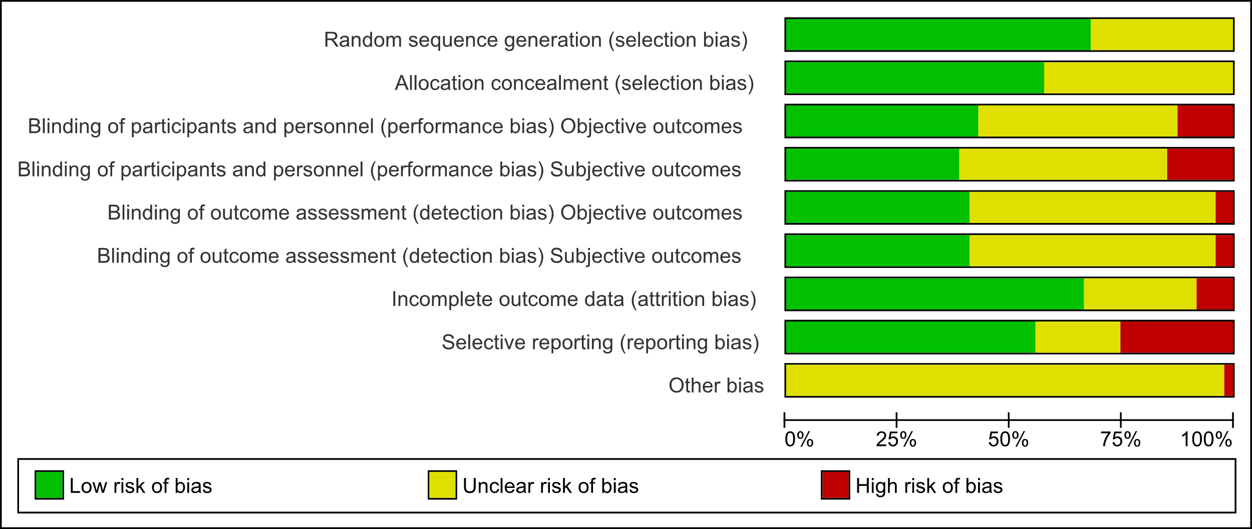

## Figure C2. Randomised controlled trials risk of bias summary: review authors’ judgements about each risk of bias item for each included study

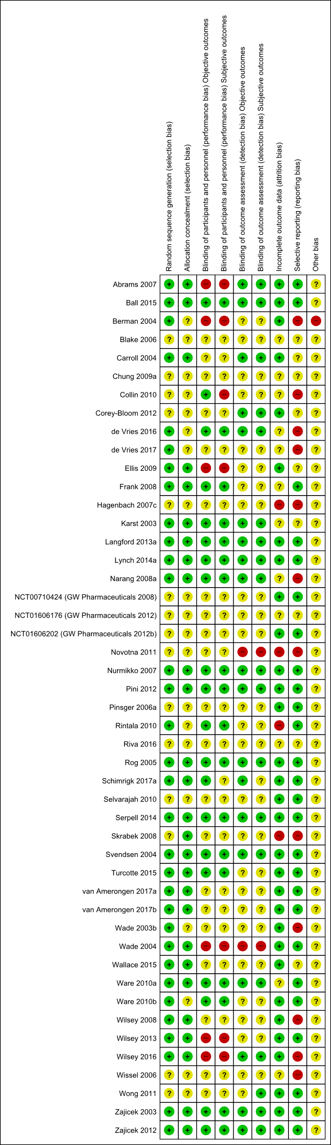

## Table C3. Observational studies and non- controlled trials risk of bias graph: review authors’ judgements about each risk of bias item presented as percentages across all included studies

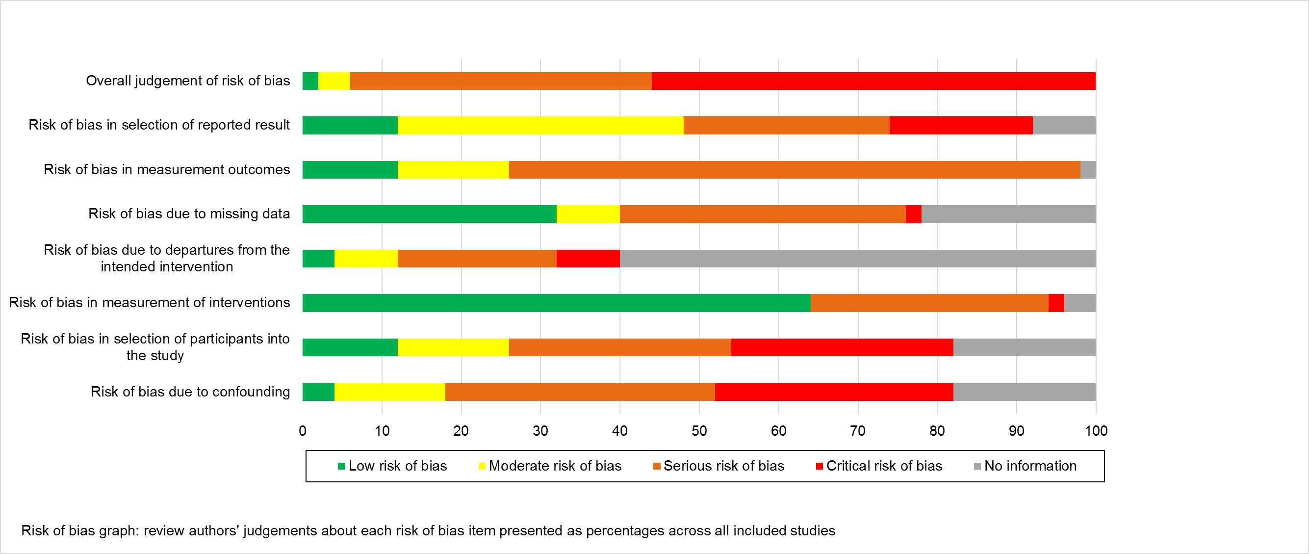

# Appendix D: Outcomes

## Table D1. Reporting of IMMPACT outcomes for randomised controlled trials (n = 47)

| Study ID | Study design | Cannabinoid | Condition | Pain outcome | Pain intensity | 30% reduction | 50% reduction | Physical functioning | Emotional function | PGIC | Adverse events | Withdrawals |
| --- | --- | --- | --- | --- | --- | --- | --- | --- | --- | --- | --- | --- |
| Abrams 2007 (USA) [2] | Parallel RCT | Plant-based cannabis | Neuropathic pain | Primary | **✓** | **✓\*** |  |  | **✓** |  | **✓\*** | **✓\*** |
| Ball 2015 (UK - multicentre) [16] | Parallel RCT | Dronabinol | CNCP | Secondary | **✓\*** |  |  |  |  |  | **✓\*** | **✓\*** |
| Berman 2004 (UK) [26] | Crossover RCT | THC extract | Neuropathic pain | Primary | **✓\*** |  |  | **✓\*** |  |  | **✓** | **✓** |
| Blake 2006 (UK) [28] | Parallel RCT | Nabiximols | Arthritis | Primary | **✓\*** |  |  | **✓\*** |  |  | **✓\*** | **✓\*** |
| Carroll 2004 (UK) [37] | Crossover RCT | THC:CBD | CNCP | Secondary | **✓\*** |  |  |  |  |  | **✓\*** |  |
| Chung 2009a (Canada) [42] | Crossover RCT | Nabilone | Fibromyalgia | Primary |  |  |  | **✓** |  |  | **✓** | **✓** |
| Collin 2010 (Multicentre -15 centres in UK, 8 in Czech Republic) [50] | Parallel RCT | Nabiximols | CNCP | Secondary | **✓** | **✓** |  | **✓** | **✓** | **✓a\*** | **✓\*** | **✓\*** |
| Corey-Bloom 2012 (USA) [51] | Crossover RCT | Plant-based cannabis | CNCP | Secondary | **✓\*** |  |  | **✓\*** |  |  | **✓** | **✓** |
| de Vries 2016 (Netherlands) [57] | Crossover RCT | Dronabinol | CNCP | Primary | **✓\*** |  |  |  |  |  | **✓\*** |  |
| deVries 2017 (Netherlands) [60] | Parallel RCT | Dronabinol | CNCP | Primary | **✓\*** |  |  | **✓** | **✓** | **✓** | **✓\*** | **✓\*** |
| Ellis 2009 (USA) [69] | Crossover RCT | Plant-based cannabis | Neuropathic pain | Primary | **✓** | **✓** |  | **✓** | **✓** |  | **✓** | **✓** |
| Frank 2008 (UK) [86] | Crossover RCT | Nabilone | Neuropathic pain | Primary | **✓\*** |  |  | **✓\*** | **✓\*** |  | **✓** | **✓** |
| Hagenbach 2007c (Switzerland) [92] | Parallel RCT | Dronabinol | CNCP | Secondary |  |  |  |  |  |  |  | **✓\*** |
| Karst 2003 (Germany) [114] | Crossover RCT | CT-3 | Neuropathic pain | Primary | **✓** | **✓\*** | **✓\*** |  |  |  | **✓\*** | **✓\*** |
| Langford 2013a (Multi-centre: 12 UK; 7 Czech Republic; 5 Canada; 5 Spain; 4 France) [125] | Parallel RCT | Nabiximols | Neuropathic pain | Primary | **✓** | **✓\*** | **✓\*** | **✓\*** | **✓\*** | **✓\*** | **✓\*** | **✓\*** |
| Lynch 2014a (Canada) [137] | Crossover RCT | Nabiximols | Neuropathic pain | Primary | **✓** |  |  | **✓** | **✓\*** |  | **✓** | **✓** |
| Narang 2008a (USA) [158] | Crossover RCT | Dronabinol | CNCP | Primary | **✓** |  |  |  | **✓** |  | **✓** | **✓** |
| NCT00710424 (GW Pharmaceuticals 2008) (Multi-centre - UK, Czech Republic, Romania) [233] | Parallel RCT | Nabiximols | Neuropathic pain | Primary | **✓\*** | **✓\*** |  | **✓\*** |  | **✓\*** | **✓\*** | **✓\*** |
| NCT01606176 (GW Pharmaceuticals 2012) (UK) [25] | Parallel RCT | Nabiximols | Neuropathic pain | Primary | **✓\*** |  |  | **✓\*** |  | **✓\*** | **✓\*** | **✓\*** |
| NCT01606202 (GW Pharmaceuticals 2012b) (Multi-centre - UK, Romania) [162] | Parallel RCT | Nabiximols | Neuropathic pain | Primary | **✓\*** |  |  | **✓\*** |  | **✓\*** | **✓\*** | **✓\*** |
| Novotna 2011 (Multi centre: 18 in UK, 11 in Spain, 10 in Poland, 8 in Czech Republic and 5 in Italy) [168] | Parallel RCT | Nabiximols | CNCP | Secondary | **✓\*** |  |  |  |  |  | **✓\*** | **✓\*** |
| Nurmikko 2007 (Multi-centre: 5 UK; 1 Belgium) [172] | Parallel RCT | Nabiximols | Neuropathic pain | Primary | **✓\*** | **✓\*** | **✓\*** | **✓\*** |  | **✓\*** | **✓\*** | **✓\*** |
| Pini 2012 (Italy) [189] | Crossover RCT | Nabilone | CNCP | Primary | **✓** |  |  | **✓\*** | **✓\*** |  | **✓** | **✓** |
| Pinsger 2006a (Austria) [190] | Crossover RCT | Nabilone | CNCP | Primary | **✓~** |  |  | **✓** |  |  | **✓** |  |
| Rintala 2010 (USA) [200] | Crossover RCT | Dronabinol | Neuropathic pain | Primary | **✓\*** |  |  |  |  |  | **✓** | **✓** |
| Riva 2016 (Italy - multicentre) [201] | Parallel RCT | Nabiximols | CNCP | Secondary | **✓** |  |  |  |  |  | **✓\*** | **✓\*** |
| Rog 2005 (UK) [204] | Parallel RCT | Nabiximols | Neuropathic pain | Primary | **✓\*** |  |  | **✓\*** | **✓\*** | **✓\*** | **✓\*** | **✓\*** |
| Schimrigk 2017a (Germany)[215] | Parallel RCT | Dronabinol | Neuropathic pain | Primary | **✓\*** |  |  | **✓** | **✓** |  | **✓\*** | **✓\*** |
| Selvarajah 2010 (UK) [220] | Parallel RCT | Nabiximols | Neuropathic pain | Primary | **✓\*** | **✓\*** |  | **✓\*** | **✓\*** |  |  | **✓** |
| Serpell 2014 (Multicentre- 21 centres in UK, 7 in Czech Republic, 6 centres in Romania, 4 centres in Belgium and 1 centre in Canada) [221] | Parallel RCT | Nabiximols | CNCP | Primary | **✓\*** | **✓** | **✓\*** | **✓\*** |  | **✓\*** | **✓\*** | **✓\*** |
| Skrabek 2008 (Canada) [226] | Parallel RCT | Nabilone | Fibromyalgia | Primary | **✓** |  |  | **✓\*** | **✓\*** |  | **✓\*** | **✓\*** |
| Svendsen 2004 (Denmark) [232] | Crossover RCT | Dronabinol | Neuropathic pain | Primary | **✓\*** |  | **✓\*** | **✓\*** | **✓\*** |  | **✓** |  |
| Turcotte 2015 (Canada) [243] | Parallel RCT | Nabilone | Neuropathic pain | Primary | **✓** |  |  |  |  | **✓\*** | **✓\*** | **✓\*** |
| van Amerongen 2017a (Netherlands) [247] | Crossover RCT | THC extract | Neuropathic pain | Primary | **✓\*** |  |  |  | **✓** |  | **✓** |  |
| van Amerongen 2017b (Netherlands) [247] | Parallel RCT | THC extract | Neuropathic pain | Primary | **✓\*** |  |  | **✓\*** |  | **✓\*** | **✓\*** | **✓\*** |
| Wade 2003b (UK) [255] | Crossover RCT | THC extract | Neuropathic pain | secondary | **✓** |  |  |  |  |  | **✓** | **✓** |
| Wade 2004 (UK) [253] | Parallel RCT | Nabiximols | CNCP | Secondary | **✓\*** |  |  | **✓\*** | **✓\*** |  | **✓\*** | **✓\*** |
| Wallace 2015 (USA) [259] | Crossover RCT | Plant-based cannabis | Neuropathic pain | Primary | **✓** | **✓** |  |  |  |  | **✓** |  |
| Ware 2010a (Canada) [261] | Crossover RCT | Nabilone | Fibromyalgia | Secondary | **✓\*** |  |  | **✓\*** |  |  | **✓\*** | **✓** |
| Ware 2010b (Canada) [263] | Crossover RCT | Plant-based cannabis | Neuropathic pain | Primary | **✓\*** |  |  | **✓\*** | **✓\*** |  | **✓** |  |
| Wilsey 2008 (USA) [270] | Crossover RCT | Plant-based cannabis | Neuropathic pain | Primary | **✓\*** |  |  |  | **✓** | **✓\*** | **✓** |  |
| Wilsey 2013 (USA) [269] | Crossover RCT | Plant-based cannabis | Neuropathic pain | Primary | **✓** | **✓** |  |  | **✓** | **✓** | **✓** |  |
| Wilsey 2016 (USA) [271] | Crossover RCT | Plant-based cannabis | Neuropathic pain | Primary | **✓** | **✓** |  |  |  | **✓** | **✓** |  |
| Wissel 2006 (Switzerland) [273] | Crossover RCT | Nabilone | CNCP | Primary | **✓\*** |  |  |  |  |  | **✓** | **✓** |
| Wong 2011 (USA) [274] | Parallel RCT | Dronabinol | CNCP | Secondary | **✓** |  |  |  |  |  | **✓\*** |  |
| Zajicek 2003 (UK) [277] | Parallel RCT | Dronabinol | CNCP | Secondary | **✓** | **✓\*** |  |  |  |  | **✓\*** | **✓** |
| Zajicek 2012 (UK - multicentre) [279] | Parallel RCT | THC extract | CNCP | Secondary | **✓\*** |  |  |  |  |  | **✓\*** | **✓\*** |
| Randomised controlled trials |  |  |  |  | **45/47** | **13/47** | **5/47** | **26/47** | **19/47** | **14/47** | **45/47** | **36/47** |
| Observational studies |  |  |  |  | **55/57** | **5/57** | **5/57** | **26/57** | **24/57** | **10/57** | **36/57** | **35/57** |
| TOTAL |  |  |  |  | **100/104** | **18/104** | **10/104** | **52/104** | **43/104** | **24/104** | **81/104** | **71/104** |

a carer global impression of change

PGIC = patient global impression of change

*Data used in meta-analysis of RCTs

~Data used in meta-analysis of observational trials with a comparison group

## Table D2. Reporting of IMMPACT outcomes for observational studies (n = 57)

| Study ID | Study design | Cannabinoid | Condition | Pain outcome | Pain intensity | 30% reduction | 50% reduction | Physical functioning | Emotional function | PGIC | Adverse events | Withdrawals |
| --- | --- | --- | --- | --- | --- | --- | --- | --- | --- | --- | --- | --- |
| Aggarwal 2009 (USA) [3] | Chart review | Cannabis sativa | Neuropathic pain | Primary | **✓** |  |  |  |  |  |  |  |
| Allegretti 2013 (USA) [6] | Prospective survey | Cannabis sativa | CNCP | Secondary | **✓** |  |  |  |  |  |  |  |
| Attal 2004 (France) [13] | Open label | Dronabinol | Neuropathic pain | Primary | **✓** |  |  | **✓** | **✓** |  | **✓** | **✓** |
| Bestard 2011 (Canada) [27] | Open label | Nabilone | Neuropathic pain | Primary | **✓~** |  |  | **✓~** | **✓~** |  | **✓** | **✓** |
| Boehnke 2016 (USA) [29] | Cross-sectional survey | Cannabis sativa | CNCP | Primary | **✓** |  |  | **✓** |  |  |  |  |
| Bonn-Miller 2014 (USA) [30] | Cross-sectional survey | NR | CNCP | Primary | **✓** |  |  |  |  |  |  |  |
| Brady 2004a (USA) [33] | Open label | THC extract | CNCP | Secondary | **✓** |  |  |  |  |  |  | **✓** |
| Brady 2004b (USA) [33] | Open label | THC extract | CNCP | Secondary | **✓** |  |  |  |  |  |  | **✓** |
| Cameron 2014 (Canada) [36] | Chart review | Nabilone | CNCP | Primary | **✓** |  |  |  |  |  | **✓** | **✓** |
| Centonze 2009 (Italy) [39] | Open label | Nabiximols | CNCP | Primary | **✓** |  |  |  |  |  | **✓** | **✓** |
| Chung 2009b (Canada) [42] | Chart review | Nabilone | Fibromyalgia | Primary | **✓** |  |  | **✓** |  |  |  |  |
| Cimas-Hernando 2015 (Spain) [43] | Prospective survey | Nabiximols | CNCP | Primary | **✓** |  |  |  |  |  | **✓** | **✓** |
| Clermont 2002 (France) [46] | Prospective survey | Dronabinol | Neuropathic pain | Primary | **✓** |  |  |  | **✓** |  | **✓** |  |
| Degenhardt 2015 (Australia) [61] | Cross-sectional survey | cannabis sativa | CNCP | Primary | **✓~** |  |  |  | **✓** |  |  |  |
| Eisenberg 2014 (Israel) [67] | Open label | Cannabis sativa | Neuropathic pain | Secondary | **✓** |  |  |  |  |  | **✓** | **✓** |
| Ferre 2016 (Italy) [73] | Open label | Nabiximols | CNCP | Secondary | **✓** |  |  |  |  |  | **✓** | **✓** |
| Fiz 2011 (Spain) [81] | Cross-sectional survey | Cannabis sativa | Fibromyalgia | Primary | **✓** |  |  | **✓** | **✓** |  | **✓** |  |
| Gerardi 2016 (Italy) [87] | Open label | Cannabis sativa | CNCP | Primary | **✓** |  |  | **✓** | **✓** |  | **✓** | **✓** |
| Gurevich 2015 (Israel) [90] | Cross-sectional survey | Cannabis sativa | CNCP | Primary | **✓** |  |  | **✓** |  | **✓** | **✓** | **✓** |
| Hagenbach 2007a (Switzerland) [92] | Open label | Dronabinol | CNCP | Secondary | **✓** |  |  |  | **✓** |  | **✓** | **✓** |
| Hagenbach 2007b (Switzerland) [92] | Open label | THC-HS | CNCP | Secondary |  |  |  |  |  |  |  | **✓** |
| Haroutiunian 2008 (Israel) [94] | Open label | THC extract | CNCP | Primary | **✓** |  |  | **✓** | **✓** |  | **✓** | **✓** |
| Haroutiunian 2011 (Israel) [93] | Prospective survey | Cannabis sativa | CNCP | Primary | **✓** |  |  | **✓** | **✓** |  |  |  |
| Haroutiunian 2016 (Israel) [95] | Open label | Cannabis sativa | CNCP | Primary | **✓** |  |  | **✓~** | **✓** | **✓** | **✓** | **✓** |
| Hoggart 2015 (Multi-centre: 38 UK; 15 Czech Republic; 8 Romania; 4 Belgium; 1 Canada) [101] | Open label | Nabiximols | Neuropathic pain | Primary | **✓** | **✓** | **✓** |  |  | **✓** | **✓** | **✓** |
| Holdcroft 1997 (UK) [103] | Case series | THC extract | CNCP | Primary | **✓** |  |  |  |  |  |  |  |
| Ko 2016 (Canada) [119] | Case series | Cannabis sativa | Arthritis, Neuropathic pain | Primary | **✓** |  |  |  |  |  |  |  |
| Lahat 2012 (Israel)[123] | Open-label, prospective, single-arm trial | Cannabis sativa | CNCP | Secondary | **✓** |  |  |  | **✓** | **✓** | **✓** | **✓** |
| Langford 2013b (Multi-centre: 12 UK; 7 Czech Republic; 5 Canada; 5 Spain; 4 France) [125] | Open label | Nabiximols | Neuropathic pain | Primary | **✓** |  |  | **✓~** |  | **✓** | **✓~** | **✓** |
| Lotan 2014 (Israel) [134] | Open label | Cannabis sativa | CNCP | Secondary | **✓** |  |  | **✓** |  |  | **✓** |  |
| Lynch 2014b (Canada) [137] | Extension study | Nabiximols | Neuropathic pain | Primary | **✓** |  |  |  |  |  | **✓** | **✓** |
| Martinez-Rodriguez 2008 (Spain) [144] | Cross-sectional survey | Cannabis sativa | CNCP | Secondary | **✓** |  |  | **✓** | **✓** |  | **✓** |  |
| Martyn 1995 (UK) [145] | Case series | Nabilone | CNCP | Secondary |  |  |  |  |  |  |  |  |
| Maurer 1990 (Switzerland) [146] | Case series | THC extract | CNCP | Primary | **✓** |  |  |  | **✓** | **✓** |  |  |
| Narang 2008b (USA) [158] | Open label | Dronabinol | CNCP | Primary | **✓** |  |  | **✓** | **✓** | **✓** | **✓** |  |
| Notcutt 2004 (UK) [165] | Case series | THC extract; CBD extract; THC:CBD extract | CNCP | Primary | **✓** |  | **✓~** | **✓~** | **✓~** |  |  | **✓** |
| Notcutt 2014 (UK) [164] | Retrospective survey | Nabilone | CNCP | Primary | **✓** |  |  |  |  |  | **✓** | **✓** |
| Palmieri 2017 (Italy) [176] | Open label | CBD extract | CNCP | Secondary | **✓** |  |  |  |  |  |  | **✓** |
| Paolicelli 2016 (Italy) [177] | Open label | Nabiximols | CNCP | Secondary | **✓** |  |  |  |  |  | **✓** | **✓** |
| Pinsger 2006b (Austria) [190] | Modified early-escape study | Nabilone | CNCP | Primary | **✓** |  |  | **✓~** |  |  |  |  |
| Robinson 2016 (Israel) [202] | Prospective survey | Cannabis sativa | Neuropathic pain | Primary | **✓** |  |  |  |  | **✓** | **✓** | **✓** |
| Rog 2007 (UK) [205] | Open label | Nabiximols | Neuropathic pain | Secondary | **✓** |  |  |  |  |  | **✓** | **✓** |
| Rudich 2003 (Canada) [206] | Case study | Dronabinol | Neuropathic pain | Primary | **✓** | **✓** |  | **✓** | **✓** |  |  |  |
| Schimrigk 2017b (Germany)[215] | Open-label trial | Dronabinol | Neuropathic pain | Primary | **✓** |  |  | **✓** | **✓** |  | **✓** | **✓** |
| Schimrigk 2017c (Germany)[215] | Open-label trial with long-term follow-up | Dronabinol | Neuropathic pain | Primary | **✓** |  |  | **✓** | **✓** |  | **✓** | **✓** |
| Schley 2006 (Germany) [216] | Open label | THC extract | CNCP | Primary | **✓** |  | **✓** | **✓~** |  |  |  | **✓** |
| Shah 2017 (USA) [223] | Chart review | Unknown | CNCP | Primary | **✓~** |  |  | **✓~** | **✓~** |  |  | **✓** |
| Storr 2014 (Germany) [229] | Cross-sectional survey | Cannabis sativa | CNCP | Secondary | **✓** |  |  |  |  |  |  |  |
| Toth 2008 (Canada) [234] | Prospective survey | Nabilone | Neuropathic pain | Primary | **✓** | **✓** | **✓** |  |  |  | **✓** |  |
| Toth 2012a (Canada) [235] | Single-blind flexible dose run-in phase | Nabilone | Neuropathic pain | Primary | **✓** | **✓** |  | **✓** | **✓** | **✓** | **✓** | **✓** |
| Toth 2012b (Canada) [235] | Enriched enrolment trial | Nabilone | Neuropathic pain | Primary | **✓~** | **✓~** | **✓~** | **✓~** | **✓~** | **✓~** | **✓** | **✓** |
| Vermersch 2016 (Multicentre: 34 centres in Italy, 2 in Norway and 1 in Denmark) [251] | Prospective survey | Nabiximols | CNCP | Secondary | **✓** |  |  |  |  |  | **✓** | **✓** |
| Wade 2003a (UK) [255] | Open label | THC:CBD extract | Neuropathic pain | Secondary | **✓** |  |  |  |  |  | **✓** | **✓** |
| Wade 2006 (UK) [252] | Open label | Nabiximols | CNCP | Secondary | **✓** |  |  |  |  |  | **✓** | **✓** |
| Ware 2003 (Canada) [260] | Prospective survey | Cannabis sativa | CNCP | Primary | **✓** |  |  | **✓** | **✓** |  | **✓** |  |
| Ware 2015 (Canada) [262] | Prospective survey | Cannabis sativa | CNCP | Secondary | **✓~** |  |  | **✓~** | **✓~** |  | **✓~** |  |
| Weber 2009 (Germany) [265] | Retrospective survey | Dronabinol | Neuropathic pain, fibromyalgia | Primary | **✓** |  |  | **✓** | **✓** |  | **✓** | **✓** |
| Randomised controlled trials |  |  |  |  | **45/47** | **13/47** | **5/47** | **26/47** | **19/47** | **14/47** | **45/47** | **36/47** |
| Observational studies |  |  |  |  | **55/57** | **5/57** | **5/57** | **26/57** | **24/57** | **10/57** | **36/57** | **35/57** |
| TOTAL |  |  |  |  | **100/104** | **19/104** | **10/104** | **52/104** | **43/104** | **2/104** | **81/104** | **71/104** |

~Data used in meta-analysis of observational trials with a comparison group

# Appendix E: Additional results tables and figures

## Table E1: Effect sizes for pain-related outcomes from meta-analyses of RCTs and observational studies of cannabis or cannabinoids in chronic non-cancer pain, by cannabinoid, outcome type and comparator, with associated GRADE rating

| **Study type** | **Refs** | **N studies (N part.)** | **Cannabis or Cannabinoid used** | **Comparator** | **Summary estimate**  **(95% CI)** | **Favours** | ***I2*** | **GRADE rating$** |
| --- | --- | --- | --- | --- | --- | --- | --- | --- |
| **30% reduction in pain** |  |  |  |  |  |  |  |  |
| **Parallel RCT** | [125; 172; 220; 221; 233] | 5 (1036) | Nabiximols | Placebo | OR 1.21 (0.93 to 1.57) | Neither | 32% | ⨁⨁⨁⨁ HIGH |
| **Parallel RCT** | [277] | 1 (312) | Dronabinol | Placebo | OR 2.09 (0.92 to 4.73) | Neither | n/a | ⨁⨁⨁◯ MODERATE |
| **Parallel RCT** |  | 0 (0) | Nabilone | Placebo | No studies | - | - | - |
| **Parallel RCT** | **[2]** | **1 (50)** | **Plant-based cannabis** | **Placebo** | **OR 3.43 (1.03 to 11.48)** | **Cannabis** | **n/a** | **⨁◯◯◯ VERY LOW** |
| **Parallel RCT** |  | 0 (0) | THC extract | Placebo | No studies | - | - | - |
| **Parallel RCT** | **[277]** | **1 (317)** | **THC:CBD extract** | **Placebo** | **OR 2.69 (1.21 to 6.00)** | **THC:CBD extract** | **n/a** | **⨁⨁⨁◯ MODERATE** |
| **Cross-over RCTa** | **[114]** | **1 (19)** | **Ajulemic acid (CT-3)** | **Placebo** | **OR 8.00 (1.00 to 63.96)** | **Ajulemic acid** | **n/a** | ⨁⨁◯◯ LOW |
| **Parallel RCT; Cross-over RCTa** | **[2; 114; 125; 172; 220; 221; 233; 277]** | **9 (1734)** | **Any type** | **Placebo** | **OR 1.46 (1.16 to 1.84)c** | **Cannabinoidc** | **52%c** | **⨁⨁⨁◯ MODERATE** |
| ***Observationalb*** | ***[235]*** | ***1 (26)*** | ***Nabilone*** | ***Placebo*** | ***OR 8.80 (1.35 to 57.43)*** | ***Nabilone*** | ***n/a*** | ***⨁◯◯◯ VERY LOW*** |
| **50% reduction in pain** |  |  |  |  |  |  |  |  |
| **Parallel RCT** | [125; 172; 221] | 3 (710) | Nabiximols | Placebo | OR 1.35 (0.91 to 2.00) | Neither | 31% | ⨁⨁⨁⨁ HIGH |
| **Cross-over RCTa** | [232] | 1 (24) | Dronabinol | Placebo | OR 7.86 (0.75 to 82.13) | Neither | n/a | ⨁⨁◯◯ LOW |
| **Parallel RCT** |  | 0 (0) | Nabilone | Placebo | No studies | - | - | - |
| **Parallel RCT** |  | 0 (0) | Cannabis sativa | Placebo | No studies | - | - | - |
| **Parallel RCT** |  | 0 (0) | THC extract | Placebo | No studies | - | - | - |
| **Parallel RCT** |  | 0 (0) | THC:CBD extract | Placebo | No studies | - | - | - |
| **Cross-over RCTa** | [114] | 1 (19) | Ajulemic acid (CT-3) | Placebo | OR 3.71 (0.13 to 103.11) | Neither | n/a | ⨁◯◯◯ VERY LOW |
| **Parallel RCT; Cross-over RCTa** | [114; 125; 172; 221; 232] | **5 (753)** | **Any type** | **Placebo** | **OR 1.43 (0.97 to 2.11)** | **Neither** | **25%** | **⨁⨁⨁◯ MODERATE** |
| ***Observationalb*** | *[164; 235]* | ***2 (74)*** | ***Any type*** | ***Placebo*** | ***OR 5.54 (1.75 to 17.49)*** | ***Cannabinoid*** | ***0%*** | ***⨁◯◯◯ VERY LOW*** |
| **Change in pain intensity** |  |  |  |  |  |  |  |  |
| **Parallel RCT; Cross-over RCTa** | **[25; 27; 28; 50; 125; 162; 168; 172; 204; 220; 221; 233; 253]** | **13 (2051)** | **Nabiximols** | **Placebo** | **SMD -0.11 (-0.20 to -0.03)d** | **Nabiximolsd** | **65%d** | **⨁⨁⨁◯ MODERATE** |
| **Parallel RCT; Cross-over RCTa** | [16; 57; 60; 200; 215; 232] | 6 (786) | Dronabinol | Placebo | SMD -0.07 (-0.22 to 0.07) | Neither | 49% | ⨁⨁⨁◯ MODERATE |
| **Parallel RCT; Cross-over RCTa** | [86; 261; 273] | 3 (232) | Nabilone | Placebo | SMD 0.26 (0.00 to 0.52)f | Neitherf | 67%f | ⨁◯◯◯ VERY LOW |
| **Cross-over RCTa** | [51; 263; 270] | 6 (296) | Cannabis sativa | Placebo | SMD -0.18 (-0.39 to 0.04)g | Neitherg | 73%g | ⨁◯◯◯ VERY LOW |
| **Parallel RCT; Cross-over RCTa** | **[26; 247; 279]** | **4 (445)** | **THC extract** | **Placebo** | **SMD -0.39 (-0.58 to -0.20)** | **THC extract** | **0%** | **⨁⨁⨁◯ MODERATE** |
| **Cross-over RCTa** | [37] | 1 (38) | THC:CBD extract | Placebo | SMD -0.26 (-0.90 to 0.38) | Neither | n/a | ⨁⨁◯◯ LOW |
| **Cross-over RCTa** | [114] | 1 (21) | Ajulemic acid (CT-3) | Placebo | SMD -0.32 (-1.18 to 0.55) | Neither | n/a | ⨁◯◯◯ VERY LOW |
| **Parallel RCT; Cross-over RCTa** | **[16; 25; 26; 28; 37; 50; 51; 57; 60; 86; 114; 125; 162; 168; 172; 200; 204; 215; 220; 221; 232; 233; 247; 251; 253; 261; 263; 270; 273; 279]** | **34 (3869)** | **Any type** | **Placebo** | **SMD -0.12 (-0.19 to -0.06)h** | **Cannabinoidh** | **63%h** | **⨁⨁⨁◯ MODERATE** |
| **Observationalb** |  | *4 (263)* | *Nabilone* | *Gabapentin; Placebo* | *SMD -0.07 (-0.17 to 0.02)i* | *Neitheri* | *66%i* | ⨁◯◯◯ VERY LOW |
| **Observationalb** | *[61; 223; 262]* | *3 (999)* | *Cannabis sativa* | *Non-cannabis users* | *SMD 0.01 (-0.37 to 0.40)* | *Neither* | *84%* | ⨁◯◯◯ VERY LOW |
| **Observationalb** | *[27; 61; 190; 223; 235; 262]* | *7 (1262)* | *Any type* | *Gabapentin; placebo; non-cannabis users* | *SMD -0.02 (-0.10 to 0.06)* | *Neither* | *76%j* | ⨁◯◯◯ VERY LOW |

N – number; RCT – randomised controlled trial; part. – participants.

**$**High: We are very confident that the true effect lies close to that of the estimate of the effect; Moderate: We are moderately confident in the effect estimate: The true effect is likely to be close to the estimate of the effect, but there is a possibility that it is substantially different; Low quality: Our confidence in the effect estimate is limited: The true effect may be substantially different from the estimate of the effect; Very low quality: We have very little confidence in the effect estimate: The true effect is likely to be substantially different from the estimate of effect

aOnly those cross-over trials where data were amenable to meta-analysis were included (i.e. where appropriate paired analyses were conducted and could be extracted or obtained from study authors; or where results were presented separately for each period of the trial).[54; 68] Where results from paired analyses were amenable to meta-analyses, we have analysed these data, otherwise to avoid carry-over effects, we analysed data from the first period only.[55]

bOnly observational studies with a comparator group are included here. For observational groups with no comparator, the proportion reporting improvement is presented in Appendix F.

cSensitivity analysis indicated this effect did not differ when using the random effects model (OR 1.63, 95%CI 1.13 to 2.35).

dSensitivity analysis indicated this effect did not differ when using the random effects model (SMD -0.16, 95%CI -0.32 to -0.00).

fSensitivity analysis indicated this effect did not differ when using the random effects model (SMD 0.25, 95%CI -0.27 to 0.77).

gSensitivity analysis indicated this effect did not differ when using the random effects model (SMD -0.16, 95%CI -0.58 to 0.26).

hSensitivity analysis indicated this effect did not differ when using the random effects model (SMD -0.16, 95%CI -0.27 to -0.04).

iSensitivity analysis indicated this effect did not differ when using the random effects model (SMD -0.30, 95%CI -0.71 to 0.10).

jSensitivity analysis indicated this effect did not differ when using the random effects model (SMD -0.10, 95%CI -0.32 to 0.12).

## Table E2: Effect sizes for other outcomes from meta-analyses of RCTs and observational studies of cannabis or cannabinoids in CNCP, by outcome type, CNCP condition and comparator, with associated GRADE rating

|  |  |  |  |  |  |  |  |  |
| --- | --- | --- | --- | --- | --- | --- | --- | --- |
| **Study type** | **Refs** | **N studies (N part.)** | **Medical condition** | **Comparator** | **Summary estimate**  **(95% CI)** | **Favours** | ***I2*** | **GRADE rating$** |
| **Overall physical functioning** | | | | | | | | |
| Parallel RCT; Cross-over RCTa | **[25; 26; 86; 125; 162; 172; 220; 221; 232; 233; 263]** | 14 (1404) | Neuropathic pain | Placebo; dihydrocodeine | SMD 0.03 (-0.06 to 0.12) | Neither | 0% | ⨁⨁⨁◯MODERATE |
| **[26; 86; 162; 172; 220; 221; 233; 263]**Parallel RCT | [25; 125; 232] | 3 (410) | …MS-related | Placebo | SMD 0.02 (-0.17 to 0.21) | Neither | 0% | ⨁⨁⨁◯MODERATE |
| Parallel RCT; Cross-over RCTa | [26; 86; 162; 172; 220; 221; 233; 263] | 11 (994) | …non-MS-related | Placebo | SMD 0.04 (-0.07 to 0.14) | Neither | 0% | ⨁⨁⨁◯MODERATE |
| Parallel RCT; Cross-over RCTa | [226; 261] | 2 (272) | Fibromyalgia | Placebo; Ibuprofen | SMD 0.29 (-0.13 to 0.72)c | Neithera | 72%c | ⨁◯◯◯ VERY LOW |
| - |  | 0 (0) | Arthritis | Placebo | No studies | - | *-* | - |
| Parallel RCT; Cross-over RCTa | **[189; 253]** | 2 (149) | CNCP – mixed | Placebo | SMD 0.20 (-0.0 to 0.40) | Neither | 5% | ⨁◯◯◯ VERY LOW |
| Parallel RCT | **[253]** | 1 (24) | …MS-related CNCP | Placebo | SMD 0.07 (-0.24 to 0.39) | Neither | n/a | ⨁◯◯◯ VERY LOW |
| Cross-over RCTa | **[189]** | **1 (125)** | **…non-MS-related** | **Placebo** | **SMD 0.29 (0.02 to 0.56)** | **Cannabinoid** | **n/a** | **⨁⨁◯◯ LOW** |
| - |  | 0 (0) | …visceral pain | Placebo | No studies | - | *-* | - |
| All RCTs | [25; 26; 86; 125; 162; 172; 189; 220; 221; 226; 232; 233; 253; 261; 263] | 18 (1825) | Any pain type | Placebo; dihydrocodeine; ibuprofen | SMD 0.07 (-0.01 to 0.15) | Neither | 0% | ⨁⨁⨁◯MODERATE |
| *Observationalb* | *[27; 165; 190; 223; 235; 262]* | *7 (623)* | *Any pain type&* | *Gabapentin; Placebo; non-cannabis users* | *SMD 0.17 (-0.02 to 0.33)* | *Neither* | *0%* | *⨁◯◯◯ VERY LOW* |
| **Sleep problems** | | | | | | | | |
| **Parallel RCT; Cross-over RCTa** | **[25; 86; 162; 172; 204; 221; 233; 247; 261]** | **11 (1144)** | **Neuropathic pain** | **Placebo; dihydrocodeine** | **SMD -0.26 (-0.38 to -0.15)** | **Cannabinoid** | **42%** | **⨁⨁⨁⨁ HIGH** |
| **Parallel RCT** | **[162; 204; 247]** | **3 (159)** | **…MS-related** | **Placebo** | **SMD -0.38 (-0.69 to -0.06)d** | **Cannabinoid** | **67%d** | **⨁⨁◯◯ LOW** |
| **Parallel RCT; Cross-over RCTa** | **[25; 86; 172; 221; 233; 261]** | **8 (985)** | **…non-MS-related** | **Placebo; dihydrocodeine** | **SMD -0.25 (-0.37 to -0.12)** | **Cannabinoid** | **35%** | **⨁⨁⨁◯MODERATE** |
| **Cross-over RCTa** | **[261]** | **1 (64)** | **Fibromyalgia** | **Amitriptyline** | **SMD -0.78 (-1.29 to -0.27)** | **Cannabinoid** | **n/a** | **⨁⨁◯◯ LOW** |
| **Parallel RCT** | **[28]** | **1 (58)** | **Arthritis** | **Placebo** | **SMD -0.58 ( -1.11 to -0.05)** | **Cannabinoid** | **n/a** | **⨁⨁◯◯ LOW** |
| Parallel RCT; Cross-over RCTa | [51; 253] | 2 (216) | CNCP | Placebo | SMD -0.23 (-0.50 to 0.03) | Neither | 0% | ⨁◯◯◯ VERY LOW |
| Parallel RCT; Cross-over RCTa | [51; 253] | 2 (216) | …MS-related | Placebo | SMD -0.23 (-0.50 to 0.03) | Neither | 0% | ⨁◯◯◯ VERY LOW |
| - |  | 0 (0) | …non-MS-related | Placebo | No studies | - | - | - |
| - |  | 0 (0) | …visceral pain | Placebo | No studies | - | - | - |
| **All RCTs** | **[25; 28; 51; 86; 162; 172; 204; 221; 233; 247; 253; 263]** | **15 (1482)** | **Any pain type** | **Placebo; amitriptyline; dihydrocodeine** | **SMD -0.29 (-0.40 to -0.19)** | **Cannabinoid** | **40%** | **⨁⨁◯◯ LOW** |
| *Observational* | [27; 95; 125; 216; 235] | *6 (708)* | *Any pain type&* | *Gabapentin; non-cannabis users* | *SMD -0.51 (-0.73 to -0.29)e* | *Cannabinoide* | *84%e* | *⨁◯◯◯ VERY LOW* |
| **Quality of life** | | | | | | | | |
| Parallel RCT; Cross-over RCTa | [25; 125; 162; 220; 233; 261] | 8 (903) | Neuropathic pain | Placebo | SMD 0.03 ( -0.09 to 0.14) | Neither | 0% | ⨁⨁⨁⨁ HIGH |
| Parallel RCT | [125; 162] | 2 (403) | …MS-related | Placebo | SMD 0.10 (-0.09 to 0.30) | Neither | 0% | ⨁⨁⨁⨁ HIGH |
| Parallel RCT; Cross-over RCTa | [25; 125; 162; 220; 233; 261] | 6 (500) | …non-MS-related | Placebo | SMD -0.01 (-0.16 to 0.13) | Neither | 0% | ⨁⨁⨁◯MODERATE |
| Parallel RCT; Cross-over RCTa | [226; 261] | 2 (104) | Fibromyalgia | Placebo; amitriptyline | SMD 0.29 ( -0.13 to 0.72)f | Neither | 72%f | ⨁◯◯◯ VERY LOW |
| - |  | 0 (0) | Rheumatoid arthritis | Placebo | No studies | - | - | - |
| **Cross-over RCT**a | **[189]** | **1 (52)** | **CNCP** | **Ibuprofen** | **SMD 0.29 (0.02 to 0.56)** | **Cannabinoid** | **n/a** | **⨁⨁◯◯ LOW** |
| **Parallel RCT** |  | 0 (0) | …MS-related | Placebo | No studies | - | - | - |
| **Cross-over RCT**a | **[189]** | **1 (52)** | **…non-MS-related** | **Ibuprofen** | **SMD 0.29 (0.02 to 0.56)** | **Cannabinoid** | **n/a** | **⨁⨁◯◯ LOW** |
| - |  | 0 (0) | …visceral pain | Placebo | No studies | - | - | - |
| All RCTs | [25; 125; 162; 189; 220; 226; 233; 263] | 11 (1059) | Any pain type | Placebo; amitriptyline; ibuprofen | SMD 0.08 (-0.02 to 0.19) | Neither | 14% | ⨁⨁⨁◯MODERATE |
| *Observationalb* | *[27; 235; 262]* | *4 (534)* | *Any pain type* | *Gabapentin; placebo; non-cannabis users* | *SMD 0.14 (-0.03 to 0.31)g* | *Neither* | *81%g* | *⨁◯◯◯ VERY LOW* |
| **Overall emotional functioning** | | | | | | | | |
| Parallel RCT; Cross-over RCTa | [125; 137; 220; 232; 263] | 7 (509) | Neuropathic pain | Placebo | SMD -0.13 (-0.28 to 0.01) | Neither | 42% | ⨁⨁⨁⨁ HIGH |
| Parallel RCT; Cross-over RCTa | [125; 232] | 2 (363) | …MS-related | Placebo | SMD -0.09 (-0.30 to 0.12)h | Neither | 73%h | ⨁⨁◯◯ LOW |
| Parallel RCT; Cross-over RCTa | [137; 220; 261] | 5 (146) | …non-MS-related | Placebo | SMD -0.17 (-0.38 to 0.03) | Neither | 37% | ⨁⨁◯◯ LOW |
| - |  | 0 (0) | Fibromyalgia | Placebo | No studies | - | - | - |
| - |  | 0 (0) | Rheumatoid arthritis | Placebo | No studies | - | - | - |
| Crossover RCTa | [189] | 1 (52) | CNCP | Ibuprofen | SMD -0.13 (-0.40 to 0.14) | Neither | n/a | ⨁⨁◯◯ LOW |
| - |  | 0 (0) | …MS-related | Placebo | No studies | - | - | - |
| Crossover RCTa | [189] | 1 (52) | …non-MS-related | Ibuprofen | SMD -0.13 (-0.40 to 0.14) | Neither | n/a | ⨁⨁◯◯ LOW |
| - |  | 0 (0) | …visceral pain | Placebo | No studies | - | - | - |
| **All RCTs** | **[125; 137; 189; 220; 232; 261]** | **8 (561)** | **Any pain type** | **Placebo; ibuprofen** | **SMD -0.13 (-0.26 to -0.00)** | **Cannabinoid** | **32%** | **⨁⨁⨁◯MODERATE** |
| *Observationalb* | [27; 165; 262] | *4 (557)* | *Any pain type* | *Gabapentin; placebo; non-cannabis users* | *SMD -0.21 (-0.38 to -0.05)i* | *Cannabinoid* | *52%i* | *⨁◯◯◯ VERY LOW* |
| **Change in depression scores** | | | | | | | | |
| Parallel RCT; Cross-over RCTa | [86; 204; 263] | 5 (379) | Neuropathic pain | Placebo; dihydrocodeine | SMD 0.00 (-0.19 to 0.20) | Neither | 0% | ⨁⨁⨁◯MODERATE |
| Parallel RCT | [204] | 1 (140) | …MS-related | Placebo | SMD 0.06 (-0.42 to 0.55) | Neither | n/a | ⨁⨁◯◯ LOW |
| Parallel RCT; Cross-over RCTa | [86; 263] | 4 (239) | …non-MS-related | Placebo; dihydrocodeine | SMD -0.01 (-0.22 to 0.21) | Neither | 0% | ⨁⨁◯◯ LOW |
| - |  | 0 (0) | Fibromyalgia | Placebo | No studies | - | - | - |
| - |  | 0 (0) | Rheumatoid arthritis | Placebo | No studies | - | - | - |
| Parallel RCT; Cross-over RCTa | [189; 253] | 2 (117) | CNCP | Placebo; ibuprofen | SMD 0.05 (-0.15 to 0.26) | Neither | 0% | ⨁◯◯◯ VERY LOW |
| Parallel RCT | [253] | 1 (65) | …MS-related | Placebo | SMD 0.12 (-0.19 to 0.44) | Neither | n/a | ⨁◯◯◯ VERY LOW |
| Cross-over RCTa | [189] | 1 (52) | …non-MS-related | Ibuprofen | SMD 0.00 (-0.27 to 0.27) | Neither | n/a | ⨁⨁◯◯ LOW |
| - |  | 0 (0) | …visceral pain | Placebo | No studies | - | - | - |
| All RCTs |  | 7 (496) | Any pain type | Placebo; dihydrocodeine; ibuprofen | SMD 0.03 (-0.12 to 0.17) | Neither | 0% | ⨁⨁⨁◯MODERATE |
| *Observationalb* | [27; 165; 223; 235] | 5 (305) | Any pain type | Gabapentin; placebo; non-cannabis users | SMD -0.12 (-0.34 to 0.10) | Neither | 34% | ⨁◯◯◯ VERY LOW |
| **Change in anxiety scores** | | | | | | | | |
| Parallel RCT; Cross-over RCTa | [86; 204] | 2 (205) | Neuropathic pain | Placebo; dihydrocodeine | SMD 0.06 (-0.21 to 0.34)j | Neither | 63%j | ⨁◯◯◯ VERY LOW |
| Parallel RCT | [204] | 1 (65) | …MS-related | Placebo | SMD -0.28 (-0.77 to 0.21) | Neither | n/a | ⨁⨁◯◯ LOW |
| Cross-over RCTa | [86] | 1 (140) | …non-MS-related | Dihydrocodeine | SMD 0.22 (-0.11 to 0.55) | Neither | n/a | ⨁⨁◯◯ LOW |
| **Parallel RCT** | **[226]** | **1 (40)** | **Fibromyalgia** | **Placebo** | **SMD -0.80 (-1.44 to -0.15)** | **Cannabinoid** | **n/a** | **⨁◯◯◯ VERY LOW** |
| - |  | 0 (0) | Rheumatoid arthritis | Placebo | No studies | - | - | - |
| Cross**-over RCT**a | [189] | 1 (52) | CNCP | Ibuprofen | SMD -0.12 (-0.37 to 0.12) | Neither | n/a | ⨁⨁◯◯ LOW |
| - |  | 0 (0) | …MS-related | Placebo | No studies | - | - | - |
| Cross-over RCTa | [189] | 1 (52) | …non-MS-related | Placebo | SMD -0.12 (-0.37 to 0.12) | Neither | n/a | ⨁⨁◯◯ LOW |
| **-** |  | 0 (0) | …visceral pain | Placebo | No studies | - | - | - |
| All RCTs | [86; 189; 204; 226] | 4 (297) | Any pain type | Placebo; dihydrocodeine; ibuprofen | SMD -0.10 (-0.27 to 0.08)k | Neither | 65%k | ⨁◯◯◯ VERY LOW |
| *Observationalb* | [27; 165; 235] | 4 (270) | Any pain type | Gabapentin; placebo | SMD -0.11 (-0.35 to 0.13) | Neither | 40% | ⨁◯◯◯ VERY LOW |
| **Patients’ global impression of change (continuous)** | | | | | | | | |
| **Parallel RCT; Cross-over RCTa** | **[172; 247; 270]** | **4 (301)** | **Neuropathic pain** | **Placebo** | **SMD 0.73 (0.49 to 0.97)l** | **Cannabinoid** | **73%l** | ⨁◯◯◯ VERY LOW |
| Parallel RCT | [247] | 1 (24) | …MS-related | Placebo | SMD -0.54 (-1.36 to 0.28) | Neither | n/a | ⨁◯◯◯ VERY LOW |
| **Parallel RCT; Cross-over RCTa** | **[172; 270]** | **3 (227)** | **…non-MS-related** | **Placebo** | **SMD 0.84 (0.60 to 1.09)** | **Cannabinoid** | **0%** | ⨁◯◯◯ VERY LOW |
| - |  | 0 (0) | Fibromyalgia | Placebo | No studies | - | - | - |
| - |  | 0 (0) | Rheumatoid arthritis | Placebo | No studies | - | - | - |
| **-** |  | 0 (0) | CNCP | Placebo | No studies | - | - | - |
| **-** |  | 0 (0) | …MS-related | Placebo | No studies | - | - | - |
| **-** |  | 0 (0) | …non-MS-related | Placebo | No studies | - | - | - |
| **-** |  | 0 (0) | …visceral pain | Placebo | No studies | - | - | - |
| **All RCTs** | **[172; 247; 270]** | **4 (301)** | **Any pain type** | **Placebo** | **SMD 0.73 (0.49 to 0.97)l** | **Cannabinoid** | **73%l** | ⨁◯◯◯ VERY LOW |
| *Observationalb* |  | *7 (1262)* | *Any pain type* | *Gabapentin; placebo; non-cannabis users* | *SMD -0.02 (-0.10 to 0.06)j* |  |  |  |
| **Patients’ global impression of change (dichotomous)** | | | | | | | | |
| **Parallel RCT** | **[25; 125; 162; 172; 204; 221; 233; 243]** | **8 (1258)** | **Neuropathic pain** | **Placebo** | **OR 1.75 (1.41 to 2.18)l** | **Cannabinoid** | **56%m** | ⨁⨁◯◯ LOW |
| Parallel RCT | **[125; 162; 204; 243]** | **4 (490)** | **…MS-related** | **Placebo** | **OR 1.51 (1.06 to 2.15)** | **Cannabioid** | **10%** | **⨁◯◯◯ VERY LOW** |
| **Parallel RCT** | **[25; 172; 221; 233]** | **4 (768)** | **…non-MS-related** | **Placebo** | **OR 1.92 (1.45 to 2.53)** | **Cannabinoid** | **74%n** | ⨁◯◯◯ VERY LOW |
| **-** |  | 0 (0) | Fibromyalgia | Placebo | No studies | - | - | - |
| - |  | 0 (0) | Rheumatoid arthritis | Placebo | No studies | - | - | - |
| Parallel RCT | [50] | 1 (337) | CNCP | Placebo | OR 1.25 (0.84 to 1.86) | Neither | n/a | ⨁◯◯◯ VERY LOW |
| Parallel RCT | [50] | 1 (337) | …MS-related | Placebo | OR 1.25 (0.84 to 1.86) | Neither | n/a | ⨁◯◯◯ VERY LOW |
| **-** |  | 0 (0) | …non-MS-related | Placebo | No studies | - | - | - |
| **-** |  | 0 (0) | …visceral pain | Placebo | No studies | - | - | - |
| **All RCTs** | **[172; 247; 270]** | **9 (1595)** | **Any pain type** | **Placebo** | **OR 1.62 (1.34 to 1.96)l** | **Cannabinoid** | **56%o** | **⨁⨁⨁◯MODERATE** |
| *Observationalb* | *[235]* | *1 (26)* | *Neuropathic pain* | *Placebo* | *OR 12.38 (1.83 to 83.77)* | *Cannabinoid* | *n/a* | *⨁◯◯◯ VERY LOW* |

Notes: N – number; RCT – randomised controlled trial; part. – participants, n/a – not applicable.

**$**High: We are very confident that the true effect lies close to that of the estimate of the effect; Moderate: We are moderately confident in the effect estimate: The true effect is likely to be close to the estimate of the effect, but there is a possibility that it is substantially different; Low quality: Our confidence in the effect estimate is limited: The true effect may be substantially different from the estimate of the effect; Very low quality: We have very little confidence in the effect estimate: The true effect is likely to be substantially different from the estimate of effect.

aOnly those cross-over trials where data were amenable to meta-analysis were included (i.e. where appropriate paired analyses were conducted and could be extracted or obtained from study authors; or where results were presented separately for each period of the trial and participants were not double counted).[54; 68] Where results from paired analyses were amenable to meta-analyses, we have analysed these data, otherwise to avoid carry-over effects, we analysed data from the first period only.[55]

bOnly observational studies with a comparator group are included here. For observational groups with no comparator, the proportion reporting improvement is presented in Appendix F.

cSensitivity analysis indicated this effect did not differ when using the random effects model (SMD 0.45, 95% CI:-0.45 to 1.35).

dSensitivity analysis indicated this effect was no longer significant when using the random effects model (SMD -0.29, 95%CI: -0.87 to 0.29).

eSensitivity analysis indicated this effect did not differ when using the random effects model (SMD -0.76, 95% CI:-1.37 to -0.14).

fSensitivity analysis indicated this effect did not differ when using the random effects model (SMD 0.45, 95% CI:-0.45 to 1.35).

gSensitivity analysis indicated this effect did not differ when using the random effects model (SMD 0.28, 95% CI:-0.18 to 0.74).

hSensitivity analysis indicated this effect did not differ when using the random effects model (SMD -0.36, 95% CI:-1.18 to 0.45).

iSensitivity analysis indicated this effect was no longer significant when using the random effects model (SMD -0.21, 95%CI: -0.47 to 0.05).

jSensitivity analysis indicated this effect did not differ when using the random effects model (SMD 0.01, 95% CI:-0.48 to 0.49).

kSensitivity analysis indicated this effect did not differ when using the random effects model (SMD -0.17, 95% CI:-0.50 to 0.17).

lSensitivity analysis indicated this effect did not differ when using the random effects model (SMD 0.62, 95% CI: 0.14 to 1.11).

mSensitivity analysis indicated this effect did not differ when using the random effects model (OR 2.00, 95% CI: 1.37 to 2.94).

nSensitivity analysis indicated this effect did not differ when using the random effects model (OR 2.38, 95% CI: 1.32 to 4.30).

oSensitivity analysis indicated this effect did not differ when using the random effects model (OR 1.83, 95% CI: 1.32 to 2.54).

## Table E3: Effect sizes for other outcomes from meta-analyses of RCTs and observational studies of cannabis or cannabinoids in CNCP, by outcome type, cannabinoid, and comparator, with associated GRADE rating

| **Study type** | **Refs** | **N studies (N part.)** | **Cannabis or Cannabinoid** | **Comparator** | **Summary estimate**  **(95% CI)** | **Favours** | ***I2*** | **GRADE rating$** |
| --- | --- | --- | --- | --- | --- | --- | --- | --- |
| **Overall physical functioning** | | | | | | | | |
| Parallel RCT; cross-over RCTa | [25; 26; 125; 162; 172; 220; 221; 233; 253] | 9 (991) | Nabiximols | Placebo | SMD 0.06 (-0.05 to 0.16) | Neither | 0% | ⨁⨁⨁◯ MODERATE |
| Cross-over RCTa | [232] | 1 (24) | Dronabinol | Placebo | SMD 0.39 (-0.42 to 1.2) | Neither | n/a | ⨁⨁◯◯ LOW |
| Parallel RCT; cross-over RCTa | [86; 189; 226; 261] | 4 (468) | Nabilone | Placebo; dihydrocodeine; ibuprofen; amitriptyline | SMD 0.16 (-0.03 to 0.35)c | Neither | 61%c | ⨁◯◯◯ VERY LOW |
| Cross-over RCTa | [263] | 3 (246) | Plant-based cannabis | Placebo | SMD -0.08 (-0.29 to 0.13) | Neither | 11% | ⨁⨁◯◯ LOW |
| Cross-over RCTa | [26] | 1 (96) | THC extract | Placebo | SMD 0.27 (-0.13 to 0.67) | Neither | n/a | ⨁◯◯◯ VERY LOW |
| Parallel RCT; cross-over RCTa | [26; 86; 125; 159-161; 172; 189; 220; 221; 226; 232; 253; 261; 263] | **18 (1825)** | **Any type** | **Placebo; dihydrocodeine; ibuprofen; amitriptyline** | SMD 0.07 (-0.01 to 0.15) | Neither | 0% | ⨁⨁⨁◯MODERATE |
| Observational | [27; 165; 190; 223; 235; 262] | 7 (623) | Any type& | Gabapentin; Placebo; non-cannabis users | SMD 0.17 (-0.02 to 0.33) | Neither | 0% | ⨁◯◯◯ VERY LOW |
| **Sleep problems** | | | | | | | | |
| Parallel RCT | [25; 28; 162; 172; 204; 221; 233; 253] | **8 (1108)** | **Nabiximols** | **Placebo** | **SMD -0.32 (-0.44 to -0.20)** | **Nabiximols** | **37%** | **⨁⨁⨁◯ MODERATE** |
| Parallel RCT |  | 0 (0) | Dronabinol | Placebo | - |  |  |  |
| **Parallel RCT; cross-over RCTa** | [86; 261] | **2 (206)** | **Nabilone** | **Dihydrocodeine; amitriptyline** | **SMD -0.38 (-0.66 to -0.11)d** | **Nabilone** | **70%d** | **⨁◯◯◯ VERY LOW** |
| Cross-over RCT**a** | [51; 263] | 4 (144) | Plant-based cannabis | Placebo | SMD -0.03 (-0.38 to 0.33) | Neither | 7% | ⨁⨁◯◯ LOW |
| Parallel RCT | [247] | 1 (24) | THC extract | Placebo | SMD 0.42 (-0.39 to 1.23) | Neither | n/a | ⨁⨁◯◯ LOW |
| Parallel RCT; cross-over RCTa | **[28; 51; 86; 159-161; 172; 204; 221; 247; 253; 261; 263]** | **15 (1482)** | **Any type** | **Placebo; dihydrocodeine; amitriptyline** | **SMD -0.29 (-0.40 to -0.19)** | **Cannabinoid** | **40%** | ⨁⨁◯◯ LOW |
| *Observational* | *[27; 95; 125; 216; 235]* | *6 (708)* | *Any type&* | *Gabapentin; placebo* | *SMD -0.51 (-0.73 to -0.29)e* | *Cannabinoid* | *84%e* | ⨁◯◯◯ VERY LOW |
| **Quality of life** | | | | | | | | |
| Parallel RCT | [25; 125; 162; 220; 233] | 5 (819) | Nabiximols | Placebo | SMD 0.07 (-0.07 to 0.21) | Neither | 0% | ⨁⨁⨁⨁ HIGH |
| Parallel RCT |  | 0 (0) | Dronabinol | Placebo | - |  |  |  |
| **Parallel RCT; cross-over RCTa** | **[189; 226; 235; 261]** | **3 (156)** | **Nabilone** | **Placebo; dihydrocodeine; amitriptyline** | **SMD 0.29 (0.07 to 0.52)** | **Nabilone** | **45%** | **⨁◯◯◯ VERY LOW** |
| Cross-over RCTa | [263] | 3 (84) | Plant-based cannabis | Placebo | -0.08 (-0.29 to 0.13) | Neither | 11% | ⨁⨁◯◯ LOW |
| Parallel RCT |  | 0 (0) | THC extract | Placebo | - |  |  |  |
| Parallel RCT; cross-over RCTa | [125; 159-161; 189; 220; 226; 261; 263] | 11 (1059) | Any type | Placebo; dihydrocodeine; amitriptyline | SMD 0.08 (-0.02 to 0.19) | Neither | 14% | ⨁⨁⨁◯ MODERATE |
| Observational | [27; 235; 262] | 4 (534) | Any type* | Gabapentin; Placebo; non-cannabis users | SMD 0.14 (-0.03 to 0.31)f | Neither | 81%f | ⨁◯◯◯ VERY LOW |
| **Overall emotional functioning** |  |  |  |  |  |  |  |  |
| Parallel RCT; Cross-over RCTa | [125; 137; 220] | 3 (401) | Nabiximols | Placebo | SMD -0.13 (-0.32 to 0.07)g | Neither | 71%g | ⨁⨁⨁◯ MODERATE |
| **Cross-over RCTa** | **[232]** | **1 (24)** | **Dronabinol** | **Placebo** | **SMD -0.90 (-1.74 to -0.05)** | **Dronabinol** | **n/a** | **⨁⨁◯◯ LOW** |
| Cross-over RCTa | [189] | 1 (52) | Nabilone | Ibuprofen | SMD -0.13 (-0.40 to 0.14) | Neither | n/a | ⨁⨁◯◯ LOW |
| Cross-over RCTa | [263] | 3 (84) | Plant-based cannabis | Placebo | SMD -0.09 (-0.31 to 0.13) | Neither | 0% | ⨁⨁◯◯ LOW |
| Parallel RCT |  | 0 (0) | THC extract | Placebo | - |  |  |  |
| Parallel RCT; Cross-over RCTa | [125; 137; 189; 220; 232; 263] | 8 (561) | Any type | Placebo | SMD -0.13 (-0.26 to -0.00) | Neither | 32% | ⨁⨁⨁⨁ HIGH |
| *Observational* | [27; 165; 262] | *4 (557)* | *Any type~* | *Gabapentin; placebo; non-cannabis users* | *SMD -0.21 (-0.38 to -0.05)h* | *Cannabinoid g* | *52%h* | ⨁◯◯◯ VERY LOW |
| **Change in depression scores** | | | | | | | | |
| Parallel RCT | [204; 253] | 2 (205) | Nabiximols | Placebo | SMD 0.1 (-0.16 to 0.37) | Neither | 0% | ⨁◯◯◯ VERY LOW |
| Parallel RCT |  | 0 (0) | Dronabinol | Placebo | - |  |  |  |
| Cross-over RCTa | [86; 189] | 2 (207) | Nabilone | Dihydrocodeine; ibuprofen | SMD 0.05 (-0.28 to 0.38) | Neither | n/a | ⨁⨁◯◯ LOW |
| Cross-over RCTa | [263] | 3 (84) | Plant-based cannabis | Placebo | SMD 0.05 (-0.28 to 0.38) | Neither | 0% | ⨁⨁◯◯ LOW |
| Parallel RCT |  | 0 (0) | THC extract | Placebo | - |  |  |  |
| Parallel RCT; cross-over RCT | [86; 189; 204; 253; 263] | **6 (444)** | **Any type** | **Placebo** | **SMD 0.03 (-0.12 to 0.17)** | **Neither** | **0%** | ⨁⨁◯◯ LOW |
| *Observational* | *[27; 165; 223; 235]* | 5 (305) | *Any type~* | Gabapentin; placebo; non-cannabis users | SMD -0.12 (-0.34 to 0.10) | Neither | 34% | ⨁◯◯◯ VERY LOW |
| **Change in anxiety scores** | | | | | | | | |
| Parallel RCT | [204] | 1 (65) | Nabiximols | Placebo | SMD -0.28 (-0.77 to 0.21) | Neither | n/a | ⨁⨁◯◯ LOW |
| Parallel RCT |  | 0 (0) | Dronabinol | Placebo | - |  |  |  |
| Parallel RCT; cross-over RCTa | [86; 189; 226] | 3 (232) | Nabilone | Placebo; dihydrocodeine; ibuprofen | SMD -0.07 (-0.26 to 0.12)i | Neither | 75%i | ⨁◯◯◯ VERY LOW |
| Parallel RCT |  | 0 (0) | Plant-base cannabis sativa | Placebo | - |  |  |  |
| Parallel RCT |  | 0 (0) | THC extract | Placebo | - |  |  |  |
| Parallel RCT; cross-over RCTa | [86; 189; 204; 226] | 4 (297) | Any type | Placebo; dihydrocodeine; ibuprofen | SMD -0.10 (-0.27 to 0.08)j | Neither | 65%j | ⨁◯◯◯ VERY LOW |
| *Observational* | [27; 165] | 4 (270) | *Any type^* | Gabapentin; placebo | SMD -0.11 (-0.35 to 0.13) | Neither | 40% | ⨁◯◯◯ VERY LOW |
| **Patients’ global impression of change** | | | | | | | | |
| **Parallel RCT** | [172] | **1 (125)** | **Nabiximols** | **Placebo** | **0.71 (0.35 to 1.07)** | **Nabiximols** | **n/a** | **⨁⨁⨁◯ MODERATE** |
| Parallel RCT |  | 0 (0) | Dronabinol | Placebo | - |  |  |  |
| Parallel RCT |  | 0 (0) | Nabilone | Placebo | - |  |  |  |
| **Cross-over RCTa** | [270] | **2 (152)** | **Plant-based cannabis sativa** | **Placebo** | **SMD 0.96 (0.63 to 1.3)** | **Cannabis sativa** | **0%** | **⨁⨁◯◯ LOW** |
| Parallel RCT | [247] | 1 (24) | THC extract | Placebo | SMD -0.54 (-1.36 to 0.28) | Neither | n/a | ⨁⨁⨁◯ MODERATE |
| Parallel RCT; cross-over RCTa | [172; 247; 270] | **4 (301)** | **Any type** | **Placebo** | **SMD 0.73 (0.49 to 0.97)k** | **Cannabinoid** | **73% k** | ⨁◯◯◯ VERY LOW |
| *Observational* |  | *0 (0)* | *Any type* | *-* | *-* | *-* | *-* | *-* |

Notes: N – number; RCT – randomised controlled trial; part. – participants, n/a – not applicable.

**$**High: We are very confident that the true effect lies close to that of the estimate of the effect; Moderate: We are moderately confident in the effect estimate: The true effect is likely to be close to the estimate of the effect, but there is a possibility that it is substantially different; Low quality: Our confidence in the effect estimate is limited: The true effect may be substantially different from the estimate of the effect; Very low quality: We have very little confidence in the effect estimate: The true effect is likely to be substantially different from the estimate of effect.

&Cannbinoid types included nabiximols; nabilone; cannabis sativa; and THC extract.

*Cannabinoid types included nabiximols and cannabis sativa.

~Cannabinoid types included nabilone; cannabis sativa; and THC extract.

^Cannabinoid types included nabilone and THC extract.

aOnly those cross-over trials where data were amenable to meta-analysis were included (i.e. where appropriate paired analyses were conducted and could be extracted or obtained from study authors; or where results were presented separately for each period of the trial and participants were not double counted).[54; 68] Where results from paired analyses were amenable to meta-analyses, we have analysed these data, otherwise to avoid carry-over effects, we analysed data from the first period only.[55]

bOnly observational studies with a comparator group are included here. For observational groups with no comparator, the proportion reporting improvement is presented in Appendix F.

cSensitivity analysis indicated this effect did not differ when using the random effects model (SMD 0.19, 95% CI:-0.14 to 0.53).

dSensitivity analysis indicated was no longer significant when using the random effects model (SMD -0.47, 95%CI: -1.01 to 0.08).

eSensitivity analysis indicated this effect did not differ when using the random effects model (SMD -0.76, 95%CI: -1.37 to -0.14).

fSensitivity analysis indicated this effect did not differ when using the random effects model (SMD 0.28, 95%CI: -0.18 to 0.74).

gSensitivity analysis indicated this effect did not differ when using the random effects model (SMD -0.37, 95%CI: -0.96 to 0.22).

hSensitivity analysis indicated this effect was no longer significant when using the random effects model (SMD -0.21, 95%CI: -0.47 to 0.05).

iSensitivity analysis indicated this effect did not differ when using the random effects model (SMD -0.15, 95%CI: -0.58 to 0.28).

jSensitivity analysis indicated this effect did not differ when using the random effects model (SMD -0.17, 95%CI: -0.50 to 0.17).

kSensitivity analysis indicated this effect did not differ when using the random effects model (SMD 0.62, 95%CI: 0.14 to 1.11).

## Table E4: Effect sizes for adverse events (all-cause, serious and treatment-related) and study withdrawals (all-cause, adverse events and lack of efficacy) from meta-analyses of RCTs and observational studies of cannabis or cannabinoids in chronic non-cancer pain, by cannabinoid, dose, outcome type and comparator, with associated GRADE rating

| Study type | Refs | N studies (N part.) | Cannabinoid | Comparator | Summary estimate  (95% CI) | Favours | *I2* | GRADE rating$ |
| --- | --- | --- | --- | --- | --- | --- | --- | --- |
| Adverse events – all cause | | | | | | | | |
| Parallel RCT | [25; 50; 125; 162; 168; 233] | **6 (1400)** | **Nabiximols** | **Placebo** | **OR 2.04 (1.59 to 2.61)b** | **Placebob** | **68%b** | ⨁⨁⨁◯ MODERATE |
| Parallel RCT | [215] | **1 (240)** | **Dronabinol** | **Placebo** | **OR 2.65 (1.34 to 5.22)** | **Placebo** | **n/a** | ⨁⨁◯◯ LOW |
| Parallel RCT |  | 0 (0) | Nabilone | Placebo | No studies | - | - | - |
| Parallel RCT |  | 0 (0) | Cannabis sativa | Placebo | No studies | - | - | - |
| Parallel RCT | [92; 247; 279] | **2 (301)** | **THC extract** | **Placebo** | **OR 4.39 (2.18 to 8.82)** | **Placebo** | **0%** | ⨁⨁◯◯ LOW |
| Parallel RCT |  | 0 (0) | THC: CBD extract | Placebo | No studies | - | - | - |
| Parallel RCT | [114] | **1 (18)** | **Ajulemic acid (CT-3)** | **Placebo** | **OR 35.29 (1.55 to 804.41)** | **Placebo** | **n/a** | ⨁⨁◯◯ LOW |
| Parallel RCT | **[50; 114; 125; 159-161; 168; 215; 247; 279]** | **10 (1959)** | **Any type** | **Placebo** | **OR 2.33 (1.88 to 2.89)c** | **Placeboc** | **62%c** | ⨁⨁⨁◯ MODERATE |
| *Observational* | *[125]* | *1 (42)* | *Nabiximols* | *Placebo (open label)* | *OR 0.34 (0.06 to 1.98)* | *Neither* | *n/a* | ⨁◯◯◯ VERY LOW |
| Serious adverse events | | | | | | | | |
| Parallel RCT | [25; 28; 125; 162; 201; 233] | 6 (940) | Nabiximols | Placebo | OR 1.25 (0.77 to 2.04) | Neither | 0% | ⨁⨁⨁◯ MODERATE |
| Parallel RCT | [215; 277] | **2 (482)** | **Dronabinol** | **Placebo** | **OR 4.06 (1.77 to 9.29)** | **Placebo** | **81%d** | ⨁⨁◯◯ LOW |
| Parallel RCT | [243] | 1 (15) | Nabilone | Placebo | Not estimable* | - | n/a* | ⨁◯◯◯ VERY LOW |
| Parallel RCT |  | 0 (0) | Cannabis sativa | Placebo | No studies | - | - | - |
| Parallel RCT | [279] | 1 (277) | THC extract | Placebo | OR 2.25 (0.57 to 8.88) | Neither | n/a | ⨁◯◯◯ VERY LOW |
| Parallel RCT | [277] | **1 (260)** | **THC: CBD extract** | **Placebo** | **OR 33.45 (2.02 to 555.30)** | **Placebo** | **n/a** | ⨁⨁◯◯ LOW |
| Parallel RCT |  | 0 (0) | Ajulemic acid (CT-3) | Placebo | No studies | - | - | - |
| Parallel RCT | [28; 125; 159-161; 201; 215; 243; 277; 279] | 11 (1974) | Any cannabinoid | Placebo | OR 1.82 (0.93 to 3.59) | Neither | 48% | ⨁⨁◯◯ LOW |
| *Observational* | *[235; 262]* | *2 (457)* | *Cannabis sativa* | *Non-cannabis users* | *OR 0.70 (0.45 to 1.10)* | *Neither* | *46%* | ⨁◯◯◯ VERY LOW |
| Treatment-related serious adverse events | | | | | | | | |
| Parallel RCT | [50; 201] | **2 (397)** | **Nabiximols** | **Placebo** | **OR 6.38 (3.86 to 10.55)** | **Placebo** | **49%** | ⨁⨁◯◯ LOW |
| Parallel RCT | [215] | 1 (240) | Dronabinol | Placebo | 2.83 (0.11 to 70.17) | Neither | n/a | ⨁⨁◯◯ LOW |
| Parallel RCT |  | 0 (0) | Nabilone | Placebo | No studies | - | - | - |
| Parallel RCT |  | 0 (0) | Cannabis sativa | Placebo | No studies | - | - | - |
| Parallel RCT |  | 0 (0) | THC extract | Placebo | No studies | - | - | - |
| Parallel RCT |  | 0 (0) | THC: CBD extract | Placebo | No studies | - | - | - |
| Parallel RCT |  | 0 (0) | Ajulemic acid (CT-3) | Placebo | No studies | - | - | - |
| Parallel RCT | **[50; 201; 215; 235]** | **3 (637)** | **Any type** | **Placebo** | **OR 6.25 (3.80 to 10.27)** | **Placebo** | **9%** | ⨁⨁◯◯ LOW |
| *Observational* | *[235]* | *1 (26)* | *Nabilone* | *Placebo* | *OR 1.36 (0.29 to 6.36)* | *Neither* | *n/a* | ⨁◯◯◯ VERY LOW |
| Study withdrawal – all cause | | | | | | | | |
| Parallel RCT | **[25; 28; 50; 125; 162; 168; 201; 204; 233; 253]** | **10 (1744)** | **Nabiximols** | **Placebo** | **OR 2.00 (1.45 to 2.77)** | **Placebo** | **0%** | ⨁⨁◯◯ LOW |
| Parallel RCT | **[16; 92; 215]** | **3 (746)** | **Dronabinol** | **Placebo** | **OR 2.03 (1.42 to 2.90)** | **Placebo** | **0%** | ⨁⨁⨁◯ MODERATE |
| Parallel RCT | [226] | 1 (40) | Nabilone | Placebo | OR 3.00 (0.51 to 17.74) | Neither | n/a | ⨁◯◯◯ VERY LOW |
| Parallel RCT |  | 0 (0) | Cannabis sativa | Placebo | No studies | - | - | - |
| Parallel RCT | [279] | 1 (277) | THC extract | Placebo | OR 1.78 (0.96 to 3.28) | Neither | n/a | ⨁⨁⨁◯ MODERATE |
| Parallel RCT |  | 0 (0) | THC: CBD extract | Placebo | No studies | - | - | - |
| Parallel RCT; Cross-over RCTa | [114] | 1 (21) | Ajulemic acid (CT-3) | Placebo | OR 1.11 (0.06 to 20.49) | Neither | n/a | ⨁◯◯◯ VERY LOW |
| Parallel RCT; Cross-over RCTa | **[16; 28; 50; 92; 114; 125; 159-161; 168; 201; 204; 215; 226; 253; 279]** | **16 (2828)** | **Any type** | **Placebo** | **OR 1.99 (1.60 to 2.48)** | **Placebo** | **0%** | ⨁⨁⨁◯ MODERATE |
| *Observational* | *[235]* | *1 (26)* | *Nabilone* | *Placebo* | *OR 0.31 (0.01 to 8.30)* | *Neither* | *n/a* | ⨁◯◯◯ VERY LOW |
| Study withdrawal - AEs | | | | | | | | |
| Parallel RCT | **[25; 28; 50; 125; 162; 168; 172; 204; 221; 233; 253]** | **11 (2055)** | **Nabiximols** | **Placebo** | **OR 2.63 (1.83 to 3.78)** | **Placebo** | **21%** | ⨁⨁◯◯ LOW |
| Parallel RCT | **[16; 60; 215]** | **3 (798)** | **Dronabinol** | **Placebo** | **OR 5.94 (3.47 to 10.16)** | **Placebo** | **0%** | ⨁⨁◯◯ LOW |
| Parallel RCT | [226; 243] | 2 (55) | Nabilone | Placebo | OR 3.23 (0.47 to 22.23) | Neither | 0% | ⨁◯◯◯ VERY LOW |
| Parallel RCT | [2] | 1 (56) | Cannabis sativa | Placebo | Not estimable* | - | n/a | ⨁◯◯◯ VERY LOW |
| Parallel RCT | **[247; 279]** | **2 (301)** | **THC extract** | **Placebo** | **OR 3.13 (1.50 to 6.56)d** | **Placebod** | **52%e** | ⨁◯◯◯ VERY LOW |
| Parallel RCT |  | 0 (0) | THC: CBD extract | Placebo | No studies | - | - | - |
| Parallel RCT |  | 0 (0) | Ajulemic acid (CT-3) | Placebo | No studies | - | - | - |
| Parallel RCT; Cross-over RCTa | **[2; 16; 28; 50; 60; 125; 159-161; 168; 172; 204; 215; 221; 226; 243; 247; 253; 279]** | **19 (3265)** | **Any type** | **Placebo** | **OR 3.47 (2.64 to 4.56)** | **Placebo** | **21%** | ⨁⨁⨁◯ MODERATE |
| *Observational* |  |  |  |  |  |  |  |  |
| Study withdrawal – lack of efficacy | | | | | | | | |
| Parallel RCT | [50; 125; 172; 221; 233] | 5 (1344) | Nabiximols | Placebo | OR 0.66 (0.37 to 1.17) | Neither | 0% | ⨁⨁◯◯ LOW |
| Parallel RCT | **[16; 215]** | **2 (733)** | **Dronabinol** | **Placebo** | **OR 0.50 (0.28 to 0.92)** | **Dronabinol** | **61%f** | ⨁⨁⨁◯ MODERATE |
| Parallel RCT |  | 0 (0) | Nabilone | Placebo | No studies | - | - | - |
| Parallel RCT | [2] | 1 (56) | Cannabis sativa | Placebo | OR 0.32 (0.01 to 8.24) | Neither | n/a | ⨁◯◯◯ VERY LOW |
| Parallel RCT |  | 0 (0) | THC extract | Placebo | No studies | - | - | - |
| Parallel RCT |  | 0 (0) | THC: CBD extract | Placebo | No studies | - | - | - |
| Parallel RCT |  | 0 (0) | Ajulemic acid (CT-3) | Placebo | No studies | - | - | - |
| Parallel RCT | **[2; 16; 50; 125; 159; 172; 215; 221]** | **8 (2133)** | **Any type** | **Placebo** | **OR 0.58 (0.38 to 0.87)** | **Cannabinoid** | **0%** | ⨁◯◯◯ VERY LOW |
| *Observational* |  | *0 (0)* | *Any type* | *Placebo* | *No studies* | *-* | *-* | *-* |

**$**High: We are very confident that the true effect lies close to that of the estimate of the effect; Moderate: We are moderately confident in the effect estimate: The true effect is likely to be close to the estimate of the effect, but there is a possibility that it is substantially different; Low quality: Our confidence in the effect estimate is limited: The true effect may be substantially different from the estimate of the effect; Very low quality: We have very little confidence in the effect estimate: The true effect is likely to be substantially different from the estimate of effect.

aOnly those cross-over trials where data were amenable to meta-analysis were included (i.e. where appropriate paired analyses were conducted and could be extracted or obtained from study authors; or where results were presented separately for each period of the trial and participants were not double counted).[54; 68] Where results from paired analyses were amenable to meta-analyses, we have analysed these data, otherwise to avoid carry-over effects, we analysed data from the first period only.[55]

bSensitivity analysis indicated this effect did not differ when using the random effects model (OR 2.35, 95%CI 1.45 to 3.82).

cSensitivity analysis indicated this effect did not differ when using the random effects model (OR 2.80, 95%CI 1.76 to 4.44).

dSensitivity analysis indicated this effect was no longer significant when using the random effects model (OR 5.98, 95% CI 0.20 to 181.49).

eSensitivity analysis indicated this effect was no longer significant when using the random effects model (OR 1.82, 95% CI 0.20 to 16.44).

fSensitivity analysis indicated this effect was no longer significant when using the random effects model (OR 0.79, 95% CI 0.13 to 4.70).

*An OR is not estimable if there are no events in either the intervention or comparison group. If two studies are included in any estimate, but one has an OR that is not estimable, the *I2* statistic is not calculated.

## Figure E1: Forest plot for RCT study evidence for impact of cannabis or cannabinoids used for treatment of CNCP upon 30% reduction in pain, by pain type

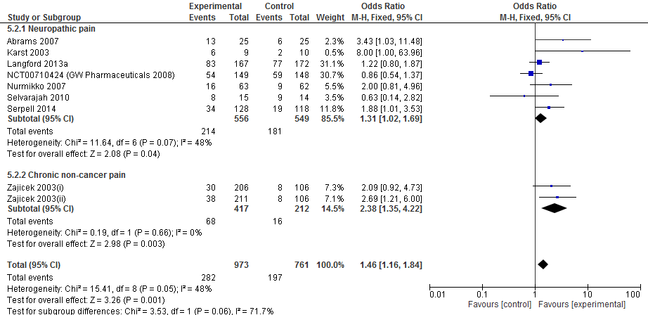

## Figure E1.1: Forest plot for RCT study evidence for impact of cannabis or cannabinoids used for treatment of CNCP upon 30% reduction in pain, by study risk of bias

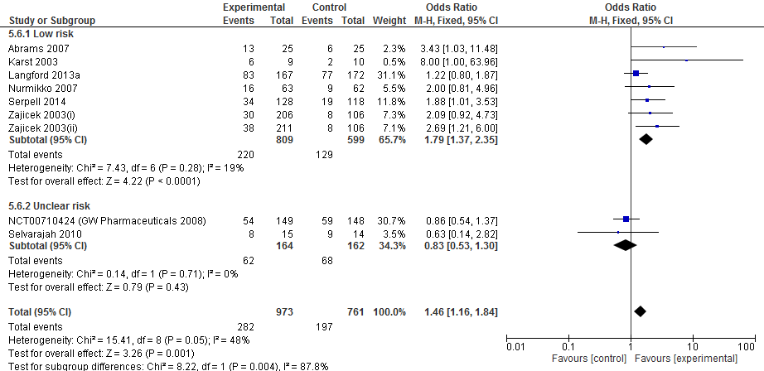

## Figure E1.1a: Forest plot for RCT study evidence for impact of cannabis or cannabinoids used for treatment of CNCP upon 30% reduction in pain, by study risk of bias based on sample size

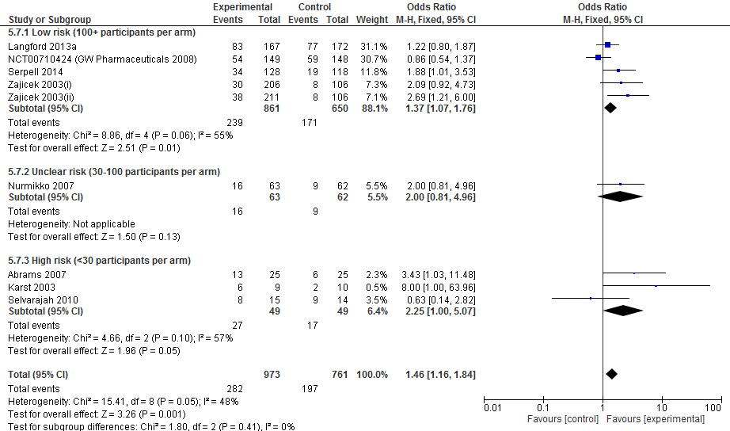

## Figure E1.2: Forest plot for RCT study evidence for impact of cannabis or cannabinoids used for treatment of CNCP upon 30% reduction in pain, by study intervention length

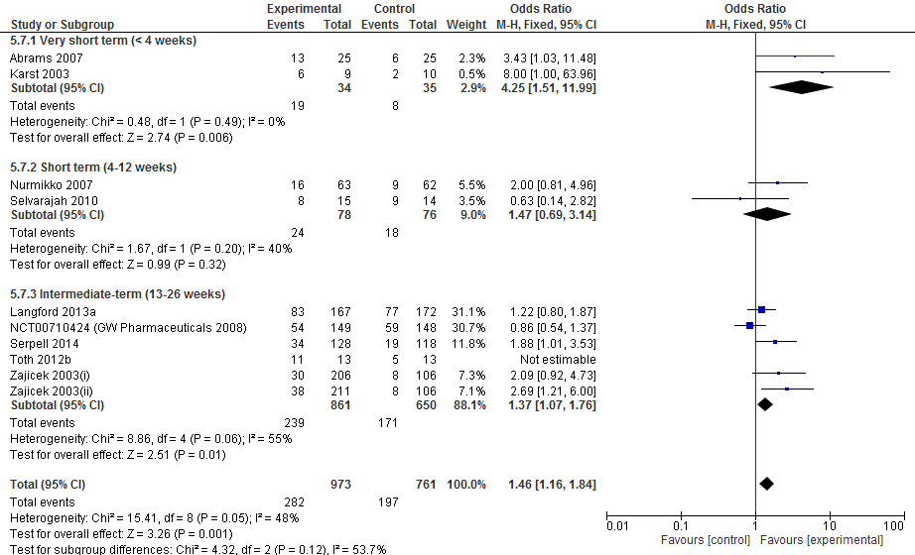

## Figure E2: Forest plot for RCT study evidence for impact of cannabis or cannabinoids used for treatment of CNCP upon 50% reduction in pain, by pain type

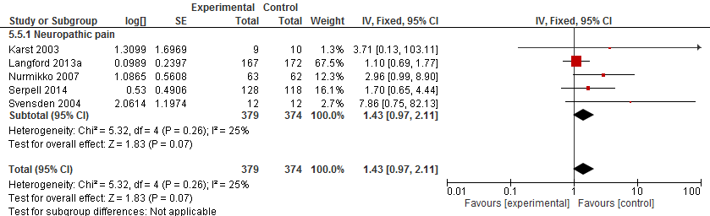

## Figure E2.1: Forest plot for RCT study evidence for impact of cannabis or cannabinoids used for treatment of CNCP upon 50% reduction in pain, by study risk of bias

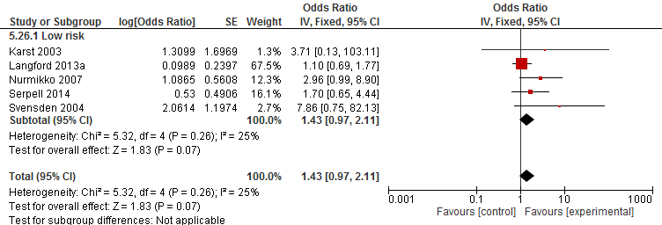

## Figure E2.1a: Forest plot for RCT study evidence for impact of cannabis or cannabinoids used for treatment of CNCP upon 50% reduction in pain, by study risk of bias based on sample size

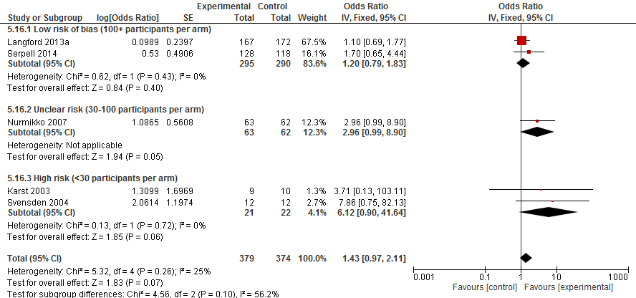

## Figure E2.2: Forest plot for RCT study evidence for impact of cannabis or cannabinoids used for treatment of CNCP upon 50% reduction in pain, by study intervention length

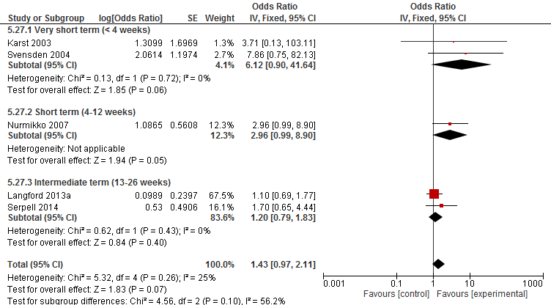

## Figure E3: Forest plot for RCT study evidence for impact of cannabis or cannabinoids used for treatment of CNCP upon pain intensity, by pain type

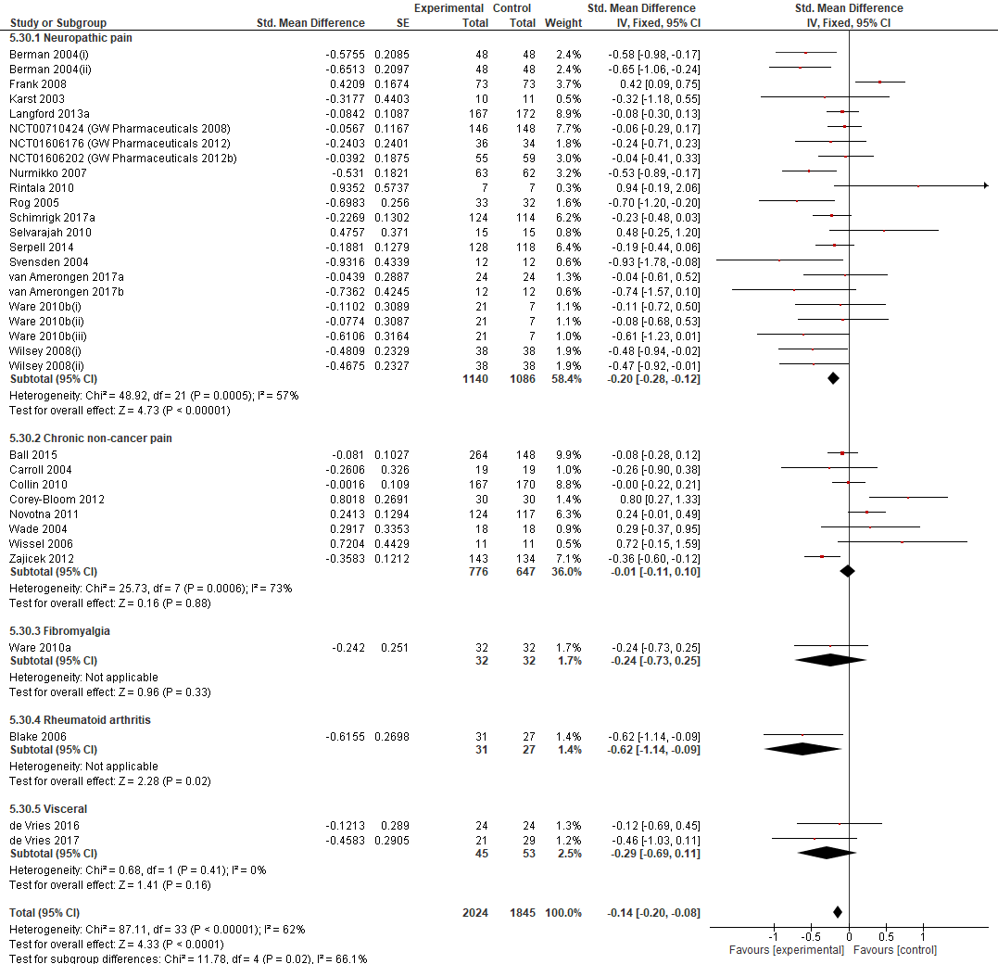

## Figure E3.1: Forest plot for RCT study evidence for impact of cannabis or cannabinoids used for treatment of CNCP upon pain intensity, by study risk of bias

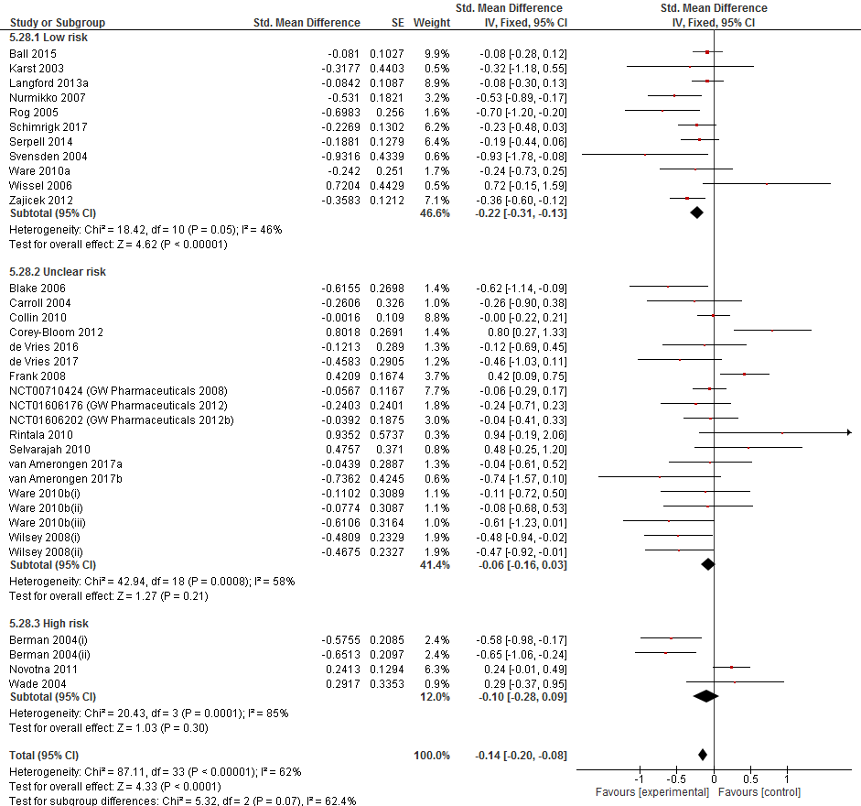

## Figure E3.1a: Forest plot for RCT study evidence for impact of cannabis or cannabinoids used for treatment of CNCP upon pain intensity, by study risk of bias based on sample size

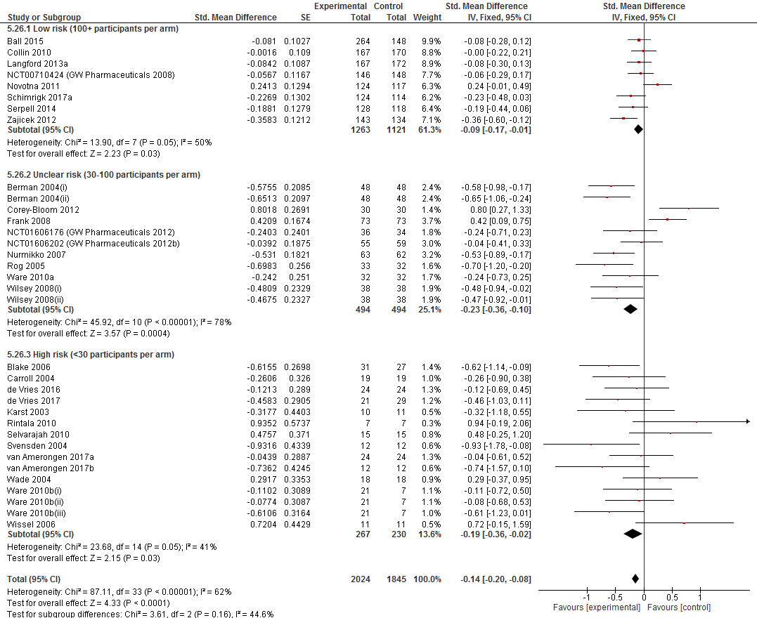

## Figure E3.2: Forest plot for RCT study evidence for impact of cannabis or cannabinoids used for treatment of CNCP upon pain intensity, by study intervention length

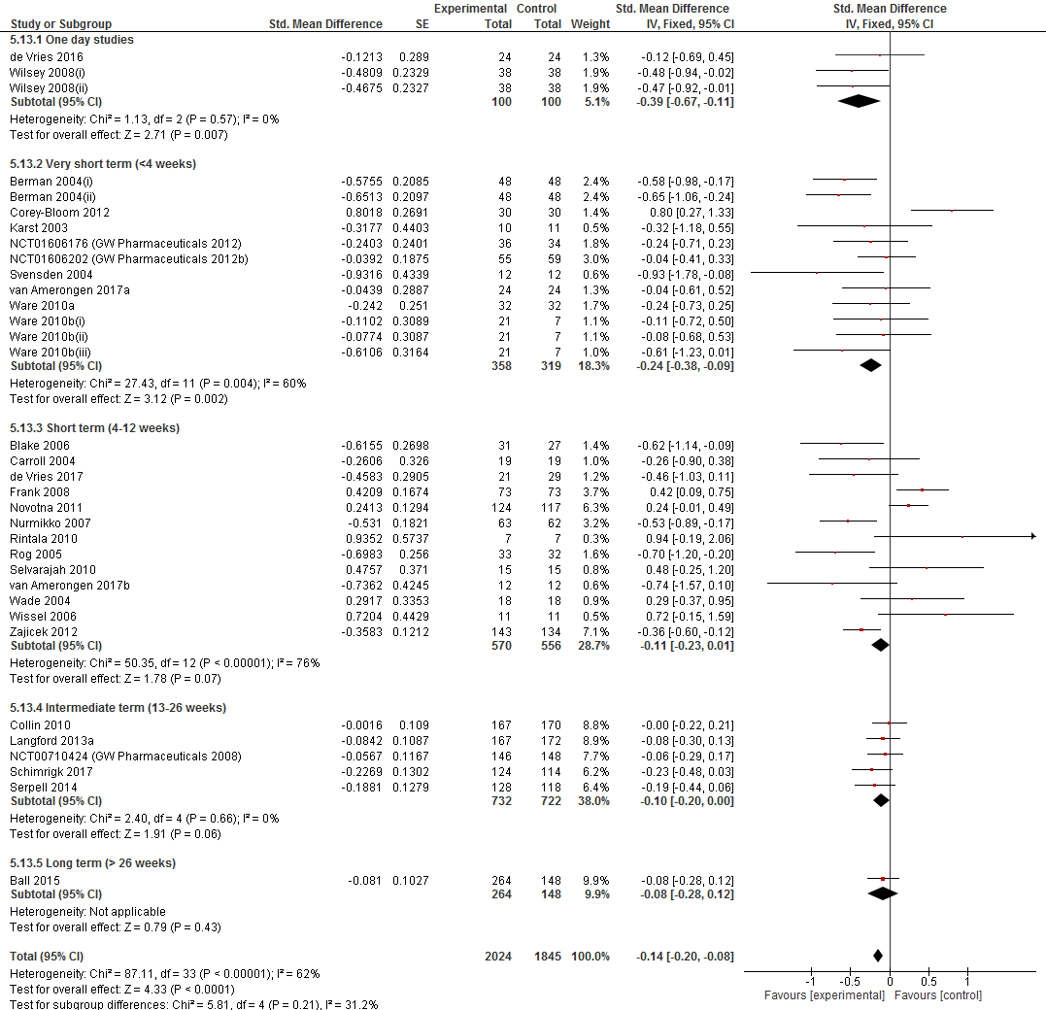

## Figure E3.3: Forest plot for RCT study evidence for impact of cannabis or cannabinoids used for treatment of CNCP upon pain intensity, by study imputation method

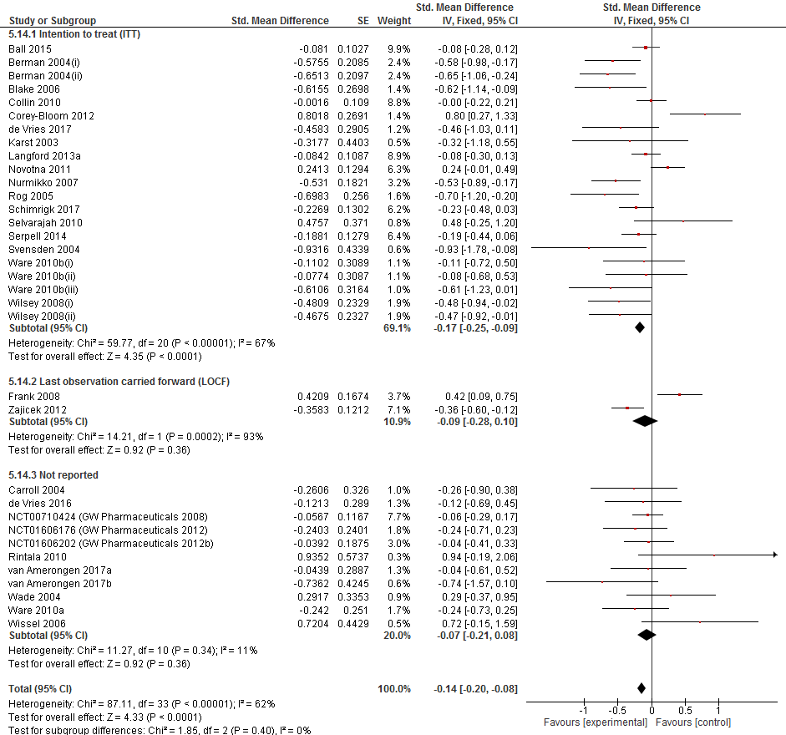

## Figure E5. Forest plot for the proportion of participants achieving 30% reduction in pain in observational studies, and cross-over trials that were not amenable to meta-analysis, by cannabinoid type



## Figure E6: Forest plot for RCT study evidence for impact of cannabis or cannabinoids used for treatment of CNCP upon physical functioning

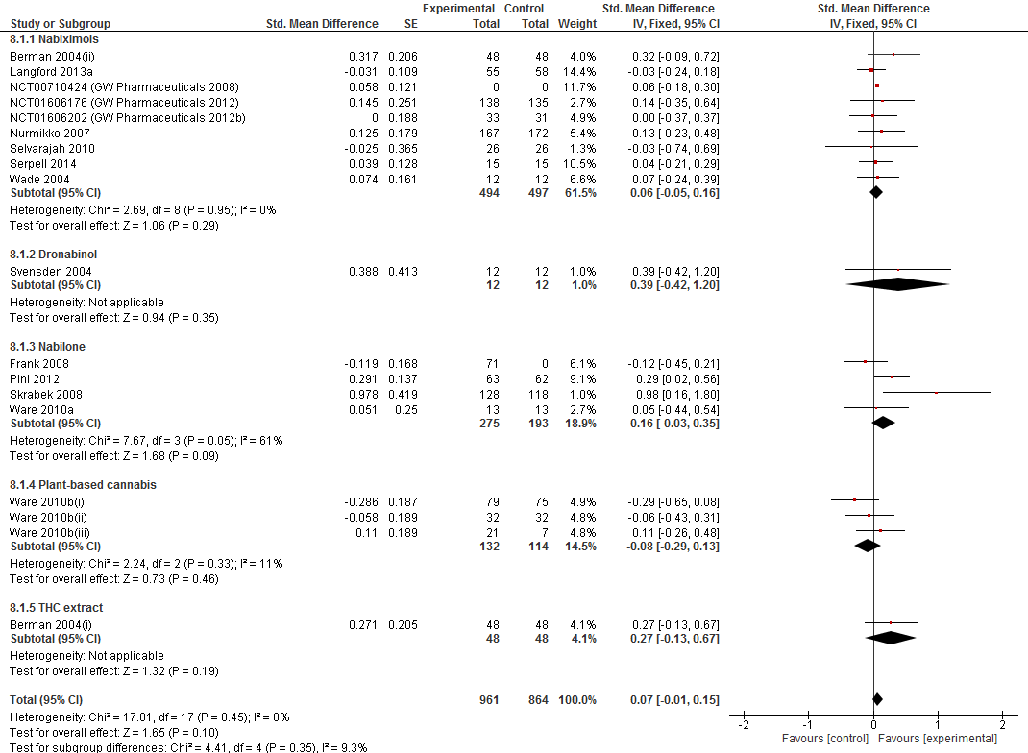

## Figure E7: Forest plot for RCT study evidence for impact of cannabis or cannabinoids used for treatment of CNCP upon sleep problems

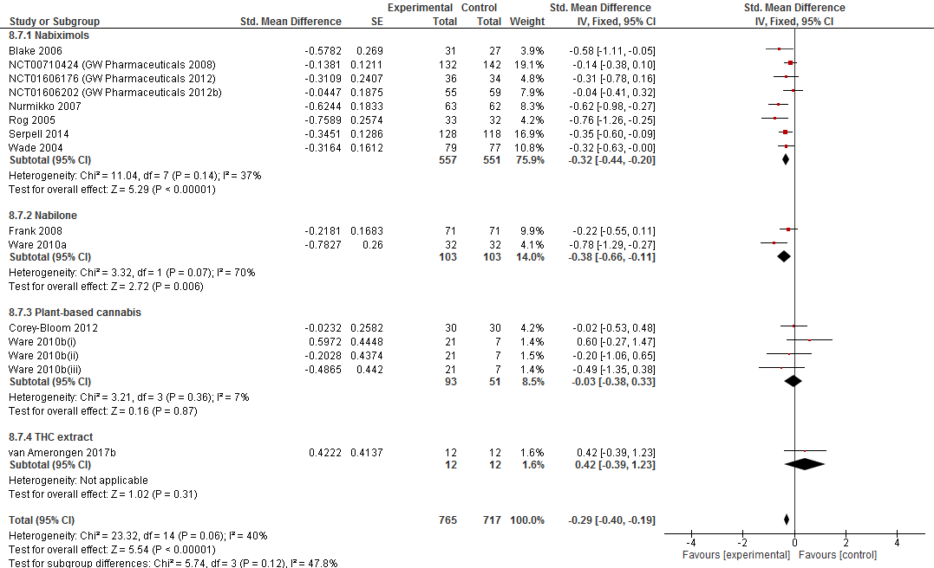

## Figure E8: Forest plot for RCT study evidence for impact of cannabis or cannabinoids used for treatment of CNCP upon quality of life

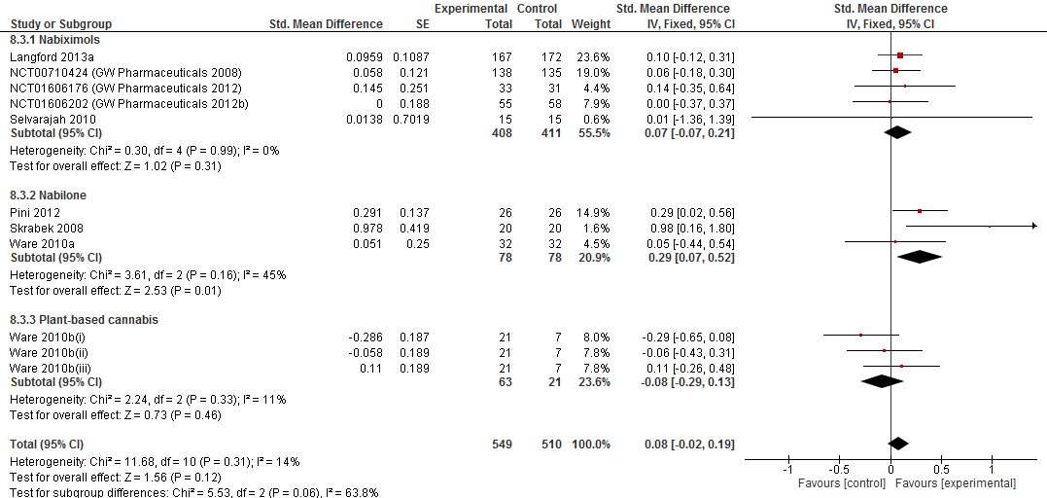

## Figure E9: Forest plot for RCT study evidence for impact of cannabis or cannabinoids used for treatment of CNCP upon overall emotional functioning

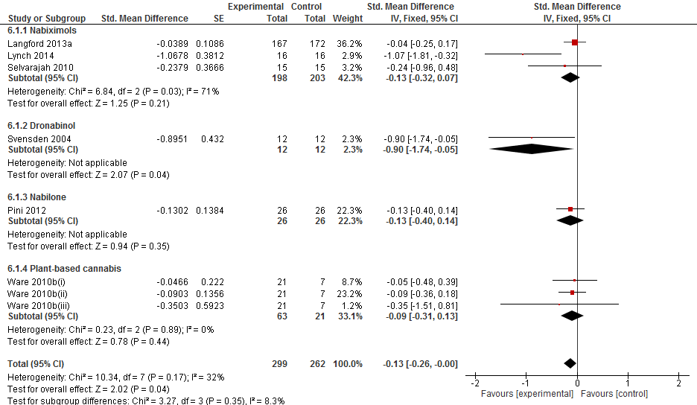

## Figure E10: Forest plot for RCT study evidence for impact of cannabis or cannabinoids used for treatment of CNCP upon depression scores

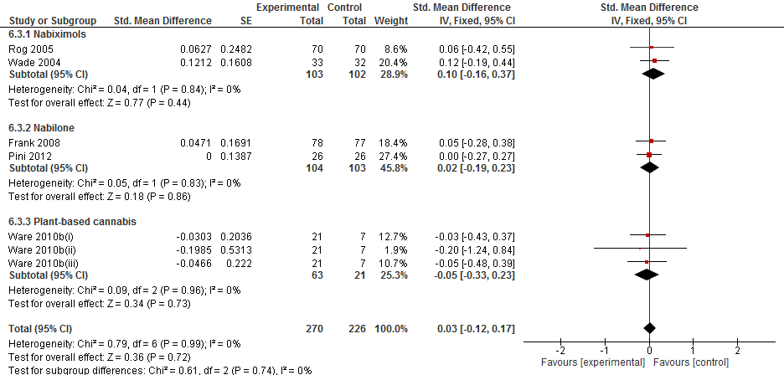

## Figure E11: Forest plot for RCT study evidence for impact of cannabis or cannabinoids used for treatment of CNCP upon anxiety scores

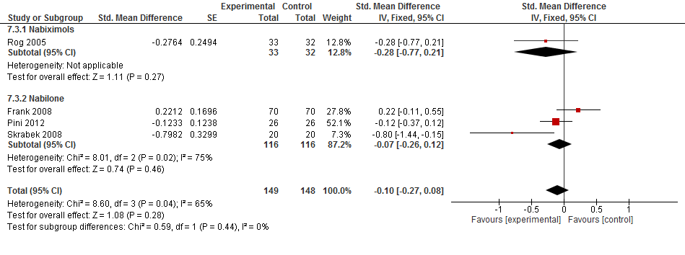

## Figure E12: Forest plot for RCT study evidence for impact of cannabis or cannabinoids used for treatment of CNCP upon patient global impression of change (continuous outcome)

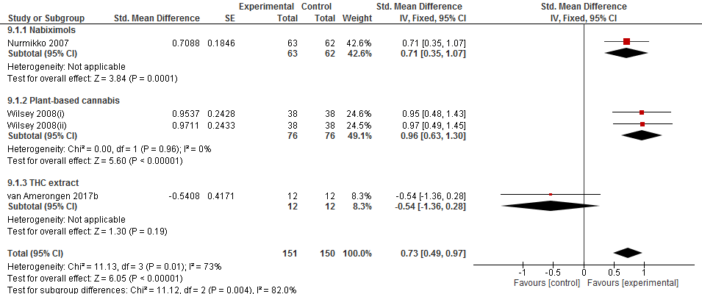

## Figure E13. Forest plot for RCT study evidence for impact of cannabis or cannabinoids used for treatment of CNCP upon patient global impression of change (dichotomous outcome)

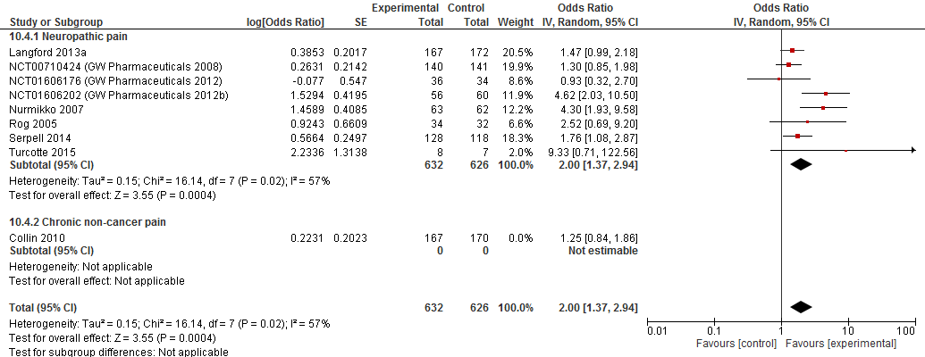

# Appendix F: Findings for Observational studies and cross-over trials where comparative meta-analysis was not possible

## 30% reduction in pain

Studies with a comparison group

One study with a comparison group (an open-label study with a randomised withdrawal phase)[235] examined 30% reduction in pain and found that nabilone was significantly more likely to produce a 30% reduction in pain relative to placebo (See **Table 4** in the main manuscript).

Studies with no comparison group

Ten studies (490 participants in the analysis) [206; 234; 259; 269; 271] examined 30% reduction in pain, 3 of which were observational studies without a comparison group[206; 234] and 7 were multi-arm cross-over trials that did not report outcomes appropriately to be included in the main comparative meta-analysis.[259; 269; 271] The proportion of participants receiving the cannabinoid who achieved a 30% reduction in pain was 72% (66-78%. *I2* = 0%). No differences were identified by drug type, see Figure E5 in Appendix E. A sensitivity test confirmed that results did not differ for observational studies or cross-over trials (data available upon request).

There were no studies for which data were reported narratively.

## 50% reduction in pain

Studies with a comparison group

Two observational studies with a comparison group[165; 235] examined 50% reduction in pain in patients receiving THC extract, CBD extract,THC:CBD extract and nabilone compared to placebo and found no significant evidence of effect (see **Table 4** in the main manuscript and **Table E1** in Appendix E). One observational study without a comparison group[123] examined change in “severe or very severe” pain and found that 8 of the 13 participants (61.5%) no longer had “severe or very severe” pain following treatment.

Studies with no comparison group

There was insufficient data to conduct a meta-analysis on the proportion of patients achieving 50% reduction in pain. Five observational studies (17 participants in the analysis)[216; 234] reported data on 50% reduction in pain, however none were amenable to meta-analysis and have been described narratively. Toth 2008[234] comprised two studies: nabilone vs. placebo and THC:CBD extract vs. placebo for patients with peripheral neuropathic pain, both of which found that none (0%) of the participants achieved a 50% reduction in pain. Schley 2006[216] examined THC extract for patients with fibromyalgia and found that all 4 patients (100%) who completed the therapy over three months achieved a 50% reduction in pain. Ware 2003[260] reported that 12 of 32 (37.5%) participants with CNCP who used cannabis sativa had “strong or complete pain relief”. Hoggart 2015[101] examined nabiximols for the treatment of diabetes-related neuropathic pain and reported that "…the number of patients who demonstrated a 50% improvement [in pain] increased with time, with a minimum of 30% of patients at the 50 % improvement level at all time points.”

## Change in pain intensity

Studies with a comparison group

Seven studies (four testing nabilone [27; 190; 235], and three testing cannabis sativa [61; 223; 262]) examined change in pain intensity and found no significant evidence of effect (**Table 4** in the main manuscript and **Table E1** in Appendix E).

Studies with no comparison group

Twenty studies[2; 13; 33; 46; 67; 73; 87; 134; 158; 177; 202; 205; 216; 251; 252; 255; 265] (n = 1776) studies examined change in pain intensity within samples before and after the administration of the cannabinoid and found a significant reduction in pain intensity (SMD = -0.77, 95%CI -0.87 to -0.67), however heterogeneity was very high (*I2* = 91%). A random effects sensitivity meta-analysis revealed a similar result, however with a larger overall effect (SMD = -1.19, 95%CI -1.59 to -0.78). Significant effects were found for all cannabinoids examined, including nabiximols[73; 177; 205; 251; 252] (SMD = -0.53, 95%CI -0.64 to -0.41), dronabinol[13; 46; 158; 265] (SMD = -1.78, 95%CI -204 to -1.51), THC extract [33; 216] (SMD = -0.73, 95%CI -1.30 to -0.16), THC:CBD extract [255] (SMD = -0.65, 95%CI -1.29 to -0.01) and cannabis sativa [33; 67; 87; 134; 202] (SMD = -1.36, 95%CI -1.73 to -0.99). Forest plot available upon request. Two studies with no comparison group reported change in pain intensity narratively and stated that during both the 32-week open label period [215], and the 119-week long term treatment of dronabinol [215] pain intensity remained at a low level (2.5 to 3.8 on an 11-point numerical rating scale).

# Appendix G: Summary of the statistics and metrics used in this review

|  |  |  |
| --- | --- | --- |
| **Panel G1: Summary of the statistics and metrics used in this review** | | |
| **Statistic or metric** | **Definition** | **Some guiding notes on interpretation** |
| Odds ratio (OR) | Ratio of the odds of an outcome with the active treatment to the odds of an outcome with placebo | The odds ratio represents the odds that a particular outcome will occur following a certain exposure, (e.g. medication) compared to the odds that the outcome will occur in the absence of the exposure. In short:   * OR = 1 Exposure to intervention does not change the odds of the outcome of interest. * OR <1 Exposure to intervention is associated with lower odds of the outcome of interest. * OR >1 Exposure to intervention is associated with increased odds of the outcome of interest. |
| Standardised mean difference (SMD) | Used when outcomes are continuous and measured using different instruments and thus combining raw means (via a mean difference) would not be meaningful; compares treatment and placebo group scores in each study relative to the variability observed in that study. | Interpretation of SMDs can sometimes be difficult as the outcome is expressed as units of standard deviation rather than units of a specific measurement scale, such as a 100mm visual analogue scale.  A common rule of thumb for interpreting SMDs is: 0.2 represents a "small" effect, 0.5 represents a "moderate" effect and 0.8 represents a "large" effect[47]. |
| Pooled event rate (PER) | The pooled percentage of a group (e.g. experimental) in whom the event or outcome of interest occurs (pooled via meta-analysis) | The higher the PER, the more people in a given population group will experience the outcome of interest. PERs for experimental conditions should always be interpreted alongside PERs for control groups in order to take into account the naturally occurring control event rate, which varies depending on the target outcome and population. |
| Number needed to treat (NNT) | Number of people needed to treat for one person to improve on the outcome of interest | The lower the NNT, the more effective the intervention or exposure. A NNH of 1 means that, on average, every person exposed to an intervention will improve on that outcome of interest. |
| Number needed to harm (NNH) | Number of people needed to treat for one person to experience the negative outcome of interest | The lower the NNH, the more harmful the intervention or exposure. A NNH of 1 means that, on average, every person exposed to an intervention will experience a negative outcome of interest. |

# References

[1] Abrams D. Cannabis in cancer and palliative care. Asia-Pacific Journal of Clinical Oncology 2014;10:113.

[2] Abrams DI, Jay C, Shade S, Vizoso H, Reda H, Press S, Kelly M, Rowbotham M, Petersen K. Cannabis in painful HIV-associated sensory neuropathy A randomized placebo-controlled trial. Neurology 2007;68(7):515-521.

[3] Aggarwal SK, Carter GT, Sullivan MD, ZumBrunnen C, Morrill R, Mayer JD. Characteristics of patients with chronic pain accessing treatment with medical cannabis in Washington State. Journal of opioid management 2009;5(5):257-286.

[4] Aggarwal SK, Carter GT, Sullivan MD, Zumbrunnen C, Morrill R, Mayer JD. Prospectively Surveying Health-Related Quality of Life and Symptom Relief in a Lot-Based Sample of Medical Cannabis-Using Patients in Urban Washington State Reveals Managed Chronic Illness and Debility. American Journal of Hospice and Palliative Medicine 2013;30(6):523-531.

[5] Ahmed AI, van den Elsen GA, Colbers A, van der Marck MA, Burger DM, Feuth TB, Rikkert MG, Kramers C. Safety and pharmacokinetics of oral delta-9-tetrahydrocannabinol in healthy older subjects: a randomized controlled trial. European neuropsychopharmacology : the journal of the European College of Neuropsychopharmacology 2014;24(9):1475-1482.

[6] Allegretti JR, Courtwright A, Lucci M, Korzenik JR, Levine J. Marijuana use patterns among patients with inflammatory bowel disease. Inflammatory bowel diseases 2013;19(13):2809-2814.

[7] Anonymous. Cannabis-based medicines--GW pharmaceuticals: high CBD, high THC, medicinal cannabis--GW pharmaceuticals, THC:CBD. Drugs in R&D 2003;4(5):306-309.

[8] Anonymous. Cannabis-based medicines - GW Pharmaceuticals. High CBD, high THC, medicinal cannabis - GW Pharmaceuticals, THC:CBD. Drugs in R and D 2003;4(5):306-309.

[9] Anonymous. Cannabis and Cannabinoids. Medical Letter on Drugs and Therapeutics 2016;58(1500):97-98.

[10] ANZCA. Australian and New Zealand College of Anaesthetists. National pain strategy: pain management for all Australians. 2010.

[11] Arroyo R, Vila C, Dechant KL. Impact of Sativex on quality of life and activities of daily living in patients with multiple sclerosis spasticity. Journal of Comparative Effectiveness Research 2014;3(4):435-444.

[12] Ashton JC, Milligan ED. Cannabinoids for the treatment of neuropathic pain: Clinical evidence. Current Opinion in Investigational Drugs 2008;9(1):65-75.

[13] Attal N, Brasseur L, Guirimand D, Clermond-Gnamien S, Atlami S, Bouhassira D. Are oral cannabinoids safe and effective in refractory neuropathic pain? European journal of pain (London, England) 2004;8(2):173-177.

[14] Attal N, Mazaltarine G, Perrouin-Verbe B, Albert T. Chronic neuropathic pain management in spinal cord injury patients. What is the efficacy of pharmacological treatments with a general mode of administration? (oral, transdermal, intravenous). Annals of Physical and Rehabilitation Medicine 2009;52(2):124-141.

[15] Balash Y, Shabtai H, Hilel A, Korczyn A, Giladi N, Gurevich T. Effects of cannabis smoking in patients with advanced Parkinson's disease and Parkinsonism. European Journal of Neurology 2011;18:499.

[16] Ball S, Vickery J, Hobart J, Wright D, Green C, Shearer J, Nunn A, Cano MG, MacManus D, Miller D, Mallik S, Zajicek J. The Cannabinoid Use in Progressive Inflammatory brain Disease (CUPID) trial: a randomised double-blind placebo-controlled parallel-group multicentre trial and economic evaluation of cannabinoids to slow progression in multiple sclerosis. Health technology assessment (Winchester, England) 2015;19(12):vii-viii, xxv-xxxi, 1-187.

[17] Bar-Sela G, Vorobeichik M, Drawsheh S, Omer A, Goldberg V, Muller E. The medical necessity for medicinal cannabis: Prospective, observational study evaluating the treatment in cancer patients on supportive or palliative care. Evidence-based Complementary and Alternative Medicine 2013;2013:no pagination.

[18] Barnes MP. Sativex: Clinical efficacy and tolerability in the treatment of symptoms of multiple sclerosis and neuropathic pain. Expert Opinion on Pharmacotherapy 2006;7(5):607-615.

[19] Baron EP. Comprehensive review of medicinal marijuana, cannabinoids, and therapeutic implications in medicine and headache: What a long strange trip it's been. Headache 2015;55(6):885-916.

[20] Bazinski H, Jensen HB, Stenager E. [There is evidence for the use of cannabinoids for symptomatic treatment of multiple sclerosis]. Der er evidens for brug af cannabinoider til symptomatisk behandling af multipel sklerose 2015;177(20):956-960.

[21] Bazinski H, Jensen HB, Stenager E. [There is evidence for the use of cannabinoids for symptomatic treatment of multiple sclerosis]. Ugeskr Laeger 2015;177(20):956-960.

[22] Beaulieu P. Effects of nabilone, a synthetic cannabinoid, on postoperative pain. Canadian Journal of Anesthesia 2006;53(8):769-775.

[23] Beaulieu P, Ware M. Reassessment of the role of cannabinoids in the management of pain. Current Opinion in Anaesthesiology 2007;20(5):473-477.

[24] Ben Amar M. Cannabinoids in medicine: A review of their therapeutic potential. J Ethnopharmacol 2006;105(1-2):1-25.

[25] Berman. A Study of Cannabis Based Medicine Extracts and Placebo in Patients With Pain Due to Spinal Cord Injury. NCT01606202, Vol. 2017: Clinicaltrials.gov, 2012.

[26] Berman JS, Symonds C, Birch R. Efficacy of two cannabis based medicinal extracts for relief of central neuropathic pain from brachial plexus avulsion: results of a randomised controlled trial. Pain 2004;112(3):299-306.

[27] Bestard JA, Toth CC. An open-label comparison of nabilone and gabapentin as adjuvant therapy or monotherapy in the management of neuropathic pain in patients with peripheral neuropathy. Pain practice : the official journal of World Institute of Pain 2011;11(4):353-368.

[28] Blake DR, Robson P, Ho M, Jubb RW, McCabe CS. Preliminary assessment of the efficacy, tolerability and safety of a cannabis-based medicine (Sativex) in the treatment of pain caused by rheumatoid arthritis. Rheumatology (Oxford, England) 2006;45(1):50-52.

[29] Boehnke KF, Litinas E, Clauw DJ. Medical Cannabis Use Is Associated With Decreased Opiate Medication Use in a Retrospective Cross-Sectional Survey of Patients With Chronic Pain. The journal of pain : official journal of the American Pain Society 2016;17(6):739-744.

[30] Bonn-Miller MO, Boden MT, Bucossi MM, Babson KA. Self-reported cannabis use characteristics, patterns and helpfulness among medical cannabis users. The American journal of drug and alcohol abuse 2014;40(1):23-30.

[31] Bowling A. Cannabinoids in MS - Are we any closer to knowing how best to use them? Multiple Sclerosis 2006;12(5):523-525.

[32] Boychuk DG, Goddard G, Mauro G, Orellana MF. The effectiveness of cannabinoids in the management of chronic nonmalignant neuropathic pain: a systematic review. Journal of oral & facial pain and headache 2015;29(1):7-14.

[33] Brady CM, DasGupta R, Dalton C, Wiseman OJ, Berkley KJ, Fowler CJ. An open-label pilot study of cannabis-based extracts for bladder dysfunction in advanced multiple sclerosis. Multiple sclerosis (Houndmills, Basingstoke, England) 2004;10(4):425-433.

[34] Brunt TM, Van Genugten M, Honer-Snoeken K, Van De Velde MJ, Niesink RJM. Therapeutic satisfaction and subjective effects of different strains of pharmaceutical-grade cannabis. Journal of clinical psychopharmacology 2014;34(3):344-349.

[35] Buggy DJ, Toogood L, Maric S, Sharpe P, Lambert DG, Rowbotham DJ. Lack of analgesic efficacy of oral Δ-9-tetrahydrocannabinol in postoperative pain. Pain 2003;106(1):169-172.

[36] Cameron C, Watson D, Robinson J. Use of a synthetic cannabinoid in a correctional population for posttraumatic stress disorder-related insomnia and nightmares, chronic pain, harm reduction, and other indications: a retrospective evaluation. Journal of clinical psychopharmacology 2014;34(5):559-564.

[37] Carroll CB, Bain PG, Teare L, Liu X, Joint C, Wroath C, Parkin SG, Fox P, Wright D, Hobart J, Zajicek JP. Cannabis for dyskinesia in Parkinson disease: a randomized double-blind crossover study. Neurology 2004;63(7):1245-1250.

[38] Caudevilla Galligo F, Cabrera Majada A. New developments regarding cannabis. FMC Formacion Medica Continuada en Atencion Primaria 2009;16(4):204-212.

[39] Centonze D, Mori F, Koch G, Buttari F, Codeca C, Rossi S, Cencioni MT, Bari M, Fiore S, Bernardi G, Battistini L, Maccarrone M. Lack of effect of cannabis-based treatment on clinical and laboratory measures in multiple sclerosis. Neurological sciences : official journal of the Italian Neurological Society and of the Italian Society of Clinical Neurophysiology 2009;30(6):531-534.

[40] Chen ZZ. Progress in study of new drugs for treatment of multiple sclerosis. Pharmaceutical Biotechnology 2009;16(2):186-188.

[41] Chohan H, Greenfield AL, Yadav V, Graves J. Use of Cannabinoids for Spasticity and Pain Management in MS. Current Treatment Options in Neurology 2016;18(1):1-14.

[42] Chung SA, Hossain NK, Blackman AS, Shapiro CM. Can the cannabinoid nabilone help with pain and sleep in fibromyalgia patients? Sleep 2009;32:A325-A326.

[43] Cimas-Hernando I, Pato-Pato A, Lorenzo-Gonzalez JR, Rodriguez-Constenla I. [Assessment of the effectiveness and safety of Sativex(R) in compassionate use]. Revista de neurologia 2015;60(5):202-206.

[44] Clark AJ, Lynch ME. Cannabinoids for pain management: What is their role? Pain Research and Management 2005;10(SUPPL. A):5A-6A.

[45] Clark AJ, Lynch ME, Ware M, Beaulieu P, McGilveray IJ, Gourlay D. Guidelines for the use of cannabinoid compounds in chronic pain. Pain Research and Management 2005;10(SUPPL. A):44A-46A.

[46] Clermont-Gnamien S, Atlani S, Attal N, Le Mercier F, Guirimand F, Brasseur L. [The therapeutic use of D9-tetrahydrocannabinol (dronabinol) in refractory neuropathic pain]. Utilisation therapeutique du D9-tetrahydrocannabinol (dronabinol) dans les douleurs neuropathiques refractaires 2002;31(39 Pt 1):1840-1845.

[47] Cohen J. Statistical Power Analysis for the Behavioral Sciences. New York, NY: Routledge Academic, 1988.

[48] Collen M. Prescribing cannabis for harm reduction. Harm Reduction Journal 2012;9:no pagination.

[49] Collin C, Davies P, Mutiboko IK, Ratcliffe S. Randomized controlled trial of cannabis‐based medicine in spasticity caused by multiple sclerosis. European Journal of Neurology 2007;14(3):290-296.

[50] Collin C, Ehler E, Waberzinek G, Alsindi Z, Davies P, Powell K, Notcutt W, O'leary C, Ratcliffe S, Nováková I. A double-blind, randomized, placebo-controlled, parallel-group study of Sativex, in subjects with symptoms of spasticity due to multiple sclerosis. Neurol Res 2010;32(5):451-459.

[51] Corey-Bloom J, Wolfson T, Gamst A, Jin S, Marcotte TD, Bentley H, Gouaux B. Smoked cannabis for spasticity in multiple sclerosis: a randomized, placebo-controlled trial. Canadian Medical Association Journal 2012;184(10):1143-1150.

[52] Croxford JL. Therapeutic potential of cannabinoids in CNS disease. CNS Drugs 2003;17(3):179-202.

[53] Cudmore J, Daeninck PJ. Use of medical cannabis to reduce pain and improve quality of life in cancer patients. Journal of Clinical Oncology 2015;33(29 SUPPL. 1):no pagination.

[54] Curtin F, Elbourne D, Altman DG. Meta-analysis combining parallel and cross-over clinical trials. II: Binary outcomes. Statistics in medicine 2002;21(15):2145-2159.

[55] Curtin F, Elbourne D, Altman DG. Meta-analysis combining parallel and cross-over clinical trials. III: The issue of carry-over. Statistics in medicine 2002;21(15):2161-2173.

[56] De Trane S, Buchanan K, Keenan L, Valentine C, Liddicut M, Stevenson V, Farrell R. Nabiximols has a beneficial effect on self report of MS related spasticity. Multiple Sclerosis 2016;22:684.

[57] de Vries M, Van Rijckevorsel DC, Vissers KC, Wilder-Smith OH, Van Goor H. Single dose delta-9-tetrahydrocannabinol in chronic pancreatitis patients: analgesic efficacy, pharmacokinetics and tolerability. Br J Clin Pharmacol 2016;81(3):525-537.

[58] De Vries M, Van Rijckevorsel DC, Wilder-Smith OH, Van Goor H. Dronabinol and chronic pain: Importance of mechanistic considerations. Expert Opinion on Pharmacotherapy 2014;15(11):1525-1534.

[59] de Vries M, van Rijckevorsel DCM, Vissers KCP, Wilder-Smith OHG, van Goor H. Tetrahydrocannabinol Does Not Reduce Pain in Patients With Chronic Abdominal Pain in a Phase 2 Placebo-controlled Study. Clinical Gastroenterology and Hepatology 2016(pagination).

[60] de Vries M, van Rijckevorsel DCM, Vissers KCP, Wilder-Smith OHG, van Goor H. Tetrahydrocannabinol Does Not Reduce Pain in Patients With Chronic Abdominal Pain in a Phase 2 Placebo-controlled Study. Clinical gastroenterology and hepatology : the official clinical practice journal of the American Gastroenterological Association 2017;15(7):1079-1086.e1074.

[61] Degenhardt L, Lintzeris N, Campbell G, Bruno R, Cohen M, Farrell M, Hall WD. Experience of adjunctive cannabis use for chronic non-cancer pain: findings from the Pain and Opioids IN Treatment (POINT) study. Drug and alcohol dependence 2015;147:144-150.

[62] Di Marzo V. The endocannabinoid system for the development of new drugs for spasticity. Drugs of the Future 2007;32(4):341-351.

[63] Di Marzo V, Centonze D. Placebo Effects in a Multiple Sclerosis Spasticity Enriched Clinical Trial with the Oromucosal Cannabinoid Spray (THC/CBD): Dimension and Possible Causes. CNS Neuroscience & Therapeutics 2015;21(3):215-221.

[64] Dray A. Neuropathic pain: Emerging treatments. British Journal of Anaesthesia 2008;101(1):48-58.

[65] Dunn SL, Wilkinson JM, Crawford A, Le Maitre CL, Bunning RAD. Cannabinoid WIN-55,212-2 mesylate inhibits interleukin-1beta induced matrix metalloproteinase and tissue inhibitor of matrix metalloproteinase expression in human chondrocytes. Osteoarthritis and cartilage 2014;22(1):133-144.

[66] Duran M, Laporte JR, Capella D. News about therapeutic use of Cannabis and endocannabinoid system. Medicina Clinica 2004;122(10):390-398.

[67] Eisenberg E, Ogintz M, Almog S. The pharmacokinetics, efficacy, safety, and ease of use of a novel portable metered-dose cannabis inhaler in patients with chronic neuropathic pain: A phase 1a study. Journal of Pain and Palliative Care Pharmacotherapy 2014;28(3):216-225.

[68] Elbourne DR, Altman DG, Higgins JP, Curtin F, Worthington HV, Vail A. Meta-analyses involving cross-over trials: methodological issues. International journal of epidemiology 2002;31(1):140-149.

[69] Ellis RJ, Toperoff W, Vaida F, Van Den Brande G, Gonzales J, Gouaux B, Bentley H, Atkinson JH. Smoked medicinal cannabis for neuropathic pain in HIV: A randomized, crossover clinical trial. Neuropsychopharmacology 2009;34(3):672-680.

[70] Erbe B. [Cannabis - medicinal use]. Deutsche medizinische Wochenschrift (1946) 2014;139(3):74-75.

[71] Erkens JA, Janse AFC, Herings RMC. Limited use of medicinal cannabis but for labeled indications after legalization. Pharmacoepidemiology and Drug Safety 2005;14(11):821-822.

[72] Etges T, Taylor A, Karolia K, Lauder H, Daka B, Wright S. A final report of an observational post-marketing safety registry of patients primarily from the United Kingdom who have been prescribed an oromucosal spray containing DELTA9-tetrahydrocannabinol and cannabidiol (THC:CBD). Multiple Sclerosis 2015;1):610.

[73] Ferre L, Nuara A, Pavan G, Radaelli M, Moiola L, Rodegher M, Colombo B, Keller Sarmiento IJ, Martinelli V, Leocani L, Martinelli Boneschi F, Comi G, Esposito F. Efficacy and safety of nabiximols (Sativex((R))) on multiple sclerosis spasticity in a real-life Italian monocentric study. Neurological sciences : official journal of the Italian Neurological Society and of the Italian Society of Clinical Neurophysiology 2016;37(2):235-242.

[74] Fife TD, Moawad H, Moschonas C, Shepard K, Hammond N. Clinical perspectives on medical marijuana (cannabis) for neurologic disorders. Neurology: Clinical Practice 2015;5(4):344-351.

[75] Fijal K, Filip M. Clinical/therapeutic approaches for cannabinoid ligands in central and peripheral nervous system diseases: Mini review. Clinical Neuropharmacology 2016;39(2):94-101.

[76] Fine PG, Rosenfeld MJ. Cannabinoids for Neuropathic Pain. Current Pain and Headache Reports 2014;18(10):no pagination.

[77] Finnerup NB, Attal N, Haroutounian S, McNicol E, Baron R, Dworkin RH, Gilron I, Haanpaa M, Hansson P, Jensen TS, Kamerman PR, Lund K, Moore A, Raja SN, Rice ASC, Rowbotham M, Sena E, Siddall P, Smith BH, Wallace M. Pharmacotherapy for neuropathic pain in adults: A systematic review and meta-analysis. The Lancet Neurology 2015;14(2):162-173.

[78] Finnerup NB, Sindrup SH, Jensen TS. The evidence for pharmacological treatment of neuropathic pain. Pain 2010;150(3):573-581.

[79] Fitzcharles MA, Baerwald C, Ablin J, Hauser W. Efficacy, tolerability and safety of cannabinoids in chronic pain associated with rheumatic diseases (fibromyalgia syndrome, back pain, osteoarthritis, rheumatoid arthritis): A systematic review of randomized controlled trials. Schmerz 2016;30(1):47-61.

[80] Fitzcharles MA, Ste-Marie PA, Hauser W, Clauw DJ, Jamal S, Karsh J, Landry T, LeClercq S, McDougall JJ, Shir Y, Shojania K, Walsh Z. Efficacy, Tolerability, and Safety of Cannabinoid Treatments in the Rheumatic Diseases: A Systematic Review of Randomized Controlled Trials. Arthritis Care and Research 2016;68(5):681-688.

[81] Fiz J, Durán M, Capellà D, Carbonell J, Farré M. Cannabis use in patients with fibromyalgia: effect on symptoms relief and health-related quality of life. PLoS One 2011;6(4):e18440.

[82] Flachenecker P. Evolution of multiple sclerosis spasticity-associated symptoms: Latest data. Neurodegenerative Disease Management 2016;6(6s):9-12.

[83] Flachenecker P, Henze T, Zettl UK. Long-term effectiveness and safety of nabiximols (Tetrahydrocannabinol/Cannabidiol Oromucosal Spray) in clinical practice. European Neurology 2014;72(1-2):95-102.

[84] Flachenecker P, Henze T, Zettl UK. Nabiximols (THC/CBD oromucosal spray, Sativex) in clinical practice--results of a multicenter, non-interventional study (MOVE 2) in patients with multiple sclerosis spasticity. European Neurology 2014;71(5-6):271-279.

[85] Flachenecker P, Henze T, Zettl UK. Nabiximols (THC/CBD Oromucosal Spray, Sativex) in clinical practice - results of a multicenter, non-interventional study (MOVE 2) in patients with multiple sclerosis spasticity. European Neurology 2014;71(5-6):271-279.

[86] Frank B, Serpell MG, Hughes J, Matthews JNS, Kapur D. Comparison of analgesic effects and patient tolerability of nabilone and dihydrocodeine for chronic neuropathic pain: Randomised, crossover, double blind study. BMJ 2008;336(7637):199-201.

[87] Gerardi MC, Batticciotto A, Talotta R, Ditto MC, Atzeni F, Sarzi-Puttini P. Efficacy of cannabis flos in patients with fibromyalgia: A monocentric observational study. Arthritis and Rheumatology, 2016;68: 72-74.

[88] Grant I, Hampton Atkinson J, Gouaux B, Wilsey B. Medical marijuana: Clearing away the smoke. Open Neurology Journal 2012;6(1):18-25.

[89] Grotenhermen F. Cannabinoids. Current Drug Targets: CNS and Neurological Disorders 2005;4(5):507-530.

[90] Gurevich T, Chleider LBL, Rosenberg A, Knaani J, Baruch Y, Djaldetti R. Effect of medical cannabis in Parkinson's disease: Survey of patient experiences. Movement Disorders 2015;30:S88-S89.

[91] Guy G, Gover J, Rogerson M, Atwell B, Dineen J. Positive data in sativex phase IIb trial: Support advancing into phase III development in cancer pain. Revista de la Sociedad Espanola del Dolor 2010;17(4):219-221.

[92] Hagenbach U, Luz S, Ghafoor N, Berger J, Grotenhermen F, Brenneisen R, Mäder M. The treatment of spasticity with [Delta] 9-tetrahydrocannabinol in persons with spinal cord injury. Spinal cord 2007;45(8):551.

[93] Haroutiunian S, Ratz Y, Rosen G, Ezra Y, Livay R, Davidson E. Evaluation of pain and health-related quality of life (HRQOL) outcomes in chronic pain patients treated with cannabis. European Journal of Pain Supplements 2011;5(1):277.

[94] Haroutiunian S, Rosen G, Shouval R, Davidson E. Open-label, add-on study of tetrahydrocannabinol for chronic nonmalignant pain. Journal of pain & palliative care pharmacotherapy 2008;22(3):213-217.

[95] Haroutounian S, Ratz Y, Ginosar Y, Furmanov K, Saifi F, Meidan R, Davidson E. The Effect of Medicinal Cannabis on Pain and Quality-of-Life Outcomes in Chronic Pain: A Prospective Open-label Study. The Clinical journal of pain 2016;32(12):1036-1043.

[96] Haupts M, Jonas A, Witte K, Alvarez-Ossorio L. Influence of optimized anti-spastic pre-treatment on the efficacy and tolerability of THC: CBD oromucosal spray in multiple sclerosis spasticity patients. A post-hoc RCT data analyses. Multiple Sclerosis 2015;1):708-709.

[97] Haupts M, Vila C, Jonas A, Witte K, Alvarez-Ossorio L. Influence of Previous Failed Antispasticity Therapy on the Efficacy and Tolerability of THC:CBD Oromucosal Spray for Multiple Sclerosis Spasticity. European Neurology 2016;75(5-6):236-243.

[98] Higgins J, Green S. Cochrane Handbook for Systematic Reviews of Interventions Version 5.1.0 2011.

[99] Hill KP. Medical marijuana for treatment of chronic pain and other medical and psychiatric problems: A clinical review. JAMA - Journal of the American Medical Association 2015;313(24):2474-2483.

[100] Hill KP, Hurley-Welljams-Dorof WM. Low to moderate quality evidence demonstrates the potential benefits and adverse events of cannabinoids for certain medical indications. Evidence-Based Medicine 2016;21(1):17.

[101] Hoggart B, Ratcliffe S, Ehler E, Simpson KH, Hovorka J, Lejcko J, Taylor L, Lauder H, Serpell M. A multicentre, open-label, follow-on study to assess the long-term maintenance of effect, tolerance and safety of THC/CBD oromucosal spray in the management of neuropathic pain. Journal of Neurology 2015;262(1):27-40.

[102] Holdcroft A, Maze M, Dore C, Tebbs S, Thompson S. A multicenter dose-escalation study of the analgesic and adverse effects of an oral cannabis extract (Cannador) for postoperative pain management. The Journal of the American Society of Anesthesiologists 2006;104(5):1040-1046.

[103] Holdcroft A, Smith M, Jacklin A, Hodgson H, Smith B, Newton M, Evans F. Pain relief with oral cannabinoids in familial Mediterranean fever. Anaesthesia 1997;52(5):483-486.

[104] Iannitti T, Kerr BJ, Taylor BK. Mechanisms and pharmacology of neuropathic pain in multiple sclerosis. Current Topics in Behavioral Neurosciences 2014;20:75-97.

[105] Iskedjian M, Bereza B, Gordon A, Piwko C, Einarson TR. Meta-analysis of cannabis based treatments for neuropathic and multiple sclerosis-related pain. Current medical research and opinion 2007;23(1):17-24.

[106] Issa MA, Narang S, Jamison RN, Michna E, Edwards RR, Penetar DM, Wasan AD. The subjective psychoactive effects of oral dronabinol studied in a randomized, controlled crossover clinical trial for pain. The Clinical Journal of Pain 2014;30(6):472-478.

[107] Issa MA, Narang S, Jamison RN, Michna E, Edwards RR, Penetar DM, Wasan AD. The subjective psychoactive effects of oral dronabinol studied in a randomized, controlled crossover clinical trial for pain. Clinical Journal of Pain 2014;30(6):472-478.

[108] Jain AK, Ryan JR, McMahon FG, Smith G. Evaluation of intramuscular levonantradol and placebo in acute postoperative pain. The Journal of Clinical Pharmacology 1981;21(S1).

[109] Jalil B, Sibbitt Jr W, Cabacangun R, Qualls C, Bankhurst A, Fields R. Medical marijuana related outcomes in patients with systemic lupus erythematosis. Arthritis and Rheumatology 2014;66:S1218.

[110] Jochimsen PR, Lawton RL, VerSteeg K, Noyes R. Effect of benzopyranoperidine, a Δ‐9‐THC congener, on pain. Clinical Pharmacology & Therapeutics 1978;24(2):223-227.

[111] Johnson JR, Burnell-Nugent M, Lossignol D, Ganae-Motan ED, Potts R, Fallon MT. Multicenter, Double-Blind, Randomized, Placebo-Controlled, Parallel-Group Study of the Efficacy, Safety, and Tolerability of THC:CBD Extract and THC Extract in Patients with Intractable Cancer-Related Pain. Journal of Pain and Symptom Management 2010;39(2):167-179.

[112] Johnson JR, Lossignol D, Burnell-Nugent M, Fallon MT. An open-label extension study to investigate the long-term safety and tolerability of THC/CBD oromucosal spray and oromucosal THC spray in patients with terminal cancer-related pain refractory to strong opioid analgesics. Journal of pain and symptom management 2013;46(2):207-218.

[113] Kahan M, Spithoff S. How physicians should respond to the new cannabis regulations. CJAM Canadian Journal of Addiction Medicine 2013;4(3):13-20.

[114] Karst M, Salim K, Burstein S, Conrad I, Hoy L, Schneider U. Analgesic Effect of the Synthetic Cannabinoid CT-3 on Chronic Neuropathic Pain: A Randomized Controlled Trial. Journal of the American Medical Association 2003;290(13):1757-1762.

[115] Keehbauch J, Rensberry M. Effectiveness, adverse effects, and safety of medical marijuana. American Family Physician 2015;92(10):856-863.

[116] Killestein J, Hoogervorst ELJ, Reif M, Kalkers NF, Van Loenen AC, Staats PGM, Gorter RW, Uitdehaag BMJ, Polman CH. Safety, tolerability, and efficacy of orally administered cannabinoids in MS. Neurology 2002;58(9):1404-1407.

[117] Klooker TK, Leliefeld KEM, Van Den Wijngaard RM, Boeckxstaens GEE. The cannabinoid receptor agonist delta‐9‐tetrahydrocannabinol does not affect visceral sensitivity to rectal distension in healthy volunteers and IBS patients. Neurogastroenterology & Motility 2011;23(1):30.

[118] Knishkowy B. Medical cannabis for pain in adolescence. Journal of Pain Management 2016;9(4):415-421.

[119] Ko GD, Bober SL, Mindra S, Moreau JM. Medical cannabis–the Canadian perspective. Journal of pain research 2016;9:735.

[120] Ko GD, Bober SL, Mindra S, Moreau JM. Medical cannabis - The Canadian perspective. Journal of Pain Research 2016;9:735-744.

[121] Koehler J, Feneberg W, Meier M, Pollmann W. Clinical experience with THC:CBD oromucosal spray in patients with multiple sclerosis-related spasticity. International Journal of Neuroscience 2014;124(9):652-656.

[122] Kraft B. Is there any clinically relevant cannabinoid-induced analgesia? Pharmacology 2012;89(5-6):237-246.

[123] Lahat A, Lang A, Ben-Horin S. Impact of cannabis treatment on the quality of life, weight and clinical disease activity in inflammatory bowel disease patients: a pilot prospective study. Digestion 2012;85(1):1-8.

[124] Lamarine RJ. Marijuana: Modern medical chimaera. Journal of Drug Education 2012;42(1):1-11.

[125] Langford R, Mares J, Novotna A, Vachova M, Novakova I, Notcutt W, Ratcliffe S. A double-blind, randomized, placebo-controlled, parallel-group study of THC/CBD oromucosal spray in combination with the existing treatment regimen, in the relief of central neuropathic pain in patients with multiple sclerosis. J Neurol 2013;260(4):984-997.

[126] Leehey M, Liu Y, Epstein C, Hart F, Bainbridge J, Cook M, Sillau S, Baud Z, Newman H. Open label study of cannabidiol in Parkinson's disease. Movement Disorders 2017;32:913.

[127] Leung L. Cannabis and its derivatives: Review of medical use. Journal of the American Board of Family Medicine 2011;24(4):452-462.

[128] Lopez-Sendon Moreno JL, Garcia Caldentey J, Trigo Cubillo P, Ruiz Romero C, Garcia Ribas G, Alonso Arias MAA, Garcia de Yebenes MJ, Tolon RM, Galve-Roperh I, Sagredo O, Valdeolivas S, Resel E, Ortega-Gutierrez S, Garcia-Bermejo ML, Fernandez Ruiz J, Guzman M, Garcia de Yebenes Prous J. A double-blind, randomized, cross-over, placebo-controlled, pilot trial with Sativex in Huntington's disease. Journal of neurology 2016;263(7):1390-1400.

[129] Lorente Fernandez L, Monte Boquet E, Perez-Miralles F, Gil Gomez I, Escutia Roig M, Bosca Blasco I, Poveda Andres JL, Casanova-Estruch B. Clinical experiences with cannabinoids in spasticity management in multiple sclerosis. Neurologia 2014;29(5):257-260.

[130] Lorente Fernandez L, Monte Boquet E, Perez-Miralles F, Gil Gomez I, Escutia Roig M, Bosca Blasco I, Poveda Andres JL, Casanova-Estruch B. Clinical experiences with cannabinoids in spasticity management in multiple sclerosis. Neurologia (Barcelona, Spain) 2014;29(5):257-260.

[131] Lorente Fernandez L, Monte Boquet E, Perez-Miralles F, Gil Gomez I, Escutia Roig M, Bosca Blasco I, Poveda Andres JL, Casanova-Estruch B. Clinical experiences with cannabinoids in spasticity management in multiple sclerosis. [Spanish]. Neurologia 2014;29(5):257-260.

[132] Lotan I, Treves T, Roditi Y, Djaldetti R. Cannabis smoking for treatment of Parkinson's disease. Neurology 2012;78(1 Meeting Abstract):no pagination.

[133] Lotan I, Treves T, Roditi Y, Djaldetti R. Medical marijuana (cannabis) treatment for motor and nonmotor symptoms in Parkinson's disease. An open-label observational study. Movement Disorders 2013;28:S160.

[134] Lotan I, Treves TA, Roditi Y, Djaldetti R. Cannabis (medical marijuana) treatment for motor and non–motor symptoms of Parkinson disease: An open-label observational study. Clinical neuropharmacology 2014;37(2):41-44.

[135] Lynch Me C-RPHAG. A double-blind, placebo-controlled, crossover pilot trial with extension using an oral mucosal cannabinoid extract for treatment of chemotherapy-induced neuropathic pain. Journal of pain and symptom management 2014;47(1):166.

[136] Lynch ME, Campbell F. Cannabinoids for treatment of chronic non-cancer pain; a systematic review of randomized trials. British Journal of Clinical Pharmacology 2011;72(5):735-744.

[137] Lynch ME, Cesar-Rittenberg P, Hohmann AG. A double-blind, placebo-controlled, crossover pilot trial with extension using an oral mucosal cannabinoid extract for treatment of chemotherapy-induced neuropathic pain. Journal of Pain and Symptom Management 2014;47(1):166-173.

[138] Lynch ME, Cesar-Rittenberg P, Hohmann AG. A double-blind, placebo-controlled, crossover pilot trial with extension using an oral mucosal cannabinoid extract for treatment of chemotherapy-induced neuropathic pain. Journal of pain and symptom management 2014;47(1):166-173.

[139] Maldonado R, Banos JE, Cabanero D. The endocannabinoid system and neuropathic pain. Pain 2015;157:S23-S32.

[140] Manzanares J, Julian MD, Carrascosa A. Role of the cannabinoid system in pain control and therapeutic implications for the management of acute and chronic pain episodes. Current Neuropharmacology 2006;4(3):239-257.

[141] Marinelli L, Mori L, Canneva S, Colombano F, Curra A, Fattapposta F, Bandini F, Capello E, Abbruzzese G, Trompetto C. The effect of cannabinoids on the stretch reflex in multiple sclerosis spasticity. Clinical Neurophysiology 2016;127 (12):e326.

[142] Marinelli L, Mori L, Canneva S, Colombano F, Curra A, Fattapposta F, Bandini F, Capello E, Abbruzzese G, Trompetto C. The effect of cannabinoids on the stretch reflex in multiple sclerosis spasticity. Int Clin Psychopharmacol 2016;31(4):232-239.

[143] Martin-Sanchez E, Furukawa TA, Taylor J, Martin JLR. Systematic review and meta-analysis of cannabis treatment for chronic pain. Pain Medicine 2009;10(8):1353-1368.

[144] Martínez-Rodríguez JE, Munteis E, Carreño M, Blanco Y, Roquer J, Abanades S, Graus F, Saiz A. Cannabis use in Spanish patients with multiple sclerosis: Fulfilment of patients' expectations? Journal of the neurological sciences 2008;273(1):103-107.

[145] Martyn C, Illis L, Thom J. Nabilone in the treatment of multiple sclerosis. The Lancet 1995;345(8949):579.

[146] Maurer M, Henn V, Dittrich A, Hofmann A. Delta-9-tetrahydrocannabinol shows antispastic and analgesic effects in a single case double-blind trial. European archives of psychiatry and clinical neuroscience 1990;240(1):1-4.

[147] Meng H, Hanlon JG, Katznelson R, Ghanekar A, McGilvray I, Clarke H. The prescription of medical cannabis by a transitional pain service to wean a patient with complex pain from opioid use following liver transplantation: a case report. Canadian journal of anaesthesia = Journal canadien d'anesthesie 2016;63(3):307-310.

[148] Meuth SG, Vila C, Dechant KL. Effect of Sativex on spasticity-associated symptoms in patients with multiple sclerosis. Expert Review of Neurotherapeutics 2015;15(8):909-918.

[149] Miller G. Pot and pain. Science 2016;354(6312):566-568.

[150] Mischley L, Bennett R, Sexton M, Ricciardi G, McNames J. Cannabis and Parkinson's disease tremor. Movement Disorders 2017;32:502-503.

[151] Muirhead C. Marijuana and CF: Controversies associated with patient use. Pediatric Pulmonology 2015;50:152-154.

[152] Naftali T, Bar-Lev Schleider L, Dotan I, Lansky EP, Sklerovsky Benjaminov F, Konikoff FM. Cannabis induces a clinical response in patients with Crohn's disease: a prospective placebo-controlled study. Clinical gastroenterology and hepatology : the official clinical practice journal of the American Gastroenterological Association 2013;11(10):1276-1280.e1271.

[153] Naftali T, Mechulam R, Lev LB, Konikoff FM. Cannabis for inflammatory bowel disease. Digestive Diseases 2014;32(4):468-474.

[154] Naftali T, Mechulam R, Marii A, Gabay G, Stein A, Bronshtain M, Laish I, Benjaminov F, Konikoff FM. Low-Dose Cannabidiol Is Safe but Not Effective in the Treatment for Crohn's Disease, a Randomized Controlled Trial. Digestive Diseases and Sciences 2017;62(6):1615-1620.

[155] Naftali T, Mechulam R, Marii A, Gabay G, Stein A, Bronshtain M, Laish I, Benjaminov F, Konikoff FM. Low-Dose Cannabidiol Is Safe but Not Effective in the Treatment for Crohn's Disease, a Randomized Controlled Trial. Digestive Diseases and Sciences 2017.

[156] Naguib M, Foss JF. Medical use of marijuana: Truth in evidence. Anesthesia and Analgesia 2015;121(5):1124-1127.

[157] Namaka M, Leong C, Grossberndt A, Klowak M, Turcotte D, Esfahani F, Gomori A, Intrater H. A treatment algorithm for neuropathic pain: An update. Consultant Pharmacist 2009;24(12):885-902.

[158] Narang S, Gibson D, Wasan AD, Ross EL, Michna E, Nedeljkovic SS, Jamison RN. Efficacy of dronabinol as an adjuvant treatment for chronic pain patients on opioid therapy. The Journal of Pain 2008;9(3):254-264.

[159] NCT00710424 (GW Pharmaceuticals). A Study of Sativex® for Pain Relief Due to Diabetic Neuropathy. NCT00710424, Vol. 2017. Clinicaltrials.gov, 2008.

[160] NCT01606176 (GW Pharmaceuticals). A Study to Evaluate the Effects of Cannabis Based Medicine in Patients With Pain of Neurological Origin. NCT01606176, Vol. 2017. Clinicaltrials.gov, 2012.

[161] NCT01606202 (GW Pharmaceuticals). A Study of Cannabis Based Medicine Extracts and Placebo in Patients With Pain Due to Spinal Cord Injury. NCT01606202, Vol. 2017: Clinicaltrials.gov, 2012.

[162] Notcutt. A Study to Evaluate the Effects of Cannabis Based Medicine in Patients With Pain of Neurological Origin. NCT01606176, Vol. 2017. Clinicaltrials.gov, 2012.

[163] Notcutt W, Langford R, Davies P, Ratcliffe S, Potts R. A placebo-controlled, parallel-group, randomized withdrawal study of subjects with symptoms of spasticity due to multiple sclerosis who are receiving long-term Sativex®(nabiximols). Multiple Sclerosis Journal 2012;18(2):219-228.

[164] Notcutt W, Phillips C, Hughes J, Lacoux P, Vijayakulasingam V, Baldock L. A retrospective description of the use of nabilone in uk clinical practice – extension study (conference poster). Multiple Sclerosis 2014;September(1):468.

[165] Notcutt W, Price M, Miller R, Newport S, Phillips C, Simmons S, Sansom C. Initial experiences with medicinal extracts of cannabis for chronic pain: results from 34 ‘N of 1’studies. Anaesthesia 2004;59(5):440-452.

[166] Notcutt WG. A questionnaire survey of patients and carers of patients prescribed Sativex as an unlicensed medicine. Primary health care research & development 2013;14(2):192-199.

[167] Notcutt WG. Clinical Use of Cannabinoids for Symptom Control in Multiple Sclerosis. Neurotherapeutics 2015;12(4):769-777.

[168] Novotna A, Mares J, Ratcliffe S, Novakova I, Vachova M, Zapletalova O, Gasperini C, Pozzilli C, Cefaro L, Comi G, Rossi P, Ambler Z, Stelmasiak Z, Erdmann A, Montalban X, Klimek A, Davies P. A randomized, double-blind, placebo-controlled, parallel-group, enriched-design study of nabiximols* (Sativex((R)) ), as add-on therapy, in subjects with refractory spasticity caused by multiple sclerosis. Eur J Neurol 2011;18(9):1122-1131.

[169] Noyes R, Brunk S, Baram DA, Canter A. Analgesic Effect of Delta‐9‐Tetrahydrocannabinol. The Journal of Clinical Pharmacology 1975;15(2‐3):139-143.

[170] Noyes R, Brunk SF, Avery DH, Canter A. The analgesic properties of delta‐9‐tetrahydrocannabinol and codeine. Clinical Pharmacology & Therapeutics 1975;18(1):84-89.

[171] Nurmikko TJ, Gupta S, Maclver K. Multiple sclerosis-related central pain disorders. Current Pain and Headache Reports 2010;14(3):189-195.

[172] Nurmikko TJ, Serpell MG, Hoggart B, Toomey PJ, Morlion BJ, Haines D. Sativex successfully treats neuropathic pain characterised by allodynia: a randomised, double-blind, placebo-controlled clinical trial. Pain® 2007;133(1):210-220.

[173] Oreja-Guevara C. Clinical efficacy and effectiveness of Sativex, a combined cannabinoid medicine, in multiple sclerosis-related spasticity. Expert Review of Neurotherapeutics 2012;12(4 SUPPL.):3-8.

[174] Oreja-Guevara C. Treatment of spasticity in multiple sclerosis: New perspectives regarding the use of cannabinoids. Revista de neurologia 2012;55(7):421-430.

[175] Pacher P, Batkai S, Kunos G. The endocannabinoid system as an emerging target of pharmacotherapy. Pharmacological Reviews 2006;58(3):389-462.

[176] Palmieri B, Laurino C, Vadala M. Short-term efficacy of CBD-enriched hemp oil in girls with dysautonomic syndrome after human papillomavirus vaccination. Israel Medical Association Journal 2017;19(2):79-84.

[177] Paolicelli D, Direnzo V, Manni A, D'Onghia M, Tortorella C, Zoccolella S, Di Lecce V, Iaffaldano A, Trojano M. Long-Term Data of Efficacy, Safety, and Tolerability in a Real-Life Setting of THC/CBD Oromucosal Spray-Treated Multiple Sclerosis Patients. Journal of clinical pharmacology 2016;56(7):845-851.

[178] Patti F. Health Authorities Data Collection of THC:CBD Oromucosal Spray (L'Agenzia Italiana del Farmaco Web Registry): Figures after 1.5 Years. European Neurology 2016;75 Suppl 1:9-12.

[179] Patti F, Messina S, Amato MP, Benedetti MD, Bergamaschi R, Bertolotto A, Bonavita S, Bruno Bossio R, Brescia Morra V, Cavalla P, Centonze D, Comi G, Cottone S, Danni M, Francia A, Fuiani A, Gasperini C, Ghezzi A, Iudice A, Lus G, Maniscalco GT, Marrosu MG, Mirabella M, Montanari E, Pozzilli C, Rovaris M, Sessa E, Spitaleri D, Trojano M, Valentino P, Zappia M, Solaro C. Multicenter, prospective, observational study aimed at evaluating SAtivex efFEcts (effectiveness and tolerability) in a large population of Italian multiple sclerosis patients: SA.FE. Study. Multiple Sclerosis 2015;1):613-615.

[180] Patti F, Messina S, Solaro C, Amato MP, Bergamaschi R, Bonavita S, Bruno Bossio R, Brescia Morra V, Costantino GF, Cavalla P, Centonze D, Comi G, Cottone S, Danni M, Francia A, Gajofatto A, Gasperini C, Ghezzi A, Iudice A, Lus G, Maniscalco GT, Marrosu MG, Matta M, Mirabella M, Montanari E, Pozzilli C, Rovaris M, Sessa E, Spitaleri D, Trojano M, Valentino P, Zappia M. Efficacy and safety of cannabinoid oromucosal spray for multiple sclerosis spasticity. Journal of Neurology, Neurosurgery and Psychiatry 2016;87(9):944-951.

[181] Pearce DD, Mitsouras K, Irizarry KJ. Discriminating the effects of Cannabis sativa and Cannabis indica: A web survey of medical cannabis users. Journal of Alternative and Complementary Medicine 2014;20(10):787-791.

[182] Petro DJ, Ellenberger C. Treatment of Human Spasticity with Δ9‐Tetrahydrocannabinol. The Journal of Clinical Pharmacology 1981;21(S1).

[183] Petzke F, Enax-Krumova EK, Hauser W. Efficacy, tolerability and safety of cannabinoids for chronic neuropathic pain: A systematic review of randomized controlled studies. Schmerz 2016;30(1):62-88.

[184] Pharmaceuticals GW. A study of sativex® for pain relief due to diabetic neuropathy, Vol. NCT00710424. Bethesda (MD): National Library of Medicine (US), 2005.

[185] Pharmaceuticals GW. A study of cannabis based medicine extracts and placebo in patients with pain due to spinal cord injury, Vol. NCT01606202. Bethesda (MD): National Library of Medicine (US), 2012.

[186] Pharmaceuticals GW. A study to evaluate the effects of cannabis based medicine in patients with pain of neurological origin, Vol. NCT01606176. Bethesda (MD): National Library of Medicine (US), 2012.

[187] Pharmaceuticals GW, Health USNIo. Sativex versus placebo when added to existing treatment for central neuropathic pain in MS [Clinical-Trials.gov identifier NCT00391079].2017(July 17).

[188] Phatak UP, Rojas-Velasquez D, Porto A, Pashankar DS. Prevalence and Patterns of Marijuana Use in Young Adults with Inflammatory Bowel Disease. Journal of Pediatric Gastroenterology and Nutrition 2017;64(2):261-264.

[189] Pini LA, Guerzoni S, Cainazzo MM, Ferrari A, Sarchielli P, Tiraferri I, Ciccarese M, Zappaterra M. Nabilone for the treatment of medication overuse headache: results of a preliminary double-blind, active-controlled, randomized trial. The journal of headache and pain 2012;13(8):677-684.

[190] Pinsger M, Schimetta W, Volc D, Hiermann E, Riederer F, Pölz W. Benefits of an add-on treatment with the synthetic cannabinomimetic nabilone on patients with chronic pain--a randomized controlled trial. Wiener Klinische Wochenschrift 2006;118(11-12):327-335.

[191] Platt L, Reed J, Minozzi S, Vickerman P, Hagan H, French C, Jordan A, Degenhardt L, Hope V, Hutchinson S. Effectiveness of needle/syringe programmes and opiate substitution therapy in preventing HCV transmission among people who inject drugs. The Cochrane Library 2016.

[192] Podda G, Constantinescu CS. Nabiximols in the treatment of spasticity, pain and urinary symptoms due to multiple sclerosis. Expert Opinion on Biological Therapy 2012;12(11):1517-1531.

[193] Pooyania S, Ethans K, Szturm T, Casey A, Perry D. A randomized, double-blinded, crossover pilot study assessing the effect of nabilone on spasticity in persons with spinal cord injury. Archives of physical medicine and rehabilitation 2010;91(5):703-707.

[194] Portenoy RK, Ganae-Motan ED, Allende S, Yanagihara R, Shaiova L, Weinstein S, McQuade R, Wright S, Fallon MT. Nabiximols for opioid-treated cancer patients with poorly-controlled chronic pain: A randomized, placebo-controlled, graded-dose trial. Journal of Pain 2012;13(5):438-449.

[195] Pozzilli C. Advances in the management of multiple sclerosis spasticity: Experiences from recent studies and everyday clinical practice. Expert Review of Neurotherapeutics 2013;13(12 SUPPL.):49-54.

[196] Radiano R, Or R, Shouval R, Mechoulam R, Abu-Zaid B. Improved symptom management by use of medical cannabis. Bone Marrow Transplantation 2011;46:S394-S395.

[197] Raft D, Gregg J, Ghia J, Harris L. Effects of intravenous tetrahydrocannabinol on experimental and surgical pain; Psychological correlates of the analgesic response. Clinical Pharmacology & Therapeutics 1977;21(1):26-33.

[198] Reichenbach ZW, Sloan J, Rizvi-Toner A, Bayman L, Valestin J, Schey R. A 4-week pilot study with the cannabinoid receptor agonist dronabinol and its effect on metabolic parameters in a randomized trial. Clinical therapeutics 2015;37(10):2267-2274.

[199] Rekand T. THC: CBD spray and MS spasticity symptoms: Data from latest studies. European Neurology 2014;71(SUPPL. 1):4-9.

[200] Rintala DH, Fiess RN, Tan G, Holmes SA, Bruel BM. Effect of dronabinol on central neuropathic pain after spinal cord injury: a pilot study. Am J Phys Med Rehabil 2010;89(10):840-848.

[201] Riva N, Mora G, Soraru G, Lunetta C, Falzone Y, Marinou K, Maestri E, Fazio R, Comola M, Comi G. The canals study: A randomized, double-blind, placebo-controlled, multicentre study to assess the safety and efficacyon spasticity symptoms of a cannabis sativa extract in motor neuron disease patients. Amyotrophic Lateral Sclerosis and Frontotemporal Degeneration 2016;17:44.

[202] Robinson D, Garti A, Yassin M. Cannabis treatment of diabetic neuropathy: Treatment effect and change in health over a 6 month period. Foot and Ankle Surgery 2016;22(2):58.

[203] Rog DJ. Cannabis-based medicines in multiple sclerosis - A review of clinical studies. Immunobiology 2010;215(8):658-672.

[204] Rog DJ, Nurmikko TJ, Friede T, Young CA. Randomized, controlled trial of cannabis-based medicine in central pain in multiple sclerosis. Neurology 2005;65(6):812-819.

[205] Rog DJ, Nurmikko TJ, Young CA. Oromucosal delta9-tetrahydrocannabinol/cannabidiol for neuropathic pain associated with multiple sclerosis: an uncontrolled, open-label, 2-year extension trial. Clinical therapeutics 2007;29(9):2068-2079.

[206] Rudich Z, Stinson J, Jeavons M, Brown SC. Treatment of chronic intractable neuropathic pain with dronabinol: case report of two adolescents. Pain research & management 2003;8(4):221-224.

[207] Russo E. Cannabis and Cannabis based medicine extracts: Additional results. Journal of Cannabis Therapeutics 2003;3(4):153-161.

[208] Russo EB. Cannabinoids in the management of difficult to treat pain. Therapeutics and Clinical Risk Management 2008;4(1):245-259.

[209] Russo EB. Clinical endocannabinoid deficiency (CECD): Can this concept explain therapeutic benefits of cannabis in migraine, fibromyalgia, irritable bowel syndrome and other treatment-resistant conditions? Neuroendocrinology Letters 2008;29(2):192-200.

[210] Sacca F, Pane C, Carotenuto A, Massarelli M, Lanzillo R, Florio EB, Brescia Morra V. The use of medical-grade Cannabis (Bedrocan) in patients non-responders to nabiximols (sativex). Multiple Sclerosis Conference: 32nd Congress of the European Committee for Treatment and Research in Multiple Sclerosis, ECTRIMS 2016;22(686).

[211] Salim K, Schneider U, Burstein S, Hoy L, Karst M. Pain measurements and side effect profile of the novel cannabinoid ajulemic acid. Neuropharmacology 2005;48(8):1164-1171.

[212] Savage SR, Romero-Sandoval A, Schatman M, Wallace M, Fanciullo G, McCarberg B, Ware M. Cannabis in Pain Treatment: Clinical and Research Considerations. Journal of Pain 2016;17(6):654-668.

[213] Schicho R, Storr M. Cannabis finds its way into treatment of Crohn's disease. Pharmacology 2014;93(1-2):1-3.

[214] Schicho R, Storr M. IBD: Patients with IBD find symptom relief in the Cannabis field. Nature Reviews Gastroenterology and Hepatology 2014;11(3):142-143.

[215] Schimrigk S, Marziniak M, Neubauer C, Kugler EM, Werner G, Abramov-Sommariva D. Dronabinol Is a Safe Long-Term Treatment Option for Neuropathic Pain Patients. European Neurology 2017;78(5-6):320-329.

[216] Schley M, Legler A, Skopp G, Schmelz M, Konrad C, Rukwied R. Delta-9-THC based monotherapy in fibromyalgia patients on experimentally induced pain, axon reflex flare, and pain relief. Current medical research and opinion 2006;22(7):1269-1276.

[217] Schnelle M, Grotenhermen F, Reif M, Gorter RW. Results of a standardized survey on the medical use of Cannabis products in the German-speaking area. Forschende Komplementarmedizin 1999;6(SUPPL. 3):28-36.

[218] Schrot RJ, Hubbard JR. Cannabinoids: Medical implications. Annals of medicine 2016;48(3):128-141.

[219] Schulz V. Cannabis inhalation against neuropathic pains: Randomized double blind study on the benefit-risk assessment. Zeitschrift fur Phytotherapie 2009;30(2):75-76.

[220] Selvarajah D, Gandhi R, Emery CJ, Tesfaye S. Randomized placebo-controlled double-blind clinical trial of cannabis-based medicinal product (Sativex) in painful diabetic neuropathy: depression is a major confounding factor. Diabetes care 2010;33(1):128-130.

[221] Serpell M, Ratcliffe S, Hovorka J, Schofield M, Taylor L, Lauder H, Ehler E. A double-blind, randomized, placebo-controlled, parallel group study of THC/CBD spray in peripheral neuropathic pain treatment. European journal of pain (London, England) 2014;18(7):999-1012.

[222] Serpell MG, Notcutt W, Collin C. Sativex long-term use: an open-label trial in patients with spasticity due to multiple sclerosis. Journal of neurology 2013;260(1):285-295.

[223] Shah A, Craner J, Cunningham JL. Medical cannabis use among patients with chronic pain in an interdisciplinary pain rehabilitation program: Characterization and treatment outcomes. Journal of substance abuse treatment 2017;77:95-100.

[224] Shohet A, Khlebtovsky A, Roizen N, Roditi Y, Djaldetti R. Effect of medical cannabis on thermal quantitative measurements of pain in patients with Parkinson's disease. European journal of pain 2016(pagination).

[225] Shohet A, Khlebtovsky A, Roizen N, Roditi Y, Djaldetti R. Effect of medical cannabis on thermal quantitative measurements of pain in patients with Parkinson's disease. European Journal of Pain (United Kingdom) 2017;21(3):486-493.

[226] Skrabek RQ, Galimova L, Ethans K, Perry D. Nabilone for the treatment of pain in fibromyalgia. The journal of pain : official journal of the American Pain Society 2008;9(2):164-173.

[227] Smith PF. Medicinal cannabis extracts for the treatment of multiple sclerosis. Current opinion in investigational drugs (London, England : 2000) 2004;5(7):727-730.

[228] Sterne J, Higgins J, Reeves B. Extending the risk of bias tool to allow for assessment of non-randomised studies, cluster-randomised trials and cross-over trials: a Cochrane methods innovation fund project (Workshop), Proceedings of the Book Extending the Risk of Bias Tool to Allow for Assessment of Non-Randomised Studies, Cluster-Randomised Trials and Cross-Over Trials: A COCHRANE METHODS INNOVATION FUND PROJECT (Workshop), 2013. pp. 203-204.

[229] Storr M, Devlin S, Kaplan GG, Panaccione R, Andrews CN. Cannabis use provides symptom relief in patients with inflammatory bowel disease but is associated with worse disease prognosis in patients with Crohn's disease. Inflammatory bowel diseases 2014;20(3):472-480.

[230] Stuchiner T, Baraban E, Chen C, Cohan S. Use of medical marijuana for symptoms of multiple sclerosis (MS) among participants of the pacific northwest MS registry (pnwmsr). Neurology 2014;82(10 SUPPL. 1):no pagination.

[231] Stuchiner T, Baraban E, Chen C, Cohan S. Use of medical marijuana for symptoms of multiple sclerosis (MS) among participants of the pacific northwest MS registry (pnwmsr). Neurology Conference: 66th American Academy of Neurology Annual Meeting, AAN 2014;82(10 SUPPL. 1).

[232] Svendsen KB, Jensen TS, Bach FW. Does the cannabinoid dronabinol reduce central pain in multiple sclerosis? Randomised double blind placebo controlled crossover trial. BMJ 2004;329(7460):253.

[233] Tesfaye. A Study of Sativex® for Pain Relief Due to Diabetic Neuropathy. NCT00710424, Vol. 2017. Clinicaltrials.gov, 2008.

[234] Toth C, Au S. A prospective identification of neuropathic pain in specific chronic polyneuropathy syndromes and response to pharmacological therapy. Pain 2008;138(3):657-666.

[235] Toth C, Mawani S, Brady S, Chan C, Liu C, Mehina E, Garven A, Bestard J, Korngut L. An enriched-enrolment, randomized withdrawal, flexible-dose, double-blind, placebo-controlled, parallel assignment efficacy study of nabilone as adjuvant in the treatment of diabetic peripheral neuropathic pain. Pain 2012;153(10):2073-2082.

[236] Toth C, Mawani S, Brady S, Chan C, Liu CX, Mehina E, Garven A, Bestard J, Korngut L. A randomized, double-blind, placebo controlled, parallel assignment, flexible dose, efficacy study of nabilone as adjuvant in the treatment of diabetic peripheral neuropathic pain. Pain Research and Management 2012;17(3):194-195.

[237] Trojano M. Effectiveness of THC:CBD oromucosal spray in multiple sclerosis spasticity. First data from a large observational study in Italy. Multiple Sclerosis 2015;1):327-328.

[238] Trojano M. THC:CBD Observational Study Data: Evolution of Resistant MS Spasticity and Associated Symptoms. European Neurology 2016;75:4-8.

[239] Trojano M, Celius EG, Donze C, Izquierdo G, Patti F, Pohlau D. Clinical case reviews and poster sessions in multiple sclerosis spasticity: Main outcomes and highlights. European Neurology 2014;72:15-19.

[240] Trojano M, Vila C. Effectiveness and Tolerability of THC/CBD Oromucosal Spray for Multiple Sclerosis Spasticity in Italy: First Data from a Large Observational Study. European Neurology 2015;74(3-4):178-185.

[241] Turcotte D, Chateau D, Doupe M, Esfahani F, Ethans K, Gomori A, Prout M, Namaka M. A randomised, double-blinded, placebo-controlled study evaluating the efficacy and safety of nabilone as an adjunctive to gabapentin in managing multiple sclerosisinduced neuropathic pain. Multiple Sclerosis 2011;17(10 SUPPL. 1):S475-S476.

[242] Turcotte D, Dorze JAL, Esfahani F, Frost E, Gomori A, Namaka M. Examining the roles of cannabinoids in pain and other therapeutic indications: A review. Expert Opinion on Pharmacotherapy 2010;11(1):17-31.

[243] Turcotte D, Doupe M, Torabi M, Gomori A, Ethans K, Esfahani F, Galloway K, Namaka M. Nabilone as an adjunctive to gabapentin for multiple sclerosis-induced neuropathic pain: a randomized controlled trial. Pain Medicine 2015;16(1):149-159.

[244] Turcotte D, Le Dorze J-A, Esfahani F, Frost E, Gomori A, Namaka M. Examining the roles of cannabinoids in pain and other therapeutic indications: a review. Expert opinion on pharmacotherapy 2010;11(1):17-31.

[245] Turcotte DA, Gomori AJ, Esfahani FE, Namaka MP. Randomized, double-blinded, placebo-controlled study evaluating the efficacy and safety of nabilone adjunctive to gabapentin in managing multiple sclerosis-induced neuropathic pain. European Journal of Pain Supplements 2011;5(1):240-241.

[246] Ungerleider JT, Andyrsiak T, Fairbanks L, Ellison GW, Myers LW. Delta-9-THC in the treatment of spasticity associated with multiple sclerosis. Advances in alcohol & substance abuse 1988;7(1):39-50.

[247] van Amerongen G, Kanhai K, Baakman AC, Heuberger J, Klaassen E, Beumer TL, Strijers RLM, Killestein J, van Gerven J, Cohen A, Groeneveld GJ. Effects on Spasticity and Neuropathic Pain of an Oral Formulation of delta9-Tetrahydrocannabinol in Patients With Progressive Multiple Sclerosis. Clinical therapeutics 2017;[Early view].

[248] Vaney C, Heinzel-Gutenbrunner M, Jobin P, Tschopp F, Gattlen B, Hagen U, Schnelle M, Reif M. Efficacy, safety and tolerability of an orally administered cannabis extract in the treatment of spasticity in patients with multiple sclerosis: A randomized, double-blind, placebo-controlled, crossover study. Multiple Sclerosis 2004;10(4):417-424.

[249] Vaney C, Heinzel-Gutenbrunner M, Jobin P, Tschopp F, Gattlen B, Hagen U, Schnelle M, Reif M. Efficacy, safety and tolerability of an orally administered cannabis extract in the treatment of spasticity in patients with multiple sclerosis: a randomized, double-blind, placebo-controlled, crossover study. Multiple Sclerosis Journal 2004;10(4):417-424.

[250] Vermersch P. Sativex (tetrahydrocannabinol + cannabidiol), an endocannabinoid system modulator: Basic features and main clinical data. Expert Review of Neurotherapeutics 2011;11(4 SUPPL. 1):15-19.

[251] Vermersch P, Trojano M. Tetrahydrocannabinol: Cannabidiol oromucosal spray for multiple sclerosis-related resistant spasticity in daily practice. European Neurology 2016;76(5-6):216-226.

[252] Wade DT, Makela P, House H, Bateman C, Robson P. Long-term use of a cannabis-based medicine in the treatment of spasticity and other symptoms in multiple sclerosis. Multiple Sclerosis Journal 2006;12(5):639-645.

[253] Wade DT, Makela P, Robson P, House H, Bateman C. Do cannabis-based medicinal extracts have general or specific effects on symptoms in multiple sclerosis? A double-blind, randomized, placebo-controlled study on 160 patients. Multiple Sclerosis Journal 2004;10(4):434-441.

[254] Wade DT, Robson P, House H, Makela P, Aram J. A preliminary controlled study to determine whether whole-plant cannabis extracts can improve intractable neurogenic symptoms. Clinical Rehabilitation 2003;17(1):21-29.

[255] Wade DT, Robson P, House H, Makela P, Aram J. A preliminary controlled study to determine whether whole-plant cannabis extracts can improve intractable neurogenic symptoms - cross over study. Clinical rehabilitation 2003;17(1):21-29.

[256] Wallace JM. Update on pharmacotherapy guidelines for treatment of neuropathic pain. Current Pain and Headache Reports 2007;11(3):208-214.

[257] Wallace M. Correlation of tetrahydrocannabinol plasma levels with pain reduction in diabetic peripheral neuropathy. Pain Medicine (United States) 2017;18 (3):e4.

[258] Wallace M, Atkinson J, Gouaux B, Marcotte T, Umlauf A. Effect of smoked cannabis on painful diabetic peripheral neuropathy. Journal of Pain 2013;14(4 SUPPL. 1):S62.

[259] Wallace MS, Marcotte TD, Umlauf A, Gouaux B, Atkinson JH. Efficacy of inhaled cannabis on painful diabetic neuropathy. The Journal of Pain 2015;16(7):616-627.

[260] Ware MA, Doyle CR, Woods R, Lynch ME, Clark AJ. Cannabis use for chronic non-cancer pain: results of a prospective survey. Pain 2003;102(1-2):211-216.

[261] Ware MA, Fitzcharles M-A, Joseph L, Shir Y. The effects of nabilone on sleep in fibromyalgia: results of a randomized controlled trial. Anesth Analg 2010;110(2):604-610.

[262] Ware MA, Wang T, Shapiro S, Collet JP, team Cs. Cannabis for the Management of Pain: Assessment of Safety Study (COMPASS). The journal of pain : official journal of the American Pain Society 2015;16(12):1233-1242.

[263] Ware MA, Wang T, Shapiro S, Robinson A, Ducruet T, Huynh T, Gamsa A, Bennett GJ, Collet J-P. Smoked cannabis for chronic neuropathic pain: a randomized controlled trial. Can Med Assoc J 2010;182(14):E694-E701.

[264] Wasan AD, Chen Y, Penetar D, Jamison R, Narang S. The addictive qualities of cannabinoid medication studied in a randomized, controlled, crossover trial for pain. Pain Medicine 2009;10(1):245-246.

[265] Weber J, Schley M, Casutt M, Gerber H, Schuepfer G, Rukwied R, Schleinzer W, Ueberall M, Konrad C. Tetrahydrocannabinol (Delta 9-THC) treatment in chronic central neuropathic pain and fibromyalgia patients: Results of a multicenter survey. Anesthesiology research and practice 2009;2009.

[266] Welty TE, Luebke A, Gidal BE. Cannabidiol: Promise and Pitfalls. Epilepsy Currents 2014;14(5):250-252.

[267] Whiting PF, Wolff RF, Deshpande S, Di Nisio M, Duffy S, Hernandez AV, Keurentjes JC, Lang S, Misso K, Ryder S, Schmidlkofer S, Westwood M, Kleijnen J. Cannabinoids for medical use: A systematic review and meta-analysis. JAMA - Journal of the American Medical Association 2015;313(24):2456-2473.

[268] Williamson EM, Evans FJ. Cannabinoids in clinical practice. Drugs 2000;60(6):1303-1314.

[269] Wilsey B, Marcotte T, Deutsch R, Gouaux B, Sakai S, Donaghe H. Low-dose vaporized cannabis significantly improves neuropathic pain. The Journal of Pain 2013;14(2):136-148.

[270] Wilsey B, Marcotte T, Tsodikov A, Millman J, Bentley H, Gouaux B, Fishman S. A randomized, placebo-controlled, crossover trial of cannabis cigarettes in neuropathic pain. The Journal of Pain 2008;9(6):506-521.

[271] Wilsey B, Marcotte TD, Deutsch R, Zhao H, Prasad H, Phan A. An Exploratory Human Laboratory Experiment Evaluating Vaporized Cannabis in the Treatment of Neuropathic Pain From Spinal Cord Injury and Disease. Journal of Pain 2016;17(9):982-1000.

[272] Wilsey BL, Deutsch R, Samara E, Marcotte TD, Barnes AJ, Huestis MA, Le D. A preliminary evaluation of the relationship of cannabinoid blood concentrations with the analgesic response to vaporized cannabis. Journal of Pain Research 2016;9:587-598.

[273] Wissel J, Haydn T, Müller J, Brenneis C, Berger T, Poewe W, Schelosky LD. Low dose treatment with the synthetic cannabinoid Nabilone significantly reduces spasticity-related pain. Journal of neurology 2006;253(10):1337-1341.

[274] Wong BS, Camilleri M, Busciglio I, Carlson P, Szarka LA, Burton D, Zinsmeister AR. Pharmacogenetic trial of a cannabinoid agonist shows reduced fasting colonic motility in patients with nonconstipated irritable bowel syndrome. Gastroenterology 2011;141(5):1638-1647. e1637.

[275] Wong BS, Camilleri M, Eckert D, Carlson P, Ryks M, Burton D, Zinsmeister AR. Randomized pharmacodynamic and pharmacogenetic trial of dronabinol effects on colon transit in irritable bowel syndrome‐diarrhea. Neurogastroenterology & Motility 2012;24(4):358.

[276] Yadav V, Narayanaswami P. Complementary and alternative medical therapies in multiple sclerosis - The American Academy of Neurology Guidelines: A commentary. Clinical therapeutics 2014;36(12):1972-1978.

[277] Zajicek J, Fox P, Sanders H, Wright D, Vickery J, Nunn A, Thompson A, group UMr. Cannabinoids for treatment of spasticity and other symptoms related to multiple sclerosis (CAMS study): multicentre randomised placebo-controlled trial. The lancet 2003;362(9395):1517-1526.

[278] Zajicek JP, Apostu VI. Role of cannabinoids in multiple sclerosis. CNS Drugs 2011;25(3):187-201.

[279] Zajicek JP, Hobart JC, Slade A, Barnes D, Mattison PG, Group MR. Multiple sclerosis and extract of cannabis: results of the MUSEC trial. Journal of Neurology, Neurosurgery & Psychiatry 2012;83(11):1125-1132.

[280] Zajicek JP, Sanders HP, Wright DE, Vickery PJ, Ingram WM, Reilly SM, Nunn AJ, Teare LJ, Fox PJ, Thompson AJ. Cannabinoids in multiple sclerosis (CAMS) study: safety and efficacy data for 12 months follow up. Journal of Neurology, Neurosurgery & Psychiatry 2005;76(12):1664-1669.

[281] Zettl UK, Rommer P, Hipp P, Patejdl R. Evidence for the efficacy and effectiveness of THC-CBD oromucosal spray in symptom management of patients with spasticity due to multiple sclerosis. Therapeutic Advances in Neurological Disorders 2016;9(1):9-30.

[282] Zhornitsky S, Potvin S. Cannabidiol in humans-The quest for therapeutic targets. Pharmaceuticals 2012;5(5):529-552.