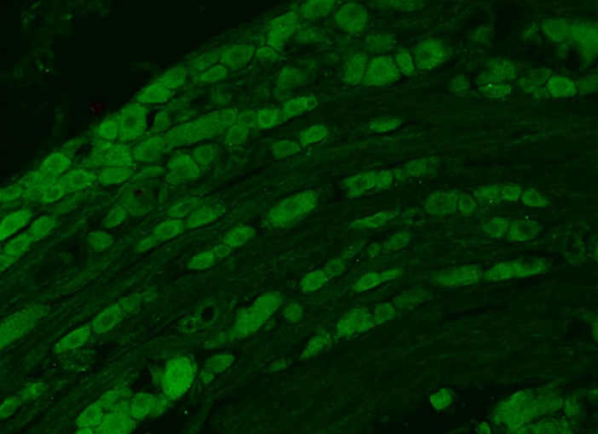
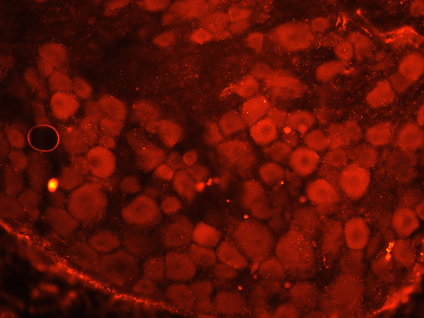
Supplemental Data 1

Immunostaining of dorsal root ganglion slices with commercially available antibodies to the oxytocin receptor. Left image is with primary antibody sc-8102 (1:100, Santa Cruz Biotechnology, Dallas, TX, USA) and right image is with primary antibody AVR-013 (1:1000, Alomone Labs, Jerusalem, IL. Details are described in Methods. Scale bar =

