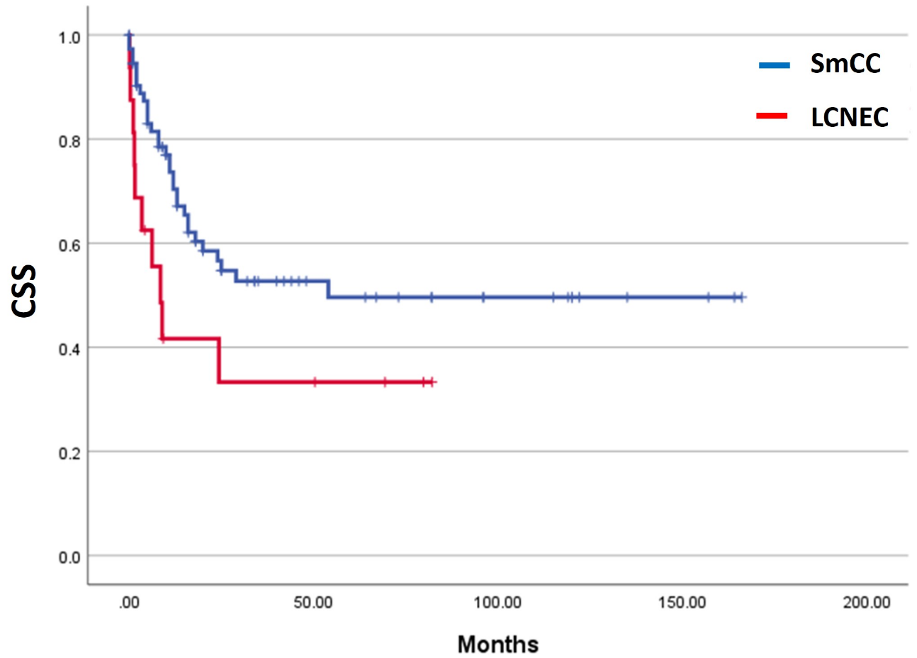

Supplemental Figure 1, Kaplan-Meier survival analyses of urinary large cell neuroendocrine carcinoma (LCNEC) without small cell carcinoma (SmCC) component. LCNEC had poorer cancer specific survival than small cell carcinoma (SmCC) (p=0.015).

