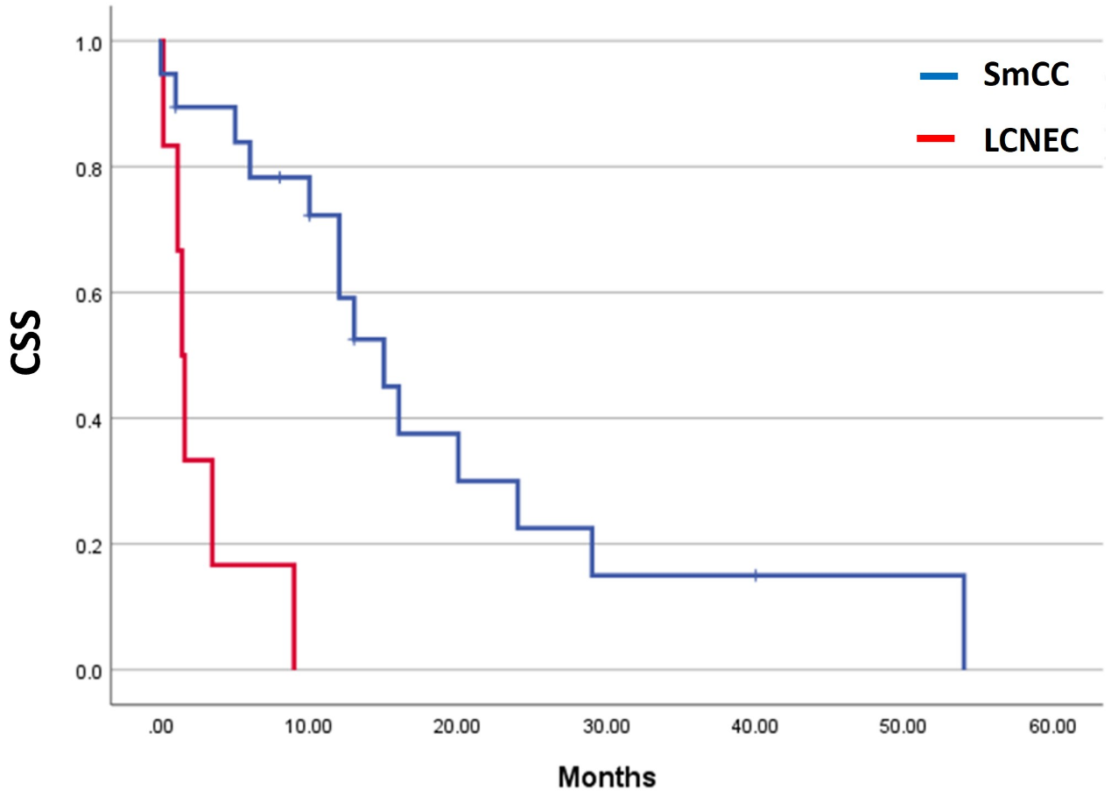

Supplemental Figure 3, Kaplan-Meier survival analyses of urinary large cell neuroendocrine carcinoma (LCNEC) without small cell carcinoma (SmCC) component. A. LCNEC had poorer cancer specific survival than small cell carcinoma (SmCC) (p=0.015). B. There is no significant difference in cancer-specific survival between LCNEC and SmCC in stage I-III disease (p=0.658). C. Cancer-specific survival for metastatic LCNEC is significantly worse than that for metastatic SmCC in stage IV disease (p=0.001).

