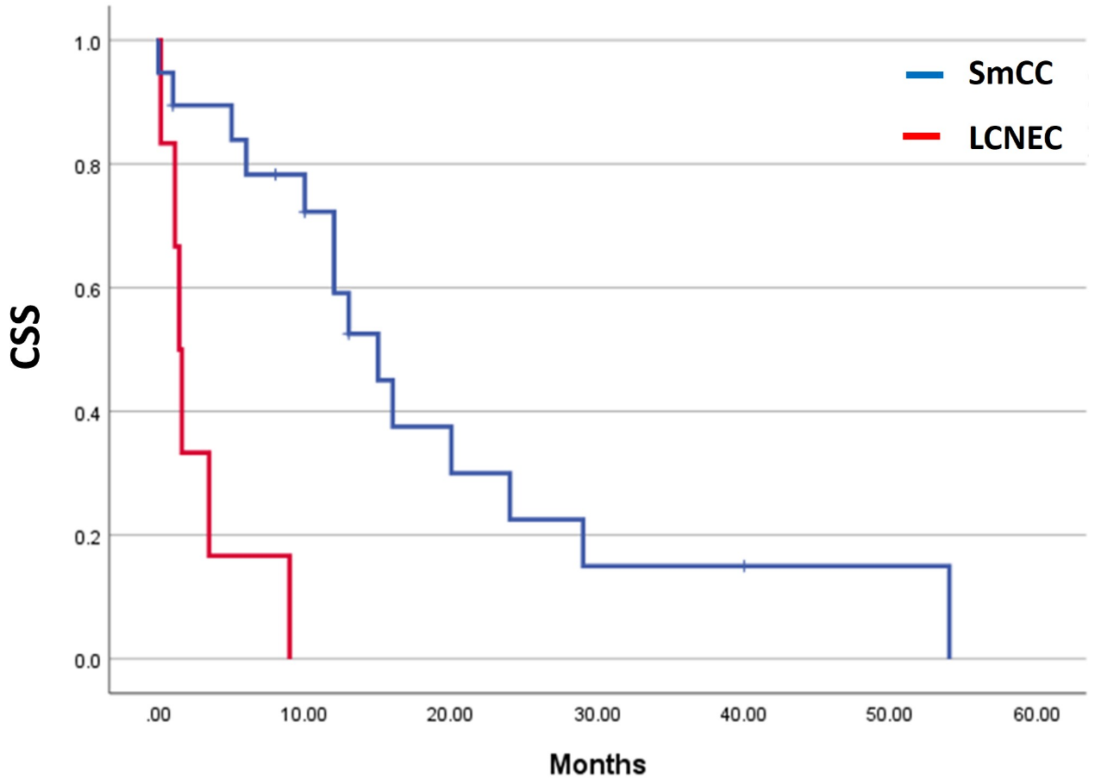

Supplemental Figure 3, Kaplan-Meier survival analyses of urinary large cell neuroendocrine carcinoma (LCNEC) without small cell carcinoma (SmCC) component. Cancer-specific survival for metastatic LCNEC is significantly worse than that for metastatic SmCC (p=0.001).

