Figure, Supplemental Digital Content 1: Type-I-Interferon-related proteins expression scores.
Histograms describing expression scores of Type-I-Interferon-related proteins, evaluated by immunohistochemistry, on inflammatory infiltrate of Cutaneous Lupus Erythematosus, on neoplastic cells of Blastic plasmacytoid dendritic cells neoplasm and Leukemia Cutis and on keratinocytes of all groups, including Normal skin.

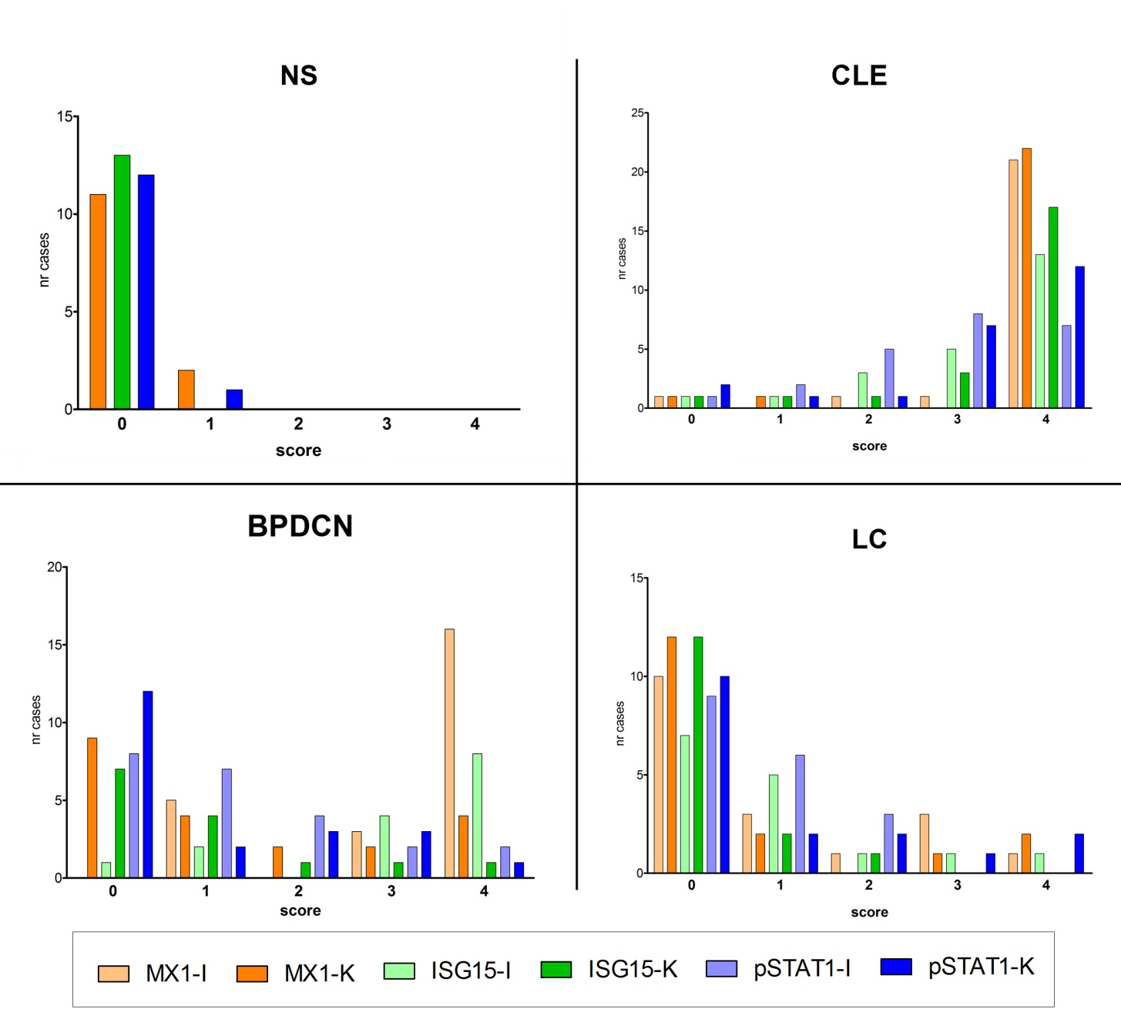

Legend: BPDCN, Blastic plasmacytoid dendritic cell neoplasm; CLE, Cutaneous Lupus erythematous; I, dermal infiltrate; K, keratinocytes; LC, Leukemia cutis; NS, Normal Skin.

