Figure, Supplemental Digital Content 2: Expression patterns of IFN-I-related proteins in Cutaneous Lupus Erythematosus, Blastic plasmacytoid dendritic cell neoplasm and Leukemia Cutis. (A-C) Prototypical example of Cutaneous Lupus Erythematosus, MX1, ISG15 and phospho-STAT1 are strongly expressed in the dermal inflammatory infiltrate and on keratincytes. (D-F) In a case of Blastic plasmacytoid dendritic cell neoplasm charachterized by neoplastic infiltrate strongly positive for MX1 and ISG15, the epidermis is completely negative. (G-I) Leukemia cutis shows negativity for IFN-I-related proteins both in the leukemic infiltrate and on overlying keratinocytes. (A-I: 40X)

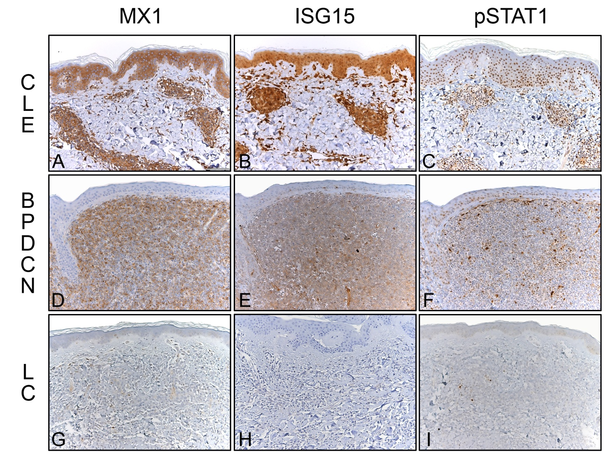

Legend: BPDCN, Blastic plasmacytoid dendritic cell neoplasm; CLE, Cutaneous Lupus Erythematosus; LC, Leukemia Cutis.

