Online-Only Supplementary Text

Grouping of antibiotics
Antibiotic | Chemical class | Functional class
Amikacin | Aminoglycoside | Anti-pseudomonal
Amoxicillin | Penicillin | CA - Narrow
Amoxicillin/clavulanic acid | Penicillin | CA - Broad
Ampicillin | Penicillin | CA - Narrow
Ampicillin/sulbactam | Penicillin | CA - Broad
Azithromycin | Macrolide | Atypical
Cefazolin | Cephalosporin-1st/2nd gen. | MSSA
Cefdinir | Cephalosporin-3rd/4th gen. | CA - Broad
Cefepime | Cephalosporin-3rd/4th gen. | Anti-pseudomonal
Cefotaxime | Cephalosporin-3rd/4th gen. | CA - Broad
Cefoxitin | Cephalosporin-1st/2nd gen. | MSSA
Ceftazadine | Cephalosporin-3rd/4th gen. | Anti-pseudomonal
Ceftriaxone | Cephalosporin-3rd/4th gen. | CA - Broad
Cefuroxime | Cephalosporin-1st/2nd gen. | MSSA
Ciprofloxacin | Fluoroquinolone | Anti-pseudomonal
Clindamycin | Other | MRSA
Gentamicin | Aminoglycoside | Anti-pseudomonal
Levofloxacin | Fluoroquinolone | MRSA
Linezolid | Other | MRSA
Meropenem | Carbapenem | Anti-pseudomonal
Nafcillin | Penicillin | MSSA
Oxacillin | Penicillin | MSSA
Penicillin | Penicillin | CA - Narrow
Piperacillin/tazobactam | Penicillin | Anti-pseudomonal
Tobramycin | Aminoglycoside | Anti-pseudomonal
Trimethoprim/sulfamethoxazole | Other | MRSA
Vancomycin | Glycopeptide | MRSA

Data Source
Data for this study were obtained from the Pediatric Health Information System (PHIS), an administrative database that contains inpatient, emergency department, ambulatory surgery and observation encounter-level data from over 45 not-for-profit, tertiary care pediatric hospitals in the United States. These hospitals are affiliated with the Children’s Hospital Association (Overland Park, KS). Data quality and reliability are assured through a joint effort between the Children’s Hospital Association and participating hospitals. Portions of the data submission and data quality processes for the PHIS database are managed by Truven Health Analytics (Ann Arbor, MI). For the purposes of external benchmarking, participating hospitals provide discharge/encounter data including demographics, diagnoses, and procedures. Nearly all of these hospitals also submit resource utilization data (e.g. pharmaceuticals, imaging, and laboratory) into the PHIS database. Data are de-identified at the time of data submission, and are subjected to a number of reliability and validity checks before being included in the database.

Supplemental Table 1. Multivariate models including children <2mo at hospital admission (n = 1058)

Variable | Duration of MV |  | Length of Stay
 | Estimate (95% CI) | p-value | Estimate (95% CI) | p-value
Intercept | 7.23 (6.12, 8.33) | <0.001 | 13.84 (12.19, 15.48) | <0.001
Antibiotics on first 2 days of MV vs. not | -1.29 (-2.00, -0.58) | <0.001 | -2.40 (-3.61, -1.19) | <0.001
Admit age | 0.40 (-0.10, 0.90) | 0.117 | 0.20 (-0.65, 1.06) | 0.643
Race - African-American vs. Caucasian | 0.80 (0.06, 1.53) | 0.034 | 1.56 (0.31, 2.82) | 0.015
- Other vs. Caucasian | 0.29 (-0.37, 0.95) | 0.387 | 1.08 (-0.03, 2.19) | 0.056
Female vs. male | 0.18 (-0.32, 0.68) | 0.487 | 0.07 (-0.79, 0.93) | 0.872
Vasoactive medication on day1 MV vs. not | 0.88 (0.13, 1.63) | 0.022 | 0.93 (-0.35, 2.21) | 0.155
No private insurance vs. private insurance | 0.87 (0.30, 1.45) | 0.003 | 1.67 (0.69, 2.65) | <0.001
MV, mechanical ventilation

Supplemental Table 2. Multivariate models including children ≥2mo at hospital admission (n = 1049)

Variable | Duration of MV |  | Length of Stay
 | Estimate (95% CI) | p-value | Estimate (95% CI) | p-value
Intercept | 7.87 (6.87, 8.88) | <0.001 | 14.01 (12.40, 15.63) | <0.001
Antibiotics on first 2 days of MV vs. not | -1.24 (-1.87, -0.61) | 0.001 | -1.70 (-2.82, -0.57) | 0.003
Admit age | -0.07 (-0.12, -0.02) | 0.003 | -0.13 (-0.22, -0.05) | 0.003
Race - African-American vs. Caucasian | 0.68 (0.00-1.35) | 0.0499 | 1.81 (0.61, 3.02) | 0.003
- Other vs. Caucasian | 0.15 (-0.48, 0.79) | 0.632 | 0.36 (-0.76, 1.49) | 0.525
Female vs. male | 0.26 (-0.24, 0.75) | 0.313 | 0.77 (-0.12, 1.65) | 0.091
Vasoactive medication on day1 MV vs. not | 1.23 (0.44, 2.02) | 0.002 | 2.16 (0.75, 3.58) | 0.003
No private insurance vs. private insurance | 0.62 (0.05, 1.19) | 0.032 | 1.35 (0.33, 2.36) | 0.009
MV, mechanical ventilation

Supplemental Table 3. Multivariate models including children with non-RSV disease

Variable | Duration of MV |  | Length of Stay
 | Estimate (95% CI) | p-value | Estimate (95% CI) | p-value
Intercept | 7.43 (6.73, 8.12) | <0.001 | 13.50 (12.45, 14.55) | <0.001
Antibiotics on first 2 days of MV vs. not | -1.01 (-1.41, -0.62) | <0.001 | -1.57 (-2.28, -0.87) | <0.001
Admit age | -0.10 (-0.13, -0.07) | <0.001 | -0.19 (-0.24, -0.13) | <0.001
Race - African-American vs. Caucasian | 0.26 (-0.14, 0.66) | 0.208 | 1.14 (0.43, 1.86) | 0.002
- Other vs. Caucasian | -0.02 (-0.40, 0.37) | 0.935 | 0.30 (-0.38, 0.98) | 0.391
Female vs. male | 0.24 (-0.06, 0.53) | 0.112 | 0.47 (-0.06, 0.99) | 0.084
Vasoactive medication on day1 MV vs. not | 0.90 (0.45, 1.35) | <0.001 | 1.41 (0.60, 2.21) | <0.001
No private insurance vs. private insurance | 0.64 (0.30, 0.98) | <0.001 | 1.31 (0.70, 1.92) | <0.001
MV, mechanical ventilation
Note: In order to adjust for institutional variation, each center’s difference from the overall average proportion of early antibiotic administration (i.e. center usage rate minus overall usage rate for children with RSV or non-RSV disease) was included in the mixed-effect models as a random effect.

Supplemental Figure 1
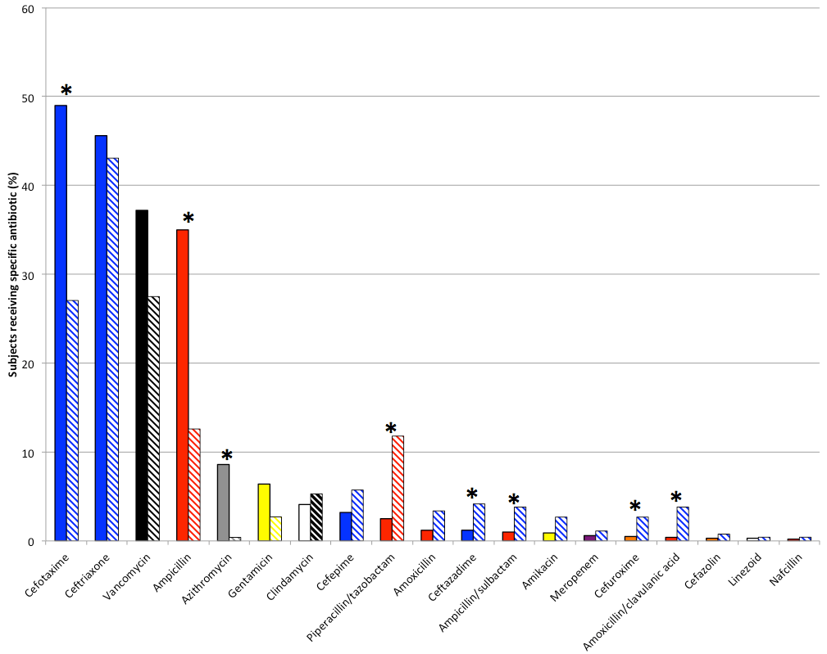
1a

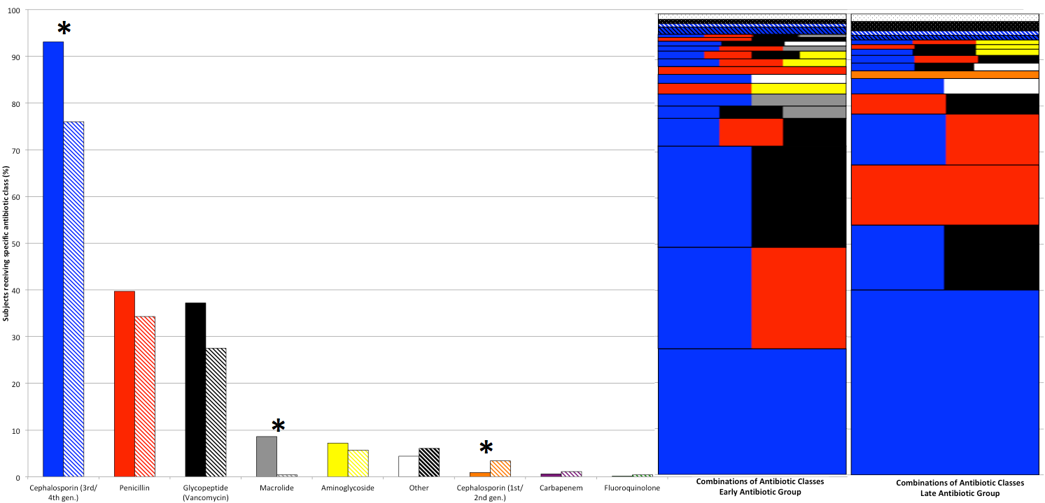
1b

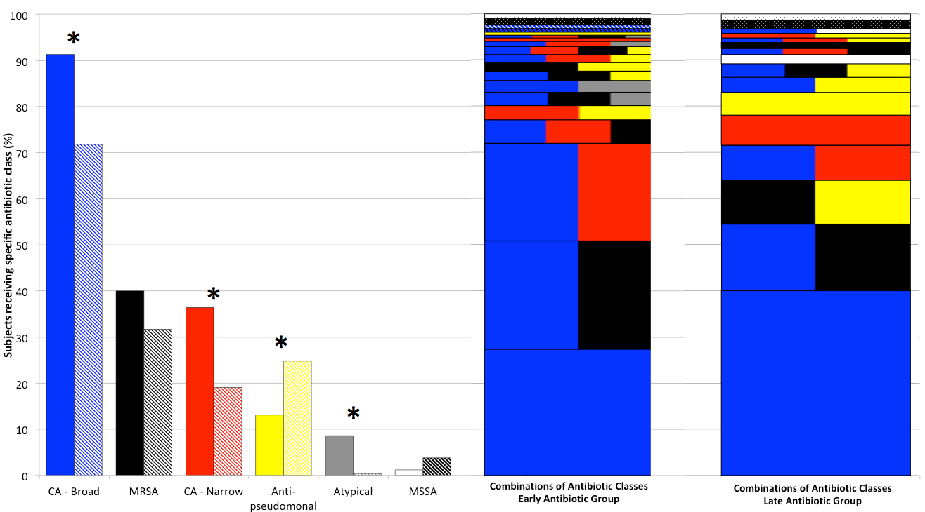
1c

Antibiotics prescribed during the first two days of antibiotic therapy. Bars represent the percentage of subjects prescribed that specific antibiotic or individual antibiotic class. Solid bars represent early antibiotic group. Striped bars represent late antibiotic group. Asterisks denote statistically significant differences between groups (p < 0.001 by Fisher’s exact test). Individual antibiotics prescribed ≤5 times in the dataset are not shown in Supplementary Figure 1a. In 1b and 1c, the stacked horizontal bars show the percentage of subjects prescribed each unique combination of antibiotic classes (e.g. just CA-Broad, just MRSA, both CA-Broad and MRSA, etc.). These combinations were mutually exclusive and each subject is only included in a single category. In 1b and 1c, both the individual bars and the stacked bars use the same colors to represent the same antibiotic class (e.g. blue represents CA-Broad, etc.).
CA, community acquired. MRSA = methicillin-resistant Staphylococcal aureus, MSSA = methicillin-sensitive Staphylococcal aureus.

Supplemental Figure 2

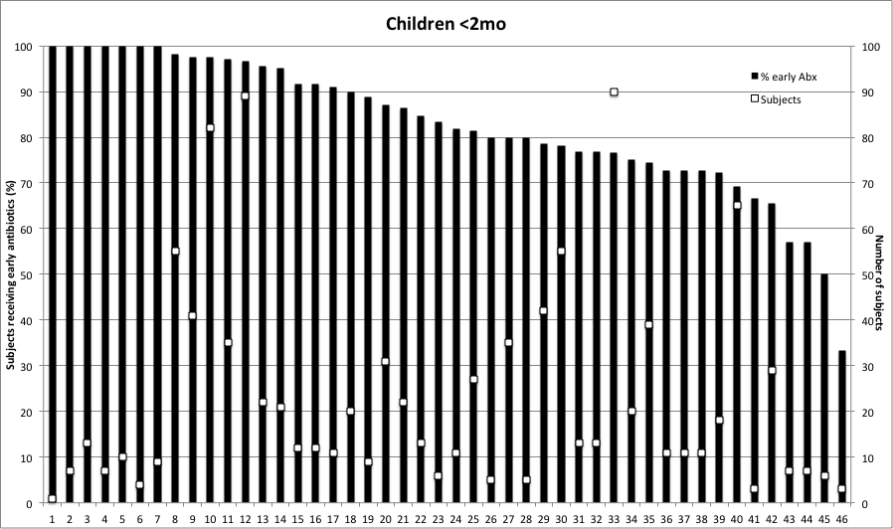

Early antibiotic usage by PHIS hospital among children <2mo. Black bars show the percentage of subjects prescribed early antibiotics at each hospital. White boxes show the number of subjects included from each center (right y-axis)

Supplemental Figure 3

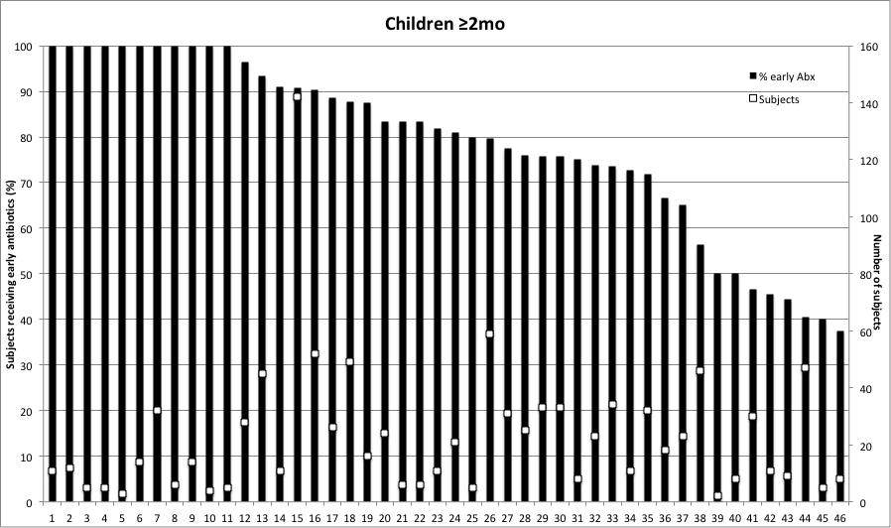

Early antibiotic usage by PHIS hospital among children ≥2mo. Black bars show the percentage of subjects prescribed early antibiotics at each hospital. White boxes show the number of subjects included from each center (right y-axis)

