**Timing and Significance of Fluid Overload in Pediatric Acute Respiratory Distress Syndrome: A Retrospective Cohort Study**

Celeste G. Black, MD; Neal J. Thomas, MD, MSc; Nadir Yehya, MD, MSCE

**DATA SUPPLEMENT**

**Supplementary Table 1:** Diuretic and continuous renal replacement therapy (CRRT) over the first 7 days after ARDS onset.

|  |  |  |  |  |  |
| --- | --- | --- | --- | --- | --- |
|  | **N total/N non-survivors** | **All patients** | **Survivors** | **Non-survivors** | **Nominal *p* value** |
| **Diuretic Use (%)** |  |  |  |  |  |
| Day 1 | 723/132 | 160 (22) | 126 (21) | 34 (26) | 0.296 |
| Day 2 | 713/122 | 230 (32) | 195 (33) | 35 (29) | 0.395 |
| Day 3 | 700/109 | 311 (44) | 274 (46) | 37 (34) | 0.021 |
| Day 4 | 688/98 | 342 (50) | 304 (52) | 38 (39) | 0.022 |
| Day 5 | 672/87 | 329 (49) | 296 (51) | 33 (38) | 0.029 |
| Day 6 | 651/75 | 290 (45) | 263 (46) | 27 (36) | 0.138 |
| Day 7 | 633/66 | 260 (41) | 237 (42) | 23 (35) | 0.293 |
| **CRRT Use (%)** |  |  |  |  |  |
| Day 1 | 723/132 | 22 (3) | 12 (2) | 10 (8) | 0.003 |
| Day 2 | 713/122 | 33 (5) | 19 (3) | 14 (11) | < 0.001 |
| Day 3 | 700/109 | 38 (5) | 22 (4) | 16 (15) | < 0.001 |
| Day 4 | 688/98 | 41 (6) | 26 (4) | 15 (15) | < 0.001 |
| Day 5 | 672/87 | 49 (7) | 30 (5) | 19 (22) | < 0.001 |
| Day 6 | 651/75 | 43 (7) | 25 (4) | 18 (24) | < 0.001 |
| Day 7 | 633/66 | 40 (6) | 20 (4) | 20 (30) | < 0.001 |
|  |  |  |  |  |  |

**Supplementary Table 2:** Tidal volumes (VT), PEEP, and ΔP (PIP minus PEEP) at ARDS onset and 24 hours later, stratified by year. The p value is for a non-parametric test of trend, and is presented at the nominal value. Comparisons with statistical significance p < 0.05 after Bonferroni correction (nominal p ≤ 0.007) are depicted with an asterisk (*).

|  |  |  |  |  |  |  |  |
| --- | --- | --- | --- | --- | --- | --- | --- |
| **Year** | **Dates** | **VT initial** | **PEEP initial** | **ΔP initial** | **VT 24 Hr** | **PEEP 24 Hr** | **ΔP 24 Hr** |
| 1 | 07/2011-06/2012 | 7.5 [6.9,8.3] | 10 [8,10] | 20 [17,24] | 7.3 [6.9,8] | 10 [8,10] | 18 [15,22] |
| 2 | 07/2012-06/2013 | 7.5 [6.5,8.3] | 10 [8,12] | 20.5 [16,25] | 7.2 [6.3,8.2] | 8 [8,10] | 18 [14,23] |
| 3 | 07/2013-06/2014 | 7.7 [6.2,8.5] | 10 [8,10] | 21 [17,25] | 7.5 [6.3,8.3] | 10 [8,10] | 19 [15,24] |
| 4 | 07/2014-06/2015 | 7.7 [6.8,8.9] | 10 [8,12] | 21 [17,24] | 7.2 [6.5,8.1] | 10 [8,12] | 15.5 [12.5,22] |
| 5 | 07/2015-06/2016 | 7.3 [6.5,7.9] | 10 [8,12] | 20.5 [16,26] | 7.2 [6.4,8] | 10 [8,10] | 17 [14,20] |
| 6 | 07/2016-06/2017 | 7.1 [6.2,8.3] | 10 [8,12] | 20 [15,24] | 7.2 [6.4,8] | 10 [8,12] | 18 [15,23] |
| 7 | 07/2017-06/2018 | 7 [6.2,8] | 10 [8,12] | 21 [17,26] | 7.3 [6.2,7.9] | 10 [8,12] | 18.5 [15,22] |
| 8 | 07/2018-06/2019 | 7.4 [6.3,8.5] | 10 [8,12] | 21.5 [17,23.5] | 6.7 [6.1,7.7] | 10 [8,12] | 17 [15,21] |
| *p* value for trend |  | 0.037 | <0.001* | 0.671 | 0.010 | <0.001* | 0.850 |

**Supplementary Table 3:** Day 1 and Day 2 fluid intake, stratified by year. The p value is for a non-parametric test of trend, and is presented at the nominal value. Comparisons with statistical significance p < 0.05 after Bonferroni correction (nominal p ≤ 0.007) are depicted with an asterisk (*).

|  |  |  |  |
| --- | --- | --- | --- |
| **Year** | **Dates** | **Day 1 ins ml/kg** | **Day 2 ins ml/kg** |
| 1 | 07/2011-06/2012 | 134 [94,174] | 111 [87,148] |
| 2 | 07/2012-06/2013 | 123 [84,178] | 107 [76,134] |
| 3 | 07/2013-06/2014 | 125 [99,160] | 118 [89,152] |
| 4 | 07/2014-06/2015 | 133 [105,176] | 110 [86,148] |
| 5 | 07/2015-06/2016 | 122 [94,159] | 109 [79,140] |
| 6 | 07/2016-06/2017 | 108 [73,138] | 98 [71,125] |
| 7 | 07/2017-06/2018 | 112 [78,157] | 94 [72,119] |
| 8 | 07/2018-06/2019 | 110 [69,134] | 86 [66,116] |
| *p* value for trend |  | <0.001* | <0.001* |

**Supplementary Figure 1:** Unadjusted comparison between survivors (white) and non-survivors (gray) of daily total intake (mL/kg), daily total output (mL/kg), and daily urine output (ml/kg/hr). Box plots represent median (line), lower and upper quartiles (boxes), and range (error bars). Comparisons with statistical significance p < 0.05 after Bonferroni correction (nominal p ≤ 0.007) are depicted with an asterisk (*).



**Supplementary Figure 2:** Adjusted association (adjusted for OI, number of non-pulmonary organ failures, immunocompromised status, and vasopressor score) of cumulative fluid intake, cumulative fluid output, cumulative urine output, and cumulative fluid balance with mortality over the first 7 days of ARDS for subjects with available data for all 7 days. Adjusted odds ratios are plotted per day and are scaled per increase in 100 mL/kg. Comparisons with statistical significance p < 0.05 after Bonferroni correction (nominal p ≤ 0.007) are depicted with an asterisk (*).

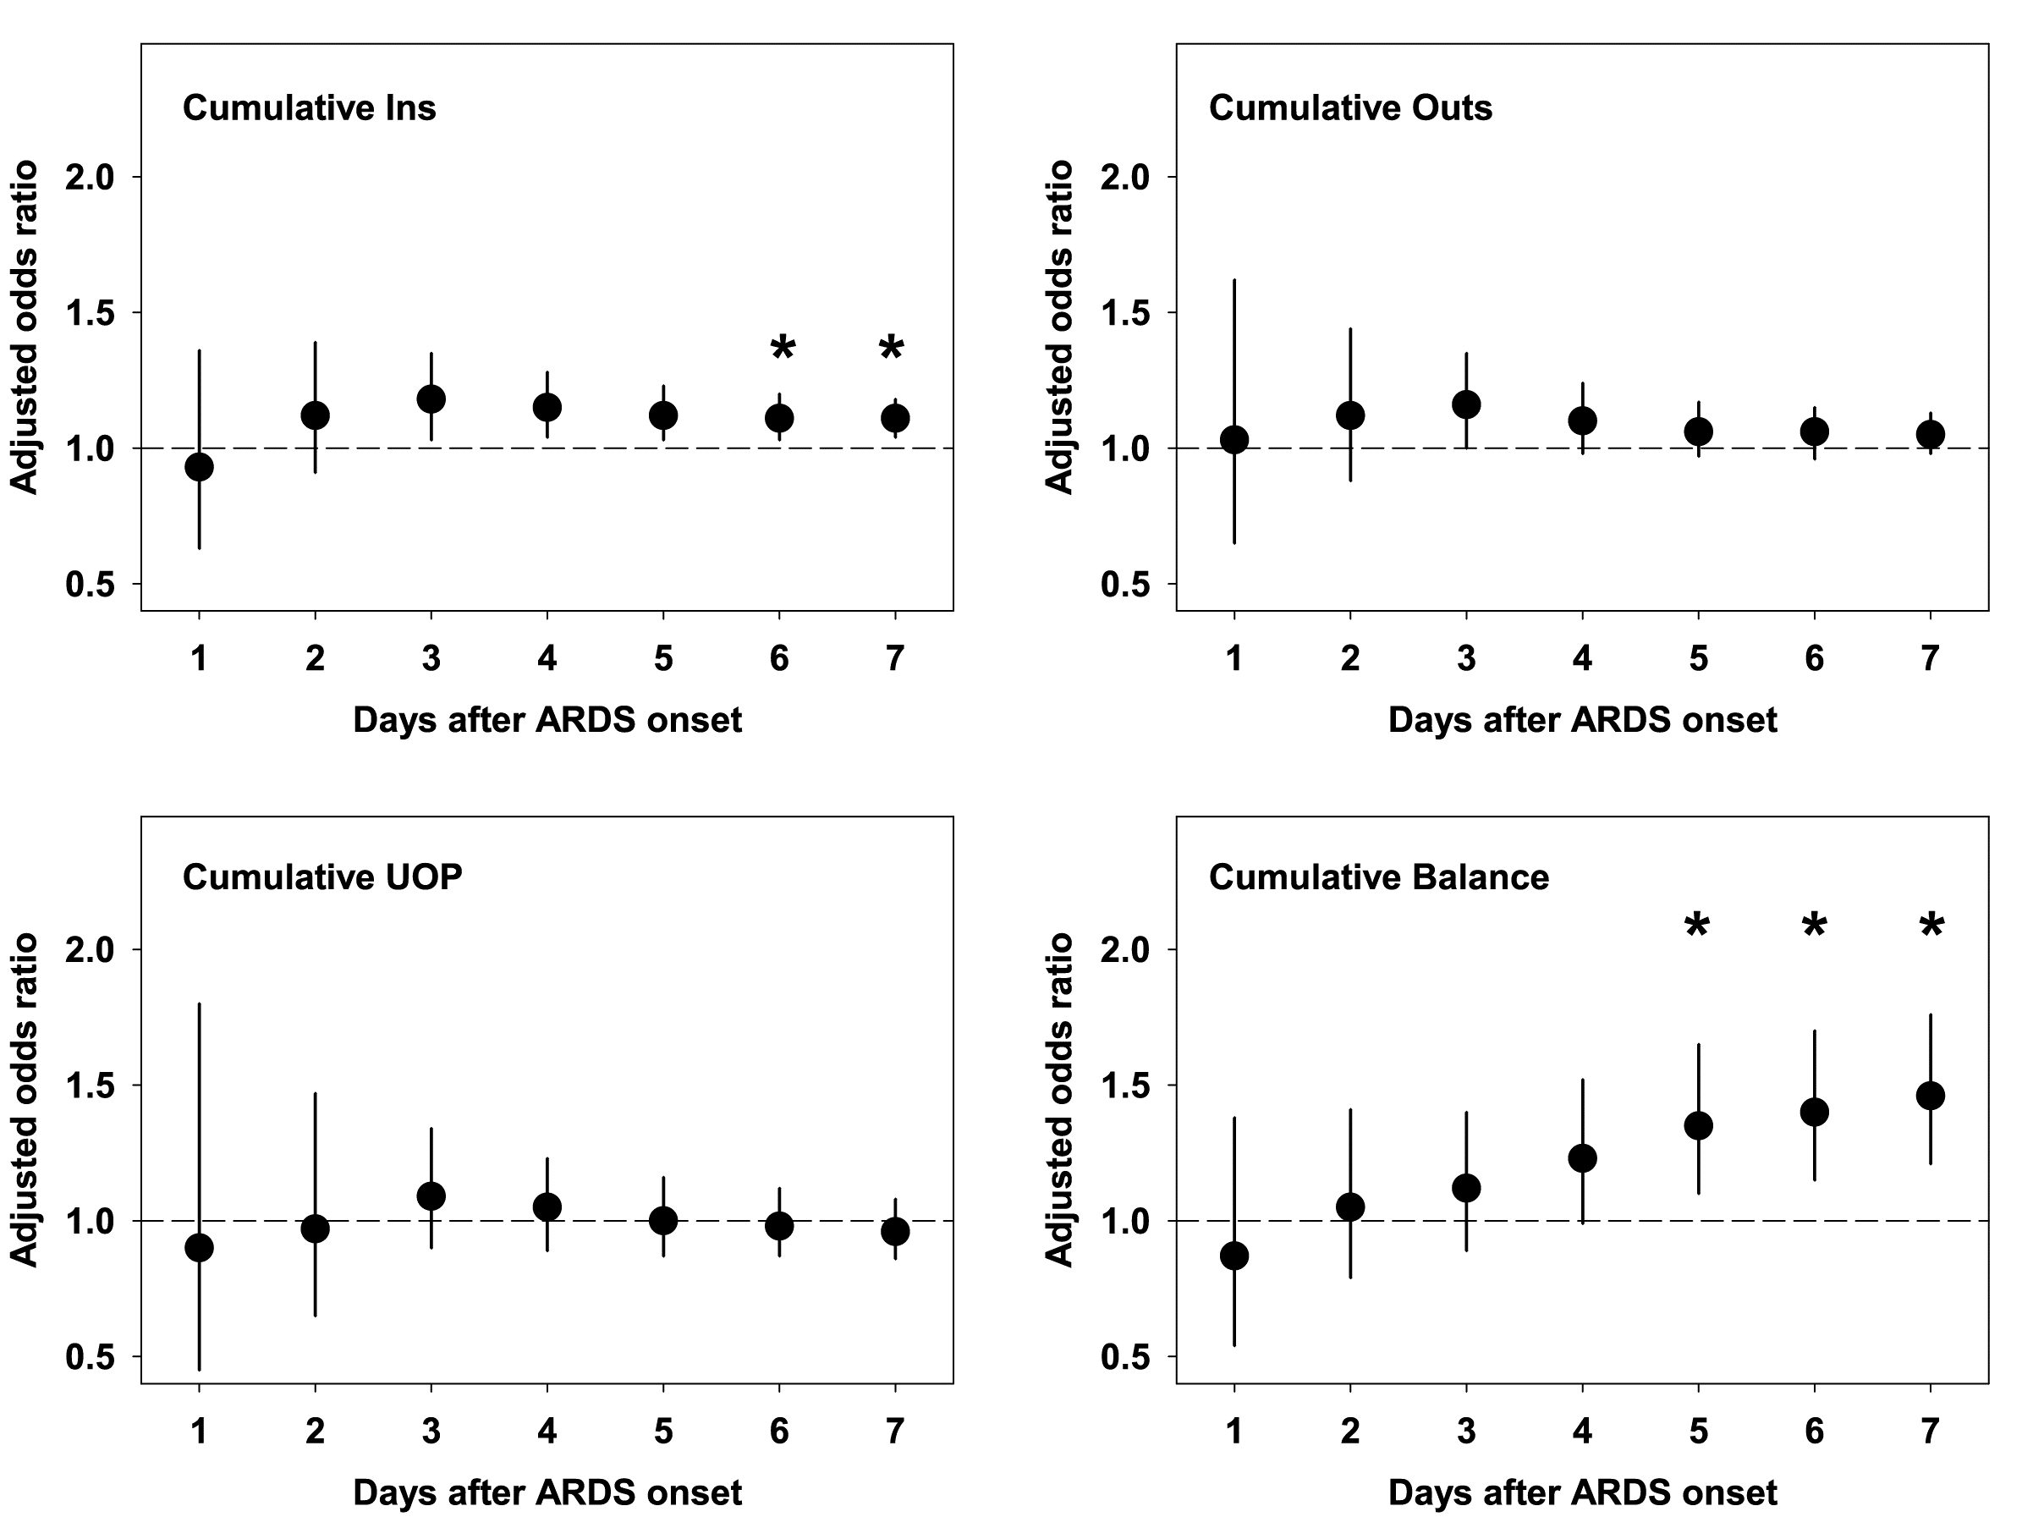

**Supplementary Figure 3:** Adjusted association (adjusted for OI, number of non-pulmonary organ failures, immunocompromised status, and vasopressor score) of cumulative fluid intake, cumulative fluid output, cumulative urine output, and cumulative fluid balance with probability of extubation, given the competing risk of death, over the first 7 days of ARDS for subjects with available data for all 7 days. Adjusted subdistribution hazard ratios (SHRs) are plotted per day and are scaled per increase in 100 mL/kg. Adjusted SHR < 1 implies slower extubation/fewer VFDs. Comparisons with statistical significance p < 0.05 after Bonferroni correction (nominal p ≤ 0.007) are depicted with an asterisk (*).

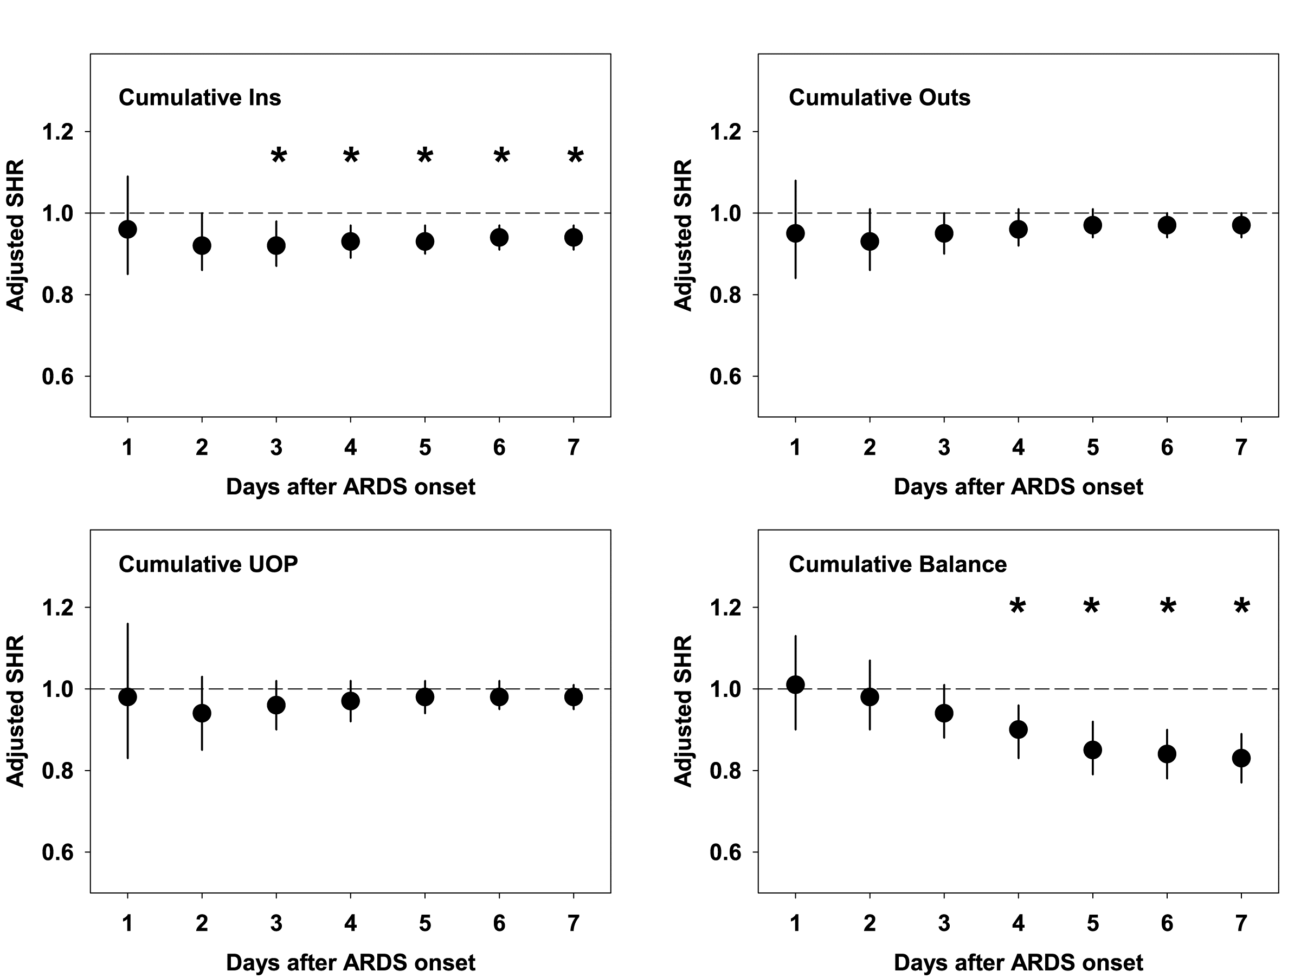

**Supplementary Figure 4:** Unadjusted comparison between survivors (white) and non-survivors (gray) of daily and cumulative combination (urine + stool) output in ml/kg (top graphs). Box plots represent median (line), lower and upper quartiles (boxes), and range (error bars). Cumulative combination output was tested for association with mortality and probability of extubation at 28 days, given competing risk of death, after adjustment for confounders (adjusted for OI, number of non-pulmonary organ failures, immunocompromised status, and vasopressor score). Adjusted subdistribution hazard ratio (SHR) < 1 implies slower extubation/fewer VFDs. Comparisons with statistical significance p < 0.05 after Bonferroni correction (nominal p ≤ 0.007) are depicted with an asterisk (*).



**Supplementary Figure 5:** Adjusted association (adjusted for OI, number of non-pulmonary organ failures, immunocompromised status, and vasopressor score) of cumulative fluid intake, cumulative fluid output, cumulative urine output, and cumulative fluid balance with mortality over the first 7 days of ARDS, with an additional adjustment for year. Adjusted odds ratios are plotted per day and are scaled per increase in 100 mL/kg. Comparisons with statistical significance p < 0.05 after Bonferroni correction (nominal p ≤ 0.007) are depicted with an asterisk (*).



**Supplementary Figure 6:** Adjusted association (adjusted for OI, number of non-pulmonary organ failures, immunocompromised status, and vasopressor score) of cumulative fluid balance with mortality (top panels) and probability of extubation given competing risk of death (bottom panels) over the first 7 days of ARDS, stratified by cause of ARDS. Adjusted odds ratios (mortality) and subdistribution hazard ratios (SHRs, for probability of extubation) are plotted per day and are scaled per increase in 100 mL/kg. Adjusted SHR < 1 implies slower extubation/fewer VFDs. Comparisons with statistical significance p < 0.05 after Bonferroni correction (nominal p ≤ 0.007) are depicted with an asterisk (*).



**Supplementary Figure 7:** Adjusted association (adjusted for OI, number of non-pulmonary organ failures, immunocompromised status, and vasopressor score) of cumulative fluid balance with mortality over the first 7 days of ARDS, stratified by the etiology of death. Adjusted odds ratios (mortality) are plotted per day and are scaled per increase in 100 mL/kg. Comparisons with statistical significance p < 0.05 after Bonferroni correction (nominal p ≤ 0.007) are depicted with an asterisk (*).



**Supplementary Figure 8:** Mediation analyses of the association between later fluid overload and mortality in ARDS. We tested the specific independent variable of cumulative fluid overload on days 4 to 7 and the specific binary outcome of PICU mortality. Using structural equation modeling, we separately tested two potential mediator variables: acute kidney injury (AKI) by day 3 and maximum vasopressor score by day 3. Both AKI and vasopressor score showed minimal evidence (p = 0.142 and p = 0.068, respectively) of mediating the association between late fluid overload (≥ 10% on days 4 to 7) and mortality.

