Appendix A: Synthesis Table: Interventions

Interventions | 1 | 2 | 3 | 4 | 5 | 6 | 7 | 8 | 9 | 10 | 11 | Synthesis
Home Visit | X | X |  |  |  |  |  |  |  |  |  | 2 of 11
Post Discharge Phone Calls | X | X |  |  | X |  |  |  |  |  |  | 3 of 11
Discharge instructions / disease education |  | X | X |  |  |  |  |  |  | X | X | 4 of 11
Inpatient Care Planning |  |  |  |  |  |  |  |  | X |  |  | 1 of 11
Schedule Follow-up visits before discharge |  | X | X | X |  |  |  | X | X | X | X | 7 of 11
Youth Adult Transition Clinic |  |  | X |  |  |  |  |  |  |  |  | 1 of 11
Self-management strategies |  |  | X |  |  |  |  |  |  |  |  | 1 of 11
Sickle Cell Outpatient Infusion Center / Clinic |  |  |  |  |  | X | X |  |  |  |  | 2 of 11
Prescribe Hydroxyurea |  |  |  |  |  |  |  |  |  | X | X | 2 of 11
1 = Bronstein, L.R., et al. (2015); 2 = Gao, W., et al. (2018); 3 = Dangi-Garimella, S. (2015); 4 = Limenis (2017); 5 = Harrison et al. (2014); 6 = Lanzkron, S. et al. (2015); 7 = Koch, K. L., et al. (2013); 8 = Leschke, J., et al. (2012); 9 = Manwani, D., et al. (2014); 10 = Pashankar, F.D., et al. (2018); 11 = Onimoe, G.I., et al. (2016).

Appendix B: Synthesis Table: Outcomes

 | 1 | 2 | 3 | 4 | 5 | 6 | 7 | 8 | 9 | 10 | 11 | Synthesis
Interventions | HV  PDCC | HV  DCE  FUA | DCE  FUA  YATC  SMS | FUA | PDCC | SCIC | SCIC | FUA | ICP  FUA | DCE  FUA  HYDR | DCE  FUA  HYDR
Outcomes
Self-Management |  |  | ⬇ |  |  |  |  |  |  |  |  | 1 of 11
30-day Readmission Rate | ⬇ | ⬇ | ⬇ | - | ⬇ | ⬇ | ⬇ | ⬇ | ⬇ | ⬇ | ⬇ | 10 of 11
14-day Readmission Rate |  |  |  |  |  |  |  | ⬇ |  |  |  | 1 of 11
Patient satisfaction / engagement | ⬆ | ⬆ |  |  |  |  |  |  |  |  |  | 2 of 11
Health Literacy |  |  | ⬇ |  |  |  |  |  |  |  |  | 1 of 11
Number of Infusion Visits |  |  |  |  |  | ⬆ |  |  |  |  |  | 1 of 11
ED visits |  |  |  |  |  | ⬆ |  |  |  |  |  | 1 of 11
Admissions / Acute Care Utilization |  |  |  |  |  | ⬇ | ⬇ |  |  | ⬇ |  | 3 of 11
Length of Stay (LOS) |  |  |  |  |  |  |  |  | ⬇ | ⬇ |  | 2 of 11
High Utilizers |  |  |  |  |  |  |  |  |  | ⬇ |  | 1 of 11
1 = Bronstein, L.R., et al. (2015); 2 = Gao, W., et al. (2018); 3 = Dangi-Garimella, S. (2015); 4 = Limenis (2017); 5 = Harrison et al. (2014); 6 = Lanzkron, S. et al. (2015); 7 = Koch, K. L., et al. (2013); 8 = Leschke, J., et al. (2012); 9 = Manwani, D., et al. (2014); 10 = Pashankar, F.D., et al. (2018); 11 = Onimoe, G.I., et al. (2016).
HV=Home Visits; PDCC=Post-discharge calls; DCE=Discharge Education; FUA=Follow-Up Appointments; YATC = Youth Adult Transition Center; SMS =self-management system; SCIC = Sickle Cell Infusion Center; ICP = Inpatient Care Plan; HYDR = Hydroxyurea
⬇ = decrease ⬆ = increase - = no change

Appendix C: SCD Toolkit

What to Know Before You Go to the ER
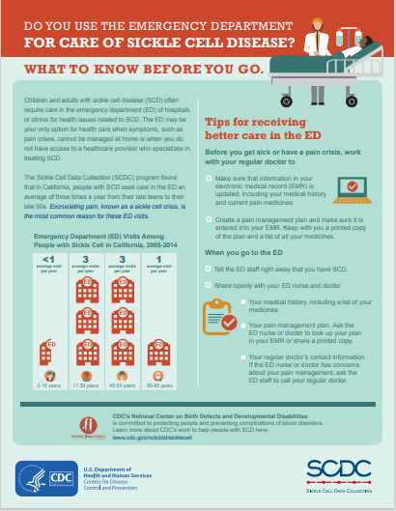

Appendix C: SCD Toolkit continued

Medical Appointment Sheet

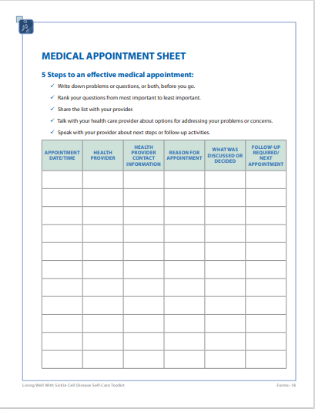
Appendix C: SCD Toolkit continued

Medical Emergency Information Sheet

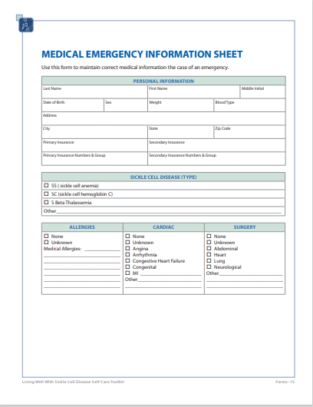
Appendix C: SCD Toolkit continued

SMART Goals

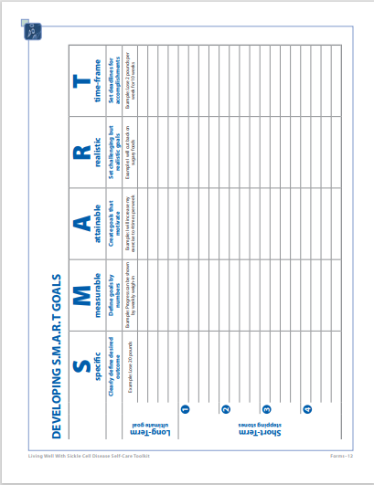

Appendix C: SCD Toolkit continued

Healthy Behavior Contract

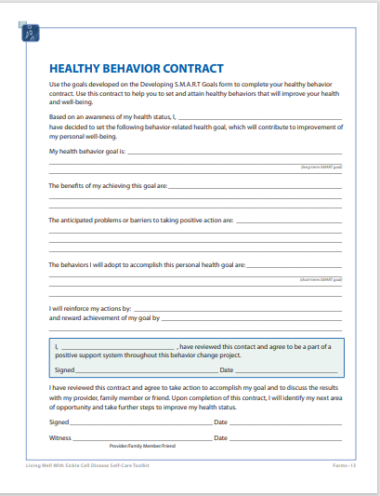
Appendix C: SCD Toolkit continued

Daily Pain Tracking Sheet

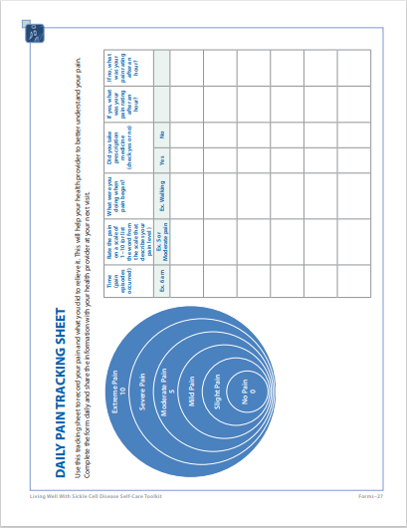
Appendix C: SCD Toolkit continued

Describe the Pain Sheet

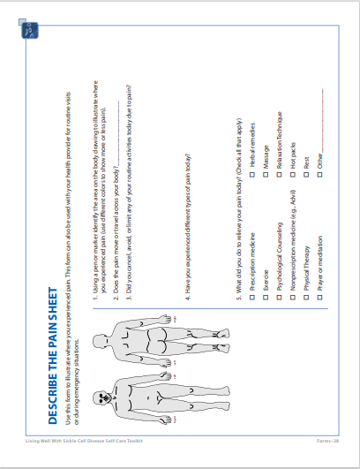
Appendix C: SCD Toolkit continued

Patient Education Materials: Stress Diary Sheet

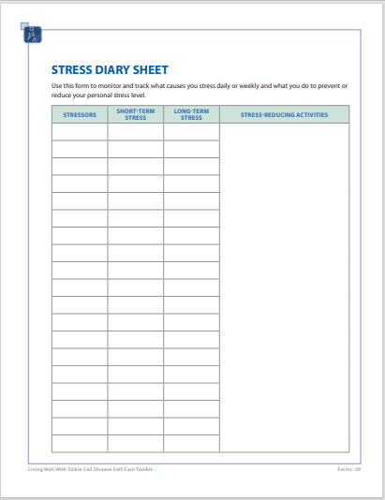
Appendix C: SCD Toolkit continued

Water Intake Tracking Sheet

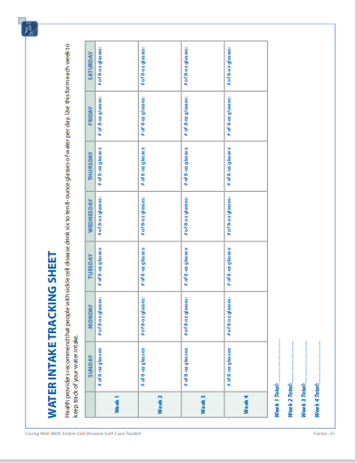
Appendix C: SCD Toolkit continued

Questions to Ask My Health Provider

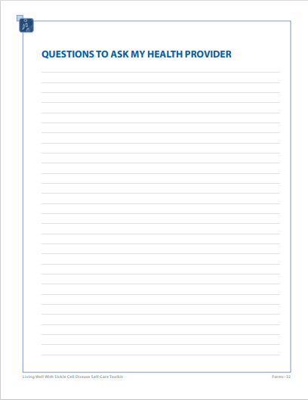
Appendix C: SCD Toolkit continued

Fact Sheet: Sickle Cell Status

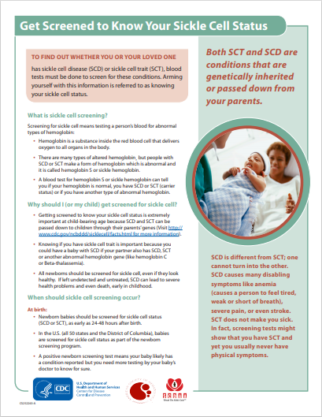
Appendix C: SCD Toolkit continued

Fact Sheet: Sickle Cell Status

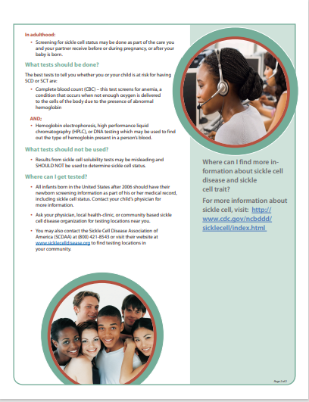
Appendix C: SCD Toolkit continued

Sickle Cell Disease and Hemoglobin S

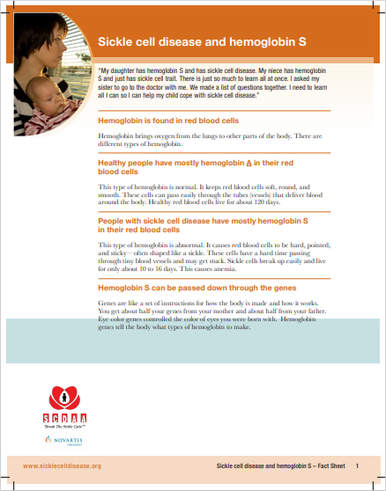

Appendix C: SCD Toolkit continued

Sickle Cell Disease and Hemoglobin S

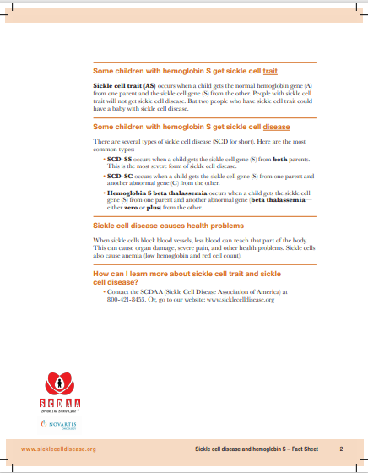

Appendix D: Process Measures Results

SCD-specific education  Threshold >/= 90%  Target >/= 95%  Baseline data: ~51% |  |  | Post-discharge follow-up appointments  Threshold >/= 90%  Target >/= 95%  Baseline data: ~15%
Number of encounters with completed SCD-specific education | 178 |  | Number of encounters with post-discharge follow-up appointment scheduled prior to discharge | 132
Total number of encounters | 178 |  | Total number of encounters | 178
Compliance Rate | 100% |  | Compliance Rate | 74%
Reasons appointments not scheduled
Patient Refusal or request for self-schedule | 17
Incomplete appointments | 14
Unplanned discharges | 6
Staff omissions (forgot to schedule) | 5
Late appointments | 4
Total | 46

Appendix E: Outcome Measures Results

Total Inpatient & Emergency Department Visits Principal Diagnosis Sickle Cell
Admit Type | Pre-Implementation | Post-Implementation | Grand Total |  | % Reduction Overall Visits
Emergency | 134 | 109 | 243 |  | 18.7%
Inpatient | 208 | 178 | 386 |  | 14.4%
Observation | 68 | 52 | 120 |  | 23.5%
Grand Total | 410 | 339 | 749 |  | 17.3%
Admit Type | Pre-Implementation | Post-Implementation | Variance
Inpatients | 208 | 178 | 30
30-day readmissions | 95 | 64 | 31
Readmission Rate | 46% | 36% | -22%
Hospital Stay ALOS Principal Diagnosis Sickle Cell | Pre-Implementation |  | Post-Implementation |  | % Reduction
Admit Type | Count of Encounter | Average length of stay (ALOS) | Count of Encounter | Average length of stay (ALOS)
Inpatient | 208 | 7.7 | 178 | 6.8 | 11.7%
Observation | 68 | 1.0 | 52 | 1.0 | 0.0%

