Forest plot of the effect of GPR on pain showing the subgroup analysis according to the blinded outcome measurement.

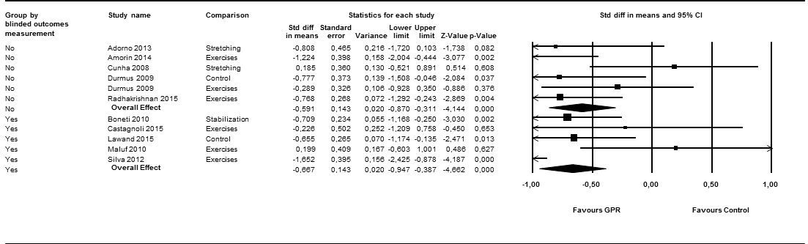
Abbreviations: Std diff: standardized difference, GPR: global postural reeducation.

Forest plot of the effect of GPR on pain showing the subgroup analysis according to the type of design.

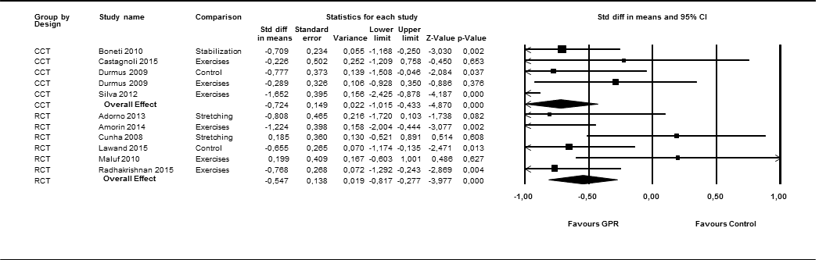
Abbreviations: Std diff: standardized difference, RCT: randomized controlled trial, CCT: controlled clinical trial,
GPR: global postural reeducation.

Plot showing the results of the analysis of meta-regression of GPR and pain on type of pathology.

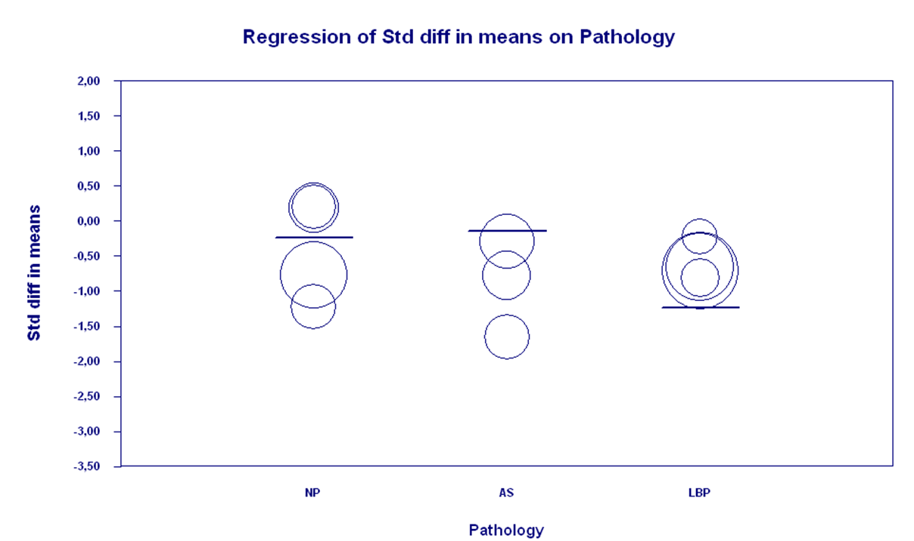
Abbreviations: Std diff: standardized difference, NP: Neck Pain, AS: ankylosing spondylitis, LBP: Low Back Pain,
GPR: global postural reeducation.

Plot showing the results of the analysis of meta-regression of GPR and pain on follow-up.

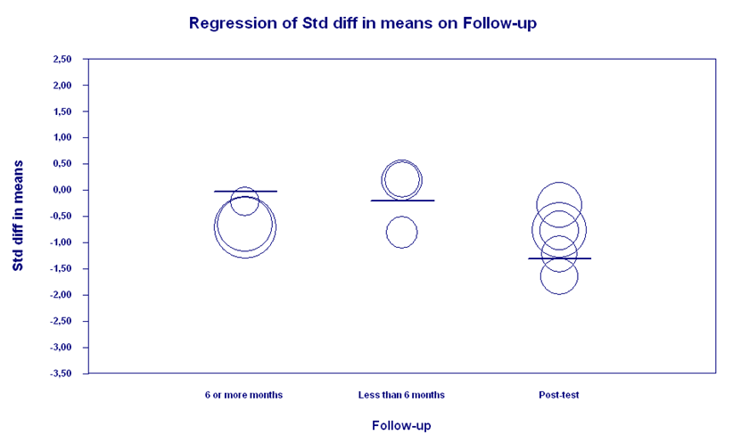

Abbreviations: Std diff: standardized difference, NP: Neck Pain, AS: ankylosing spondylitis, LBP: Low Back Pain,
GPR: global postural reeducation.

Forest plot of the effect of GPR on function showing the subgroup analysis according to the blinded outcome measurement.

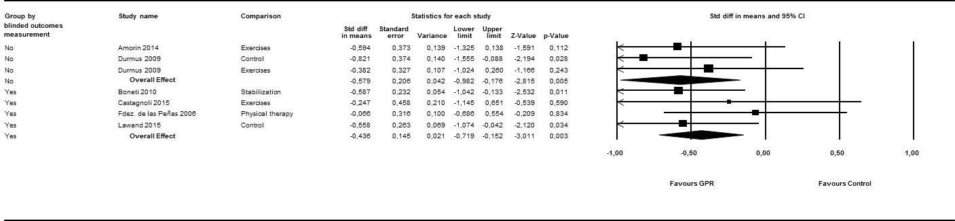

Abbreviations: Std diff: standardized difference, GPR: global postural reeducation.

Forest plot of the effect of GPR on function showing the subgroup analysis according to the type of design.

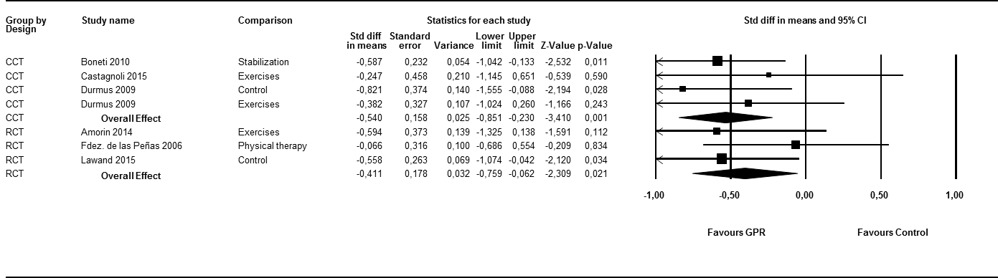
Abbreviations: Std diff: standardized difference, RCT: randomized controlled trial, CCT: controlled clinical trial,
GPR: global postural reeducation.

