Appendix 6. Egger’s test of the effective size of VAS pain score changes from baseline at (A) 1.5 months, (B) 3 months, and (C) 6 months after PRP injections. VAS: visual analogue scale; PRP: platelet‑rich plasma

A. PRP: 1.5 months
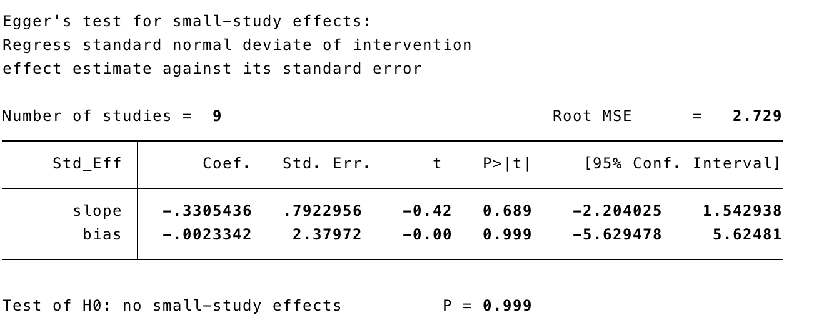

B. PRP: 3 months
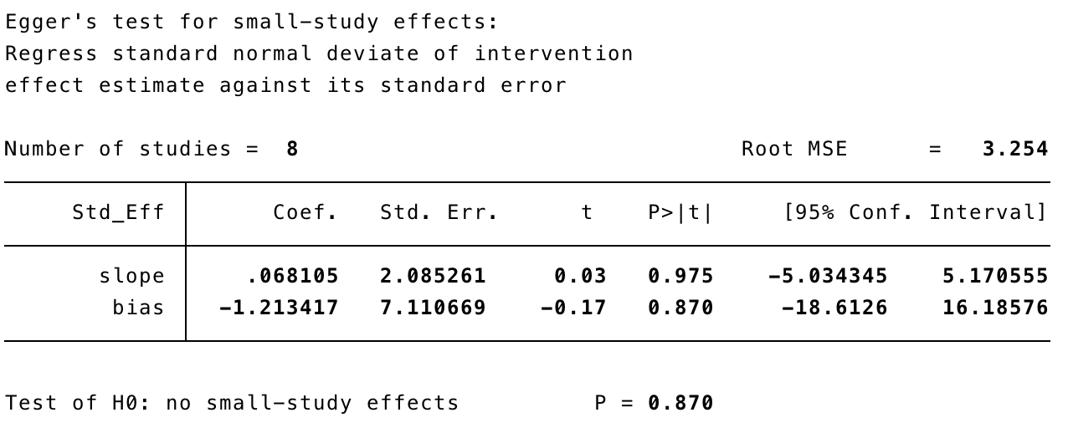

C. PRP: 6 months
