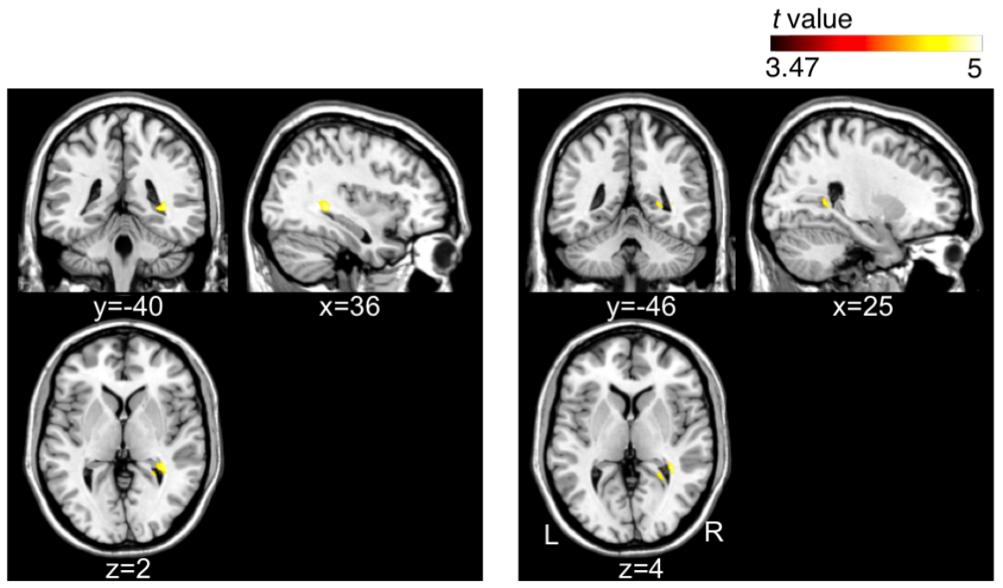

Supplemental Digital Content Figure 1: Comparison of volume changes between the mild traumatic brain injury (mTBI) groups with early (< 60 days) and late phases (≥ 60 days) after injury. Volume expansion was observed in the mTBI group with late phase of injury compared to the early phase, in the white matter area near the right hippocampal gyrus (uncorrected P < 0.001 within a cluster of an extent threshold of k > 100).

