Appendix Figure 1: Calibration of Full Model
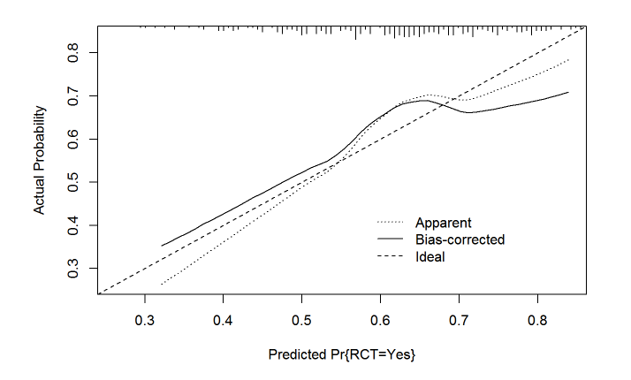

Small vertical lines at the top of the graph denote the frequency of predicted probabilities for the patient set. The apparent line depicts the relationship between predicted and observed probabilities of a rotator cuff tear. The bias corrected line compares predicted probabilities from a bootstrap corrected model to observed probabilities. These lines are constructed using a loess smoother. The ideal line of perfect agreement originates at the origin (0,0) with a slope of 1.

