Big Data Analysis of Traditional Knowledge Based Ayurveda Medicine
Harpreet Singh^{a,b}; Sapna Bhargava^{c}; Sailesh Ganeshan^{b}; Ravneet Kaur^{b}; Tavpritesh Sethi^{d};
Mukesh Sharma^{c}; Madhusudan Chauhan^{c}; Neerja Chauhan^{c}; Rishipal Chauhan^{c,e}; Partap Chauhan^{c,e}; Samir K. Brahmachari^{a,f}

ªAcademy of Scientific and Innovative Research, New Delhi, India; ^{b}Oxyent Medical Private Limited, New Delhi, India; ^{c}Jiva Ayurveda, Faridabad, India; ^{d}Wellcome Trust/DBT India Alliance Early Career Fellow at Department of Pediatrics, All India Institute of Medical Sciences, New Delhi, India; ^{e}Jiva Institute of Vedic Science and Culture, Faridabad, Haryana, India; and ^{f}CSIR-Institute of Genomics and Integrated Biology, New Delhi, India.

Corresponding authors:

^{a,f}Samir K. Brahmachari, PhD
CSIR-Institute of Genomics and Integrative Biology,
Mathura Road, New Delhi -110020, India
Email: skb@igib.in

^{c,e}Partap Chauhan
Jiva Institute of Vedic Science and Culture,
Faridabad, Haryana, 121001, India.
Email: drchauhan@jiva.com

Supplemental Digital Content 1: Definition of Prakriti & Vikriti and treatment methodology in Ayurveda

According to Ayurveda, an individual is born with a specific Prakriti(healthy proportion of physiological constituents i.e. Vata, Pitta and Kapha) which is understood to be the biological basis of each individual .Prakriti describes individual’s susceptibility to disease and responsiveness to extrinsic and intrinsic environments^{9,10,38}.
During diseased state an individual moves away from Prakriti to a Vikriti state (diseased state – imbalanced proportion of Vata, Pitta and Kapha). Ayurveda treatment involves: (a) assessment of disease by investigating basic physical constituents of body (Prakriti and Vikriti) as documented in the Ayurveda, (b) treatment through personalized mixture of naturally available herbs and other ingredients for each patient based on specific imbalance of its physical constituents and (c) management of health and prevention of disease through lifestyle and diet via continuous participation with patients .

Supplemental Digital Content 2: Ayurvedic disease elements correlated with modern medicine description

Ayurvedica assessment of disease phenotype correlated with modern medicine description. 106 modern medicine sub disease type were used to categorise 318 disease elements as defined by Ayurveda having specific treatment.

S.No | System | Disease sub-category | Disease element
1 | Cardiovascular | Angina | Angina Pectoris
2 |  |  | Hrit Shool
3 |  | Congenital Heart Disease | Congenital Heart Disease
4 |  | Coronary artery Disease | Hridya Bhighat
5 |  |  | Myocardial Infarction
6 |  | Disease of heart muscles | Caridomyopathy
7 |  |  | Myocarditis
8 |  | Dyspnoea | Paroxysmal Dyspnoea
9 |  | Heart disease | Hrid Rog
10 |  | High Cholesterol | Hypercholestraemia
11 |  |  | Hyperlipidaemia
12 |  | Hypertension | Hypertension
13 |  |  | Pulmonary Hypertension
14 |  | Hypertension / Coronary Heart Disease | cardiomegaly
15 |  | Irregular Heartbeat | Heart Block
16 |  |  | Paroxymal Atrial Techycardia
17 |  |  | sinus Tachycardia
18 |  | Rheumatic Fever | Rheumatic Fever
19 |  | Venous disease | Varicose Veins
20 |  |  | Deep Veinous Thrombosis
21 | Digestive | Diabetes_Digestive | Trishna
22 |  | Diabetes(Thirst) | Thirst
23 |  | Disease of Appendix | Appendicitis
24 |  | Disease of Oesophagus | Dysphagia
25 |  | Disease of Pancreas | Pancreatitis
26 |  | Disease of Spleen | Splenomegaly
27 |  | Dyspepsia | Aaddhmana
28 |  |  | Aatopa
29 |  |  | Agni Mandhya
30 |  |  | Ajirna
31 |  |  | amajirna
32 |  |  | Aruchi
33 |  |  | Dyspepsia
34 |  |  | Gastritis
35 |  |  | Rassheshajirna
36 |  |  | Vidangdhajirna
37 |  | Gall Bladder Stone | Gall stone: Cholecystitis
38 |  | Hernia | Inguinal Hernia
39 |  |  | Umblical Hernia
40 |  | Hyperacidity | Amal pitta
41 |  |  | Chardi
42 |  |  | Gastric Ulcer
43 |  |  | GERD (Gastroesophageal Reflux Disease)
44 |  |  | Hiatus Hernia
45 |  | Hyperthyroidism | Karshayata
46 |  | IBS | Atisaar
47 |  |  | Coeliac Disease
48 |  |  | Crohnâ€šÃ„Ã´s Disease
49 |  |  | Diverculitis
50 |  |  | Grahanij
51 |  |  | Irritable Bowel syndrome
52 |  |  | Kaphaj Grahani
53 |  |  | Pittaj Grahani
54 |  |  | Pravahika
55 |  |  | Ulcerative Colitis
56 |  |  | Vibandh
57 |  |  | Vataj Grahani
58 |  | Liver | Ascites
59 |  |  | Cirrhosis of the Liver
60 |  |  | Hepatitis B
61 |  |  | Hepatitis C
62 |  |  | Hepatomegaly
63 |  |  | Hicca
64 |  |  | Hiccup
65 |  |  | Jaundice
66 |  |  | Kamla
67 |  |  | Kumbh Kamla
68 |  |  | Liver abscess
69 |  |  | Liver Failure
70 |  | Parasite infection | Worm infestation
71 |  | Piles/Fissure/Fistula | Fissure
72 |  |  | Fissure
73 |  |  | Fistula
74 |  |  | Piles
75 |  |  | Rectal prolapse
76 |  |  | Rectal prolapse
77 |  | Ulcers | esophageal ulcers
78 |  |  | Peptic Ulcer
79 |  |  | Rakta Pitta
80 |  |  | Stomatitis
81 | Eyes and Ears | Ear | Ear perforation
82 |  |  | Suppurative otitis media
83 |  |  | Senile deafness
84 |  | Eye | Blephritis
85 |  |  | Cataract
86 |  |  | Conjuctivities
87 |  |  | Glucoma
88 |  |  | Hypermetropia
89 |  |  | Myopia
90 |  |  | Night blindness
91 |  |  | Retinitis pigmentosa
92 |  |  | Stye
93 |  | Tinnitus | Tinnitus
94 | Endocrine | Diabetes | Diabetes Mellitus
95 |  |  | Diabetic nephropathy
96 |  |  | Diabetic Neuropathy
97 |  |  | Diabetic retinopathy
98 |  |  | Periphral neuropathy
99 |  | Diabetes Insipidus | Diabetes Insipidus
100 |  | Obesity | Obesity
101 |  | Pituitary | Hyperpituarism
102 |  |  | Hypopituarism
103 |  | Short stature | Height Short
104 |  | Thyroid | Goitre
105 |  |  | Hyperthyroidism
106 |  |  | Hypothyroidism
107 |  |  | Atikrish
108 | Gynaecological | Abortion | Missed Abortion
109 |  | BOD | Ectopic Pregnancy
110 |  | BOH | Abortion
111 |  |  | Habitual Abortion
112 |  | BOH | Putraghni
113 |  |  | Spontaneous Abortion
114 |  |  | Vamini
115 |  | Cancer | Carcinomata Cervical
116 |  |  | Carcinomata Endometrial
117 |  |  | Carcinomata Ovarian
118 |  |  | Carcinomata Uterine Tube
119 |  |  | Carcinomata Vaginal
120 |  |  | Carcinomata Vulval
121 |  | Carcinoma | Yonikanda
122 |  | Contraception | Contraception
123 |  | Disease of Red blood cells | Anemia
124 |  | Disease of cervix | Antarmukhi
125 |  |  | Kardini
126 |  | Disease of Ovary | Atrophic Ovary
127 |  |  | Ovary Absense
128 |  |  | Ovary Duplication
129 |  |  | Ovary Single
130 |  | Disease of Uterus | Adenomyosis Uteri
131 |  |  | Endometriosis
132 |  |  | Fibroid uterus
133 |  |  | Uterus Absense
134 |  |  | Uterus Duplication
135 |  |  | Uterus Enlarged
136 |  |  | Uterus Myomas
137 |  |  | Uterus Retroflexion
138 |  |  | Uterus Retroversion
139 |  |  | Uterus Shrinked
140 |  |  | Vataja
141 |  | Disease of vagina | Krichra Maithunta (dyspareunia)
142 |  |  | Suchimukhi
143 |  |  | Sushka Yoni
144 |  | Dysmenorrhea | Udavartini
145 |  | Genital warts | Yoni arsh
146 |  | Hymen Imperforate | Hymen Imperforate
147 |  | Infection | Cervicitis
148 |  |  | Pelvic Inflammatory Disease
149 |  |  | Pittaja
150 |  |  | sveda pradar
151 |  |  | Vaginitis
152 |  |  | Vaginitis (Yonishotha)
153 |  |  | Infertility
154 |  |  | Primary infertility
155 |  |  | Secondary infertility
156 |  |  | Shanda Yoni
157 |  | Menstrual Disorder | Amenorrhoea
158 |  |  | Arajaska
159 |  |  | Dysfunctional Uterine Bleeding
160 |  |  | Dysmenorrhoea
161 |  |  | Menorrhagia
162 |  |  | Post Menopausal syndrome
163 |  |  | Premenstrual Tension
164 |  |  | Primary Amenorrhoea
165 |  |  | Rakta Yoni
166 |  |  | Secondary Amenorrhoea
167 |  | Misc_Gynae | Tumours of the Trophoblast
168 |  | Polyps | Polyps
169 |  | Prolapse | Cystocoele
170 |  |  | Mahayoni
171 |  |  | Rectocoele
172 |  |  | Uterus Prolapse
173 |  | UTI_Gynae | Urine Incontinence
174 |  | Vaginitis | Sannipataja
175 |  |  | Acharana
176 |  |  | Aticharana
177 |  |  | Bartholinitis
178 |  |  | Kaphaja
179 |  |  | Paripluta
180 |  |  | Prakcharana
181 |  |  | Upapluta
182 |  | Misc | Karni Yoni vyapad
183 | Nervous | Headache | Headache
184 |  |  | migraine
185 |  |  | Shankak
186 |  |  | Suryavarta
187 |  |  | suryavarta vipraya
188 |  |  | Trigeminal neuralgia
189 |  | Muscles disorders | muscular dystrophy
190 |  | Neurological disorders | Carebral palsy
191 |  |  | CVA
192 |  |  | Fatigue
193 |  |  | Parkinsons disease
194 |  | Osteoarthritis | Sarvang vaat
195 |  | Paralysis | Ardhang vaat
196 |  |  | Ekangvaat
197 |  |  | Facial Paralysis
198 |  |  | Paralysis
199 |  | Psychological Disorder | Agerophobia
200 |  |  | Anxiety Neurosis
201 |  |  | Delirium
202 |  |  | Dementia
203 |  |  | Epilepsies
204 |  |  | Major Depressive Illness
205 |  |  | OCD
206 |  |  | Unmaad
207 |  |  | Vishad
208 |  |  | Yoshaparmar
209 |  |  | Schizophrenia
210 |  | Spinal Disorder_Nervous | Gridhrasi vataj
211 |  |  | Gridhrasivata kaphaj
212 |  |  | Sciatica
213 | Respiratory | Allergies | Allergic Rhinitis
214 |  | Asthma | Allergic asthma
215 |  |  | Bronchial Asthma
216 |  |  | Kas Rog
217 |  |  | Swas Rog
218 |  |  | Tamak Swas
219 |  | COPD | Chronic Bronchitis
220 |  |  | Bronchiectasis
221 |  |  | COPD
222 |  |  | Emphysema
223 |  | Liver_Respiratory | Hicca Rog
224 |  | Nasal cavity disease | Bhranshthu
225 |  |  | Coryza
226 |  |  | DNS
227 |  |  | Nasal polyps
228 |  |  | pinas
229 |  |  | Pittaj-Pratishya
230 |  |  | Pratishya
231 |  |  | Swathu
232 |  | Pneumonias | Pneumonias
233 |  | Psychological Disorder_Respiratory | Senile dementia
234 |  | Sarcoidosis | Sarcoidosis
235 |  | Tuberculosis | Parshav Shool
236 |  |  | Pleurial Effusion
237 |  |  | Pleurisy
238 |  |  | Post TB
239 |  |  | Tuberculosis
240 |  | Upper respiratory infection | Laryngitis
241 |  |  | Swar bheda
242 |  | Upper Respiratory Tract Infection | Pharngitis
243 | Sexual | Prostate | Benign Prostatic Hypertrophy (BPH)
244 |  | Sexual Disorder | Azoospermia
245 |  |  | Erectile Dysfunction
246 |  |  | Frigidity
247 |  |  | Genital Warts
248 |  |  | Gonorrhea
249 |  |  | Oligospermia
250 |  |  | Premaha
251 |  |  | Premature Ejaculation
252 |  |  | Syphilis
253 |  |  | Dhatu Rog
254 |  | UTI_Sexual | Non-specific Urethritis
255 |  | Viral | Herpes Simplex
256 |  | Virus | HIV / AIDS
257 | Skeleton | Arthritis | Amavata
258 |  |  | Arthritis
259 |  |  | Frozen shoulder
260 |  |  | Psoriatic Arthritis
261 |  |  | Rheumatoid Arthritis
262 |  |  | vatakantak
263 |  | Connective Tissue Disorder | Systemic Lupus Erythematosus (SLE)
264 |  | Gout | Vata Rakta
265 |  |  | Gout
266 |  | Neurological disorders | Avbauak
267 |  |  | carpal tunnel syndrome
268 |  |  | Vishvachi
269 |  | Osteoarthritis | Osteoarthrosis
270 |  |  | Sandivata
271 |  | Spinal Disorder | Ankylosing Spondylitis
272 |  |  | Cervical Spondylosis
273 |  |  | DDD (Degenerative disc degeneration)
274 |  |  | Herniated Disc
275 |  |  | Lumbar Spondylosis
276 |  | Temporo mandibular Joint Disorders | hanustambh
277 |  | Tendonitis | Tennis elbow
278 |  |  | Writers dystonia
279 | Skin | Acne | Acne Vulgaris
280 |  |  | Yuvana Pidaka
281 |  | Allergy | Skin Allergy
282 |  | Diseases of Skin | Crack heel
283 |  |  | Hypomelanosis
284 |  |  | Kshudra Kushtha
285 |  |  | Lichen simplex
286 |  |  | Maha Kushtha
287 |  |  | Moles
288 |  |  | Pityriasis (tenia) Versicolor
289 |  |  | Pityriasis Rosea
290 |  | Eczema | Eczema
291 |  | Hair | Indralopta
292 |  |  | khalitya
293 |  |  | Paliyta
294 |  | Infection_Skin | Moniliasis
295 |  |  | Pemphigus
296 |  |  | Pyodermas
297 |  |  | Ringworm
298 |  | Parastic skin infestation | Scabies
299 |  | Parastic skin/hair infestation | Pediculosis
300 |  | Pruritis | Pruritis
301 |  | Psoriasis | Lichen Planus
302 |  |  | Psoriasis
303 |  | Urticaria | Urticaria
304 |  | Viral | Herpes Simplex
305 |  |  | Herpes Zoster
306 |  | Vitiligo | Shwet Kushtha
307 |  |  | vitiligo
308 | Urinary | Diseases of Kidney | Hydronephrosis
309 |  |  | Kidney cyst
310 |  |  | Mutraghat
311 |  |  | Nephrotic syndrome
312 |  | High BP | Pulmonary Hypertension
313 |  | Renal Failure | Renal Failure
314 |  | Stone | Ashmari
315 |  |  | Urinary Calculi
316 |  | UTI_Urinary | Hematuria
317 |  |  | Mutrakrisha
318 |  |  | Urinary Tract Infection

Supplemental Digital Content 3: Scaled population pyramid: Telemedicine vs census patient population
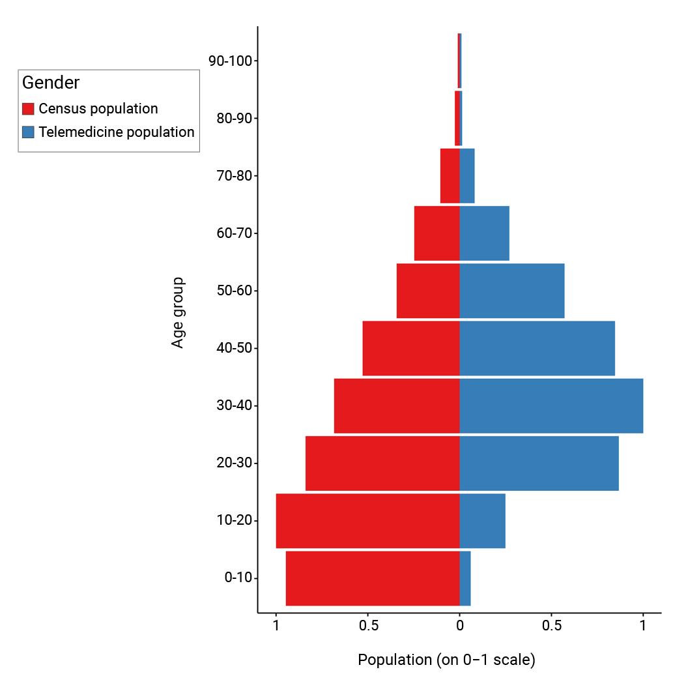

Suppl. Figure 3: India Census population count vs Telemedicine patient count for various age groups

Supplemental Digital Content 4: Three most prevelant disease elements of six major disease systems
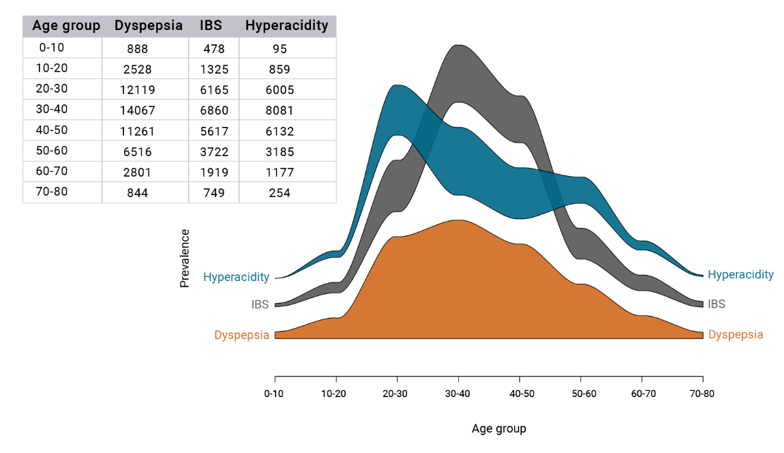
Fig Supp 4A: Digestive
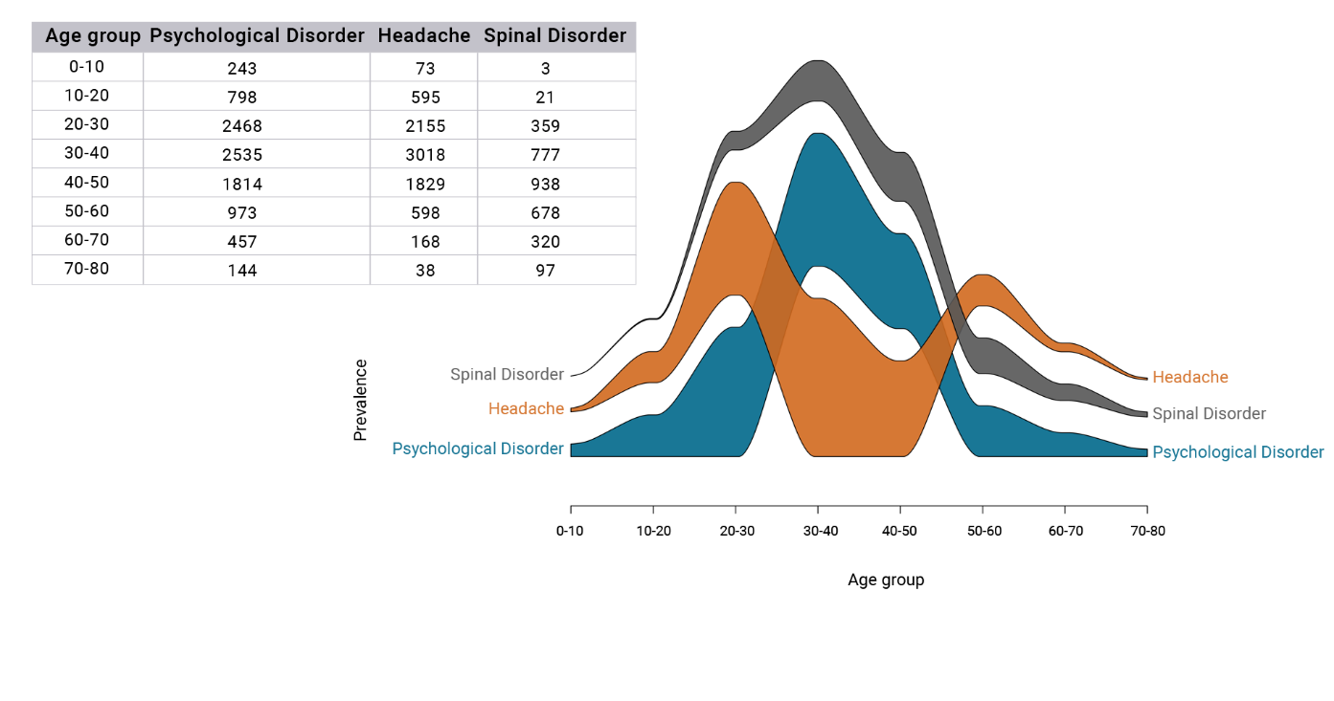
Fig Supp 4B: Nervous

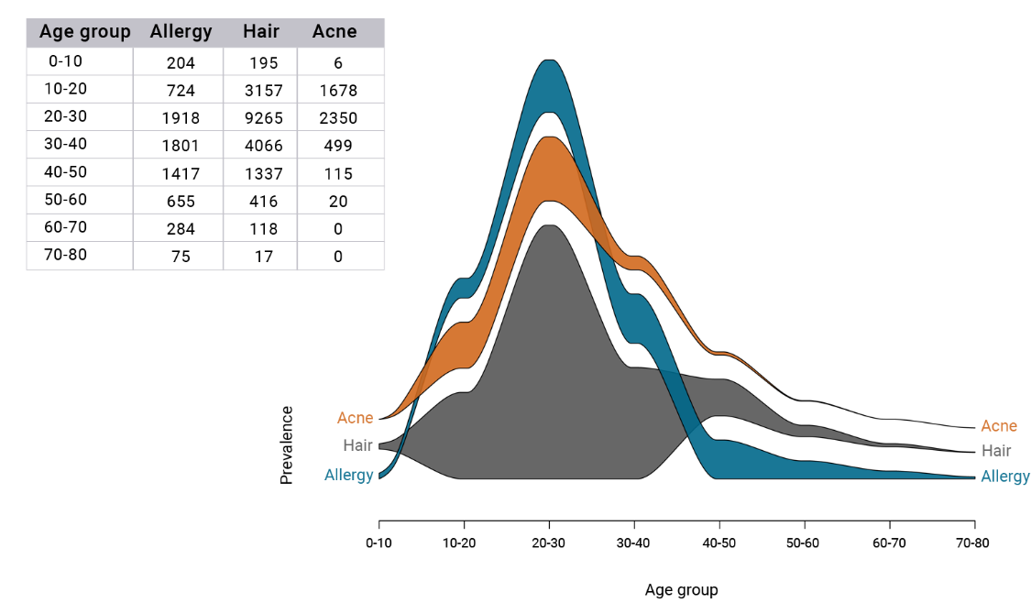
Fig Supp 4C: Skin

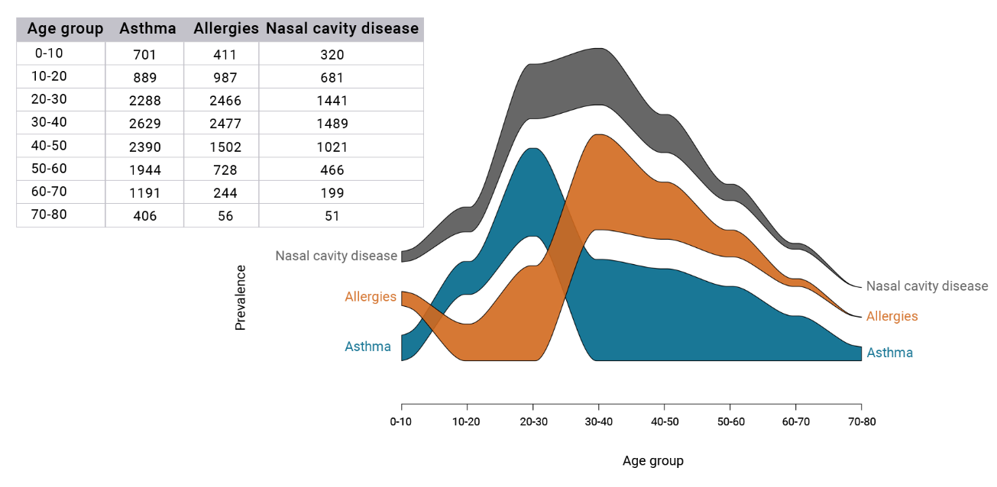
Fig Supp 4D: Respiratory

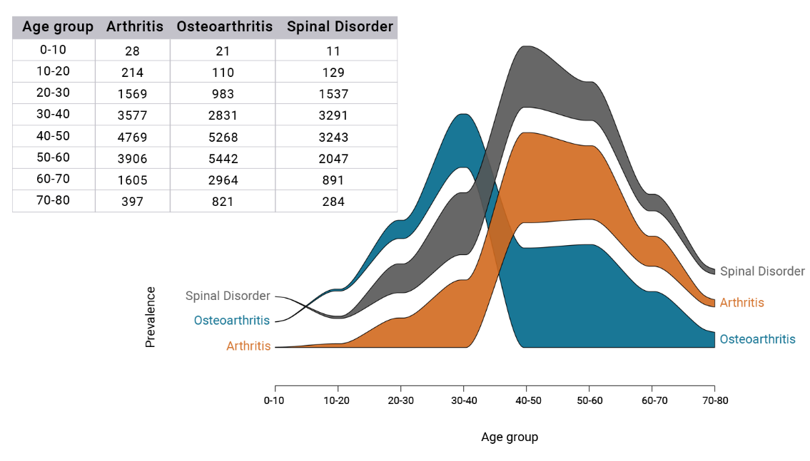
Fig 4E: Skeleton

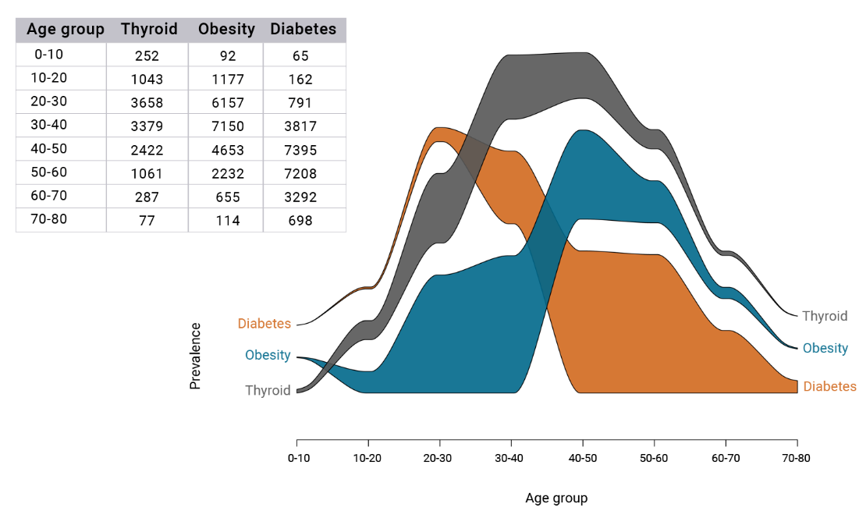
Fig 4F: Endocrine

Supplemental Digital Content 5: Vikriti based classification of sub diseases and disease elements
Below table shows dosha based (color coded) classification of six major diseases, patient count at disease
level, their sub diseases (as per modern medicine name mapping), major dosha at sub disease level and
patient count at sub disease level.
Dominant vikriti | Disease | Count | Disease sub category | Count
 |  | 954 | Tinnitus | 381
Vata | Ears & Eyes |  | Ear | 179
 |  |  | Eye | 394
 |  | 10988 | Psychological disorder | 4030
 |  |  | Headache | 3521
Vata | Nervous |  | Misc | 1937
 |  |  | Spinal disorder | 1392
 |  |  | Osteoarthritis | 108
 |  | 23208 | Osteoarthritis | 8942
 |  |  | Arthritis | 6086
Vata | Skeleton |  | Spinal disorder | 5659
 |  |  | Gout | 2248
 |  |  | Misc | 231
 |  |  | Connective Tissue Disorder | 42
 |  | 13690 | Liver | 7
 |  |  | Asthma | 6090
 |  |  | Allergies | 4155
Kapha | Respiratory |  | Sinusitis | 2755
 |  |  | Misc | 418
 |  |  | COPD | 157
 |  |  | Upper Respiratory Tract Infection | 108
 |  | 27754 | Thyroid | 5235
Kapha | Endocrine |  | Pituitary | 1218
 |  |  | Diabetes | 12959
 |  |  | Obesity | 8342
 |  | 18636 | Hair | 8755
 |  |  | Allergy | 2872
 |  |  | Acne | 2014
 |  |  | Psoriasis | 1411
Pitta | Skin |  | Vitiligo | 1143
 |  |  | Urticaria | 917
 |  |  | Misc | 752
 |  |  | Eczema | 574
 |  |  | Infection | 198

Supplemental Digital Content 6: Male Jaccard’s similarity based Alluvial diagram
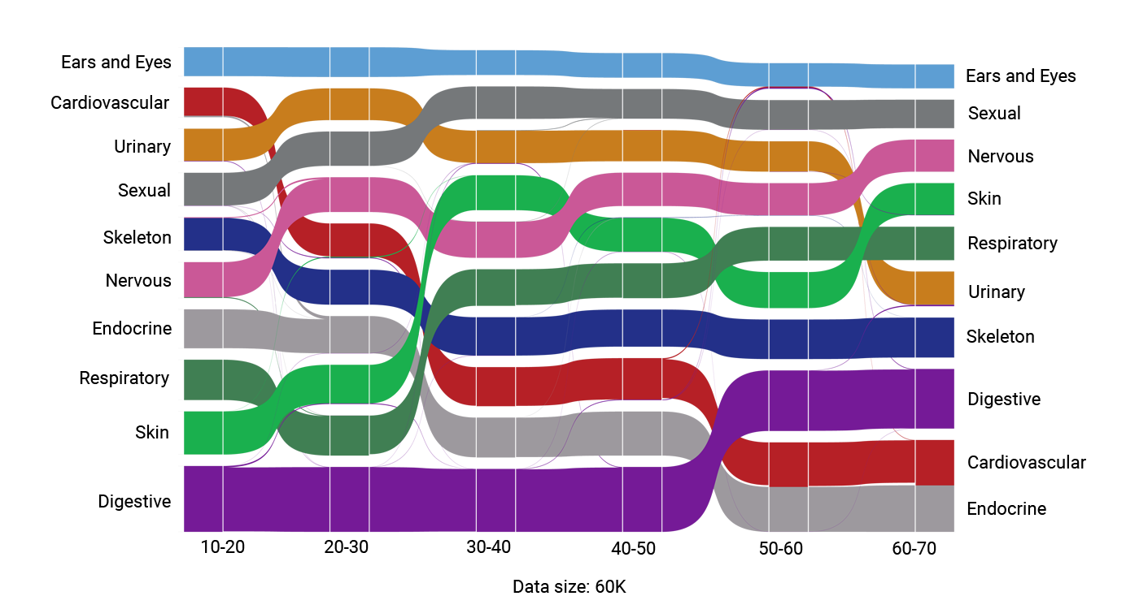

Supplemental Digital Content 7: Female Jaccard’s similarity based Alluvial diagram 