Appendix
The variable used in this research are: Microalbumin value (malb), Hemoglobin(a1c), Cholesterol value (ldl), Systolic Blood Pressure (spb), Diastolic Blood Pressure (dbp), Age, Weight, Heigh and Body Mass Index (BMI)
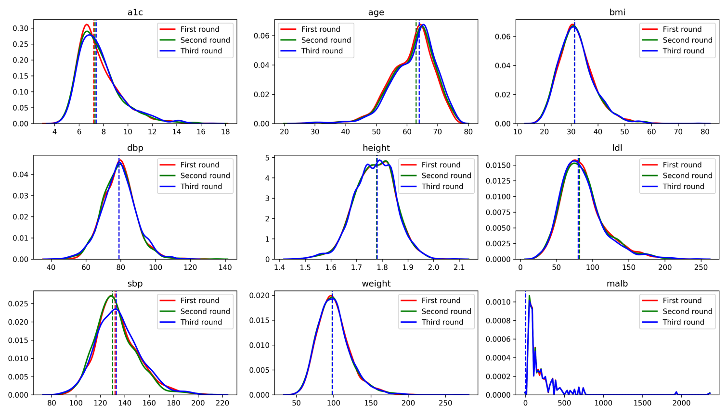
Figure 1. Data for each patient was collected at three appointments, at approximately six months intervals. The distribution of the data is illustrated in the panels for each appointment as labeled. Vertical lines show the median.
Table 1.
 | height  (meter) | weight  (kg) | bmi  (kg/cm) | age  (year) | a1c  (%) | ldl  (mg/dl) | sbp  (mm Hg) | dbp  (mm Hg) | malb  (mg)
mean | 1.77 | 100.45 | 32.00 | 61.97 | 7.65 | 85.88 | 133.87 | 78.90 | 28.61
std | 0.08 | 22.16 | 6.58 | 7.14 | 1.75 | 29.71 | 17.67 | 9.59 | 107.29
min | 1.47 | 47.63 | 16.95 | 25.00 | 4.10 | 25.00 | 85.00 | 42.00 | 0.10
25% | 1.73 | 85.28 | 27.48 | 58.00 | 6.40 | 65.00 | 122.00 | 73.00 | 0.90
50% | 1.78 | 98.29 | 31.28 | 63.00 | 7.30 | 81.00 | 132.00 | 79.00 | 2.60
75% | 1.83 | 112.04 | 35.51 | 67.00 | 8.40 | 100.00 | 144.00 | 85.00 | 9.80
max | 2.08 | 266.80 | 77.60 | 75.00 | 17.10 | 244.00 | 212.00 | 135.00 | 2357.00

