Introduction and Instruction for
Placing Your Infant in Sidelying

I would like to teach you 3 ways to handle and position your baby. These positions will be developmentally helpful for your baby, because they will help your baby move and strengthen his or her muscles. In addition, doing these activities will give you a nice chance to interact with and be close to your baby. During the following instruction, it will be important to note how long and how often you should do each activity. Each step is an important part of the activity.

The first position is to move your baby from back to sidelying. To do this:
  - First, roll up a baby blanket and put it aside so it is ready to use once your baby is lying on the side.
  - Then, gently un-swaddle your baby.
  - Next, approaching from your baby’s right side, place one of your hands under your baby’s neck & shoulder and your other hand under your baby’s buttocks & hip (see picture 1).
  - Gently roll, or turn, your baby onto the left side.
  - Once your baby is in sidelying, place the rolled up blanket behind your baby’s head and back for support (see picture 2).
  - Then, roll up a diaper cloth and place it between your baby’s legs for support at the legs and hips (much like you might do with a pillow when sleeping on your side) (see picture 3).
  - Next, gently move your baby’s top arm across the chest toward the middle of the body. And, be sure your baby’s lower arm is not stuck under his or her body (see picture 4).
  - Once your baby is settled, cover your baby snuggly with a blanket.
  - Then, softly speak to your baby and attempt to make eye contact. This is a nice chance for the two of you to socialize (see picture 5).
  - You can place your baby in sidelying before or after feeding- as often as you and your nurse decide- and your baby can stay in that position as long as the nurse allows.

- Next time, approach your baby from the left side and move your baby to the right side. It is important for the balance of the neck muscles that you change the side on which your baby is placed. If you place your baby on the left side first, next time place your baby on the right side.

Again: place your baby in sidelying before or after feeding. Your baby can stay in this position as long as the nurse allows. If you place your baby on the right side, next time use the left side.

Placing Your Infant in Sidelying

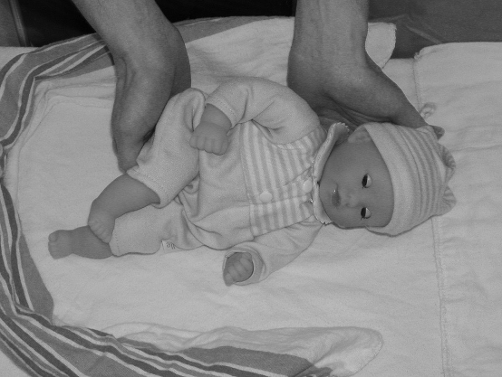  Picture 1 (turning to the side) | 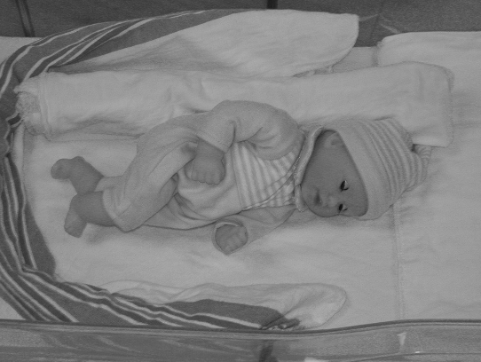  Picture 2 (blanket roll behind baby)
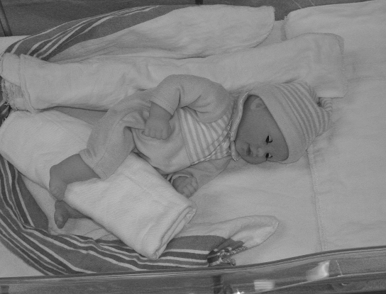  Picture 3 (cloth roll between legs) | 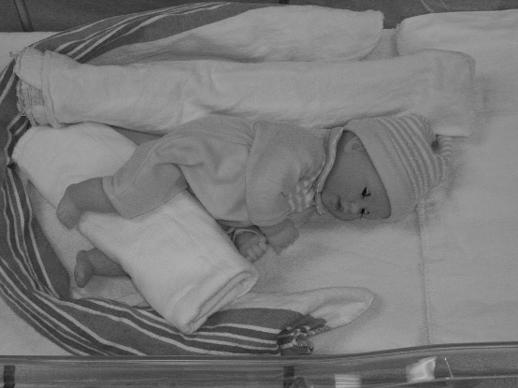  Picture 4 (arms toward midline)
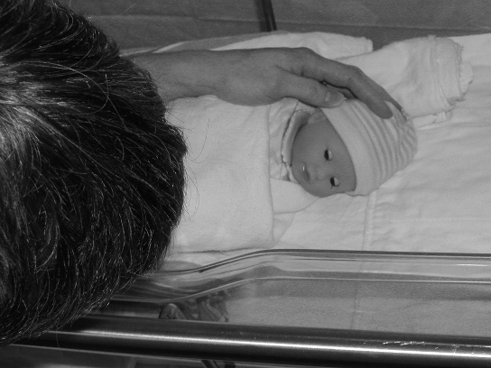
Picture 5 (attempt eye contact/speak to baby)

Remember: place your baby in sidelying before or after feeding. Your baby can stay in this position as long as the nurse allows. If you place your baby on the right side, next time use the left side. Also: if your baby appears overwhelmed or tired during this activity- by yawning, hiccupping, closing the eyes, looking away from you, getting a pale skin color, or having significant changes in heart rate, oxygen levels or respiratory rate- stop the activity and talk to your nurse.

Guided Lower Extremity Movements

The second activity is to move your baby’s legs up and down in a bicycle riding pattern, while your baby is on his or her back. To do this:

- Gently place your baby on the back, if she or he is not already there.
- Gently place your hands around your baby’s legs (see picture 1). For proper hand placement:
  - Hold your hands in front of you as though you are holding the sides of a small box.
  - Wrap the palms of your hands around the sides of your baby’s legs.
  - Hold the knee between your thumb and first finger.
- Be sure your baby’s knees are pointed up toward the ceiling and not out to the sides or in toward each other (refer to picture 1).
- Then, gently and slowly move one leg at a time up toward the chest and down toward the end of the bed, in a bicycle riding pattern (see picture 2).
- Never force a movement, but when your baby wants to kick, put your hands on the soles of the feet and allow your baby to gently push (extend) against your hand (see picture 3). This activity is similar to your baby kicking against your uterus during pregnancy.
- There will be times when your baby wants to kick strongly. For this, move one hand to your baby’s tummy for comfort and allow your baby to finish kicking (see picture 4). Then, place your hands back on the legs and continue as before.
- As you do this exercise, softly speak to your baby and attempt to make eye contact (see picture 5). This is a nice chance for the two of you to socialize.
- Do this exercise for up to 2 minutes before changing the diaper prior to feeding up to 2 times per day. If your baby begins to cry or get upset before 2 minutes, stop the exercise and try to calm your baby. You can try the exercise once more if you and the nurse decide it is okay, but do not exceed 2 minutes per attempt.

Again: Do this exercise for up to 2 minutes before changing the diaper prior to feeding. The exercise may be done up to 2 times per day as your baby tolerates.

Guided Lower Extremity Movements

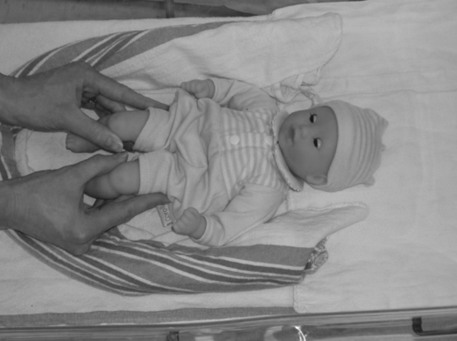  Picture 1 (hand placement/knees up) | 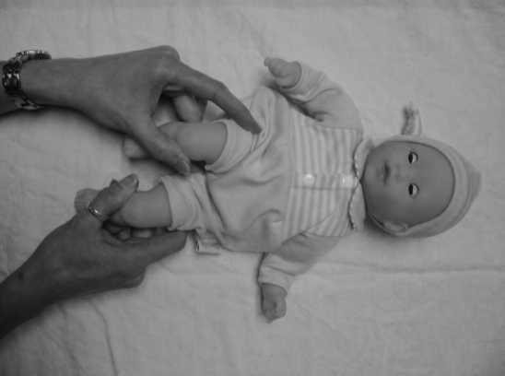  Picture 2 (move legs)
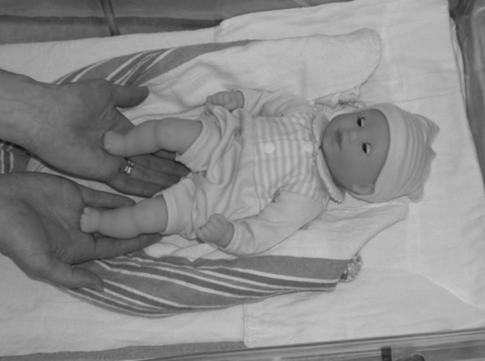  Picture 3 (kicking against your hand) | 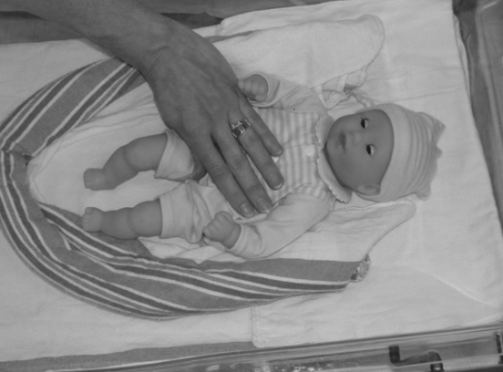  Picture 4 (stabilize tummy)
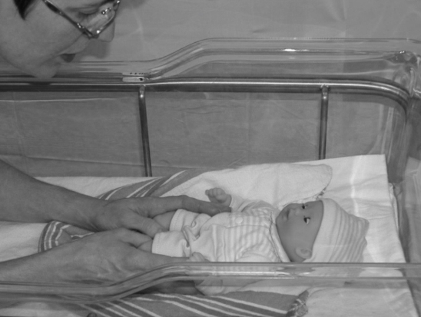
Picture 5 (attempt eye contact/speak to baby)

Remember: Do this exercise for up to 2 minutes before changing the diaper prior to feeding. The exercise may be done up to 2 times per day as your baby tolerates. Also: if your baby appears overwhelmed or tired during this activity- by yawning, hiccupping, closing the eyes, looking away from you, getting a pale skin color, or having significant changes in heart rate, oxygen levels or respiratory rate- stop the activity and talk to your nurse.
SUPPORTED SITTING ACTIVITY

The third activity will be done in 2 parts with your baby in your lap. To do this activity:
Part 1
- Gently pick up your swaddled baby by placing your hands under your baby’s head and buttocks.
- Sit down in the chair with your baby facing you in your arms. To support your baby’s head and body, cross your arms in front of you so that your hands come together behind your baby’s neck and back. Your elbows may rest on your hip area to support your arms.
- Your baby will be propped up in a semi-upright position in your arms, about 10-12 inches from your face (see picture 1- starting position for rocking movement). To help your baby alert, gently rock your baby (not yourself) forward and backward 2 times if needed (see picture 2- ending position for rocking movement). Over the next 30 seconds, talk to your baby.
- If your baby does not open the eyes, repeat the gentle forward and backward rocking a maximum of 2 more times. Talk to your baby to help your baby wake up.
- While your baby has the eyes open, slowly and smoothly move your face about 45 degrees to the right, and slowly back to center (see picture 3). Then, repeat this motion to the left. Keep your face about 10-12 inches away from your baby’s face and softly speak to your baby to help your baby focus on your face (refer to picture 3).
- Do this part of the activity for up to 2 minutes, then move on to part 2 (even if baby not yet alert).
Part 2
- Move the baby into a sideways position sitting in your lap (similar to a burping position).
- In this position, you will have one hand at the base of your baby’s chin and the other at the base of the back of your baby’s head (see picture 4).
- Next, gently tilt your baby slightly forward so your baby can practice lifting the head upright off your front hand (at the chin). Again, softly speak to your baby to encourage head lifting (see picture 5).
- Do this part of the activity for up to 2 minutes as well. The total time spent on this supported sitting activity should not exceed 4 minutes (2 minutes for each part).
- If your baby becomes upset, try calming your baby. Continue with the activity only if you and the nurse decide it is okay.
- If your baby begins to look too tired by the activity- by yawning, hiccupping, closing the eyes, looking away from you, getting a pale skin color, or having significant changes in heart rate, oxygen levels or respiratory rate- stop the activity and talk to your nurse.
- If your baby tolerates this, you may try the activity for up to 2 times per day (maximum) prior to feeding.

Again: Do each phase for up to 2 minutes (a total of 4 minutes for the activity) prior to feeding. The activity may be done up to 2 times per day as your baby tolerates.
SUPPORTED SITTING ACTIVITY

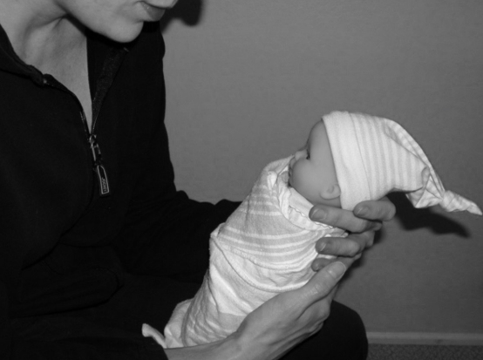  Picture 1 (starting position of rocking movement) | 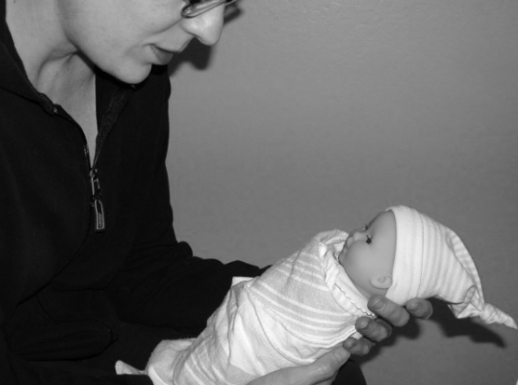  Picture 2 (ending position of rocking movement)
Note: the rocking movement should occur over the course of about 1 second.

Picture 3 (move your head out 45°) | Picture 4 (supported side sit) | Picture 5 (baby tilted forward)

Remember: Do each phase for up to 2 minutes (a total of 4 minutes for the activity) prior to feeding. The activity may be done up to 2 times per day as your baby tolerates. Also: if your baby appears overwhelmed or tired during this activity- by yawning, hiccupping, closing the eyes, looking away from you, getting a pale skin color, or having significant changes in heart rate, oxygen levels or respiratory rate- stop the activity and talk to your nurse.

