Supplemental Digital Content 1: Progressive Functional Strength and Power Training Protocol
a. Functional strength training
Functional strength training was implemented using a computer-aided horizontal leg press machine (Functional Squat System version 3.12, Monitored Rehab Systems, Haarlem, The Netherlands) and included eccentric, concentric and isometric muscle contractions. First, the one-repetition maximum (1RM) for the affected side was assessed to calculate the training weight for each child. According to the NSCA protocol, the intensity of training was set at an intensity of 60% to 80% of the 1RM. Progressive increases of 10% of the 1RM were attempted every two weeks as tolerated. Each child performed leg-presses by playing six different games (Random Reactive, Isometric Gate, Random Explosive, Controlled Position, Random Deceleration, Controlled Route) completing 3 sets per game ( 1 set with the affected leg, 1 set with the unaffected leg, and the last set again with the affected leg). Each set lasted 90 seconds, with a total exercise time of approximately 40 minutes per session, including rest periods.
Random Reactive: Child move the red block with the close chain exercises and try to run away from the blue blocks. The speed of the game is gradually increased to change difficulty of the game.
Isometric gate: Child tries to move red block in free space between blue blocks. The blue blocks are gradually become smaller and faster.
Random Explosive: Child tries to catch blue blocks with red block and not to drop blue blocks. The blue blocks come faster with time.
Controlled Position: Child tries to hold the red block in the moving column. The moving column speed is gradually increased.
Random Deceleration: Child tries to catch the blue blocks and some blue blocks suddenly change the red blocks and child tries to escape these red blocks. The speed is gradually increased.
Controlled Route: Child tries to hold the red marker in the zigzag line. The speed of line and amount of zigzags are gradually increased.

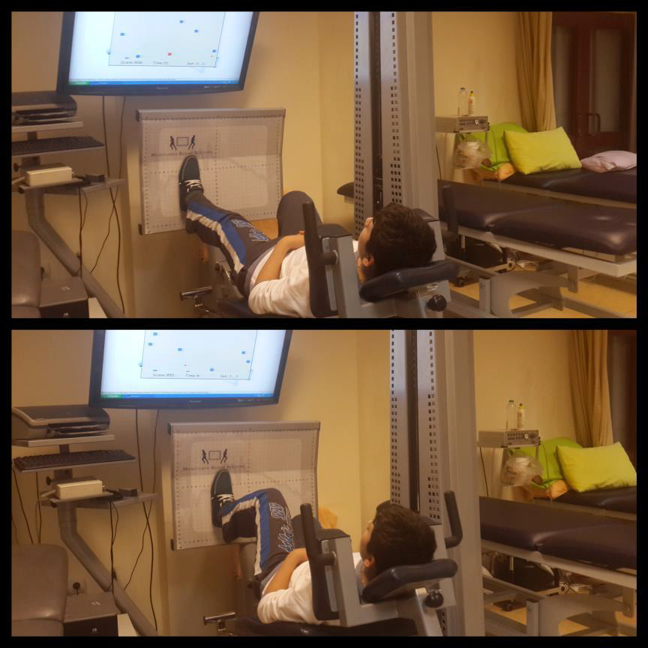
Computer based functional strength training with Functional Rehabilitation
System

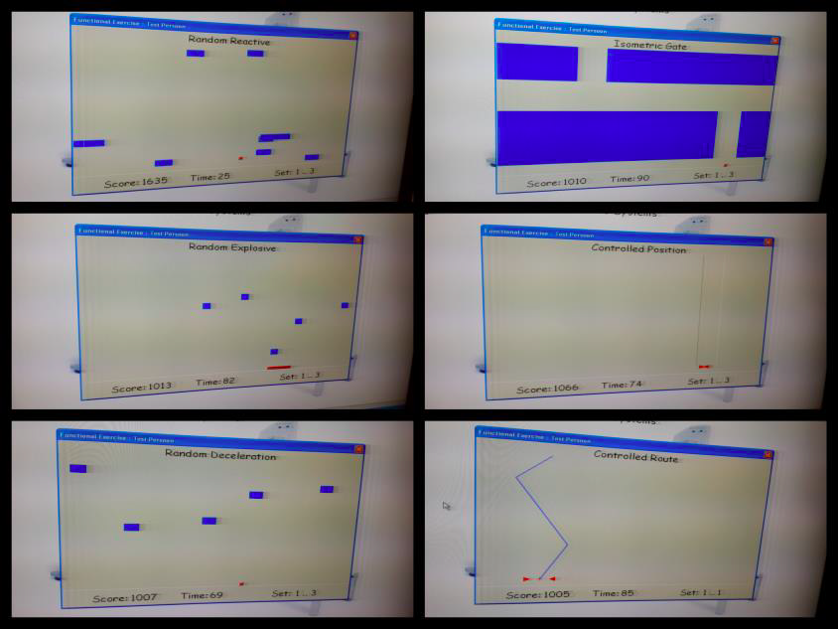

Computer based games (Random Reactive, Isometric Gate, Random Explosive, Controlled Position, Random Deceleration, Controlled Route, respectively)

b. Plyometric exercises
According to the NSCA protocol, 3 sets of 6 repetitions for each exercise were performed including jumping forward on 2 legs and jumping forward on the affected leg with therapist support if necessary. The number of repetitions was increased every 2 weeks up to a maximum of 15 repetitions. Total dose of plyometric exercises in one session was approximately15 minutes.
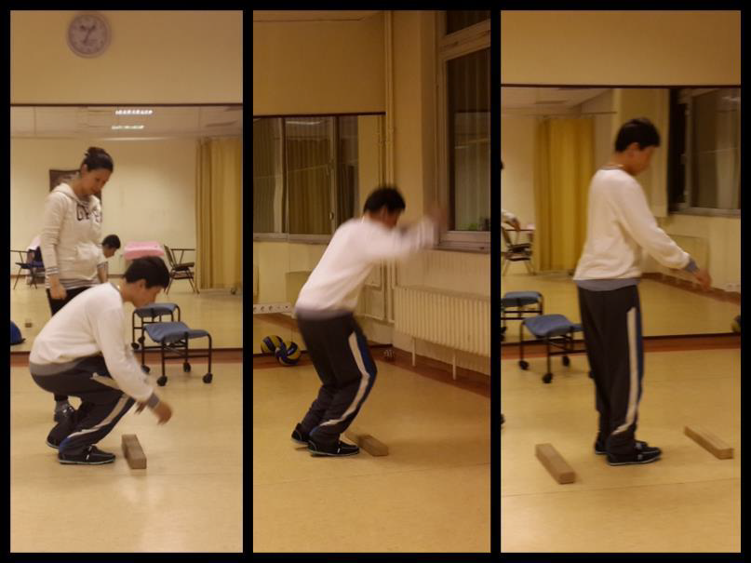

Plyometric exercises: Jumping Forward on Two Legs

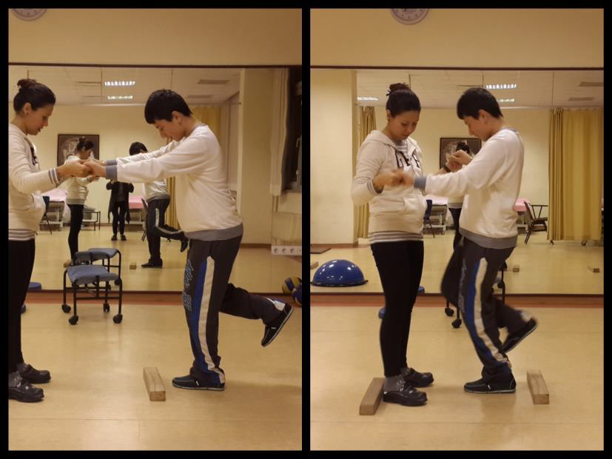

Plyometric exercises: Jumping Forward on the Affected Leg with Therapist Support If
Necessary

c. Balance training on unstable surfaces using a BOSU® ball
Balance training exercises included:(1) standing on a BOSU ball while throwing and catching a ball, (2) one-legged standing (affected leg) on the BOSU ball while throwing and catching a ball with therapist support and (3) small jumps on the BOSU ball. Three sets of 6 repetitions for each exercise were performed both repetitions increased by 10% every 2 weeks up to a maximum of 10 repetitions. Total dose of balance training in one session was 15 minutes.
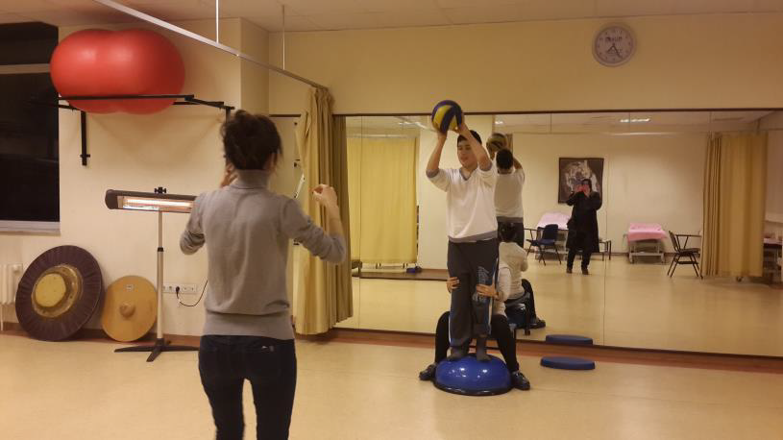

Balance training on unstable surfaces using a BOSU® ball

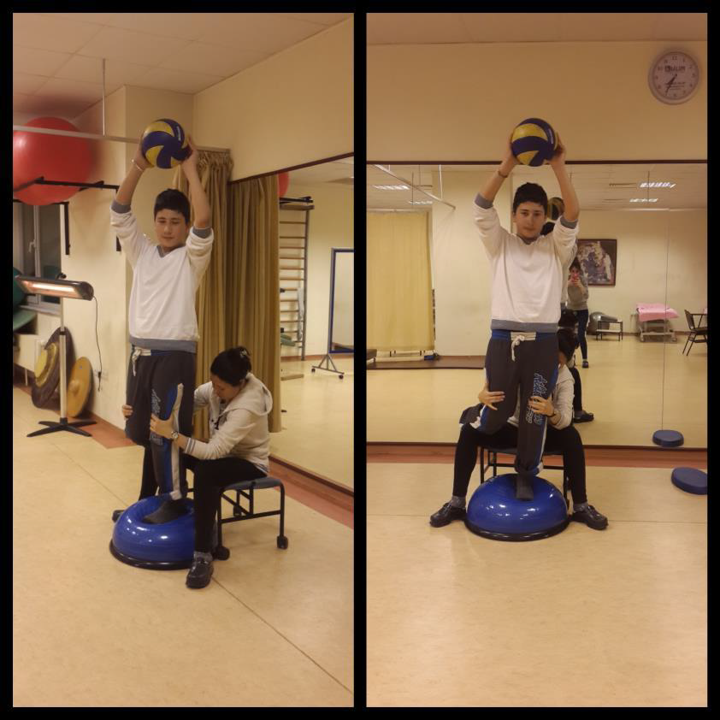

Balance training on the Affected Leg on unstable surfaces using a BOSU® ball

